EXPERIMENT 07

**Aim**: create a web application for BMI calculation using JavaScript.

**Objective**: Students will be able to:

• Understand and implement BMI calculator using Javascript.

• Understand javascript basics and DOM.

**Theory**:

**BMI Calculator Implementation Overview:**

The implemented BMI (Body Mass Index) calculator is designed to provide users with a straightforward and functional tool for assessing their BMI based on height and weight inputs. The following sections outline the key components and functionalities of this BMI calculator:

**HTML Structure:**

The HTML structure of the BMI calculator is thoughtfully organized to facilitate user interaction. It comprises: - Input fields for height (in centimeters) and weight (in kilograms) with corresponding labels for clarity. - A “Calculate” button that enables users to trigger the BMI calculation process. - A designated result display area, represented by the “result” div, where the calculated BMI and its category are presented.

**JavaScript Implementation:**

The calculator’s interactivity and BMI computation are handled through JavaScript. The primary functions of the JavaScript code include: - Associating an event listener with the “Calculate” button, ensuring that the BMI calculation is initiated upon user request. - Extracting and validating user input for height and weight, converting the input values into numeric form for accurate calculations. - Implementing robust error handling to detect and address empty or non-numeric inputs, providing clear error messages to users. - Performing the actual BMI calculation, adhering to the BMI formula: BMI = weight (kg) / (height (m) * height (m)), with the result rounded to two decimal places for precision. - Categorizing the calculated BMI into well-defined health ranges, specifically underweight, normal weight, or overweight, based on widely accepted BMI thresholds.

**Result Presentation:**

The calculated BMI, along with its corresponding health category, is prominently displayed within the designated “result” div. This presentation format ensures that users can readily interpret the significance of their BMI in the context of their overall health.

In summary, this BMI calculator implementation combines structured HTML elements with responsive JavaScript functionality to create an accessible and user-friendly tool for BMI assessment. Its robust error handling ensures data integrity, and its categorization of BMI aligns with established health standards. This implementation represents a valuable resource for individuals seeking to understand their BMI and its implications for their well-being.

**Source code:**

<!DOCTYPE html>

<html lang="en">

<head>

    <meta charset="UTF-8" />

    <meta name="viewport" content="width=device-width, initial-scale=1.0" />

    <title>BMI Calculator</title>

    <link rel="stylesheet" href="./index.css">

    <script src="./index.js"></script>

</head>

<body style="background-color: rgb(199, 232, 243)">

    <!-- rgb(244, 255, 244) -->

    <div class="container bmi-form">

        <h1>BMI Calculator</h1>

        <!-- Option for providing height

            and weight to the user-->

        <div>

            <label for="height">Height in Meters</label>

            <input type="text" id="height" />

        </div>

        <div>

            <label for="weight">Weight in Kgs</label>

            <input type="text" id="weight" />

        </div>

        <div>

            <button class="btn">Calculate</button>

        </div>

        <div id="result"></div>

    </div>

    <footer>by 1 TE ITA NISHANT AGARWAL</footer>

</body>

</html>

.bmi-form>h1 {

    padding-left: 16px;

}

.bmi-form>div {

    padding: 5px 16px 10px;

}

.bmi-form>div>label {

    margin-right: 8px;

}

.bmi-form {

    border: 2px solid black;

    padding: 5px 16px 10px;

    margin: 0 20% 0;

}

footer {

    text-align: right;

    padding: 60px 20% 20px;

}

.btn {

    -webkit-border-radius: 8;

    -moz-border-radius: 8;

    border-radius: 8px;

    font-family: Arial;

    color: #ffffff;

    font-size: 16px;

    background: #3498db;

    padding: 6px 12px 6px 12px;

    text-decoration: none;

}

.btn:hover {

    background: #3cb0fd;

    text-decoration: none;

}

window.onload = () => {

    let button = document.querySelector("#btn");

    // Function for calculating BMI

    button.addEventListener("click", calculateBMI);

};

function calculateBMI() {

    /* Getting input from user into height variable.

    Input is string so typecasting is necessary. */

    let height = parseInt(document

        .querySelector("#height").value);

    /* Getting input from user into weight variable.

    Input is string so typecasting is necessary.*/

    let weight = parseInt(document

        .querySelector("#weight").value);

    let result = document.querySelector("#result");

    // Checking the user providing a proper

    // value or not

    if (height === "" || isNaN(height))

        result.innerHTML = "Provide a valid Height!";

    else if (weight === "" || isNaN(weight))

        result.innerHTML = "Provide a valid Weight!";

    // If both input is valid, calculate the bmi

    else {

        // Fixing upto 2 decimal places

        let bmi = (weight / ((height * height)

        )).toFixed(2);

        // Dividing as per the bmi conditions

        if (bmi < 18.6) result.innerHTML =

            `Under Weight : <span>${bmi}</span>`;

        else if (bmi >= 18.6 && bmi < 24.9)

            result.innerHTML =

                `Normal : <span>${bmi}</span>`;

        else result.innerHTML =

            `Over Weight : <span>${bmi}</span>`;

    }

}

Output (web page):

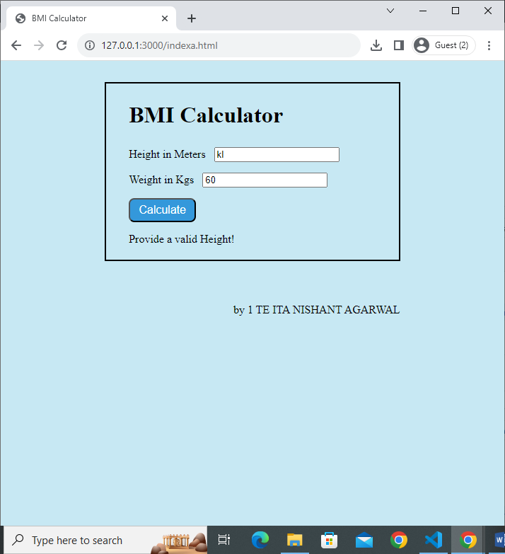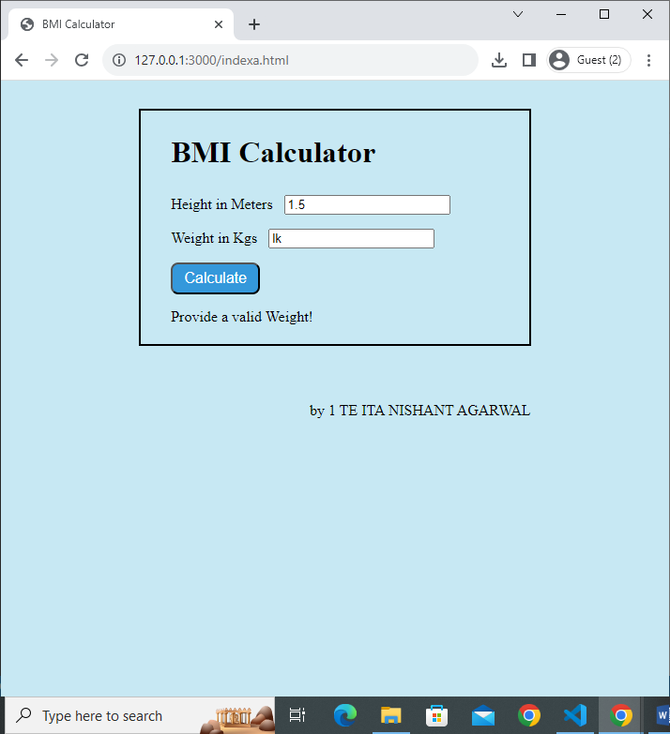

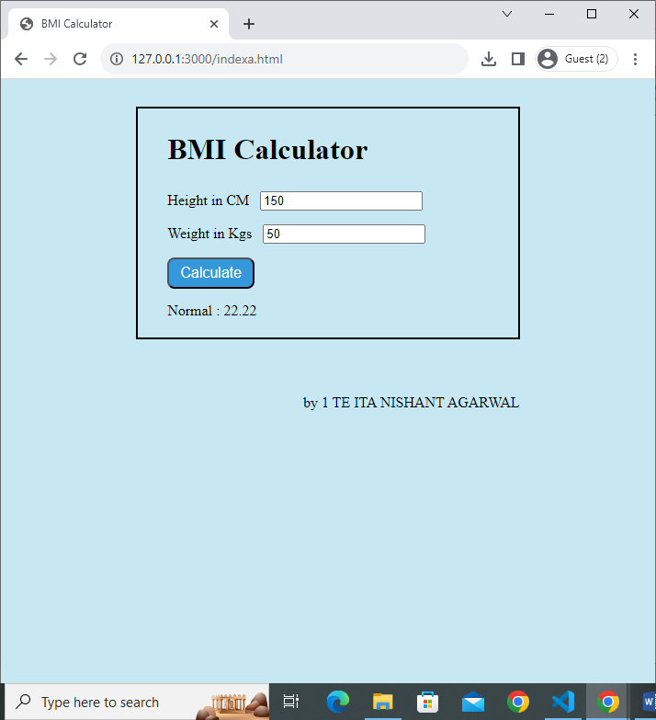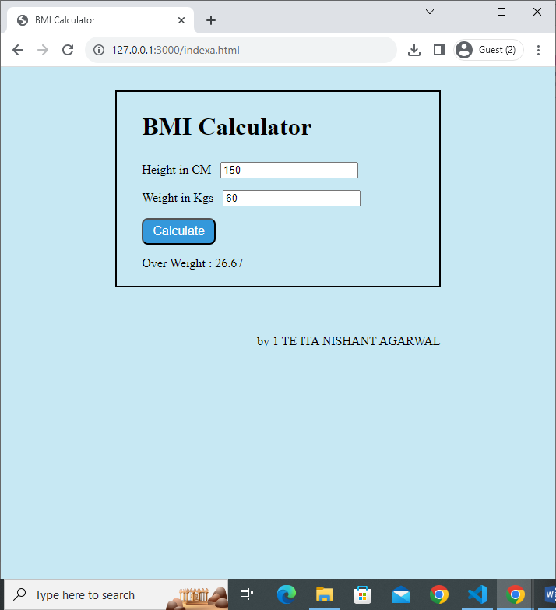

Conclusion:

In conclusion, the BMI calculator presented herein represents a user-centric solution for the assessment of an individual's Body Mass Index. Notably, the implementation prioritizes data accuracy by enforcing the entry of valid numeric values, a fundamental aspect in ensuring the reliability of the BMI result. Furthermore, the calculator employs a systematic categorization scheme for BMI values, offering users a straightforward interpretation of their health status. The interactive design, coupled with its user-friendly interface, significantly enhances the overall user experience, rendering it an invaluable tool for health-conscious individuals. This BMI calculator, by harmonizing functionality, usability, and informative feedback, stands as an effective instrument in fostering heightened health awareness and comprehension among its users.

Lab Outcome: Students were able to:

• Implement BMI calculator using Javascript.

• Understand javascript basics and DOM.

COs attained:

POs attained:

PEOs achieved: