EXPERIMENT 1A

Aim: To study basic HTML tags, font, anchors, images, lists, table, frames and forms

Objective: Students will be able to:

* Understand basic HTML elements

Theory:

Tags in HTML:

In HTML (Hypertext Markup Language), tags are special codes used to structure and define the content of a web page. HTML tags are enclosed in angle brackets (< >) and come in pairs, consisting of an opening tag and a closing tag. The opening tag indicates the beginning of an element, and the closing tag indicates the end of that element. Some HTML tags may also be self-closing, meaning they don't require a separate closing tag.

Here's a basic example of an HTML tag:

<p>This is a paragraph.</p>

In this example, the `<p>` tag represents a paragraph element. The content "This is a paragraph." is the text within the paragraph, and the opening tag `<p>` and closing tag `</p>` surround it.

Here are some commonly used HTML tags:

1. `<h1>`, `<h2>`, `<h3>`, `<h4>`, `<h5>`, `<h6>`: Headings of different levels (from highest to lowest).

2. `<p>`: Paragraph.

3. `<a>`: Anchor, used for creating hyperlinks.

4. `<img>`: Image, for displaying images on the page.

5. `<ul>`, `<ol>`, `<li>`: Unordered list, ordered list, and list items, respectively.

6. `<div>`, `<span>`: Block-level and inline containers used for grouping elements.

7. `<table>`, `<tr>`, `<td>`: Table, table row, and table cell, respectively.

8. `<form>`, `<input>`, `<button>`, `<select>`, `<textarea>`: Form and form elements for user input.

9. `<br>`: Line break, used to create a new line within text.

10. `<hr>`: Horizontal rule, used to insert a horizontal line.

11. `<strong>`, `<em>`: Bold and italic text, respectively.

12. `<iframe>`: Inline frame, used to embed external content like videos or maps.

These are just a few examples of HTML tags. There are many more tags available, each serving a specific purpose in defining the structure and content of a web page.

Font in HTML:

In HTML, the `<font>` tag was traditionally used to define the font and text formatting of content within a web page. However, it is now considered deprecated, meaning it is no longer recommended for use because it's part of the older HTML specification and has been replaced by CSS (Cascading Style Sheets) for styling web pages.

Instead of using the `<font>` tag, you should use CSS to style your web page's fonts. CSS provides much more control over the appearance of text and allows you to apply styles consistently across your entire website. You can set font properties such as font family, font size, font weight, font style, and more using CSS.

With CSS, you can create much more sophisticated and visually appealing designs for your web pages, making it the preferred method for styling fonts and other aspects of web page layout and presentation.

In HTML, an anchor is a hyperlink that allows you to create clickable links that take users to another web page, a specific section within the same page, or any other online resource. The anchor is represented by the `<a>` tag.

Here's the basic syntax of an anchor tag:

<a href="URL">Link Text</a>

Let's break down the components of the anchor tag:

- `href`: This attribute specifies the destination of the link. It can be a URL (e.g., https://www.example.com) or a relative path to a file or location on the same website (e.g., "page.html" or "#section-id").

- `Link Text`: This is the visible text that appears on the web page and represents the link. When users click on this text, they will be directed to the URL specified in the `href` attribute.

You can also use anchors in combination with other HTML elements, such as images or buttons, to create clickable elements that navigate to different resources. Anchors are a fundamental part of web navigation and are widely used to provide a seamless browsing experience for users.

Images in HTML:

In HTML, you can display images on a web page using the `<img>` tag. The `<img>` tag is a self-closing tag, which means it doesn't have a separate closing tag. It's used to embed images in various formats, such as JPEG, PNG, GIF, etc., into the web page.

Here's the basic syntax of the `<img>` tag:

<img src="image_path_or_url" alt="alternate_text">

Remember to replace the file path or URL in the `src` attribute with the actual location of your image. Additionally, provide meaningful and descriptive alternate text in the `alt` attribute to ensure accessibility for all users.

You can also use CSS to style images or control their positioning and alignment on the web page. Images are an integral part of web design, and proper use of the `<img>` tag enhances the visual appeal and user experience of your website.

Lists in HTML:

In HTML, you can create both ordered and unordered lists using the `<ul>` (unordered list) and `<ol>` (ordered list) tags, respectively. Lists are used to group related items together, making content more organized and easier to read. Each item in the list is represented by the `<li>` (list item) tag.

Here's the basic syntax for an unordered list:

<ul>

<li>Item 1</li>

<li>Item 2</li>

<li>Item 3</li>

</ul>

And here's the basic syntax for an ordered list:

<ol>

<li>First item</li>

<li>Second item</li>

<li>Third item</li>

</ol>

2. Ordered List (`<ol>`):

- Items are displayed with numbers by default, representing the order of the items.

- Use this list type when the order of items is important.

Lists are versatile and commonly used in web content to present information in an organized and easily readable format.

Table in HTML:

In HTML, you can create tables to organize data in rows and columns using the `<table>` tag. Tables are useful for displaying structured data, such as financial information, comparison charts, or any other tabular data. The structure of a table in HTML involves several tags, including `<table>`, `<tr>`, `<th>`, and `<td>`.

Here's the basic syntax for creating a table:

<table>

<tr>

<th>Header 1</th>

<th>Header 2</th>

<th>Header 3</th>

</tr>

<tr>

<td>Data 1</td>

<td>Data 2</td>

<td>Data 3</td>

</tr>

<!-- Add more rows as needed -->

</table>

Let's break down the tags used in the table structure:

- `<table>`: This is the container tag for the entire table.

- `<tr>`: Stands for "table row" and represents a row of the table.

- `<th>`: Stands for "table header" and represents a header cell. Header cells are typically used for column headings and are displayed in bold and centered by default.

- `<td>`: Stands for "table data" and represents a data cell. Data cells contain the actual content of the table.

You can further customize the appearance of the table, such as adding borders, changing the alignment, or applying styles using CSS. Tables provide a straightforward and effective way to present tabular data in HTML documents. However, in some cases, using modern CSS layouts may be a better choice, especially for complex page layouts, as it provides more flexibility and responsiveness.

Frames in HTML:

Frames were a feature of older versions of HTML that allowed developers to divide a web page into multiple independent sections, each displaying a separate HTML document. However, the use of frames is now considered outdated and has been deprecated in modern HTML standards (HTML5). Instead, developers are encouraged to use more flexible and accessible methods to achieve similar functionalities.

Frames were typically defined using the `<frameset>`, `<frame>`, and `<iframe>` tags:

1. `<frameset>`: This tag was used to define the structure of the frames on a web page. It allowed developers to specify the layout and size of each frame.

2. `<frame>`: This tag was used inside the `<frameset>` to define each individual frame. Each `<frame>` tag would load a separate HTML document.

3. `<iframe>`: This tag is still in use and stands for "inline frame." It allows you to embed another HTML document or web page within the current page. However, the use of `<iframe>` is often limited to specific use cases, such as embedding videos, maps, or external content, rather than dividing a page into separate sections.

The main reasons why frames fell out of favor and were deprecated include:

1. Accessibility: Frames could cause problems for users with disabilities or those using screen readers, as they could struggle to navigate or understand the content inside frames.

2. Bookmarking and URL sharing: Frames made it difficult to bookmark and share specific pages or content within frames, as the URL in the address bar would often remain the same regardless of the content displayed.

3. Search engine indexing: Search engines had difficulties indexing content within frames, leading to potential SEO issues.

Instead of using frames, developers are encouraged to use modern techniques such as CSS for layout, and if necessary, the `<iframe>` element to embed external content. For dividing a web page's content into sections, developers can use HTML5 semantic elements like `<header>`, `<nav>`, `<main>`, `<section>`, `<article>`, and `<footer>`. These elements provide clearer and more accessible page structures.

In summary, while frames were once commonly used to split a web page into multiple sections, they are now considered outdated and deprecated. It's best to use more modern and accessible techniques for designing web pages.

Forms in HTML:

In HTML, forms are used to collect and submit user input, such as text, selections, checkboxes, and more, to a web server for processing. Forms play a crucial role in enabling interactive web pages that allow users to interact with the website and provide data.

To create a form in HTML, you use the `<form>` element, which acts as a container for form elements. Inside the `<form>` element, you place various input elements like text fields, checkboxes, radio buttons, dropdown menus, etc. When the user submits the form, the data entered in the form elements is sent to the server for processing using either the "GET" or "POST" method, as specified by the form's `method` attribute.

The `action` attribute of the `<form>` element specifies the URL to which the form data will be submitted. The `method` attribute is set to "POST," which means the form data will be sent to the server using the HTTP POST method. Alternatively, you can use "GET" if you want the form data to be included in the URL.

When the user clicks the "Submit" button, the form data will be sent to the specified URL, and the server can then process the data and respond accordingly.

Forms are a fundamental part of web development, and they enable various types of user interactions, such as user registration, login, search, feedback submission, and more.

Source Code:

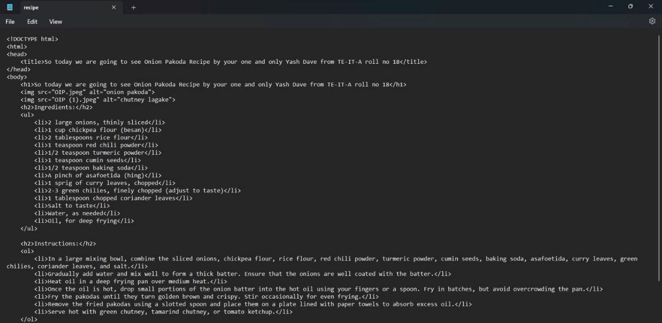

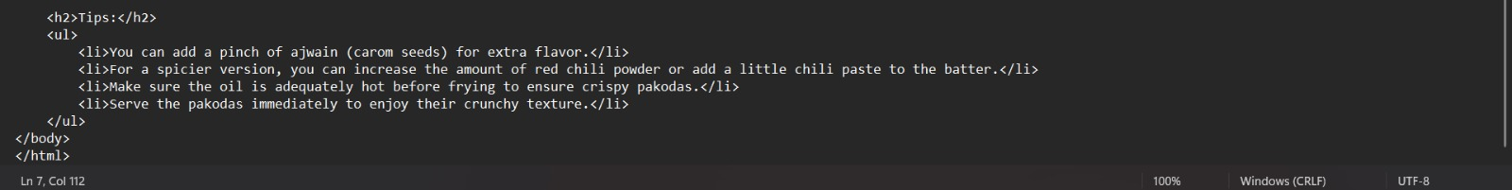

Output (Web Page):

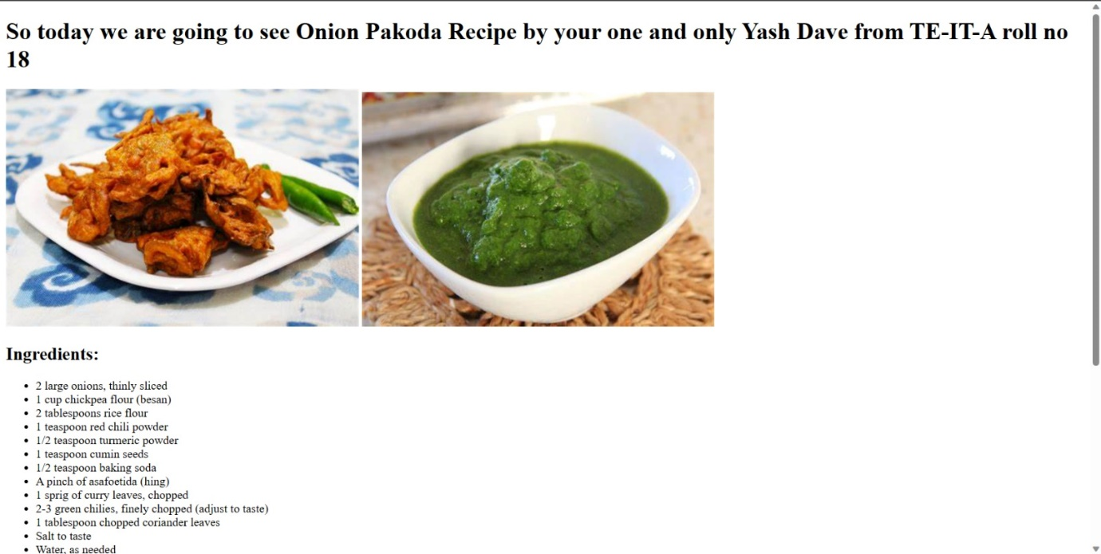

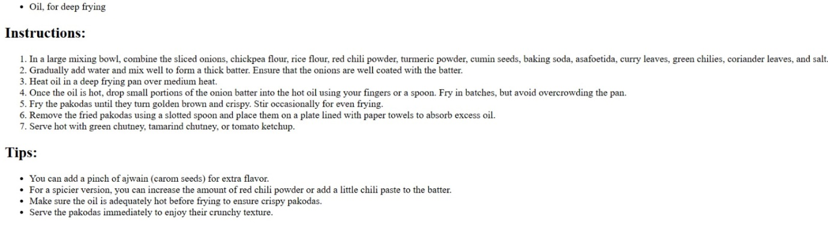

Lab Outcome: Students were able to:

* Understand the basic elements used in HTML

Conclusion: In conclusion, this HTML code provides a simple yet effective recipe for delicious Onion Pakodas, a popular Indian snack. By following the step-by-step instructions and using the specified ingredients, anyone can recreate this flavorful dish in the comfort of their own kitchen. Whether you're a seasoned chef or a novice cook, this recipe is easy to follow and promises a delightful outcome. Enjoy the crispy and savory Onion Pakodas as a perfect accompaniment to a hot cup of tea or as a mouthwatering appetizer for any occasion. Happy cooking!

COs attained:

POs attained:

PEOs achieved: