EXPERIMENT 1B

Aim: To design and implement resume registration form using HTML

Lab Objective: Students will be able to:

* Understand the use of forms in html

Theory:

Designing and implementing a resume registration form using HTML involves creating a form that collects essential information from users, typically for job applications or recruitment purposes. Below is a step-by-step guide to creating a simple resume registration form using HTML:

1. Set Up the Basic Structure:

Create a new HTML file and set up the basic structure with the `<!DOCTYPE html>` declaration, `<html>`, `<head>`, and `<body>` tags.

2. Form Element:

Inside the `<body>` tag, create a `<form>` element to start building the registration form. Specify the `action` attribute to define the URL where the form data will be sent for processing (e.g., a server-side script or backend service). Use the `method` attribute to set the form submission method (e.g., "POST" or "GET").

3. Add Input Fields:

Inside the form, add various input fields to collect user information. Common input types include text (`<input type="text">`), email (`<input type="email">`), textarea (`<textarea>`), etc.

4. Use Labels and IDs:

Use the `<label>` element to provide a description for each input field. The `for` attribute of the `<label>` should be the same as the `id` attribute of the corresponding input field. This association ensures that clicking the label focuses on the associated input field.

5. Input Field Attributes:

You can add specific attributes to input fields to make them required (`required`), specify input patterns (`pattern`), set minimum and maximum lengths (`minlength`, `maxlength`), and more.

6. Text area Field:

For the "Resume" field, use a `<textarea>` element to allow users to type or paste their resume content. Use the `accept` attribute to specify the allowed file types for the resume upload field.

7. Submit Button:

Add a submit button to the form to allow users to submit their details.

8. Additional Styles and Layout (Optional):

You can add CSS to style the form elements, adjust the layout, and make the form visually appealing. Use CSS classes and IDs to target specific elements for styling.

9. Form Validation (Optional):

To enhance user experience and data integrity, consider adding client-side form validation using JavaScript. This helps validate input before submission and provides immediate feedback to users if they miss any required fields or provide incorrect data.

10. Server-Side Processing (Optional):

Remember that the form's `action` attribute should point to a server-side script that handles the form data and stores it in a database or performs other processing tasks.

Once you have completed these steps, your resume registration form using HTML is ready to use. It's important to ensure that the form collects necessary and relevant information while providing a user-friendly experience.

Source code:

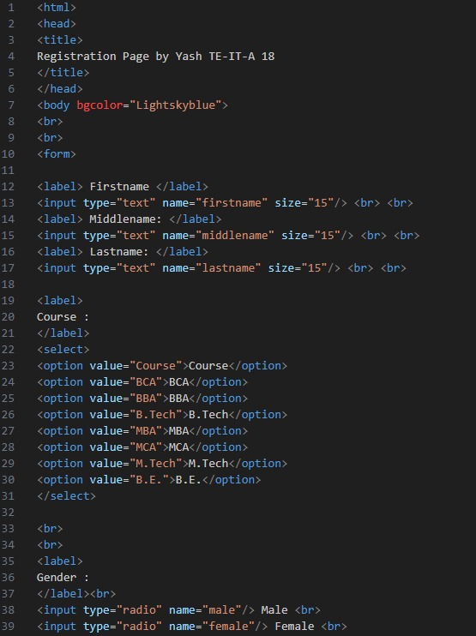

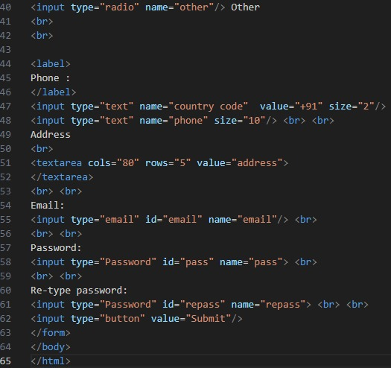

Output (Web Page):

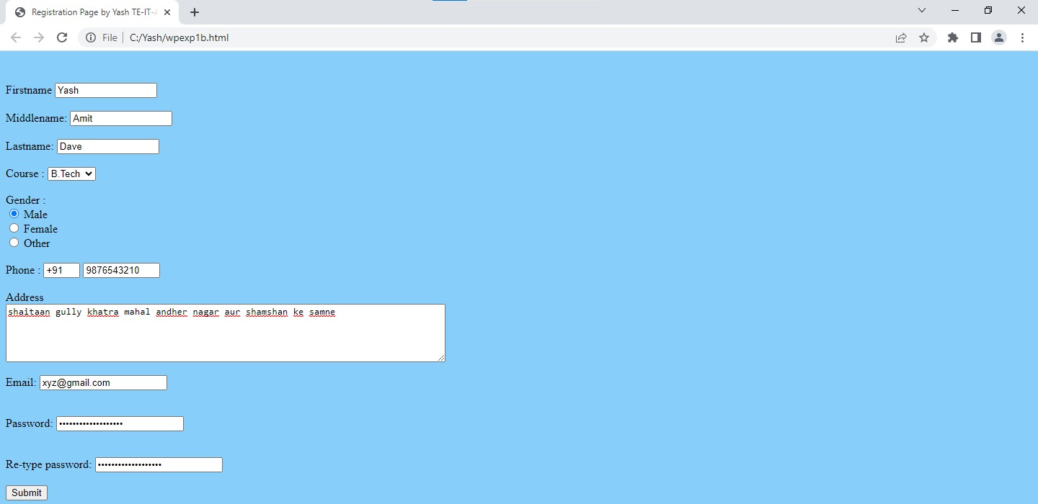

Lab Outcome: Students were able to:

* Understand the different components used in designing of a resume registration form.

Conclusion: Designing and implementing a resume registration form using HTML is a straightforward and essential task in web development. The goal of the form is to collect essential information from applicants and enable them to register for job opportunities by submitting their resumes.

COs attained:

POs attained:

PEOs achieved: