**EXPERIMENT**

**Aim:**  Design Students Information using JavaScript.

**Lab Objective:** Students will be able to:

• Learn how to implement JavaScript.

**Theory:**

The provided HTML+CSS+JS code snippet demonstrates a simple implementation of a web page displaying student details and employing interactivity through "Show More" and "Show Less" buttons. Let's discuss some theoretical concepts related to this code:

1. HTML (Hypertext Markup Language):

HTML is the backbone of web pages, used to structure content on the web. In the code snippet:

* `<html>`, `<head>`, and `<body>` tags define the structure of the page.
* Elements like `<div>`, `<h2>`, `<p>`, `<img>`, and `<button>` are used to create the content and user interface.

2. CSS (Cascading Style Sheets):

CSS is used to style and format HTML elements. In the code snippet:

* CSS rules define the background colour, fonts, margins, and padding for elements.
* The `. hidden` class is used to initially hide the SGPA and CGPA details.

3. JavaScript:

JavaScript adds interactivity to web pages. In the code snippet:

* JavaScript is used to toggle the visibility of SGPA and CGPA details when "Show More" and "Show Less" buttons are clicked.
* Event listeners (`addEventListener`) are used to capture button clicks and execute functions.

4. Document Object Model (DOM):

The DOM is a programming interface for web documents. It represents the page so that programs can change the document structure, style, and content. In the code snippet:

- JavaScript interacts with the DOM by selecting elements using `querySelectorAll` and modifying their CSS classes to show/hide details.

5. User Interface (UI):

The UI includes the design elements and interactive components that users see and interact with on a web page. In the code snippet:

* Buttons ("Show More" and "Show Less") enhance the UI by allowing users to control the visibility of additional information.
* Different background colours for student sections improve the visual appeal and organization of content.

6. Interactivity:

Interactivity on web pages enhances user engagement and experience. In the code snippet:

* Click events on buttons trigger actions, making the SGPA and CGPA details appear or disappear.
* This interactivity provides a more user-friendly way to view additional information without cluttering the page.

1. Scalability:

The code can be easily scaled to include more students by duplicating the student `<div>` block and customizing the details for each new student. This scalability is important for real world applications with dynamic content.

1. Web Design Principles:

The code snippet follows basic web design principles by using consistent fonts, spacing, and colour schemes. It also employs buttons for functionality and organization.

**Source code:**

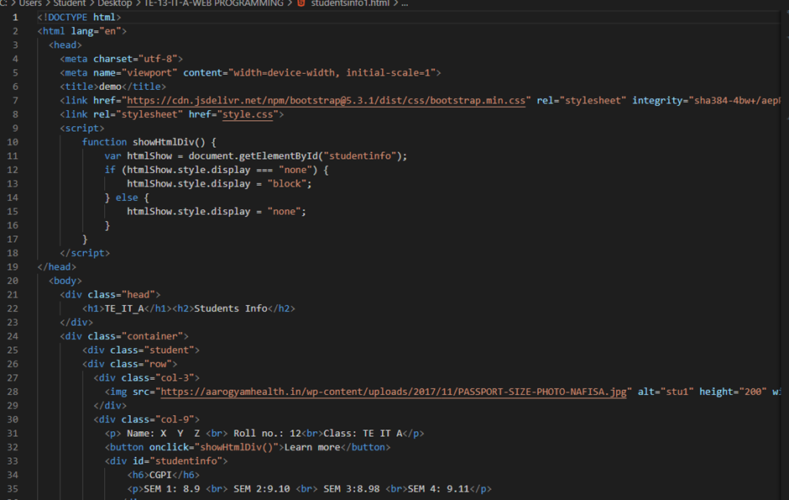

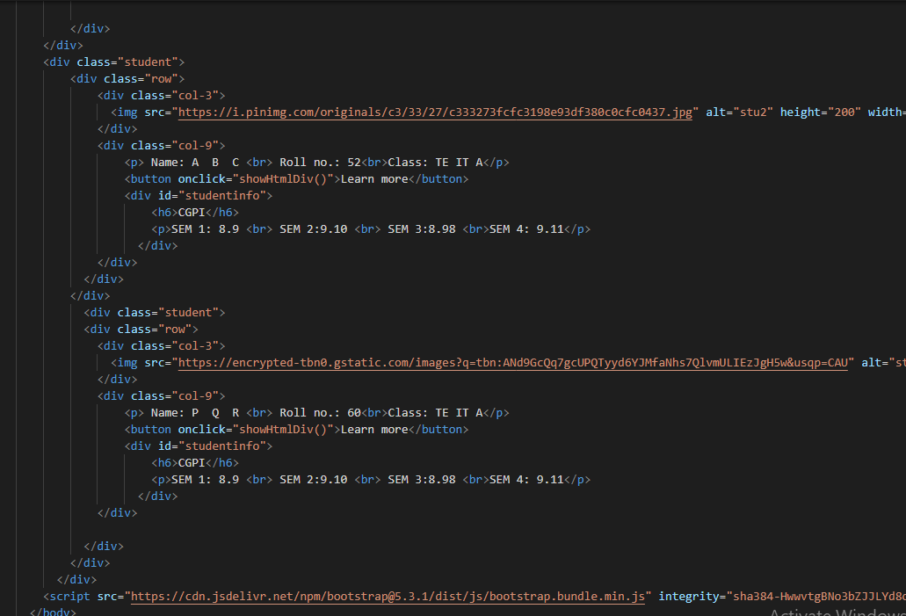

**Output (Web Page):**

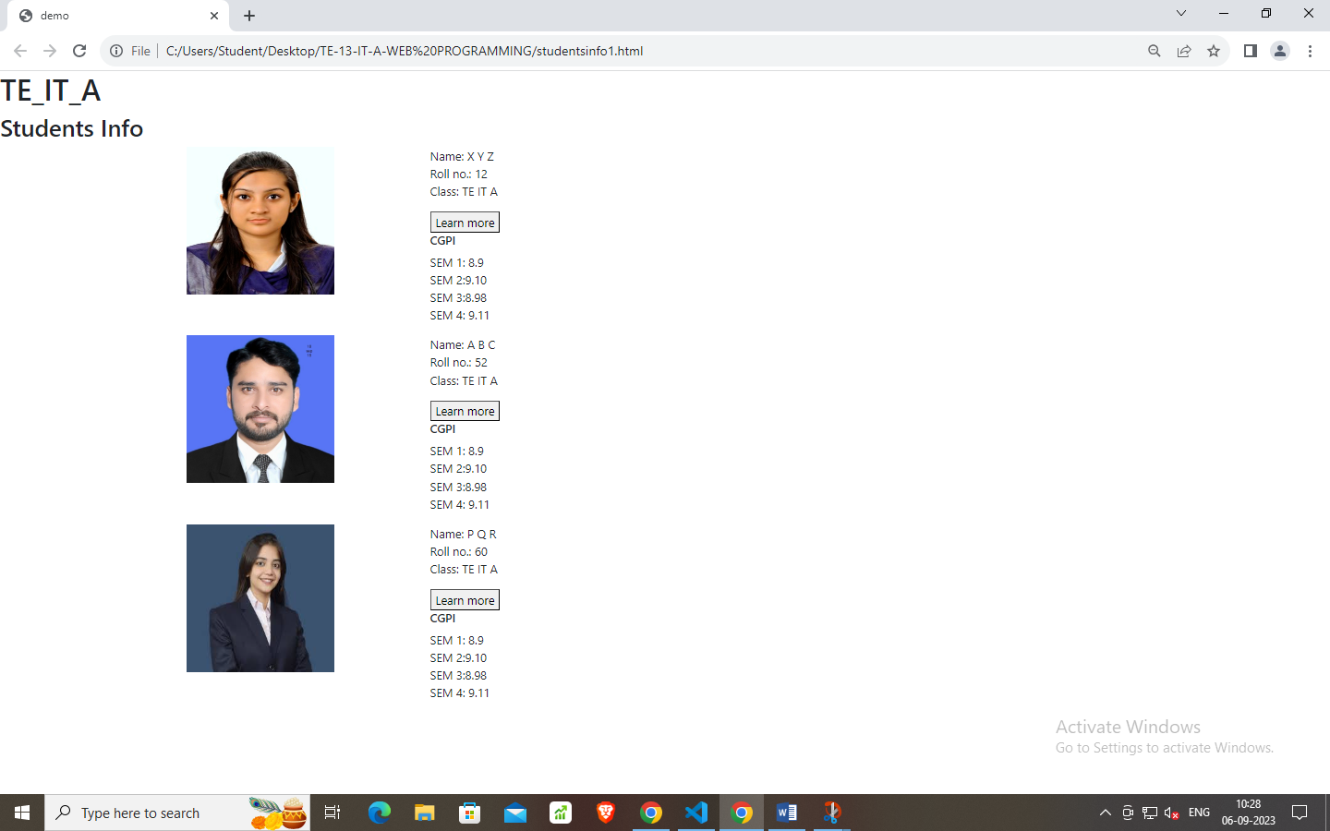

**Lab Outcome**: Students were able to:

Learn a new way for implementing JavaScript.

**Conclusion:**

The provided HTML+CSS+JS code snippet showcases a simple yet effective implementation of a student details web page. It demonstrates the synergy of HTML's structural markup, CSS's styling capabilities, and JavaScript's interactivity. The "Show More" and "Show Less" buttons offer a user-friendly approach to toggle additional information, enhancing the user experience. The code's scalability allows for the easy addition of more student sections, making it adaptable for real-world applications. Overall, it exemplifies the fundamental principles of web development, emphasizing clean design, interactivity, and organization of content.

**COs attained:** CO1 (Implement interactive web page(s) using HTML)

CO2 (Create Responsive Web Design with CSS & Bootstrap)

CO3 (Design and develop web applications using JavaScript)

**POs attained:**

PO 1: ENGINEERING KNOWLEDGE (Apply Knowledge of Mathematics, Science,

engineering fundamentals and an engineering specialization to the solution of complex engineering problems.)

PO 2: PROBLEM ANALYSIS (Identify, formulate, research literature and analyse complex

engineering problems reaching substantiated conclusions using first principles of mathematics, natural sciences and engineering sciences.)

PO 3: DESIGN / DEVELOPMENT OF SOLUTIONS (Design solutions for complex engineering problems and design system components or processes that meet specified needs with appropriate consideration for public health and safety, cultural, societal and environmental considerations.)

PO 5:MODERN TOOL USAGE (Create, select and apply appropriate techniques, resources and modern engineering and IT tools including prediction and modelling to complex engineering activities with an understanding of the limitations.)

**PEOs achieved:**

PEO 1: To prepare learners with a strong foundation in the area of Information Technology required solving real life problems arising from software technology. (Knowledge)(CURRICULAR)

PEO 3: To prepare learners to understand the need for lifelong learning with effective written

and oral communication skills and to be able to readily adapt to new software engineering environments. (PRESENTATION AND GROWTH)**.**