**EXPERIMENT 08(A)**

**Aim:** Implement PHP Session and Cookie.

**Lab Objective:** Students will be able to:

• Understand and implement php Session and cookies

**Theory:**

A session is a way to store information (in variables) to be used across multiple pages. When a user visits a website and starts a new session, the server creates a unique session ID and stores it in a cookie on the user’s computer. The server also creates a file on the server to store the session variables for that user.

The session ID in the cookie is used to identify the user’s session on the server. When the user navigates to a different page on the website, the session ID is sent back to the server in a cookie, and the server retrieves the corresponding session variables for that user.

Sessions are useful for storing temporary data that is specific to a single user and a single browser session. For example, you might use a session to store a user’s shopping cart items or login status.

$_SESSION['username'] = $username;

A cookie is a small piece of data that is stored in a user’s web browser. It can be used to store information such as user preferences or login information. When a user visits a website, the server can send a cookie to the user’s browser, which the browser will then store. When the user returns to the website later, the server can access the cookie and use the information stored in it.

Cookies are useful for storing longer-term data that needs to be persisted across multiple sessions. For example, you might use a cookie to store a user’s preferred language or theme so that the user doesn’t have to set their preferences every time they visit the website.

Cookies are stored as files on the user’s computer and can remain there for a specified length of time unless the user chooses to delete them. Cookies are limited in size, typically to 4KB or less.

setcookie("username", "John Doe", time() + (86400 * 30), "/");

$username = $_COOKIE['username'];

**Session:**

**Source code:**   
<html>  
<body>  
<?php

session_start();

$_SESSION['favorite_color'] = 'blue';

echo "Session variables are set.";

?>   
</body>  
</html>

**Output:**

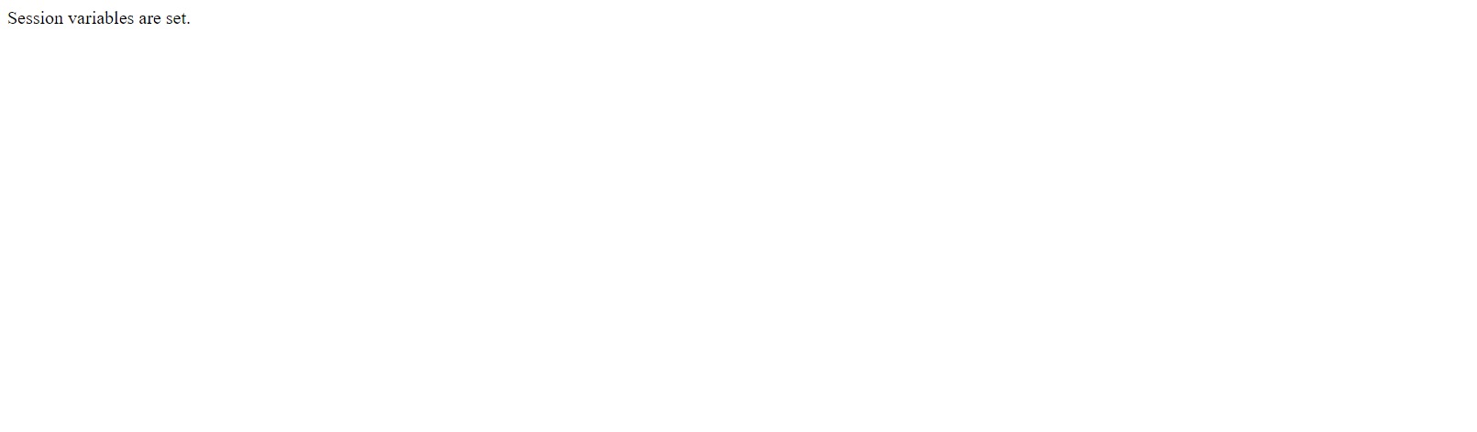

**Cookie:**

**Source code:**

<?php  
// set the expiration date to one hour ago  
setcookie("user", "", time() - 3600);  
?>  
<html>  
<body>  
  
<?php  
echo “Cookie has been set for 60 seconds.”;  
?>  
  
</body>  
</html>

**Output:**

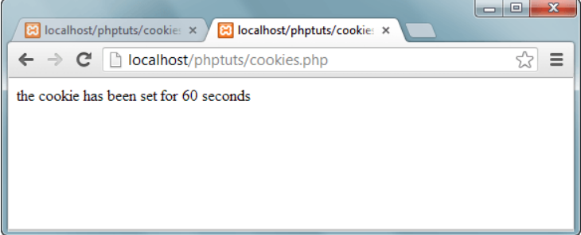

**Lab Outcome**: Students were able to:

Implement concepts of php for understanding sessions and cookies.

**Conclusion:**

PHP sessions and cookies are both powerful tools for storing information about users and their interactions with your website or application.

Sessions are stored on the server and are typically used to store information about a user's current session, such as whether they are logged in or what items they have added to their shopping cart. Cookies are stored on the user's computer and can be used to store information about a user's preferences, such as their language or time zone.

Which one you use depends on your specific needs. If you need to store information about a user's current session, then you should use sessions. If you need to store information about a user's preferences, then you should use cookies.

**COs attained:**

**POs attained:**

PO 1: ENGINEERING KNOWLEDGE (Apply Knowledge of Mathematics, Science,

engineering fundamentals and an engineering specialization to the solution of complex engineering problems.)

PO 2: PROBLEM ANALYSIS (Identify, formulate, research literature and analyse complex

engineering problems reaching substantiated conclusions using first principles of mathematics, natural sciences and engineering sciences.)

PO 3: DESIGN / DEVELOPMENT OF SOLUTIONS (Design solutions for complex engineering problems and design system components or processes that meet specified needs with appropriate consideration for public health and safety, cultural, societal and environmental considerations.)

PO 5:MODERN TOOL USAGE (Create, select and apply appropriate techniques, resources and modern engineering and IT tools including prediction and modelling to complex engineering activities with an understanding of the limitations.)

**PEOs achieved:**

PEO 1: To prepare learners with a strong foundation in the area of Information Technology required solving real life problems arising from software technology. (Knowledge)(CURRICULAR)

PEO 3: To prepare learners to understand the need for lifelong learning with effective written

and oral communication skills and to be able to readily adapt to new software engineering environments. (PRESENTATION AND GROWTH) **.**