EXPERIMENT 08(C)

**Aim:** Implement PHP File System Functions

**Lab Objective:** Students will be able to:

• Understand and implement PHP File System Functions

**Theory:**

PHP provides a wide range of file system functions that allow you to work with files and directories. These functions enable you to perform tasks such as reading and writing files, manipulating directories, checking file and directory properties, and more. Here is an overview of some of the key PHP file system functions:

File I/O Functions:

1. file_get_contents(): Reads the entire content of a file into a string.
2. file_put_contents(): Writes a string to a file.
3. fopen(): Opens a file or URL for reading or writing.
4. fclose(): Closes an open file.
5. fread(): Reads from an open file.
6. fwrite(): Writes to an open file.
7. feof(): Checks if the end of a file has been reached.
8. File Information Functions:
9. file_exists(): Checks if a file or directory exists.
10. is_file(): Checks if a path is a regular file.
11. is_dir(): Checks if a path is a directory.
12. filesize(): Retrieves the size of a file.
13. filetype(): Determines the type of a file (e.g., file, directory).
14. stat(): Retrieves information about a file.
15. pathinfo(): Returns an array of information about a file path.

File and Directory Manipulation Functions:

1. copy(): Copies a file.
2. rename(): Renames a file or directory.
3. unlink(): Deletes a file.
4. mkdir(): Creates a new directory.
5. rmdir(): Removes an empty directory.
6. scandir(): Lists files and directories in a directory.

File Permissions Functions:

1. chmod(): Changes file permissions.
2. chown(): Changes file owner.
3. chgrp(): Changes file group.

Directory Functions:

1. opendir(): Opens a directory handle.
2. readdir(): Reads the contents of a directory handle.
3. closedir(): Closes a directory handle.

File Upload Functions:

1. move_uploaded_file(): Moves an uploaded file to a new location.
2. is_uploaded_file(): Checks if a file was uploaded via HTTP POST.

Filesystem Path Functions:

1. realpath(): Resolves the absolute path of a file or directory.
2. basename(): Returns the base name of a file or directory.
3. dirname(): Returns the directory name component of a path.

**Source code:**

<?php

// Create a directory

$directory = 'my_directory';

if (!is_dir($directory)) {

mkdir($directory);

echo "Directory '$directory' created.<br>";

} else {

echo "Directory '$directory' already exists.<br>";

}

// Create a file within the directory

$filename = $directory . '/my_file.txt';

if (!file_exists($filename)) {

$file = fopen($filename, 'w');

if ($file) {

echo "File` '$filename' created.<br>";

fclose($file);

} else {

echo "Failed to create file '$filename'.<br>";

}

} else {

echo "File '$filename' already exists.<br>";

}

// Write data to the file

$data = "This is some sample data to write to the file.";

if (file_put_contents($filename, $data)) {

echo "Data written to '$filename'.<br>";

} else {

echo "Failed to write data to '$filename'.<br>";

}

// Read the contents of the file

$fileContents = file_get_contents($filename);

if ($fileContents !== false) {

echo "File Contents:<br>";

echo $fileContents;

} else {

echo "Failed to read file contents.<br>";

}

// Clean up: Delete the file and the directory

if (unlink($filename)) {

echo "File '$filename' deleted.<br>";

} else {

echo "Failed to delete file '$filename'.<br>";

}

if (rmdir($directory)) {

echo "Directory '$directory' deleted.<br>";

} else {

echo "Failed to delete directory '$directory'.<br>";

}

?>

Output:

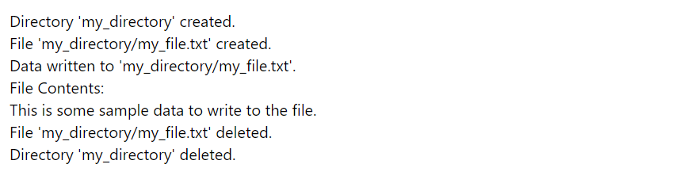

**Lab Outcome**: Students were able to:

Implement PHP File System Functions

**Conclusion:**

In conclusion, PHP provides a powerful set of file system functions that allow you to interact with the file system, manage directories and files, and manipulate data. Here are some key points to remember about PHP file system functions:

* File and Directory Manipulation
* File Handling
* File Information
* Path Handling
* Error Handling
* Security

**COs attained:**

**POs attained:**

PO 1: ENGINEERING KNOWLEDGE (Apply Knowledge of Mathematics, Science,

engineering fundamentals and an engineering specialization to the solution of complex engineering problems.)

PO 2: PROBLEM ANALYSIS (Identify, formulate, research literature and analyse complex

engineering problems reaching substantiated conclusions using first principles of mathematics, natural sciences and engineering sciences.)

PO 3: DESIGN / DEVELOPMENT OF SOLUTIONS (Design solutions for complex engineering problems and design system components or processes that meet specified needs with appropriate consideration for public health and safety, cultural, societal and environmental considerations.)

PO 5:MODERN TOOL USAGE (Create, select and apply appropriate techniques, resources and modern engineering and IT tools including prediction and modelling to complex engineering activities with an understanding of the limitations.)

**PEOs achieved:**

PEO 1: To prepare learners with a strong foundation in the area of Information Technology required solving real life problems arising from software technology. (Knowledge)(CURRICULAR)

PEO 3: To prepare learners to understand the need for lifelong learning with effective written

and oral communication skills and to be able to readily adapt to new software engineering environments. (PRESENTATION AND GROWTH)