

**EDC LIMITED**

EDC House, 1st Floor, Dr.AtmaramBorkar Road

Panaji – Goa. 403 001

E-mail: edcpanaji@edc-goa.com

E-mail: [startup@edc-goa.com](mailto:startup@edc-goa.com)

Website: www.edc-goa.com/startup

**APPLICATION FORM**

**(For enrolment for EDC TECHNOLOGY STARTUP COMPETITION)**

**Name of applicant**

**/entity: : CM MULTITRADE**

**Address of main : F-5, MANSUKH APT.**

**Operations of B. B. BORKAR ROAD**

**Start-up unit in Goa ALTO PORVORIM BARDESH GOA**

**Main promoter(s): 1. MR. CHAITANYA BHIWA MALIK**

**E-mail ID:** [**chaitanyamalik1993@gmail.com**](mailto:chaitanyamalik1993@gmail.com)

**Website: ________________________________**

**Cell No: +91-9420164141**

**Land Line No: +91-0832-2414059**

**To,**

**The Managing Director**

**EDC Limited**

**CERTIFICATE**

**I/We hereby certify that the particulars given in this application form are to the best of my/our knowledge and belief true and correct, and that no material fact has been concealed or withheld. I/We agree to abide by the rules of the competition with regard to the due diligence exercise and agree that the decisions of EDC Limited will be final.**

**Signature _________________________**

**_________________________**

***(Proprietor/Partner/Director)***

**Date: ________________**

**GENERAL DETAILS**

**O**

**R**

**Y**

**R**

**A**

**P**

**T**

**E**

**I**

**R**

**P**

**1. Constitution:**

**(Proprietary/Partnership/Company/LLP)**

**2. Registration No. and Date of**

**5**

**7**

**7**

**1**

**1**

**3**

**0**

**9**

**4**

**0**

**3**

**incorporation/registration of**

**the concern (DD/MM/YYYY):**

**1**

**0**

**2**

**9**

**0**

**2**

**0**

**5**

**3. Key Persons (Attach separate sheets of each – Format as per Annexure ‘A’):**

**(Please give details of founders, promoters and the team)**

**4. Name &Description of Product/Services: (Also indicate Technology, process)**– (Max 2 pages) : **PLEASE SEE ANNEXURE B**

**5. Present status of the project: BETA TESTING**

**6. Future plans for the project: NATIONWIDE DEPLOYMENT**

**7. Risks identified in future: NONE**

**8. Details of fixed assets (including space) required:**

1. **2 Laptops for Sales Executives & Developers**
2. **Source Code Repository**
3. **Production Server**
4. **One cubicle office space with internet**

**9. Details of fixed assets (including space) yet to be acquired): ALL OF THE ABOVE**

**10. Details of other Infrastructural requirements: NONE**

**11. Date of commencement of commercial**

**Production/operations (DD/MM/YYYY): (Please provide suitable basis / proof): PLEASE FIND THE ENCLOSED LETTER FROM KADAMBA TRANSPORT CORPORATION LIMITED**

**12. a) Brief History: (Use separate sheet) : PLEASE SEE ANNEXURE C**

**b) Working results for the two years:**

***(Rs.in Lakh)***

|  |  |  |
| --- | --- | --- |
| **FINANCIAL YEAR** | **FY 2014-15** | **FY 2015-16**  **Upto**  **31/12/2015** |
| **Equity** |  |  |
| **Reserves** |  |  |
| **Networth** |  |  |
| **Term Loan (if any)** |  |  |
| **Working Capital loan (if any)** |  |  |
| **Turnover**  **(Net of taxes & income from other sources)** |  |  |
| **Net profit/loss before tax** |  |  |
| **Depreciation** |  |  |
| **Cash profit** |  |  |
| **Income Tax paid** |  |  |

**c) Existing sources of funding and approximate amounts: PERSONAL FUNDING, APPROXIMATE AMOUNT: RS. 50,000/-**

**d) Additional funds required for the project and expected sources of additional funds: ADDITIONAL FUNDS REQUIRED: RS. 2 LAKHS, SOURCE OF ADDITIONAL FUNDS: ANGEL INVESTORS**

**13. Justify why you believe your startup is eligible (max 15 lines):**

**______________________________________________________________**

**______________________________________________________________**

**______________________________________________________________**

**______________________________________________________________**

**______________________________________________________________**

**______________________________________________________________**

**______________________________________________________________**

**______________________________________________________________**

**______________________________________________________________**

**______________________________________________________________**

**______________________________________________________________**

**______________________________________________________________**

**______________________________________________________________**

**______________________________________________________________**

**14. Any other details/highlights/achievements you wish to indicate (max 15 lines):**

1. **SELECTED IN TOP 3 IN A COMPETITION ‘TECH PITCH’ ORGANISED BY CIBA, VERNA IN 2014**
2. **PROJECT BEING CURRENTLY IMPLEMENTED BY THE KADAMBA TRANSPORT CORPORATION LIMITED**
3. **PRESENTED TO DIRECTORATE OF TRANSPORT. THE DIRECTORATE WISHES TO IMPLEMENT THE PROJECT FOR PRIVATE BUS OPERATORS AFTER IMPLEMENTATION FOR KTCL IS COMPLETE**

**15. MARKET POTENTIAL/DEMAND**

**Brief note on market demand/supply/competitors/alternate products or services available in the market/type of customers and their location and commercial viability of the project: PLEASE SEE ANNEXURE ‘D’**

**Last date for submission of the application form: 15th February 2016 (Monday).**



**~ ANNEXURE A ~**

**BACKGROUND OF ALL KEY TEAM MEMBERS**

**(Please use separate sheets per team member)**

*Affix recentcolourpassport size photo*

**1. Name:** (Lastname)

(Firstname)

(Middlename)

**2. a) Address:**

**b) Email:**

**c) Website:**

**3. Telephone/ Mobile no.:**

**4. Father’s/Husband’s name :**

**5. Designation: Proprietor/Partner/Promoter/**

**Director/Professional Director/Manager**

**6. Role in the organization:**

**7. Date of birth:**

**(DD-MM-YYYY)**

**8. Academic Qualifications: ______________________________________**

**9. % shareholding in the concern: ______________**

**10. Work/Business/Professional Experience:**

|  |  |  |  |  |  |
| --- | --- | --- | --- | --- | --- |
| **Sr. No.** | **Name &Address of the Enterprise** | **Designationin the Enterprise** | **Period of Service/work** | | **Nature of Work** |
| **From** | **To** |
|  |  |  |  |  |  |
|  |  |  |  |  |  |
|  |  |  |  |  |  |
|  |  |  |  |  |  |

**11. Any other information like achievements, awards, recognition:**

**(Enclose separate sheet & give all details) : PLEASE SEE ANNEXURE ‘E’**

**~ ANNEXURE B ~**

Public Transport Time-Table Publisher

# Motivation

Goa is witnessing rampant rise in the usage of personal vehicles by locals as well as tourists. This is taking a major toll on the state's infrastructure, peacefulness and environment. Most people prefer personal vehicles due to lack of awareness of public transport options to get to their destination. Goa's roads and waterways have a strong public transport operated by the Govt. and private operators. The convenience of having the time-table of all public transport services in Goa available on the internet, will translate into people being able to plan their commute in advance and avoid the hassles of using personal vehicles.

# Google support

Google allows the user to obtain driving, walking and public transit directions between any two locations in the world. The public transit options are available on Google Maps only if the transport providers upload their routes, stops, trip timings to Google. The process of providing the timetables to Google is cumbersome. The data needs to be provided in Google's GTFS format. The entire data can run into thousands of lines of text files. Most importantly, the geo-location of stops has to be accurately provided as a latitude and longitude.

# Concept

P3TP

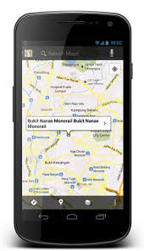

Provide fleet settings

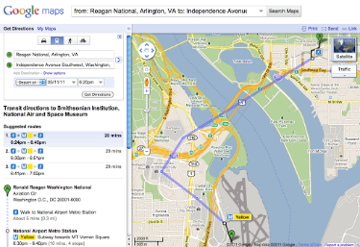

GTFS data

Travel options

Google Maps on mobile

Google Maps on website

# Solution

The Public Transport Time-Table Publisher (P3TP) simplifies the process of generating the data. It provides a simple visual tool for feeding time-table details of a transit agency.

* The stops can be accurately marked on a map.
* It allows two stops on opposites sides of the road to be linked to each other as peer-stops.
* Each route operated by the agency can be marked on the map by choosing stops that have been previously marked.
* Onward and Return trips on the route can be added by specifying start times of the trips.
* The timings at intermediate stops along the route can be automatically computed by the tool.
* The tool allows offline creation of time-tables in Microsoft Excel.
* The tool generates a passenger-friendly timetable that can be printed and pasted at different locations of the city.
* It can generate the GTFS file that can be uploaded to Google.

**P3TP has been adopted by Goa's Kadamba Transport Corporation Ltd. who will be the first customer.**

# Passenger Experience

A passenger can search for travel options between any two points on a Google Maps application. The results provide step-by-step directions including different modes such as Walking, Ferries, and Buses.

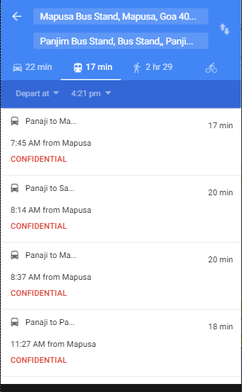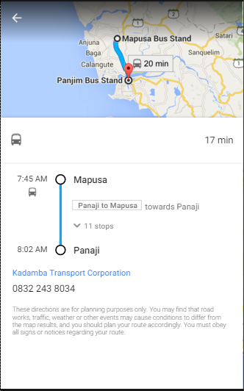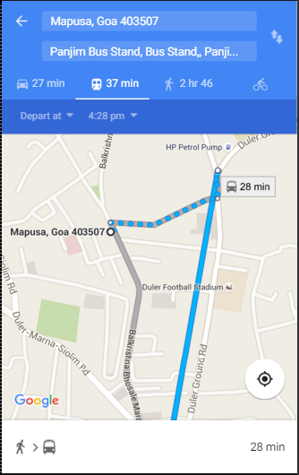

# Future enhancements

* Further Improve the User Interface.
* Once the time-table data is digitized, it can be presented to citizens through multiple additional channels such as SMS, IVR, websites, etc.
* Passenger-experience can be further enhanced by providing real-time status updates of every trip provided the transit agencies install GPS devices.

# Technologies

|  |  |
| --- | --- |
| **Component** | **Technology** |
| User Interface | Google’s Angular.JS library |
| Backend application | Node.js |
| Database | MySQL |
| Map provider | Google maps |

# Summary

This project will place Goa among the few places in India that provide public transport options to citizens at their fingertips. Any agency that subscribes to this service should expect increased revenue from passengers as citizens will begin to turn to public transport. The city/state will witness lesser traffic and cleaner air. Reduced fuel consumption will be a positive side effect of this project.

**~ ANNEXURE C ~**

The concept of digitization of Stops, Routes & Timings of Transit Agencies was undertaken as a final year project in the academic year 2013-14 by Mr. Chaitanya B. Malik & his group. The concept was converted into a model project with regular mentoring from Mr. Yash Ganthe who provided valuable support & technological ideas.

The team approached officials of Kadamba Transport Corporation Ltd. to undertake the case study of various conditions & requirements of a transit agency. Mr. Sanjay Ghate & Mr. Jeorge Fernandes provided us all the information regarding KTCL.

An analysis was undertaken after this phase to narrow down on the main requirements of the agency & to sort the requirements in order of occurrence. Eg. Stops had to be added first, then linked together to create a route & then finally the route will carry timings.

In the design phase, the database design was presented and all the requirements were met in the database. Then a user friendly interface for the admin was also designed for intuitive data entry with just a few clicks. Integration of Google maps was suggested for better understanding & accurate data entry.

Coding was initially done in HTML to get the UI as per requirement. Then the server code was written using the node.js technology of Javascript. Modern languages like Angular.js were used for data display. Database & queries were created in MySQL language. CSS was finally used to tune the UI & make it look better.

Random routes & timings data was added using the UI into the system. Errors discovered while entering the data were troubleshooted. GTFS was uploaded to Google & testing was done on Google Maps app.

The ready product was presented to Kadamba Transport Corporation. After rigorous testing by KTCL, the product was accepted by KTCL and data entry is in progress. River navigation department is also joining on board soon to upload their feed to Google Maps too.

**~ ANNEXURE D ~**

Governments across the world will encourage citizens to use public transport. Providing timetables over the internet is one of the most basic expectations from any transit agency of the digital era. Transit organizations in only 25 cities of India have done so. There is a huge potential for this service to be used by hundreds of transport corporations in the country.

The GTFS editors available in the market are not as user friendly as in this product. The product has unique features such as the support for stops on either side of the road, automatic computation of timings based on distances between stops, intuitive user interface, etc. This product has a huge price advantage compared to the existing editors which are available at around 5 lacs per year.

**~ ANNEXURE E ~**

1. **SELECTED IN TOP 3 IN A COMPETITION ‘TECH PITCH’ ORGANISED BY CIBA, VERNA IN 2014**
2. **PROJECT BEING CURRENTLY IMPLEMENTED BY THE KADAMBA TRANSPORT CORPORATION LIMITED**
3. **PRESENTED TO DIRECTORATE OF TRANSPORT. THE DIRECTORATE WISHES TO IMPLEMENT THE PROJECT FOR PRIVATE BUS OPERATORS AFTER IMPLEMENTATION FOR KTCL IS COMPLETE**
4. **DEPARTMENT OF RIVER NAVIGATION, GOVT OF GOA WILL ALSO SOON UPLOAD THE TRANSIT INFORMATION OF THEIR FLEET OF FERRY BOATS TO GOOGLE VIA OUR APPLICATION.**