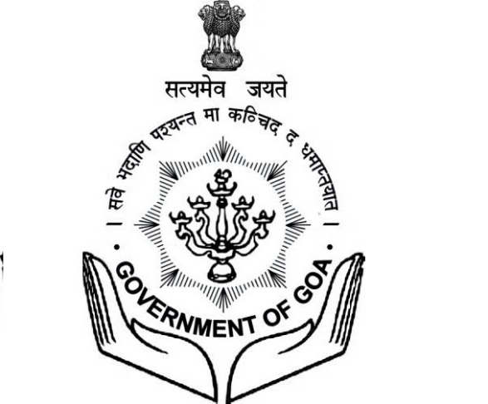

**DIRECTORATE OF TRANSPORT**

**ON**

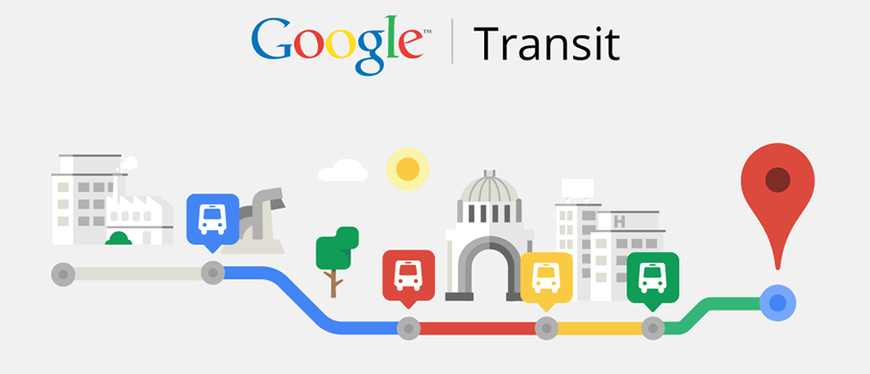

Chaitanya B. Malik

**NewYug Technologies** – Mentored by **Goa IT Professionals** (www.goaitpro.org)

Rgn No. : DOIT-403521436669

(C) 942 016 4141, 880 523 6091

[newyug@googlegroups.com](mailto:newyug@googlegroups.com),

F-5, Mansukh Apt, B. B. Borkar Rd, Alto Porvorim Goa 403521

The project makes innovative use of technology and the power of internet to make accurate travel information available to tourists as well as locals.

Contents

Executive Summary 2

Existing problem 2

The solution 2

Our offering 2

The benefit 2

Technical solution 3

Google support 3

Our offering 3

Data entry by Operator 4

Admin User Interface for Data entry 4

Passenger Experience 5

Financials 6

Engagement with Directorate of Transport 7

Role of Directorate of Transport 7

Role of NewYug Technologies 7

**Execution of Project** 8

**Milestone 1: Pilot project** 8

**Milestone 2: ORS routes** 8

**Ongoing future changes** 9

# Executive Summary

## Existing problem

Every Indian state is witnessing rampant rise in the usage of personal vehicles by tourists as well as locals. This is a result of public transport information not being available to locals as well as tourists, because of which they are not able to plan their visit in advance. This is taking a major toll on the state's infrastructure, peacefulness and environment. Most people prefer personal vehicles due to lack of awareness of public transport options to get to their destination.

## The solution

Goa's roads have a strong public transport system operated by the Kadamba Transport Corp. Ltd as well as the Private Bus Owners under the rules of Directorate of Transport. The convenience of having the time-table of all public transport services in Goa available on the internet, will translate into people being able to plan their commute in advance and avoid the hassles of using personal vehicles.

## Our offering

We offer an online software that allows transit agencies to publish their routes, stops and timetables to Google Maps. Once the data is published, tourists as well as residents will be able to access travel information without the need of any new app on their phones.

## The benefit

Travelers in the state will be able to plan their visit in advance long before their visit. People will be able to travel all across the state without using personal vehicles. Goa will see sustainable mass transportation without an additional burden on infrastructure.

This project will place Goa among the few states in India that provide public transport options to citizens at their fingertips. This initiative of making Goa digitally equipped and smarter will play a big role in the national vision of Digital India. Goa Transport operators should expect increased revenue from passengers as citizens will begin to turn to public transport. As a result, the state will witness lesser traffic on road and cleaner air. Reduced fuel consumption will be a positive side effect of this project.

# Technical solution

## Google support

Google allows the user to obtain driving, walking and public transit directions between any two locations in the world. The public transit options are available on Google Maps only if the transport providers upload their routes, stops, trip timings to Google. The process of providing the timetables to Google is cumbersome. The data needs to be provided in Google's GTFS format. The entire data can run into thousands of lines of text files. Most importantly, the geo-location of stops has to be accurately provided as a latitude and longitude.

TARA



Provide Fleet Details

GTFS data

Travel options

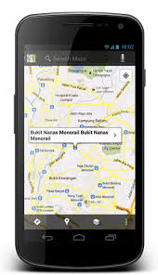

Google Maps on mobile

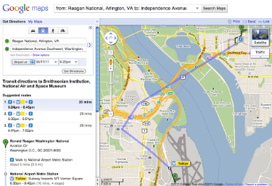

Google Maps on website

## Our offering

The sophisticated software **Transit Agency Route Administrator (TARA)** developed by **NewYug Technologies** simplifies the process of generating the data, suitable for uploading to Google Transit. It provides a simple visual tool for feeding time-table details of a transit agency.

* The stops can be accurately marked on a map.
* It allows two stops on opposites sides of the road to be linked to each other as peer-stops.
* Each route operated by the agency can be marked on the map by choosing stops that have been previously marked.
* Onward and Return trips on the route can be added by specifying start times of the trips.
* The timings at intermediate stops along the route can be automatically computed by the tool with assistance of Google.
* The tool allows offline creation of time-tables in Microsoft Excel.
* The tool generates a passenger-friendly timetable that can be printed and pasted at different locations of the city.
* It can generate the GTFS file by click of a button that is accepted by Google in its prescribed format.

### Data entry by Operator

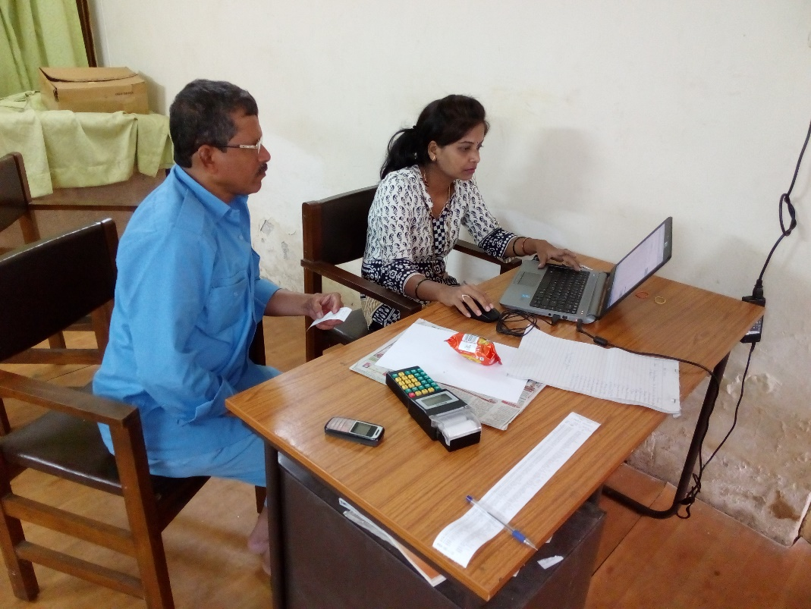

Figure 1 Data entry being performed by operator with Driver's assistance

* Data entry is performed with the assistance of a driver by an operator.
* The driver guides the operator in identifying the precise location of bus stops on Google map satellite/traffic.

### Admin User Interface for Data entry

Figure 2: Representative image of admin tool

# Passenger Experience

A passenger can search for travel options between any two points on a Google Maps application. The results provide step-by-step directions including different modes such as Walking, Ferries, and Buses.

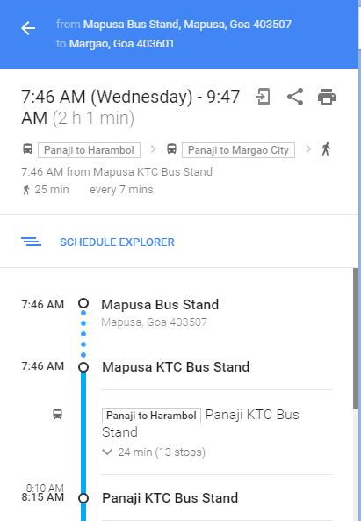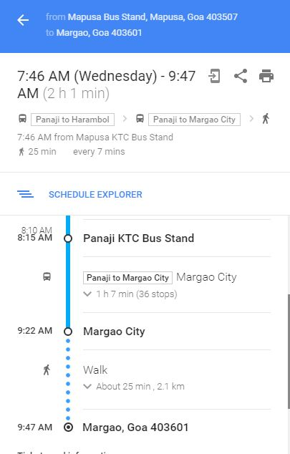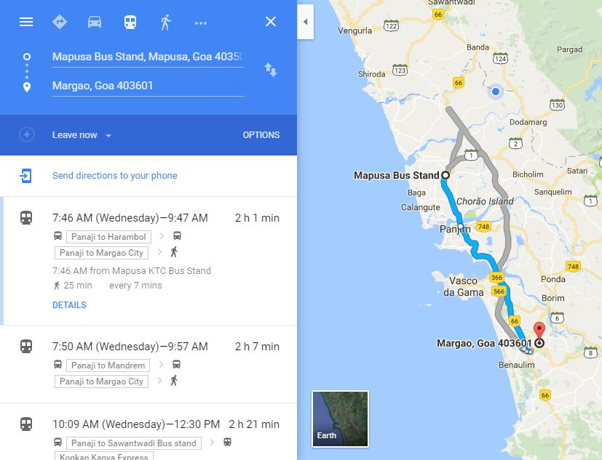

Figure 3 Representative image of user interface

# Financials

* The subscription to the TARA service is based on an annual fee which depends on the approximate number of routes.
* An agency operating 500 routes will be typically charged a maximum fee of **Rs. 6 Lakhs for the first year**.
* However, the cost may be decided on factors such as readiness of data in any electronic format. If data can be imported into TARA automatically, the cost will be significantly reduced.
* The subscription includes the following:
  + Managing communication with Google for on-boarding the data
  + Training the staff of the agency within the agency premises for data entry, updating & validation.
  + Automated data entry from existing digital sources held by the agency
  + Dedicated Relationship Manager to resolve queries of the agency
* The annual fee for subsequent years would be half the fee of the first year provided there is no significant increase in the number of routes.
* **The above pricing model is flexible and can be tuned based on the data conditions within every transit agency.**

# Engagement with Directorate of Transport, Goa

The data entry can be performed easily with dedicated efforts and determination.

## Role of Directorate of Transport

* Provide list of Stops, Routes, Trips and Stop Timings for each route on a particular trip in CSV or Excel format to NewYug Technologies with the requisite details.
* Mark the location of stops on both sides of the road on the User Interface of TARA software on a Google map.
* Complete the data entry within the project duration decided at the start of the project.
* Validate the data and fix; errors & warnings raised by Google Transit.

NewYug Technologies intends to involve voluntary citizen groups to assist DoT staff in data entry.

## Role of NewYug Technologies

* Host the TARA software for entering the data.
* Import Routes, Stops, Trips and Timings data provided by DoT.
* Communication with Google to make the data Live & troubleshoot the errors.
* Create multiple user accounts for DoT staff and volunteers.
* Provide training to DoT staff for performing the data entry.

**Note:** The training to the DoT data entry staff will be conducted at a suitable bus stand in the presence of drivers or conductors, operating the routes linked to the bus stand. The training sessions will be a maximum of 5 in number lasting up to 3 hours. The skills required by the DoT staff is primary basic knowledge of Computers, Microsoft Excel & Internet Explorer.

## **Execution of Project**

### **Milestone 1: Pilot project**

* In this phase only a select few routes will be covered, for which the stop  
  locations are readily available.
* The major bus terminus locations will be provided by MSRTC in the format  
  requested by NewYug Technologies.
* The routes from the ETM system that pass through the provided stops will  
  be uploaded to Google.

|  |  |
| --- | --- |
| Estimated number of routes | **1000** |
| Estimated number of trips | **2000** |
| Annual subscription for 1st year with data entry | **NIL** |
| Estimated project duration after work order issuance   * The duration may vary based on correctness of data as well as response from MSRTC and Google | **3 months** |

### **Milestone 2: ORS routes**

* In this phase, the routes and trips provided under Online Reservation System will be covered.
* Stop locations need to be fed into the system from readily available data in electronic format.

|  |  |
| --- | --- |
| Estimated number of routes | **5236** |
| Estimated number of trips | **10400** |
| Charges for Phase 2 | **Rs. 3 lakhs\***   * **GST as applicable** |
| Estimated project duration | **5 months** |
| Mobilization amount at start of project | **5%** |
| Payment upon completion of project | **95%** |

### **Ongoing future changes**

* This phase covers changes to existing routes as well as new routes to be added into the system after completion of all milestones.
* Stop locations and intermediate timings need to be fed into the system manually.
* Engagement with Google and regular updation of data will be carried out.

|  |  |
| --- | --- |
| Annual subscription charges | **Rs. 5 lakhs\***   * **GST as applicable** |
| Mobilization amount at start of the year | **100%** |

**THANK YOU**