Public transport time-table publisher

# Motivation

Goa is witnessing rampant rise in the usage of personal vehicles by locals as well as tourists. This is taking a major toll on the state's infrastructure, peacefulness and environment. Most people prefer personal vehicles due to lack of awareness of public transport options to get to their destination. Goa's roads and waterways have a strong public transport operated by the Govt. and private operators. The convenience of having the time-table of all public transport services in Goa available on the internet, will translate into people being able to plan their commute in advance and avoid the hassles of using personal vehicles.

# Google support

Google allows the user to obtain driving, walking and public transit directions between any two locations in the world. The public transit options are available on Google Maps only if the transport providers upload their routes, stops, trip timings to Google. The process of providing the timetables to Google is cumbersome. The data needs to be provided in Google's GTFS format. The entire data can run into thousands of lines of text files. Most importantly, the geo-location of stops has to be accurately provided as a latitude and longitude.

# Concept

P3TP

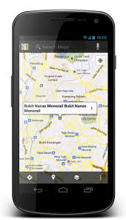

Provide fleet settings

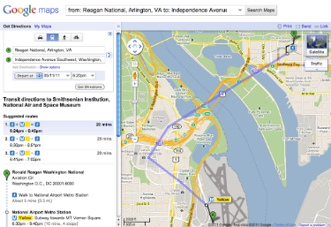

GTFS data

Travel options

Google Maps on mobile

Google Maps on website

# Solution

The Public Transport Time-Table Publisher (P3TP) simplifies the process of generating the data. It provides a simple visual tool for feeding time-table details of a transit agency.

* The stops can be accurately marked on a map.
* It allows two stops on opposites sides of the road to be linked to each other as peer-stops.
* Each route operated by the agency can be marked on the map by choosing stops that have been previously marked.
* Onward and Return trips on the route can be added by specifying start times of the trips.
* The timings at intermediate stops along the route can be automatically computed by the tool.
* The tool allows offline creation of time-tables in Microsoft Excel.
* The tool generates a passenger-friendly timetable that can be printed and pasted at different locations of the city.
* It can generate the GTFS file that can be uploaded to Google.

**P3TP has been adopted by Goa's Kadamba Transport Corporation Ltd. who will be the first customer.**

# Passenger Experience

A passenger can search for travel options between any two points on a Google Maps application. The results provide step-by-step directions including different modes such as Walking, Ferries, and Buses.

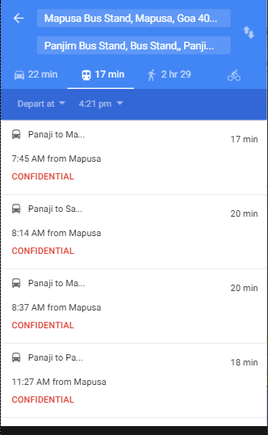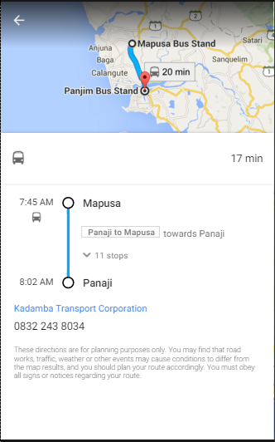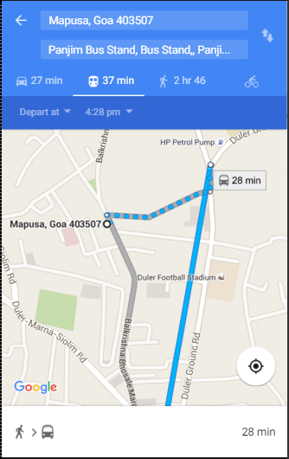

# Future enhancements

* Further Improve the User Interface.
* Once the time-table data is digitized, it can be presented to citizens through multiple additional channels such as SMS, IVR, websites, etc.
* Passenger-experience can be further enhanced by providing real-time status updates of every trip provided the transit agencies install GPS devices.

# Technologies

|  |  |
| --- | --- |
| **Component** | **Technology** |
| User Interface | Google’s Angular.JS library |
| Backend application | Node.js |
| Database | MySQL |
| Map provider | Google maps |

# Summary

This project will place Goa among the few places in India that provide public transport options to citizens at their fingertips. Any agency that subscribes to this service should expect increased revenue from passengers as citizens will begin to turn to public transport. The city/state will witness lesser traffic and cleaner air. Reduced fuel consumption will be a positive side effect of this project.