

Proposal for managing public transport timetables in Goa

Contents

1 Introduction 2

2 Core features 2

2.1 Administrators 2

2.2 Citizens 3

3 Future extensions 3

4 Technical Approach 4

4.1 Admin application 4

4.2 Mobile web application 4

4.3 SMS application 4

4.4 Tools and Technologies 4

4.5 Deployment 5

5 Cost 6

5.1 Add-on costs 6

6 Role of Transport Operators 7

7 Timelines 8

# Introduction

We are a team of Computer Engineering Graduates who intend to develop a software that will significantly revolutionize the commuting experience of citizens of Goa. We had developed a prototype as part of our final year engineering course under the guidance of KTCL officials. **This project has been highly appreciated by officials of KTCL who have also pledged support for the success of the project.** We would like to apply the acquired knowledge for developing a full-fledged online software platform.

The application for defining routes and timetables and providing easy access to passengers will be developed with a Software As A Service (SAAS) model. We propose to host Govt. of Goa as the first customer of this service so that routes and timetables of Transport Operators such as private bus operators, KTCL and River Navigation department’s ferry service can be fed into the system and made available to the general public over the internet and SMS.

# Core features

Once Govt. of Goa subscribes to the service, it will be a **win-win condition** for both transport operators as well as innumerable passengers who use public transport as a mode of commute on a daily basis.

## Administrators

Certain employees of Dept. of Transport, KTCL and River Navigation will be identified as **Fleet Administrators** who will manage the data required by the application.

* The administrator will accurately mark the locations of stops across the state on a map served by Google.
* The administrator will define the path taken by the bus on each route and the stops visited on the path.
* The administrator will identify the stages in the journey, each stage comprising of multiple stops. This grouping will be from the perspective of defining fares.
* The administrator will define the timings of each trip at the starting point of the route. The application will automatically determine the timings at intermediate stops along the route.
* The data provided by the administrator will be automatically uploaded to Google Transit which is the most widely used transit-planning tool in the world.

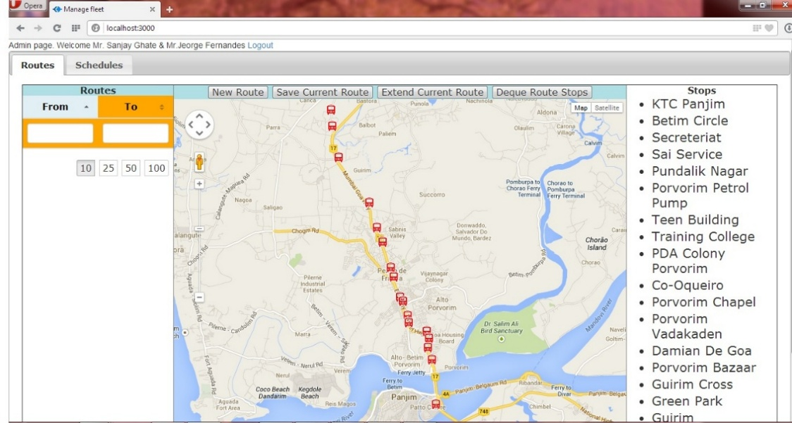

## Citizens

The entire schedule of transport modes will be available in the hands of cell-phone users.

* A passenger intending to travel to a target location will send text message from a cell phone such as: **@goatrans Old Goa to Vasco Harbour after 8 am**.
* A passenger with a smartphone with data connection will be able to visit mobile website customized for transport options within Goa.
* A passenger with access to Google through a computer or a smartphone will be able to obtain travel options between a source and target locations.

# Future extensions

KTCL officials have envisioned a number of innovative initiatives that will further improve the efficiency of the organization. Our application can leverage the concepts, ideas and technology and integrate it to enhance the features listed above. The following features have been requested by KTCL officials and have been added to our list of planned features which will be developed in the future:

* Real-time tracking of vehicles based on GPS-enabled devices installed in the bus.
* Detection of departure of the bus from the point of origin based on signals generated from the RFID-based system.

The above features are present out-of-scope of the current proposal.

# Technical Approach

## Admin application

The Admin application will be a browser-based application that displays the data related to routes, stops and timetables, which is fetched from a web-service hosted at the server. The application will authenticate the user on a login screen before providing access to data of the fleet to which the user belongs.

Data captured in the admin application will be exported to the industry-standard GTFS format. This will then be uploaded to Google so that all timetables of transport operators are available to any smartphone user with a data connection on Google’s website.

## Mobile web application

The mobile web application is a mobile-enabled website that allows the user to specify the Source and Destination of his journey and additionally provide timing details. The application uses Google’s Transit service and API for displaying travel options to the user.

## SMS application

TxtWeb is a service, provided by a company named Intuit, which allows a user of a basic phone to access the internet over SMS. A TxtWeb ID will be registered for Goa’s public transport and it will be configured to use our web service as the source of data. Passengers will be able to send a message to TxtWeb which will in turn fetch the data from our web service. More details of TxtWeb can be found at [www.txtweb.com](http://www.txtweb.com).

## Tools and Technologies

The application uses **free open-source** technologies

|  |  |
| --- | --- |
| **Application** | **Technologies** |
| Database | MySQL |
| Server-side technologies | Node.js |
| Client-side technologies | Javascript, HTML5 |
| Map provider | Google Maps |

## Deployment

The application will be served from cloud servers procured from Amazon. Cloud servers ensure reduced operational costs and better management.

**The servers will remain under the ownership of the developers as the application can potentially serve multiple fleets in the country in the future.**

The precise requirement of hardware for hosting the system can be determined only once all the data is captured and the application is Beta-tested. However, based on prior experience, we have arrived at the following estimate of the hardware requirements:

|  |  |
| --- | --- |
| **Server** | **Description** |
| DB Server | This server hosts the MySQL database. |
| Admin server | This server hosts the application used for feeding data into the system |
| Graph server | This server hosts the graph that provides connections between trips |
| Text server | This server hosts the SMS application |
| Mobile App server | This server hosts the mobile website |

# Cost

Govt. of Goa will pay an annual subscription for the Core Features provided by the application. The amount will be utilized for:

* Operating the servers
* Paying monthly fees of software developers
* Miscellaneous costs
* Training imparted to Dept. of Transport, KTCL and River Navigation employees for data entry

Transport operators can expect to recover the cost from the goodwill generated between the organization and the passengers.

The annual subscription cost for this service will depend on:

* Number of routes to be covered in Goa
* Number of trips being performed on the routes
* Number of passengers who will benefit from this service

The annual subscription cost for the first and subsequent years will be determined based on discussions with officials of Govt. of Goa to determine the above parameters.

This annual amount may be revised in the future if the service is shared by other fleets in the country thus making the platform financially sustainable.

## Add-on costs

Upon requests from transport operators, we may develop additional features to integrate other systems with the application for enhancing operations. This development will involve additional cost that will be agreed between us and the transport operators or Govt. of Goa.

# Role of Transport Operators

This project will be successful with a joint participation between us and transport operators. We expect the following details from the transport operators:

|  |  |
| --- | --- |
| **Deliverables from Transport Operators** | **Description** |
| Fare Rules | The rules used for determining the fares on different routes will be provided to us. |
| Operator details | Data entry into the system involves identification of the precise location of stops, knowledge of stops on a route and knowledge of the timetable for the routes. Transport operators will identify such individuals within the organization and provide their names to us so that their login accounts can be created |
| Acceptance of NDA received from Google | Google will make the Google feed live only once the NDA is signed by officials of the transport operators |

# Timelines

With an aim to make the application available to passengers on the auspicious occasion of Diwali, we propose the following timeline for commissioning the system:

|  |  |  |  |
| --- | --- | --- | --- |
| **Task** | **Start date** | **End date** | **Comments** |
| Agreement with Google | 1st Oct 2014 | 1st Oct 2014 | Google will send an NDA document to be signed and submitted for Govt of Goa’s Google feed to be made live on Google’s website |
| Deployment of Admin application | 6th Nov 2014 | 10th Nov 2014 | The Admin application will be made live on the internet and access will be provided to officials.  Officials will be trained to feed the data into the system. |
| Data entry | 8th Nov 2014 | 19th Nov 2014 | KTCL employees will feed the routes, stops and timetables for the 254 operational routes of KTCL at an average of 25 routes per working day.  Drivers, Conductors, Controllers, etc. may be involved in this process for ensuring accuracy of the data |
| Upload to Google | 20th Nov 2014 | 19th Dec 2014 | Data will be submitted to Google in GTFS format.  Google will perform elaborate testing before making the data live on the transit site. |
| Test SMS application | 20th Nov 2014 | 19th Dec 2014 | Officials will test the SMS application |
| Soft-launch | 19th Dec 2014 | 19th Dec 2014 | The application will be launched as a Beta release on the occasion of Liberation Day for the sole purpose of testing. It will be only advertised on social media so that testing is crowed-sourced to citizens. |
| **Official launch** | **1st Jan 2015** | **1st Jan 2015** | **The application will be launched for the general public on the occasion of New Year at the peak of the tourist season in Goa!** |