*WALRUS*
projects build on walrus
1) TUSKY - Tusky’s a decentralized storage maxi
Rescue your files from Dropbox and Google Drive, make them assets stored on Walrus
With these tools you can:
Rescue your files from Google Drive and Dropbox, and make them assets on Tusky.
Share private, end-to-end encrypted data with magic links for viewing or uploading (set permissions and allocate storage).
it basically replaces cloud storage with decentralized walrus protocol

Check these tweets
https://x.com/trevinvsgaming/status/1897124408084328843
https://x.com/GrootKkw/status/1903849880021299205
2) Seal - https://sealplus.wal.app/
Seal is a decentralized secrets management (DSM) service that relies on access control policies defined and validated on Sui. Application developers and users can use Seal to secure sensitive data at rest on decentralized storage like Walrus, or on any other onchain / offchain storage.
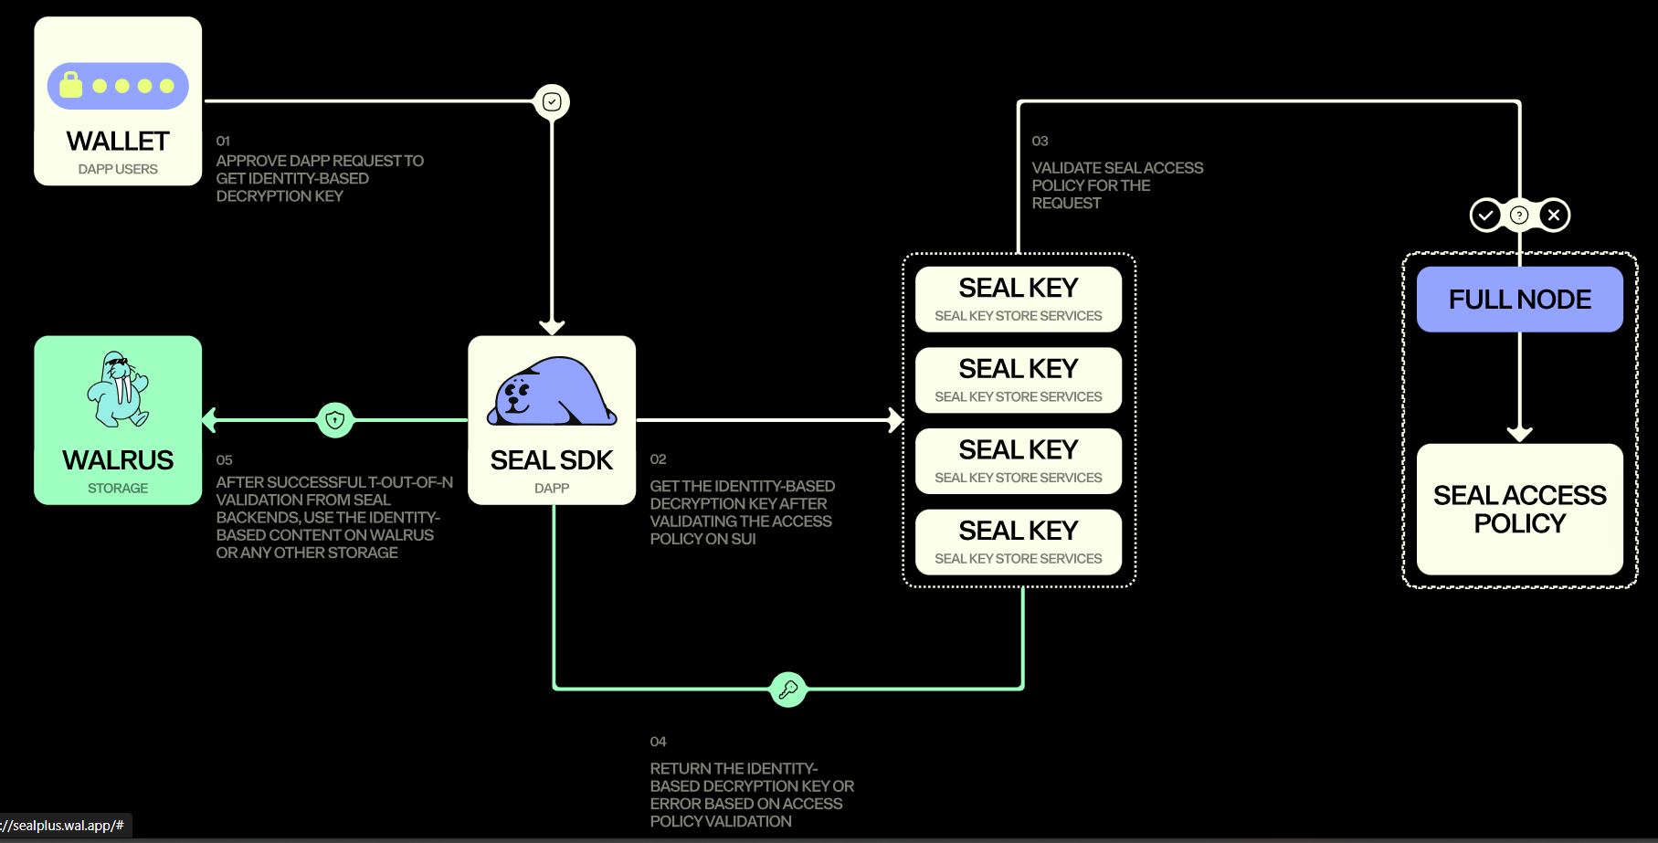

3) Inflective AI
Ideas to building using Walrus
1. AI Agent Data Marketplace
Concept: Build autonomous AI agents that collect, process, and sell data stored on Walrus
- Agents scrape public data, store on Walrus with metadata
- Smart contracts handle payments and access control
- Privacy-preserving data analytics using homomorphic encryption
- Why it wins: Combines trending AI agents + decentralized storage + real utility
2. Decentralized Creator Economy Platform
Concept: YouTube alternative where all content is stored on Walrus
- Creators upload videos/content directly to Walrus
- Built-in monetization through micro-payments
- Content discovery through AI recommendations
- Censorship-resistant with creator ownership
- Why it wins: Addresses real problems + uses Walrus's strength + content creator appeal
3. Programmable Gaming Assets
Concept: Dynamic NFT game where assets evolve based on data stored on Walrus
- Game saves, player statistics, and asset evolution data on Walrus
- Smart contracts update NFT properties based on stored data
- Cross-game asset interoperability
- AI-generated content based on player behavior data
- Why it wins: Gaming is hot + programmable storage is unique + NFT utility
4. Decentralized Research Data Repository
Concept: Platform for researchers to store and monetize datasets
- Researchers upload datasets to Walrus with metadata
- Smart contracts handle licensing and payments
- AI tools for data analysis and visualization
- Citation tracking and reputation systems
- Why it wins: Real-world utility + academic appeal + data monetization
5. Climate Data Oracle Network
Concept: Decentralized network collecting and storing environmental data
- IoT sensors store data on Walrus
- AI processes data for climate insights
- Carbon credit marketplace based on verified data
- Government/NGO partnerships for funding
- Why it wins: Social impact + real-world data + sustainability theme
6. Decentralized Social Media Analytics
Concept: Platform for analyzing social media trends stored on Walrus
- Collect public social media data, store on Walrus
- AI-powered sentiment analysis and trend prediction
- NFT-based reports and insights for brands
- Privacy-first analytics without user tracking
- Why it wins: Data analytics + AI + business utility
7. Web3 Educational Platform
Concept: Learn-to-earn platform with content stored on Walrus
- Educational content and user progress stored on Walrus
- AI tutors that adapt based on learning data
- NFT certificates and achievements
- Gamified learning with token rewards
- Why it wins: Education + gamification + AI personalization

Major Platform Partners
1. TradePort
- Website: https://www.tradeport.xyz
- Description: Largest NFT marketplace on Sui, multichain platform supporting Sui, Aptos, NEAR, Movement, and Stacks
- Integration: Uses Walrus to store metadata for all Move-based ecosystem NFT projects
2. Plume Network
- Website: https://www.plume.network
- Description: First public Layer 1 blockchain purpose-built for RWAfi (Real World Asset Finance)
- Integration: Uses Walrus as default blob storage for asset records, compliance data, and financial metadata
3. Tusky (formerly Akord)
- Website: https://tusky.io
- Official Docs: https://docs.akord.com
- Description: Web3 data management platform providing Dropbox-like experience with end-to-end encryption
- Integration: Migrated from Arweave to Walrus, offers app, API, SDK and CLI on Walrus
Walrus Native Applications
4. Flatland NFTs
- Website: https://flatland.walrus.site/
- Description: NFT collection on Sui testnet demonstrating Walrus Sites functionality
- Integration: Each NFT has its own personalized Walrus Site, minted from Walrus-hosted frontend
5. Walrus Staking Platform
- Website: https://stake.walrus.site/
- Description: Official staking application for WAL tokens
- Integration: Built natively on Walrus for token staking and validator selection
6. Walrus Publisher
- Website: https://publish.walrus.site/
- Description: Tool for uploading and publishing blobs to Walrus network
- Integration: Direct interface for Walrus storage functionality
7. WalrusScan Explorer
- Website: https://walruscan.com
- Description: Blockchain explorer for Walrus network built by Stakestab Inc (makers of SuiScan)
- Integration: Comprehensive explorer for analyzing Walrus network activity
Infrastructure & Development Partners
8. Veea Inc.
- Website: https://www.veea.com
- Description: Edge infrastructure company providing VeeaHub STAX platform
- Integration: Powers Walrus with NVMe-powered edge computing nodes for high-performance data transport
9. Luganodes
- Website: https://luganodes.com
- Description: Institutional-grade blockchain infrastructure provider
- Integration: Validator for Walrus protocol, supporting network decentralization
SO BASICALLY, WE USE WALRUS AS ONE OF OUR TRACK TU BUILD WHERE WE NEED TO STORE OUR DATA IN A DECENTRALIZED WAY.
image it as alternative of google drive

