**Q2**

T = 3

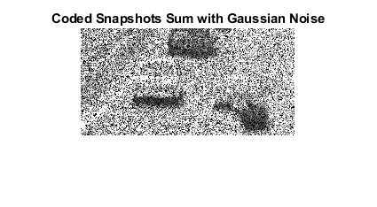

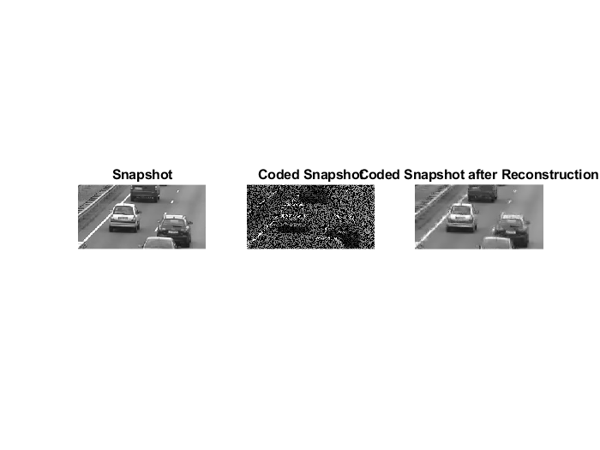

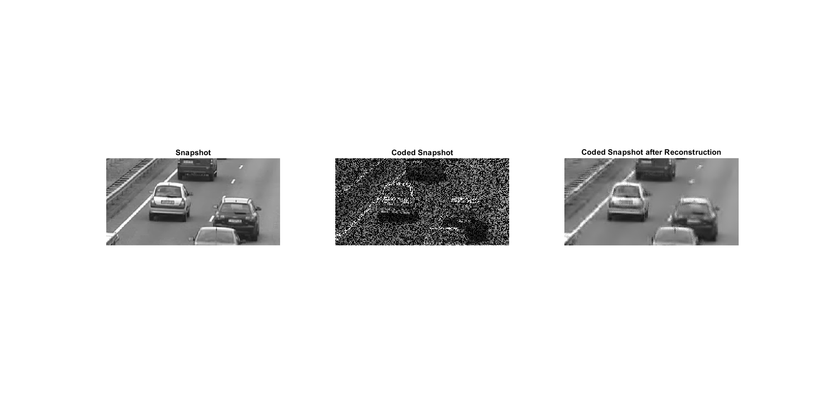

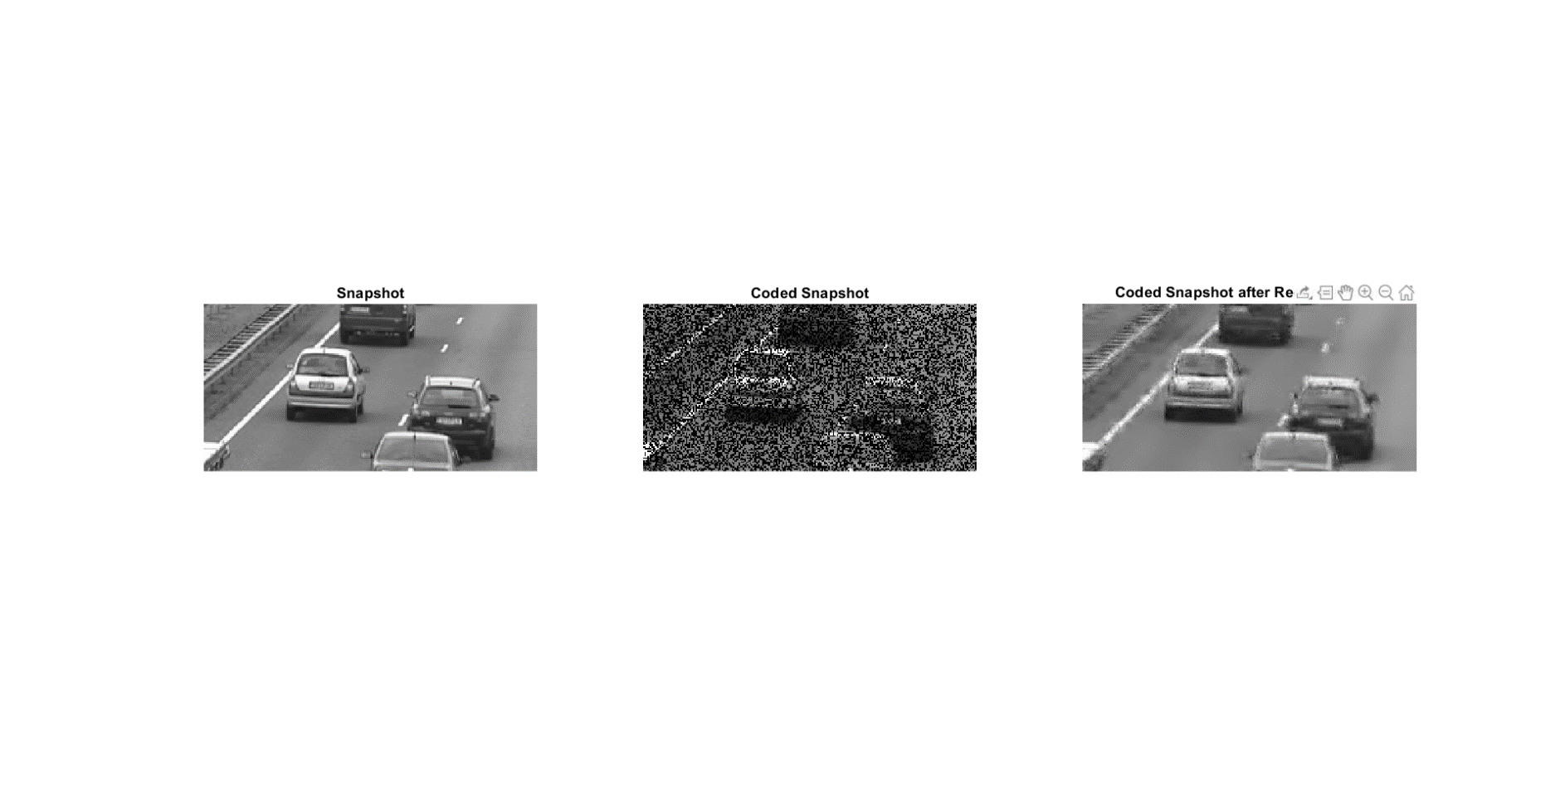

T = 5

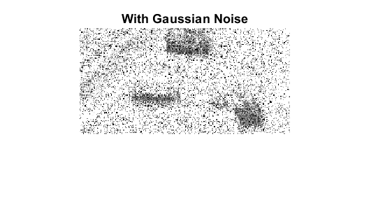

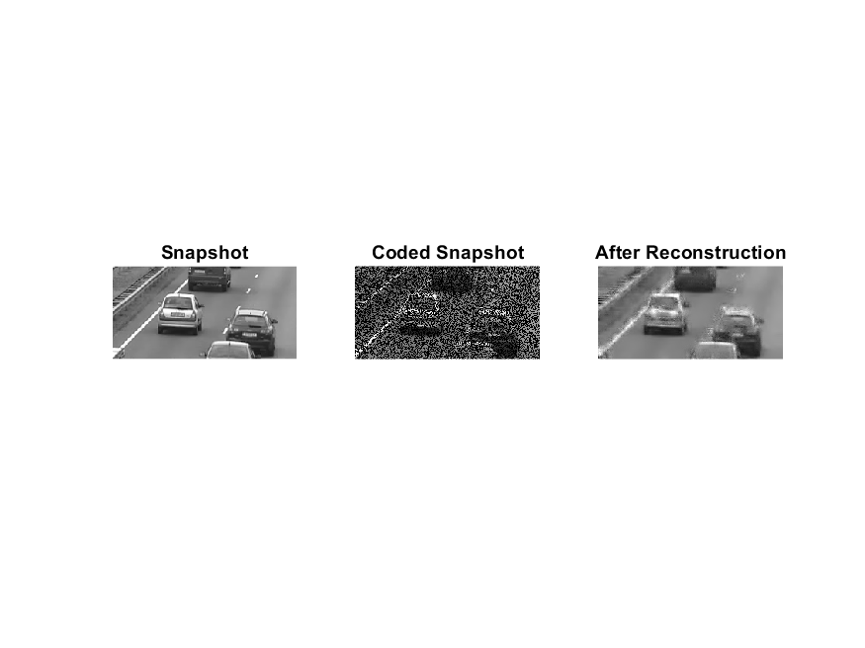

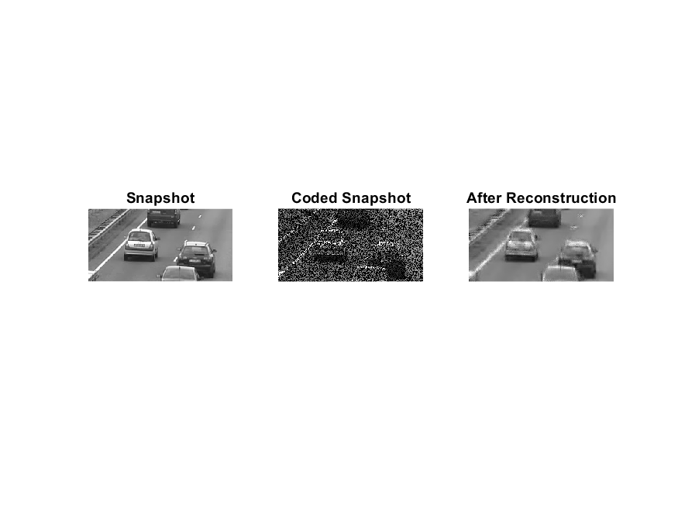

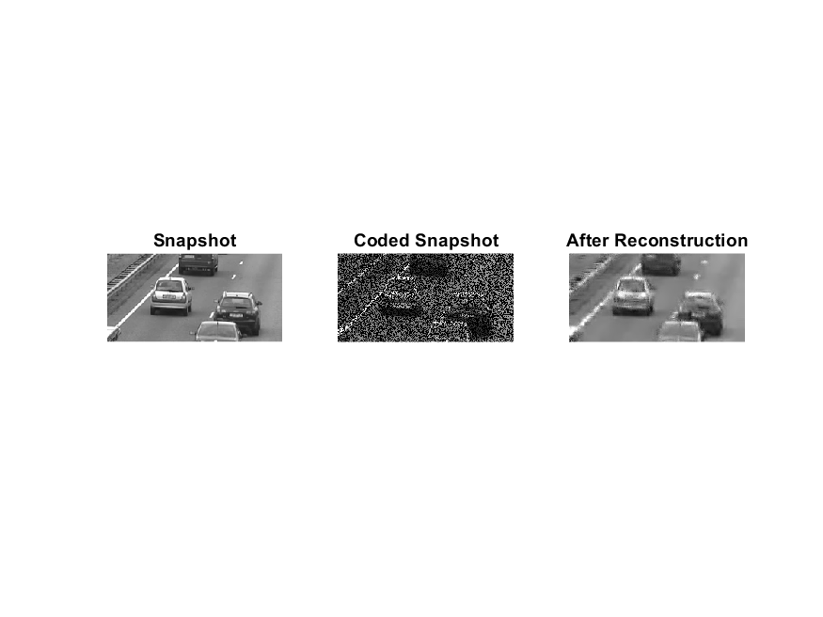

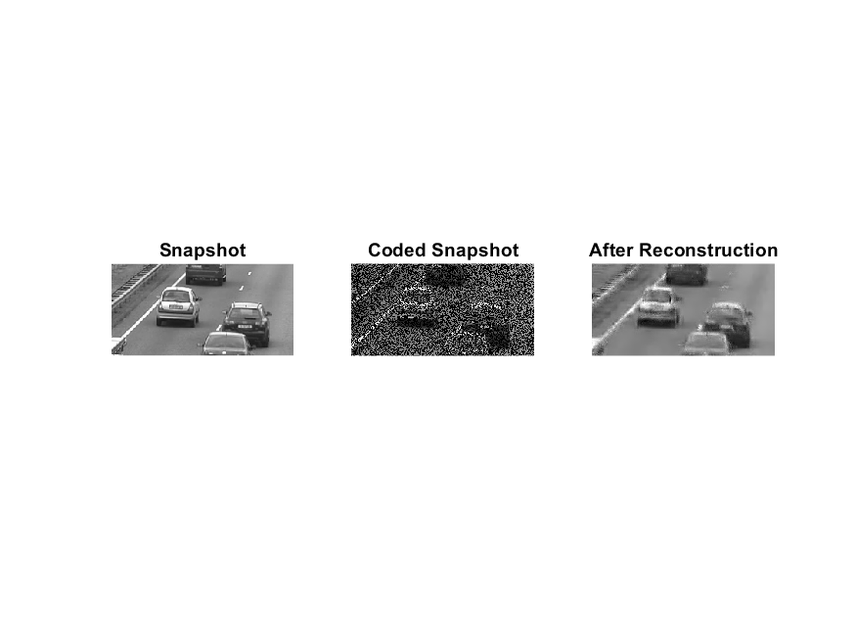

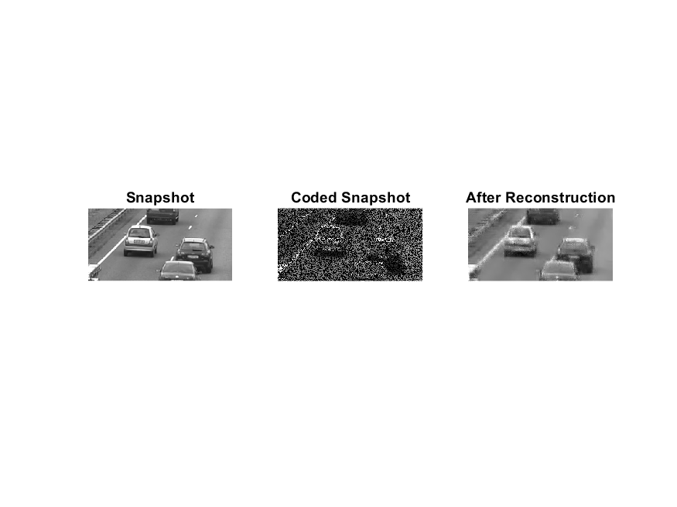

T = 7

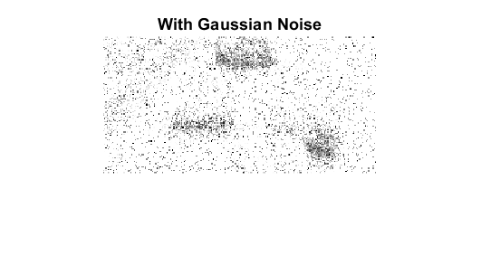

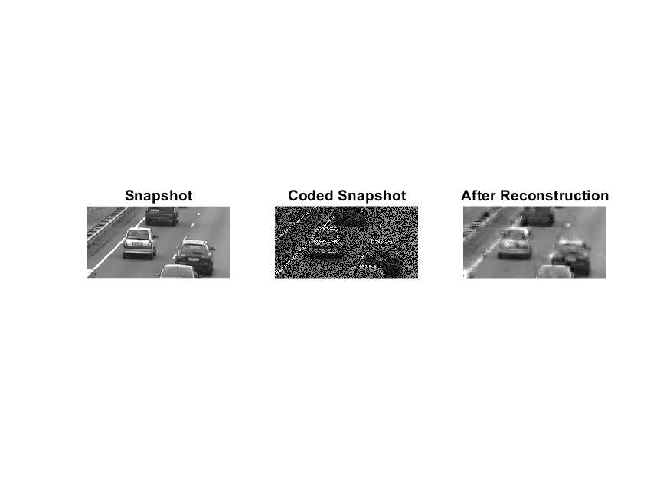

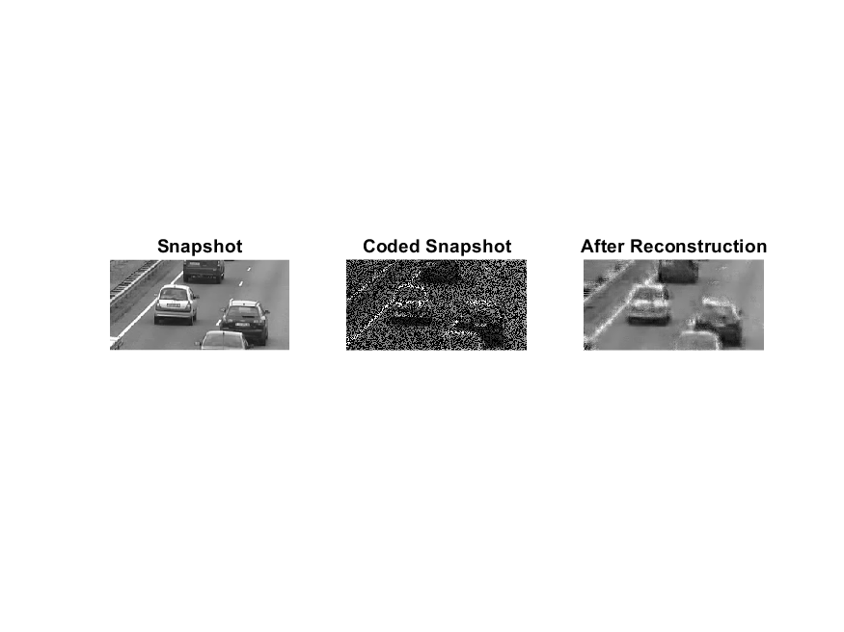

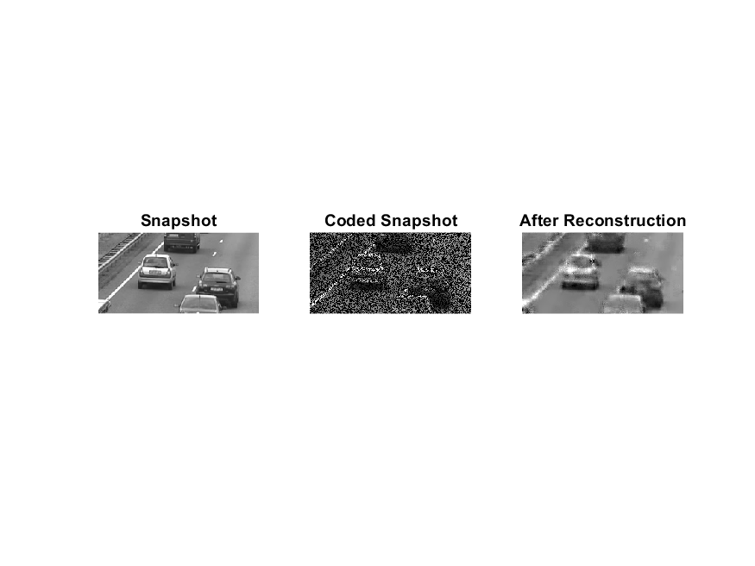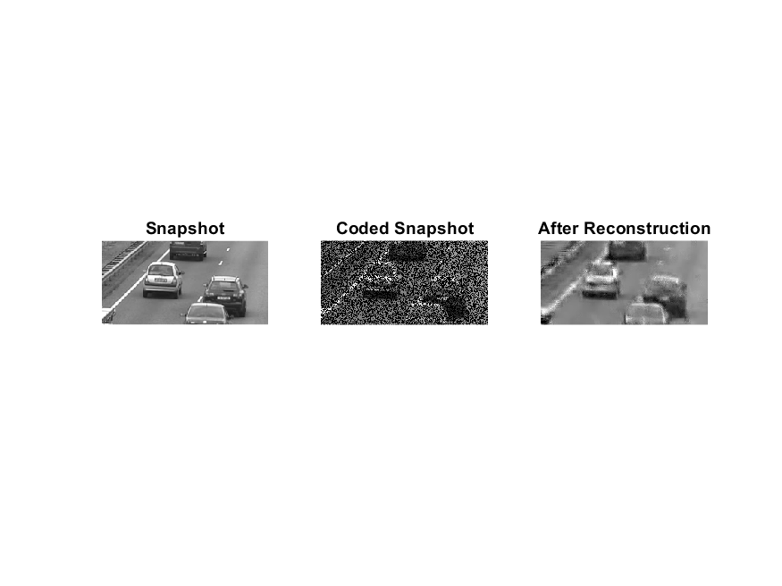

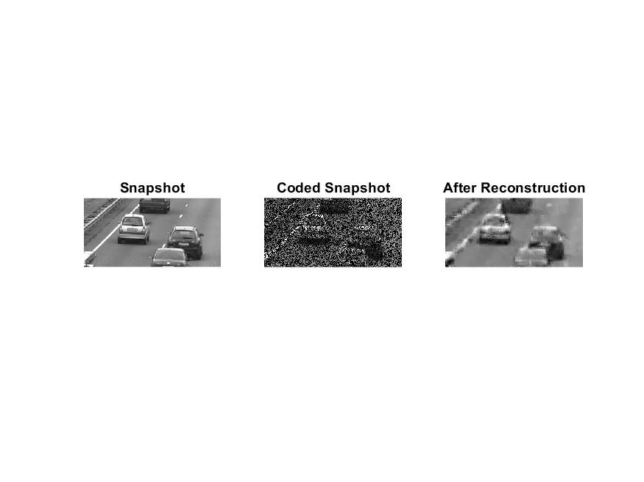

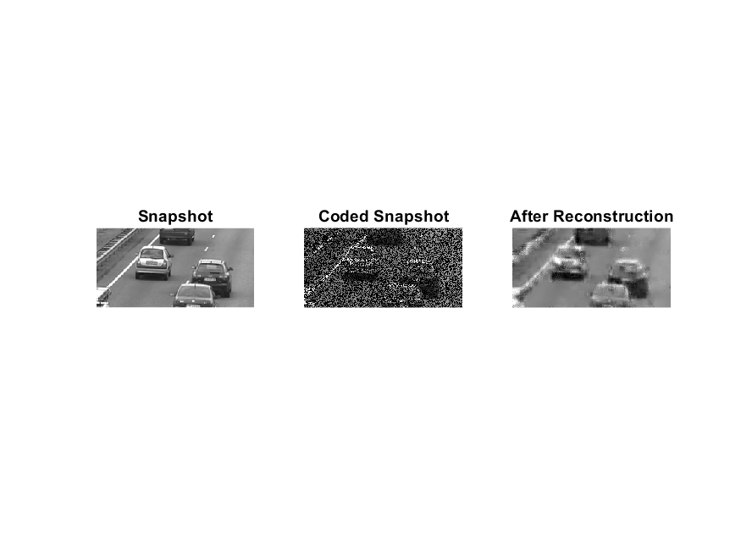

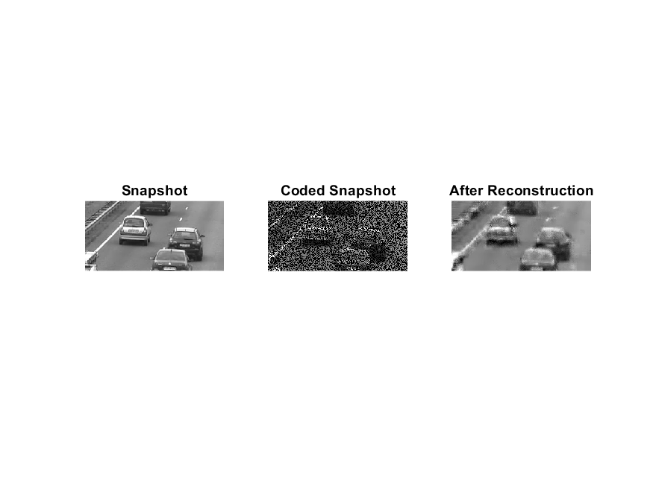

Explanation for **Ax = b:**

t

Eis the obtained image. We divide it into patches of 8*8. Let E­ij (and similiarly for other matrices) be the patch with left corner at (i,j) coordinate.

Then t .

So, . Also , with being sparse.

Converting all products to matrix products :

Where Kronecker products are taken for forming 2-D DCT matrix diag(M) means putting all elements of the matrix along the diagonal row-first wise.

Explanation for error Term:

Consider **y = Φ*f + η = Φ*Ψ*θ + η.** If for each i = 1 to m, **ηi** ~ N (0,), with known σ then the squared magnitude of the vector **η** is a chi-square random variable. Hence with very high probability, the magnitude of **η**will lie within 3 standard deviations from the mean, i.e. set ε ≥ 3*σ*√m.

Therefore, set ε = 3*2*8 = 48.

RMSE

T =3 - 0.1043

T =5 - 0.1371

T =7 - 0.1759

FLAMES

