Q3

1. rmse_noise = 0.0147

rmse_recon = 0.0135

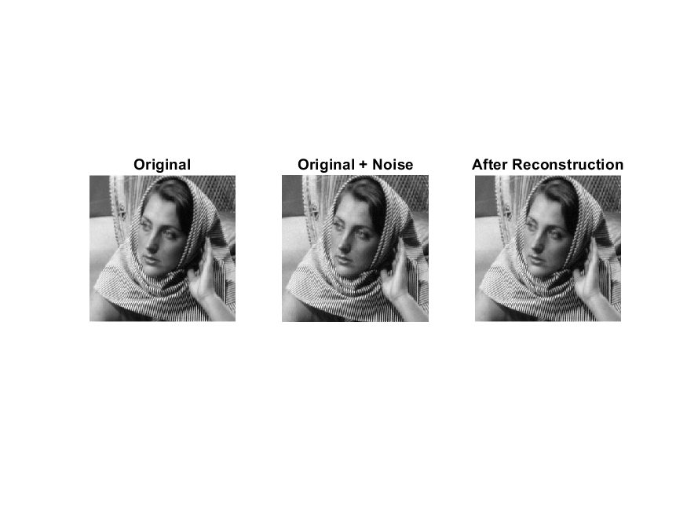

1. rmse_recon = 0.4521

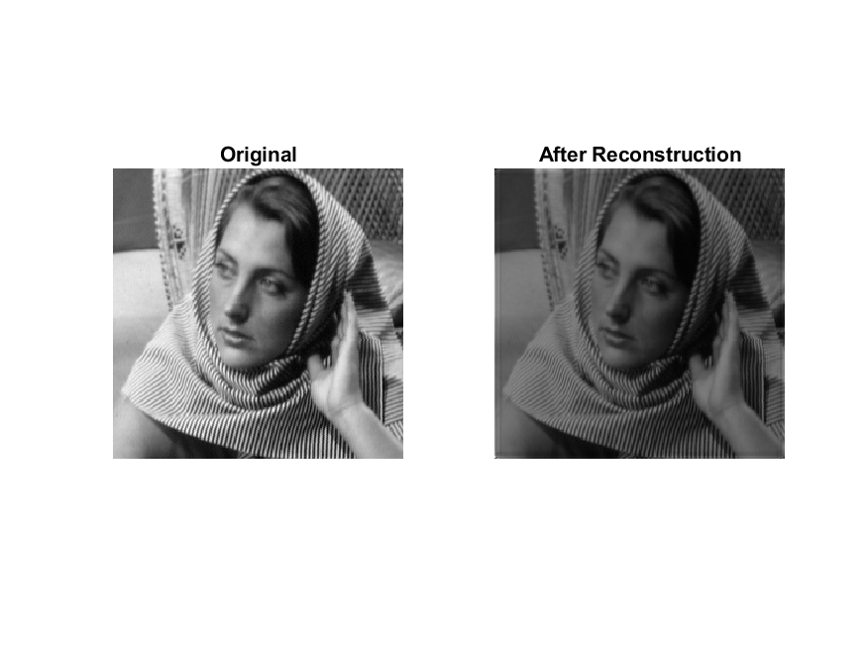

rmse_recon = 0.5533

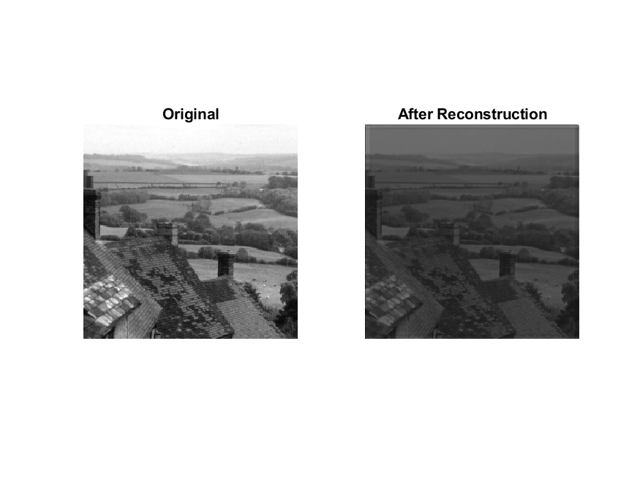

1. For this part number of iteration(last parameter of ist2 has been set to 30 for better reconstruction results , however that takes a lot of time . For faster results, set number of iterations to 10 or less)

Rmse = 0.2266

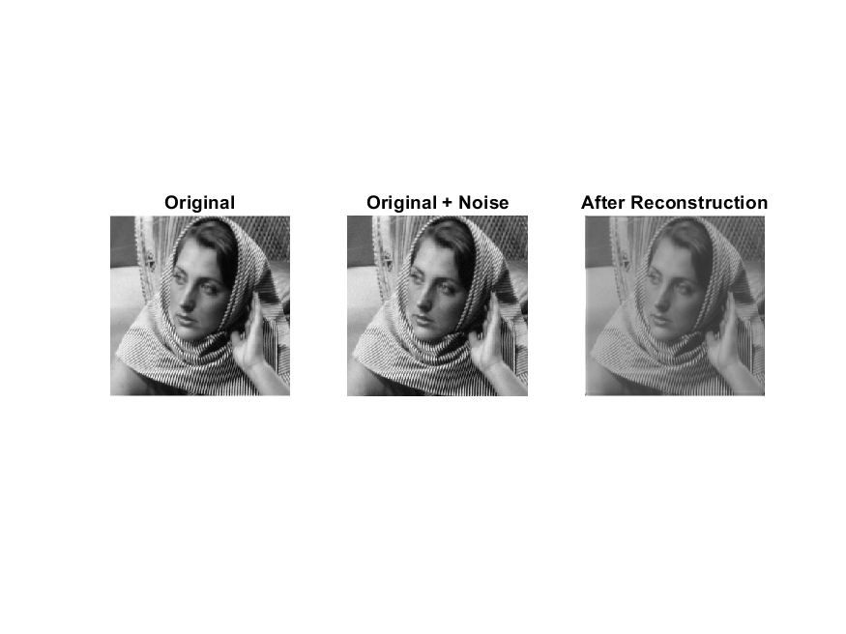

Rmse = 0.3455

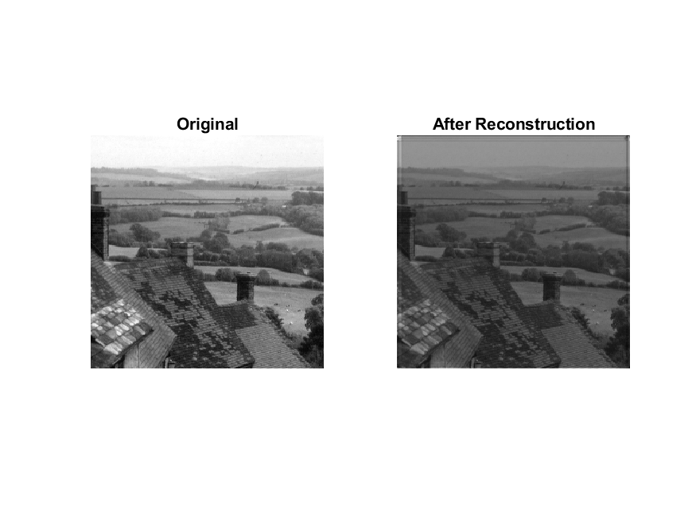

1. Rmse = 0.7925

