**Book Inventory Management System**

**This program deal with two types of user:**

1. **Admin**
2. **Customer**

**In order to archive maximum readability the whole program is divided into several file along with two separate txt file which store data . All the files are listed down along with their functions:-**

1. **login.py---** This is the python source code for providing a login interface . This is also the starting point of the program .
2. **user_data_handler.py---** This python source code provides all the functions to handle user data and handles login interface.
3. **user_handler.py**---This python sources provides an interface to a Customer and handles all the customer related requests.
4. **books_data_handler.**py—This python source code provides all the functions to handle book data. It also provides interface to admin to deal with books information and an interface for customer to buy books .
5. **admin_handler.**py—This python source code provides an interface to admin and deals with all his requests
6. **user.**txt—This text file store data of users.
7. **books.**txt—This txt file store data of books
8. **analysis.py – this python source manages analysis of book data**

**Login.py**

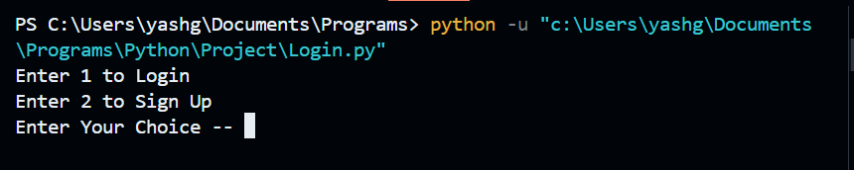

**user_data_handler.py**

1. **user_database=[ ]**--It holds a list of dictionary data type designed to store user data.

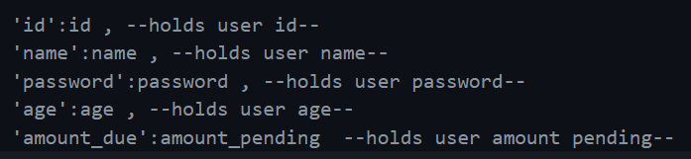

1. def login(): It provide an interface for login irrespective of user type. It cross-checks user input information with the user database and returns id if the login is successful .It deals with brute force attack by limiting a number of attempts.

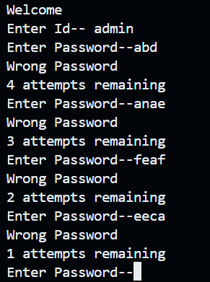

1. def check_id(s)->int: -- This functions check if the id is present in user database or not . if present then returns the index of the user in userdatabase
2. def check_password(password,index)->bool: this funtions checks if password is correct or not for a user
3. def get_data( ): This reads data from file “user.txt”
4. def fill_user_database(line): This function receives line from get_data function and fill data in “user_database”
5. def add_user(): This functions add a new user in “user_database”.
6. def remove_user(): It removes a user from "user_database”
7. def update_user_information(id): It updates user information of a specific user in "user_database"
8. def set_bill_for_user(userid,amount): Set pending amount for a user .
9. def get_user_pending_bill(userid)->int : returns the pending amount of a user.

**user_handler.py**

This code provides an interface to user to deal with all requests.

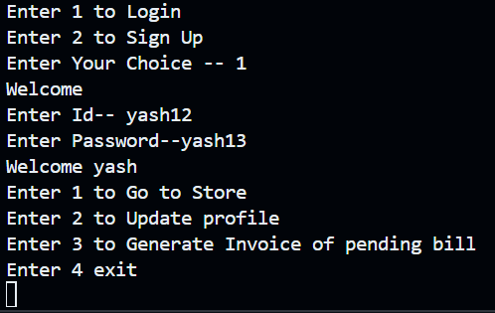

**books_data_handler.py**

It contains all the functions related to handle books data .It also provides interface for admin and customer.

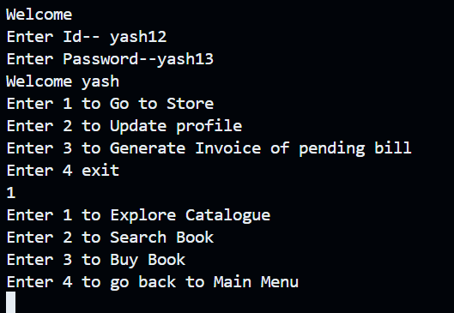

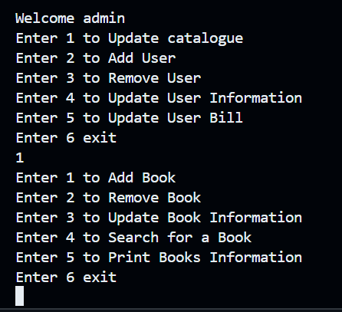

1. books=[] This list store books information in a dictionary.
2. def get_data(): This function read data from the file “books.txt”
3. def get_book_data(line): This function receive line from “get_data()” function and fill the list “books” by filtering data from the received line.
4. def add_book():This function adds a new book dictionary in list "books"
5. def print_book_details():This function prints information of all the books present in list "books"
6. def remove_book():This function remove a books form list "books"
7. def update_book_details(): This function updates books information.
8. def search_book():This functions search if a book is present in the list "books"
9. def fill_book_data():This function writes the books information in file "books.txt"
10. def books_data_controller_for_admin():this function provides an interface for admin to deal with all his requests
11. def books_data_controller_for_user(id): This function provides an interface for customer and deals with all his requests
12. def buybook(user_id):This provides an interface to customer to buy a book or to add book in a cart.
13. def check_book_id(book_id:int)->bool: This function checks if the book id is valid or not
14. def checkout(user_id:str , book_cart):This function updates the pending bill of user as per the books he bought
15. def update_inventory(book_cart):This updates the “books”data when a user buys a book.

**admin_handler.py**

This source code provides an interface for admin and deals with all his requests

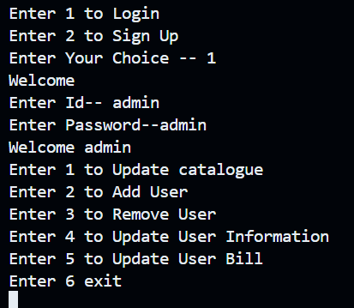

**books.txt**

It holds data of all the books present in the inventory in a specific format.

“Book name , number of books available , price of book \n”

This format is used to store the data of books.

“ , ” in the format helps in filtering different types of information.

“\n” is added intentionally to make sure the data of different books don’t get mixed up.

**user.txt**

It holds data of all the users in a specific format.

“username , full name , password , age , amount due \n”

This format is used to store the data of users.

“ , ” in the format helps in filtering different types of information.

“\n” is added intentionally to make sure the data of different user don’t get mixed up.

**Analysis.py**

1. **Class analysis**
2. **Def most_sold_book() –** finds the most sold book
3. **Def trending_books()—**finds top 5 sold book
4. **Def total_sales() –** calculates total sales
5. **Def controller_for_user()—**manages options related to user
6. **Def controller –** manages options for admin