"Cortex AI"
Tagline: Your Development Team's AI Brain - Learns, Decides, Automates
The One-Liner Pitch:
"Cortex AI monitors your entire development workflow, learns from your team's patterns using reinforcement learning, and autonomously makes decisions to optimize your pipeline - from code review to deployment."

Why This WINS
1. Strong Innovation Story
- Not just automation - autonomous decision-making
- Not just monitoring - predictive intelligence
- Not just AI summaries - RL-trained on YOUR team's data
2. Clear Value Proposition
Every developer immediately understands: "An AI that learns my team's patterns and automates decisions? That's game-changing."
3. Perfect Tool Integration (All 5 tools are ESSENTIAL, not forced)
4. Demonstrable Impact
Live demo shows real decisions being made in real-time
5. Scalable Vision
Judges can immediately see how this becomes a real product

THE CORE CONCEPT
What Cortex AI Does:
Think of it as an AI team member that:
- Observes - Monitors your GitHub repo, PRs, CI/CD, deployments
- Learns - Uses RL to understand what "good" looks like for your team
- Summarizes - Provides intelligent insights across your workflow
- Decides - Makes autonomous decisions based on learned patterns
- Acts - Executes decisions through automated workflows

The Magic Moment (What Makes Judges Go "Wow"):
A developer pushes code → Cortex AI analyses it → Learns similar to past successful patterns → Decides to fast-track it → Auto-approves review → Triggers deployment → Monitors success → Updates its decision model.
All autonomous. All learned. All demonstrated live.

HOW EACH TOOL CREATES THE SYSTEM
1. Cline CLI - The Command Interface
Role: Direct interaction layer for developers
Commands You'll Build:
cline analyze # Analyze current repo state
cline predict # Predict PR merge time, deployment risk
cline decide [action] # Ask Cortex to make a decision
cline deploy [env] # Intelligent deployment with AI checks
cline learn # Trigger RL training update
cline insights # Get AI-generated insights
cline status # Full system status
Why It's Essential: Gives developers direct access to AI brain. Showcases automation.

2. Kestra - The Orchestration Engine
Role: Workflow automation and data pipeline backbone
Workflows You'll Build:
Workflow 1: Data Collection Pipeline
- Continuously pulls data from GitHub (commits, PRs, reviews, CI results)
- Stores in structured format for AI training
- Runs every 15 minutes
Workflow 2: AI Decision Engine
- Triggered on PR creation/update
- Collects contextual data (author history, file changes, test coverage)
- Feeds to Kestra AI Agent
- Executes decisions

Workflow 3: Deployment Orchestration
- Handles staging → production pipeline
- AI-driven deployment decisions
- Rollback triggers based on metrics
Why It's Essential: The nervous system connecting everything. Shows real orchestration complexity.

3. Kestra AI Agent - The Decision Maker
BONUS POINTS
Role: Summarizes data AND makes autonomous decisions
Decision Examples:
Decision 1: PR Review Priority
- Summarizes: PR complexity, author reliability, urgency signals
- Decides: "High priority - assign senior reviewer immediately" vs "Low risk - auto-approve after CI"
Decision 2: Deployment Go/No-Go
- Summarizes: Test results, code coverage delta, similar past deployments
- Decides: "Safe to deploy" vs "Hold - similar pattern caused rollback 3 weeks ago"
Decision 3: Resource Allocation
- Summarizes: CI queue length, historical patterns
- Decides: "Allocate extra runners - high traffic period predicted"
Why It's Essential: This gets you BONUS POINTS. Shows AI not just summarizing but actually making calls.

4. Oumi - The Learning Brain
Role: RL fine-tuning for personalized intelligence
What You'll Train:
Dataset: Your team's historical data
- Successful PRs vs problematic ones
- Fast deployments vs failed ones
- Good code patterns vs bug-prone patterns
RL Training Goal: Learn to predict outcomes and recommend actions that maximize:
- Code quality
- Deployment success rate
- Developer velocity
The Model Learns:
- "PRs from developer X touching auth code need extra review"
- "Deployments on Friday afternoons have 3x higher rollback rate"
- "Small PRs with high test coverage can be fast-tracked"
Why It's Essential: This is your INNOVATION showcase. Shows real ML, not just API calls.

5. Vercel - The Intelligence Dashboard
Role: Real-time visualization and interaction interface
Dashboard Sections:
1. Command Center
- Live workflow status
- Recent AI decisions with reasoning
- System health metrics
2. Intelligence Feed
- Real-time insights stream
- Decision explanations
- Prediction confidence scores
3. Learning Dashboard
- RL training progress
- Model accuracy metrics
- Decision success rate over time
4. Interactive Console
- Chat interface to query Cortex
- Manual decision overrides
- Training data exploration
5. Analytics
- Team velocity trends
- Deployment success rates
- Time saved through automation
Why It's Essential: Makes everything visible. Perfect for demo video. Shows it's a real product.

6. CodeRabbit - The Quality Guardian
Role: Code review throughout your development + training data source
How You'll Use It:
During Development (Visible Activity):
- Every feature gets a PR with CodeRabbit review
- Document CodeRabbit suggestions you implement
- Show 10-15 PRs with clear CodeRabbit activity
As Data Source:
- Use CodeRabbit's reviews as training signal for Oumi
- "CodeRabbit flagged security issue" → "Cortex learns to catch similar patterns"
- Makes the system smarter over time
Why It's Essential: Shows development best practices + feeds your AI training.

THE DEMO NARRATIVE (5-7 Minutes)
Act 1: The Problem (1 min)
"Development teams waste 40% of time on decisions that could be automated. Let me show you Cortex AI - an AI that learns your team's patterns and makes decisions for you."
Act 2: The Learning (1.5 min)
- Show Oumi RL training on sample repository data
- Explain: "Cortex learned from 200 PRs, 50 deployments"
- Display model accuracy metrics improving
Act 3: The Intelligence (2 min)
Live Demo:
- Create a PR in demo repo
- Show Kestra workflow trigger
- Kestra AI Agent analyzes and decides
- Dashboard updates with decision reasoning
- Run cline predict - see AI predictions
- Show decision execution
Act 4: The Impact (1.5 min)
- Show analytics: "Cortex saved 15 hours this week"
- Display decision accuracy: 92%
- Explain scalability: "Learns continuously, gets smarter over time"
Act 5: The Vision (1 min)
"Today: PR reviews and deployments. Tomorrow: Sprint planning, incident response, resource optimization. Cortex becomes your team's AI brain."

4-DAY EXECUTION PLAN
DAY 1: Foundation + Quick Win
- Repository setup with proper structure
- Vercel deployment (basic Next.js app)
- CodeRabbit integration enabled
- Kestra Docker setup
- First PR with CodeRabbit review (setup docs)
- Basic dashboard skeleton deployed
- Cline CLI installation and first 2 commands
- First Kestra workflow (GitHub data collection)
- Basic data pipeline working
- 2-3 PRs with CodeRabbit reviews
Deliverable: All tools connected, basic data flowing, deployed dashboard

DAY 2: Intelligence Layer
- Oumi environment setup
- Prepare training dataset (can use synthetic + some real data)
- Start RL fine-tuning (let it run while you work on other things)
- Build 3 more Cline commands
- 3-4 PRs with CodeRabbit
- Kestra AI Agent integration
- Build first decision workflow (PR analysis)
- Test decision-making logic
- Dashboard: Add Intelligence Feed section
- 2-3 PRs
Deliverable: AI Agent making first decisions, RL training running, CLI functional

DAY 3: Integration + Polish
- Complete Oumi RL training
- Integrate trained model into decision pipeline
- Build deployment decision workflow
- Complete remaining Cline commands
- Dashboard: Add Learning Dashboard section
- 3-4 PRs
- End-to-end testing
- Dashboard: Complete all sections
- Build interactive console
- Polish UI/UX
- 2-3 PRs for bug fixes
Deliverable: Fully integrated system, impressive dashboard, all features working

DAY 4: Demo Prep + Submission
- Create demo repository with realistic activity
- Record demo video (multiple takes)
- Write comprehensive README with:
  - Project overview
  - Architecture diagrams
  - Setup instructions
  - Each tool's role explained
  - Screenshots/GIFs
- Final testing
Polish demo video (editing, captions)
- Final Vercel deployment check
- Verify all CodeRabbit activity visible
- Create submission materials
- Final PR with complete docs
- Submit
Deliverable: Submitted project with killer demo

SUCCESS METRICS
Technical Excellence
- All 5 tools integrated seamlessly
- Working RL model with visible training
- AI making real decisions
- Clean, professional code
Innovation
- Autonomous decision-making (rare in hackathons)
- RL personalization (technical depth)
- Holistic workflow intelligence (big thinking)
Impact
- Solves real pain point
- Quantifiable benefits (time saved, accuracy)
- Clear scalability path
Execution
- Polished dashboard
- Professional demo video
- Comprehensive documentation
- Visible development process (CodeRabbit PRs)

RISK MITIGATION
Risk 1: Oumi RL Training Takes Too Long
Mitigation:
- Use small dataset (200-500 examples)
- Train overnight Day 1 → Day 2
- Have backup: Use pre-trained model with light fine-tuning
Risk 2: Kestra AI Agent Complex
Mitigation:
- Start with simple summarization
- Add decision logic incrementally
- Worst case: 1-2 decisions are enough for demo
Risk 3: Integration Issues
Mitigation:
- Test integrations daily
- Build modularly (each component works standalone)
- Have backup demo data ready
Risk 4: Time Crunch
Mitigation:
- Built-in buffer (plan for 10 hours/day, can go 12 if needed)
- Prioritize core features (marked ⭐ in plan)
- Can cut: Some Cline commands, some dashboard sections

DELIVERABLES CHECKLIST
GitHub Repository
- Clean project structure
- 15+ PRs with CodeRabbit reviews
- Comprehensive README
- Architecture documentation
- Setup instructions
- All source code
Vercel Deployment
- Live dashboard URL
- Stable and responsive
- All features functional
- Professional UI
README
- Project overview with "why"
- Architecture diagram
- Tool integration explanations
- Setup/installation guide
- Usage examples
- Screenshots/GIFs
- Demo video link
- Team information
Demo Video
- 5-7 minutes
- Clear narrative
- Live demonstrations
- Impact metrics
- Professional quality
- Captions/annotations

Tech Stack Breakdown - Cortex AI
MANDATORY TOOLS (Competition Requirements)
1. Cline CLI
- Domain: Command-line interface / Developer tools
- Usage: Build custom automation commands for the system
- Tech: Node.js/TypeScript based CLI tool
2. Kestra
- Domain: Backend orchestration / Workflow engine
- Usage: Automate workflows, data pipelines, AI agent integration
- Tech: YAML workflows, REST API, Docker deployment
- AI Agent: Built-in feature for data summarization + decision-making
3. Oumi
- Domain: Machine Learning / AI training
- Usage: Reinforcement Learning fine-tuning on team's code patterns
- Tech: Python library, PyTorch-based

4. Vercel
- Domain: Frontend hosting / Deployment platform
- Usage: Deploy the dashboard web application
- Tech: Next.js deployment
5. CodeRabbit
- Domain: Development process / Code review
- Usage: PR reviews throughout development, training data source
- Tech: GitHub integration

Supporting Technologies
Frontend (Dashboard)
- Framework: Next.js 14 (React)
- Styling: Tailwind CSS
- UI Components: shadcn/ui
- Charts: Recharts
- Deployment: Vercel
- Language: TypeScript
Backend/API
- API Routes: Next.js API routes
- Database: Optional - PostgreSQL/SQLite (for storing metrics)
- OR: Simple JSON file storage
- Language: TypeScript/Node.js
Orchestration Layer
- Kestra: Workflow orchestration
- Docker: Running Kestra instance
- Language: YAML (Kestra workflows) + Python (custom tasks)
ML/AI Layer
- Oumi: RL fine-tuning
- Python: Training scripts
- PyTorch: Under the hood (via Oumi)
- Dataset: JSON/CSV format
CLI Tool
- Cline CLI: Command interface
- Language: Node.js/TypeScript
- Integration: Calls Kestra APIs, GitHub APIs
Data Sources
- GitHub API: Pull repo data, PRs, commits
- REST APIs: Communication between components
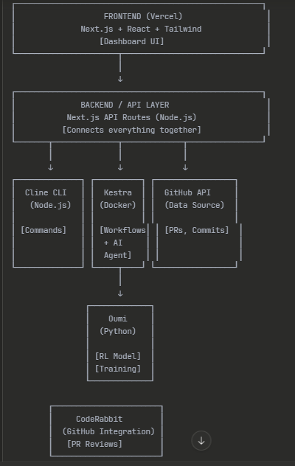
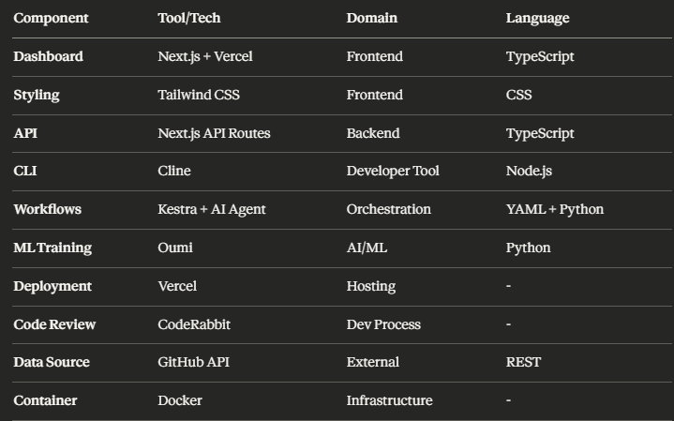

Efficient Task Division - Cortex AI
TEAM STRUCTURE
Person A (You): Full-Stack + Integration Lead
- Strengths: Frontend, Backend, AI
- Role: System architect, integration specialist, dashboard builder
Person B (Aditya): AI/ML Specialist
- Strengths: AI models
- Role: ML training, AI agent logic, intelligent decision-making

PERSON A (YOU) - Responsibilities
Infrastructure & Setup
- GitHub repository setup
- Vercel deployment pipeline
- CodeRabbit integration
- Docker setup for Kestra
- All environment configurations

Frontend Development
- Next.js dashboard (complete UI)
- All dashboard sections:
  - Command Center
  - Intelligence Feed
  - Analytics
  - Interactive Console
- Real-time updates
- Charts and visualizations
Backend/API Development
- Next.js API routes
- GitHub API integration
- Data collection and storage
- API endpoints for dashboard
Cline CLI
- All CLI commands (7 commands)
- CLI → API communication
- Command testing and documentation
Kestra Workflows
- Workflow YAML files
- Data pipeline orchestration
- GitHub data collection workflow
- Deployment workflow
- Integration with AI components
Integration Work
- Connect Oumi model to system
- Connect Kestra AI Agent to workflows
- End-to-end system integration
- Testing all components together
Documentation & Demo
- README file
- Demo video recording
- Architecture diagrams
- Setup instructions
CodeRabbit Management
- Creating all PRs
- Managing reviews
- Ensuring visible activity

PERSON B (TEAMMATE) - Responsibilities
Oumi RL Training (PRIMARY FOCUS)
- Setup Oumi environment
- Prepare training dataset
- Design RL training strategy
- Run RL fine-tuning
- Model evaluation and optimization
- Export trained model
- Create inference code
- Document training process
Kestra AI Agent Logic (SECONDARY FOCUS)
- Design decision-making algorithms
- Create prompts for AI Agent
- Define decision rules and thresholds
- Test AI Agent responses
- Document AI Agent behavior
AI Decision Engine
- PR analysis logic
- Deployment risk assessment
- Prediction algorithms
- Confidence scoring system
Training Data Preparation
- Data cleaning and preprocessing
- Feature engineering
- Dataset formatting

HANDOFF POINTS (Critical Communication)
From Person B → Person A
- Day 2 Evening:
  - Trained model file (.pth or equivalent)
  - Inference code/function
  - Input/output format specification
- Day 3 Morning:
  - Kestra AI Agent prompt templates
  - Decision rules documentation
  - Expected behavior examples
- Day 3 Afternoon:
  - Final model version
  - Performance metrics
  - Edge case handling
From Person A → Person B
- Day 1 Evening:
  - Data format from GitHub API
  - Sample data for training
  - Integration endpoint specs
- Day 2 Evening:
  - Integration API ready
  - Testing environment
  - Kestra workflow structure
- Day 3 Morning:
  - Complete system for AI integration
  - Testing framework
  - Dashboard for visualizing AI decisions

Integration Workflow
- Modular design - Each component has clear inputs/outputs
- API-based communication - Everything talks via REST APIs
- Person A handles ALL integration - You're the integration layer
Progressive Integration:
Day 2 Afternoon:
- You build API endpoints expecting Person B's model (mock it first)
- Test with dummy AI responses
Day 3 Morning (MAIN INTEGRATION):
- Person B gives you: trained model file + inference code
- You integrate model into your API routes (2-3 hours)
Day 3 Afternoon (FINAL INTEGRATION):
- Person B gives you: Kestra AI Agent prompts/logic
- You add to Kestra workflows (1-2 hours)
- Full system testing

Integration Complexity: LOW
- Person B delivers 2 simple things:
  - Python function: predict(data) → decision
  - YAML/prompts: Kestra AI Agent configuration
- You just call them:
  - API route calls Python function
  - Kestra workflow uses AI Agent
- No complex dependencies - Everything is REST/function calls
Quick Answer:
- Where? Your Next.js API routes
- When? Day 3 (morning + afternoon)
- How long? 3-4 hours total
- Easy? YES - just function calls and API endpoints

