Automatic Drawbridge Portfolio
By: Nathan Poling, Sasindra Madireddy, Jingxuan Zhou (Joel), Akash Machai,
Brady Pothier, Yash Gupta, Woo Bin Choi

School Name: Northview High School
Course Name: Engineering Concepts
Instructor Name: Paul Platt
Date: 02/03/2026-

Table of Contents
Technology Sector Research Report |  |  |  |  |  |  |  |  |  |  |  |  |  |  |  |  |  |  |  |  |  |  |  |  |  |  |  |  |  |  | 3
Operation and Application |  |  |  |  |  |  |  |  |  |  |  |  |  |  |  |  |  |  |  |  |  | 3
Main Types of Automatic Drawbridges |  |  |  |  |  |  |  |  |  |  |  |  |  |  |  |  |  |  |  |  |  |  |  |  |  |  |  |  |  |  |  | 5
Bascule (Tilting) Drawbridges |  |  |  |  |  |  |  |  |  |  |  |  |  |  |  |  |  |  |  |  |  |  |  | 8
Vertical Lift (Elevator-Style) Drawbridges |  |  |  |  |  |  |  |  |  |  |  |  |  |  |  |  |  |  |  |  |  |  |  |  |  | 12
Swing (Rotating) Drawbridges |  |  |  |  |  |  |  |  |  |  |  |  |  |  |  |  | 16
Where and Why Drawbridges Are Used |  |  |  |  |  |  |  |  |  |  |  |  |  |  |  |  |  |  |  |  |  |  |  | 20
Basic Mechanical Operation of a Drawbridge |  |  |  |  |  |  |  |  |  |  |  |  |  |  |  |  |  |  |  |  |  |  |  |  |  |  |  | 23
Mechanics of a Bascule Drawbridge System |  |  |  |  |  |  |  |  |  |  |  |  |  |  |  |  |  |  |  |  |  |  |  |  |  |  | 26
References |  |  | 29
History & Current Development |  |  |  |  |  |  |  |  |  |  |  |  |  |  |  |  |  |  |  |  |  | 31
History of Automated Drawbridges |  |  |  |  |  |  |  |  |  |  |  |  |  |  |  |  |  |  |  |  |  |  | 31
Examples of Past and Modern Automated Systems |  |  |  |  |  |  |  |  |  |  |  |  |  |  |  |  |  |  |  |  |  |  |  |  |  |  |  |  |  |  |  | 35
Future Outlook for Automated Drawbridge Technology |  |  |  |  |  |  |  |  |  |  |  |  |  |  |  |  |  |  |  |  |  |  |  |  |  |  |  |  |  |  |  |  | 39
Recent Articles and Publications on Drawbridges |  |  |  |  |  |  |  |  |  |  |  |  |  |  |  |  |  |  |  |  |  |  |  |  |  |  |  |  |  | 43
Drawbridge Impacts |  |  |  |  |  |  |  |  | 46
Environmental Impact |  |  |  |  |  |  |  |  |  | 46
Societal Impact |  |  |  | 49
Economic Impact |  |  |  |  |  | 52
Individual / Organization Contribution |  |  |  |  |  |  |  |  |  |  |  |  |  |  |  |  |  |  |  |  |  |  |  |  | 55
Joseph Baermann Strauss |  |  |  |  |  |  |  |  |  |  |  |  | 55
Important Organizations |  |  |  |  |  |  |  |  |  |  |  | 61
Industry Market Research |  |  |  |  |  |  |  |  |  |  |  |  |  |  | 63
Global Market Analysis |  |  |  |  |  |  |  |  |  |  | 63
Industry Trends and Modernization |  |  |  |  |  |  |  |  |  |  |  |  |  |  |  |  |  |  |  |  |  |  | 69
Industry Case Study |  |  |  |  |  |  |  | 72
American Bridge Company |  |  |  |  |  |  |  |  |  |  |  |  |  | 72
Services and Global Operations |  |  |  |  |  |  |  |  |  |  |  |  |  |  |  |  |  | 75
Challenges and Industry Obstacles |  |  |  |  |  |  |  |  |  |  |  |  |  |  |  |  |  |  |  |  |  | 78
Invention and Design Report |  |  |  |  |  |  |  |  |  |  |  |  |  |  |  |  | 80
Problem Statement |  |  |  |  |  |  | 80
Description of Research Collected |  |  |  |  |  |  |  |  |  |  |  |  |  |  |  |  |  |  |  |  | 81
Sketches and Possible Solutions |  |  |  |  |  |  |  |  |  |  |  |  |  |  |  |  |  |  | 83
Explanation of Process and Reasons for Choosing Final Design | 85
Explanation of How the Chosen Design Works |  |  |  |  |  |  |  |  |  |  |  |  |  |  |  |  |  |  |  |  |  |  |  |  |  |  |  |  | 87
Developmental / Analysis Work |  |  |  |  |  |  |  |  |  |  |  |  |  |  |  |  |  |  |  | 88
Truss Efficiency Calculation |  |  |  |  |  |  |  |  |  |  |  |  |  |  | 88
Schematics with Explanation |  |  |  |  |  |  |  |  |  |  |  |  |  |  |  | 89
Design Drawing |  |  |  |  | 89
System Layout and Testing Setup |  |  |  |  |  |  |  |  |  |  |  |  |  |  |  |  |  |  |  | 90

Technology Sector Research Report

Operation and Application
An automatic drawbridge is a movable bridge that opens and closes electrically or hydraulically without direct manual lifting. A control system, typically a PLC or microcontroller, coordinates the entire sequence. It reads inputs from a range of sensors, including vessel detection, traffic loops, limit switches, and wind sensors. It then lowers the traffic gates and signals, checks that the span and roadway are clear, and commands the actuators (hydraulic cylinders, electric motors with gearboxes, or winch and cable systems) to move the bridge.¹ During motion, interlocks and safety circuits continuously check position, speed, and torque so the bridge cannot operate out of sequence or with an obstacle present. Once fully open, the system maintains a safe state for marine passage; once closed, mechanical seating and locking devices secure the deck for vehicle or railway traffic. Automatic drawbridges are used where roads or rails cross navigable waterways, but a tall, fixed bridge is impractical. Compared to manual systems, automation reduces delays, improves safety, and enables reliable operation in busy ports, canals, and urban corridors, supporting everything from commuter traffic to heavy railway while keeping waterways open to vessels.
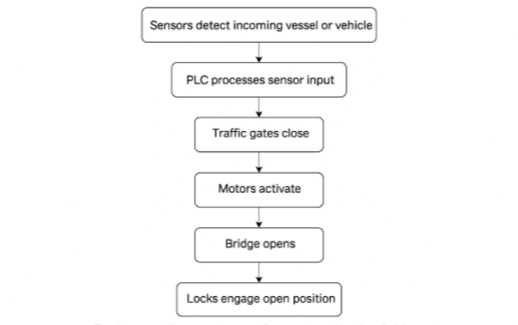
Figure 1: Flowchart showing how sensor signals are processed and converted into automated actuation commands during drawbridge operation.
Main Types of Automatic Drawbridges
Automatic drawbridges are grouped into three main types: Bascule, Vertical Lift, and Swing, each designed to match specific waterway conditions, vessel sizes, and available space. These bridges use automated systems such as PLCs, sensors, traffic gates, and locking devices to control movement safely and in sequence. In addition to the primary types, several specialized subtypes are used where site geometry or mechanical constraints require alternative designs.²³⁴
Bascule (tilting): A lever-type span with either one or two moving deck sections pivots upward around trunnions. A counterweight balances the mass to reduce power demand and allow faster openings.²
Vertical Lift (elevator-style): The whole deck rises vertically between towers using cables, sheaves, and counterweights, ideal where horizontal space is limited and heavy loads must be supported.²
Swing (rotating): The span pivots horizontally around a central pier to create two navigation channels; suited for wide rivers where a center support is practical, but it requires side clearance for rotation.³
Special Variants: Retractable bridges slide back, folding bridges collapse inward, and submersible bridges lower below the water to clear vessels. These are used where space or geometry limits traditional designs.³
Bascule (Tilting)
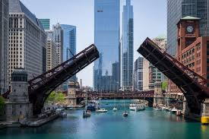
A bascule drawbridge is a movable span that rotates upward around a pivot, similar to a seesaw. Its design uses a large counterweight that balances the leaf as it rises, which reduces power demand and allows for quick, smooth operation. The bridge’s roadway, called the leaf, pivots around a fixed axle known as a trunnion. Because the counterweight offsets most of the leaf’s mass, the motors only need to overcome friction, wind loads, and small imbalances. Bascule bridges typically use hydraulic cylinders or electric motors with gearboxes for lifting, while pneumatic systems are sometimes used in lighter applications. Engineers prefer bascule bridges in areas where fast operation, energy efficiency, and limited machinery space are important. Their compact mechanical layout makes them suitable for tight urban environments, and their quick opening speed makes them ideal for waterways with frequent vessel traffic. As a result, bascule bridges are commonly found in industrial waterfronts, shipyards, urban river and canal crossings, and railway routes over navigable channels. Many older bascule bridges have been upgraded with modern automation, sensors, and control systems, allowing them to continue operating reliably in high-traffic areas.²³⁵
Figure 2: Bascule bridge opening to allow vessel traffic to pass through an urban waterway.
Vertical Lift (Elevator-Style)
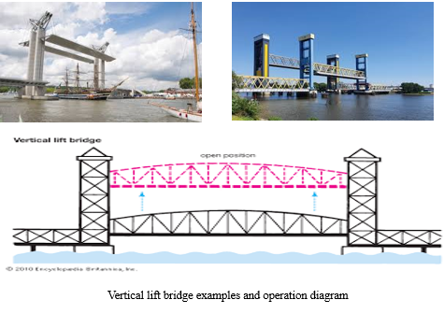
A vertical lift bridge is a movable bridge where the entire deck rises straight upward between two tall towers while staying level, similar to an elevator. This design supports heavy, rigid decking, making it ideal for heavy-traffic corridors, especially rail lines, where perfect alignment must be maintained during operation. A vertical lift bridge works using large counterweights inside the towers that balance the deck’s weight, allowing the lifting machinery to operate with reduced power. Cables, pulleys, and winch systems raise the span vertically along guide rails until it reaches a set clearance height for marine traffic. Engineers choose vertical lift bridges for their durability, strength, and ability to carry heavier loads than bascule or swing bridges. Because the deck remains horizontal, these bridges are especially favored for railroad routes, though they are also used for roads in areas with frequent vessel movement. Vertical lift bridges appear in industrial ports, shipping channels, and busy rail corridors. Notable examples include the Arthur Kill Rail Bridge between New Jersey and New York, the Pont Gustave-Flaubert in Rouen, and Germany’s Kattwyk Bridge. Unlike bascule bridges, which pivot upward, vertical lift bridges raise the entire deck as a single, rigid unit.²³⁵
Figure 3: Examples and diagram of vertical‑lift bridge designs showing the raised span, tower-supported lifting system, and structural motion path.

Swing (Rotating)
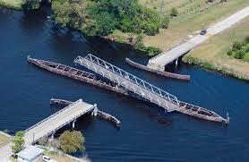
A swing bridge is a type of movable bridge that rotates horizontally around a centered vertical axis, usually a pier, to open a navigational channel for boats and ships. It accomplishes this by turning the span parallel to the waterway. Unlike bascule or vertical-lift bridges, a swing bridge does not lift vertically Instead, the entire deck rotates roughly 90 degrees using gear sets and pinions driven by electric or hydraulic motors, usually controlled from an operator’s house on the rotating span. When closed, the span carries normal vehicle or rail traffic, and when opened, it provides a clear path for marine movement in narrow or busy waterways. Swing bridges use either center-bearing pivots, which rest on a central vertical pin and are easier to maintain, or rim-bearing systems, where a large circular drum rides on rollers to support heavier and wider spans. Most swing bridges use truss or girder construction for strength, and some “bobtailed” designs use a shorter counterweighted arm on one side to keep the bridge balanced during rotation. Although they require regular maintenance to keep their mechanical components in good working condition, these bridges are valued because they do not require tall approach ramps, handle heavy loads well, and are less affected by wind compared to lift-type bridges. They are commonly used over rivers, canals, and industrial corridors for both road and rail, with well-known examples including the Willis Avenue Bridge in New York City and several historic rotating spans throughout Europe.³⁶
Figure 4: A swing bridge rotating about a center pier to open a navigational channel across the waterway.

Where and Why, Drawbridges Are Used
Fixed bridges over waterways often create major limitations because they must be built extremely high to let tall vessels pass underneath. This not only increases construction complexity but also requires longer approach spans, which can interfere with nearby land use and restrict ship movement. Drawbridges were developed as a practical solution, allowing a roadway to lift out of the way whenever maritime traffic needs to pass. Because the movable span provides full vertical clearance without relying on massive support structures in the water, drawbridges remain a cost-effective and widely used option in many coastal and inland regions.³⁴
Advancements in steel manufacturing and mechanical systems have made modern drawbridges more reliable and easier to operate. The introduction of electric motors greatly simplified daily operation, making these bridges faster, safer, and more efficient. As a result, drawbridges became an important part of transportation networks in the United States and internationally. Cities with heavy marine traffic continue to depend on them because they allow ships to move freely without requiring long detours or waiting for tides.³⁴
In places where boats pass more frequently than vehicles, railway drawbridges are especially useful. Since train schedules are predictable and less continuous than car traffic, the bridge can stay open longer for marine traffic without causing major delays. Some cities have become known for how many drawbridges they operate. Chicago, for example, has the largest number of drawbridges in North America, with dozens still active. Florida also maintains a high concentration of drawbridges because of its extensive network of intracoastal waterways and boating routes.⁴

Basic Mechanical Operation of a Drawbridge

The fundamental mechanical operation of a bascule drawbridge is based on the relationship between the bridge leaf, the pivot system, and a precisely balanced counterweight. In its simplest form, the bascule behaves like a large rotating lever. The movable roadway, or leaf, forms one arm of the lever, while a massive counterweight forms the other. Both components rotate around a fixed trunnion, which serves as the fulcrum. When the counterweight is carefully sized to match the mass of the leaf, the bridge achieves mechanical balance and requires only a small amount of torque to begin rotating upward. This balance is what allows bascule bridges to open smoothly even when supporting heavy decking and substantial traffic loads.²³⁵
As the bridge opens, the counterweight swings downward while the leaf rises upward, following a controlled rotational arc around the trunnion. The bearings at the pivot point carry the combined weight of the structure and ensure that the leaf maintains proper alignment throughout its movement. Guides and support frames help keep the leaf on its intended path, preventing twisting or misalignment as it transitions between open and closed positions. Because the counterweight provides most of the lifting force, the mechanical stresses on the structure remain relatively low, which contributes to the longevity and durability of bascule bridges in environments where frequent openings are required.²³⁵
As modern bridges incorporate advanced electrical and hydraulic systems, the mechanical foundation remains unchanged. The trunnion, counterweight, and leaf form a self-balancing system that minimizes energy use and reduces wear on the drive machinery. This efficient mechanical layout is one of the main reasons the bascule design remains a popular choice in ports and coastal cities where reliable operation and rapid movement are essential.²³⁵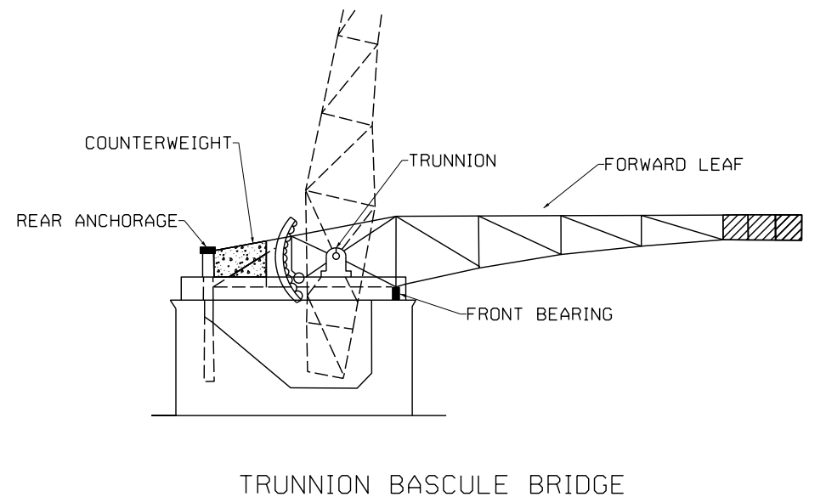Figure 5: Diagram of a trunnion bascule bridge illustrating the pivot system, counterweight, and mechanical balance during rotation.
Overall, Mechanics of a Bascule Drawbridge System
The mechanical system of a bascule drawbridge consists of several coordinated components that balance the structure and guide the motion of the leaf during each opening cycle. At the center of this system is the counterweight chamber, where heavy concrete or steel masses offset the weight of the roadway. This balanced configuration allows the span to move with relatively low drive forces and provides smooth rotation around the pivot.²³⁵
Supporting the rotating leaf is the trunnion assembly, a large bearing system that carries the structural load and keeps the leaf aligned as it travels. The bearings resist radial forces from the roadway and dynamic forces such as wind and vibration, while structural supports transfer these loads into the piers. When the bridge returns to the closed position, alignment guides and nose locks ensure the roadway connects securely and maintains a stable driving surface.²³⁵
Additional components, such as braking devices and locking systems, help regulate the movement and secure the span when it is open or closed. Although modern bridges use sensors and automated controls to manage these functions, the underlying mechanical arrangement remains essential. Together, these components form a reliable system that enables bascule bridges to operate efficiently in areas with frequent maritime traffic.²³⁵
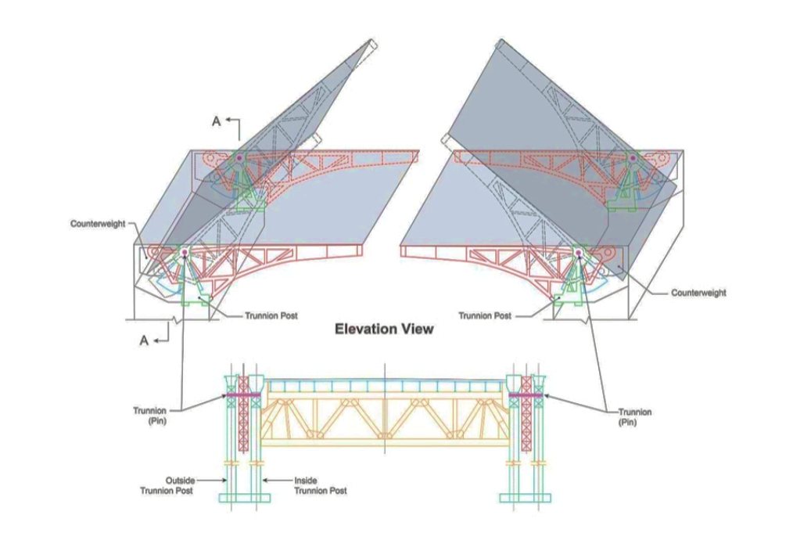
Figure 6: Elevation‑view diagram of a bascule bridge showing the raised leaves and the structural alignment during operation.

Reference:
- “Draw Bridge.” How Products Are Made, www.madetow.com/Volume-6/Draw-Bridge.html. Accessed 9 Apr. 2022.
- “How Movable Bridges Work.” Engineering Specialists, Inc., 14 May 2020, www.esnationwide.com/how-movable-bridges-work.php.
- “Principles of a Drawbridge.” Drawbridge Specific, 3 Nov. 2019, www.drawbridgespecific.com/2019/03/30/drawbridge-principles.
- McBriarty, Patrick. “Is Chicago About To Lose Its Title of the Drawbridge Capital of the World?” Chicago Architecture, 8 July 2020, www.chicagoarchitecture.org/2014/05/19/is-chicago-about-to-lose-its-title-of-the-drawbridge-capital-of-the-world/.

History & Current Development
History of Automated Drawbridges
Automated drawbridges trace their origins to early movable bridges that were raised using ropes, wooden beams, and human power.¹ These simple bridges served defensive purposes and allowed people to control access into fortified areas. As towns developed along rivers and canals, the drawbridge became a practical tool for letting boats pass beneath fixed crossings while still supporting everyday foot and wagon traffic.² Although these early structures were useful, they were slow, heavy, and depended entirely on manual labor to operate.
By the 19th century, rapid industrial growth encouraged engineers to experiment with stronger materials and mechanical lifting systems.³ Steam engines were introduced to replace hand-cranked winches, and metal gears provided smoother, more controlled movements. Later, electric motors began to replace steam power, allowing engineers to design bridges that lift faster and require less maintenance. These early electrically powered systems represented the first major shift toward true automation.
The next significant improvement came with the use of electrical relays and limit switches, which made lifting cycles more predictable and safer.⁴ These systems allowed the bridge to stop automatically at the correct height and prevented mechanisms from moving until locks were released and roadway gates were lowered. Engineers continued refining these technologies throughout the 20th century, eventually introducing sensors, cameras, and control panels that allowed operators to monitor the bridge’s movement without directly controlling every step.⁵
Today, automated drawbridges rely on digital controllers, hydraulic actuators, and advanced sensors to manage each step of the operation with precision. Programmable logic controllers coordinate motors, sensors, and mechanical components, allowing the entire lift cycle to run automatically once the operator begins the sequence.⁶ Modern drawbridges are safer and more reliable than earlier models because their automated systems constantly check for faults, obstruction, or improper alignment before allowing the bridge to move.
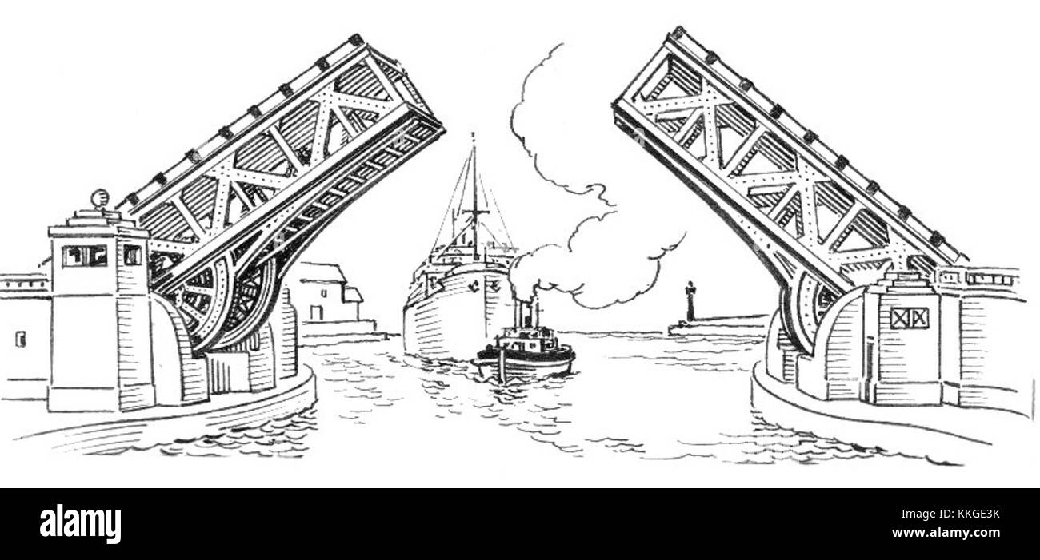Figure 7: Modern automated bascule bridge using hydraulic lifting systems.
Examples of Past and Modern Automated Systems
Early automated drawbridge systems depended heavily on electric motors and mechanical gears to raise and lower the span.¹ These bridges used large counterweights to balance the deck, so the motors needed less force, allowing for efficient lifting even with limited early-20th-century technology. While these systems still required an operator to supervise every lift, the machinery performed most of the physical work, significantly reducing the number of workers needed.
Modern automated drawbridges use hydraulic power, programmable logic controllers, and real-time monitoring systems to operate safely under heavy traffic conditions.² Hydraulic cylinders provide smooth and powerful lifting motion, while digital sensors ensure both sides of the span remain perfectly aligned. Traffic lights, gates, cameras, and vehicle sensors are synchronized by the control system, ensuring that the bridge only moves when the roadway is clear.³ These innovations have made automated drawbridges faster, safer, and more dependable in busy urban environments.
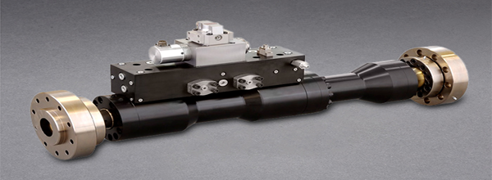
Figure 8: Hydraulic lifting cylinder used in automated drawbridges

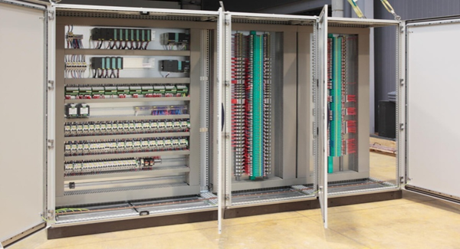
Figure 9: PLC-based control interface for bridge automation ```````

Future Outlook for Automated Drawbridge Technology

Automated drawbridge systems are expected to become more intelligent, efficient, and reliable as engineering technology continues to evolve. Engineers are developing advanced sensing networks capable of monitoring structural stress, temperature changes, vibration levels, and mechanical wear in real time.¹ These systems will allow maintenance teams to detect problems before they cause operational delays, helping bridge authorities reduce costly shutdowns and prevent unexpected mechanical failures. Predictive maintenance, supported by data-driven analysis, will likely become a central component of automated drawbridge operations in the future.
Another major area of development involves energy efficiency. Traditional drawbridges rely heavily on hydraulic pumps and electric motors that consume significant power during each lift cycle.² Future designs are expected to use variable-speed pump systems, optimized counterweight configurations, and regenerative electric drives that capture energy as the bridge lowers. These innovations could reduce energy usage dramatically, especially in bridges that operate dozens of times per day. Engineers are also researching environmentally friendly hydraulic fluids that reduce ecological impact near waterways.
Advanced software may allow bridges to communicate directly with maritime navigation systems, scheduling openings automatically based on vessel approach speed, tide cycles, and weather conditions. Remote-operation centers, which are already in use in some regions, will likely become more common allowing a small team of operators to manage multiple bridges simultaneously through encrypted communication systems.⁴ These improvements will increase safety and efficiency while reducing operational costs for municipalities.
Several modern movable bridges demonstrate the direction in which automated drawbridge technology is heading. One notable example is the Jacques Chaban-Delmas Vertical-Lift Bridge in Bordeaux, France, which uses four massive lift towers and advanced control systems to raise its roadway as a single rigid span. Its smooth, efficient motion and high clearance capabilities reflect the sophistication of next-generation lifting mechanisms. Other innovative structures include the Kieler Hörn Folding Bridge in Germany, which opens using a unique three-segment folding action, and the London Rolling Bridge, which curls itself into an octagonal shape using a fully automated hydraulic system. Together, these modern bridges highlight the expanding range of motion concepts, materials, and control strategies shaping the future of automated drawbridge engineering.

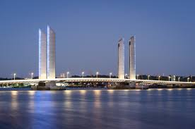
Figure 10: The Jacques Chaban‑Delmas vertical‑lift bridge, a modern example of advanced lifting technology and automated structural control.

Recent Articles and Publications on Drawbridges
Recent infrastructure reports highlight how aging drawbridges across the United States are entering major rehabilitation cycles to maintain safe operation. In February 2026, officials confirmed a large-scale rehabilitation of the 118-year-old Saugatuck River Bascule Bridge in Connecticut, with work scheduled to begin in fall 2025 and continue into 2026. Mechanical and electrical reliability issues have pushed this structure into accelerated maintenance planning, with state agencies investing over $4 million to ensure dependable openings for both rail and maritime traffic. These upgrades emphasize how many century-old movable bridges require continual modernization to meet current transportation demands. [railroad.net]
Bridge engineering publications have also noted growing interest in climate resilience and structural innovation. A 2025 article in the Dorchester Reporter described two replacement options under review for Boston’s Beades Bridge, a moveable drawbridge or a fixed, higher-clearance span. The project team highlighted ongoing concerns with repeated mechanical failures in recent years and noted that modern movable designs can significantly improve reliability while maintaining marine access. The review process illustrates how communities and engineers weigh the costs, traffic impacts, and environmental objectives associated with replacing aging drawbridge infrastructure. [dotnews.com]
Together, these recent publications show that while drawbridges remain essential infrastructure in many water-dependent communities, much of the national inventory now requires modernization. Mechanical upgrades, structural rehabilitation, and improved regulatory frameworks continue to guide the future of movable bridge design and operation

Reference:
Drawbridge Impacts
Environmental Impact
Drawbridges can reduce environmental impacts by shortening travel distances for vehicles and vessels. When a movable span provides a direct crossing instead of a long detour to the nearest high fixed bridge, total vehicle-miles traveled and idle time drop, which lowers fuel consumption and tailpipe emissions.¹ For waterways with frequent marine traffic, a well-timed opening schedule can also decrease unnecessary idling for boats, reducing localized air and noise pollution near marinas and urban riverfronts.² In addition, movable spans generally require fewer very tall approach structures than high fixed bridges, which can lessen shading on sensitive shorelines and limit the footprint of embankments in wetlands.³
At the same time, construction and maintenance activities introduce environmental costs. Fabrication, pile driving, and mechanical installations generate noise and temporary increases in suspended sediments; heavy equipment and material transport add emissions to nearby neighborhoods.⁴ Routine operation concentrates traffic near the crossing, and opening cycles can increase short episodes of vehicle idling on approaches.⁵ Lighting, glare, and the presence of machinery houses may affect riparian habitats and migratory species, while paints, lubricants, and hydraulic fluids must be carefully contained to prevent spills.⁶ If the bridge alignment alters currents or concentrates litter around piers, debris management plans and stormwater controls become essential to protect water quality.⁷ Overall, the environmental balance depends on site-specific design choices—containing construction impacts, specifying low-toxicity materials, and coordinating openings to minimize idling can meaningfully improve outcomes.⁸

Societal Impact
Movable bridges provide critical social connectivity by linking communities separated by navigable waterways. Shorter, more direct trips improve access to jobs, schools, healthcare, and emergency services, while reliable openings maintain commerce and cultural activity that depend on waterborne travel.¹ When opening schedules are communicated clearly, through signage, web feeds, or mobile alerts, drivers and pedestrians can plan around lifts, reducing frustration and improving perceived reliability of the corridor.² In many cities, historic drawbridges contribute to a distinctive sense of place and tourism, supporting waterfront revitalization and public spaces that encourage walking and cycling.³
However, openings do introduce periodic delay. Extended lift windows for vessel queues or weather-related slowdowns can raise travel time variability for buses, freight, and commuters, with outsized effects during peak hours.⁴ Safety risks must also be managed at the interface of users and machinery: pedestrians and cyclists require clear gate control, audible and visual warnings, and barrier designs that prevent encroachment during a lift.⁵ Accessibility features, tactile warnings, signal timing for crossings when the bridge is closed, and protected queuing areas, help ensure equitable use.⁶ Community engagement around scheduling, noise, and lighting can mitigate quality-of-life concerns, especially in dense waterfront neighborhoods.⁷ When supported by transparent operations and complete-streets approaches on the approaches, drawbridges can strengthen social cohesion rather than disrupt it.

Economic Impact
Economically, drawbridges can be highly efficient investments where both marine and land transportation are vital. By maintaining navigational clearance on demand, movable spans preserve working waterfronts, shipyards, and tourism while sustaining dependable road or rail connections across the channel.¹ Reduced detour distances lower logistics costs for deliveries and transit operations; in corridors with constrained right-of-way, a movable span can avoid the high capital cost of long elevated approaches required for a fixed high bridge.² For legacy crossings, targeted rehabilitation of mechanical and electrical systems can extend service life and defer full replacement, yielding favorable life-cycle costs when paired with predictive maintenance.³
Costs are real and recurring: drawbridges require specialized maintenance of gears, bearings, hydraulics, and control systems; trained operators or remote-operation centers; and periodic major overhauls.⁴ Unplanned closures, whether due to equipment faults or vessel strikes, can impose measurable delay costs on road users and supply chains.⁵ Funding plans must account for resiliency upgrades against corrosion, sea-level rise, and extreme weather, which can add to near-term capital needs while reducing long-term risk.⁶ When project sponsors evaluate alternatives, economic analysis typically compares construction and right-of-way costs, navigation requirements, operations and maintenance budgets, and user costs associated with delay.⁷ In corridors where maritime access is essential or approaches would be prohibitively long, a modern automated drawbridge can remain the cost-effective option over the asset’s life.⁸
Reference:

Individual/Organization Contribution

Joseph B. Strauss

Joseph Baermann Strauss is recognized as one of the major contributors to the development of modern drawbridges, especially the bascule type that relies on counterweights to rotate the roadway leaf upward. He was born in Cincinnati, Ohio, in 1870 and grew up in a family that valued education, craftsmanship, and practical engineering.¹ Strauss studied civil engineering at the University of Cincinnati, where he developed a strong interest in movable structures. His early life exposed him to both structural and mechanical ideas, which later helped shape his approach to designing bridges that needed to move reliably and safely.
Strauss introduced his major drawbridge ideas during the early twentieth century, a time when many American cities were expanding and required efficient river crossings. His first bascule concepts appeared in the 1910s, mainly in Chicago, Illinois, a city filled with busy waterways and industrial corridors.² Chicago became the center of his early work because its river system created a demand for bridges that could open quickly for vessel traffic while still supporting growing road and rail use. Strauss spent considerable time in these environments, observing how existing designs struggled with balance, torque, and mechanical wear.
Strauss pursued this work because he believed that a drawbridge should open with minimal energy and move smoothly from beginning to end.³ He realized that improper balance caused machinery to strain and components to fail early. For this reason, he shaped counterweights to align with the true center of mass of the leaf and placed the trunnion so loads would follow a clean path into the piers. These decisions reduced the starting force needed for lifting and made the motion gentler on both the machine and the structure. His approach also made the bridges quieter and safer for operators.
Working conditions were demanding. Engineers relied on slide rules, hand-drawn diagrams, and direct site observation rather than computer simulations. Strauss and his teams inspected gears, bearings, and lock mechanisms by hand and adjusted based on sound, temperature, and feel.⁴ They often worked in harsh Chicago weather, where heat, cold, and river moisture affected machinery. These challenges shaped Strauss’s understanding of how movable bridges behaved in real life and why they needed reliable sequencing and easy maintenance access.
Strauss profited from many of his drawbridge patents and design contracts, but the financial gain was only part of his success. His work earned him a strong reputation as an engineer whose bridges lifted smoothly and required less operator intervention. He became a sought-after designer because cities wanted bridges that would last, operate efficiently, and not cause unnecessary delays to marine or roadway traffic.⁵ His commitment to practical engineering made him one of the most respected figures in movable bridge design.
The impact of Strauss’s contributions is still visible today. Automated bascule bridges operate with digital sensors, programmable logic controllers, and motorized lifting systems, yet they continue to rely on the balance and sequencing principles Strauss emphasized.⁶ Modern maintenance procedures also follow his ideas. Technicians compare motor current during the first moments of lifting to detect rising friction, inspect trunnion alignment, and evaluate seat engagement at the nose. These are the same concepts Strauss promoted, simply updated with modern technology.
An interesting anecdote describes how Strauss, despite later becoming famous for much larger projects, frequently claimed that designing a movable bascule bridge required more mechanical understanding than designing a fixed structure. He believed a drawbridge behaved like a living machine and that its success depended on understanding its motion rather than its size.⁷ This viewpoint shows how deeply he valued the mechanical side of engineering and why his ideas continue to influence modern automated drawbridges.
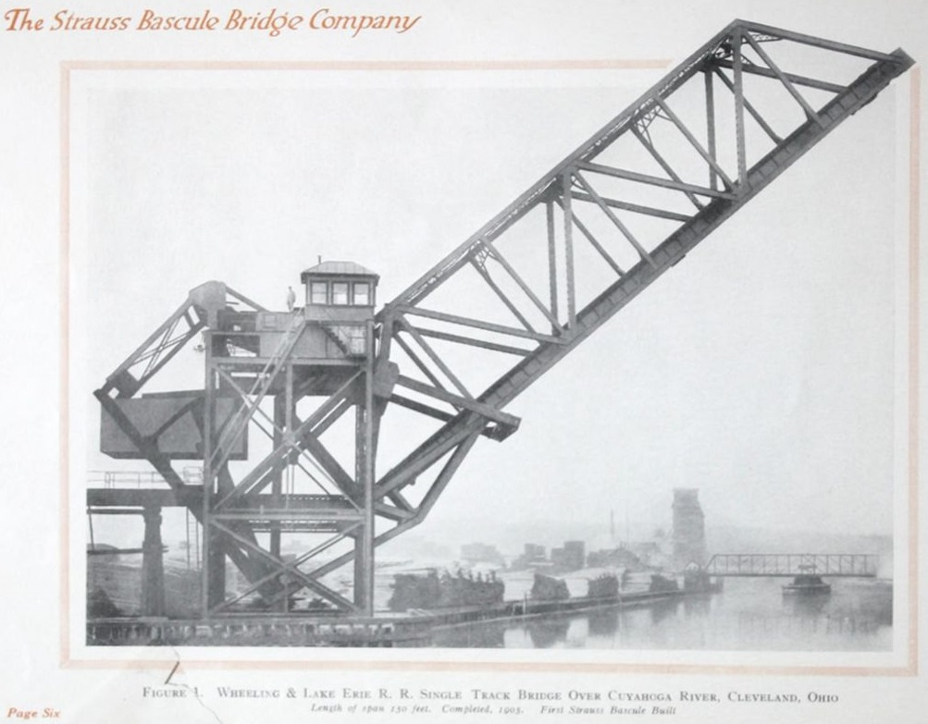
Figure 11: Early bascule bridge prototype associated with Joseph B. Strauss, showing counterweight layout and pivot geometry used in later movable bridge designs.

Important Organizations
Several organizations have played essential roles in shaping the modern automatic drawbridge. The United States Coast Guard Bridge Program has been responsible for setting operating regulations, reviewing bridge projects, and ensuring that openings occur safely for marine traffic.¹ State Departments of Transportation have overseen the construction, rehabilitation, and modernization of hundreds of movable bridges, often selecting the control systems, hydraulic equipment, and safety devices that support automated operation.² Engineering firms that specialize in movable structures have contributed by designing machinery, integrating programmable controllers, and developing diagnostic tools that help operators understand how well the bridge is functioning. University research groups have added to this progress by modeling structural behavior, testing prototype components, and publishing design recommendations that owners use when upgrading older spans.³ Each of these organizations has helped turn automated drawbridges from mechanical ideas into reliable infrastructure that can operate safely and consistently in busy waterways

Reference

Industry Market Research
Global Market Analysis
The most common types of drawbridges used in the world today are bascule bridges, vertical-lift bridges, and swing bridges. Bascule bridges remain the most widely used because they operate quickly and require relatively low power due to their balanced counterweight design. This type first appeared in medieval Europe but continues to dominate modern developments, from historic installations in London to the numerous bascule upgrades happening in major U.S. cities. Vertical-lift bridges are also common in regions with heavier rail loads because the deck can rise straight upward while staying level. Swing bridges, though less common today, remain useful in wide channels where a rotating span provides large openings with simple machinery.
Regions most likely to rely on drawbridges are those with dense networks of rivers, shipping channels, and inland waterways. In the United States, Chicago still has the most operational drawbridges of any city, due to the Chicago River system running through its urban core. Other drawbridge-dense areas include South Florida and the Atlantic coast, where intracoastal waterways intersect with major highways, as well as parts of the Pacific Northwest. Internationally, the Netherlands remains one of the highest-use regions for movable bridges because its cities are built around canals, rivers, and tidal waterways. Amsterdam alone has more than twelve hundred bridges, with many functioning as traditional or modernized movable spans, which is significantly higher than any single U.S. city.
The overall market for drawbridge technology is quite small compared to the total number of fixed bridges worldwide, but it is an important niche industry. Out of more than six hundred thousand bridges in the United States, only a small fraction are movable, and an even smaller portion require modern automation systems. As a result, only a limited number of companies specialize in movable bridge construction or modernization. The leading global firms in bridge engineering include Jacobs Engineering, HDR, T.Y. Lin International, ARUP, and AECOM. These companies support complex infrastructure projects and often serve as design or program-management firms on large movable bridge upgrades. The market is driven by rehabilitation projects more than new construction, since many existing drawbridges built in the early twentieth century now require mechanical and electrical modernization to remain reliable.
In the U.S., one company that has built a strong reputation in movable bridge construction is American Bridge, headquartered in Pittsburgh, Pennsylvania. The company has been active since the 1800s and has completed major movable span projects, including bascule, vertical-lift, and swing bridges. One of their most notable modern projects was the Woodrow Wilson Bridge Replacement in Washington, D.C., a multi-billion-dollar effort that included twin bascule spans capable of lifting for marine traffic on the Potomac River. Their involvement in long-term installation, calibration, and commissioning has influenced how mechanical and electrical systems are installed on many of today’s automated drawbridges.
Recent developments in the global market reflect growing investment in replacement and rehabilitation projects. For example, Connecticut received more than twenty-three million dollars in federal funding to replace the 118-year-old Saugatuck River Bascule Bridge due to mechanical and electrical reliability concerns. In Boston, the state has begun evaluating options for replacing the near century-old Beades Bridge, including both fixed and movable alternatives, following repeated mechanical failures. Many of these projects focus on improving resilience, updating aging machinery, and transitioning older bridges to systems that can eventually support partial or full automation.
Another important trend is the modernization of existing vertical-lift and bascule bridges in major coastal cities. Chicago began a multi-year rehabilitation of the Lake Street Bascule Bridge, a double-deck trunnion bascule built in 1916, in order to update its mechanical and electrical systems for long-term service. Several international projects, such as those in the Netherlands and France, continue to emphasize drawbridge upgrades as part of larger transportation resilience programs that address climate impacts, increased water traffic, and corrosion concerns.
Although the total number of new drawbridges being built each year is relatively small, the global market shows steady activity in replacement components, modernization contracts, and specialized engineering services. Movable bridges continue to be essential in cities with active marine transportation, and many regions are now adopting energy-efficient hydraulic systems, structural-health monitoring sensors, and programmable automation to extend their service life. As older structures approach the end of their operational lifespan, demand for specialized firms and experienced engineers in this niche sector is expected to remain strong.
Reference:
Industry Case Study

American Bridge Company
One major company involved in the construction and modernization of drawbridges is American Bridge Company, a heavy civil engineering and construction firm headquartered in Coraopolis, Pennsylvania. The company was founded in 1900 when J.P. Morgan consolidated several large steel fabricators into one organization. Today, American Bridge is known for building many of the world’s most complex bridges and marine structures, including several movable spans. The company has operated continuously for more than a century and now works in all 50 U.S. states and more than 60 foreign countries.
American Bridge develops large civil structures, including steel bridges, vertical-lift spans, bascule bridges, and major bridge rehabilitations. Their product range and service includes steel fabrication, mechanical installation, structural erection, marine construction, and full construction management. The company also performs rehabilitation work on aging drawbridges, which often includes replacing machinery, upgrading electrical systems, and performing structural strengthening. Their diversified capabilities allow them to take on projects that require both fabrication expertise and complex construction staging.
The markets served by American Bridge are global in scale. They deliver projects across the United States, Canada, Europe, the Bahamas, and parts of Asia. Their work includes moveable bridges, long-span steel bridges, cable-supported bridges, and structural components for major transportation networks. According to recent business data, American Bridge employs between 500 and 1,000 people and maintains active projects around the world, making it one of the most experienced bridges-focused contractors in the industry. Their largest clients include state transportation agencies, port authorities, marine terminal operators, and federal infrastructure programs.
The company was founded by a group of steel and construction leaders who wanted to create a single organization capable of supplying and building large steel structures. Over time, American Bridge became known not only for its fabrication abilities but also for complex field construction on iconic projects. Its long history of project delivery has given it a deep library of technology, equipment, and engineering knowledge that few competitors can reach. The company became part of Southland Holdings in recent years but continues to operate under its historic name.
Several factors contribute to American Bridge’s success. The company is known for the in-house engineering teams that support its construction crews with structural analysis, erection planning, and geometry control. They also maintain a large fleet of specialized cranes, barges, and lifting equipment that allows them to build drawbridges over navigable waterways. Their reputation for safety performance and quality control is also a major advantage when competing for federally funded and state-funded infrastructure contracts. American Bridge has a long record of working on difficult or technically demanding bridge projects, which makes transportation agencies confident in awarding them large movable-bridge assignments.
One unique feature of American Bridge’s services is its ability to fabricate, assemble, and erect extremely large steel components with precision. This capability is essential for movable spans, where machinery alignment and structural tolerances are critical. The company specializes in full-scale bridge rehabilitation, including machinery replacement on older drawbridges, dehumidification systems for steel components, and installation of new electrical and navigation systems. They also perform marine construction that supports drawbridge foundations, fender systems, and approach structures.
Although successful, the company faces obstacles similar to those affecting the rest of the infrastructure sector. Many of the movable bridges that American Bridge works on are more than 60 to 100 years old, which creates challenges related to material deterioration, obsolete parts, and unexpected structural conditions discovered during rehabilitation. The company must also compete for skilled labor in specialized fields such as structural ironwork, welding, and heavy marine construction. Supply-chain delays, rising steel prices, and increasingly complex environmental regulations can also slow construction schedules or reduce project margins. Despite these obstacles, American Bridge remains one of the most experienced and reliable contractors working on drawbridges, and its long history and engineering capabilities continue to support its position as a global industry leader.
Reference

Invention and Design Report

Problem Statement
You work as a project engineer for CNC Constructors, a highway and bridge construction company. Your company is preparing to begin two major bridge construction projects that will connect Louisville and Kentucky to Southern Indiana. The construction timeline for these new bridges is expected to take close to ten years to complete. During this period, increasing automobile traffic throughout Louisville and Southern Indiana has created an urgent need for a temporary solution to help reduce congestion near the riverfront. The bridge that the city is requesting must be capable of accommodating all types of vehicle traffic while still allowing boats to pass safely beneath the structure.
At the same time, the City of Louisville is continuing its efforts to improve the riverfront through beautification projects and by developing new public access points along the waterfront. As part of this plan, the city has requested the addition of a marina near the proposed bridge location.
To support both the traffic needs and the marina development, CNC Constructors has been asked to design a drawbridge that can open and close to allow river traffic to move through the span. This drawbridge must operate quickly, reliably, and safely for frequent daily use. CNC Constructors’ engineering team will therefore design a miniature model of the drawbridge along with a functioning boat-storage and retrieval system that can be used in coordination with the marina. The project team will use this working model to demonstrate how the automated drawbridge would function and how boats would travel through the system.

Description of Research Collected

Drawbridge Research
Research for this project began with a web search focused on miniature and small-scale drawbridge mechanisms. Many online videos demonstrate simple drawbridge models created from cardboard, wood, or basic digital designs. Even though these examples used different materials than those in this project, they provided helpful explanations of how a movable span pivots, how lifting forces act on the deck, and how motion is transferred through linkages or pull systems. One frequently referenced tutorial showed a small drawbridge lifted by water-filled syringes acting as a hydraulic mechanism. Although syringes were not supplied for this project, the video helped the team visualize how linear extension could raise a hinged platform.
Because the project required a working model with consistent performance, the team then explored alternative lifting concepts such as pistons, tensioned string systems, and counterweights. Some of these ideas were tested mentally and compared for advantages and weaknesses. While pistons offered strong lifting force, they risked damaging the balsa wood used in the model. Counterweight-based ideas appeared simpler and safer but required more workspace. Hydraulics using water bottles and fishing line were also reviewed, where the bottle would act as a counterbalance as it filled and emptied. Although creative, these systems were eventually set aside for more controlled lifting designs.
The next area of research involved understanding truss structures. Because the drawbridge leaf must remain rigid while lifting, trusses are an effective way to distribute loads across lightweight materials. A structural engineering video explained the behavior of several common trusses, including Howe, Pratt, and Warren configurations, and discussed how tension and compression are carried out through the members. These explanations helped the team understand how to choose a truss type that would keep the bridge deck from bending during operation.
Additional insight came from a publicly shared design folder containing an example Parker truss model bridge. The folder included orthographic sketches, isometric diagrams, and a breakdown of internal forces within the truss. Studying these materials gave the engineering team a clearer understanding of how the truss and the drawbridge leaf could be integrated as a single structural unit, providing rigidity while still allowing the leaf to pivot freely.
This research phase was essential to the success of the project. Understanding different lifting mechanisms, studying truss behavior, and observing how other small-scale drawbridges were built allowed the team to approach the design process with confidence. With this background knowledge, the team was prepared to brainstorm solutions and move into early sketching and concept development.

Sketches and Possible Solutions
To begin developing the final drawbridge model, my group created a series of rough sketches to visualize possible designs and understand how the structure would operate. The first group of sketches focused on the overall bridge shape. One sketch illustrated a long single-leaf bascule layout supported by a repeating triangular truss pattern. A second sketch showed an alternative truss with fewer members and wider spacing between supports. These drawings helped the team compare how different truss arrangements would influence stiffness, weight, and the appearance of the bridge during lifting.
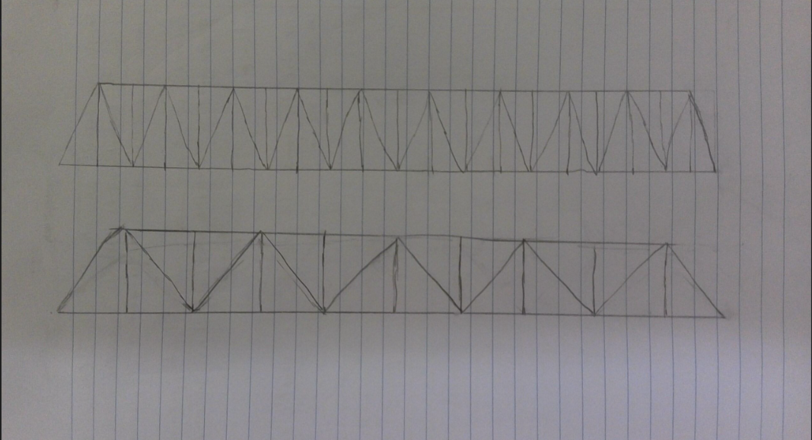
Figure 12: Early truss sketches comparing two possible structural layouts for the drawbridge leaf.
The next step was deciding how the bridge leaf would lift. Several sketches were made showing different mechanical approaches. One idea involved a lever-based lifting arm connected to a pivot point beneath the bridge. This sketch included small rollers and linkages and helped demonstrate how rotational motion could support the bridge as it opened. These drawings were useful in identifying potential stress points and in determining how much room would be needed below the table surface for the lifting mechanism to operate.
Another design explored the possibility of using a simple hydraulic-style system. In these sketches, a bottle of water acted as a counterweight. As the water shifted from one container to another along a tube, the weight change caused the bridge to rise or fall. Although this concept showed how a bridge could be lifted with minimal force, the team realized that this design required too much workspace and would be difficult to control precisely. These drawings remained helpful, however, because they illustrated the relationship between counterweight motion and the movement of the bridge leaf.
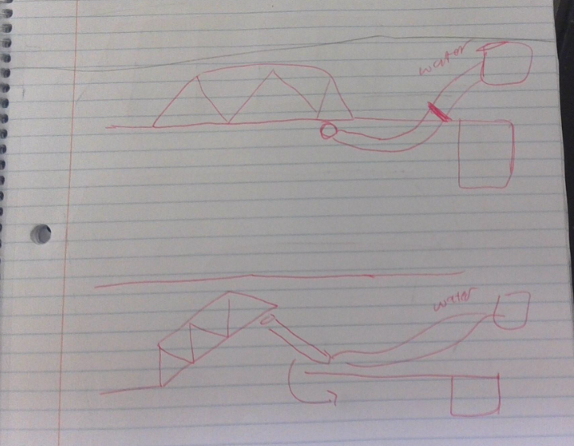
Figure 13: This sketch shows the idea of using water as a counterweight to lift the bridge leaf.
The final set of sketches focused on alternative pivot layouts and rotating components. These drawings showed how circular pivot plates, counterweight disks, or gear-like elements could interact with the bridge leaf. Although these ideas were creative, they were later set aside after the team decided on a simpler and more reliable lifting mechanism. Still, the sketches were important because they allowed the group to evaluate what concepts were realistic for the materials available.
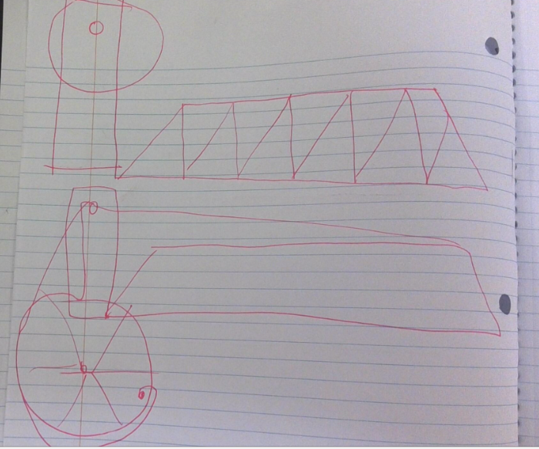
Figure 14: They drew this circular pivot concept while testing another way the bridge could rotate upward.
By comparing these sketches, the engineering team gained a clearer understanding of the advantages and limitations of each idea. The truss sketches helped determine which structure would provide enough strength while keeping the model lightweight. The lifting mechanism drawings allowed the team to evaluate motion paths and mechanical simplicity. The hydraulic and circular-pivot concepts, although not chosen, sparked useful discussion about how different mechanisms could change the way the drawbridge moves.
These early sketches formed the foundation for the design phase. They allowed the team to visualize the bridge in multiple configurations, consider all reasonable lifting methods, and identify which concepts would be carried forward into prototype construction and testing.
Explanation of Process and Reasons for Choosing Final Design
The final drawbridge design for our project was chosen after we compared several lifting methods, truss configurations, and boat-storage ideas during the prototype phase. Our group tested different bridge types and looked at how they would perform using the materials we had available. In the end, we decided on a vertical-lift design, where a single roadway deck moves straight upward and downward between two supports. We chose this design because it was the most reliable, required fewer moving parts, and provided plenty of clearance for the boats we planned to send underneath.
The first decision we made involved selecting the truss style for the bridge deck. We tested a few truss sketches and eventually chose the triangular pattern we used because it offered a good balance between strength and weight. Since our bridge had to lift vertically, the deck needed to stay rigid and not bend while rising. The truss layout we chose held its shape well during early testing, so we carried it into the final build.
We also compared different lifting systems. A bascule-style hinge was considered at first, but it required a more complicated rotation point and forced the deck to swing outward instead of staying level. Because we were building a vertical design, we wanted the road to stay flat as it moved, which made the bascule option less practical. We looked at two-leaf and single-leaf systems, but both required extra alignment steps we did not want to deal with during testing. A straight vertical lift solved these problems because the deck rises evenly and returns to the same spot every time.
For the lifting motion, we tested a few ideas before deciding what to use. One option was a counterweight system, where added weight on one side would pull the bridge deck upward. Another idea involved using a piston-like system, but we eventually chose the vertical-lift method where the deck is guided up and down by a controlled motion path. This was the most accurate and consistent during testing. It also matched the behavior of real vertical-lift bridges, which are commonly used when a level roadway surface needs to stay flat for vehicles.
Once we decided on the lifting method, we moved on to designing how the boats would be stored and retrieved. Space on our table was limited, and we had to share the area with the Pegasus robotic arm. Because of this, we selected a stacked boat-storage layout instead of spreading the boats out side by side. The stacked layout used the least amount of space and made it easier for the robot arm to grab one boat at a time. The look of the stacked system also fit well with our vertical-lift concept, almost like the boats were being taken from a vending-machine-style dispenser.
After final testing, the vertical-lift bridge proved to be the most reliable and the easiest to operate. The roadway lifted smoothly, stayed level, and returned to the correct height every time. The truss structure supported the deck without bending, and the stacked boat-storage system worked efficiently with the sensor and robotic arm. All of these factors helped us finalize our design choice. The vertical-lift bridge met the project requirements, worked consistently during testing, and was the design our team felt the most confident building.
Explanation of How the Chosen Design Works
The process begins with the bridge in the lowered position, allowing cars to travel across the roadway as normal. When a boat approaches the bridge, the sensor placed near the waterway detects the boat entering the channel. After the boat is detected, the traffic lights leading to the bridge turn red, signaling that all cars need to stop before the lift cycle begins. Once the roadway is clear, the protective barriers drop into place so no vehicles can enter the bridge span while it is moving. With traffic halted and the gates down, the bridge is ready to lift.
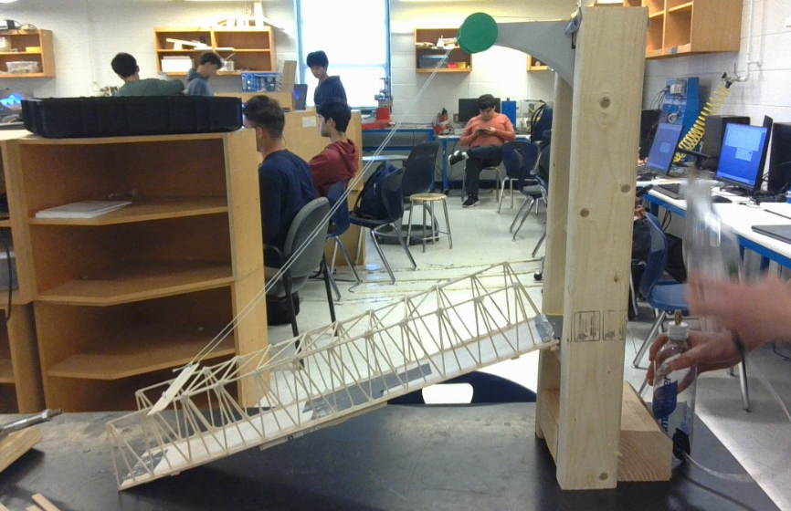
Figure 15: The vertical‑lift bridge in the lowered position before a boat approaches.
When the lifting sequence starts, the bridge deck rises straight upward between the two vertical supports. As the deck moves up, the guide rails keep it perfectly aligned so it does not tilt or twist. This allows the roadway to stay completely level throughout the lift. The design copies the same behavior used in real vertical-lift bridges where the deck must remain flat for both safety and structural reasons. When the deck reaches its maximum height, there is enough clearance for the approaching boat to travel under the bridge without any interruption.
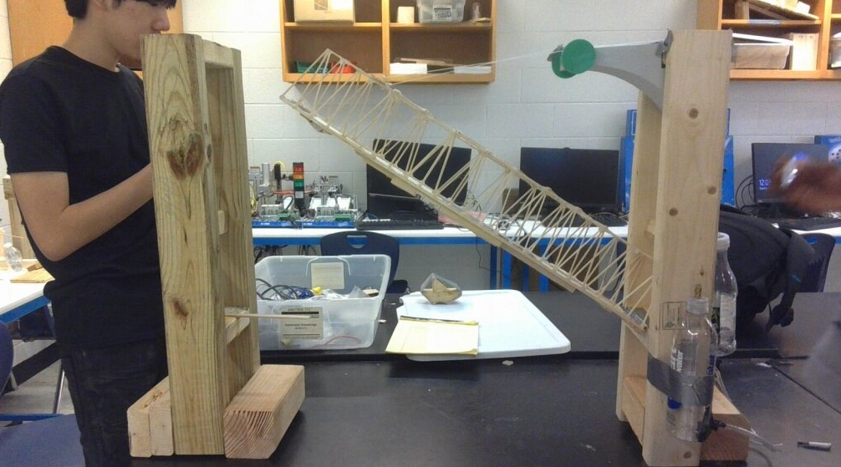
Figure 16: The deck lifting to create enough clearance for the boat to pass underneath
Once the boat has traveled fully beneath the bridge, the lowering sequence begins. The lifting mechanism slowly releases, allowing the deck to return to its original position. The guide rails once again make sure the deck lowers smoothly without drifting to either side. When the deck reaches the roadway level, the bridge rests securely on its supports. The barriers then lift back up, the traffic lights turn green, and cars can continue crossing the bridge just like before.
Because the working space for our model was limited, we had to keep the lifting system simple and compact. Our vertical-lift design worked well for this because everything moved in a straight line, and the mechanism did not require extra room on either side of the bridge to swing or rotate. This also made testing more consistent since the deck always returned to the same exact spot every time we lowered it.

Developmental / Analysis Work
Truss Efficiency Calculation
To evaluate the effectiveness of the lift deck reinforcement, a structural efficiency calculation was performed. Structural efficiency is defined as the ratio of the load supported by the structure to the weight of the structure itself.
$$\text{Efficiency}=\frac{\text{Load Supported}}{\text{Structure Weight}}$$
After construction, the completed lift deck assembly was weighed. Including the wooden roadway base, truss members, connecting supports, and adhesive joints, the lift deck weighed approximately 610 g. During testing, the lift deck supported a load of approximately 2.9 kg (6.4 lbs.) without visible bending, cracking, or joint failure.
$$\text{Efficiency}=\frac{2900\text{ g}}{610\text{ g}}≈4.75$$
Material Strength Estimation
The truss members were built from lightweight wooden strips with an estimated cross-sectional area of 10 mm². Using a typical tensile strength value for softwood of approximately 25 MPa, the theoretical maximum force per member was estimated using the equation:
$$F=σ×A$$
$$F=(25\text{ MPa})(10{\text{ mm}}^{2})=250\text{ N}$$
This corresponds to roughly 56 pounds-force, which exceeds the forces applied during testing.

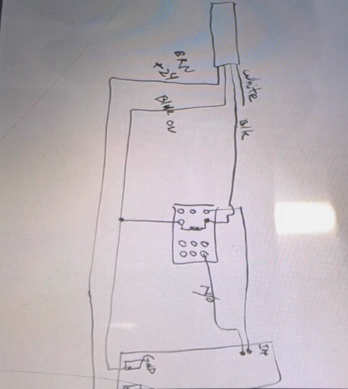
Schematics with Explanation

The diagram to the right shows the electrical wiring setup used to operate the vertical-lift drawbridge. The system is centered around a relay, which controls power delivery to the lift mechanism. The relay allows a low-power control signal to safely activate a higher-current motor circuit.
Figure 17: Electrical wiring diagram illustrating how the sensor signal activates the relay to power the lift motor.
When the sensor detects an approaching object, it sends a signal to the relay coil. Once energized, the relay closes the circuit and supplies power to the motor, causing the lift deck to rise. Indicator lights connected to the control circuit provide visual feedback, showing when the bridge is in operation. When the sensor signal is removed, the relay opens and cuts power to the motor, allowing the lift deck to return to its lowered position.
This relay-based logic ensures the bridge only operates when the correct conditions are met and prevents unintended activation. Using a relay also protects the control circuitry while providing reliable switching for the lifting mechanism. This wiring approach was similar across most groups and allowed for consistent and predictable drawbridge movement during testing.

Design Drawing
The drawing below represents the overall concept of the final vertical-lift drawbridge design. It shows the lift deck positioned between two vertical support towers and illustrates the deck in a raised position to demonstrate how vertical movement occurs. The sketch also indicates the general placement of the lifting mechanism and how the deck remains supported and guided during operation.
Although the drawing is not to scale, it was used during planning to visualize the relationship between the main components before construction began. The layout helped determine approximate spacing between the lift deck and towers, as well as how much clearance would be needed for smooth vertical motion. This drawing served as an early reference to guide the overall build and ensure that the major components were positioned logically.
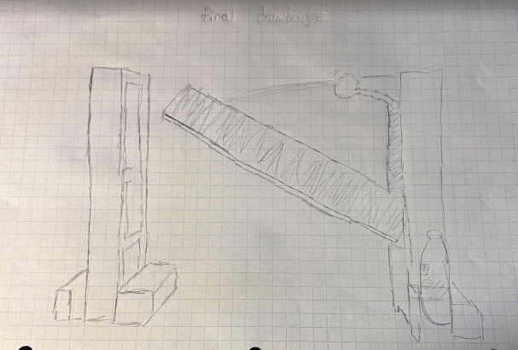
Figure 18: Design drawing showing the planned layout of the vertical lift drawbridge, including the support towers, lift deck, and lifting mechanism.
System Layout and Testing Setup
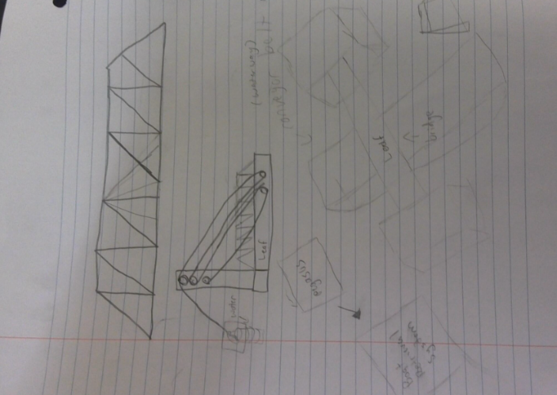
This image shows the planned layout of the drawbridge system during testing. This layout includes the position of the vertical-lift bridge, the support towers, the lift deck, the wiring, and the lifting mechanism as they were arranged on the testing table. The layout was planned in advance so that all components could be accessed easily and operated without interference during demonstrations.
This system layout sketch helped determine where each part needed to be placed relative to the others. By planning the arrangement ahead of time, the team was able to reduce setup confusion and avoid moving components repeatedly once testing began. The layout also helped ensure that wiring lengths were sufficient and that the lift deck had enough clearance to move vertically without obstruction.
Figure 19: Truss design sketch showing the triangular reinforcement pattern, side view connections, and estimated dimensions used during planning.
In addition, having the testing layout decided ahead of time made it easier to conduct multiple tests during the limited class period. Because the system was already organized, the bridge could be tested, adjusted, and retested efficiently without wasting time repositioning parts. This allowed the team to focus on observing performance and making improvements within the testing time available.
Bridge Programming
The bridge was programmed to lift and lower automatically based on sensor input. The purpose of the programming was to ensure that the bridge only moved when necessary and returned to its original position once the condition was no longer met. This allowed the system to function without manual control and made repeated testing possible during class.
The program begins with the sensor continuously monitoring the approach area in front of the bridge. When an object is detected, the sensor sends a signal to the control system. This signal activates the relay, which allows power to flow to the lift motor. Once the motor is powered, the lift deck begins to rise vertically between the two support towers.
As long as the sensor remains triggered, the relay stays energized and the lift deck remains in the raised position. Indicator lights connected to the system turn on during this process to show that the bridge is active. When the object clears the sensor, the sensor signal is removed. This causes the relay to disengage, cutting power to the motor and allowing the lift deck to lower back into its resting position.
After the deck is fully lowered, the program resets automatically and waits for the next sensor input. This sequence allowed the bridge to operate consistently during multiple tests and followed a similar structure to the programs used by most other groups
Boat Programming
The boat programming focused on how the system responds when a boat approaches the bridge. The boats used in this project were constructed with similar profiles so that each boat would interact with the sensor in the same way. This allowed the bridge to demonstrate a consistent lifting sequence regardless of which boat was used.
When a boat approaches the bridge and enters the sensor’s detection range, the system detects its presence and initiates the bridge-lifting sequence. The lift deck rises to provide sufficient clearance for the boat to pass underneath. Once the boat clears the sensor, the signal is removed and the bridge lowers back into its original position.
Using boats with similar designs helped simplify testing and ensure predictable results. This approach allowed multiple tests to be completed efficiently during the limited class time available and confirmed that the programming logic worked reliably under repeated conditions.
Overall, the boat programming allowed the system to demonstrate consistent and repeatable behavior during testing. Each boat triggered the same response from the bridge, which helped verify that the sensor and control logic were working as intended. This consistency made it easier to evaluate the bridge’s performance and ensured that testing could be completed efficiently during the limited class time available.

Bill of Materials
The following Bill of Materials lists the components and materials available through the standard project kit and used throughout development and testing. Exact quantities and dimensions were not tracked for all items, as materials were used as needed during construction and adjusted based on design changes.
Electrical and Control Components
Relay, 24 VDC
Relay base
Photoswitch sensor (24 VDC, PNP output)
Retro-reflective targets
LED indicator lights (red and green, 24 V)
Buzzer
Electrical wiring / wire leads
Power supply
Capacitors and resistors (various values)
Push buttons and contact blocks
Limit switches

Pneumatic and Fluid Components

- Pneumatic cylinders
- Tubing (polyurethane)
- Hose barbs and fittings
- Quick-connect fittings
- Valves (various types)
- Pressure regulator
- Plastic bottles and containers (used during early testing

Structural and Wood Components

- Wood studs (various lengths)
- Flat wooden board (used as lift deck base)
- Balsa wood sheets
- Balsa wood stick bundle
- Construction screws
- Construction nails

Hardware Components

- Shoulder bolts
- Hex nuts
- Mounting brackets
- Fasteners (assorted)

Miscellaneous Materials

- Fishing line
- Plastic straws
- Masking tape
- Adhesives (wood glue and modeling glue)
- Storage tote (project kit container)

Problems Encountered During Design
During the design phase of the drawbridge project, several challenges required changes to the original plan. One early issue was determining how to reinforce the lift deck while keeping the structure light enough for vertical movement. Initial design ideas added too much weight, which led to concerns about the lift mechanism’s ability to operate smoothly. This problem was addressed by choosing a truss-based reinforcement instead of a solid structure.
Another design challenge involved planning how the system would be arranged during testing. Because multiple groups shared the same limited testing tables, the design needed to allow for quick setup and removal. This required the team to consider component placement and overall footprint early in the design process rather than after construction was complete.
Designing around testing constraints influenced several decisions, including the orientation of the bridge, placement of wiring, and spacing of components. Addressing these issues during the design phase helped prevent larger problems later during construction and testing.

Description of Prototype Construction

How materials were obtained
Materials for our project were included in the drawbridge kit provided by our instructor. The kit contained the wooden pieces for the truss, the lifting mechanism hardware, electrical wiring, and the sensors required for the lifting sequence. Additional materials such as screws, hinges, glue, and support wood were taken from the classroom supply area after receiving approval. All materials used in the final model were checked with the project guidelines to make sure they met the requirements.
Cutting and Assembling the Tower Supports
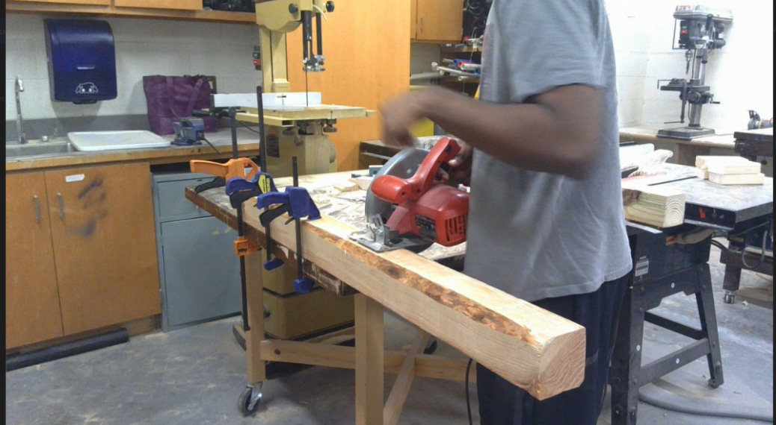
The first part of our construction process was preparing the wooden supports that would eventually hold the lifting deck. We began by marking the cut lines on the long 4×4 beam and then clamped it securely to the workbench. Clamping the wood made the cuts safer and kept the board from sliding while the saw was running. After everything was locked in place, we used a circular saw to cut the beam down into the two vertical pieces needed for the tower supports.
Figure 20: Cutting the main 4×4 beam into the two tower supports needed for the vertical lift frame.
Once the large cuts were finished, we moved on to preparing the smaller support blocks. These pieces were glued and clamped together so that the frame would stay square while it dried. Clamping the wood helped keep all the edges flush and made the structure more stable once the glue set. This step gave us a solid base that the rest of the lift system would be built on.
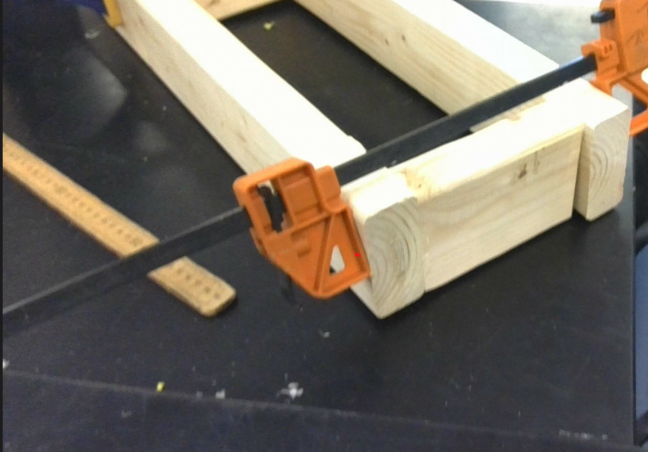
Figure 16: Clamping the smaller support pieces to keep the frame aligned while the glue dried.
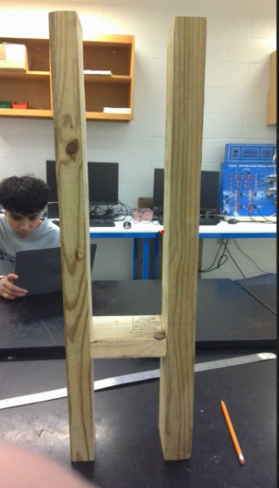
After the glued pieces dried, we assembled the first version of the tower frame. This let us check the spacing and make sure both vertical supports were the same height. Getting the frame aligned at this stage was important because any tilt or uneven spacing would cause problems once the lifting mechanism and CAD-designed bracket were added later.
Figure 21: The completed support frame standing upright after the support pieces were cut, glued, and aligned.

Creating and attaching the SolidWorks Brackets
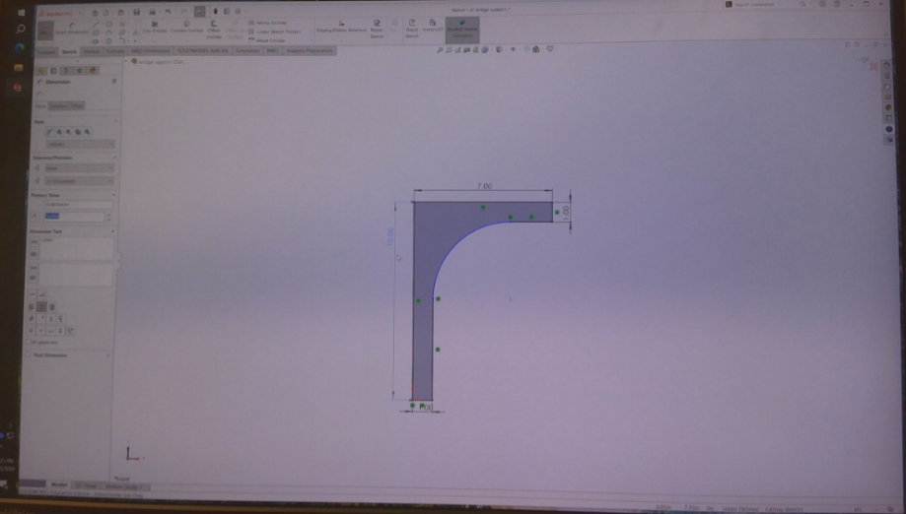
Once the wooden tower supports were completed, the next step was creating the bracket that would guide the lifting deck. We designed this piece in SolidWorks so we could control the exact measurements and make sure the curve, and mounting points were correct before attaching anything to the wood. The model let us preview how the bracket would fit on the towers and gave us a clear idea of what the final part would look like once printed or cut.
Figure 22: SolidWorks model of the curved bracket that guides the lifting deck.

After creating the bracket in SolidWorks, we sent the file to the 3D printer so the part could be made. While it was printing, we prepared the mounting area on the tower so the bracket could be attached as soon as it finished.
[INSERT IMAGE — 3D printer or CAD model screen — Figure X]
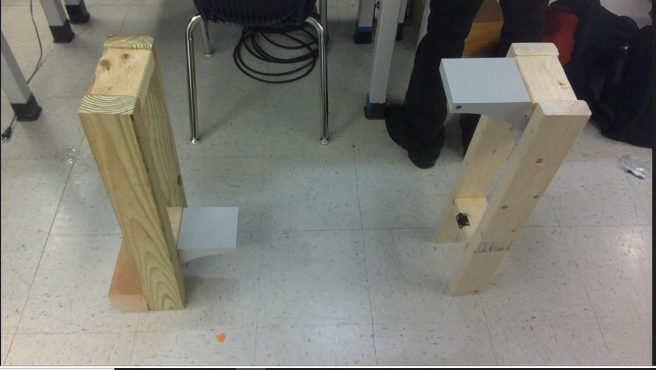
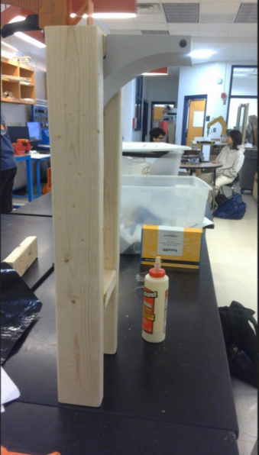
After the SolidWorks design finished printing, we attached the bracket to the top of the tower support. The bracket fit into the space we planned for it and gave the top of the tower a smooth, curved guide surface. Once the first bracket was mounted, we repeated the process on the second tower. Testing both towers side-by-side helped us check the alignment and spacing between them. Seeing both supports together with the brackets installed made it clear how the lifting deck would move straight upward between the guides.
Figure 23: both tower supports assembled with the finished brackets installed and aligned for the lifting deck.

Creating the SolidWorks model also helped us decide exactly where the bracket would attach onto the wooden supports. By checking the measurements digitally, we were able to confirm the mounting height and alignment before building the real version. This step made the printing and installation process much smoother once we moved on to assembling the actual towers.

Drilling and Preparing Support Blocks
Before attaching the lifting system, we needed to prepare several smaller parts that would support different sections of the bridge. The first part of this step was drilling holes into the wooden mounting blocks. We clamped each block into a vise so it wouldn’t move while drilling. Making clean, straight holes in these pieces was important because they were used later to attach hardware and keep the lifting mechanism stable.
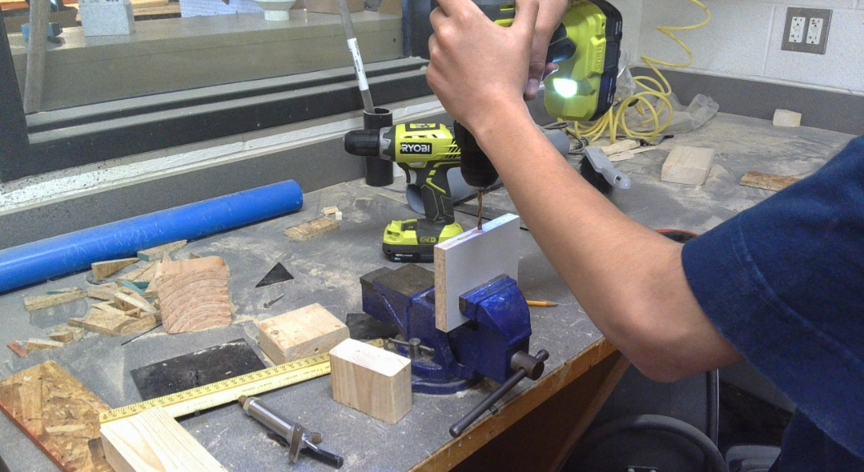
Figure 24: Drilling straight mounting holes into the support block.
We also drilled into a bottle cap to prepare the tubing connection for our early water-based lifting test. This was part of an initial hydraulic-counterweight idea we tried before finalizing the vertical-lift system. Drilling a clean hole in the cap allowed us to insert the tube and seal it so the bottles could transfer water back and forth. Even though this method was not used in the final design, preparing this setup helped us understand how weight transfer and fluid movement affect bridge motion.
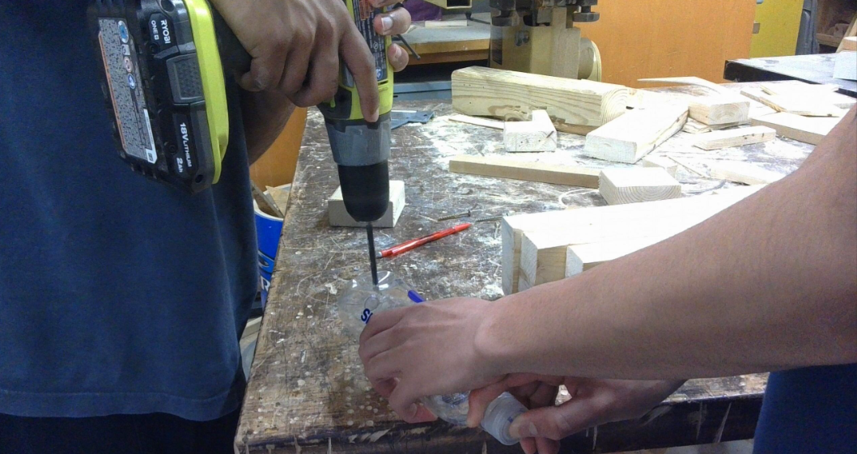
Figure 25: Drilling the bottle cap so tubing could be inserted for our early hydraulic lift test.
Once the cap and tubing were ready, we assembled the two-bottle system and tested how well the water transferred between them. The movement of the water helped us see how a counterweight system could raise or lower a structure. Although we later switched to a different lifting design, this early prototype was still helpful for learning about force, balance, and the behavior of simple lifting mechanisms.
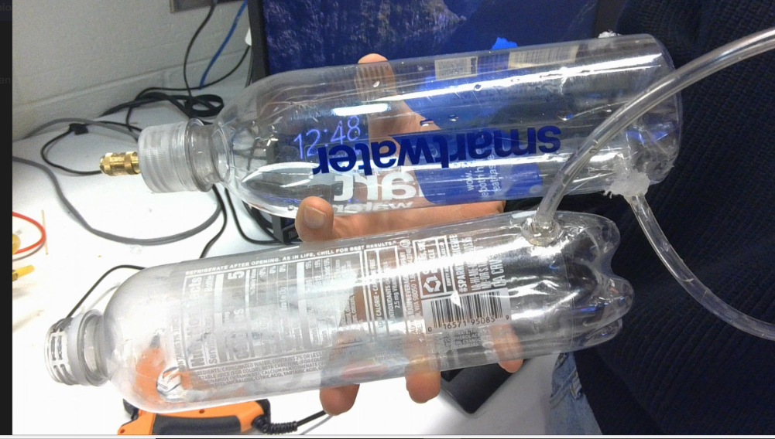
Figure 26: The two bottled water systems we assembled as part of our initial counterweight test
.
Reinforcing the Lift Deck Structure
The next stage of construction focused on reinforcing the lift deck so it would not bend or break during vertical movement. For the base of the lift deck, we reused a flat wooden board that was left over from a past project. This board worked well as the roadway because it was already cut to a usable size and provided a smooth, level surface. Using the leftover material also helped reduce waste and allowed us to spend more time strengthening the deck instead of building the base from scratch.
Once the deck base was selected, we began building the truss that would support it. The truss was constructed on a flat surface using thin wooden strips arranged in a repeating triangular pattern. Each piece was measured and glued carefully so the structure would stay straight and evenly spaced. After the first truss was completed and fully dried, we inspected it to ensure the joints were secure and the structure was rigid enough to support weight.
After deciding that we liked the design of the first truss, we used it as a reference to build the second one. Copying the original design helped ensure both trusses were the same size and shape, which was important for keeping the lift deck balanced during operation. Building the second truss based on the first allowed us to maintain consistent spacing and angles throughout the structure.
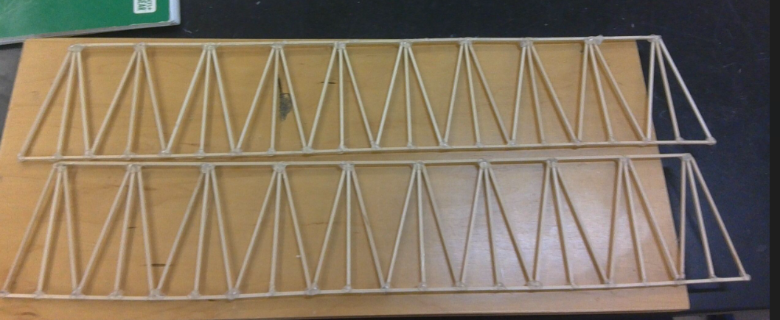
Figure 27: The two finished truss frames built separately before being attached to the lift deck.
Once both trusses were completed, we glued them to the top edges of the lift deck, running along each side of the roadway. Attaching the trusses in this position reinforced the flat wooden deck and prevented it from bending during movement. To connect the two trusses and make them work together as a single structure, we glued horizontal support pieces between them at regular intervals. These connection pieces helped keep the trusses aligned, reduced twisting, and increased the overall stiffness of the lift deck. After the glue fully dried, the lift deck became one rigid structural assembly that could safely move as part of the vertical-lift system
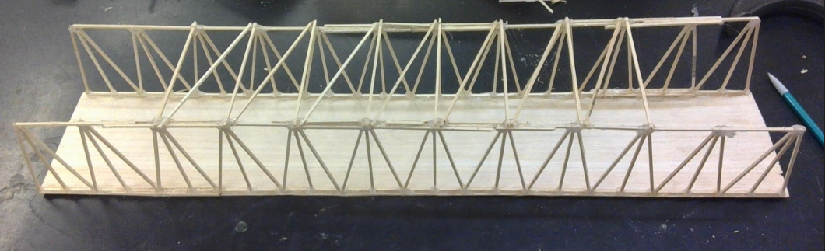Figure 28: The completed lift deck with two side trusses attached and connected by horizontal support members.
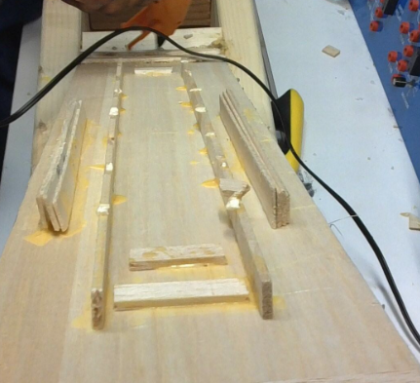
With the truss attached, we added additional supports on the bottom to further reinforce the lift deck and prevent twisting during movement. Long wooden support pieces were glued along the underside of the deck and aligned carefully to distribute weight evenly across the structure. These supports helped reduce stress on the truss members and increased the overall durability of the deck
Figure 29: Gluing longitudinal support pieces to the bottom of the lift deck for added rigidity.
After gluing the bottom support pieces into place, we carefully checked that each support was straight and fully attached. Small adjustments were made while the glue was still setting to ensure the supports lined up evenly along the underside of the lift deck. This step was important because uneven supports could cause the deck to twist or bind during movement. Once everything was properly aligned, the glue was allowed to dry completely so the structure could reach its full strength.
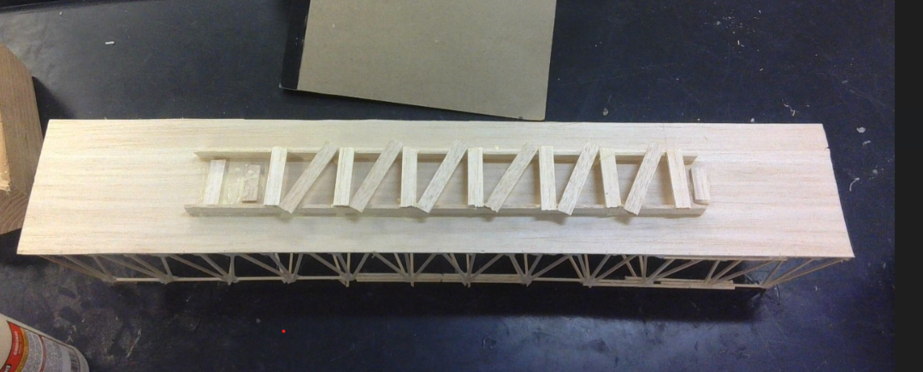Figure 30: The final reinforced lift deck with the truss and bottom support fully installed.
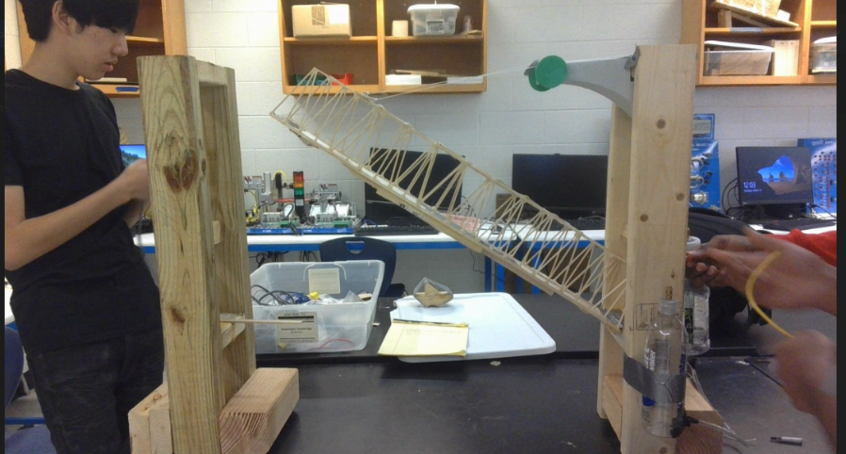
After confirming that the lift deck was sufficiently reinforced and rigid, the deck was connected to the two vertical support towers. Attaching the deck between the supports marked the completion of the bridge construction phase and allowed the vertical-lift motion to be tested. With the bridge fully assembled and supported, the project was ready to move on to the construction and testing of the boats that would interact with the drawbridge.
Figure 31: Final Drawbridge.

Boat Construction
The boats used in the drawbridge project were constructed from wood and designed to interact reliably with the bridge system during testing. Early in the construction process, smaller prototype boats were created to experiment with shape, balance, and stability. These initial prototypes helped determine how wide the base needed to be and how the angled upper section should be positioned so the boats would remain upright and move smoothly during testing.
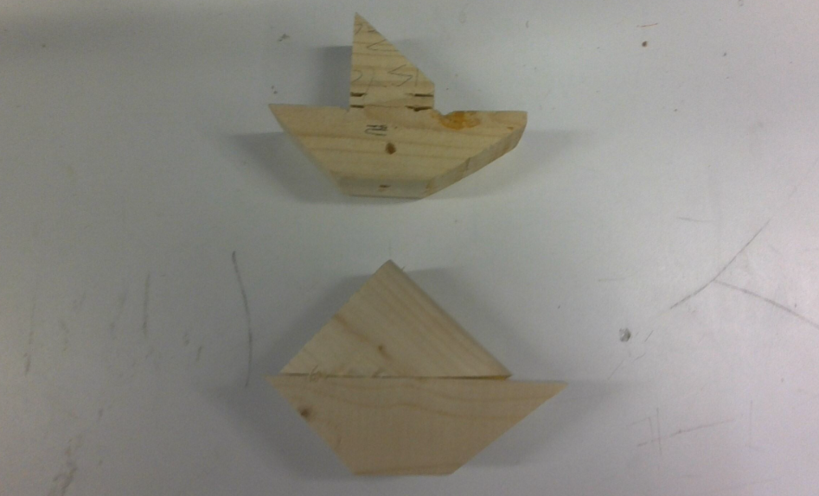
Figure 32: Early prototype boats used to test shape and stability before final construction.
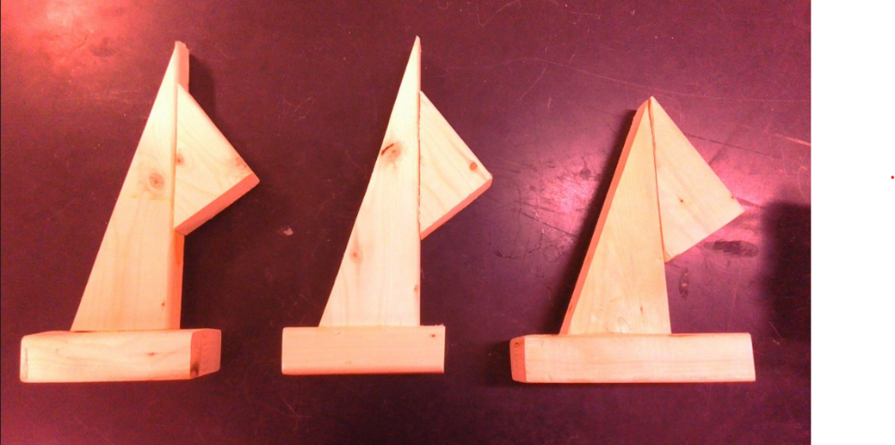
After evaluating the initial prototypes, the final boats were constructed using the same general design with improved consistency. Each final boat includes a flat rectangular base to provide stability and an angled vertical section representing a sail. This design ensured that the boats behaved predictably when approaching the bridge and interacting with the sensor
Figure 33: Final wooden boats

