BUSINESS ANALYSIS REPORT
Global Internet Speeds 2025
Connectivity Disparities, Regional Patterns & Strategic Insights
Prepared by
Yash Gupta
Business Analyst
April 2026
157  Countries Analysed  All world regions | 112.3  Avg Broadband  Mbps global mean | 105.5  Avg Mobile  Mbps global mean | 410  Fastest Country  Singapore broadband

1. Executive Summary

This report presents a comprehensive business analysis of global internet speeds in 2025, covering 157 countries across broadband and mobile download metrics. The analysis was conducted using Python-based exploratory data analysis (EDA) techniques and is intended to inform market entry decisions, digital product strategy, and infrastructure investment assessments.

Key findings at a glance:
- Singapore leads global broadband at 410 Mbps; UAE, France, Chile, and Hong Kong round out the top five.
- The UAE dominates mobile speed at 652 Mbps, followed by Qatar (515 Mbps) and Kuwait (384 Mbps) — driven by 5G investment.
- Africa (avg 39.9 Mbps broadband) and South Asia (avg 43.2 Mbps) trail the global mean by 2-3x, representing significant digital divide risk.
- A moderate correlation (r = 0.46) between broadband and mobile speeds indicates that infrastructure strategies diverge significantly across countries.
- 53 countries (33.8%) lack mobile speed data, warranting caution in global mobile comparisons.

The analysis spans 10 analytical sections, 10 data visualisations, and concludes with five strategic recommendations for digital-market practitioners.

2. Dataset Overview

2.1 Data Source & Structure
The dataset (global_internet_speeds_2025.csv) contains download speed measurements for 157 countries, sourced from Speedtest by Ookla's Global Index for 2025. Two metrics are provided:
- Broadband Download Speed (Mbps) — fixed-line internet performance
- Mobile Download Speed (Mbps) — cellular/5G network performance

Attribute | Value
File name | global_internet_speeds_2025.csv
Total countries | 157
Columns | 3 (country, broadband_download_mbps, mobile_download_mbps)
Broadband records | 156 (99.4% coverage)
Mobile records | 104 (66.2% coverage)
Both metrics | 103 countries
Reference period | 2025
Speed unit | Megabits per second (Mbps)

2.2 Scope & Limitations
- Speeds represent download performance only; upload speeds and latency are not included.
- Mobile data is absent for 53 countries (primarily Africa and smaller island nations), limiting global mobile comparisons.
- Measurements reflect averages across a country and may mask urban-rural disparities.
- Only Eswatini lacks broadband data, making broadband analysis near-complete.

3. Data Quality Assessment

Data quality analysis is a foundational step in any business analysis engagement. The following table summarises completeness:

Metric | Available | Missing | Coverage % | Notes
Broadband | 156 | 1 | 99.4% | Only Eswatini missing
Mobile | 104 | 53 | 66.2% | Primarily Africa + Caribbean

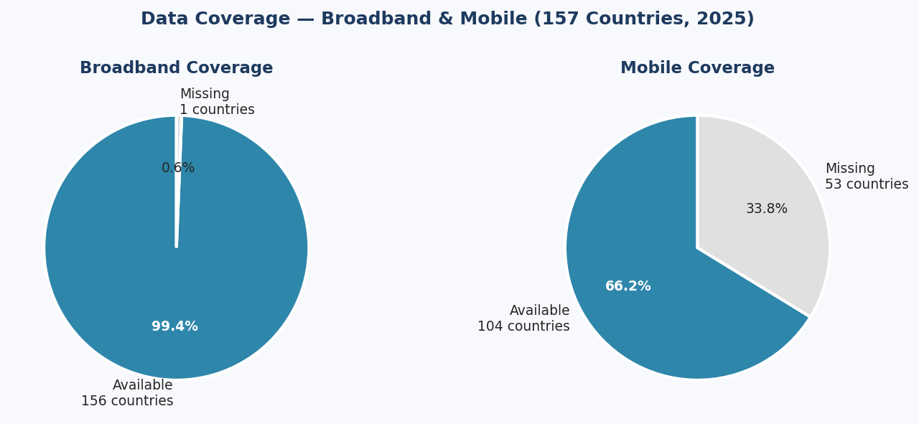
Figure 1: Data coverage — Broadband (99.4%) vs Mobile (66.2%) across 157 countries

Data Quality Insight
The high broadband coverage (99.4%) makes global broadband analysis highly reliable. Mobile analysis should be treated with greater caution given the 33.8% gap, particularly for African and Caribbean markets where mobile data is the primary connectivity mode.

4. Descriptive Statistics

The following table summarises key statistical measures for both broadband and mobile speeds.

Statistic | Broadband (Mbps) | Mobile (Mbps)
Sample Size | 156 | 104
Mean | 112.32 | 105.46
Std Deviation | 90.32 | 92.10
Minimum | 3.51 | 11.40
25th Percentile | 41.35 | 50.50
Median (50th) | 86.97 | 81.46
75th Percentile | 162.21 | 135.44
Maximum | 410.06 | 652.87

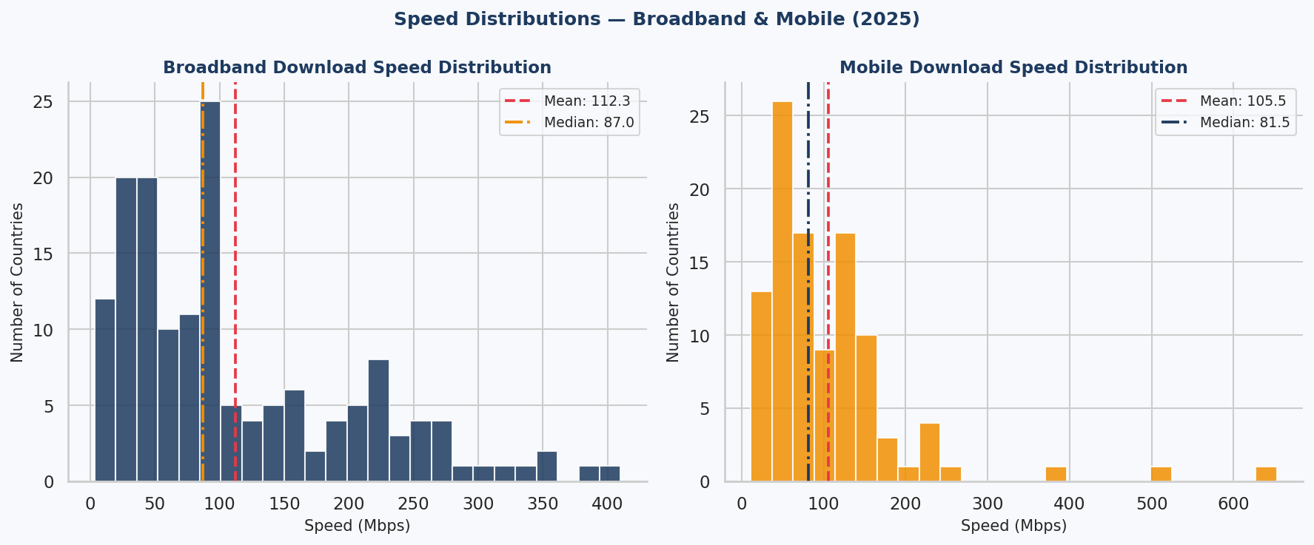
Figure 2: Right-skewed distributions show most countries cluster below 150 Mbps while a few high-performers pull the mean upward

Both distributions are strongly right-skewed (positive skew), meaning the majority of countries cluster below the mean, while a small set of high-performing nations pull averages upward. The median (87 Mbps broadband, 81 Mbps mobile) is a more representative central value than the mean for policy or market-sizing purposes.

5. Country Rankings

5.1 Top 10 Broadband Countries
Rank | Country | Broadband (Mbps) | Region
1 | Singapore | 410.06 | Southeast Asia
2 | United Arab Emirates | 382.32 | Middle East
3 | France | 349.25 | Europe
4 | Chile | 348.41 | South America
5 | Hong Kong | 343.36 | East Asia
6 | Macau | 314.32 | East Asia
7 | Iceland | 289.98 | Europe
8 | United States | 298.38 | North America
9 | Israel | 270.69 | Middle East
10 | Vietnam | 271.95 | Southeast Asia

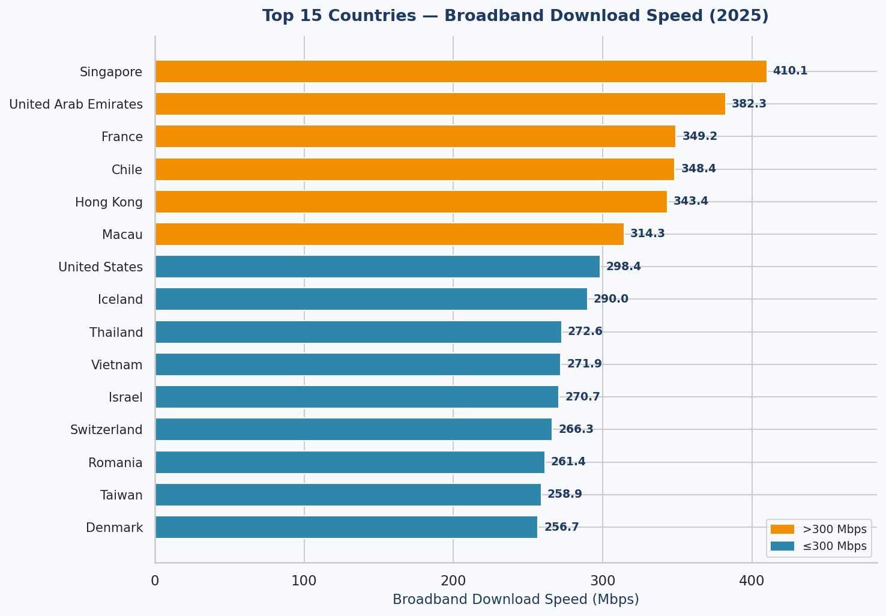
Figure 3: Top 15 countries by broadband download speed — Singapore leads at 410 Mbps

5.2 Bottom 10 Broadband Countries
Rank | Country | Broadband (Mbps) | Region
1 (lowest) | Syria | 3.51 | Middle East
2 | Cuba | 3.67 | North America
3 | Afghanistan | 4.54 | South Asia
4 | Ethiopia | 10.12 | Africa
5 | Libya | 10.63 | Africa
6 | Kenya | 15.75 | Africa
7 | Pakistan | 17.77 | South Asia
8 | Tunisia | 18.07 | Africa
9 | Iran | 19.88 | Middle East
10 | Somalia | 19.36 | Africa

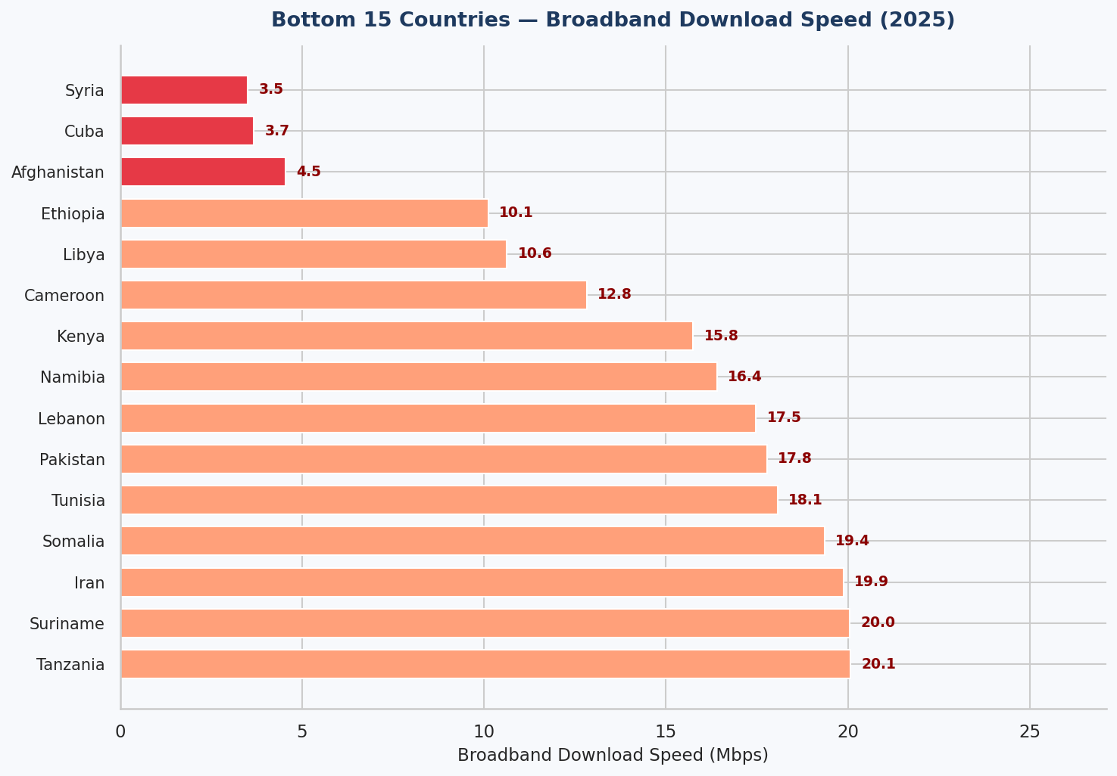
Figure 4: Bottom 15 countries by broadband speed — conflict-affected and low-income nations dominate

5.3 Top 10 Mobile Countries
Rank | Country | Mobile (Mbps) | Region
1 | United Arab Emirates | 652.87 | Middle East
2 | Qatar | 515.23 | Middle East
3 | Kuwait | 384.40 | Middle East
4 | Brazil | 251.55 | South America
5 | Bulgaria | 237.03 | Europe
6 | South Korea | 230.84 | East Asia
7 | Bahrain | 230.27 | Middle East
8 | Denmark | 183.74 | Europe
9 | Singapore | 186.07 | Southeast Asia
10 | Saudi Arabia | 194.37 | Middle East
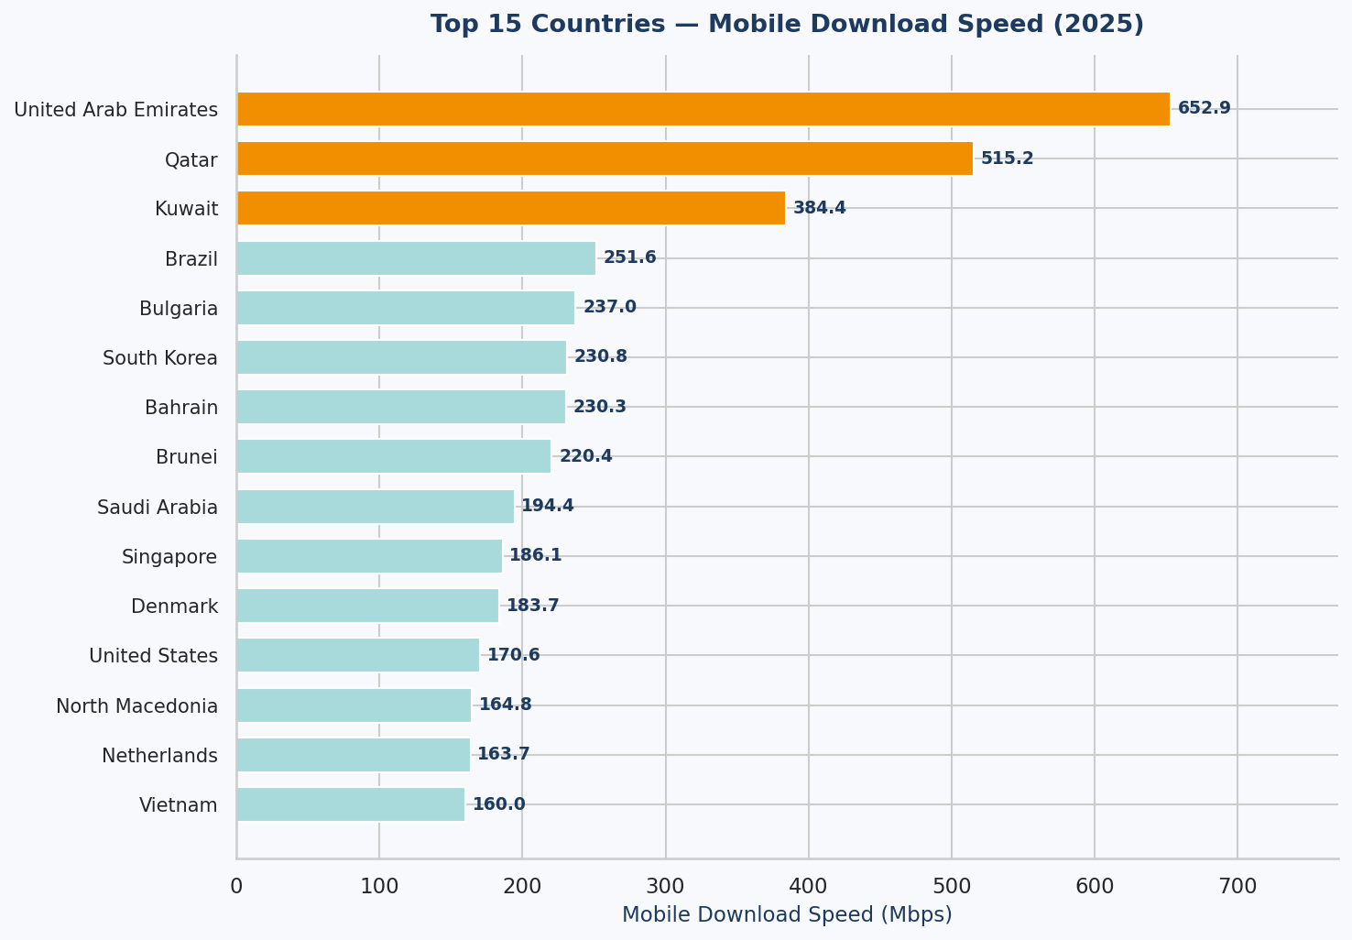
Figure 5: Top 15 countries by mobile download speed — Gulf nations dominate through 5G investment

6. Regional Analysis

Regional aggregation reveals structural patterns that transcend individual country performance, reflecting continental-level infrastructure investment, policy, and economic development.

Region | Avg Broadband (Mbps) | Avg Mobile (Mbps) | Countries Analysed
East Asia | 255.7 | 132.5 | 5
South America | 168.2 | 62.1 | 11
Southeast Asia | 161.1 | 116.2 | 9
North America | 149.5 | 74.0 | 6
Europe | 149.4 | 109.3 | 38
Middle East | 137.7 | 194.9 | 13
Oceania | 127.8 | 106.9 | 3
Central Asia | 76.3 | 83.1 | 6
South Asia | 43.2 | 52.1 | 4
Africa | 39.9 | 50.0 | 8

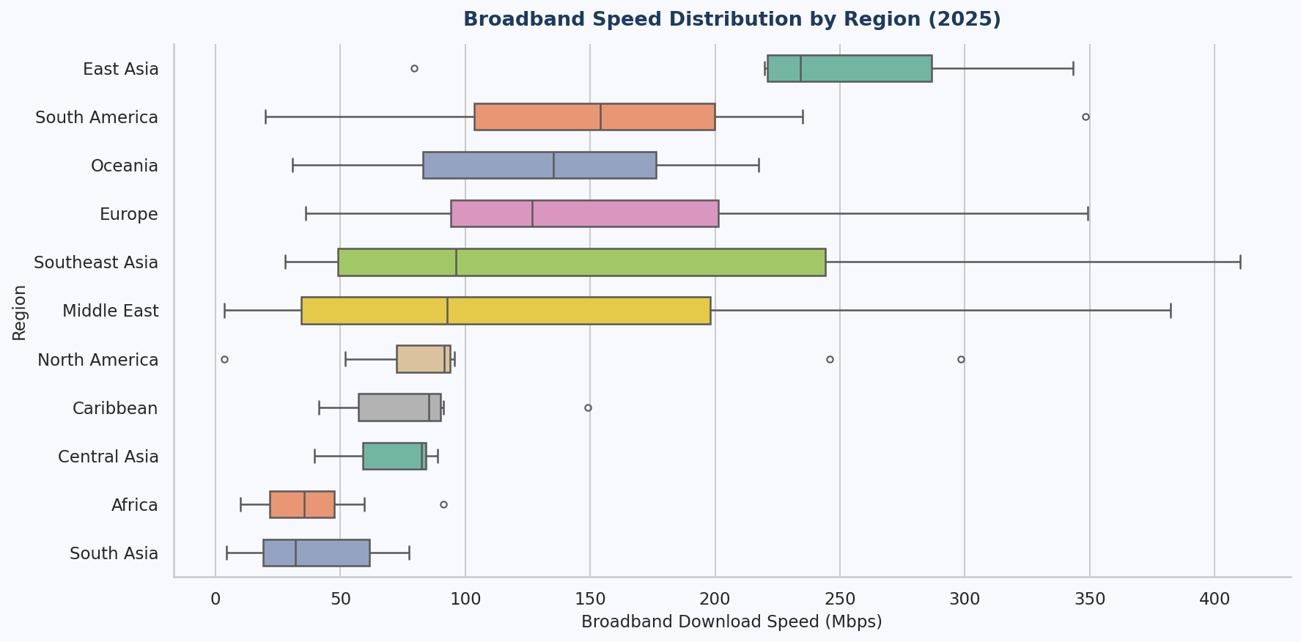
Figure 6: Broadband speed distribution by region — East Asia leads, Africa and South Asia lag significantly

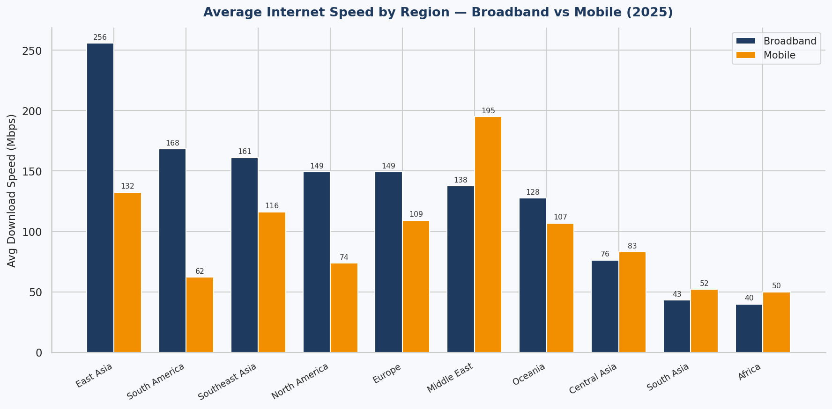
Figure 7: Average regional speeds — note Middle East mobile dominance vs lower broadband rank

Regional Insight
The Middle East presents a striking inversion: it ranks 6th in broadband but 1st in mobile speed (avg 194.9 Mbps). This reflects Gulf-state investment in 5G infrastructure as a leapfrog strategy, bypassing traditional broadband buildout. South America shows the inverse: strong broadband (2nd globally) but weak mobile (9th), suggesting urban-concentrated fixed infrastructure without equivalent cellular rollout.

7. Broadband vs Mobile Comparison

Comparing both metrics at the country level reveals strategic infrastructure choices — whether nations have invested primarily in fixed-line or cellular networks.

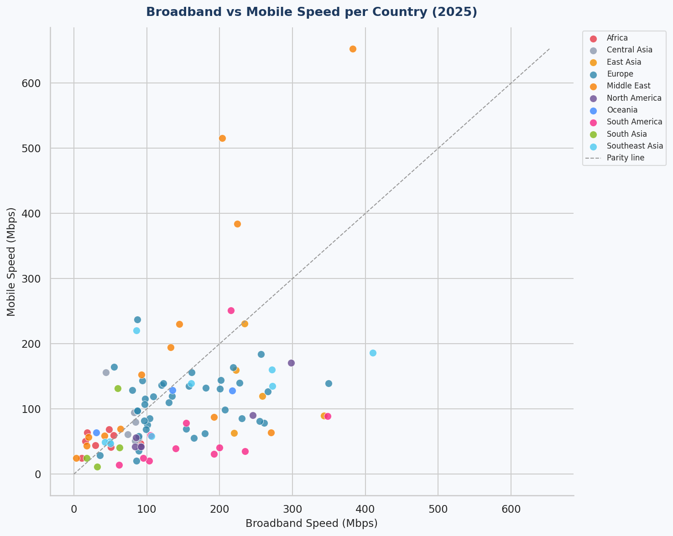
Figure 8: Scatter plot of broadband vs mobile speed — points above the parity line have faster mobile than broadband

Countries falling above the parity line (mobile > broadband) tend to be:
- Gulf states (UAE, Qatar, Kuwait, Bahrain) — 5G-driven mobile-first infrastructure
- Some emerging markets that leapfrogged fixed broadband directly to mobile
Countries falling well below the parity line (broadband >> mobile) tend to be:
- South American nations (Chile, Peru, Colombia) with strong fibre networks but slower cellular rollout
- North American markets with mature broadband but legacy LTE mobile networks

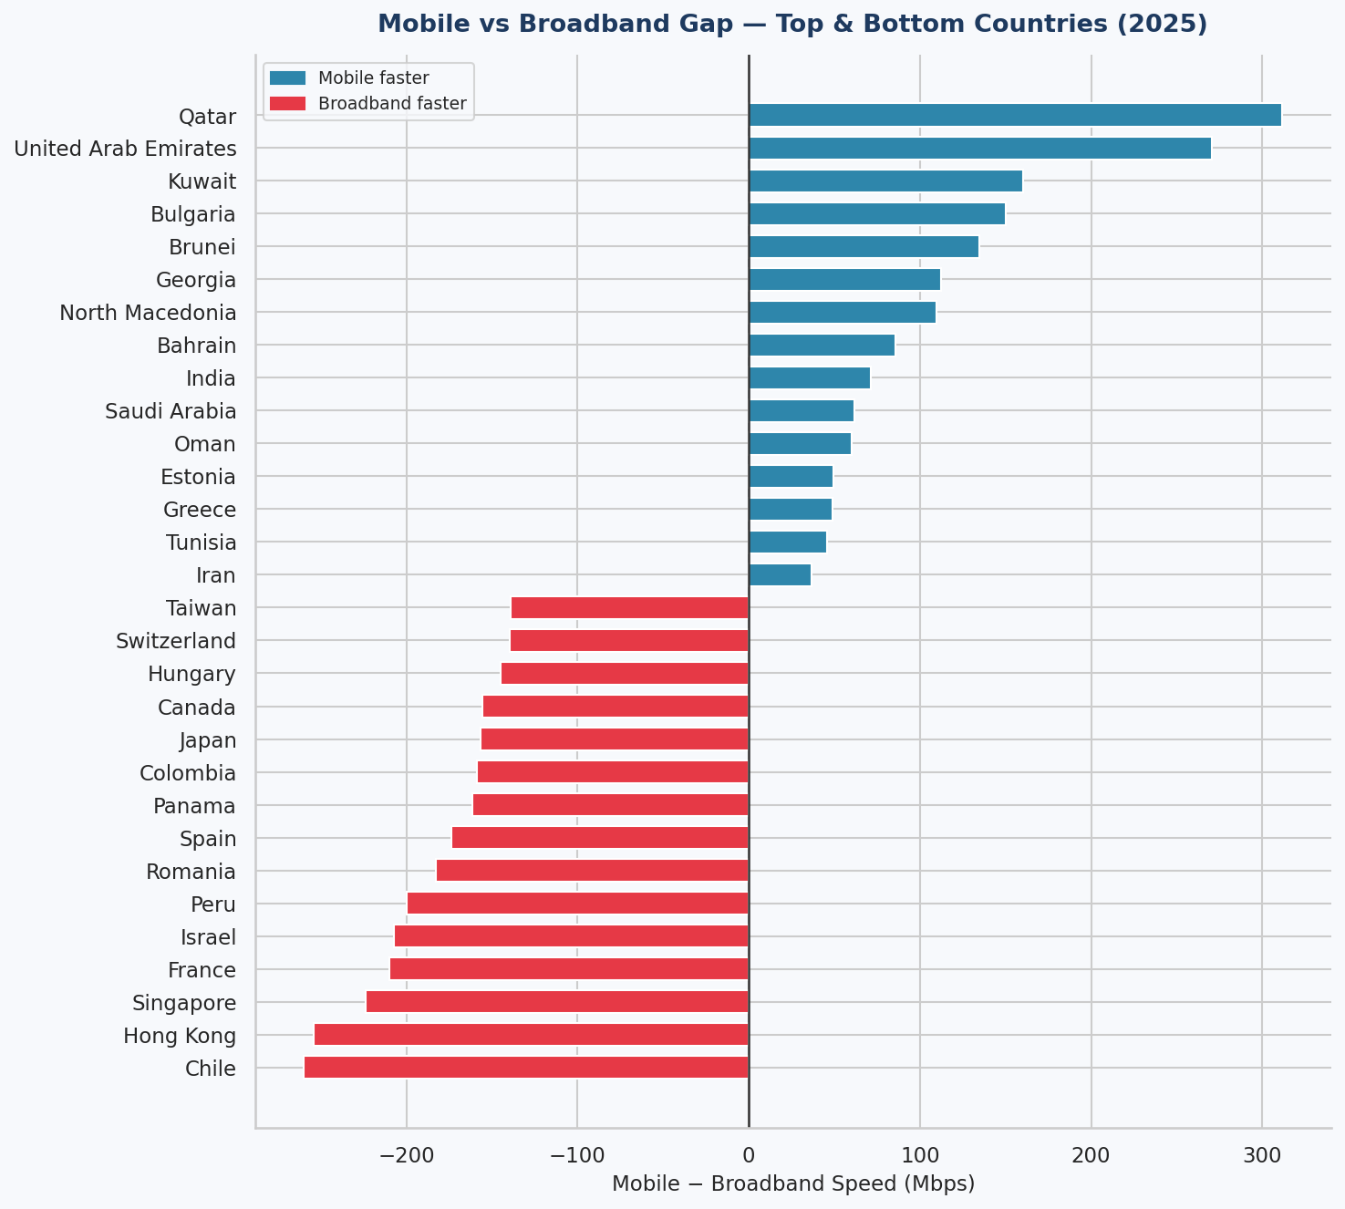
Figure 9: Speed gap (Mobile minus Broadband) — positive = mobile-dominant, negative = broadband-dominant

8. Correlation Analysis

The Pearson correlation coefficient between broadband and mobile speeds across 103 countries (with both metrics) is r = 0.463. This indicates a moderate positive relationship.

Metric Pair | Pearson r | Interpretation | Sample Size
Broadband vs Mobile | 0.4631 | Moderate positive correlation | 103 countries

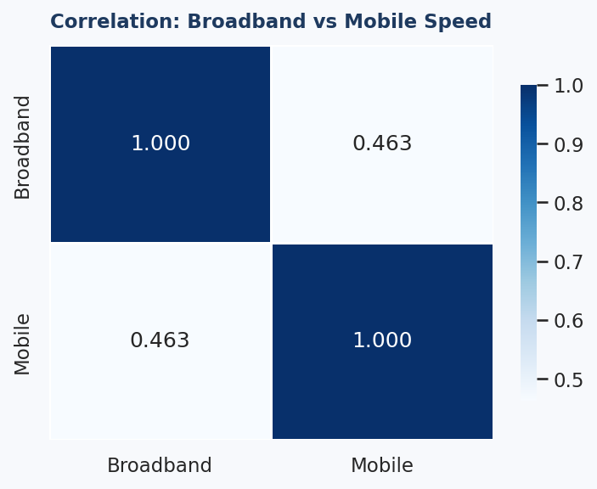
Figure 10: Correlation heatmap — broadband and mobile speeds show moderate positive correlation

While the positive correlation confirms that nations with stronger digital infrastructure generally perform well on both dimensions, the moderate strength (r ≈ 0.46) means many countries diverge significantly. This divergence is strategically important: product teams cannot assume that a country's broadband performance is predictive of its mobile performance.

9. Strategic Business Insights

Finding 1 — The 116× Digital Divide
Singapore's broadband (410 Mbps) is 116 times faster than Syria's (3.5 Mbps). Even within the top quartile, performance differences of 3-5× are common. For business analysts evaluating market entry, internet infrastructure quality is a critical risk and opportunity dimension.
Recommendation
Businesses deploying digital-heavy services (SaaS, streaming, video conferencing, e-commerce) should prioritise Europe, East Asia, and select Latin American markets where speeds reliably exceed 150 Mbps, minimising user experience risk.

Finding 2 — Gulf 5G Leadership Creates Mobile-First Markets
The UAE (652 Mbps mobile), Qatar (515 Mbps), and Kuwait (384 Mbps) lead the world in mobile speeds — each more than 3× the global average. This reflects deliberate national 5G investment strategies, particularly in preparation for high-density smart-city applications.
Recommendation
Organisations expanding to the Gulf region should design mobile-first digital products. Rely on mobile delivery rather than broadband assumptions; optimise for 5G-native features like high-resolution streaming and low-latency interactions.

Finding 3 — Africa & South Asia: The Connectivity Gap
Africa averages just 39.9 Mbps (broadband) — less than one-third the global mean. South Asia averages 43.2 Mbps. These regions also have the most missing mobile data, suggesting measurement infrastructure is itself underdeveloped.
Recommendation
Products targeting African and South Asian markets must be designed for low-bandwidth environments: lightweight applications, progressive image loading, offline-capable features, and data-efficient APIs. Infrastructure risk should be factored into SLA commitments.

Finding 4 — South America's Broadband Paradox
South America ranks 2nd globally in average broadband speed (168.2 Mbps), driven by Chile (348 Mbps), Peru (235 Mbps), and Brazil (215 Mbps) — yet mobile averages just 62.1 Mbps. This points to concentrated urban fibre networks without commensurate cellular investment.
Recommendation
In South American markets, adopt a dual-channel strategy: broadband-optimised desktop applications for urban centres with strong fibre coverage, and lightweight mobile-adaptive products for rural and lower-income demographics.

Finding 5 — Moderate r Demands Dual Evaluation
The r = 0.46 broadband-mobile correlation means country-level digital readiness cannot be assessed on a single metric. Bulgaria (237 Mbps mobile, 87 Mbps broadband) and Chile (348 Mbps broadband, 88 Mbps mobile) illustrate how dramatically strategies can diverge.
Recommendation
Digital readiness assessments and market scorecards should always include both broadband and mobile metrics as independent dimensions. Composite scores should be weighted separately to avoid masking critical differences.

10. Methodology & Tools

Component | Detail
Language | Python 3.10
Data Processing | Pandas, NumPy
Visualisation | Matplotlib, Seaborn
Notebook Format | Jupyter Notebook (.ipynb)
Region Mapping | Manual mapping of 157 countries to 11 world regions
Statistical Tests | Descriptive stats, IQR outlier detection, Pearson correlation
Document Format | Microsoft Word (.docx) via docx-js
Charts Produced | 10 analytical visualisations
Data Source | Speedtest Global Index 2025 (Ookla)

The full analysis is reproducible via the accompanying Jupyter notebook (Global_Internet_Speeds_2025_EDA.ipynb), which includes all code, visualisations, and narrative commentary.

Appendix — Full Country Data Sample

The following table shows a selection of countries across the speed spectrum for reference:

Country | Broadband (Mbps) | Mobile (Mbps) | Region
Singapore | 410.06 | 186.07 | Southeast Asia
United Arab Emirates | 382.32 | 652.87 | Middle East
France | 349.25 | 139.11 | Europe
United States | 298.38 | 170.61 | North America
Germany | 101.08 | 75.67 | Europe
Brazil | 215.58 | 251.55 | South America
India | 60.34 | 131.47 | South Asia
Nigeria | 29.73 | 44.06 | Africa
Pakistan | 17.77 | 24.72 | South Asia
Syria | 3.51 | 24.57 | Middle East

— End of Report —
Yash Gupta | Business Analyst Portfolio | April 2026

