**DBIT Tech News**

Welcome to DBIT Tech News, the place where faculty members let students know about technical workshops being conducted in Don Bosco Institue of Technology, Kurla.

**How does DBIT Tech News work?**

1. All faculty members register themselves on the website.
2. Once that is done, they can log in to the website and fill out a form, titled "Create a new event", which will contain all the information regarding the technical workshop to be conducted.
3. The faculty member then posts the event which appears on the homepage, along with other events to be held.
4. On the homepage, students can browse through various workshops, and register for those which they find interesting, by clicking on the "Register" button available on individual event tabs.
5. When a student clicks on the "Register" button, they are led to a page which contains the registration form, the successful submission of which gets them enrolled for that particular workshop.
6. The student can then come back to the homepage and continue browsing.

**Initial instructions:**

1. All the web pages are in form of .php format.
2. These pages are hosted on a localhost server.
3. User needs to download WAMP or XAMP or LAMP server on their respective machines , depending upon the type of OS.
4. These pages along with Java Script files are to saved inside the www folder of wamp server.
5. The links created inside the PHP files are supposed to be changed depending upon the path of these pages.
6. connect2.php is used to coennect php web pages with the database.
7. Login.php and signp.php pages are linked to the database to store information about the users .
8. Java scripts for each page is written for validation and data processing.

**Screen Shots:**

1.Home page

home.php

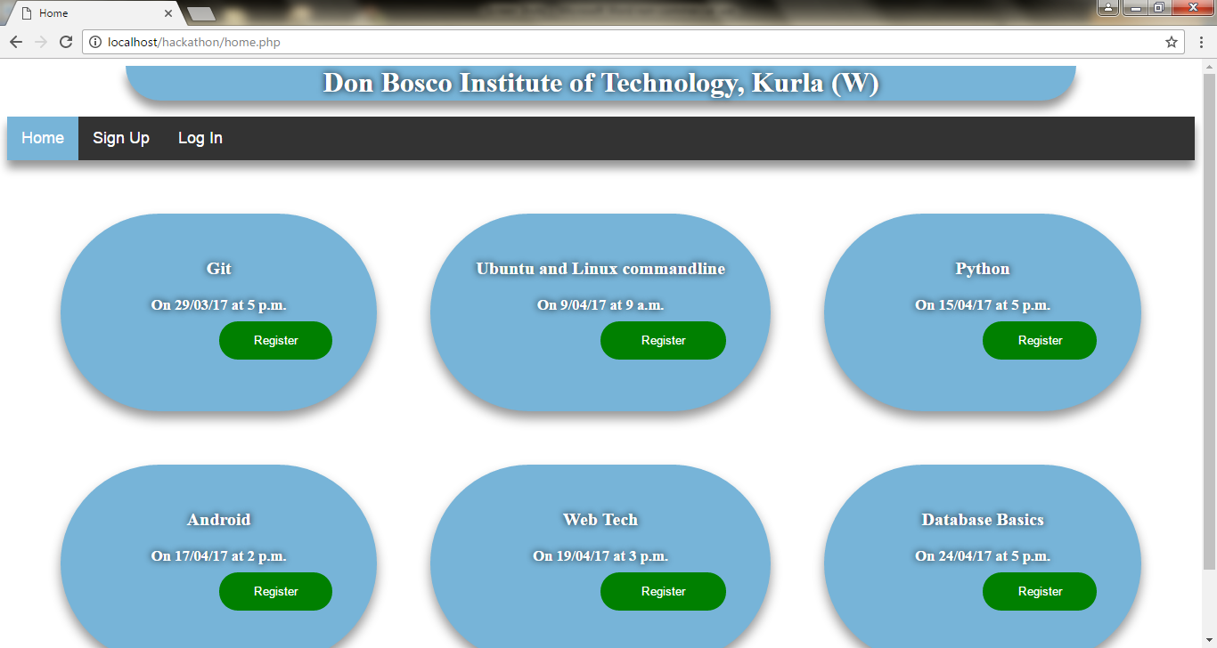

2. Sign up page

signup.php

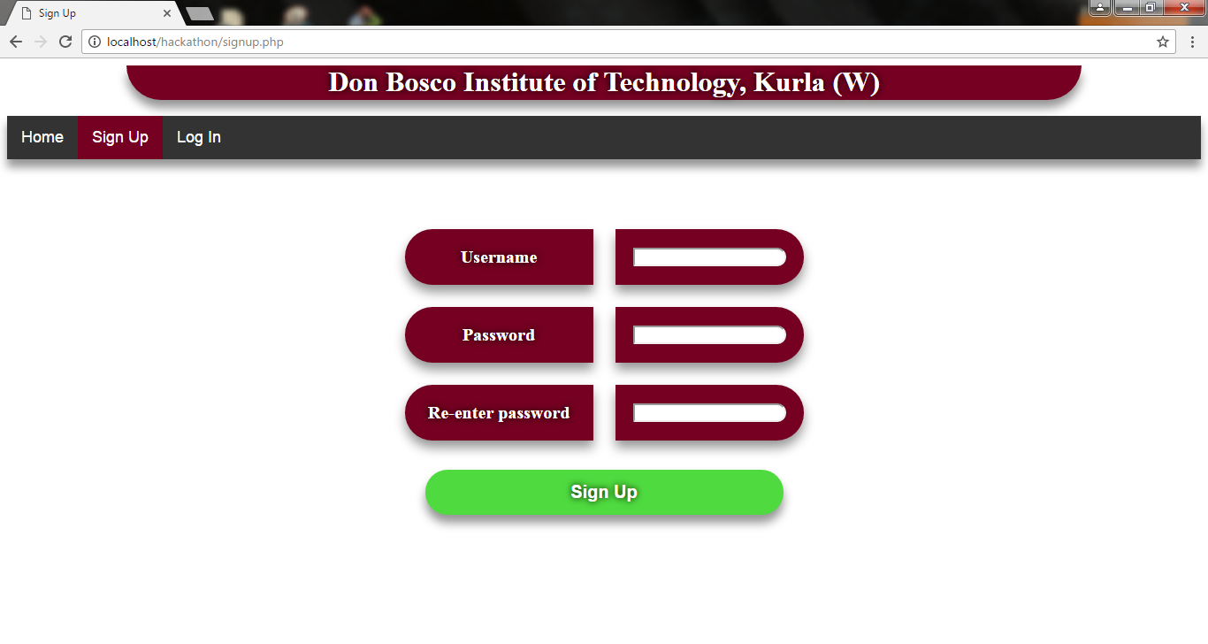

3. Login page

form2.php

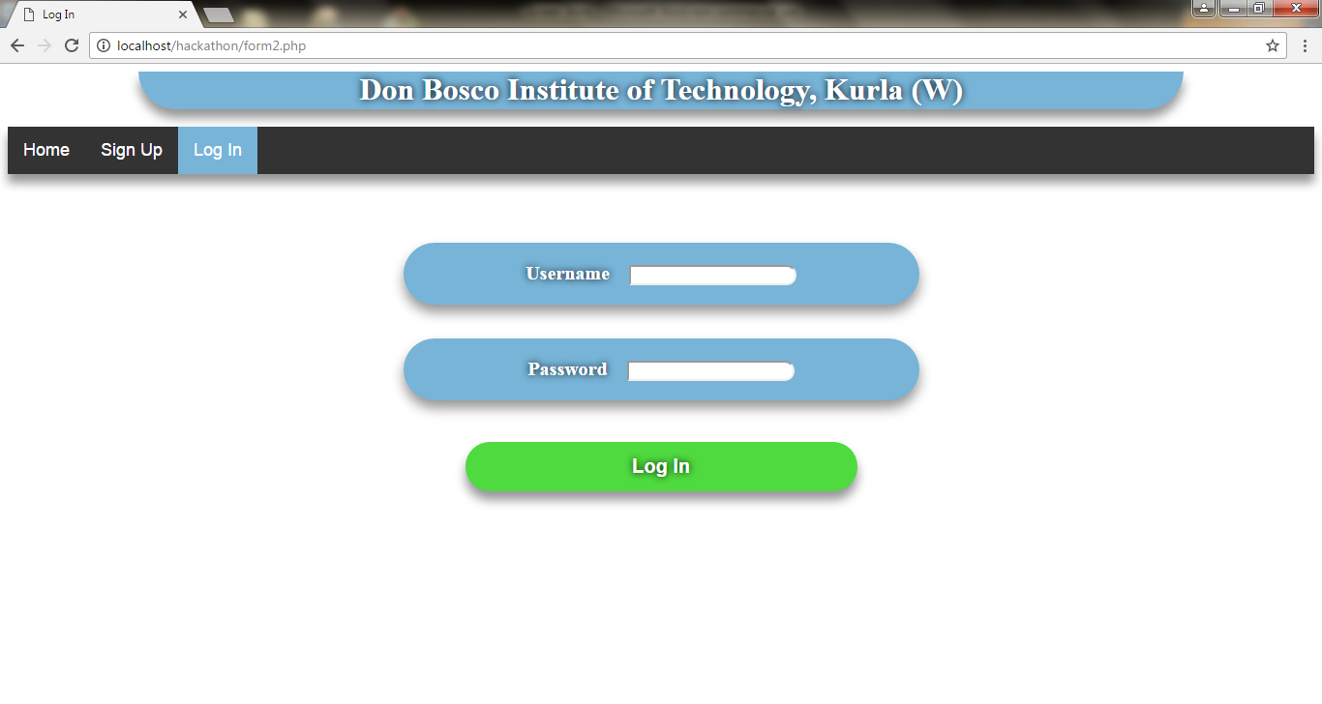

4. Create a new event

createevent.php

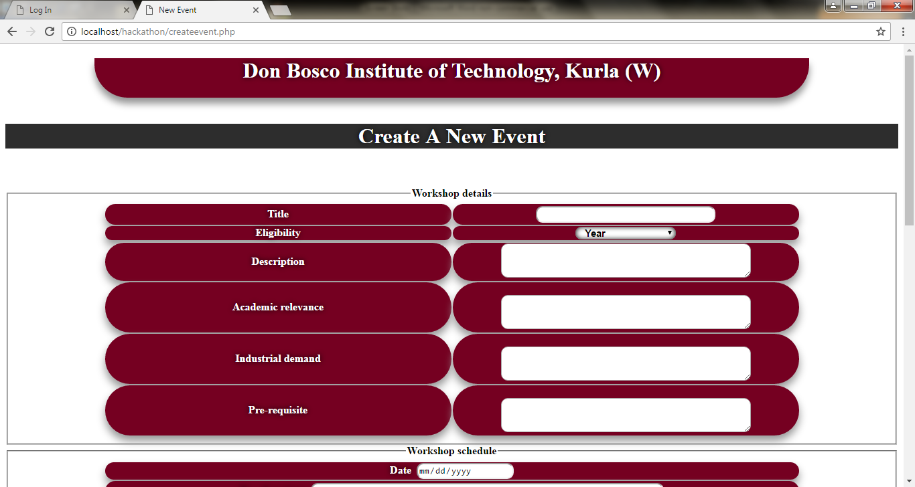

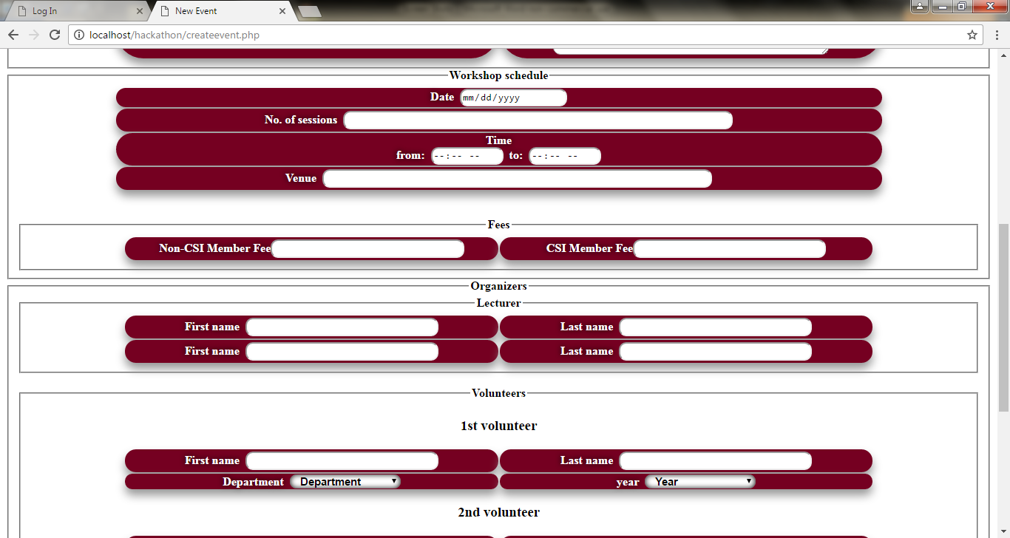

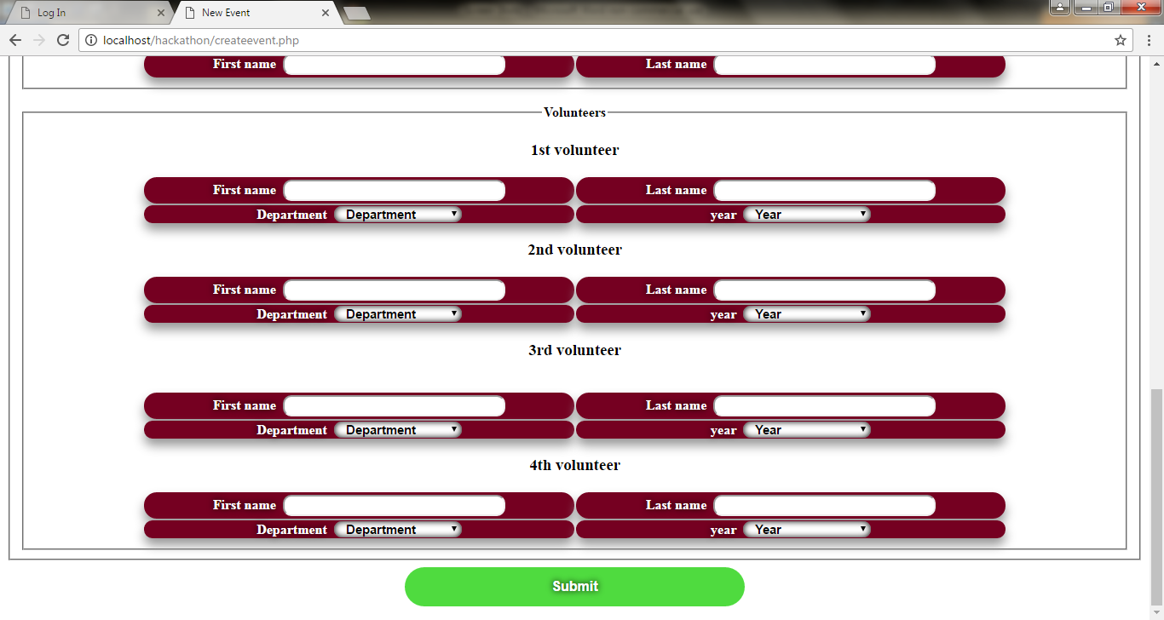

5. Registration page

register.php

