Amazon Sales SQL Queries

- products and categories generating the highest revenue
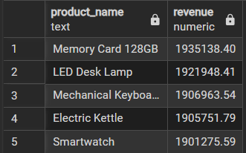

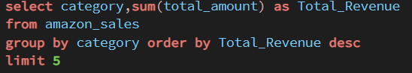
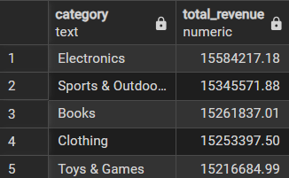

- cities and regions contributing the most sales
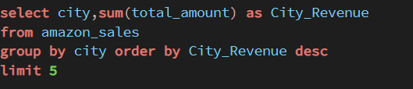
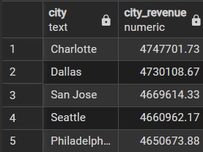
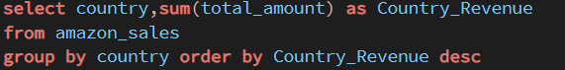
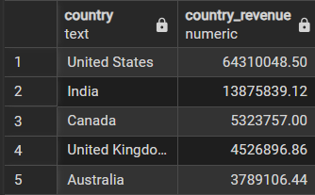

- best performing seller
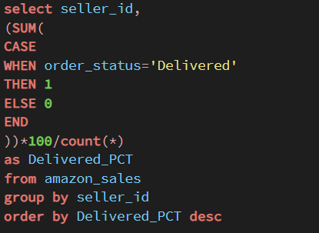
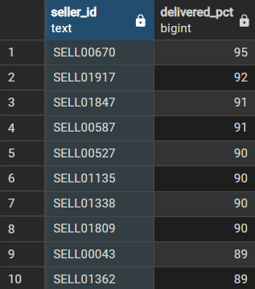
note: BEST SELLERS ARE EVALUATED ON THE BASIS OF
% OF ORDERS DELEIVERED BY THEM

- sales with reference to year
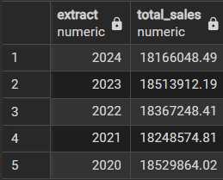

- most preferred payment methods by customers
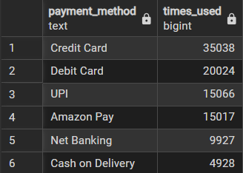

- products with highest discount
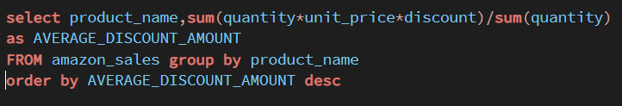
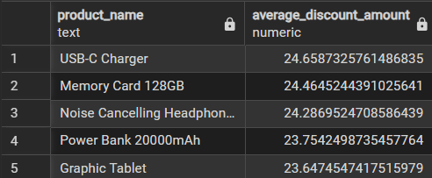

- Are there seasonal trends in customer purchasing behavior?

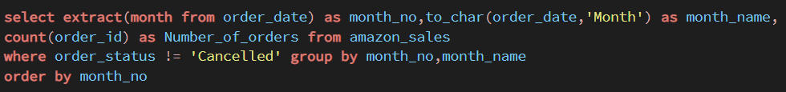

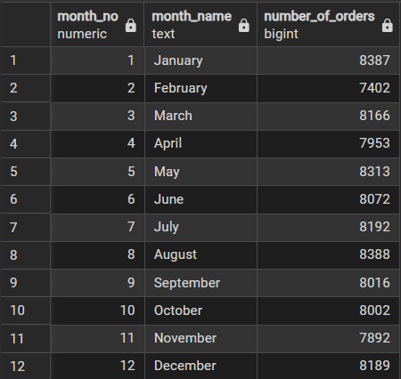

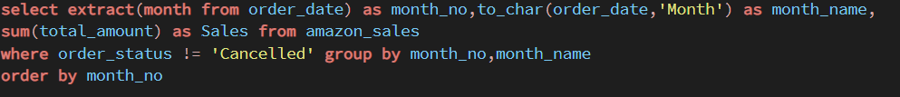

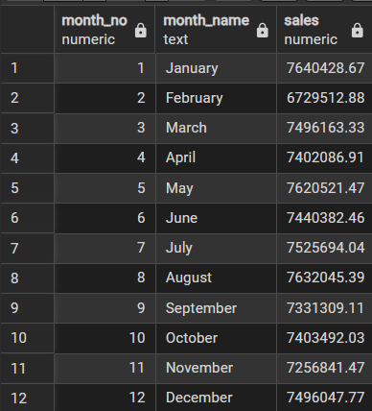

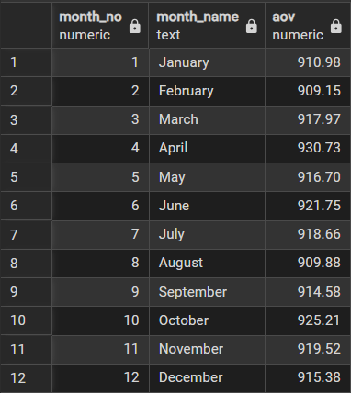

No strong seasonal purchasing trend was observed throughout the year. Monthly revenue, order volume, and Average Order Value (AOV) remained relatively stable. February recorded the lowest revenue (₹6.73M), primarily due to a lower number of orders (7,402), while the AOV remained consistent with other months. This indicates that the decline in revenue was driven by reduced order volume rather than a decrease in customer spending per order.

- Which operational metrics require management attention?

Seller Performance and Cancellation Rate are the key operational metrics that require continuous monitoring. Poor-performing sellers and high cancellation rates can negatively impact revenue, customer satisfaction, and overall operational efficiency. Management should regularly review these metrics to identify operational issues and take corrective actions.

