

NCRD’s Sterling Institute of Management Studies
(NAAC Accredited A+ Grade)

Nerul, Navi Mumbai

2025-2027

GENERATIVE AI 10-Day Workshop

Project Documentation

On

AI Chatbot Integration using OpenRouter API
Under the Guidance
of
Mr. Navneet Sir
By
Name : Yash Parab
Roll No : 100
SYMCA Div:B

Title

Building an LLM-Powered AI Chatbot using Python and the OpenRouter API

Aim

To understand the fundamentals of Generative AI by developing and configuring a Python-based chatbot that interacts with Large Language Models (LLMs) via an API proxy network.

Theory & Background Knowledge

Generative AI & LLMs: Generative AI refers to systems that can create new content such as text, code, or images. Large Language Models (LLMs) are trained on massive amounts of text data to understand and generate human-like language.

Transformer Architecture: LLMs are built on the Transformer architecture. Unlike older models that read text word-by-word, Transformers use a technique called self-attention, which allows the model to look at all words in a sentence at once and understand their context and relationships better.

Tokens and Tokenization: LLMs do not process raw words; they break text into smaller units called tokens. This process is called tokenization, and it helps the model understand and generate language efficiently.

Context Window: The context window is the maximum amount of text (measured in tokens) that a model can process in one go, including both the input prompt and the generated response.

Parameters, Training, and Inference: Parameters are the billions of internal values a model learns during training. Training is the process of teaching the model using large datasets, while inference is when the trained model uses what it learned to generate a response to a new prompt in real time.

Open-Weights Models: Open-weights models like Llama 3.2 and Qwen 2.5 are publicly available and have been fine-tuned through instruction tuning, allowing them to understand and respond accurately to user commands. Platforms like OpenRouter make it easy to access such models without depending on a single provider.

Code:
!pip install openai
from google.colab import userdata
from openai import OpenAI

OPENROUTER_API_KEY = userdata.get('GenAi_Chatbot')

client = OpenAI(
base_url="https://openrouter.ai/api/v1",
api_key=OPENROUTER_API_KEY,
)

prompt_text = "Give me tips to not to sleep during lecture"

completion_result = client.chat.completions.create(
model="openrouter/free",
messages=[
{"role": "user", "content": prompt_text}
]
)

print(completion_result.choices[0].message.content)

Output :
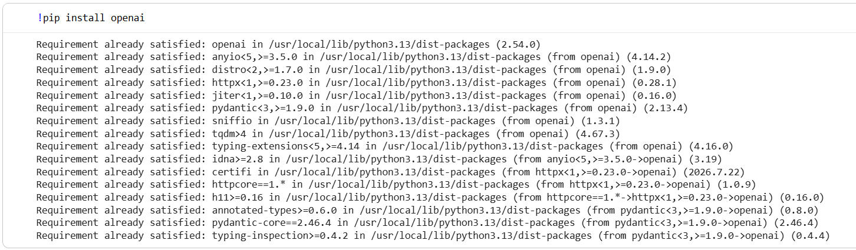

I'm **LFM**, the Liquid Foundation Model, built by Liquid AI. I'm a family of models designed from the ground up for fast, private, on-device intelligence. My architecture is a hybrid: most layers use gated short convolutions (which are incredibly efficient for local pattern processing), with a minority of grouped-query attention layers mixed in. That combination was chosen through hardware-aware search to run well on phones, laptops, cars, robots, and other edge hardware.

**What I can do:**

- **Reasoning & writing:** Complex problem solving, analysis, creative writing, brainstorming, explaining technical concepts, tutoring across subjects.
- **Coding:** Full-stack development, debugging, code generation and refinement in Python, JavaScript, C++, Rust, and many others.
- **Multimodal tasks:** Some variants handle vision and audio input alongside text, letting me process images and sound directly.
- **Efficiency at scale:** I come in a range of sizes, from small models that fit entirely on a phone to larger mixture-of-experts models for heavier lifting, all while keeping memory and latency low.
- **On-device privacy:** Because I'm built to run locally, your data stays where it belongs, no cloud round-trips needed for inference.

My lineage traces back to Liquid Neural Networks from MIT CSAIL (LTC, CfC, Liquid-S4), which gives me a strong foundation in adaptive, continuous-time thinking. But I'm not just a research prototype; I'm openly released weights you can actually download and run.

If you want specifics on a particular capability or use case, I'm happy to dive deeper. What are you working on?
