WEEK 2 M. YASHWANT RAJ (2520030181)

Step 1: Create Database
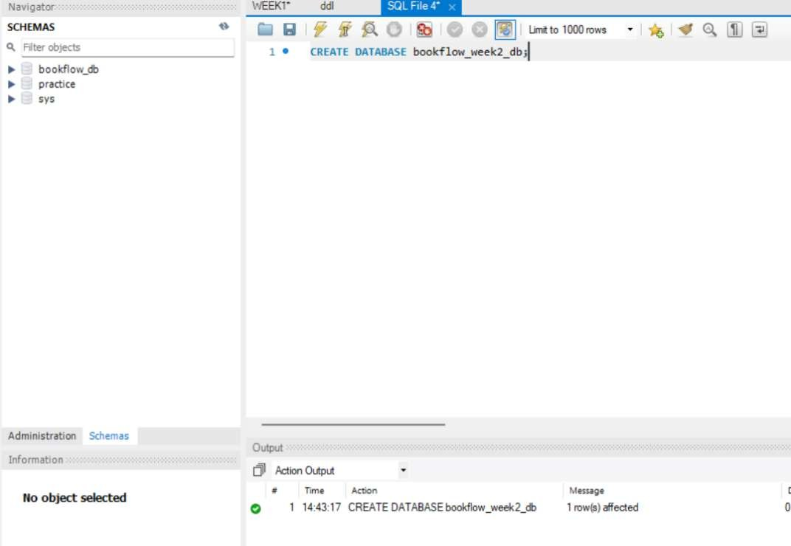

Step 2: Create Books table and insert books
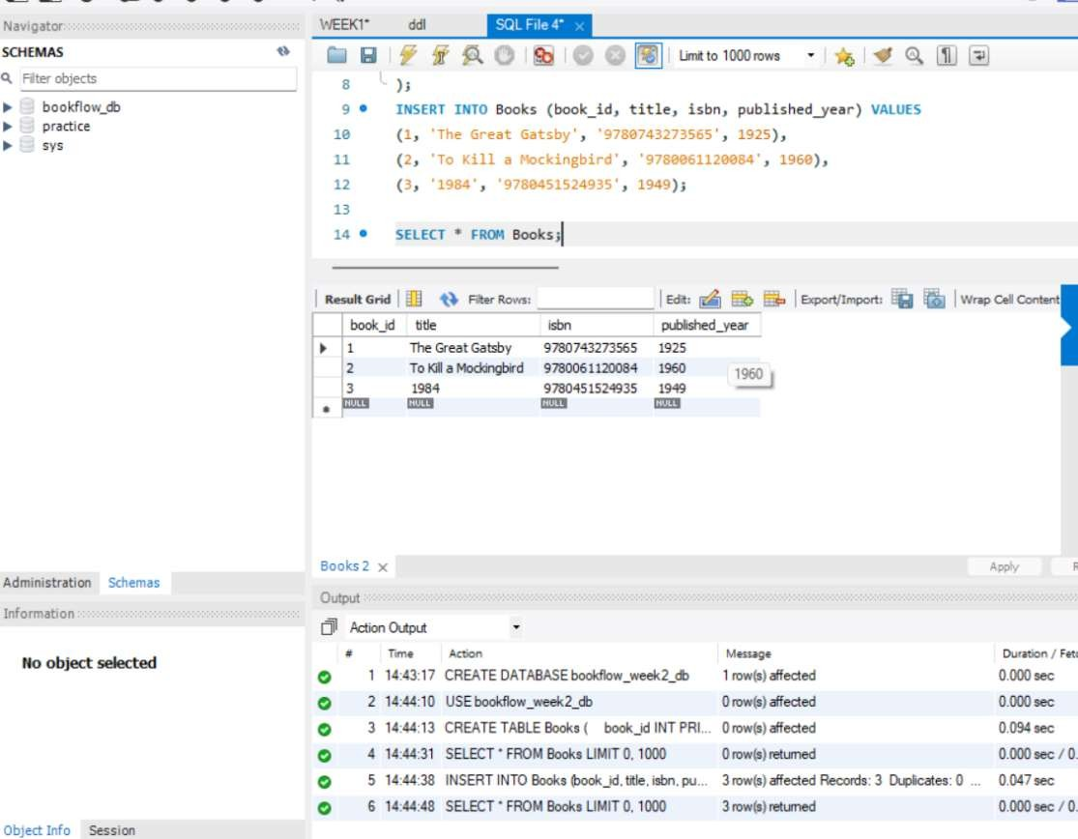

Step 3: Create Table for members and insert members
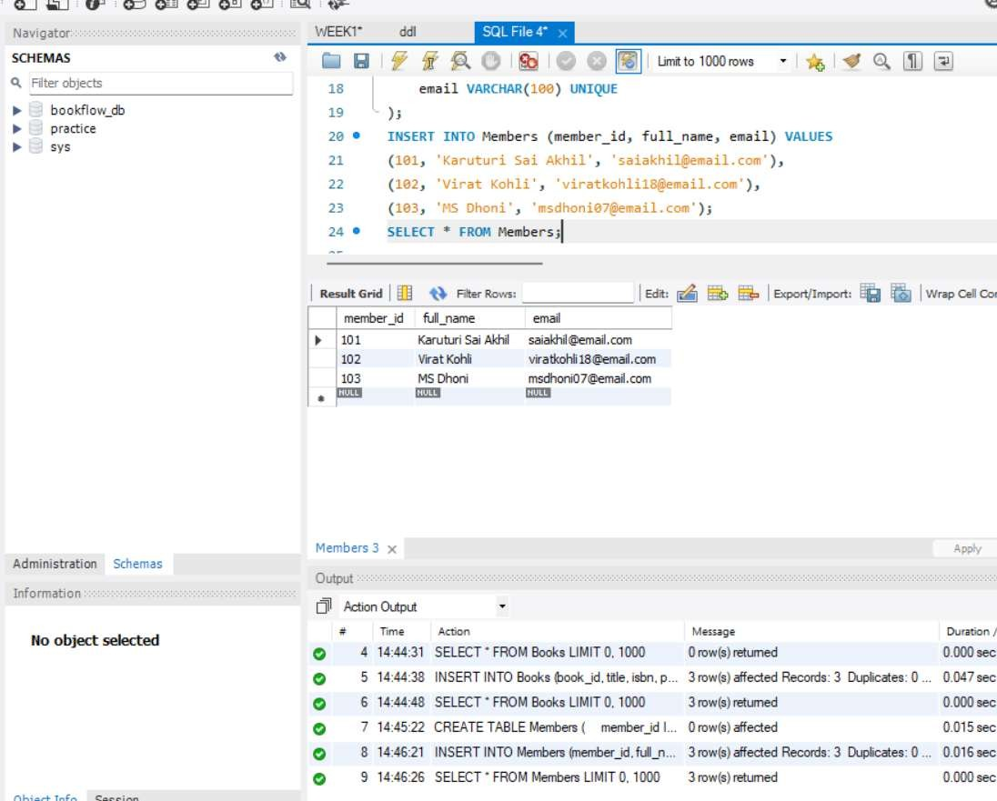
Step 4: CREATE LOANS TABLE
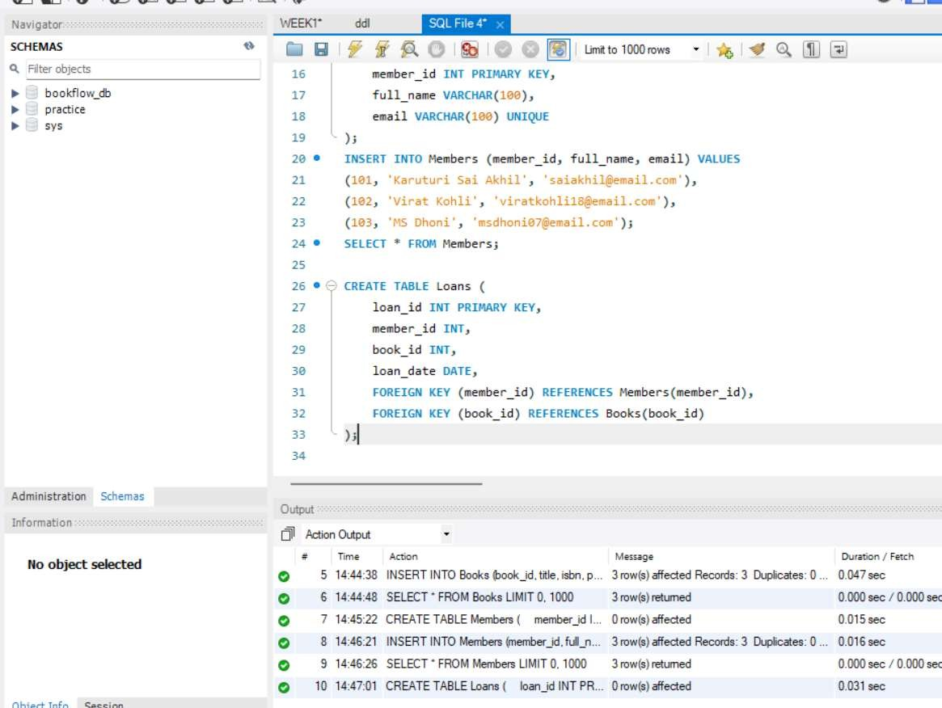

Step 5: INSERT RECORDS INTO LOANS TABLE
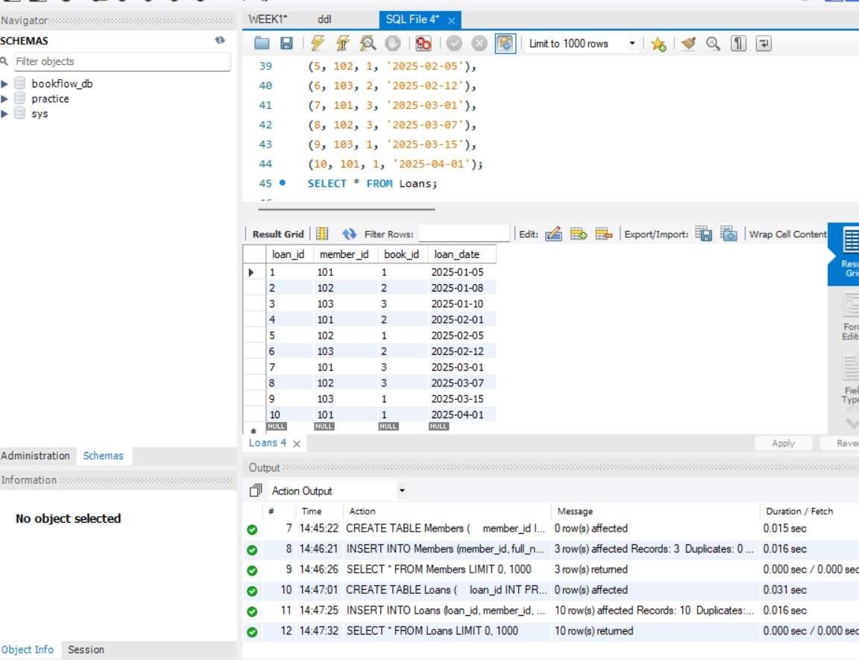
Step 6: JOIN ǪUERY

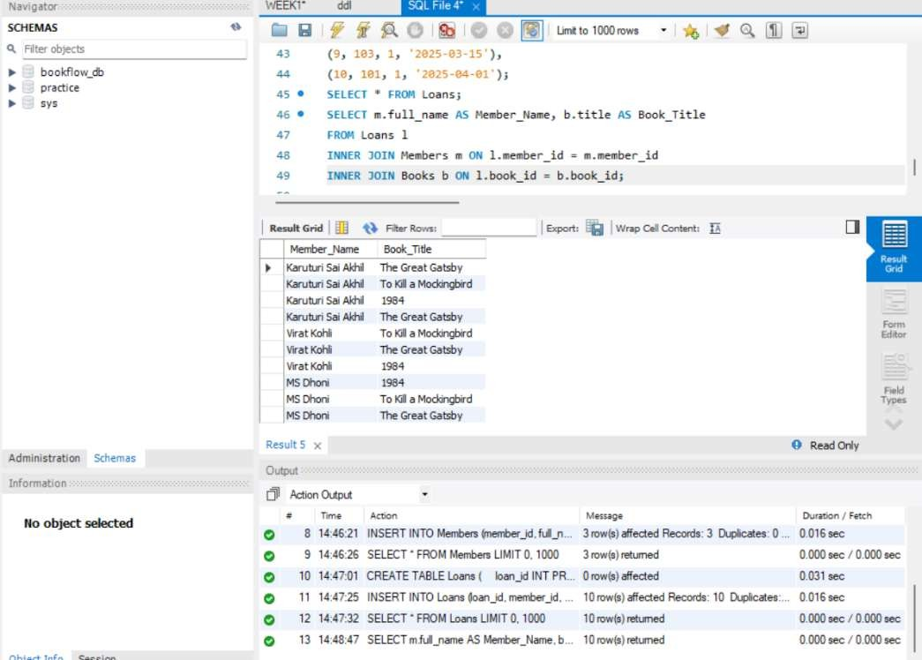
Step 7: GROUP BY + COUNT

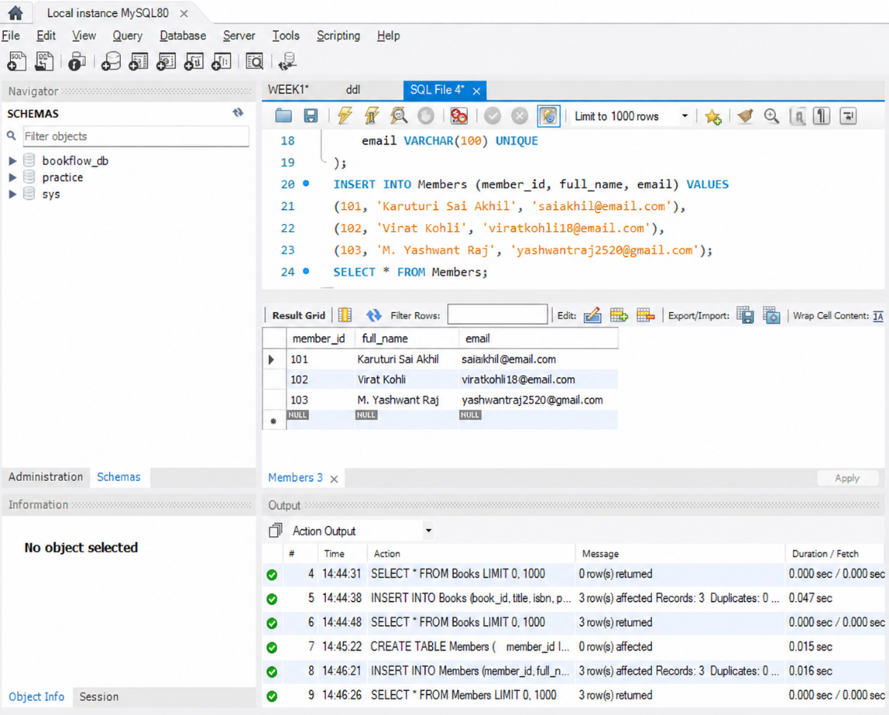
Step 8: Display Donation History
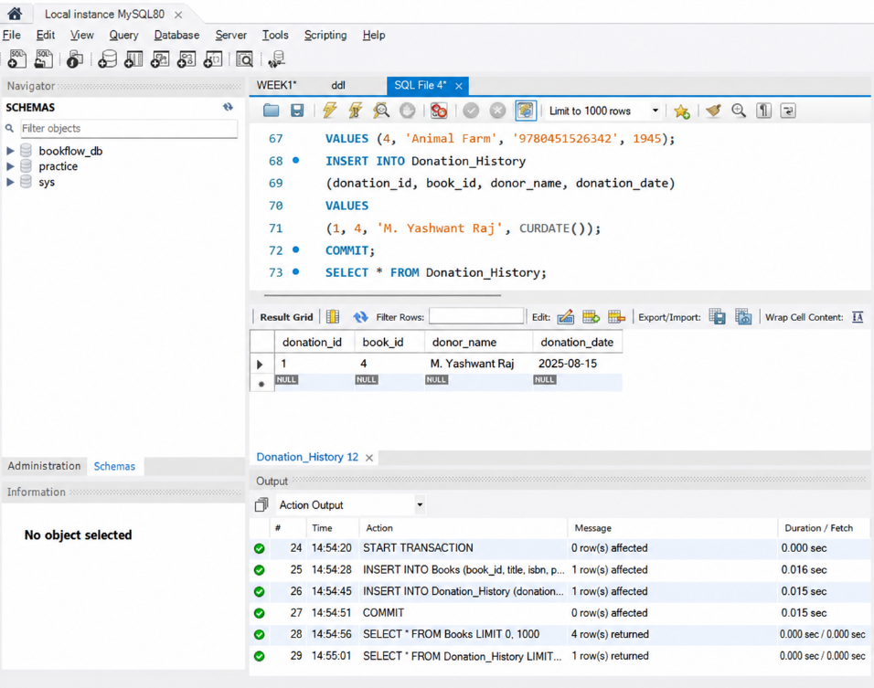

Step 9: Create ISBN Index + Search

