Agent Performance Testing Orchestrator
Runbook & User Guide
Generated: 2026-04-03 14:39

Table of Contents
1. Login Page
2. Admin Dashboard
3. Servers Configuration
4. Load Profiles
5. Agents
6. Agent Sets
7. Snapshot Manager
8. Tests — OS Level & Agent Set
9. All Baseline Tests
10. Create OS Level Test (page)
11. Trending Analytics

Overview
This runbook documents the Agent Performance Testing Orchestrator, a distributed performance testing framework that measures the CPU overhead of security agents on servers.
The system works by:
1. Calibrating thread counts to achieve target CPU levels (20-40%, 40-60%, 60-80%)
2. Running controlled workloads via JMeter against emulator endpoints
3. Collecting CPU/memory statistics during execution
4. Comparing results between baseline (no agent) and agent-installed snapshots
Key components:
- Orchestrator: FastAPI web application managing test lifecycle
- Emulator: Java Spring Boot application on targets simulating server workloads
- JMeter: Load generator sending HTTP requests to emulators
- Hypervisor: Proxmox/vSphere for snapshot management and VM operations

Test Workflow
New Baseline Test Flow:
1. Validating - Pre-flight checks (connectivity, snapshots, packages)
2. Deploying Loadgen - Revert loadgen, install JMeter
3. Deploying Calibration - Revert targets, deploy emulator, upload JMX+CSV
4. Calibrating - Find thread count for each load profile's target CPU range
5. Generating - Create deterministic ops sequence CSVs
6. Deploying Testing - Revert targets, deploy emulator for test run
7. Executing - Run JMeter at calibrated thread counts, collect stats
8. Storing - Save results to DB and disk
Compare Test Flow:
1. Validating
2. Deploying Loadgen
3. Deploying Testing - Uses stored thread counts + CSVs from parent baseline
4. Executing - Runs same workload on new snapshot (with agent)
5. Comparing - Computes CPU delta between baseline and agent snapshots
6. Storing

1. Login Page
Navigate to the orchestrator URL and enter your credentials.

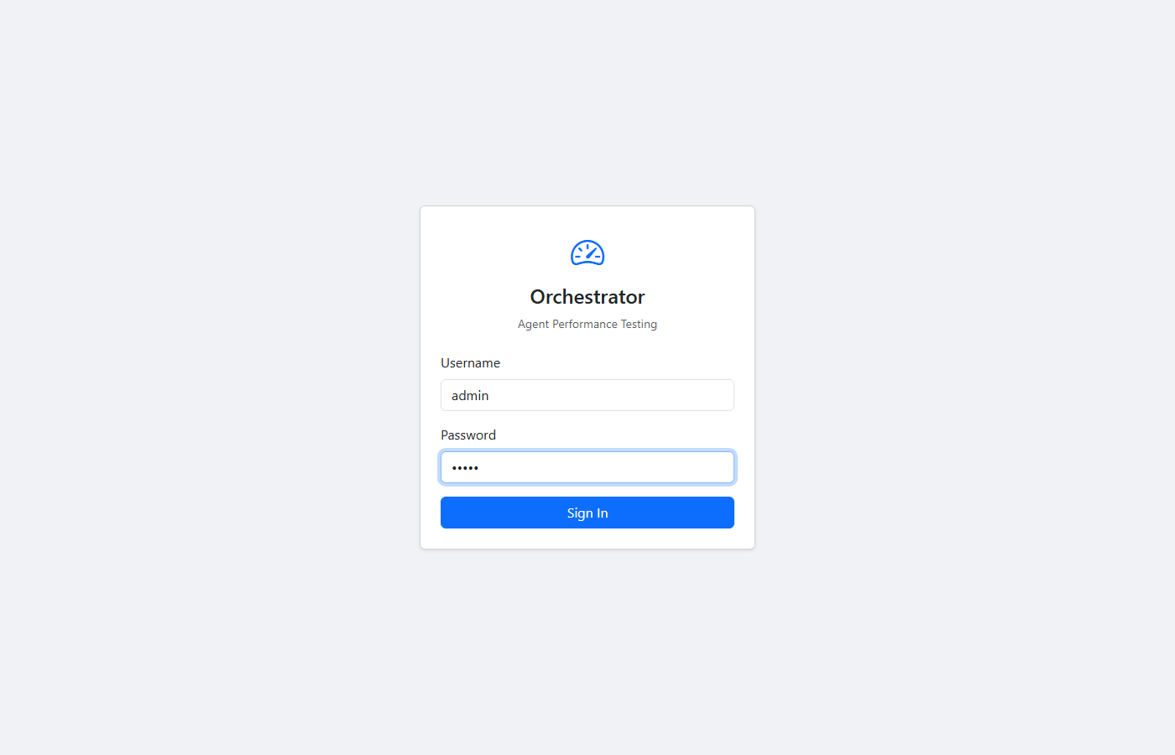

2. Admin Dashboard
The main dashboard shows an overview of labs, servers, active and completed baseline tests, and recent test runs.

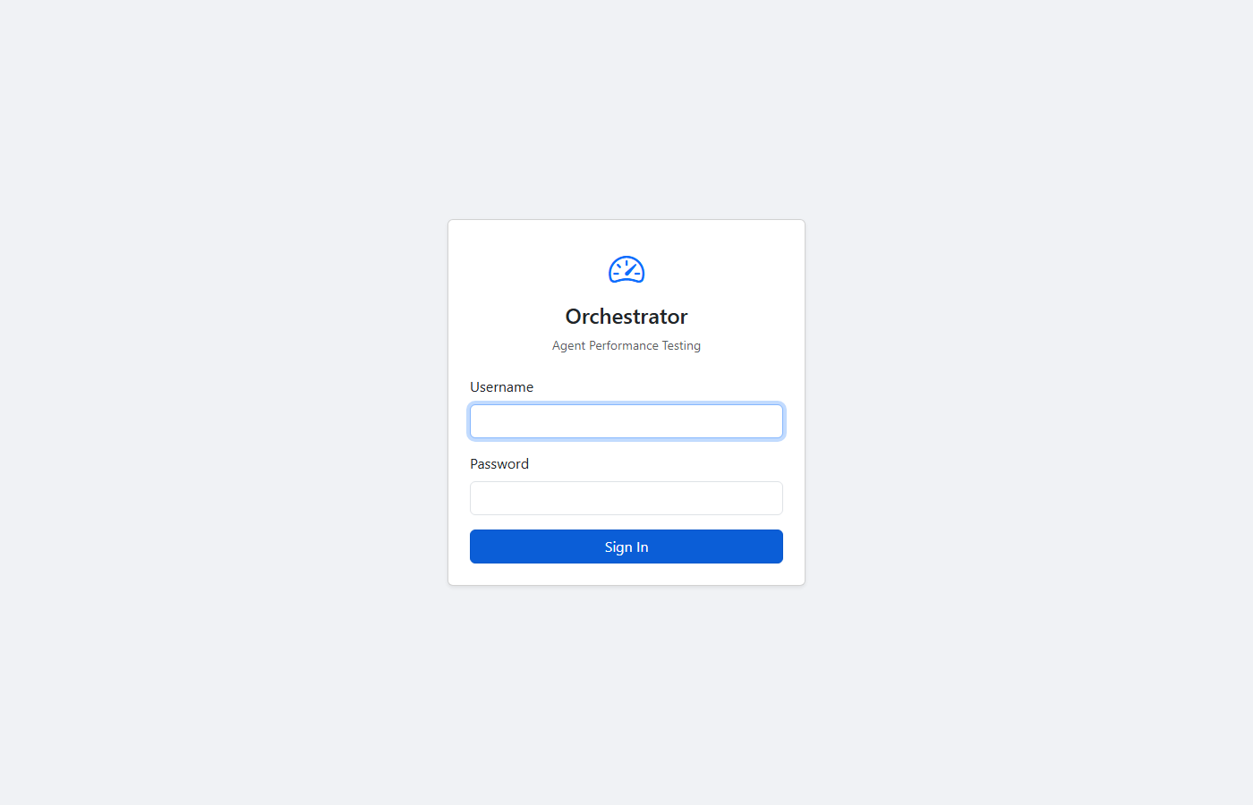

3. Servers Configuration
View all registered servers including targets, load generators, and their IP addresses, OS family, and lab assignment.



4. Load Profiles
Load profiles define target CPU ranges for calibration. Typically: low (20-40%), medium (40-60%), high (60-80%).



5. Agents
View registered security agents and their versions. Agents are installed on targets and their performance overhead is measured.



6. Agent Sets
Agent Sets define combinations of security agents for testing.
Examples: 'CrowdStrike Only' (single agent), 'CS + Tanium' (multi-agent).
Agent Sets are reused across servers — define once, test everywhere.



7. Snapshot Manager
View the snapshot hierarchy per server.
OS Level = root snapshot (clean prepared OS).
Subgroups = agent sets with snapshots taken after agent installation.



8. Tests — OS Level & Agent Set
The Tests page shows OS Level Tests (baselines) as expandable rows.
Expand a row to see Agent Set Tests nested under it.
- 'New OS Level Test': Create a clean OS baseline test.
- 'Agent Set Test' (on completed baselines): Create a compare test with agents.



9. All Baseline Tests
Flat list of all test runs (both OS Level and Agent Set).
Shows type, state, verdict, and action buttons.
Use 'Delete All Tests' to clean up.



10. Create OS Level Test (page)
OS Level Test creation page.



11. Trending Analytics
Track performance metrics across multiple test runs over time. Filter by server, load profile, and date range to identify trends in agent overhead.



Appendix: Key Commands

Start Orchestrator
cd orchestrator
PYTHONPATH=src python -m uvicorn orchestrator.app:app --host 0.0.0.0 --port 8000

Sync Code from GitHub
cd setup
python sync_setup.py
find ../orchestrator -name '*.pyc' -delete

Setup JMeter on a Machine
python setup_jmeter.py --disk sdc

Retake Snapshots
python retake_snapshots.py 'test name' --sudo-user ak1svc231

Validate Calibration
python validate_calibration.py 'test name' --check-running

Live Calibration Test
python test_calibration_live.py --target-ip 10.x.x.x --threads 8 --think-ms 100

Test Workload (Direct HTTP)
python test_workload.py --target-ip 10.x.x.x --touch-mb 1.0

Delete Cache Files
find ../orchestrator -name '*.pyc' -delete
find ../orchestrator -name '__pycache__' -type d -exec rm -rf {} + 2>/dev/null

