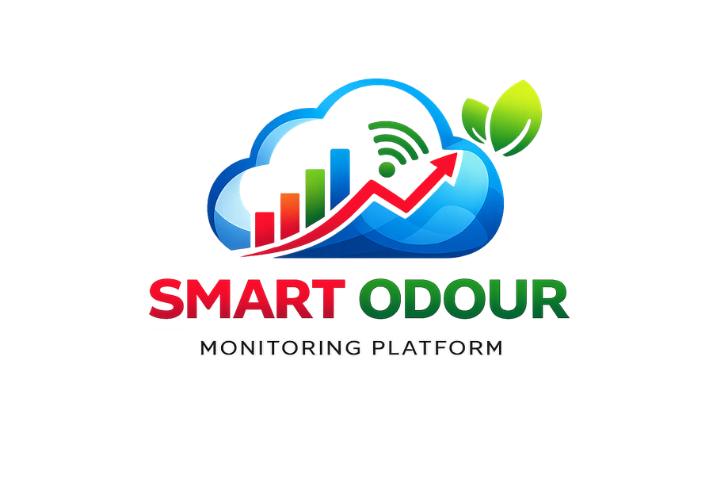
SMART ODOUR MONITORING PLATFORM
CAMPUS AIR QUALITY MONITORING USING IoT SENSOR NODES AND EDGE COMPUTING
CHAPTER 1, 3 AND 4
INTRODUCTION, METHODOLOGY, ANALYSIS AND DESIGN
FACULTY OF INFORMATION AND COMMUNICATION TECHNOLOGY
UNIVERSITI TEKNIKAL MALAYSIA MELAKA
2026
Note on Chapter 2
Chapter 2, the literature review, is not included in this document. It requires reading and synthesising the collected body of work, and writing it without access to those sources would produce citations that could not be substantiated. Section 1.7 records the foundations on which the review should be built.
The problem statement and objectives in Chapter 1 are drafted from the system as built and from the project brief. They should be reviewed against the supervisor’s framing before submission.

TABLE OF CONTENTS

CHAPTER 1: INTRODUCTION

1.1 Introduction
Airborne odour is among the most frequent environmental complaints in communities situated near agricultural and waste-handling operations. Unlike noise or visible pollution, odour is transient, highly variable, and difficult to substantiate after the fact. A resident who experiences a strong smell at four in the morning has, by the time an inspector arrives, no evidence that it occurred.
The campus of Universiti Teknikal Malaysia Melaka lies adjacent to agricultural land. Residential colleges, faculty buildings and food-service areas are subject to intermittent odour episodes whose intensity, timing and origin are not currently recorded. Facility management therefore responds to complaints rather than to measurements, and cannot demonstrate whether conditions are improving or worsening.
This project develops a monitoring platform that measures odour-associated gas concentrations continuously at fixed points across the campus, records every reading in a form that can be audited, evaluates readings against configurable thresholds, and notifies responsible staff automatically when limits are exceeded. Where a breach is severe, the system activates exhaust ventilation without human intervention.
The platform is built on distributed edge computing rather than on conventional server infrastructure. This decision is central to the project: environmental monitoring has value only if it is continuous, and a monitoring system that is itself unreliable produces gaps precisely when conditions are abnormal.

1.2 Problem Statement
The problems addressed by this project are summarised in Table 1.1.
TABLE 1.1: PROBLEM STATEMENT
PS | Problem Statement
PS1 | Odour episodes on campus are transient and are not recorded, so complaints cannot be substantiated and no evidence exists to support remediation or to demonstrate whether conditions change over time.
PS2 | Detection depends on human reporting, which is delayed and intermittent. An episode occurring overnight or in an unoccupied area is not observed at all.
PS3 | Environmental monitoring deployments commonly depend on a single server or gateway, creating a point of failure that causes data loss during the very periods when conditions are abnormal.

1.3 Project Question
The problem statements give rise to the questions summarised in Table 1.2.
TABLE 1.2: SUMMARY OF PROJECT QUESTION
PS | PQ | Project Question
PS1 | PQ1 | How can odour-associated gas concentrations be measured continuously and recorded such that each reading is attributable to specific hardware and cannot be forged or altered?
PS2 | PQ2 | How can threshold breaches be detected and communicated to responsible staff automatically, and how can ventilation be actuated without human intervention?
PS3 | PQ3 | How can the platform be architected so that no single component failure interrupts measurement or loses data, and how can that property be measured rather than asserted?

1.4 Project Objective
TABLE 1.3: SUMMARY OF PROJECT OBJECTIVE
PS | PQ | PO | Project Objective
PS1 | PQ1 | PO1 | To develop IoT sensor nodes that sample gas concentration, temperature and humidity at fixed intervals and transmit each reading with a cryptographic signature that proves its origin and integrity.
PS2 | PQ2 | PO2 | To develop an evaluation and notification subsystem that compares readings against administrator-configured thresholds, raises incidents, delivers alerts through multiple channels, and triggers exhaust ventilation autonomously.
PS3 | PQ3 | PO3 | To design a distributed architecture without a single point of failure, incorporating local buffering for network outages, and to instrument the platform so that availability and data completeness are measured from recorded observations.

1.5 Project Scope
The scope of the project is bounded as follows.

1.5.1 Within scope
- Design and construction of an ESP32-based sensor node carrying MQ-5, MQ-6 and two MQ-7 gas sensors, a DHT11 climate sensor, a local display and a relay-driven exhaust output.
- Cryptographically signed transmission of readings and their storage in a cloud database.
- Threshold evaluation, incident management and multi-channel notification.
- Three web interfaces: a public view requiring no account, a portal for registered residents, and an administrative portal with role-separated privileges.
- Historical querying and export for compliance reporting.
- A predictive component forecasting short-term trends from recorded readings.
- Instrumentation for availability measurement.

1.5.2 Outside scope
- Laboratory calibration of sensors against reference gases. The platform reports a relative severity index and does not claim absolute concentrations.
- Identification of specific chemical species. The sensors respond to families of gases rather than to individual compounds.
- Regulatory compliance certification. Output supports internal decision-making, not statutory reporting.
- Control of the odour source itself. The system measures and mitigates locally; it does not intervene at origin.

1.6 Project Significance
The project produces a record where none exists. Once episodes are logged with timestamps and intensities, facility management can determine whether complaints correlate with measurable conditions, whether episodes follow a daily or seasonal pattern, and whether any intervention has an effect.
Two design decisions extend beyond this deployment. First, signing readings at the point of measurement means a stored value is attributable to specific hardware rather than to any party holding a shared credential, which matters whenever environmental data may be contested. Second, pairing local buffering with monotonic sequence numbers and a uniqueness constraint makes delivery idempotent by construction, so a node can lose connectivity without losing data and without double-counting on recovery.
The platform also operates entirely within free-tier infrastructure, demonstrating that continuous environmental monitoring at this scale need not carry recurring cost.

1.7 Foundations for the Literature Review
This section records the areas the literature review in Chapter 2 should address. It is not itself a review.
- Gas sensing: the response characteristics of MQ-series metal-oxide sensors, their cross-sensitivity between gas families, the influence of temperature and humidity on output, drift over sensor lifetime, and the calibration procedures required to convert resistance to concentration.
- Agricultural environmental monitoring: existing deployments monitoring ammonia, carbon dioxide and related gases in poultry and composting environments, including reported thresholds, sampling intervals and observed diurnal patterns.
- IoT system architecture: architectural patterns for sensor networks, comparing gateway-centric designs against direct-to-cloud transmission, and the reliability implications of each.
- Edge computing: the migration of processing from centralised cloud to distributed edge, and the availability characteristics that motivate it.
- IoT security: device authentication in constrained environments, comparing bearer credentials, certificate-based mutual authentication and message-level signing.
- Predictive modelling: short-horizon forecasting from environmental sensor data, including model selection under limited sample counts and the treatment of temporal dependence in validation.
The review should conclude by identifying the gap this project addresses. On the evidence of the system as built, that gap concerns verifiable data provenance and measured availability: many deployments report readings, fewer establish that a reading originated from the claimed device, and fewer still measure their own uptime rather than assuming it.

CHAPTER 3: METHODOLOGY

3.1 Introduction
This chapter describes the development methodology adopted, the activities performed at each stage, and the milestones by which progress was tracked.

3.2 Methodology
The project followed an iterative prototyping methodology within the System Development Life Cycle. Iterative prototyping was selected over a linear waterfall approach for a specific reason: the project integrates physical hardware with cloud services, and several constraints in that integration could not be known in advance of implementation.
This proved correct in practice. Three constraints emerged only during construction: a platform limit on cryptographic iteration count that no documentation review would have surfaced, a browser policy governing credentials across domains, and the unavailability of a hardware peripheral while the wireless radio is active. Each required design revision. A methodology assuming requirements could be fixed before implementation would have absorbed these as defects rather than as expected iteration.

3.2.1 Overview of the System Development Life Cycle
The lifecycle comprised requirements analysis, analysis and design, prototype creation, evaluation, review and update, development, testing and maintenance. The middle stages were revisited on each iteration rather than completed once.

3.2.2 Requirements Analysis
Requirements were elicited from the project brief and refined into functional groupings: predictive analytics, hardware and edge integration, cloud architecture, alerting, platform features, and observability. Each requirement was recorded in a form permitting later verification, and traced through to a test case in Chapter 6.

3.2.3 Analysis and Design
System architecture, data model and interface design were produced during this stage. The architecture was revised once during the project: an initial design based on virtual machines, a load balancer and an auto-scaling group was replaced by distributed edge compute, on the grounds that removing the origin server eliminates a failure mode rather than mitigating it. Chapter 4 documents the resulting design.

3.2.4 Prototype Creation
Prototypes were constructed for each subsystem independently before integration: firmware sampling and signing, cloud ingestion and storage, the web interfaces, and the predictive component. Constructing them separately allowed each to be verified in isolation, so that failures during integration could be localised.

3.2.5 User Evaluation
Interface prototypes were reviewed against the intended interaction for each role. Evaluation produced two substantive changes: the administrative portal was made to refuse users lacking privilege rather than presenting a console whose panels silently failed, and the first-run experience was changed to detect an uninitialised system and offer administrator creation directly, rather than presenting a registration form that no user could yet satisfy.

3.2.6 Review and Update
Each iteration concluded with a review of implemented functionality against requirements. Where implementation revealed a constraint, the design was updated and the change recorded with its rationale in the version control history.

3.2.7 Development
Development proceeded subsystem by subsystem. Version control was maintained throughout, with continuous deployment configured so that committed changes reached the running system without manual intervention. Chapter 5 documents the configuration in detail.

3.2.8 Testing
Testing was performed continuously rather than as a terminal phase. Each subsystem was tested on completion and the full suite re-executed after every defect fix. Testing was conducted against the deployed runtime rather than a simulator, a decision vindicated when a defect was found that the simulator could not reproduce. Chapter 6 presents the results.

3.2.9 Maintenance
Maintenance provisions include a version endpoint reporting the running build, an availability probe recording uptime continuously, and structured logging of notification delivery. The database schema is versioned through migration files so that structural changes are reproducible.

3.3 Project Milestones
TABLE 3.1: PROJECT MILESTONES
No. | Milestone | Deliverable
M1 | Requirements analysis | Requirement groupings with verification criteria
M2 | Architecture design | System architecture and data model
M3 | Database implementation | Schema, migrations, seed dataset
M4 | Ingestion and API | Signed ingestion endpoint and data services
M5 | Authentication and access control | Accounts, sessions, three roles
M6 | Web interfaces | Public, resident and administrative portals
M7 | Alerting subsystem | Thresholds, incidents, notification channels
M8 | Edge firmware | Sampling, signing, buffering, actuation
M9 | Predictive component | Forecasting model with fallback tiers
M10 | Testing | Test cases executed and defects resolved
M11 | Hardware commissioning | Physical node assembled and reporting
M12 | Documentation | Project report

3.4 Conclusion
The iterative prototyping methodology suited a project whose constraints could not be fully established before implementation. Three platform limitations that emerged during construction were absorbed as design revisions rather than as failures, and each is documented with its resolution in Chapter 6.

CHAPTER 4: ANALYSIS AND INTERFACE DESIGN

4.1 Introduction
This chapter presents the analysis underlying the system design, the resulting architecture, the processing flow, and the design of the user interfaces.

4.2 Problem Analysis
Analysis of the problem statements identified four properties the system must possess.
- Verifiable provenance: a reading must be attributable to specific hardware. If environmental data may be contested, a value that could have originated from any party holding a shared credential has limited evidential weight. This requirement led to message-level signing rather than bearer authentication.
- Continuity under failure: measurement must not stop when the network does. A node that discards readings during an outage produces gaps, and outages are not independent of the conditions being measured. This requirement led to local buffering with sequence numbering.
- Autonomous response: a hazardous condition must produce a response without waiting for a person. This requirement led to autonomous actuation decided on the node, so that ventilation responds even when connectivity is lost.
- Measurable reliability: availability must be recorded rather than assumed. This requirement led to a probe writing observations to persistent storage at fixed intervals.

4.3 System Architecture
The system comprises four layers.
TABLE 4.1: SYSTEM ARCHITECTURE LAYERS
Layer | Components | Responsibility
Edge | ESP32 node, gas and climate sensors, relay | Sampling, signing, buffering, local actuation
Compute and storage | Edge functions, database, object storage, key-value store | Verification, persistence, evaluation, notification
Presentation | Public view, resident portal, administrative portal | Visualisation, historical query, administration
Analytical | Compute sidecar | Forecasting, compliance report generation
Data flows as follows:
Sensor node --HTTPS+HMAC--> Edge function --> Database
|
+--> Object storage (raw archive)
+--> Threshold evaluation --> Incident
| |
| +--> Telegram
| +--> Email
+--> Portals (public / resident / admin)
The raw payload is written to object storage before it is parsed. If a later schema change renders a stored record incorrect, the original bytes remain recoverable.
The analytical layer is deliberately not on the critical path. If the compute sidecar is unavailable, forecasts become stale and report generation fails, while ingestion, evaluation, alerting and all three portals continue to function.

4.4 Flow Chart of the System
The principal processing sequence is as follows.
- The node samples all sensors and computes a local severity index.
- If the index exceeds the actuation threshold, the exhaust relay engages. This decision is local and does not depend on network availability.
- The node constructs a payload, signs it, and attempts transmission.
- If transmission fails, the reading is placed in the local buffer with a sequence number and the loop continues.
- On receipt, the edge function verifies the signature in constant time. An invalid signature is rejected and nothing is stored.
- The raw body is archived to object storage.
- The reading is written to the database. A duplicate sequence number from a replayed buffer is discarded by the uniqueness constraint.
- The reading is evaluated against configured thresholds. A breach opens an incident, subject to a rate limit of one per zone per cooldown period.
- An incident triggers notification through the configured channels.
- Portals reflect the updated state on their next poll.

4.5 User Interface Design
Three interfaces were designed, separated by the privilege they require rather than by the data they present.

4.5.1 Public View
Accessible without an account. Presents the current campus reading, the status of each station, a map of station positions, and any active advisories. Air quality in a shared environment is information residents have a reasonable interest in, and requiring authentication to view it would serve no protective purpose.

4.5.2 Resident Portal
Requires an account. Adds a selectable home zone, historical querying with export, notification preferences, and the ability to submit an observed odour report. Community reports are stored separately from sensor readings: a human observation is not a measurement, and merging the two would corrupt both the charts and the compliance record.

4.5.3 Administrative Portal
Requires the administrator or facility role. Provides live telemetry, historical reporting, the predictive view, threshold calibration, incident management and user administration. A user lacking privilege is refused at entry and directed to the resident portal.

4.5.4 Design principles
- Colour as information: saturated colour is reserved for sensor state. Nothing decorative uses red, amber or green, so those three always carry meaning.
- Numeric legibility: every measurement is set in a monospaced face with tabular figures, so digits remain in column as values update rather than shifting the layout.
- Explicit absence: a panel that cannot show data states why. An empty chart is indistinguishable from a broken one, and a system that reports hazardous conditions must not appear broken when it is merely waiting.
- Honest labelling: stations replaying recorded data are labelled as such wherever they appear, so that a reader is never misled about which values are live measurements.

4.6 Conclusion
The analysis identified four required properties, each of which is traceable to a specific design decision: signing for provenance, buffering with sequence numbering for continuity, local actuation for autonomous response, and probe instrumentation for measurable reliability. The architecture distributes compute to the edge, removing the origin server as a failure point, and isolates the analytical layer so that its unavailability degrades capability without interrupting measurement.

End of Chapters 1, 3 and 4.

