**PRICE COMPARISON APPLICATION- USER MANUAL**

Initial Screen:

The initial screen is used to choose what websites you want to compare. For now, the application uses 2 of the biggest retailers in the world-- Amazon and Walmart--and also Costco, one of the biggest wholesalers in North America. The screen will show the 3 buttons that are clickable on: grey means the website is selected for comparison.

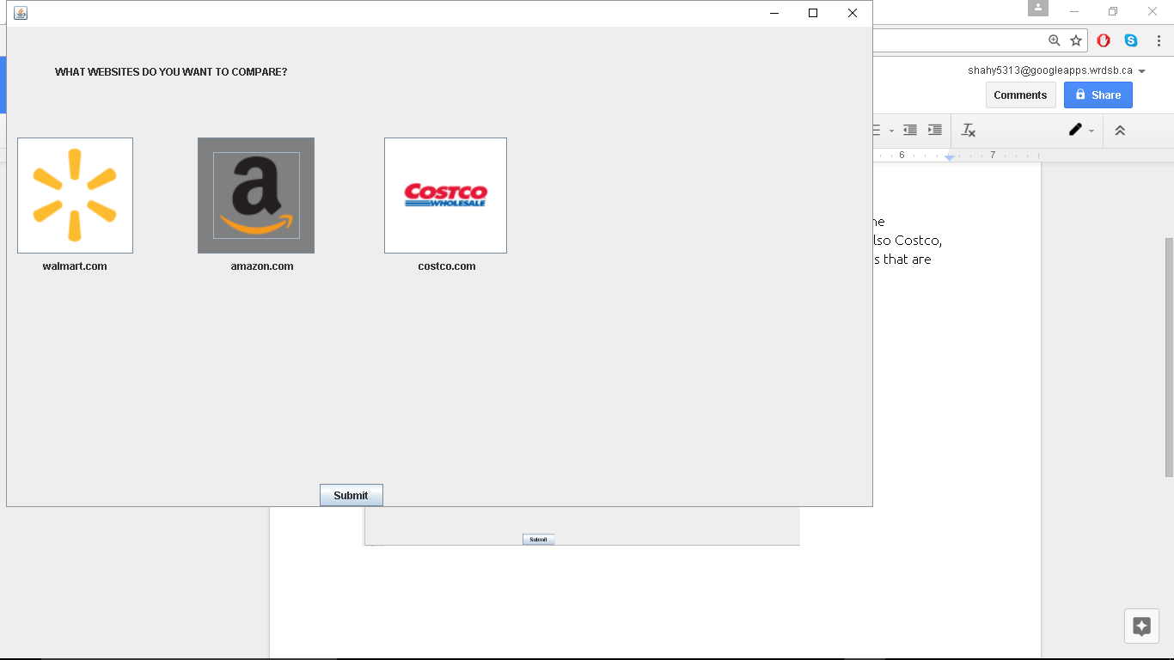

SearchBar Screen:

Once you hit submit on the first screen, you are shown a screen where you can actually search the product. For this example let’s search chips (I know I have used that example in class too many times but it is my favourite thing)

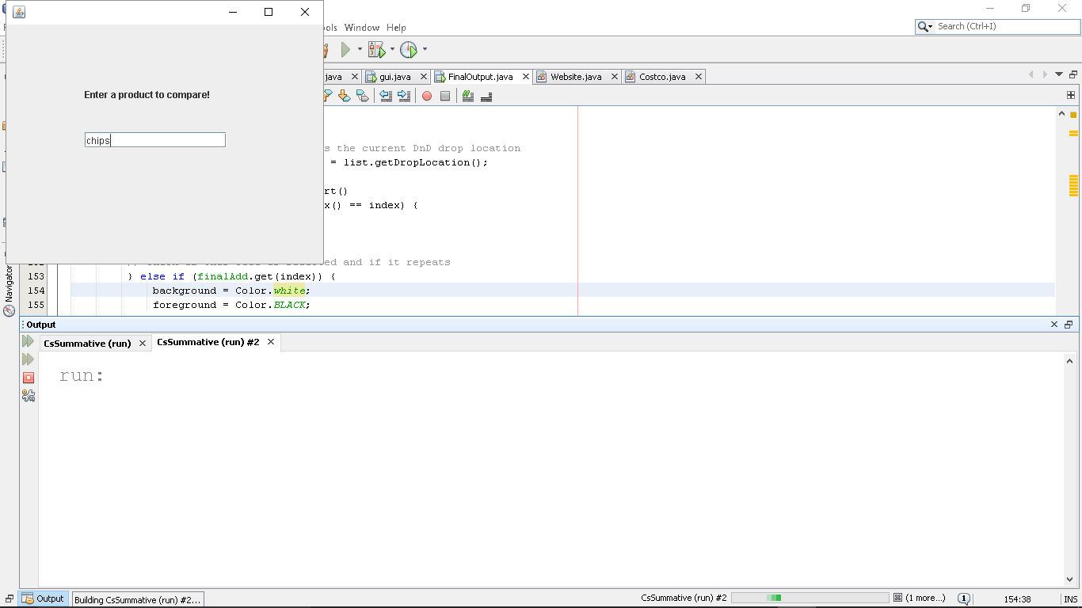

Final Screen

The final screen will present you with a list of products, sorted from lowest to highest price. The products highlighted are ones with multiple prices. Clicking on an item will give you the full product name, as well as the source and the price.

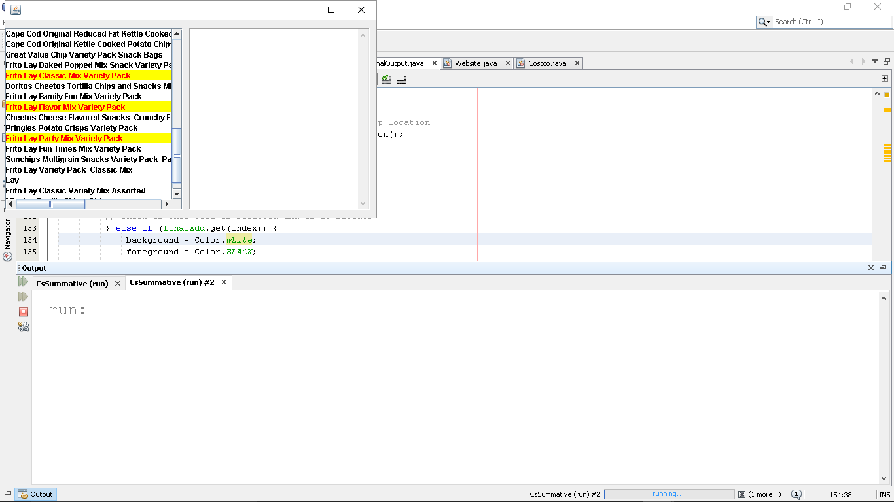

**Pls Note:**

1. Sometimes Amazon displays the wrong prices in their HTML tags. My program simply scans these prices and displays them. Once change in the future might be to get access to the official product database that amazon has, and scan that instead. However for now, this will remain an issue.
2. Full product names are displayed to give you the size and count size usually. This can help differentiate between products that have the same title, but are of different quantities.