Git Bash Commands
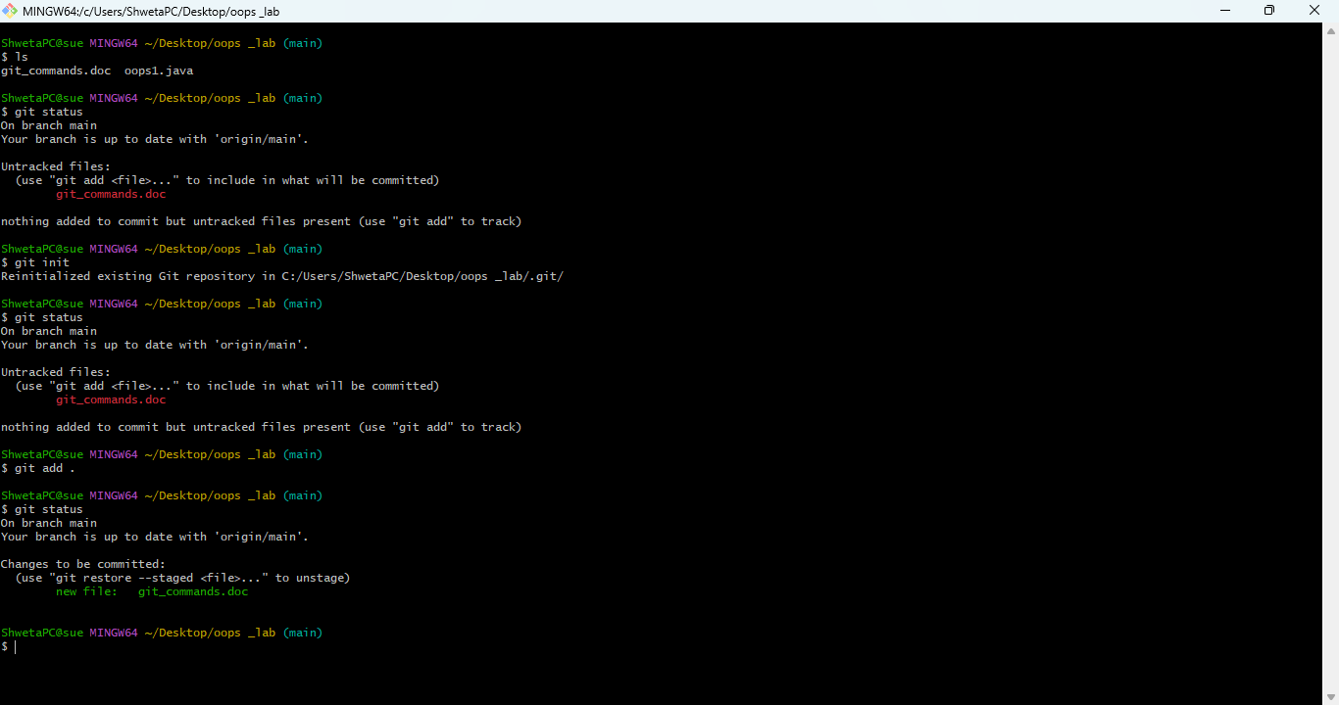

1-Touch command
This will create an empty file in the current directory.
Use case - touch file_name.extension
Ex-touch oops_1.java

2-ls command-
This will list all the files present in your current directory.
Use- ls

3-git init command-
Initializes a new Git repository in your current directory.
4-git status command-
Shows the current state of the working directory and staging area (e.g., changes, untracked files).

5-git add command-
Stages a file (or files) to be committed.
Use . to stage all

6-git commit command-
Commits staged changes to the repository with a message.
Use- git commit -m "message"

7-Branch change command-
Used to change the branch of your file.
Use- git branch -m “branch-name”.

8-git clone command-
Downloads (clones) a repository from a remote source (e.g., GitHub).
Use- Remote add origin link of remote repository.
9-git push command-
Pushes your commits to the remote repository.
Use- Git push -u origin main

