Yashica M 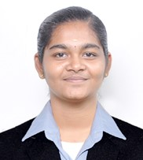
A motivated second-year Information Technology student with a strong foundation in HTML, CSS, JavaScript, and web development. Passionate about creating responsive websites, UI/UX design, and emerging web technologies, eager to gain hands-on experience.

SKILLS
Python
Java
C
C++
JavaScript

EDUCATION
(2023-2026)
VET INSTITUTE OF ARTS AND SCIENCE
BSc Information Technology

CONTACT
6380455509 T.
yashicam23sit@vetias.ac.in M.

Career Objective:
To secure a challenging role in the field of Information Technology, where I can apply my skills in web development, programming, and problem-solving to contribute to innovative projects. Eager to gain hands-on experience and enhance my technical expertise while continuously learning about emerging technologies.

LANGUAGES
Tamil
English

