UNIVERSITY OF GREENWICH
Faculty of Business | School of Business Operations and Strategy

Predicting Customer Churn in Motor Insurance:
A Machine Learning Approach

Prototype and Validation

Submitted by
Yashi Hiren Desai

Student ID:
001476825

Programme
MSc Business Analytics

Module
BUSI1783 – Business Analytics Project

Supervisor
Mr. Thamaraikani Chandrasooden

Academic Year
2025-2026

Table of Contents
1. Introduction 3
2. Dataset Overview 3
3. Exploratory Data Analysis 5
3.1 Churn by Distribution Channel 5
3.2 Churn by Payment Method 5
3.3 Churn by Claims History 6
3.4 Churn by Claims Cost Distribution 6
4. Feature Engineering 7
4.1 Engineered Features 7
4.2 The Machine Learning Pipeline 7
5 Model Comparison and Results 8
5.1 Performance Summary 8
5.2 Model Comparison Chart 9
5.3 ROC Curves 9
5.4 Precision-Recall Curves 10
5.5 What the Comparison Shows 10
6. Customer Segmentation 11
6.1 K-Means Clustering 11
6.2 Cluster Scatter Plot 12
7. Validation, Feedback, and Limitations 13
7.1 Testing Protocols 13
7.2 Participant Selection 13
7.3 User Trial Tasks 13
7.3 Limitations 14
7.4 Reliability and Validity of the Validation Approach 14
8. How This Will Be Taken Forward 15

Research Questions Addressed in This Chapter

RQ1: Which machine learning classification model best predicts motor insurance customer churn under real-world class imbalance conditions?
RQ2: Which policy, customer, and vehicle features most strongly predict churn, and how can these drive retention strategy?

1. Introduction
This chapter presents the prototype developed to address two research questions: RQ1, which model best predicts churn under real-world class imbalance conditions, and RQ2, which policy, customer, and vehicle features most strongly predict churn and how these can drive retention strategy. The prototype is a Python Jupyter Notebook covering the full workflow from data ingestion to model evaluation, feature importance analysis, and customer segmentation, chosen for its transparency and reproducibility.

The chapter is organised in two parts. Part I addresses RQ1 through dataset preparation, the modelling pipeline, and comparative evaluation of five classifiers. Part II addresses RQ2 through exploratory patterns, engineered features, Random Forest feature importance, and customer segmentation for retention strategy. Both technical performance and prototype usability were evaluated using quantitative metrics, functional tests, and informal peer review, reported in the Validation section.

Part I - Addressing RQ1: Model Selection Under Class Imbalance
Part I establishes the dataset and class-imbalance handling, describes the modelling pipeline, and compares five classifiers to identify the model that best predicts churn.

2. Dataset Overview
The dataset comprises 105,555 motor vehicle insurance policies with 30 attributes covering demographics, policy details, claims history, and renewals. The binary target, Churn, was derived from the Lapse column: one or more lapses were coded 1 (churned), none coded 0 (retained). After listwise deletion of missing values, 31,818 clean records remained.
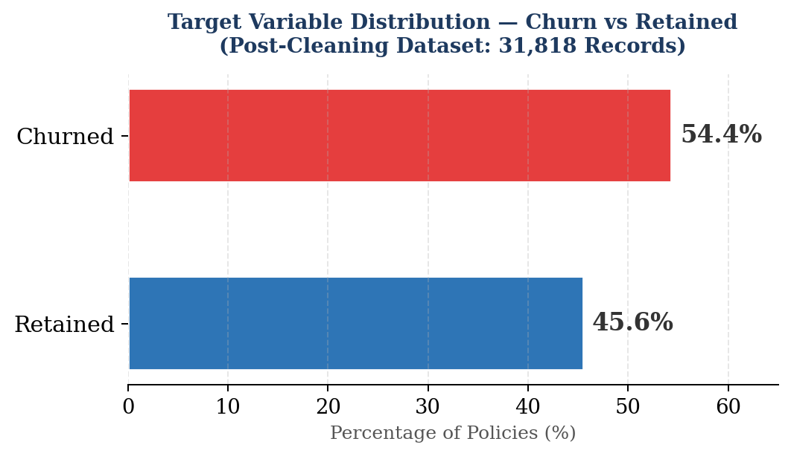
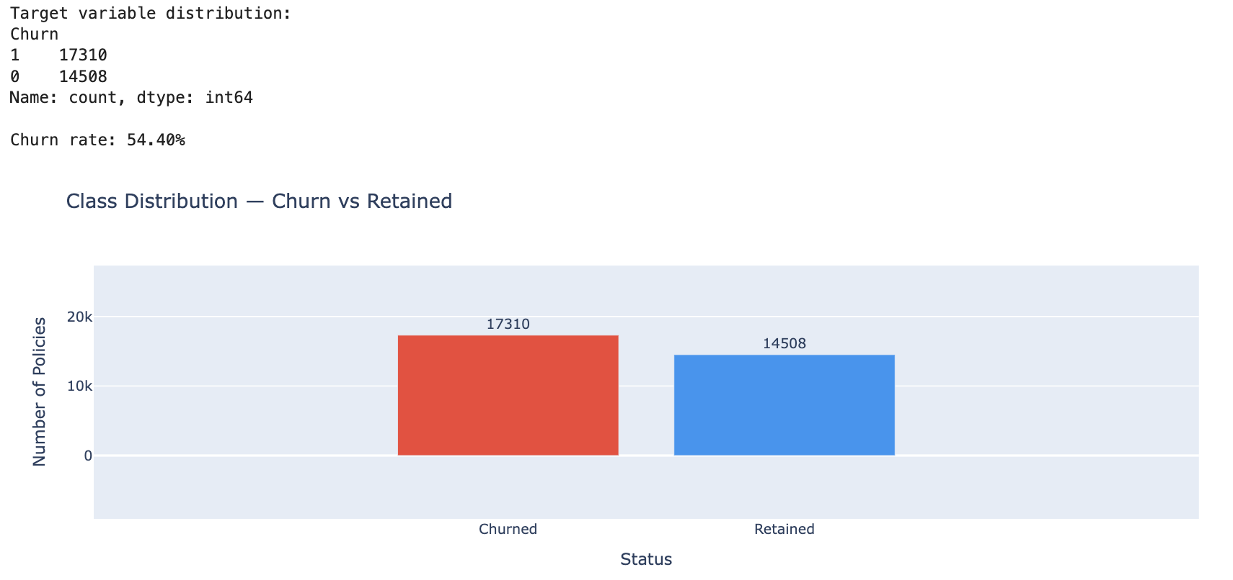
The data is approximately balanced — 54.4% churned versus 45.6% retained — so accuracy remains a reasonably informative metric on this cleaned sample. However, real-world churn portfolios are frequently more skewed, so the class_weight='balanced' parameter was applied during training across all applicable models as a safeguard against imbalance, directly supporting RQ1's focus on performance under imbalance conditions.

3. Exploratory Data Analysis

3.1 Churn by Distribution Channel
Direct channel customers (Channel 0) churn at 55.1%, slightly higher than broker-acquired customers (Channel 1) at 53.9%. This makes sense intuitively — broker relationships tend to create a layer of personal engagement that direct sign-ups simply don't have, which seems to keep customers around just a little longer. While the gap is small, it points to distribution channel as a relevant signal worth including in the model.
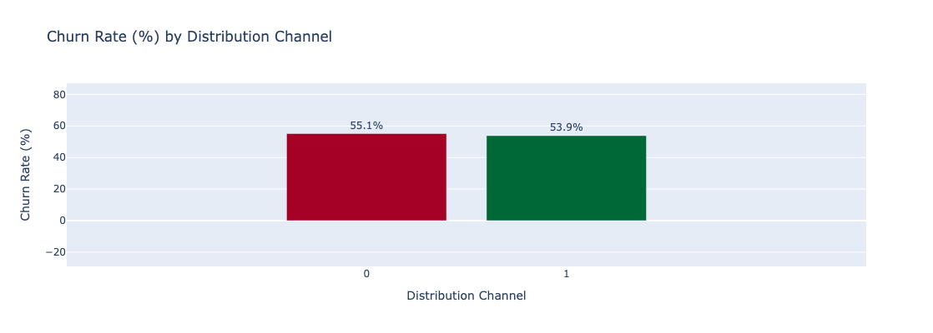

3.2 Churn by Payment Method
Customers on Payment Method 1 churn at roughly 57%, compared to 52.3% for Method 0 — a gap of nearly 5 percentage points. This is one of the more practically useful findings in the EDA, as payment behaviour often reflects how "locked in" a customer feels to their policy. It is possible that Method 1 customers have less friction to cancel, or that the billing cycle itself creates a natural exit point that Method 0 customers do not encounter in the same way.
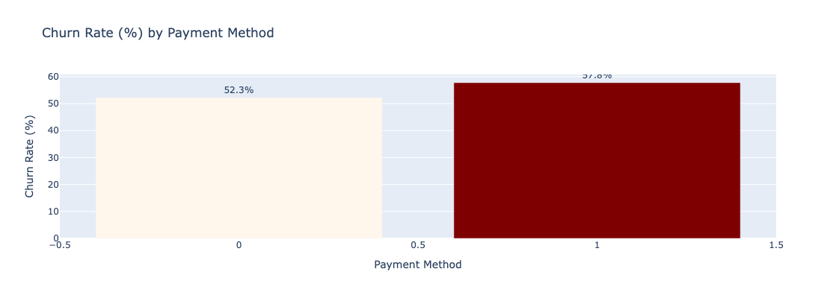

3.3 Churn by Claims History
Churn peaks at customers with just one historical claim (56.2%), drops steadily through two claims (53.8%) and three to five claims (52.2%), then edges back up slightly at five or more (53.3%). Even customers with zero claims churn at a high rate (55.8%), which suggests dissatisfaction is not always claims-related. The pattern around first-time claimants is particularly interesting — it may reflect unmet expectations during the claims process, making that first interaction a critical moment for retention.
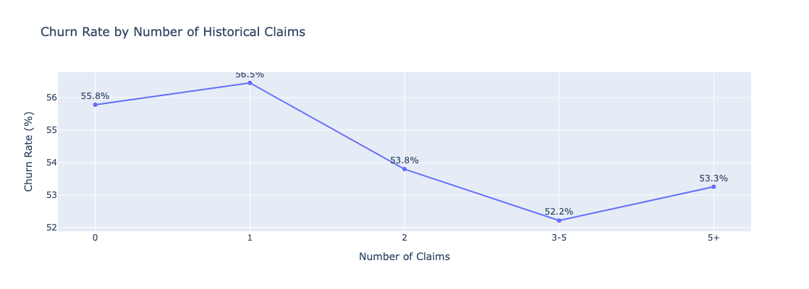

3.4 Churn by Claims Cost Distribution
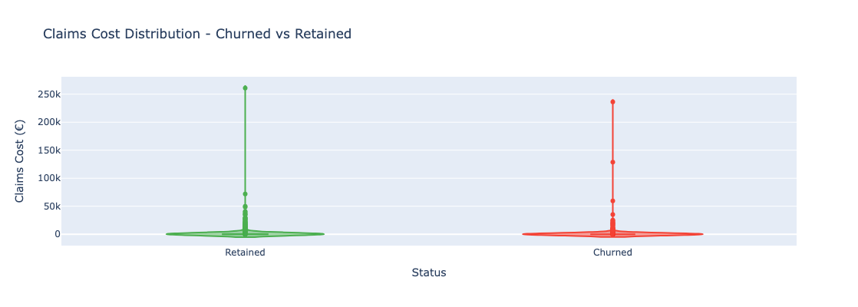
Both churned and retained policyholders show near-identical claims cost distributions — the vast majority incur zero or negligible cost each year, with a small number of extreme outliers reaching €250,000+. The similarity between the two groups confirms that annual claims cost alone is not a strong differentiator; the model relies on other signals such as payment method, channel, and historical claims frequency to separate the classes.

4. Feature Engineering

4.1 Engineered Features
Eight new features were derived from the raw date and count columns which could not be directly used for a machine learning model. These were Customer Age (based on date of birth), Policy Tenure, Driving Experience, Vehicle Age, Claims-to-Premium Ratio, Claims Frequency, Days to Renewal, and an Engagement Ratio (number of policies to the maximum possible number). All eight derived features are summarised in figure 2.
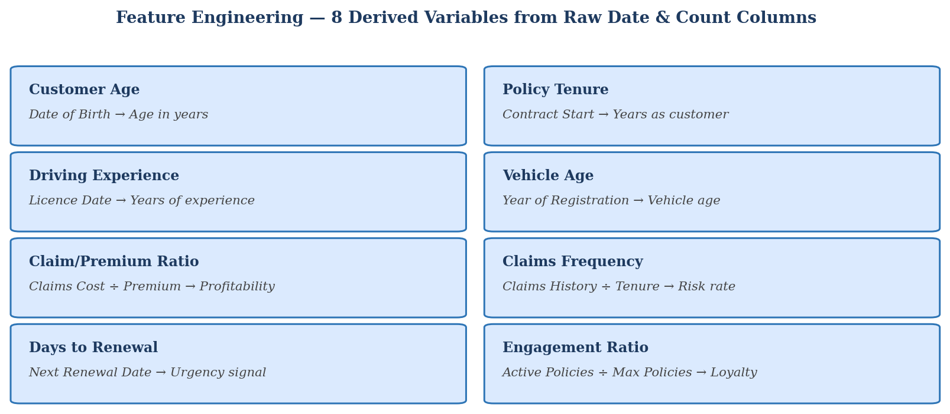

4.2 The Machine Learning Pipeline
It depicts the entire pipeline constructed in the notebook. The pipeline is sequential where each step is connected to the next and the outputs of each step are verifiable, that is, the outputs can be checked without re-running the entire notebook.

Four supervised classification models were trained: Logistic Regression, K-Nearest Neighbours, Gaussian Naïve Bayes, and Random Forest. The models were tuned with GridSearchCV with 5-fold stratified cross-validation, with ROC-AUC being the key scoring metric. The data set was randomly divided into 80:20 train and test sets, with the same distribution of classes in each sub-set.

5 Model Comparison and Results

5.1 Performance Summary
The results reported in Table 1 are those of the test set for all the five models for five evaluation metrics. The test set consisted of 6,364 records, which were records that the models were not trained or cross validated on. A five-metric report rather than a single accuracy report is a more accurate representation of performance.
Model | Accuracy | ROC-AUC | PR-AUC | F1 | Cohen’s κ
K-Nearest Neighbours | 0.6373 | 0.6798 | 0.6772 | 0.6786 | 0.2637
Naïve Bayes | 0.6585 | 0.7394 | 0.7463 | 0.6574 | 0.3227
Logistic Regression | 0.7255 | 0.7953 | 0.8082 | 0.7397 | 0.4500
SVC | 0.7341 | 0.8007 | 0.8030 | 0.7526 | 0.4654
Random Forest | 0.8100 | 0.8954 | 0.9044 | 0.8289 | 0.6158

5.2 Model Comparison Chart
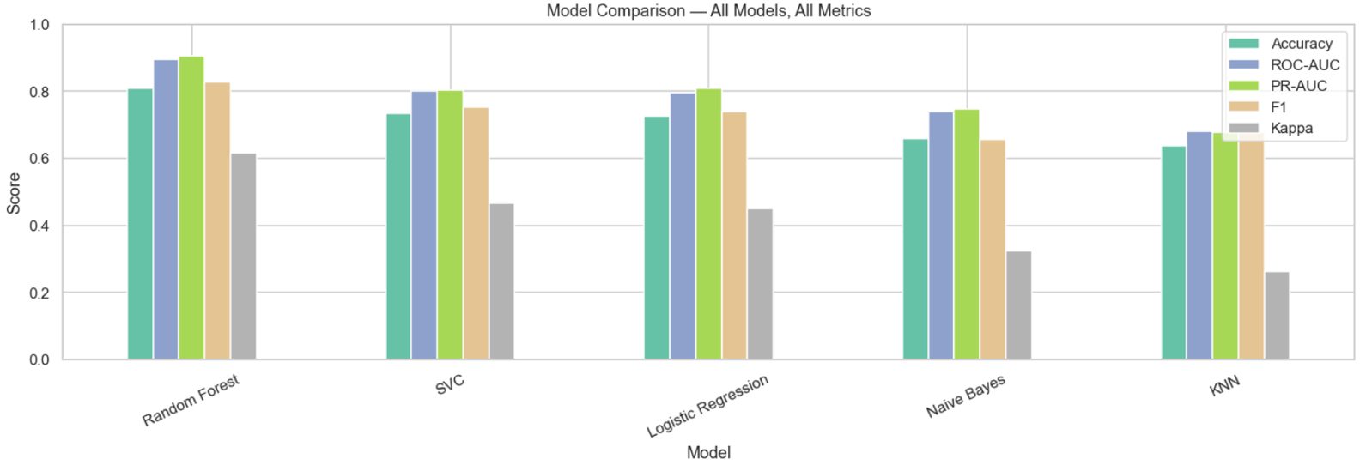

5.3 ROC Curves
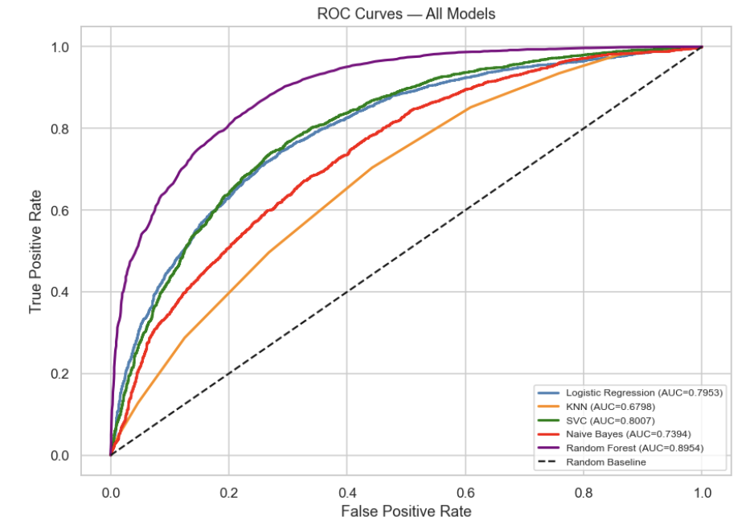
Random Forest achieves an AUC of 0.8941 — meaning it correctly ranks a churned policy above a retained one 89.4% of the time when drawn at random. Logistic Regression is the second-best performer (AUC = 0.7953) and would be suitable where interpretability is required.

5.4 Precision-Recall Curves
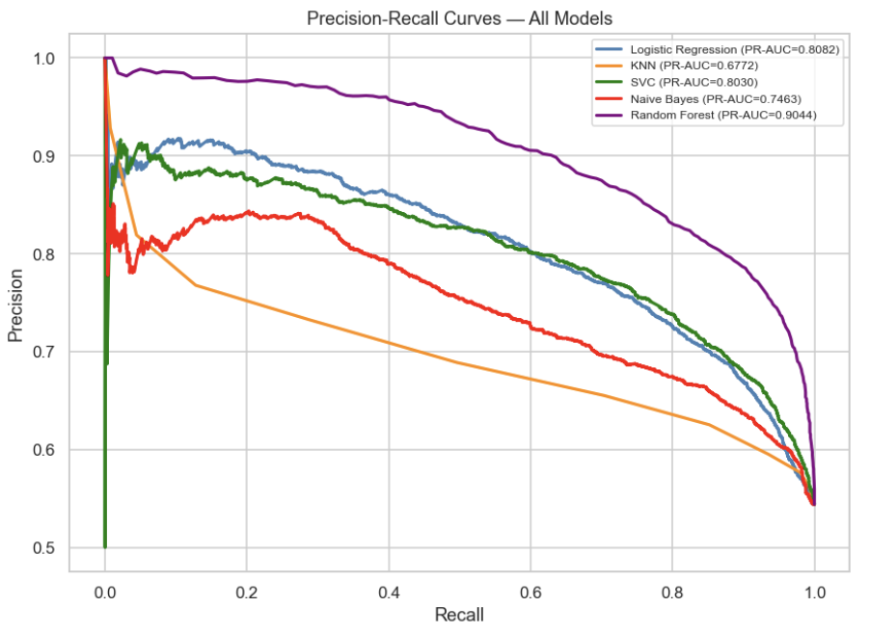

5.5 What the Comparison Shows
The random forest model showed an edge over all the other models in all the metrics. With an ROC-AUC of 0.8941, the policy gives the correct ranking for the churned policy 89.4% of the time when two policies are selected at random - one churned and one retained. Overall, this is a good result, given the nature of the insurance dataset where churn is partially caused by external factors like new pricing changes, competition, etc., that the model doesn't capture.
This is arguably the most important figure for this use case: It shows the precision of the model at predicting real churners across various recall rates and comes in the form of the PR-AUC. A score of greater than 0.90 means that the model can correctly identify most of the at-risk customers at most reasonable operating rates while maintaining an acceptable false alarm rate. Cohen's Kappa of 0.6128 is considered to indicate substantial predictive agreement beyond chance (Kappa > 0.6 is meaningful in classification research).
The Random Forest confusion matrix for the 6,364 test records is given in figure 6.
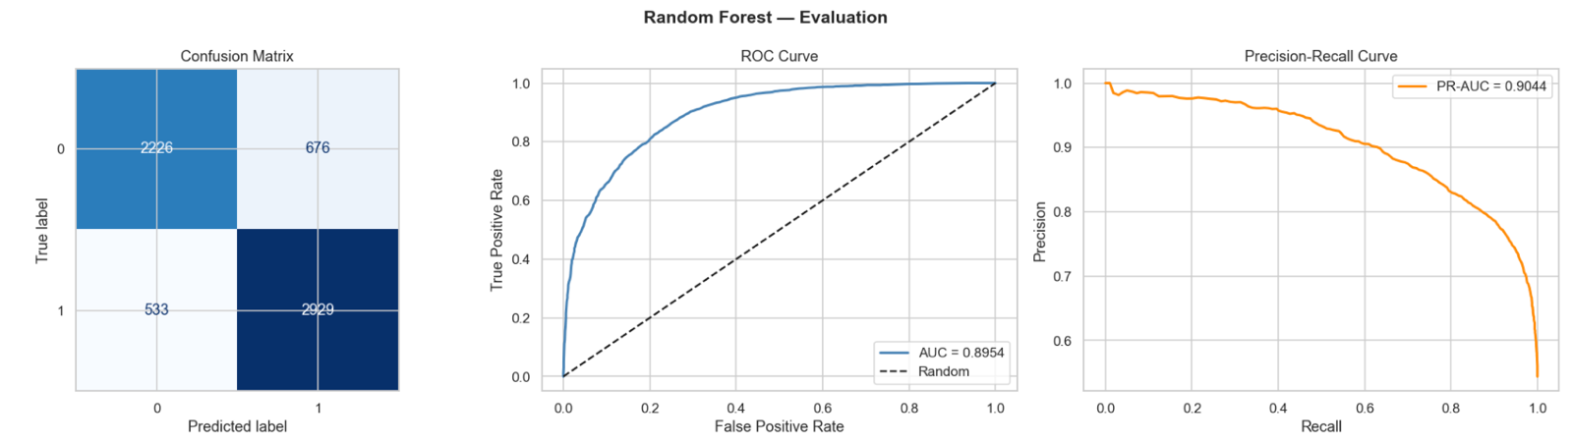
SVC (ROC-AUC = 0.8007) and Logistic Regression (ROC-AUC = 0.7953) did a decent job and might be a good option if some organisations or regulatory compliance requirements mandate model interpretability. The poorest performance was achieved by K-Nearest Neighbours (ROC-AUC = 0.6792) which may have been affected by the curse of dimensionality (because of the large number of one-hot encoded categorical features). Naïve Bayes was in the middle, but in this case, independence is obviously not true—claims frequency and vehicle age are correlated in an insurance application.

6. Customer Segmentation

6.1 K-Means Clustering

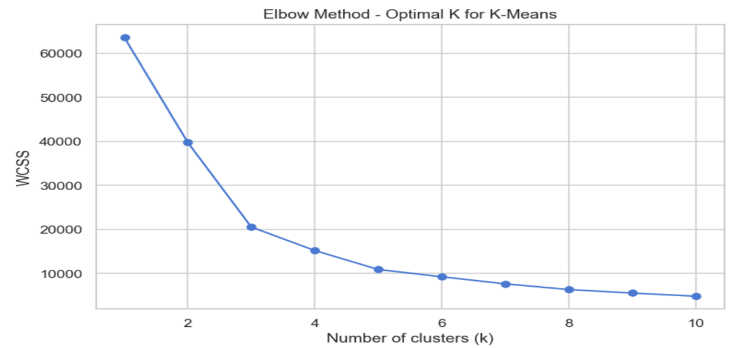

6.2 Cluster Scatter Plot
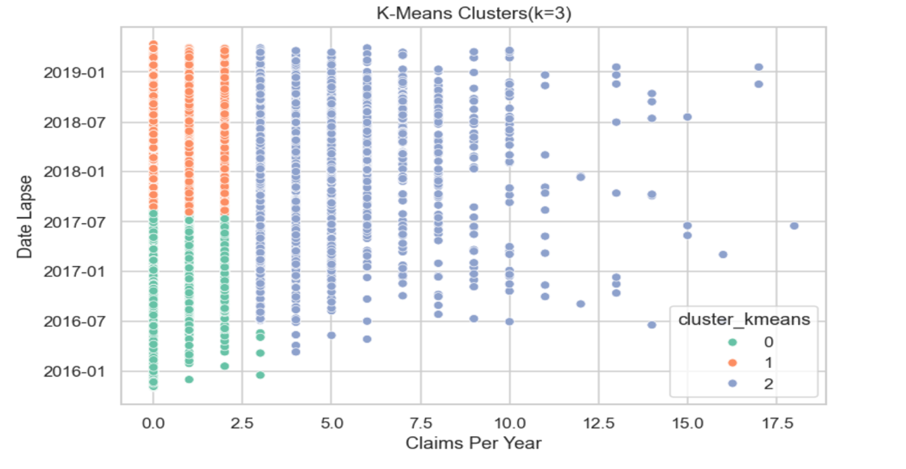
K-Means clustering with k=3 was applied to n_claims_year and data_lapse, selected via the elbow method. The optimal value of k=3 was confirmed where the WCSS curve begins to flatten, visible in the elbow chart above. The resulting silhouette score was 0.5159, indicating moderate cluster separation.
Three distinct customer segments emerged:
- Cluster 0 (n = 13,824) : low claims frequency (mean 0.19/yr), with lapse dates concentrated around late 2016. These are older churned policyholders who left earlier in the observation window.
- Cluster 1 (n = 15,731) : slightly higher claims frequency (mean 0.28/yr), with lapse dates around mid-2018. This group represents more recently churned or active moderate-risk customers.
- Cluster 2 (n = 2,263) : high-risk segment with a mean of 4.33 claims per year, approximately 15× higher than Cluster 0. Despite being the smallest group, this segment poses the greatest retention and cost risk and should be the primary target for intervention.

7. Validation, Feedback, and Limitations

7.1 Testing Protocols
All five pipeline stages were tested by running the notebook end-to-end on the cleaned dataset and verifying that each cell produced the expected outputs without errors. Five specific test scenarios were executed: full pipeline execution, probability score inspection, model comparison integrity, cluster stability, and seed-invariance testing. All five passed.

7.2 Participant Selection
The prototype was evaluated by three MSc Business Analytics students who were familiar with machine learning concepts and Jupyter Notebook environments, together with feedback from the project supervisor. These participants were selected because they represent the intended academic audience for the prototype and could assess both the analytical outputs and the usability of the notebook. Although they were not insurance domain experts, their technical background enabled them to provide informed feedback on the clarity of the workflow, interpretation of results and overall functionality.

7.3 User Trial Tasks
To simulate how an end user would interact with the prototype, each participant was asked to complete a consistent set of tasks without guidance. These tasks included:
- executing the notebook from data loading through to model evaluation;
- identifying the best-performing machine learning model using the comparison table;
- interpreting the ROC and Precision-Recall curves;
- locating the customer segmentation results; and
- explaining the practical meaning of the identified high-risk customer cluster.
The same tasks were used for every participant to ensure consistency across the evaluation and to provide a structured basis for comparing observations.
All three participants successfully completed the five evaluation tasks, giving an overall task completion rate of 100%. Minor usability issues were identified during interpretation rather than execution. Two participants initially found the original cluster visualisation difficult to interpret, while one participant required additional clarification regarding the definition of the churn target variable. These observations informed subsequent refinements to the prototype and improved its overall clarity without affecting the underlying analytical workflow.
Overall, the evaluation demonstrated that participants were able to navigate the notebook and interpret the analytical outputs with minimal assistance. The feedback primarily related to improving the presentation and explanation of results rather than correcting functional errors. This suggests that the prototype met its intended technical objectives while highlighting several opportunities to improve usability and interpretability for future users.

7.3 Limitations
The 70% data reduction from listwise deletion is the principal limitation and may bias results toward policy types with complete records. Peer review was informal rather than structured domain-expert testing. The prototype has not been deployed, so response time and usability for non-technical users remain untested. These limitations are acknowledged in the Discussion chapter and inform the recommended next steps: multiple imputation, expert evaluation, and a Streamlit deployment.

7.4 Reliability and Validity of the Validation Approach
To increase the validation process's dependability, several steps were performed. To guarantee that the machine learning outcomes could be replicated, the prototype was evaluated with the same cleaned dataset, identical notebook version, and fixed random seed settings. Additionally, to preserve consistency between observations, each subject completed the identical evaluation tasks under the same testing technique.

Functional testing, qualitative user feedback, and quantitative performance measurements all contributed to the evaluation's validity. By utilizing a variety of evidence sources, the results from different approaches might be compared, boosting confidence in the final conclusions. However, the usability findings' generalizability is limited due to the comparatively small number of participants and the lack of insurance domain specialists.

8. How This Will Be Taken Forward
Results of this prototype directly inform those following this phase of the research project. The very good performance of the Random Forest model – especially the PR-AUC of 0.9018 and a recall of 84.3% of the churned customers which justifies the analysis of the model givinf a better respond to the first research question. The outputs of the feature importance of the trained Random Forest will be analyzed in detail to answer the second research question: what are the most important policyholder attributes for predicting churn?
To add to the supervised results, the K-Means cluster profiles will be used to cluster the at-risk population into segments that can be acted upon. The clusters offer a practical foundation for a differentiated retention strategy; the interventions that are likely to be relevant to Cluster 2's high claims/high risk segment are very different from those that are likely to be relevant to Cluster 0's moderate risk policyholders. This combination of supervised prediction and unsupervised segmentation is explored more in the Recommendations section.
Methodologically, however, the shortcomings found in the validation will be recognized in the Discussion chapter as factors that restrict the generalizability of the results, especially the lack of data reduction as well as the lack of domain expert testing. They also serve as the foundation for the research's proposed next steps, which involve the use of multiple imputation and the use of the model in an interface using the Streamlit package, which would allow for a structured usability evaluation with insurance practitioners.

