MIRANDA HOUSE
University of Delhi

Cyber Forensics
PRACTICAL - FILE

NAME :- Yahsasvi Goswami
ROLL NO. :- 2022/1315
COURSE :- B.Sc. Physical Science with Computer Science

INDEX

- Demonstration of Windows Network related Commands.

- Demonstration of Linux Network related Commands.

- Data Recovery using Autopsy Tool

- Creating a Forensic Image using FTK Imager

- Creating and Analysing Network Packets using WireShark.

- Analysis of Windows Registry

QUESTION 1 :- Demonstration of Windows Network related Commands.

- ping command :- The ping command tests network connectivity by sending packets to another device.

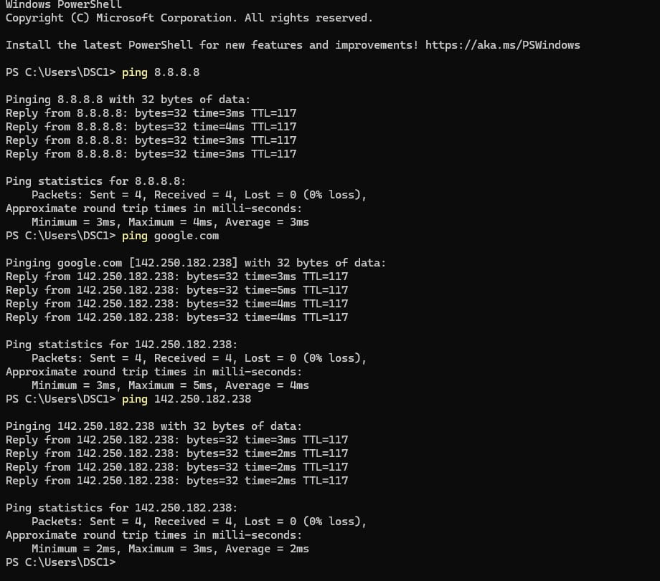
USE:- It checks if a device is reachable, measures response time, and helps identify basic network problems.

2.ipconfig :- Ipconfig displays a computer’s network configuration details.

USE :- It shows IP addresses, refreshes DHCP settings, and helps troubleshoot network issues by revealing connection status and adapter information.

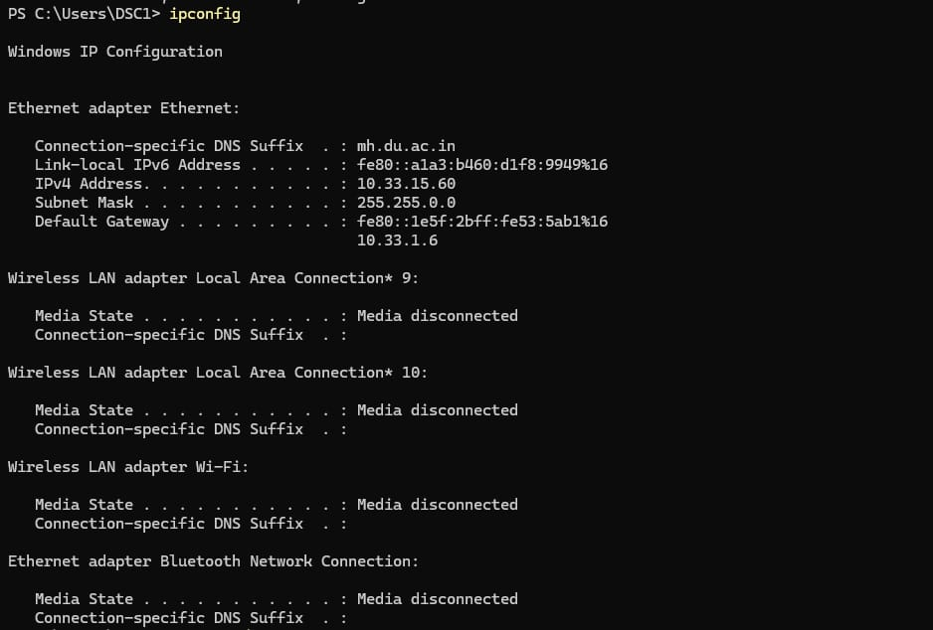

3. netstat:- Displays TCP/IP connection info,ethernet stats,and the computer’s routing table.
USE:- It helps monitor open ports, view running network services, and troubleshoot connection issues.
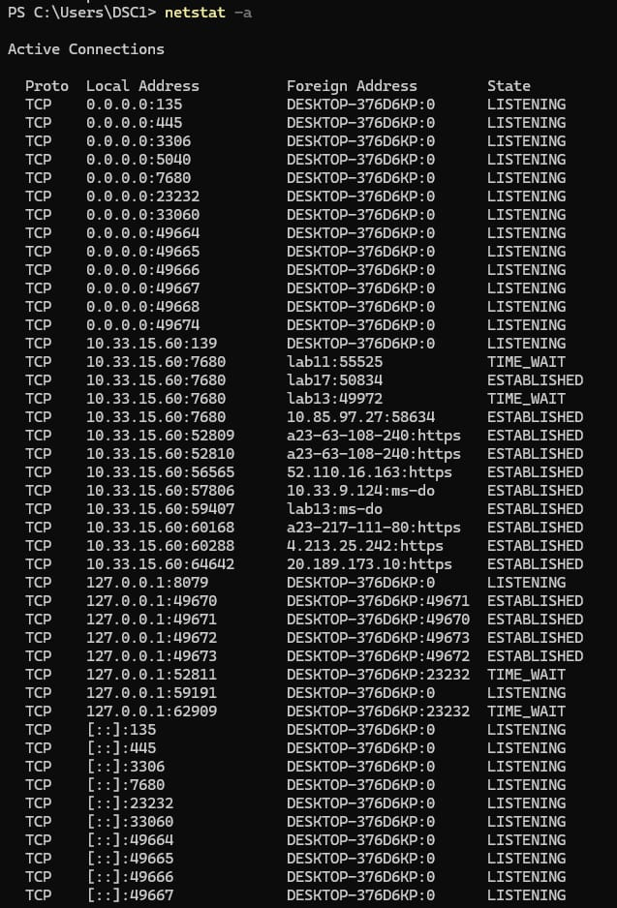
4. systeminfo:- displays configuration details on a computer such as OS name and version,hardware info,boot time,logon server .

USE:- It helps view OS details, system configuration, and hardware specifications.
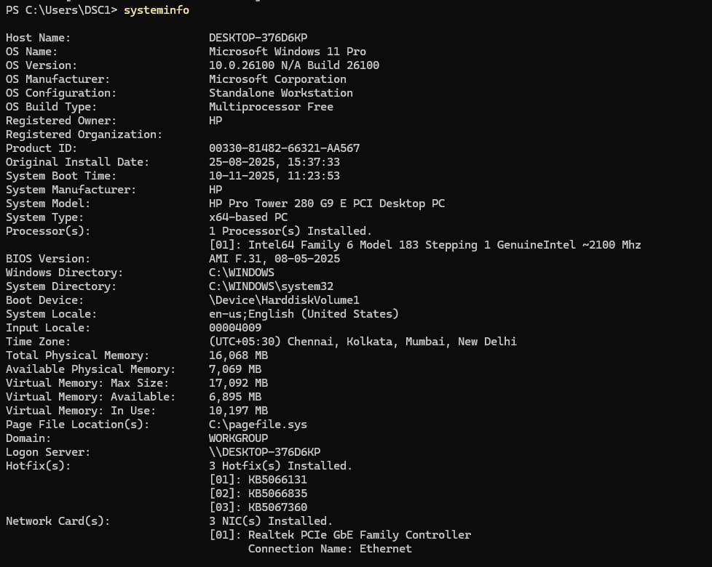

5. getmac :- returns MAC Address from all the network cards on a system.
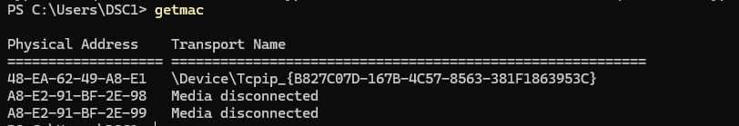

6. nslookup :- Nslookup is used to query DNS servers for domain name or IP address information.

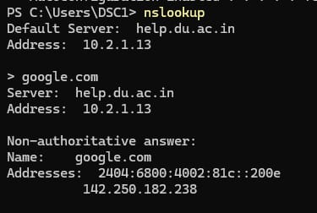

7. whoami :- displays environment variables info.
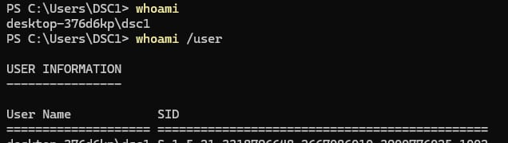

8. Route print:- To view the current routing table.

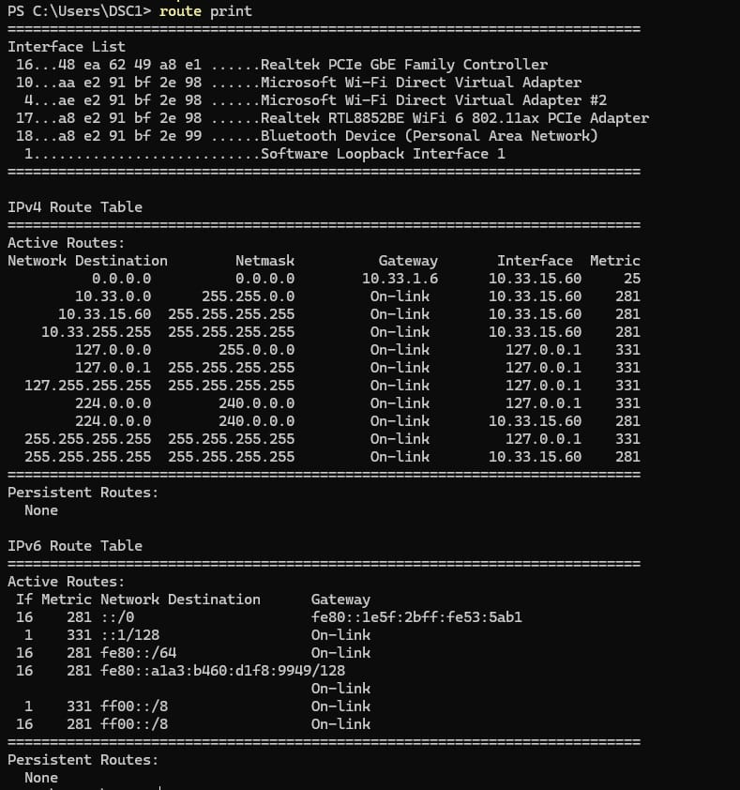

QUESTION 2 :- Demonstration of Linux Network related Commands.
- arp :- The ARP command manages and displays the system’s Address Resolution Protocol cache.
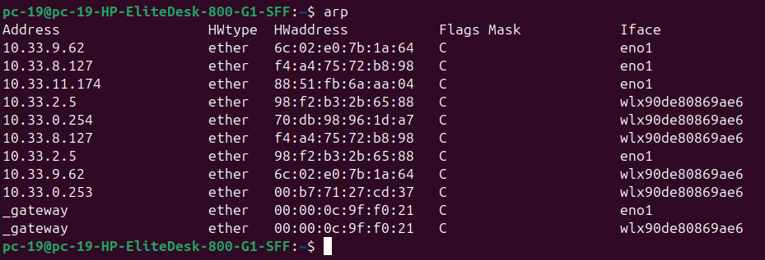
It shows IP-to-MAC address mappings and helps diagnose local network communication issues.

- hostname :- The hostname command displays or sets the system’s network name.It helps identify the machine on a network and manage its host name settings.

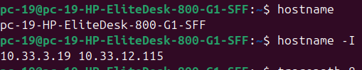

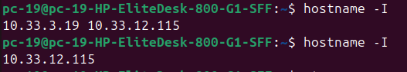

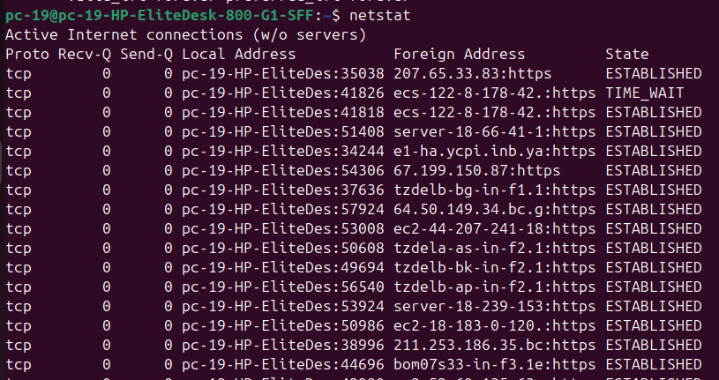
- netstat :- Netstat displays network connections, routing tables, and interface statistics.It helps monitor active connections, open ports, and diagnose network issues.

- tracepath :- Tracepath traces the route packets take to a destination.It helps identify network hops, measure path delays, and troubleshoot routing issues.
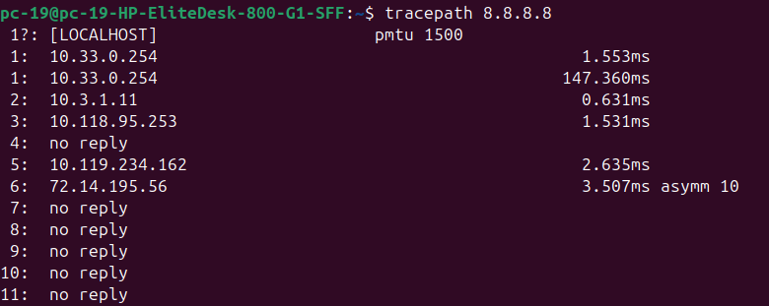
- traceroute :- Traceroute traces the path packets follow to reach a network destination.It helps identify each hop, detect delays, and troubleshoot routing problems.

- whoami :- The whoami command displays the username of the current logged-in user.It helps confirm user identity, especially when managing permissions or switching accounts.
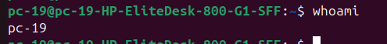
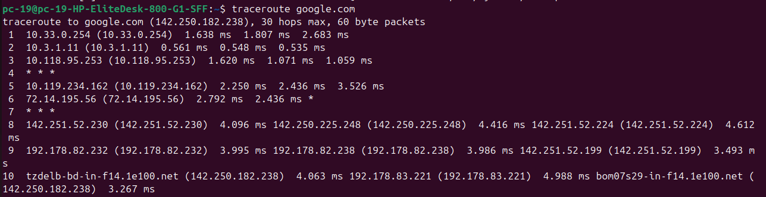

- whois :- Whois retrieves registration information about domain names.It helps check domain ownership, contact details, and DNS registration data.

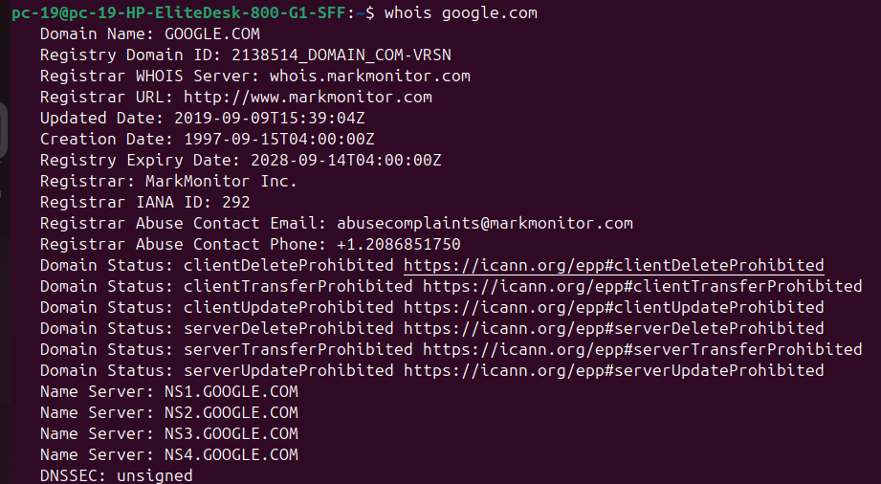

- nslookup :- Nslookup queries DNS servers to obtain domain or IP address information.It helps troubleshoot DNS issues and retrieve DNS records for domains.
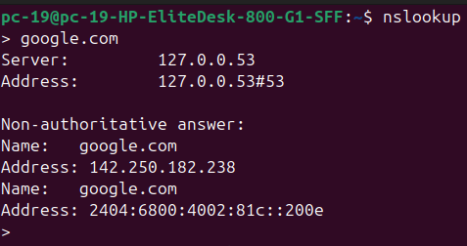

- mtr :- MTR combines the functions of traceroute and ping to analyze network paths.It helps monitor packet loss, latency, and route changes in real time.
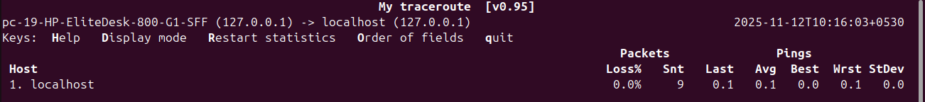

- ping :- Ping tests network connectivity by sending ICMP echo requests to a target. It is used to ensure that a computer can communicate with a specified device over the network.
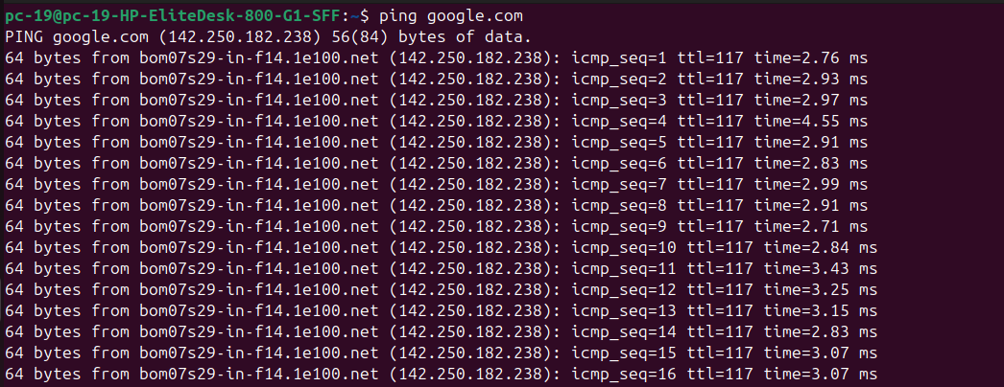

Some Grep Commands :-

- grep :- Grep searches for specific text patterns within files or output.It helps find matching lines, filter results, and analyze text efficiently.
Syntax:- grep “searchword” filename.txt

- grep -i :- It gives the lines in which the searchword is
present irrespective of the case
Syntax:- grep -i “searchword” filename.txt

- grep -n:- It gives the no. in which the search word is present
Syntax :- grep -n “searchword” filename.txt

- grep -v:- It gives the line that does not have the searchword in them.
Syntax:- grep -v “searchword” filename.txt

- grep -c :- It gives the count of the lines with the search word in them.
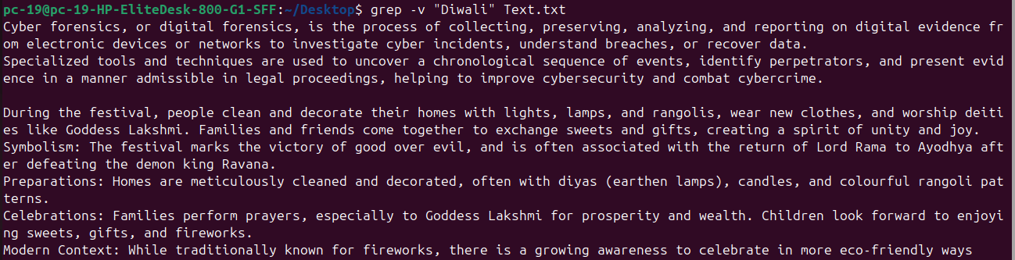
Syntax :- grep -c “searchword” filename.txt

- grep ^:- It gives the lines that start with the search word.
Syntax:- grep “^searchword” filename.txt

QUESTION 3 :- Data Recovery using Autopsy Tool

STEP 0:- The image autospy0.png simply shows the file folder (D:\CF_1_ftk) that is used to store the case files, as set up in the first step.

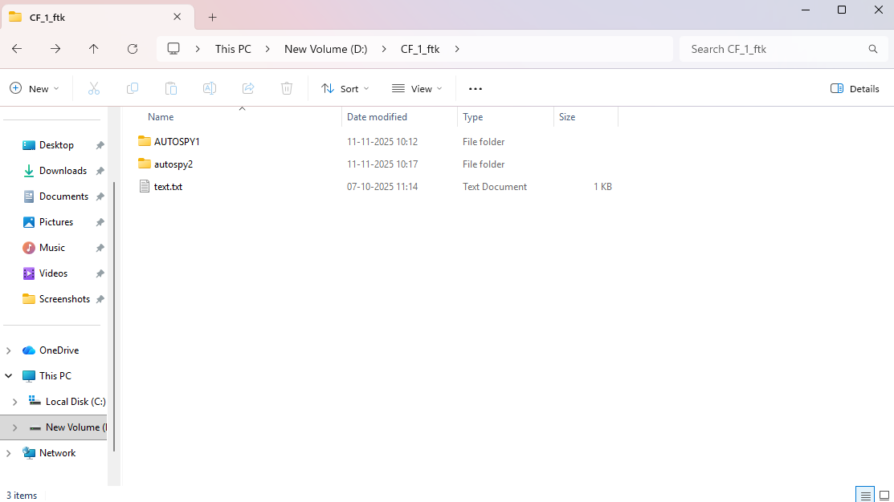
STEP 1:- Create a New Case: The process begins by creating a new case. In the "New Case Information" dialog , the examiner enters a "Case Name" and specifies a "Base Directory" (e.g., D:\CF_1_ftk) where the case file and all associated data will be stored. A "Single-User" case type is selected.

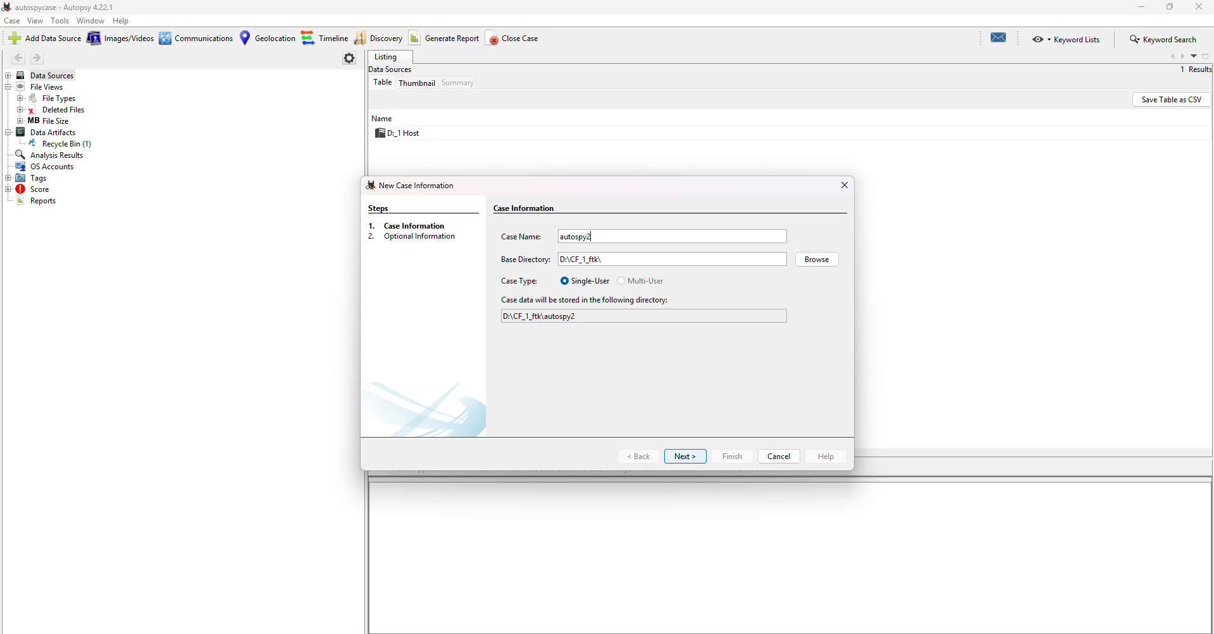

STEP 2:- Enter Optional Case Information: The next step is to enter optional, but recommended, case details (autospy2.png). This includes a "Case Number" and "Examiner" information (Name, Phone, Email) for documentation and reporting purposes. After filling in the details, the examiner proceeds by clicking "Finish".
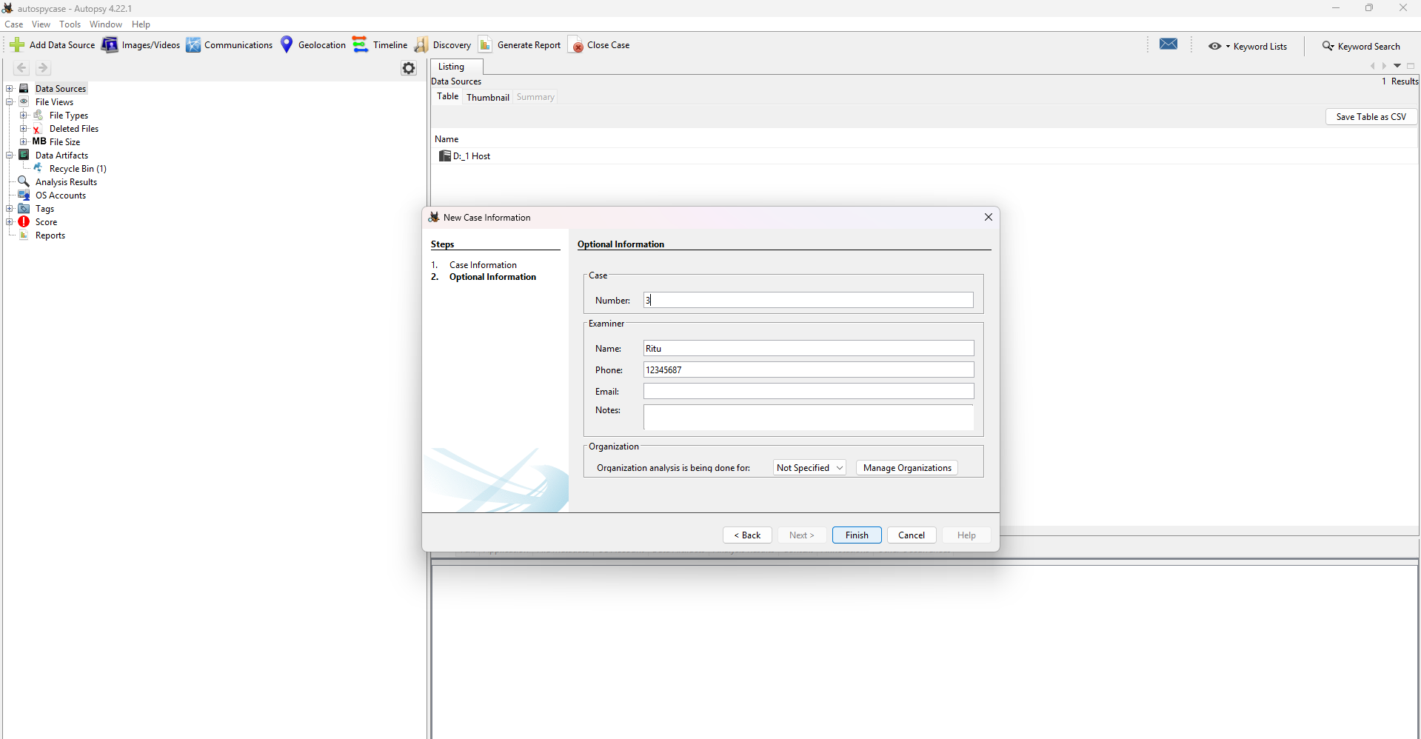
STEP 3:- Select Host: Once the case is created, the "Add Data Source" wizard launches automatically. The first step of the wizard is to "Select Host" . A host is used to organize data sources. The option "Generate new host name based on data source name" is selected.

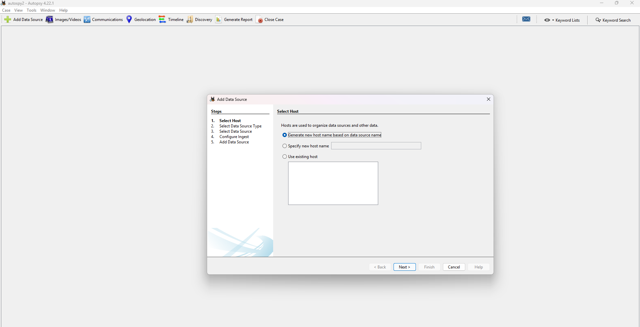
STEP 4:- Select Data Source Type: The examiner must then specify the type of data source to be added . The options include "Disk Image," "Logical Files," and others. In this instance, "Local Disk" is selected, indicating that a physical or logical drive connected to the examiner's machine will be analyzed.

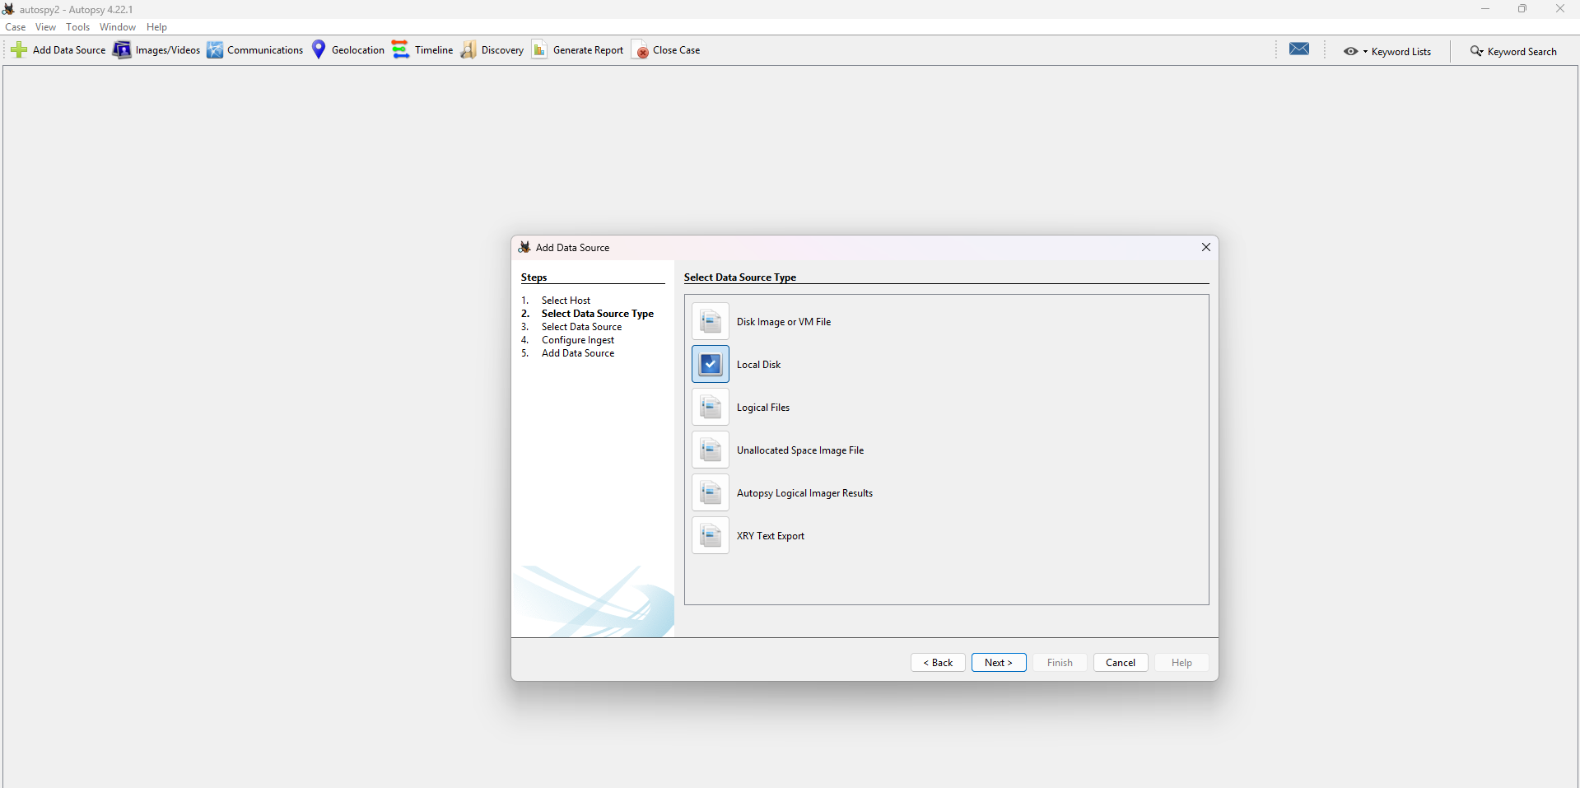

STEP 5:- Select Data Source: After choosing the type, the examiner must select the specific disk to analyze. By clicking "Select Disk," a pop-up window appears listing available local disks . Here, the "New Volume (D:)" is chosen as the target data source.
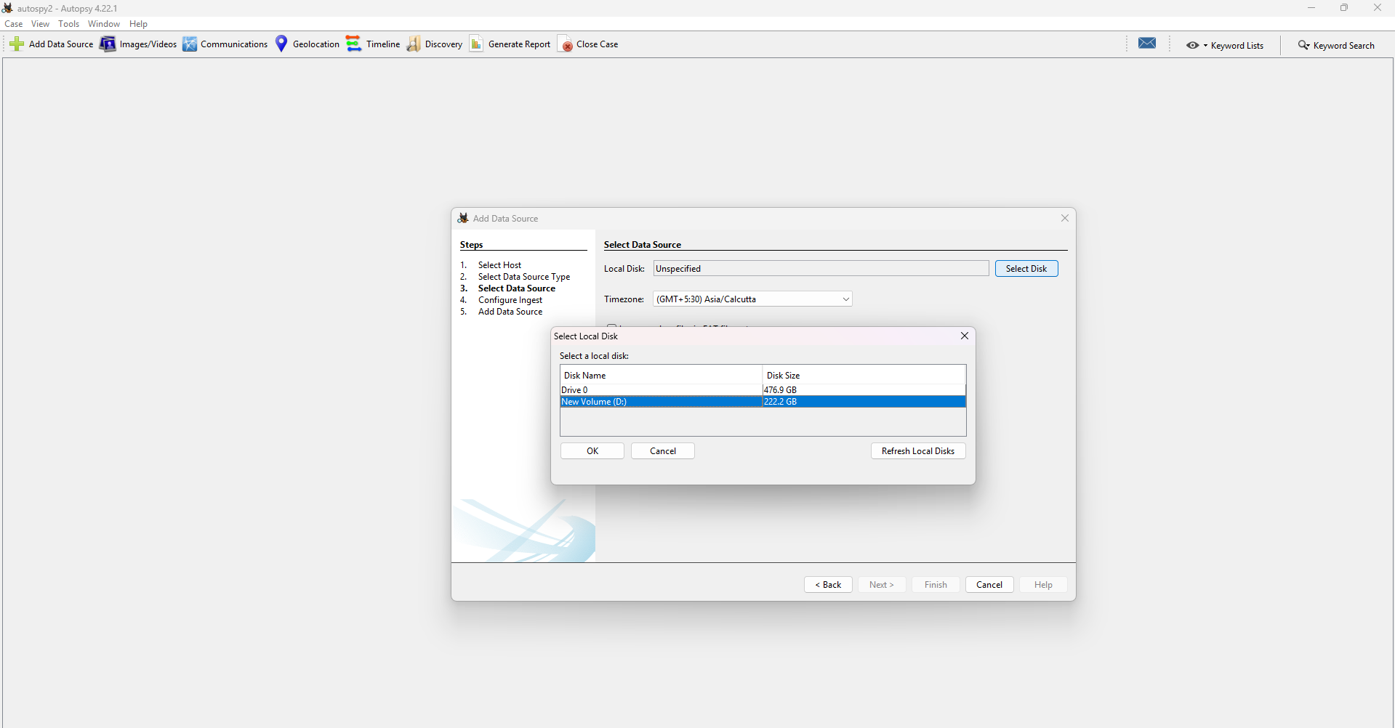
STEP 6:- Configure Ingest: This is a crucial step where the examiner selects which analysis tasks, or "Ingest Modules," to run on the data source (autospy6.png). These modules automatically extract artifacts and search for evidence. Modules such as "Recent Activity," "Hash Lookup," "Keyword Search," and "PhotoRec Carver" (for recovering deleted files) are available to be selected.

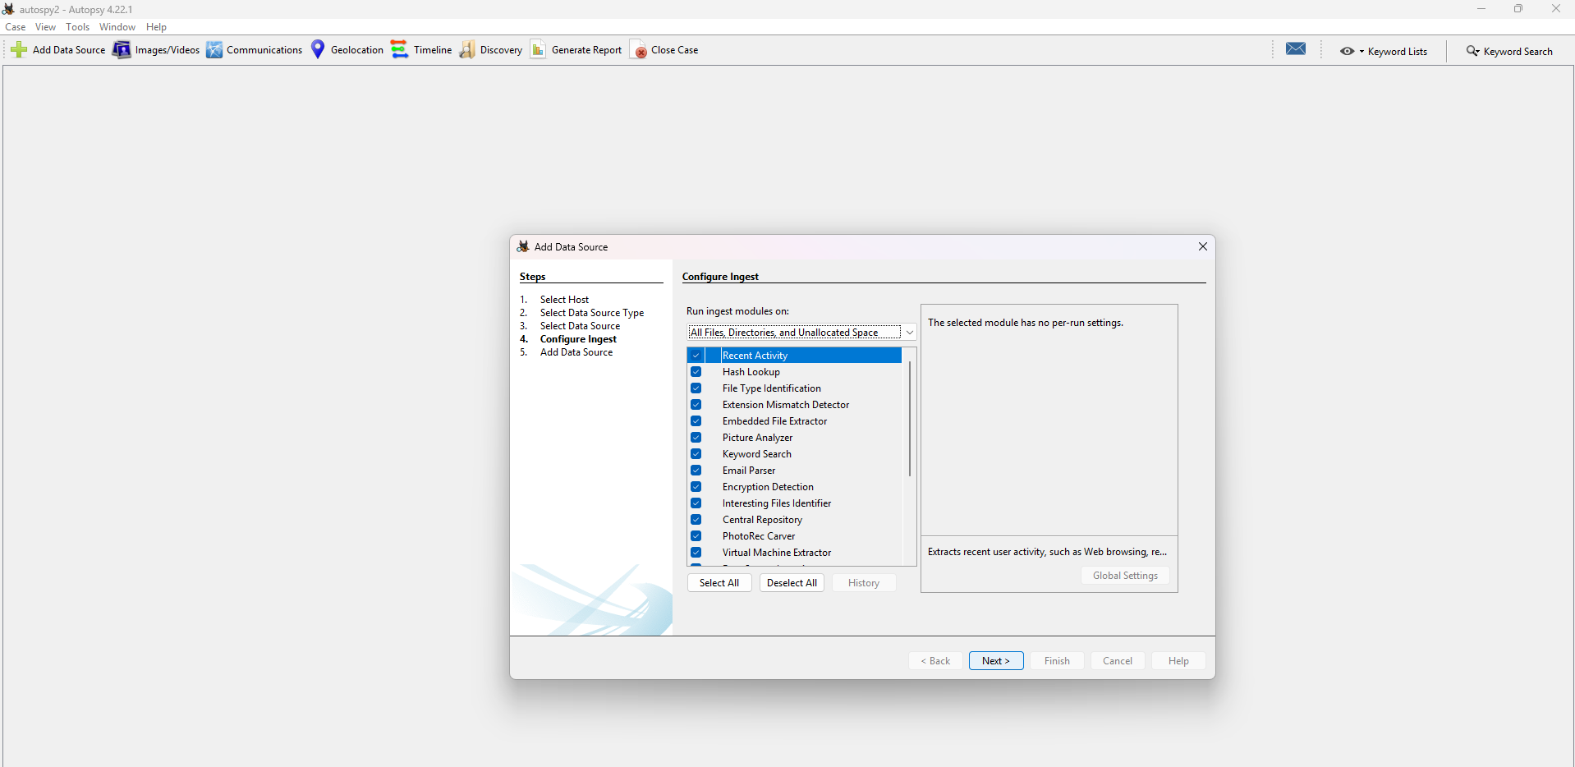
STEP 7:- Add and Analyze Data Source: After configuring the ingest modules, the examiner clicks "Next." A confirmation screen informs that the "Data source has been added to the local database. Files are being analyzed." This indicates the ingest process has started and is running in the background.
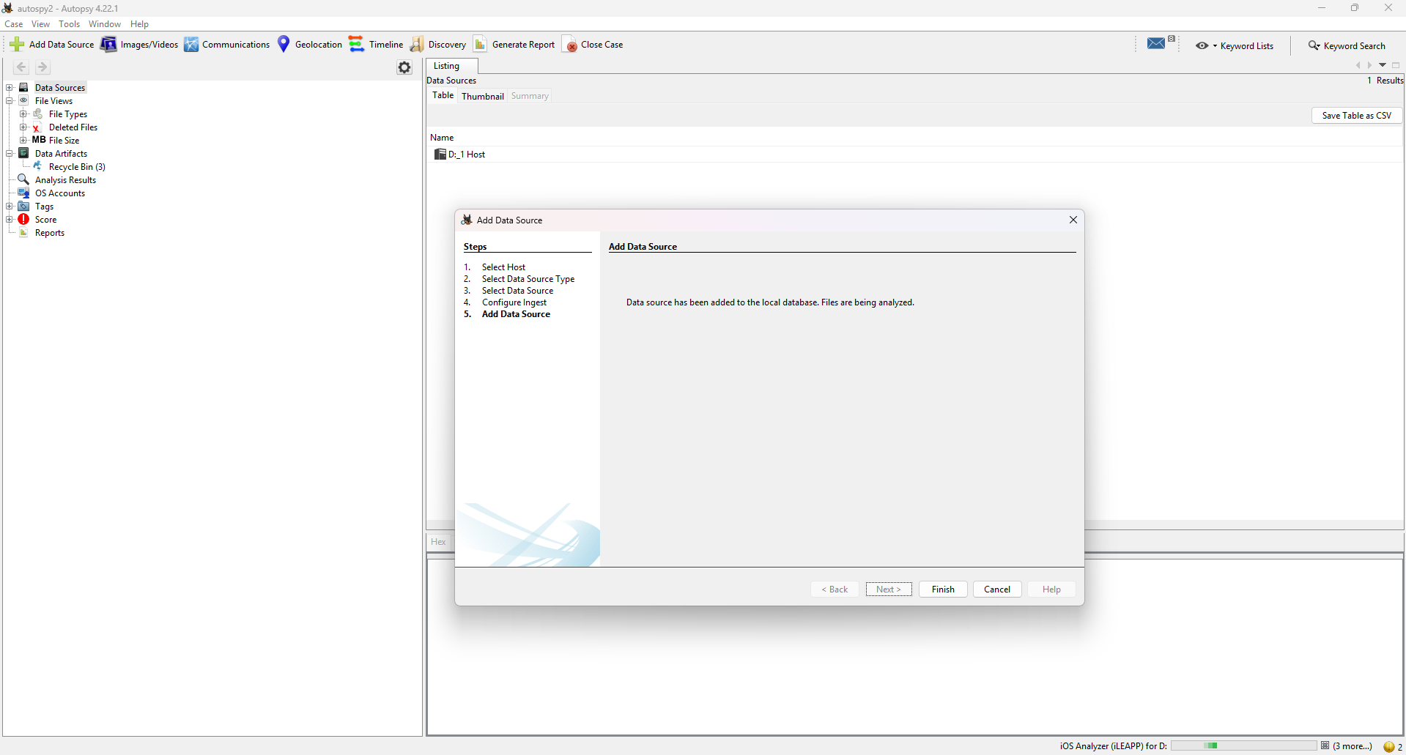

STEP 8:- Review Analysis Results: The final image shows the main Autopsy interface after the ingest process has completed. The results are now populated:
- The Tree View on the left shows the data source (D_1_Host) and categories of extracted data, including "File System," "Deleted Files," "Recycle Bin," and "Analysis Results."
- The Result Viewer (top-center) lists the files found, such as text.txt.
- The Content Viewer (bottom) displays the contents of the selected file. This screen demonstrates that the examiner can now navigate the file system, view deleted items, and inspect the content of recovered files.

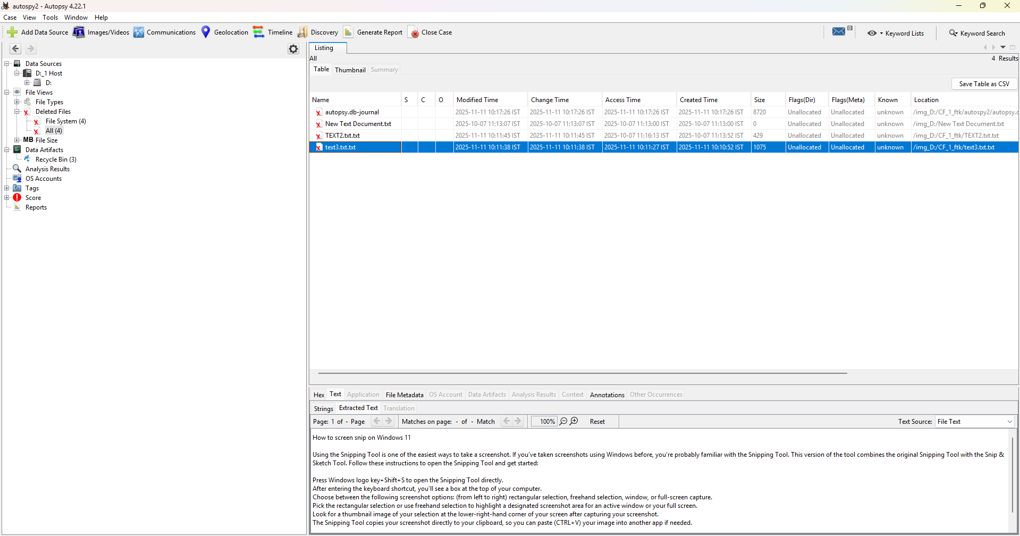

QUESTION 4 :- Creating a Forensic Image using FTK Imager.

STEP 1:- Identify Source Data : The first step is to identify the source data to be acquired. In this case, the source is a folder located at D:\CF_1_ftk\ftkimager1. This folder contains two text files: text1.txt and text2.txt.
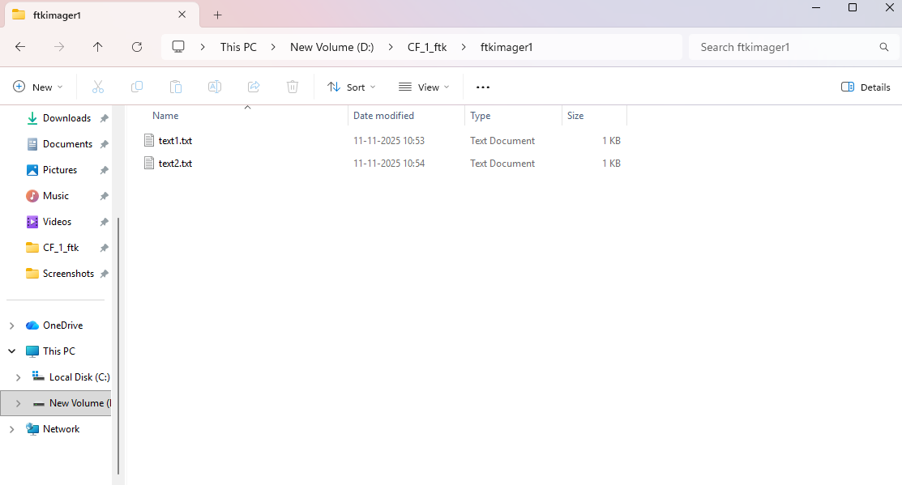

STEP 2:- Select Source Evidence Type : Within FTK Imager, the examiner initiates the image creation process. At the "Select Source" dialog, the option "Contents of a Folder" is chosen as the "Source Evidence Type." This specifies that a logical image of a folder's contents will be created, rather than a physical or logical drive.
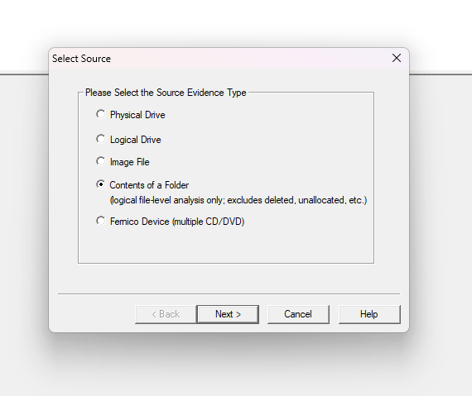

STEP 3:- Acknowledge Logical Image Warning : After selecting the source type, a warning dialog appears. This notice clarifies that the resulting image will "include only logical files" and will not contain file system metadata, deleted files, or unallocated space. The examiner clicks "Yes" to proceed.

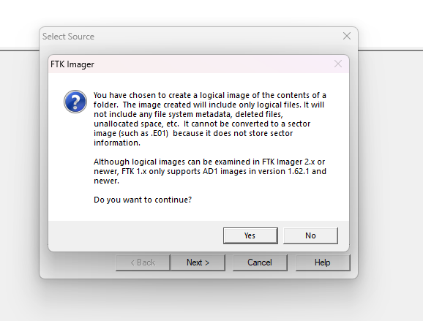

STEP 4:- Select Source Path : The examiner is then prompted to enter the path to the source folder identified in the first step. The path D:\CF_1_ftk\ftkimager1 is entered into the "Evidence Source Selection" dialog.

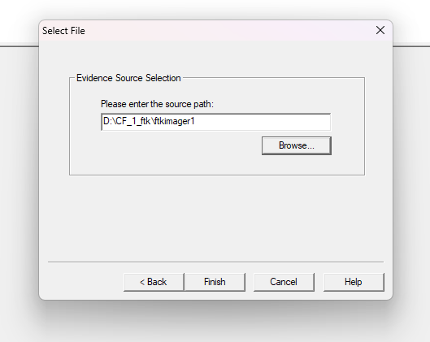

STEP 5:- Enter Evidence Item Information : The "Create Image" wizard requires the examiner to enter metadata for case documentation. This includes the "Case Number" (2), "Evidence Number" (2), and the "Examiner" (Ritu).

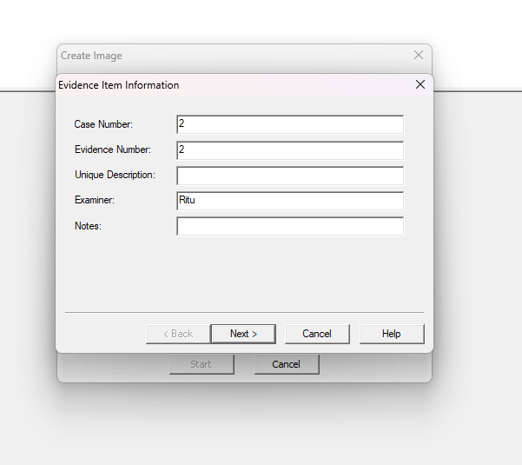

STEP 6:- Select Image Destination : The examiner then specifies the settings for the output image file.
- Image Destination Folder: D:\CF_1_ftk\ftkimager1
- Image Filename: Forensicimage (which will be saved as an .ad1 file)
- Image Fragment Size: 1500 (MB)
- Compression: 6 (a medium compression level)

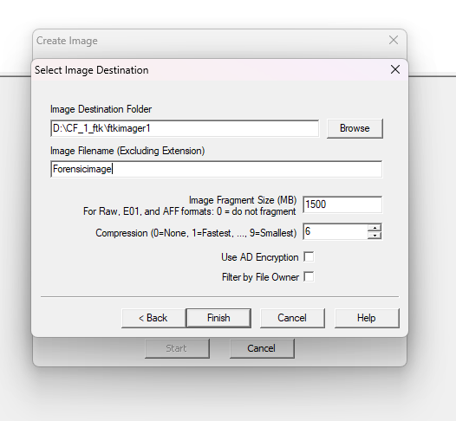

STEP 7:- Finalize Image Creation Options: The final configuration screen summarizes the "Image Source" and "Image Destination." The examiner ensures two crucial verification options are checked:
- "Verify images after they are created"
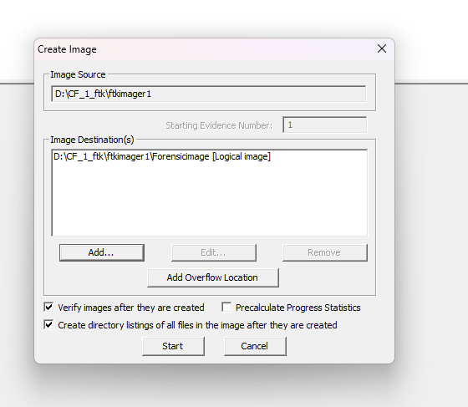
- "Create directory listings of all files in the image after they are created" The "Start" button is then clicked to begin the imaging process.

STEP 8:- Review Verification Results : Once the image is created, the automatic verification process runs. The "Drive/Image Verify Results" window shows that the "Computed hash" and "Report Hash" "Match" for both MD5 and SHA1. This confirms the integrity of the forensic image.

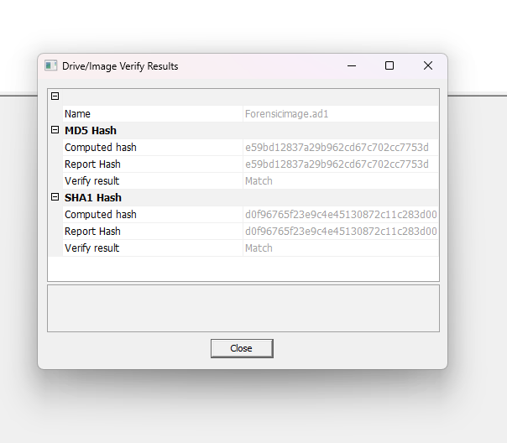

STEP 9:- Confirm Directory Listing Creation : As requested during setup, a directory listing of the new image's contents is generated. The progress window shows "Directory listing created successfully" as a .csv file.

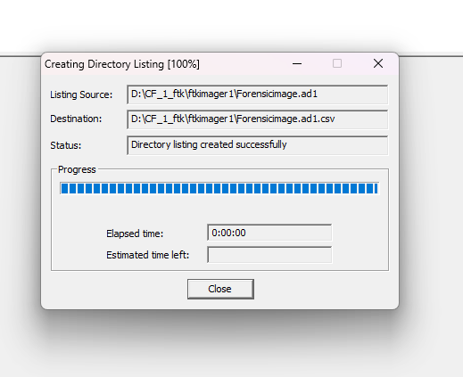

STEP 10:- Review Image Creation Status : After the examiner clicks "Start," the "Creating Image..." progress window appears. This window displays the real-time status of the imaging process.
- Process Completed with Errors: The progress bar is at 100%, indicating the process has finished, but the "Status" line shows "Failure: See summary file for details."
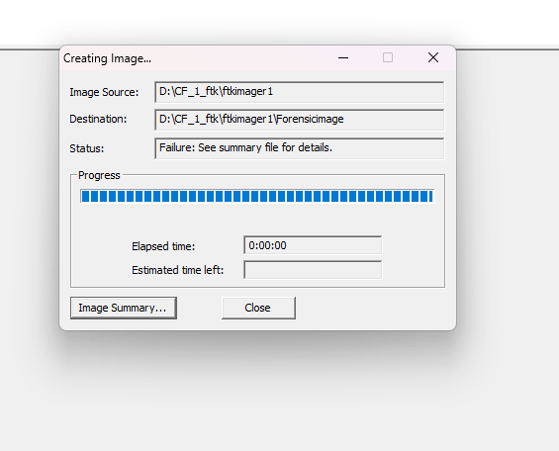
- Next Action: This indicates that the forensic image was not created successfully. The next logical action for the examiner would be to click the "Image Summary..." button to open the log file and diagnose the cause of the failure.

STEP 11:- Review Image Summary : Finally, an "Image Summary" report is displayed. This report confirms all case details, the "Acquisition finished" timestamp (Tue Nov 11 11:04:28 2025), and the final computed MD5 and SHA1 hashes, validating the entire acquisition process.
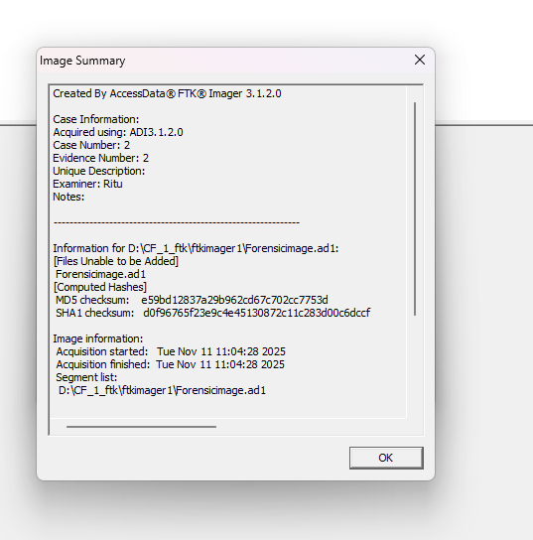

FINAL OUTPUT FILES CONTENT :-

- Forensicimage.ad1.csv
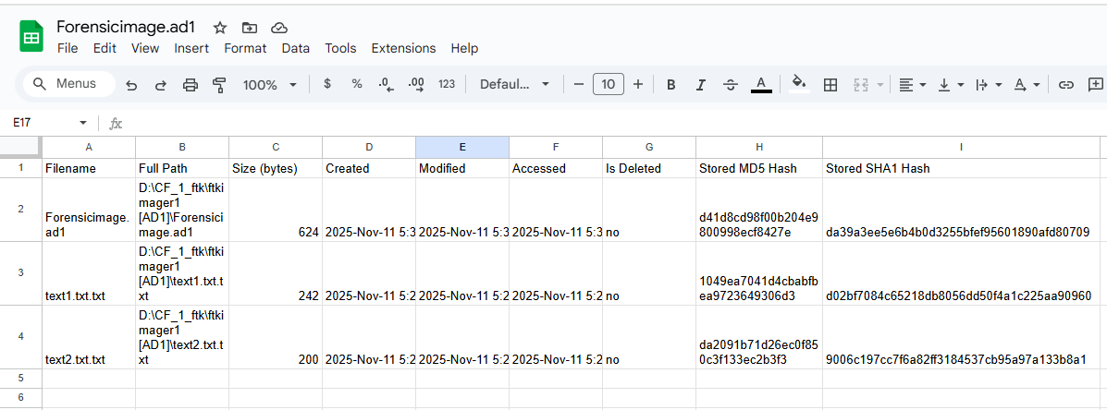

2.Forensicimage.ad1.txt

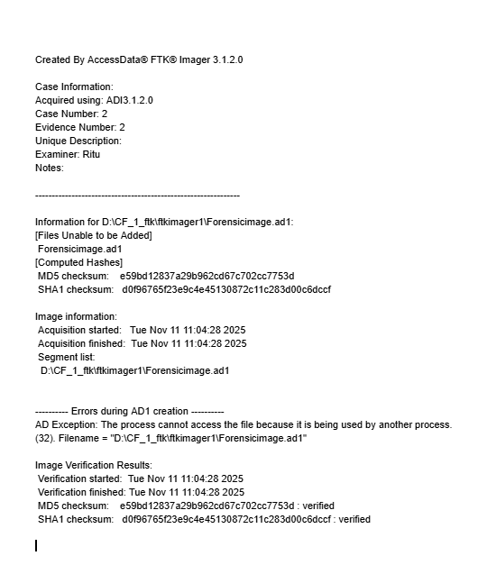

QUESTION 5 :- Creating and Analysing Network Packets using WireShark.

STEP 1:- Select Capture Interface : The process begins by launching The Wireshark Network Analyzer. On the welcome screen, the examiner selects the network interface from which to capture packets. In this case, the eno1 interface is selected.
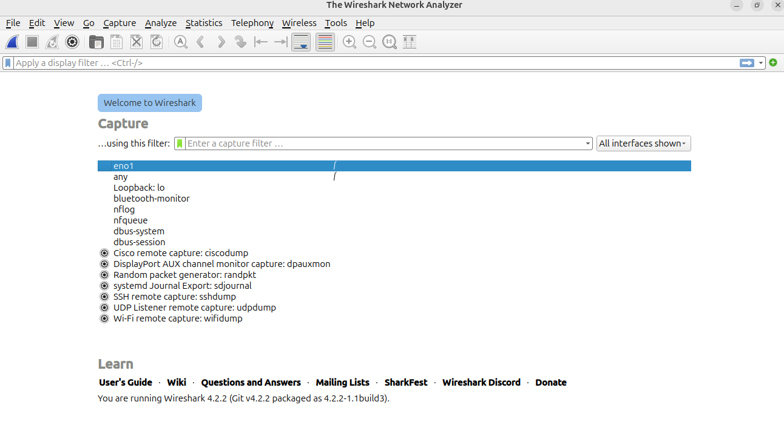
Step 2:- Initiate Live Packet Capture : After selecting the interface, the capture is started. The main window displays all packets being captured from the eno1 interface in real-time. This unfiltered view shows a variety of protocols on the network, such as DHCP, ICMPv6, and MDNS.

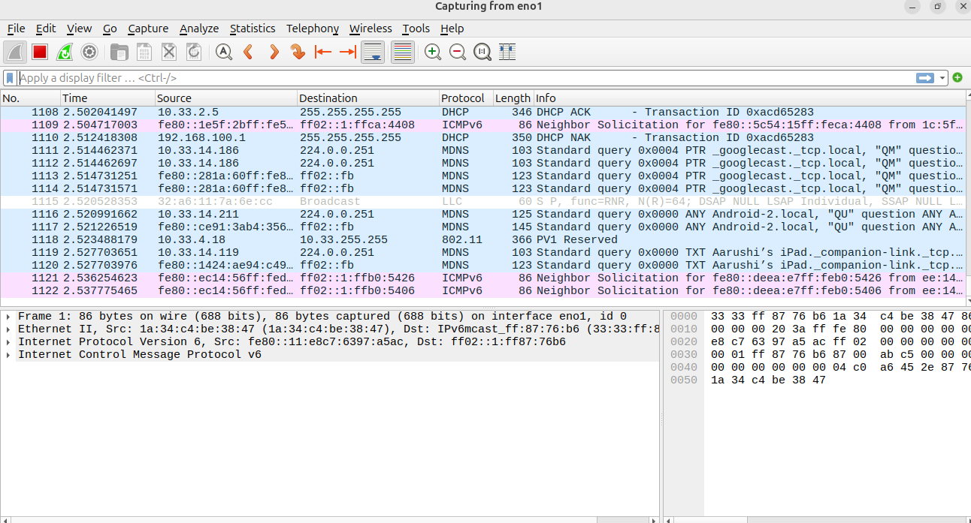
STEP 3:- Generate Network Traffic: While the capture is running, the examiner generates network activity to be recorded. In this instance, the examiner opens a web browser and navigates to the website www.kaggle.com. This action is designed to generate DNS, TCP, and HTTP/HTTPS traffic for later analysis.



STEP 4 :- Analyze Traffic with 'http' Filter : After stopping the capture (an implied step), the analysis phase begins. The examiner applies a display filter to isolate specific traffic. The filter http is typed into the filter bar to search for any unencrypted Hypertext Transfer Protocol packets.

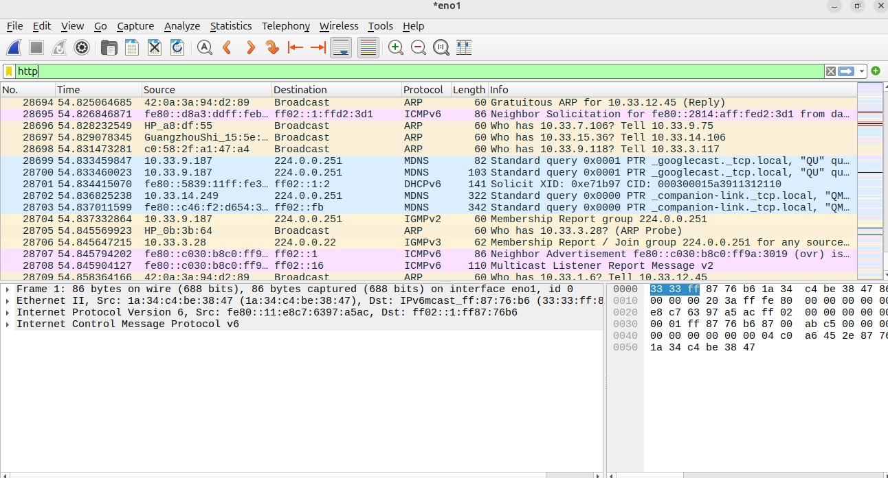
STEP 5 :- Analyze Traffic with 'arp' Filter : The examiner then applies a different filter, arp. The packet list is now updated to show only Address Resolution Protocol packets. This allows the examiner to analyze how devices on the local network are mapping IP addresses to physical MAC addresses.

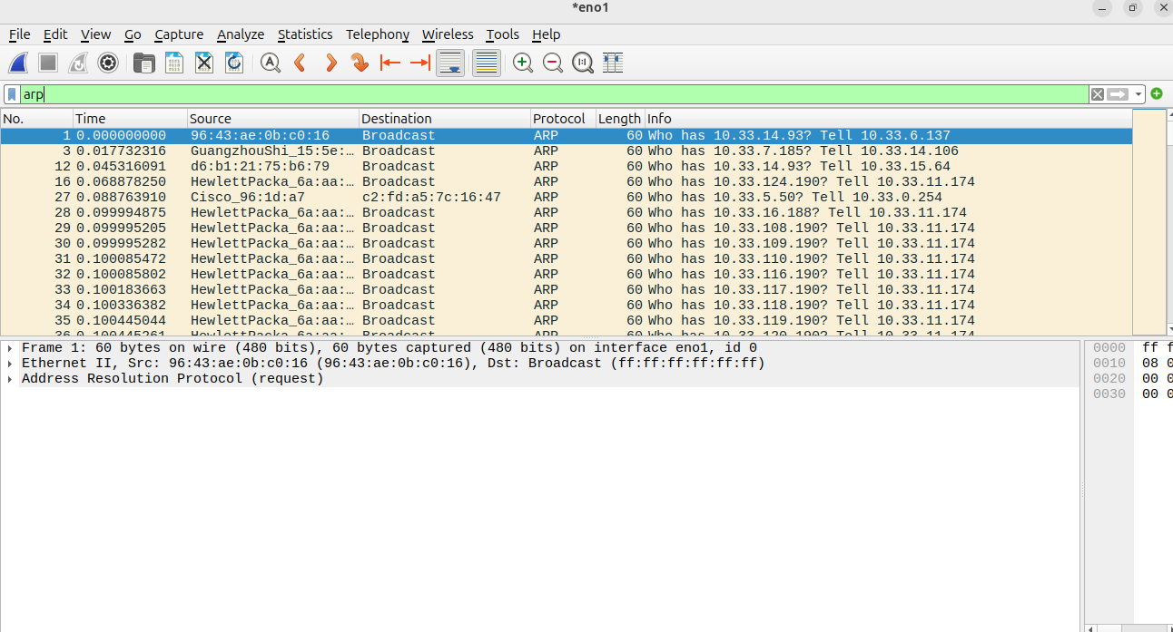

STEP 6:- Analyze Traffic with 'icmpv6' Filter : Finally, the examiner applies the icmpv6 display filter. This isolates all Internet Control Message Protocol v6 traffic, which is used for network diagnostics, router discovery, and neighbor discovery on an IPv6-enabled network.
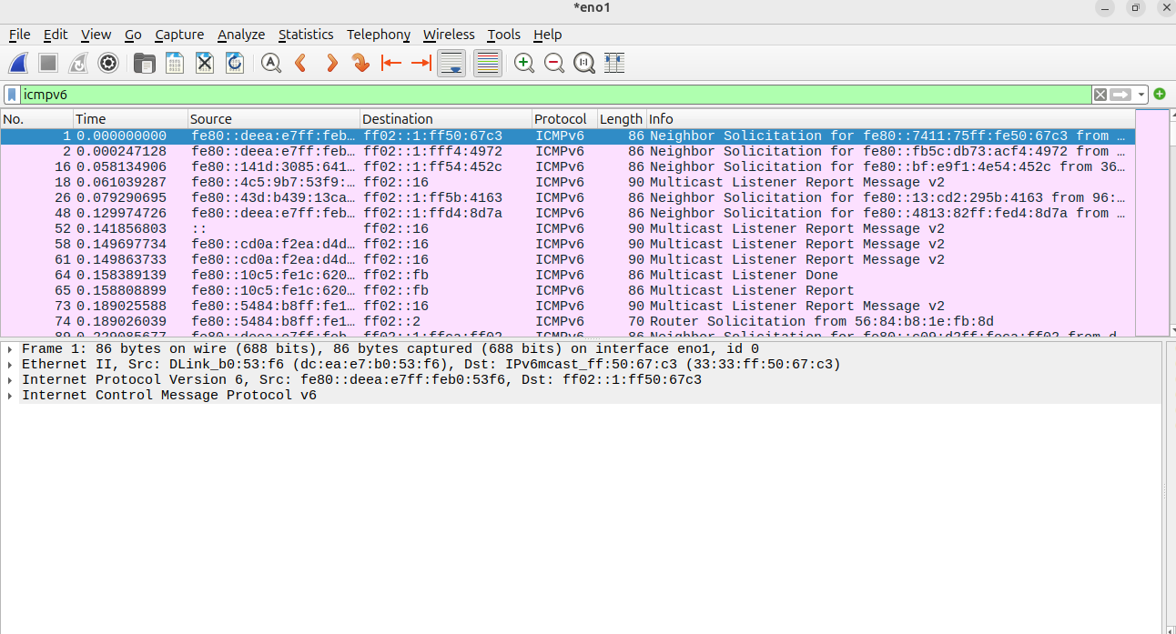
QUESTION 6 :- Analysis of Windows Registry

The Windows Registry is a collection of databases that contains the system’s configuration data. This configuration data can be about the hardware, the software, or the user’s information. It also includes data about the recently used files, programs used, or devices connected to the system.
Open the registry Editor via run command(Win+R).
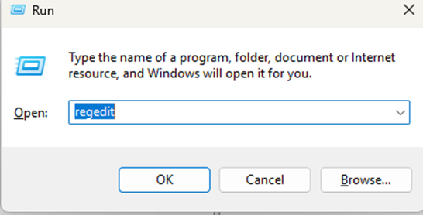
In the run dialog box, type regedit in the Open: field.

Press Enter or click OK.
The Registry Editor window opens.
You’ll see a tree structure on the left, with the five main root keys:
1. HKEY_CLASSES_ROOT
2. HKEY_CURRENT_USER
3. HKEY_LOCAL_MACHINE
4. HKEY_USERS
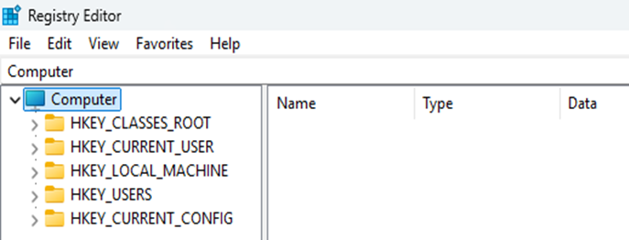
5. HKEY_CURRENT_CONFIG

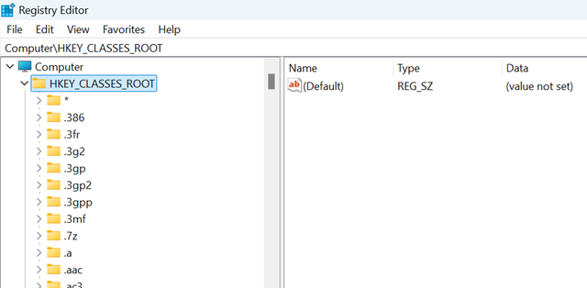
1. HKEY_CLASSES_ROOT: Handles file associations and COM objects. It tells Windows how to open a file when you double-click it — for example, that .docx files open in Word, .exe files are programs, etc.

Key Structure
- .ext (file extensions)
e.g. .txt, .jpg, .exe
→ Each points to a file type handler.
- CLSID (Class Identifiers)
→ Each represents a COM object or shell extension.
- Interface
→ Contains details on COM interfaces.
Purpose:
You can find-
I. Altered file associations- Malware may hijack .exe or .html extensions to run its own code.
II. Suspicious CLSIDs- Malware can register itself as a shell extension or context menu handler.
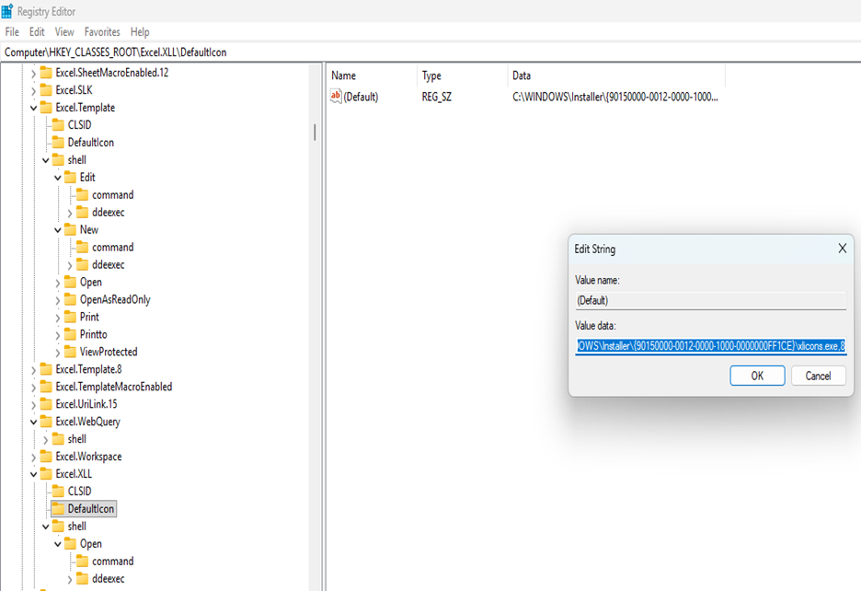

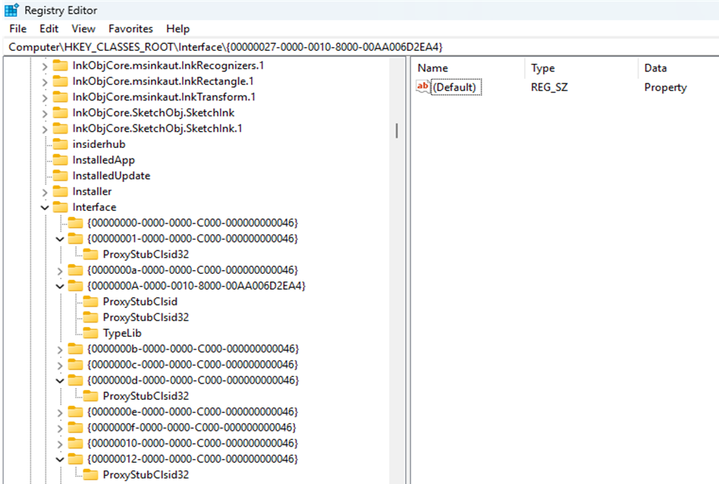

2. HKEY_CURRENT_USER: Stores configuration and preference data for the currently logged-in user.
When a user logs in, Windows loads this hive from their personal file:C:\Users\<username>\NTUSER.DAT
· HKCU\Software\Microsoft\Windows\CurrentVersion\Explorer\UserAssist
We analyze: Programs the user opened. | How many times have they opened each program? | The last time they opened it. | Evidence of user behavior (e.g., opened TOR browser, USB tools).
HKCU\Software\Microsoft\Windows\CurrentVersion\Explorer\RecentDocs
We analyze: Recently opened documents. | File extensions used. | Timestamps of when they were last accessed.
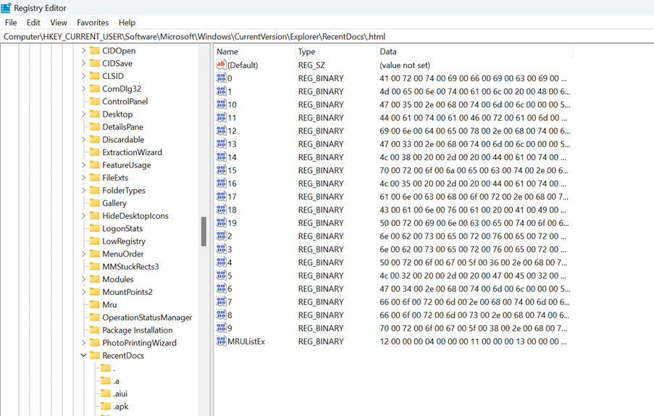
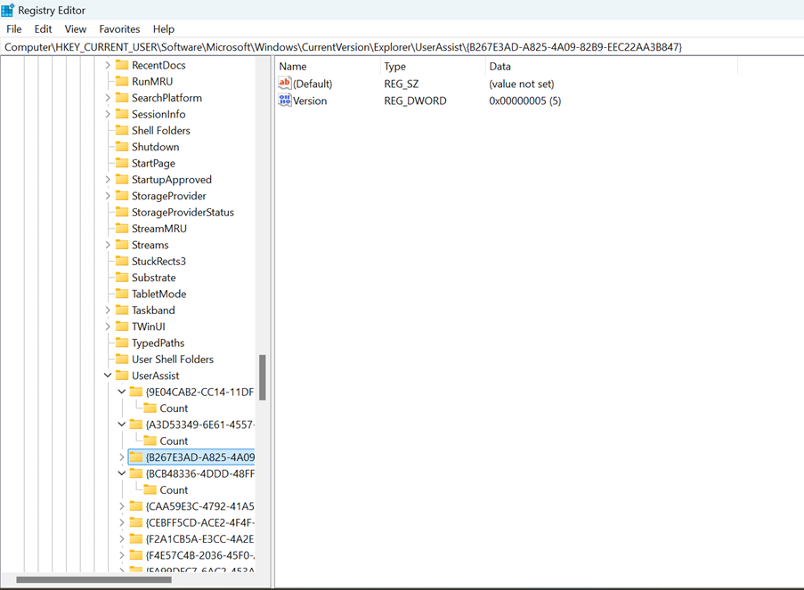

HKCU\Software\Microsoft\Windows\CurrentVersion\Explorer\RunMRU
We analyze: Commands typed in Run dialog. | Executables user manually ran.
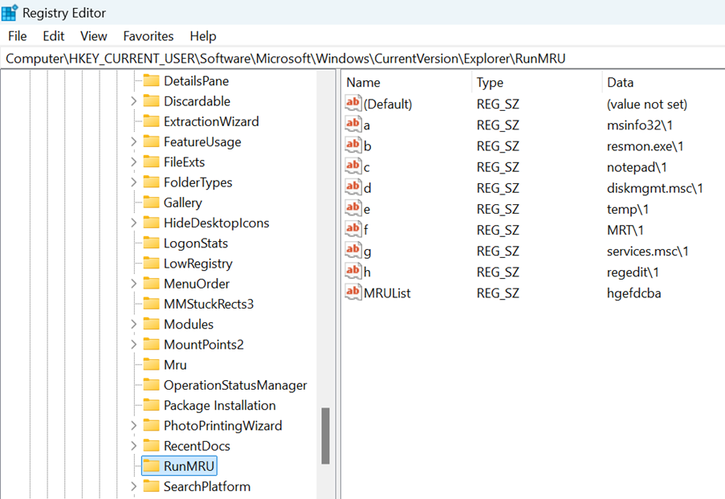

3. HKEY_LOCAL_MACHINE: System-wide settings, configuration, installed drivers, and hardware.
HKLM\Software\Microsoft\Windows\CurrentVersion\Run
We analyze: Any executable that runs automatically at system startup. | Suspicious programs placed here by malware. | Unusual file paths (AppData, Temp, hidden dirs).
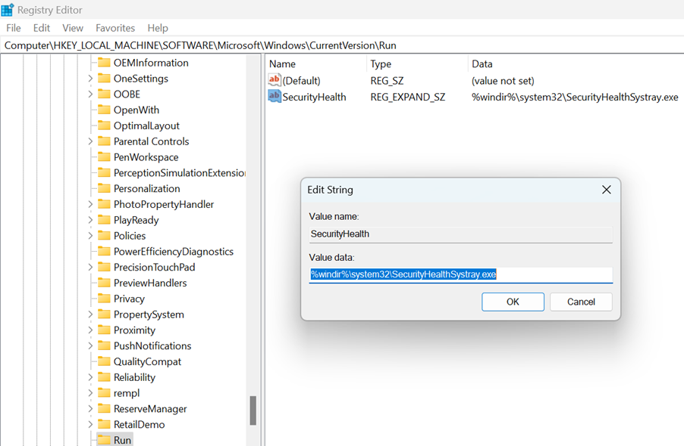

HKLM\SYSTEM\CurrentControlSet\Services:
We Analyze: Services installed on system. | Whether new malicious services exist. | Service creation timestamps. | ImagePath (where exe is located).

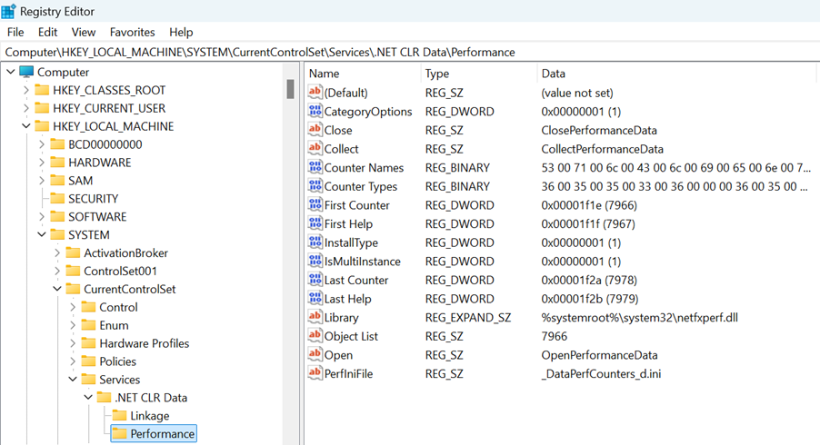

HKLM\Software\Microsoft\Windows NT\CurrentVersion\Winlogon
We Analyze: Shell replaced by malware (replaced explorer.exe) | Userinit replaced by malware.
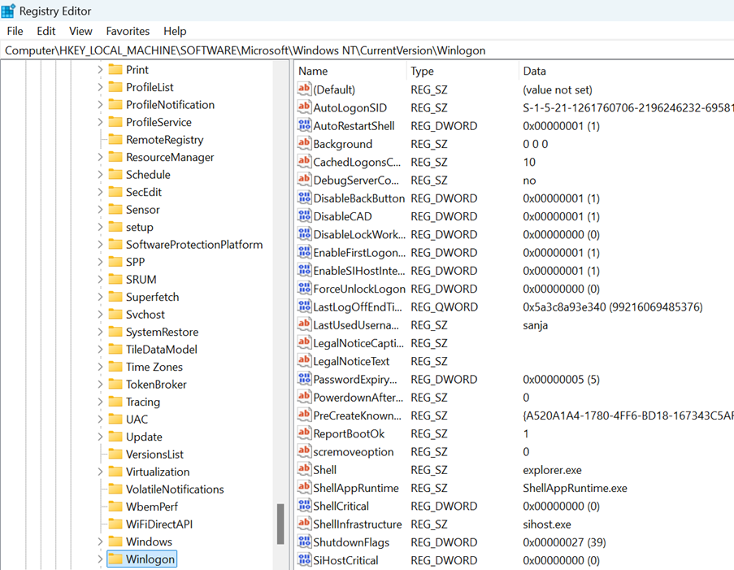

HKLM\Software\Microsoft\Windows\CurrentVersion\Uninstall
We analyze: Programs installed | Installation date | Whether dangerous software was installed.
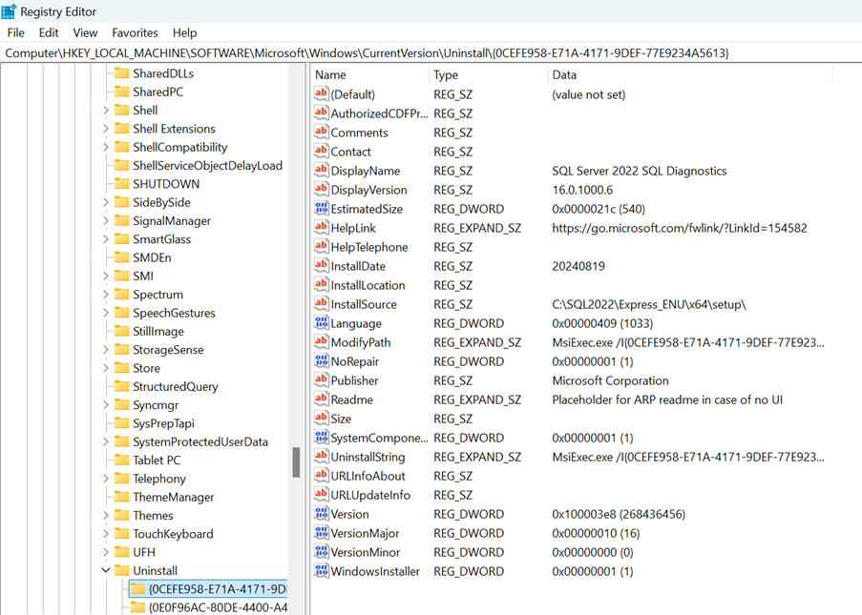

HKLM\System\MountedDevices
We analyze: Drive letter → Device ID mapping | What US or disk was mounted | The order of connected devices.

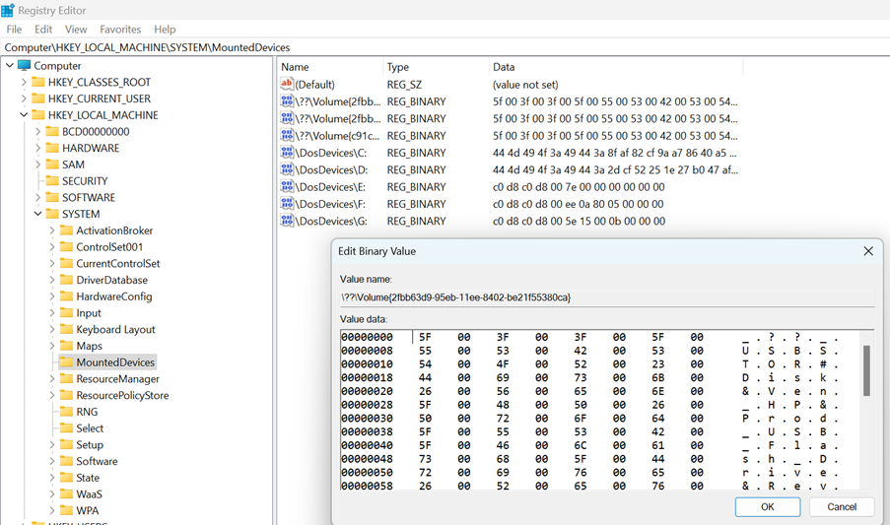

2. HKEY_USERS
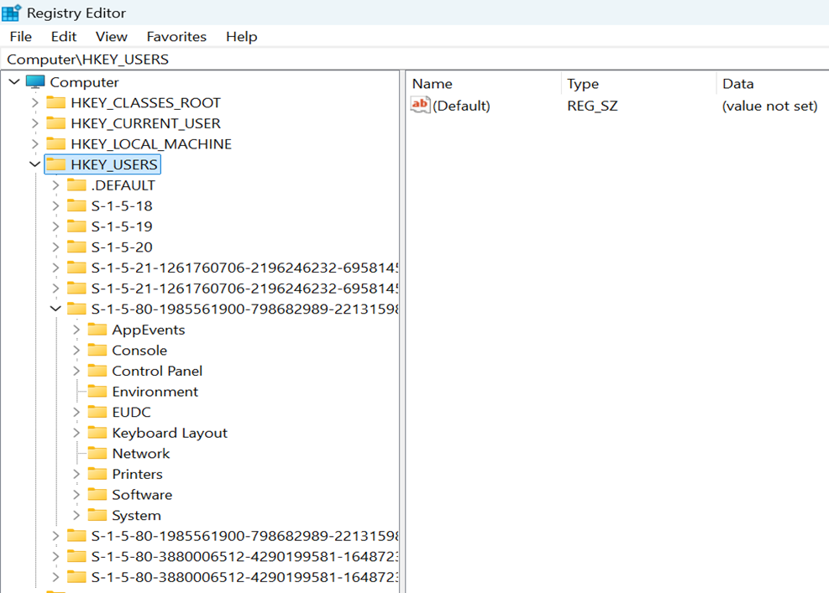
For forensic analysis, we never trust HKCU because it shows only the logged-in user.
But HKEY_USERS shows all users, including those not logged in.
From HKEY_USERS, an analyst can extract:
- UserAssist (programs opened): HKU\<SID>\Software\Microsoft\...UserAssist
- RecentDocs (recent files): HKU\<SID>\Software\Microsoft\Windows\CurrentVersion\Explorer\RecentDocs
- Typed URLs / Search history: HKU\<SID>\Software\Microsoft\Internet Explorer\TypedURLs
- Installed applications per user: HKU\<SID>\Software
- Desktop and wallpaper evidence: HKU\<SID>\Control Panel\Desktop
- Browser history and cookies (Edge/Chrome): HKU\<SID>\Software\Google\Chrome
HKU\<SID>\Software\Microsoft\Edge
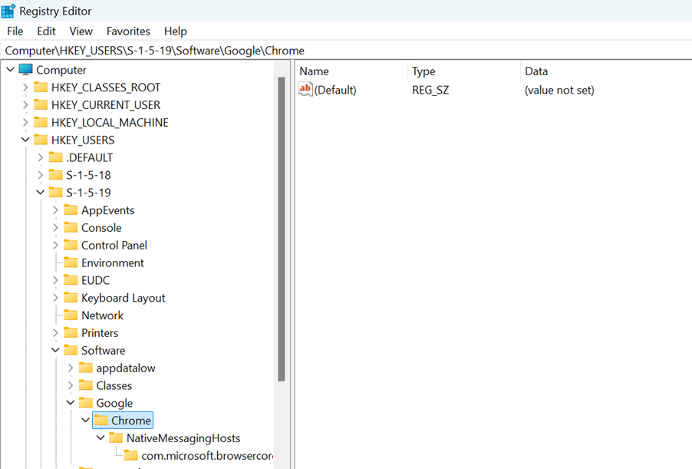

3. HKEY_CURRENT_CONFIG: This hive stores hardware configuration information that the system uses at boot time, especially display + printer + sound + drivers for the current hardware profile.
It is not a full registry hive — it’s a pointer (shortcut) to a part of:
HKLM\SYSTEM\CurrentControlSet\Hardware Profiles\Current
In forensics, it is analyzed for display history, printer info, and changes in active hardware drivers.
