Sentinel-VSC: A Real-Time Security Guardrail Extension for AI-Assisted Development
Capstone Project Proposal
Submitted by:
(102303947) Malik Mittal
(102303728) Tripat Garg
(102303989) Devanshu Singla
(102303439) Yashika
(102303138) Arnav Aggarwal
BE Third Year- COE
CPG No. 322

Under the Mentorship of
Dr. Sushma Jain
(Associate Professor)


Computer Science and Engineering Department
Thapar Institute of Engineering and Technology, Patiala
March 2026
TABLE OF CONTENTS

- Mentor Consent Form……………………………………………………3
- Project Overview…………………………………….………….……….4
- Problem Statement ……………………………………………………....5
- Need Analysis………………………………………………..………….6
- Literature Survey…………………………………………….………….7
- Objectives………………………………………………….....................10
- Methodology…………………………………………………………….11
- Project Outcomes & Individual Roles…………………………….….....14
- Work Plan……………………………………………………………….16
- Course Subjects…………………………………………………………17
- References………………………………………………………………18

Mentor Consent Form
I hereby agree to be the mentor of the following Capstone Project Team
Project Title: Sentinel-VSC: A Real-Time Security Guardrail Extension for AI-Assisted . Development
Roll No | Name | Signatures
102303947 | Malik Mittal
102303728 | Tripat Garg
102303989 | Devanshu Singla
102303439 | Yashika
102303138 | Arnav Aggarwal

NAME of Mentor: ……… . . . . . . . . . . . . . . . . . . . . . . . . . . . . . . . . . . .
SIGNATURE of Mentor: . . . . . . . . . . . . . . . . . . . . . . . . . . . . . . . . . . . .

Project Overview
The proposed capstone project focuses on the development of a Visual Studio Code (VS Code) extension for automated vulnerability detection and secure code recommendation during software development. With the increasing use of Large Language Models (LLMs) such as ChatGPT, GitHub Copilot, and CodeLlama, code generation has become faster and more efficient. However, the generated code may contain security vulnerabilities, incorrect logic, or unsafe programming practices because these models are trained on large public datasets that may include insecure or outdated code [1][2][3]. In many situations, the generated code is used without proper validation, which may introduce serious security risks in software applications.
The proposed system is designed to provide real-time security validation by integrating rule-based analysis with AI-powered vulnerability detection. The extension will continuously monitor the code being written in the editor and scan for common security issues such as SQL injection, hardcoded credentials, insecure API usage, and unsafe function calls. When a vulnerability is detected, the affected code segment will be highlighted directly in the editor, and a detailed explanation of the issue will be displayed. This approach allows the developer to understand the cause of the vulnerability and correct it before the code is committed or executed.
In addition to vulnerability detection, secure code suggestions will be generated using multiple AI APIs. The suggested fixes will be evaluated using a custom scoring model based on security level, correctness, and code quality, and the most reliable solution will be recommended. The proposed extension will follow a hybrid architecture that combines lightweight rule-based detection with deeper AI-based analysis, ensuring efficient performance with reduced computational cost. The objective of the project is to develop a practical tool that improves the reliability, security, and quality of AI-assisted software development [4][5].

Problem Statement
The increasing use of Large Language Models (LLMs) such as ChatGPT, GitHub Copilot, and other AI-based coding assistants has made software development faster and more efficient. However, the code generated by these tools may contain security vulnerabilities, incorrect logic, and unsafe programming practices. Since these models are trained on large public datasets, they may reproduce insecure or outdated coding patterns, which can introduce serious risks into software applications [1][3].
In current development environments, vulnerability detection is usually performed after the code has been written using static analysis tools. This approach makes it difficult to identify security issues during the coding process, and fixing vulnerabilities at later stages increases development time and effort. Moreover, most AI coding assistants focus only on generating syntactically correct code and do not provide real-time validation of security and reliability [2][5].
Therefore, there is a need for a system that can monitor the code continuously during development and detect vulnerabilities as soon as they appear. The system should provide real-time feedback, explain the detected issues, and suggest secure alternatives to the developer. Such a solution can improve the reliability, security, and quality of AI-assisted software development.
The objective of this project is to develop a Visual Studio Code extension that performs real-time vulnerability detection and secure code recommendation using rule-based analysis and AI-based techniques, so that developers can write safe and reliable code during the development process [4][8].

Need Analysis
The use of Large Language Models (LLMs) in software development has increased rapidly in recent years. Tools such as GitHub Copilot, ChatGPT, and CodeLlama are widely used to generate code automatically from user prompts. These AI-assisted tools help developers write programs faster and reduce development time. However, the generated code may not always follow secure programming practices [1][2][3]. Since these models are trained on large public datasets, they may reproduce insecure or outdated coding patterns, which can introduce vulnerabilities into software systems [3].
In traditional development environments, vulnerability detection is usually performed after the code has been written. Static analysis tools such as SonarQube, Bandit, ESLint, and Snyk are commonly used to scan code and identify security issues [6]. Although these tools are useful, they are generally applied after the development phase. Because of this, vulnerabilities may remain undetected during active coding, and fixing them later increases the development cost.
Another limitation of current AI coding assistants is the lack of real-time validation during code generation. These tools focus mainly on producing syntactically correct code but do not verify whether the generated code is secure or reliable [2][5]. Developers may directly use the generated code without proper review, which can lead to problems such as SQL injection, insecure API calls, hardcoded credentials, and improper authentication.
There is therefore a need for a system that can monitor code continuously during development and provide immediate feedback to the developer. A real-time validation system can help detect vulnerabilities as soon as the code is generated and suggest secure alternatives.
The proposed capstone project aims to develop a Visual Studio Code extension that performs real-time vulnerability detection and secure code recommendation. The extension will analyze code during development, identify insecure patterns using vulnerability standards such as Common Weakness Enumeration (CWE) [7], and provide suggestions for correction inside the development environment using the Visual Studio Code Extension API [8]. The system will improve the reliability and security of AI-assisted software development [4][5].
Literature Survey
The use of Large Language Models (LLMs) in software development has increased rapidly in recent years. Modern AI-based coding assistants such as GitHub Copilot, ChatGPT, and other language models are widely used to generate source code automatically from natural language prompts. These tools help developers improve productivity and reduce development time. However, several research studies have reported that the generated code may contain security vulnerabilities, inefficient logic, and unsafe programming practices [1][2][3]. Because these models are trained on large public datasets, they may reproduce insecure patterns present in the training data [3]. As a result, there is a growing need for automated systems that can verify the security and reliability of generated code during development.
Pearce et al. (2022) [1] analyzed the security of code generated by GitHub Copilot and evaluated whether the suggested code follows secure programming standards. In this study, multiple code samples generated by the AI assistant were examined to identify common security issues. The results showed that the generated code sometimes contained vulnerabilities such as SQL injection, hardcoded credentials, and improper input validation. The study concluded that AI-generated code should not be used without verification and recommended the integration of security analysis tools directly into the development environment. This work highlights the importance of real-time vulnerability detection when using AI-assisted coding tools.
Perry et al. (2022) [2] investigated whether developers write more secure code when using AI coding assistants. The study compared programs written with the help of AI tools and programs written manually by developers. It was observed that AI assistants help developers complete tasks faster, but the generated code may include insecure patterns if the suggestions are accepted without careful review. The research also showed that developers tend to trust AI-generated code even when it contains vulnerabilities. The authors suggested that automated validation systems should be used together with AI assistants to ensure that the generated code follows secure coding practices.
Sandoval et al. (2023) [3] studied the security implications of AI-generated code in modern software development. The authors observed that Large Language Models are trained on large collections of publicly available code, which may include vulnerable or outdated implementations. Because of this, the generated code may inherit the same weaknesses present in the training data. The study showed that AI-generated programs may contain errors related to authentication, input validation, and API usage. The authors recommended the use of additional verification tools to analyze the generated code before it is used in real applications. This research indicates the need for systems that can automatically detect vulnerabilities during the coding process.
Bistarelli et al. (2025) [4] presented a review of different Large Language Models used for code generation tasks. The study discussed the advantages of using LLMs in software development, such as faster coding and reduced manual effort. However, the review also identified several limitations related to reliability and security. It was observed that LLMs can generate syntactically correct code but may fail to follow secure programming guidelines. The study suggested that rule-based analysis and AI-based reasoning should be combined to improve the accuracy of vulnerability detection. The authors also recommended integrating security validation directly into development tools so that errors can be detected at an early stage.
Feng et al. (2023) [5] evaluated the performance of ChatGPT in different code generation tasks. The generated programs were tested for correctness, efficiency, and security. The results showed that although the model is capable of producing working code, the generated solutions may not always satisfy security requirements. Some generated programs contained unsafe operations and improper error handling. The study emphasized the need for additional validation mechanisms to ensure that generated code is reliable before it is executed. The authors suggested that automated analysis tools should be used together with AI models to improve the quality of generated code.
In addition to AI-based code generation research, several studies have focused on vulnerability detection techniques. Traditional static analysis tools such as SonarQube, Bandit, and ESLint are widely used to identify security issues in source code [6]. These tools use predefined rules to detect known vulnerability patterns. Although static analysis is effective for detecting common problems, it is usually performed after the code has been written. Because of this, developers may introduce vulnerabilities during coding and detect them only at later stages. Fixing vulnerabilities at a later stage increases development time and may require major changes in the program.
Recent research has proposed combining static analysis with machine learning and AI-based methods to improve vulnerability detection accuracy. Hybrid approaches allow fast detection of simple vulnerabilities using rule-based methods, while complex issues are analyzed using AI models [4][5]. This approach improves performance and reduces computational cost. Some systems also use vulnerability databases such as Common Weakness Enumeration (CWE) to classify detected issues and provide detailed explanations [7]. However, many of these tools are designed for offline analysis and are not suitable for real-time use inside the code editor.
Another important limitation identified in the literature is the absence of real-time security validation during AI-assisted coding. Most AI coding assistants generate code without checking whether the generated program follows secure coding standards. Developers often accept the generated code directly, which may introduce vulnerabilities into the software. Some recent studies suggest integrating vulnerability detection tools into Integrated Development Environments (IDEs) such as Visual Studio Code [8]. By performing analysis during development, vulnerabilities can be detected earlier and corrected immediately. However, existing extensions usually rely only on rule-based detection and do not use AI-based reasoning for deeper analysis.
From the literature survey, it can be concluded that existing research mainly focuses on code generation or vulnerability detection separately. Very few systems provide real-time validation of AI-generated code inside the development environment. Most available tools do not combine rule-based analysis, AI-based detection, and automatic fix generation in a single framework. Therefore, there is a need for a practical system that can monitor code continuously, detect vulnerabilities in real time, and provide secure code suggestions during development. The proposed project aims to address this gap by developing a Visual Studio Code extension that integrates rule-based detection, AI-powered analysis, and vulnerability databases to provide real-time security validation for AI-assisted software development.

Objectives
The main objective of the proposed capstone project is to develop a Visual Studio Code extension that provides real-time vulnerability detection and secure code recommendation during AI-assisted software development. The system is intended to improve the reliability and security of generated code by analyzing it continuously while the developer is writing the program.
The specific objectives of the project are listed below:
- To design and develop a VS Code extension that can monitor source code in real time during development.
- To implement rule-based vulnerability detection for identifying common security issues such as SQL injection, hardcoded credentials, insecure API usage, and unsafe function calls.
- To integrate AI-based analysis for detecting complex vulnerabilities and generating secure code suggestions.
- To provide automatic fix recommendations for detected vulnerabilities using AI APIs and predefined security rules.
- To develop a scoring mechanism for evaluating suggested fixes based on security, correctness, and code quality.
- To ensure that the extension performs efficient analysis without affecting the performance of the code editor.
- To create a user-friendly interface that highlights vulnerabilities and provides clear explanations inside the development environment.

Methodology
The proposed system will be developed as a Visual Studio Code extension that performs real-time vulnerability detection and secure code recommendation during AI-assisted software development. The methodology follows a stepwise approach in which the generated code is continuously monitored, analyzed, and verified using rule-based and AI-based techniques. The overall workflow of the system is shown in Figure 1. The architecture consists of multiple modules including the editor listener, rule-based analysis engine, AI detection module, vulnerability database, and suggestion generator. The extension will be implemented using the Visual Studio Code Extension API [8].
The first step in the methodology is to capture the source code from the editor. The extension will monitor the code written in Visual Studio Code and detect changes whenever the developer types or saves the file. The editor listener module will send the updated code to the analysis engine for verification. This allows the system to perform security checking continuously during development.
In the second step, the captured code will be processed by the rule-based analysis engine. This module will scan the source code using predefined security rules based on secure coding standards. The rules will be created using known vulnerability patterns such as SQL injection, hardcoded credentials, insecure API calls, unsafe function usage, and improper input validation. The rule-based analysis is similar to static analysis tools such as SonarQube that detect known vulnerability patterns in source code [6]. The rule-based analysis is designed to be fast so that it can run in real time without slowing down the editor.
If a suspicious pattern is detected, the third step will perform deeper analysis using the AI-based detection module. In this step, the code segment will be sent to a Large Language Model API for context-aware analysis. The AI module will examine the code logic and determine whether the detected pattern represents a real vulnerability. This approach is inspired by recent research on AI-based code analysis and vulnerability detection [4][5]. This step helps reduce false warnings and improves the accuracy of detection.
In the fourth step, the detected vulnerability will be compared with a vulnerability database. The database will contain information about known security issues based on standards such as Common Weakness Enumeration (CWE) [7]. By matching the detected pattern with the database, the system will identify the type of vulnerability and generate an explanation. The explanation will be displayed to the developer so that the cause of the problem can be understood.
In the fifth step, secure code suggestions will be generated. The suggestion generator module will create possible fixes using predefined secure templates and AI-generated code. Multiple suggestions may be produced, and each suggestion will be evaluated using a scoring model. The scoring model will consider factors such as security level, correctness, and code quality. The suggestion with the highest score will be selected as the recommended fix.
In the final step, the results will be displayed in the Visual Studio Code editor. The vulnerable code will be highlighted, and a warning message will be shown along with the explanation and suggested fix. The developer can accept the suggested fix or modify the code manually. Since the analysis is performed continuously, the system will verify the updated code again after modification.
The proposed methodology ensures that vulnerabilities are detected at the earliest stage of development. By combining rule-based detection with AI-based analysis, the system provides accurate results while maintaining efficient performance. The use of a modular architecture allows the extension to be expanded in the future to support additional programming languages and security rules.

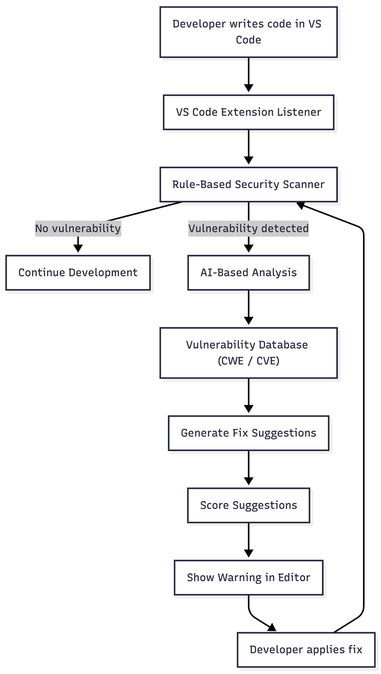
Figure 1: System Architecture of Proposed Extension
Project Outcomes & Individual Roles
Project Outcomes
The proposed project is expected to result in the development of a Visual Studio Code extension that performs real-time vulnerability detection and secure code recommendation during AI-assisted software development. The system will continuously monitor the source code written in the editor and identify insecure coding patterns using rule-based analysis and AI-based detection methods.
The extension will be capable of detecting common security vulnerabilities such as SQL injection, hardcoded credentials, insecure API usage, and unsafe function calls. When a vulnerability is detected, the system will highlight the affected code segment and provide a detailed explanation. Secure code suggestions will also be generated using AI APIs and predefined templates, and the best suggestion will be selected using a scoring mechanism based on security, correctness, and code quality.
The proposed system is expected to improve the reliability and security of AI-generated code by providing real-time feedback to the developer. Since the analysis is performed during development, vulnerabilities can be corrected at an early stage, which reduces debugging effort and improves software quality. The modular architecture of the extension will allow future expansion to support additional programming languages and new security rules.
The project will demonstrate the practical use of AI-based analysis combined with rule-based detection inside a development environment. The final outcome will be a working prototype of a VS Code extension that can assist developers in writing secure and reliable code.

Individual Roles
The project will be developed as a group effort, and the work will be divided among the team members so that different modules of the system can be implemented efficiently. Each member will be responsible for designing and developing a specific component of the proposed VS Code extension.
Devanshu Singla will be responsible for system architecture design and development of the security rule engine. The overall project coordination and final integration of all modules will also be supervised by this member to ensure proper working of the system.
Tripat Garg will be responsible for the development of the Visual Studio Code extension interface. The user interface design and implementation of the real-time notification system for displaying warnings and suggestions inside the editor will also be handled by this member.
Arnav Aggarwal will develop the Abstract Syntax Tree (AST) parsing engine and will integrate the vulnerability database with the analysis module. Performance optimization of the extension will also be carried out to ensure efficient real-time execution.
Malik Mittal will be responsible for testing and validation of the system. Test cases will be developed using vulnerable code samples, and the system will be evaluated using SARD testing datasets. Analysis of false positives and verification of detected vulnerabilities will also be performed.
Yashika will be responsible for technical documentation and preparation of research materials. This includes writing the project report, studying research papers, preparing user guides, and developing presentation materials required for the project.
All team members will participate in discussion, testing, and final integration of the project to ensure successful completion of the proposed system.

Work Plan
The work plan for the proposed project has been prepared to complete all phases of development in a systematic manner within the given time period. The schedule is divided into different activities such as project planning, literature review, core implementation, model development, system integration, testing, and final report preparation. Both the planned schedule and the actual progress are maintained to monitor the development of the project.
In the initial stage, project planning will be performed to define the problem statement and system requirements. This will be followed by a literature review to study existing research related to AI-generated code and vulnerability detection. After that, the core implementation of the Visual Studio Code extension will be carried out, including development of the rule-based detection engine and integration with the editor.
In the next phase, the AI-based detection and suggestion modules will be developed and integrated with the system. After implementation, system integration and refinement will be performed to ensure proper working of all modules. The system will then be tested using different vulnerable code samples to verify correctness and performance.
Finally, testing validation, documentation, and preparation of the final report will be completed. The detailed work schedule showing the planned and actual progress is given in Table 1.

Table1: Work Plan for Proposed Project (February-December)
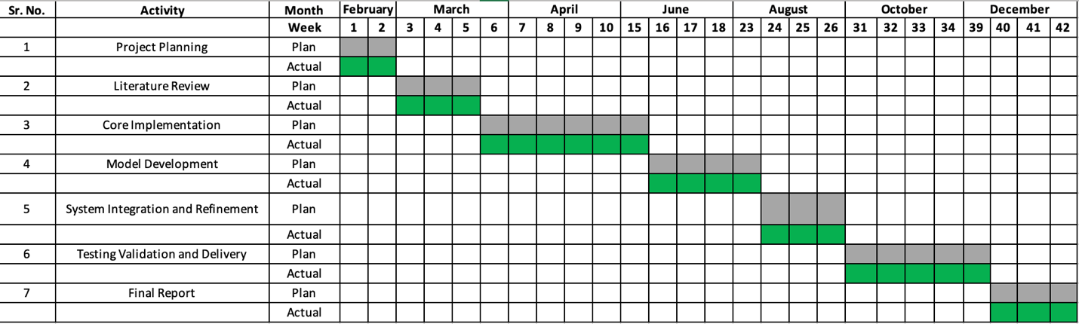
Course Subjects
The development of the proposed project requires knowledge from various subjects studied during the course. The concepts learned in these subjects will be applied in the design and implementation of the system.
1. Software Engineering
The concepts of software development life cycle, requirement analysis, system design, and testing will be used to plan and develop the project in a structured manner.
2. Programming Languages
Knowledge of programming languages such as Python, JavaScript, and TypeScript will be used to implement the extension, analysis modules, and user interface.
3. Data Structures and Algorithms
Data structures and algorithms will be used for efficient processing of source code, pattern matching, and implementation of rule-based vulnerability detection.
4. Cyber Security / Information Security
Concepts of software security, secure coding practices, and common vulnerabilities will be applied to design the vulnerability detection rules and security validation module.
5. Artificial Intelligence / Machine Learning
Basic knowledge of AI and machine learning will be used to understand the working of Large Language Models and to integrate AI-based vulnerability detection and suggestion generation.
6. Database Management Systems
Database concepts will be used to store vulnerability patterns, security rules, and scoring information required for analysis.
7. Web Technologies / Development Tools
Knowledge of development tools, APIs, and editor extensions will be used to implement the Visual Studio Code extension and integrate different modules of the system
References

[1] Pearce, H., Ahmad, A., Tan, B., Dolan-Gavitt, B., Karri, R. (2022),
Asleep at the Keyboard? Assessing the Security of GitHub Copilot’s Code Contributions,
IEEE Symposium on Security and Privacy.
[2] Perry, N., Srivastava, M., Kumar, D., Boneh, D. (2022),
Do Users Write More Secure Code with AI Assistants?,
ACM Conference on Computer and Communications Security (CCS).
[3] Sandoval, G., Pearce, H., Karri, R. (2023),
Security Implications of AI-Generated Code in Software Development,
arXiv preprint.
[4] Bistarelli, S., Fiore, M., Mercanti, I., Mongiello, M. (2025),
Usage of Large Language Models for Code Generation Tasks: A Review,
SN Computer Science.
[5] Feng, Y., Vanam, S., Cherukupally, M., et al. (2023),
Investigating Code Generation Performance of ChatGPT,
IEEE COMPSAC.
[6] SonarSource (2023),
SonarQube Static Code Analysis Tool Documentation,
SonarSource Technical Documentation.
[7] MITRE Corporation (2023),
Common Weakness Enumeration (CWE),
Available at: https://cwe.mitre.org
[8] Microsoft (2023),
Visual Studio Code Extension API,
Available at: https://code.visualstudio.com/api

