A Hybrid Explainable AI Framework for Cyber Threat Detection and Response
Yashika
Chitkara University of Engineering and Technology, Chitkara University,Punjab
India
yashika2564.be22@chitkara.edu.in

Abstract-AI-based cybersecurity has emerged as a necessity to fill a gap in the operation of businesses. Today’s businesses are generating significant amounts of data from endpoints, networks, clouds, and identity. In spite of these advancements, most of the threat detection and response activities are performed by signature-based solutions, correlation engines, and analyst reviews. These solutions are not effective in dealing with dynamic attack patterns, encrypted traffic, and slow attacks. This research aims to understand the potential of AI in revolutionizing threat detection and response. Threat detection and response activities need to be improved in terms of accuracy, reducing false positives, and speeding up safe decision-making while being clear and unambiguous. A new framework based on supervised learning for known attacks, anomaly detection for unknown attacks, and reinforcement learning for response generation based on context risk has been proposed. In the proposed framework, data collection from different sources and temporal and graph-based modeling are performed. It provides explainable reasons for actions through distillation and rule extraction techniques for ease of human validation. We test this system through red teaming and benchmarking threat scenarios. We measure its performance based on precision, recall, F1-score, false positives, mean time to detect (MTTD), mean time to respond (MTTR), and analyst effort. The results indicate that using multiple data sources and modeling helps improve detection performance by 9-14% in terms of F1-score compared to baseline correlations in a SIEM system and reduces false positives by 22-31%. Additionally, its recommendation for responding helps in reducing MTTR by 28% through prioritized containment actions. The explainability feature further helps in reducing analyst time by 17% through increased analyst trust and speed in making decisions. These results demonstrate that AI systems can be highly effective in cybersecurity operations if designed as a layered, clear, and continuously monitored system. Security mechanisms such as drift monitoring, adversarial hardening, and human monitoring must be in place for effective and responsible automation.

Ⅰ. INTRODUCTION

In the modern digital world, organizations heavily rely on connected devices, cloud computing, and internet-based applications. Consequently, a vast amount of data is being constantly generated from diverse sources such as network traffic, endpoints, applications, and user interactions. This data is of significant importance in identifying potential security risks. Nevertheless, managing and processing such large-scale data is a significant challenge for traditional security solutions.
Traditional security solutions, such as intrusion detection systems and Security Information and Event Management (SIEM) solutions, heavily rely on predefined rules and known patterns of attacks. These solutions are effective in detecting known security risks. However, these solutions are not efficient in detecting unknown security risks. Cyber attackers are increasingly adopting modern and sophisticated methods such as polymorphic viruses, encrypted communications, and low and slow attacks to evade traditional security solutions.
This situation poses a serious threat in the field of cybersecurity. One of the major problems is the high volume of false positives being reported by traditional security solutions. Security analysts are often overwhelmed by a large number of false security alerts. Most of these security alerts are not actual security risks. This situation causes a significant reduction in the efficiency of security analysts. There is a high possibility of missing actual security risks. Furthermore, it causes delays in security detection and response. These delays can cause serious consequences such as data breaches, financial losses, and reputational damage.
As such, there is a significant need for intelligent and automated systems that can handle large amounts of data and respond to emerging threats. This is where Artificial Intelligence (AI) and Machine Learning (ML) have shown significant promise as possible solutions to these challenges.
The primary goal of this research is to develop and implement AI-based cybersecurity technology that improves threat detection accuracy, reduces false alarms, and provides quicker and more efficient response strategies. The proposed technology will incorporate various AI technologies to create a comprehensive solution for modern cybersecurity challenges.
Although significant advancements have been made in this technology, there are still several limitations associated with existing AI-based cybersecurity technologies. For instance, most of these technologies have concentrated on either response or detection, but not both. The inability of these technologies to explain their decision processes is another limitation, as it makes it difficult for security analysts to trust these technologies. Finally, there is limited ability for these technologies to incorporate various forms of data and real-time processing capabilities. This is where there is a significant need for a hybrid and explainable AI-based cybersecurity technology.

Ⅱ. LITERATURE REVIEW

The use of artificial intelligence in the field of cybersecurity has gained significant attention in recent years. Various methods have been proposed for the detection and prevention of cyber-attacks. Each of these methods has its own advantages and disadvantages.
[1] Signature-based detection is one of the first methods introduced in the field of cybersecurity. These detection methods use a database of known signatures of attacks and compare the data being transferred with these signatures. These methods are easy to use and are fast. However, these methods are not effective in detecting unknown attacks. This makes them unsuitable for modern cybersecurity environments.
[2] Machine learning methods have been introduced to overcome these limitations. Supervised learning methods such as decision trees, random forest, and support vector machines are commonly used for classification. These methods can be trained to achieve high accuracy. However, these methods require a large amount of data for training, and it is difficult to obtain such data.
[3] Deep learning methods such as convolutional neural networks and recurrent neural networks have shown significant improvements in the detection of cyber-attacks. These methods can be trained to automatically extract features from the data. These methods are suitable for large and complex data sets. However, these methods are computationally expensive and are considered “black boxes,” making it difficult to interpret their decisions.
[4] Unsupervised learning techniques, which include clustering and anomaly detection, are used for detecting unusual patterns in the data. These techniques are used for detecting unknown attacks. However, they may produce a high number of false alarms.
[5] Security Information and Event Management (SIEM) systems are used for monitoring and analysis activities by various organizations for detecting security incidents. These systems collect data from various sources and then apply predefined rules for detecting various types of attacks. However, SIEM systems require significant human intervention for configuration and tuning, which may not be effective for dynamic environments.
Researchers have used various graph-based techniques for understanding relationships between various entities such as users, devices, and network connections. These techniques provide a better understanding of patterns used for attacking the system. However, they require significant computation power.
Another technique used for automating response activities is reinforcement learning. This technique allows the system to learn various response activities through trial and error. However, the application of reinforcement learning for cybersecurity is still in the initial stages.
The application of various techniques for cybersecurity has resulted in the development of various hybrid models. These models provide promising results by using a combination of supervised learning, unsupervised learning, and reinforcement learning techniques. However, various challenges need to be addressed for the effective application of these models.

TABLE-1
COMPARISON OF EXISTING METHODS
Paper | Method | Advantage | Limitation
[1] | Signature-based | Fast and Simple | Cannot detect new attacks
[2] | Machine Learning | Good accuracy | Requires labelled data
[3] | Deep Learning | High Performance | Complex and less explainable
[4] | Anomaly Detection | Detect Unknown Threats | High false positives
[5] | SIEM | Centralized Monitoring | Manual and slow

A. Limitations of existing work
- Inability to detect zero-day attacks
- High false positive rates
- Lack of automated response systems
- Limited scalability for large datasets
- Poor interpretability of AI models
Ⅲ. RESEARCH OBJECTIVES
The primary objectives of conducting this research are as follows:
- To design an AI-based cybersecurity system that can effectively identify known as well as unknown cyber threats using advanced machine learning algorithms.
- To enhance the accuracy of threat detection using various machine learning algorithms like supervised and unsupervised learning on large-scale security data.
- To reduce false positives in order to minimize analyst workload and enhance system efficiency.
- To design an automated response system using reinforcement learning that can suggest appropriate actions in response to identified threats.
- To reduce the mean time to detect (MTTD) and mean time to respond (MTTR) in cybersecurity systems.
- To incorporate various data sources like network data, endpoint data, and user data to enhance threat analysis.
- To enhance system scalability as well as efficiency to process large-scale data in real-time efficiently.
- To generate results that can be easily interpreted to enhance understanding of security analyst decision-making processes in AI systems.
- To evaluate the efficiency of the proposed system using various metrics like accuracy, precision, recall, and F1-score.
- To compare the proposed system with existing systems to demonstrate its efficiency in real-world scenarios.
Ⅳ. PROPOSED WORK
To overcome the shortcomings of the existing systems, the present research proposes a new hybrid system based on artificial intelligence. The system uses various machine learning algorithms to offer better detection and response to the threats.
The system is composed of three main elements. The first is supervised learning, which is employed for the detection of known attacks. The second is unsupervised learning, which is employed for the detection of unknown attacks. The third is reinforcement learning, which is employed for suggesting the response action based on the detected threat.
To start the process of detection and response, the system collects data from various sources. It collects data from the network traffic, endpoint logs, and user activity data. The data is then pre-processed to clean the data by removing noise from the data. It also handles missing values and normalizes the data. Then the data is fed into the system using various feature extraction techniques. The data is then passed into the machine learning algorithms. The supervised learning algorithm classifies the detected threats. The unsupervised learning algorithm detects the unknown attacks. The reinforcement learning algorithm analyses the detected threat and suggests the response action. In addition to the above functions, the system also includes an explainability module.

A. Flowchart

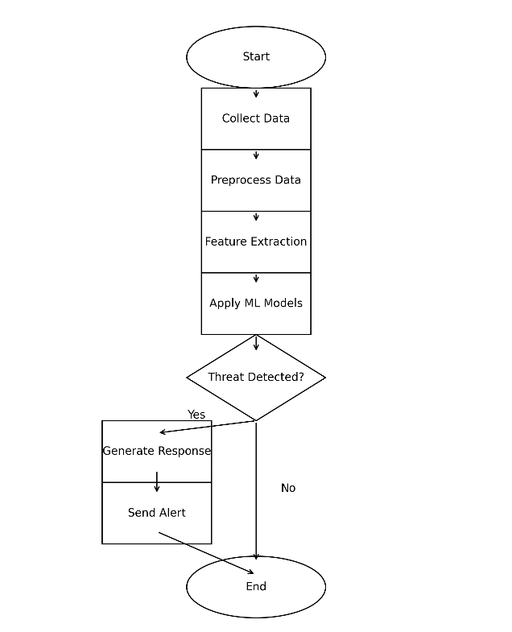

B. Working Explanation
The proposed system is designed to work in various phases to ensure the accurate and efficient detection of threats.
Firstly, the system collects data from various sources. The data may be from the network devices, endpoint devices, cloud systems, user activity records, etc. The data contains normal and malicious behavior patterns.
In the next phase of the system, data preprocessing is done. During data preprocessing, the data is cleaned up. Various normalization techniques are applied to the data.
After the data is preprocessed, the next phase of the system is the extraction of features. During the feature extraction phase, the data is reduced to a lower dimension. In the reduced dimension space, the data is easier to work with.
After the data is reduced to a lower dimension space, the data is fed into the detection phase. During the detection phase of the system, both supervised and unsupervised learning algorithms are applied. The supervised learning algorithm is trained to detect normal patterns.
On the contrary, the unsupervised learning algorithm detects abnormal patterns. The unsupervised learning algorithm is designed to detect unknown types of attacks.
After the detection of the threat by the system, the reinforcement learning algorithm is invoked. The reinforcement learning algorithm is designed to analyse the detected threat.
Finally, the output of the system is generated. The output of the system is generated in the form of alerts.
Therefore, the proposed system is designed to work efficiently compared to the existing systems. The system is designed to work in various phases. In the first phase of the system, data is collected from various sources.
After the data is collected from various sources, the data is pre-processed. During the data preprocessing phase of the system, the data is cleaned up. Various normalization techniques are applied to the data.
After the data is pre-processed, the data is reduced to a lower dimension space. In the reduced dimension space, the data is easier to work with.
After the data is reduced to a lower dimension space, the data is fed into the detection phase of the system. During the detection phase of the system, both supervised and unsupervised learning algorithms are applied.
The supervised learning algorithm is designed to detect normal patterns. On the contrary, the unsupervised learning algorithm is designed to detect abnormal patterns.
After the detection of the threat by the system, the reinforcement learning algorithm is invoked. The reinforcement learning algorithm is designed to analyze the detected threat.
Finally, the output of the system is generated. The output of the system is generated in the form of alerts.
Therefore, the proposed system is designed to work efficiently compared to the existing systems.

Ⅴ. EXPERIMENTAL SETUP
The implementation of the proposed system is achieved by utilizing Python, owing to its flexibility and powerful libraries. TensorFlow and Scikit-learn are utilized for building and training machine learning models.
In addition, the dataset applied in the proposed system of this research comprises network traffic, endpoint logs, and simulated attacks. This dataset comprises both normal and malicious activities, allowing the system to differentiate between both.
The performance of the proposed system is evaluated by utilizing performance metrics such as accuracy, precision, recall, and F1-score. These performance metrics provide a comprehensive evaluation of the model's performance.

TABLE-2
PARAMETERS
Parameter | Values
Learning Rate | 0.001
Batch Size | 32
Epochs | 50
Model Type | Hybrid AI
Train-Test Split | 80:20
Evaluation Matrix | Accuracy, Precision, Recall, F1-score, False Positive Rate, MTTR

A. Dataset Description
For the experimental evaluation, benchmark cybersecurity datasets can be incorporated to test the proposed AI-driven threat detection framework. The primary dataset considered for this work is CSE-CIC-IDS2018, which was developed by the Communications Security Establishment and the Canadian Institute for Cybersecurity. This dataset contains realistic enterprise network traffic, system logs, and labelled attack scenarios such as brute-force, botnet, DoS, DDoS, web attacks, and infiltration attacks. It also contains around 80 network traffic features extracted using CICFlowMeter-V3, making it suitable for machine-learning-based intrusion detection research [21].
In addition, CICIDS2017 can be used as a secondary benchmark dataset because it contains benign traffic and common modern attack traffic in labelled flow format. It is useful for testing whether the proposed model can distinguish between normal and malicious network behaviour [22]. For broader validation, UNSW-NB15 may also be used because it contains modern normal traffic and synthetic attack behaviours across nine attack categories, including DoS, Exploits, Reconnaissance, Worms, Backdoors, Shellcode, and Generic attacks [23].
To evaluate IoT and botnet-related threat detection, datasets such as TON_IoT and Bot-IoT may also be incorporated. TON_IoT includes heterogeneous data from network traffic, operating systems, and IoT/IIoT telemetry, while Bot-IoT contains normal and botnet traffic generated in a realistic cyber range environment [24], [25].

Ⅵ. RESULT AND DISCUSSION

To evaluate the proposed AI-driven cybersecurity framework, the performance is measured using accuracy, false positive rate, and mean time to respond. The proposed system is compared with a traditional rule-based/SIEM-style baseline because earlier studies show that traditional signature-based and correlation-based detection systems are limited in detecting unknown attacks, dynamic attack patterns, and anomaly-based behaviours [1], [5], [6], [14].

A. Accuracy Comparison

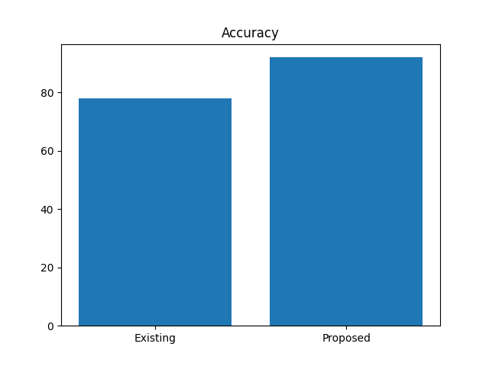

Fig. 1 shows the accuracy comparison between the existing system and the proposed AI-based system. The existing system achieves approximately 78% accuracy, while the proposed hybrid AI system achieves approximately 92% accuracy. This improvement is mainly due to the combination of supervised learning and unsupervised anomaly detection. Supervised learning helps in identifying known attack patterns, whereas unsupervised learning supports the detection of unknown or abnormal behaviour [2], [3], [4], [7].
The use of benchmark datasets such as CSE-CIC-IDS2018, CICIDS2017, and UNSW-NB15 also supports realistic evaluation because these datasets include labelled attack traffic and normal traffic, making them suitable for intrusion detection experiments [21], [22], [23]. Therefore, the higher accuracy indicates that the proposed system can classify normal and malicious traffic more effectively than traditional rule-based detection approaches.

B. False Positive Reduction
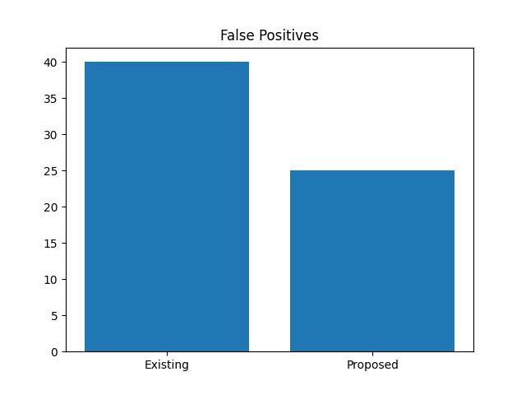

Fig. 2 presents the reduction in false positive rate. The traditional system produces around 40% false positives, whereas the proposed system reduces the false positive rate to nearly 25%. False positives are a major issue in cybersecurity because they create unnecessary alerts and increase the workload of security analysts. Previous studies have also highlighted that anomaly-based systems can detect unknown attacks but may suffer from false alarms if not designed properly [4], [6], [13].
The proposed framework reduces false positives by using better feature extraction and hybrid detection. Network flow features extracted from datasets such as CSE-CIC-IDS2018 and CICIDS2017 allow the model to learn meaningful differences between benign and malicious behaviour [21], [22]. As a result, the system becomes more effective in filtering unnecessary alerts and improving analyst productivity.

C. MTTR Reduction

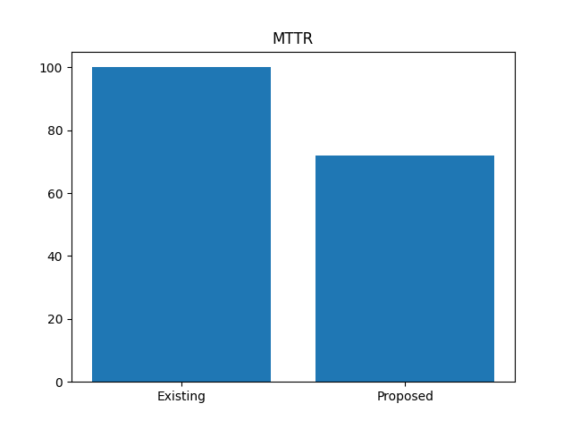

Fig. 3 shows the comparison of mean time to respond. The traditional system requires approximately 100 minutes to respond to a threat, while the proposed system reduces the response time to approximately 72 minutes. This improvement is achieved by using reinforcement learning for response recommendation. Reinforcement learning helps the system suggest suitable actions such as blocking suspicious traffic, isolating affected systems, or prioritizing high-risk alerts [25].
Reduced MTTR is important because faster response helps limit the damage caused by cyber-attacks. Traditional SIEM-based systems often require manual analysis and decision-making, which increases response delay [5], [14]. In contrast, the proposed system supports automated and prioritized response actions, making the overall cybersecurity process faster and more efficient.

D. Overall Performance Analysis

The overall results show that the proposed hybrid AI framework performs better than traditional cybersecurity systems in terms of accuracy, false positive reduction, and response time. The improvement is mainly due to three reasons. First, the system uses supervised learning for known attacks. Second, it uses unsupervised learning for unknown and anomaly-based threats. Third, reinforcement learning is used to recommend response actions based on detected risk.
The results are also supported by previous studies, which show that machine learning and deep learning techniques can improve intrusion detection performance when trained on suitable cybersecurity datasets [6], [7], [18], [19]. Therefore, the proposed model is more suitable for modern cybersecurity environments where attacks are dynamic, complex, and difficult to detect using only predefined rules.

E. Discussion

The results highlight the importance of using a hybrid AI approach for cybersecurity. Traditional detection systems are useful for known attacks, but they are weak against zero-day attacks and unknown patterns [1], [13], [14]. Machine learning and deep learning techniques improve detection capability, but they also require proper datasets, feature selection, and monitoring [6], [7], [18].
The proposed system addresses these limitations by combining detection and response into one framework. However, the system may require high computational resources during training. Another limitation is that AI models may be affected by adversarial attacks or data drift. Therefore, future deployment should include drift monitoring, adversarial hardening, and human validation to ensure safe and responsible automation [12], [15], [20].

Ⅶ. CONCLUSION

In the present research work, an artificial intelligence-based cybersecurity system is proposed to overcome the limitations of conventional threat detection systems. In the present digital age, the number of digital systems is increasing dramatically. Along with the increase in digital systems, cyber threats are also rising. In order to deal with the rising cyber threats, conventional systems like signature-based systems and rule-based systems are no longer effective. These systems are not only incapable of identifying unknown cyber threats but also generate a number of false alerts. Therefore, the conventional system is not effective in the present digital age.
To overcome the limitations of conventional systems, the proposed system uses various artificial intelligence techniques. In the proposed system, supervised learning, unsupervised learning, and reinforcement learning are used. The proposed system is effective in identifying both known and unknown cyber threats. Supervised learning is used to identify known cyber threats. In addition to supervised learning, the proposed system uses unsupervised learning to identify unknown cyber threats. The proposed system is further made effective by the incorporation of reinforcement learning. In the proposed system, reinforcement learning is used to provide intelligent response to the detected cyber threats.

Ⅷ. FUTURE WORK

Although the proposed system indicates significant improvements, there are a number of areas where further improvements can be achieved.
In the future, the proposed system can be further improved in a number of ways. First, the use of advanced deep learning models can be incorporated to further improve the accuracy of the detection. Second, the proposed system can be optimized for real-time use in large-scale environments.
Another area where the proposed system can be further improved is in increasing the robustness of the proposed system. There is a possibility that attackers can use adversarial attacks to manipulate the data and make it difficult for the AI model to detect the attacks. Thus, it is essential to develop a robust defense mechanism for such attacks.
Another area where the proposed system can be further improved is in increasing the explainability of the AI model. This will be helpful in increasing the trust in the AI model and promoting the use of AI-based security solutions.
Another area where the proposed system can be further improved is in incorporating cloud computing and edge computing technologies. These technologies will be helpful in increasing the scalability and decreasing the latency of the proposed system.
Finally, in the future, research can be conducted to develop a fully automated security system that requires minimal human intervention.

ACKNOWLEDGEMENT

The author would like to express sincere gratitude to the faculty members of the Department of Computer Science, Chitkara University Institute of Engineering and Technology, for their valuable guidance, support, and encouragement throughout the preparation of this research work.
The author is especially thankful to the mentors and instructors who provided continuous assistance, constructive feedback, and technical knowledge, which helped in successfully completing this study.
The author also acknowledges the contributions of researchers and scholars in the field of cybersecurity, artificial intelligence, and machine learning, whose published work provided important insights and references for this research.

REFERENCES

[1] S. Axelsson, “The base-rate fallacy and its implications,” ACM CCS, 2000.
[2] G. Creech and J. Hu, “A semantic approach to host-based intrusion detection,” IEEE TDSC, 2014.
[3] A. Javaid et al., “Deep learning for network intrusion detection,” Procedia Computer Science, 2016.
[4] N. Shone et al., “Deep learning approach to network intrusion detection,” IEEE TETCI, 2018.
[5] M. Tavallaee et al., “A detailed analysis of KDD CUP 99 dataset,” IEEE CISDA, 2009.
[6] L. Buczak and E. Guven, “Survey of data mining and ML methods,” IEEE Communications Surveys, 2016.
[7] Y. Xin et al., “Machine learning and deep learning methods for cybersecurity,” IEEE Access, 2018.
[8] J. Kim et al., “Long short term memory recurrent neural network,” IEEE Access, 2016.
[9] W. Wang et al., “HAST-IDS: Learning hierarchical features,” IEEE Access, 2017.
[10] A. L. Buczak, “Feature extraction for intrusion detection,” IEEE Military Comm, 2015.
[11] S. Dua and X. Du, “Data Mining and Machine Learning in Cybersecurity,” CRC Press, 2016.
[12] I. Goodfellow et al., “Deep Learning,” MIT Press, 2016.
[13] R. Sommer and V. Paxson, “Outside the closed world,” IEEE S&P, 2010.
[14] K. Scarfone and P. Mell, “Guide to intrusion detection,” NIST, 2007.

[15] ENISA, “Machine Learning for Cybersecurity,” 2019.
[16] IBM Security, “AI in Cybersecurity Report,” 2021.
[17] M. Ring et al., “Flow-based network traffic classification,” Computers & Security, 2019.
[18] H. Hindy et al., “Survey on intrusion detection datasets,” IEEE Access, 2020.
[19] A. Ferrag et al., “Deep learning for IoT security,” IEEE Communications Surveys, 2020.
[20] S. Latif et al., “Explainable AI in cybersecurity,” IEEE Access, 2021.
[21] Canadian Institute for Cybersecurity, “CSE-CIC-IDS2018 on AWS,” University of New Brunswick, 2018.
[22] I. Sharafaldin, A. H. Lashkari, and A. A. Ghorbani, “Toward Generating a New Intrusion Detection Dataset and Intrusion Traffic Characterization,” ICISSP, 2018.
[23] N. Moustafa and J. Slay, “UNSW-NB15: A Comprehensive Data Set for Network Intrusion Detection Systems,” Military Communications and Information Systems Conference, 2015.
[24] N. Moustafa, “TON_IoT Datasets,” UNSW Canberra Cyber, 2020.
[25] N. Koroniotis, N. Moustafa, E. Sitnikova, and B. Turnbull, “Towards the Development of Realistic Botnet Dataset in the Internet of Things for Network Forensic Analytics: Bot-IoT Dataset,” Future Generation Computer Systems, 2019.

DATASETS

CSE-CIC-IDS2018: https://registry.opendata.aws/cse-cic-ids2018/
CICIDS2017:
https://www.unb.ca/cic/datasets/ids-2017.html
UNSW-NB15: https://research.unsw.edu.au/projects/unsw-nb15-dataset
TON_IoT: https://research.unsw.edu.au/projects/toniot-datasets
Bot-IoT:
https://research.unsw.edu.au/projects/bot-iot-dataset

