**X3D Round Trip Testing**

Steps to follow before building the docker container:

1. Go to webapp folder inside the code root directory.
2. Create media/x3d folder and copy your x3d assets.  
   Example files:

* building_multipatch_0.x3d
* building_multipatch_1.x3d
* building_multipatch_10.x3d
* test.x3d
* hello_world.x3d

1. Now, spin the PostGIS backend container.

**PgAdmin/Database View**

There are two columns of interest in the table:

* BuildingName
* lod1_X3D

1. The database would contain a table name *x3d_buildings* by default.
2. The default files in the database tables are as follows:

The below files can be seen under lod1_X3D column.

* building_multipatch_0.x3d
* building_multipatch_1.x3d
* building_multipatch_10.x3d

Now, draw an AOI on the front-end container you should see the x3d scene in the viewer.

**How to add new files for testing?**

As of now we will be following the manual process of adding extra files in the database using query builder tool in pgAdmin apart from the three default files

In order to test new files please do the following:

1. Please change the building name under the column *BuildingName* with relevant file names inside the ***x3d_buildings*** table.

Example:

* floyd_hospital_building
* floyd_fire_station_building

1. Once the building names are changed please use the exact name under the BuildingName column with .x3d extension under the lod1_X3D column.  
     
   Example:

* floyd_fire_station_building.x3d
* floyd_hospital_building.x3d

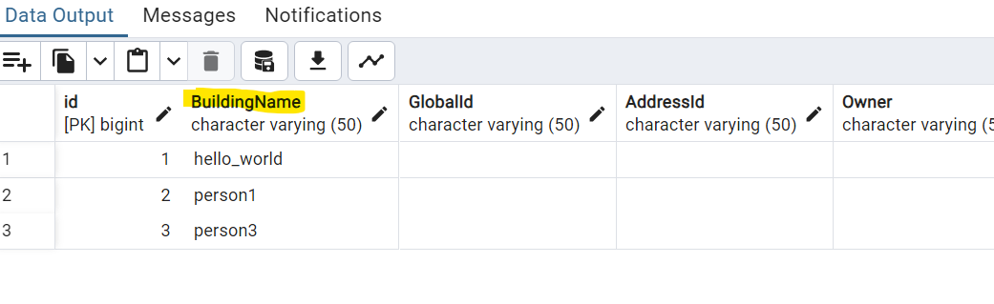

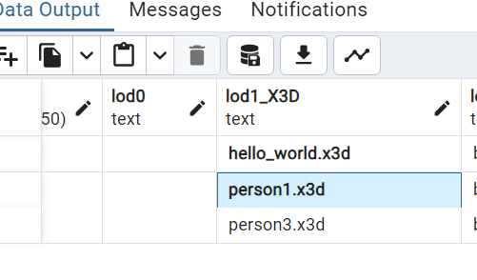

Upon selecting the co-ordinates on front end, the new data would be rendered.