DEPARTMENT OF COMPUTER SCIENCE & ENGINEERING (Data Science)
ABES Engineering College, Ghaziabad
SOFTWARE REQUIREMENTS
SPECIFICATION (SRS)
Project Title: Hotel Revenue Management Dashboard
Revenue, Occupancy & Pricing Performance Analysis
SUBMITTED BY  Yashika Sharma (Roll No: 2400321540219)  Degree: Bachelor of Technology (B.Tech)  Academic Year: 2026 - 2027  Project Type: Individual Project | UNDER THE GUIDANCE OF  Project Guide: Dr. Neerja Arora  Designation:  Department of Computer Science & Engineering (Data Science)  Status: 3rd Year Project Specification  Date of Submission: 30-10-2026
Standard Academic Compliance: IEEE Std 830-1998

Document Revision & Approval History
Version | Date | Description / Major Changes | Prepared By | Reviewed By
0.1 | 30-Sep-2026 | Initial SRS draft and project scope definition | Yashika Sharma | Project Guide
1.0 | 01-Oct-2026 | Final individual project SRS baseline | Yashika Sharma | HOD / Committee
Guidance Note
This SRS adapts the academic IEEE Std 830-1998 structure to an analytics/dashboard project. It documents the implemented Power BI das+hboard, Excel analytical workbook, data model, KPI calculations, interfaces, constraints, and analysis models.
1. Introduction
1.1 Purpose
The purpose of this Software Requirements Specification (SRS) is to define the functional scope, data requirements, analytical calculations, interfaces, performance expectations, constraints, and validation approach for the Hotel Revenue Management Dashboard. The document serves as the project baseline for academic review and implementation verification.
1.2 Scope of the System
The system addresses the need to convert hotel booking data into an interactive analytical view of room occupancy, revenue, pricing performance, and property/room-class trends.
- In-Scope Capabilities: Data ingestion; data quality checking; Power Query transformation; date/property/room dimensions; analytical data modeling; DAX KPI measures; interactive Power BI dashboards; slicers and cross-page synchronization; Excel PivotTables; Booking Date Timeline; and documented business insights.
- Out-of-Scope Boundaries: Live hotel reservation processing; online payment processing; customer account management; real-time external API integration; predictive forecasting; and transactional ERP/CRM integration.
- Expected Benefits: Faster performance analysis, consistent KPI definitions, centralized visualization, reduced manual comparison effort, interactive filtering, and traceable analytical reporting.
1.3 Definitions, Acronyms, and Abbreviations
Category | Term / Acronym | Definition / Project Context
Standard | SRS | Software Requirements Specification; structured requirements document.
Analytics | KPI | Key Performance Indicator used to measure hotel performance.
Revenue | Realized Revenue | Revenue recognized in the analyzed booking data.
Pricing | ADR | Average Daily Rate; in this project, Realized Revenue divided by Successful Bookings.
Revenue Yield | RevPAR | Revenue per Available Room; in this project, Realized Revenue divided by Total Capacity.
Occupancy | Occupancy % | Percentage of available room capacity utilized in the aggregated analysis.
BI | Power BI | Microsoft analytics and visualization platform used for the dashboard.
Data Prep | Power Query | Transformation layer used to prepare and structure source data.
Calculation | DAX | Data Analysis Expressions used to define analytical measures.
Excel | PivotTable / Timeline | Excel analytical tools used for supporting aggregation and time-based analysis.

1.4 References
IEEE Std 830-1998: IEEE Recommended Practice for Software Requirements Specifications.
Ian Sommerville, Software Engineering, 10th Edition, Pearson Education.
Microsoft Power BI Desktop documentation and DAX documentation used for dashboard modeling, visualization, and measure development.
Microsoft Excel documentation for PivotTables, PivotTable field configuration, and Timeline controls.
1.5 Document Overview
Section 2 describes the product perspective, users, operating environment, constraints, assumptions, and dependencies. Section 3 defines detailed functional requirements for data preparation, modeling, analytics, visualization, and Excel analysis. Section 4 defines user, hardware, software, and communication interfaces. Section 5 defines non-functional requirements and validation criteria. Section 6 provides system design and analysis models supporting the project implementation.
2. Overall Description
2.1 Product Perspective
The project is a self-contained business-intelligence analytics solution. It uses a tabular hotel booking dataset as input, prepares the data through Power Query and model transformations, applies DAX measures for key revenue and occupancy metrics, and presents interactive Power BI pages. Excel is used as a supporting analytical workbook containing PivotTables, a Booking Date Timeline, property-name lookup support, and written business insights.
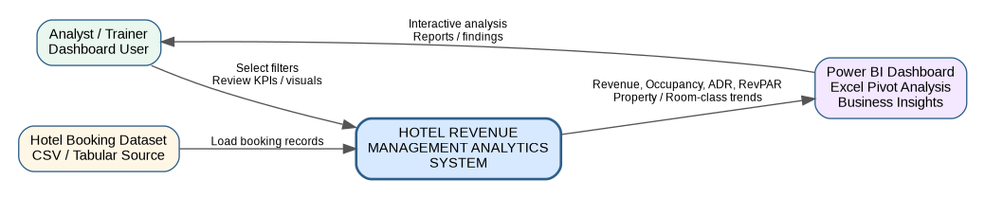
Figure 1. High-level system context for the Hotel Revenue Management Analytics System
2.2 User Classes and Characteristics
User Role / Persona | Technical Proficiency | Core Responsibilities & Rights
Project Analyst / Dashboard User | Intermediate | Use slicers, inspect KPIs, compare properties/room classes, review monthly trends, and interpret dashboard results.
Project Evaluator / Trainer | Basic to Intermediate | Review requirements, dashboard functionality, data assumptions, KPI definitions, and documented findings.
Data Maintainer | Intermediate | Refresh source data, validate transformations, update PivotTables, and maintain lookup mappings or calculations.

2.3 Operating Environment
Client / Analysis Environment: Windows-based desktop or laptop with Microsoft Power BI Desktop and Microsoft Excel. A modern browser may be used to view shared reports if the report is published to an organizational Power BI environment.
Dashboard Resolution: Designed for desktop viewing and optimized for the Power BI report canvas used during project demonstration.
Data Storage: Local project files / workbook storage and Power BI model storage. The project does not require a transactional database server or external API at runtime.
2.4 Design and Implementation Constraints
The solution is constrained by the fields, dates, and quality of the supplied hotel booking dataset.
- The project is an individual academic implementation and uses standard Microsoft analytics tools available in the working environment.
- Live transactional hotel booking, payment, authentication, and enterprise system integration are outside the project boundary.
- KPI definitions must remain consistent across Power BI visuals and the supporting Excel analysis.
- The dashboard uses Indian Rupee (₹) display formatting for ADR and RevPAR to reflect the Indian hotel context.
- The available data covers April–July 2022; therefore, “seasonal” analysis is limited to observed monthly trends over this four-month period.
2.5 Assumptions and Dependencies
Assumptions: Source records are sufficiently complete for the required KPIs; property identifiers can be mapped to readable property names; users understand the defined KPI terminology; and the project is evaluated primarily in an academic desktop environment.
Dependencies: Availability of the source dataset; successful Power Query refresh; correct relationships between fact and dimension tables; valid DAX measures; and Excel PivotTable refresh capability.
3. System Features and Functional Requirements
Requirements are categorized by analytical subsystem modules with unique requirement identifiers (FR-x.x).
3.1 Module 1: Data Ingestion & Quality Management
Req ID | Feature Description | Input / Validation Rule | Priority
FR-1.1 | Source Data Ingestion | Load hotel booking records from the project dataset; preserve source fields. | High
FR-1.2 | Data Type & Date Validation | Validate date fields, numeric measures, identifiers, and categorical fields before analysis. | High
FR-1.3 | Data Quality Review | Check key fields and inconsistent or missing values before KPI interpretation. | High
FR-1.4 | Refreshability | Transformation steps must execute again when the source data is refreshed. | Medium

3.2 Module 2: Data Transformation & Analytical Modeling
Req ID | Feature Description | Input / Validation Rule | Priority
FR-2.1 | Data Transformation | Apply Power Query transformations required to standardize and prepare analytical fields. | High
FR-2.2 | Date Dimension | Provide date, month label (mmm yy), week number, and day-type fields for trend analysis. | High
FR-2.3 | Property / Room Dimensions | Provide readable property labels and room-class information for grouping and comparison. | High
FR-2.4 | Fact / Dimension Model | Maintain fact tables with supporting dimensions for consistent slicing and aggregation. | High
3.3 Module 3: KPI Analytics & Visualization
Req ID | Feature Description | Input / Validation Rule | Priority
FR-3.1 | Realized Revenue KPI | Aggregate realized revenue for selected date/property/room-class context. | High
FR-3.2 | Occupancy KPI | Calculate and visualize room utilization percentage using aggregated capacity and successful bookings. | High
FR-3.3 | ADR KPI | Calculate ADR from Realized Revenue and Successful Bookings using safe division. | High
FR-3.4 | RevPAR KPI | Calculate RevPAR from Realized Revenue and Total Capacity using safe division. | High
FR-3.5 | Interactive Slicers | Provide filters for booking status, room class, and month/date context with synchronized views where applicable. | High
FR-3.6 | Dashboard Pages | Provide dedicated overview, property performance, and seasonal/revenue optimization views. | High
3.4 Module 4: Excel Supporting Analysis
Req ID | Feature Description | Input / Validation Rule | Priority
FR-4.1 | Monthly Revenue PivotTable | Summarize realized revenue by booking month. | High
FR-4.2 | Property Revenue PivotTable | Summarize realized revenue by readable property name. | High
FR-4.3 | Booking Status PivotTable | Count bookings by Cancelled, Checked Out, and No Show status. | Medium
FR-4.4 | Booking Platform PivotTable | Count bookings by booking platform. | Medium
FR-4.5 | Booking Date Timeline | Filter supported PivotTables by month/date context. | Medium
FR-4.6 | Business Insights Log | Document observed revenue, occupancy, ADR, RevPAR, room-class, and booking-status findings. | High
Figure 2. Level-1 analytical data flow from ingestion to dashboard and insights

4. External Interface Requirements
4.1 User Interfaces (UI)
The primary interface is the Power BI report canvas. The user navigates between three dashboard pages: Room Occupancy & Hotel Overview; Revenue Optimization & Property Performance; and Seasonal Trends & Revenue Optimization. Interactive slicers provide filtering by booking status, room class, and month/date context, with synchronized slicers used across relevant pages.
The supporting Excel interface contains Raw_data, Pivot_Analysis, Business_Insights, and Property_Lookup worksheets. The Booking Date Timeline provides time-based filtering of the PivotTables.

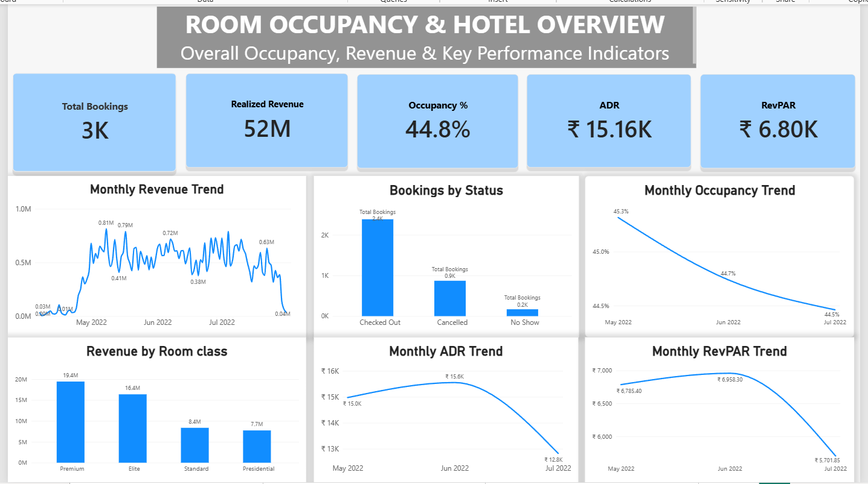
Figure 3. Power BI Page 1 - Room Occupancy & Hotel Overview

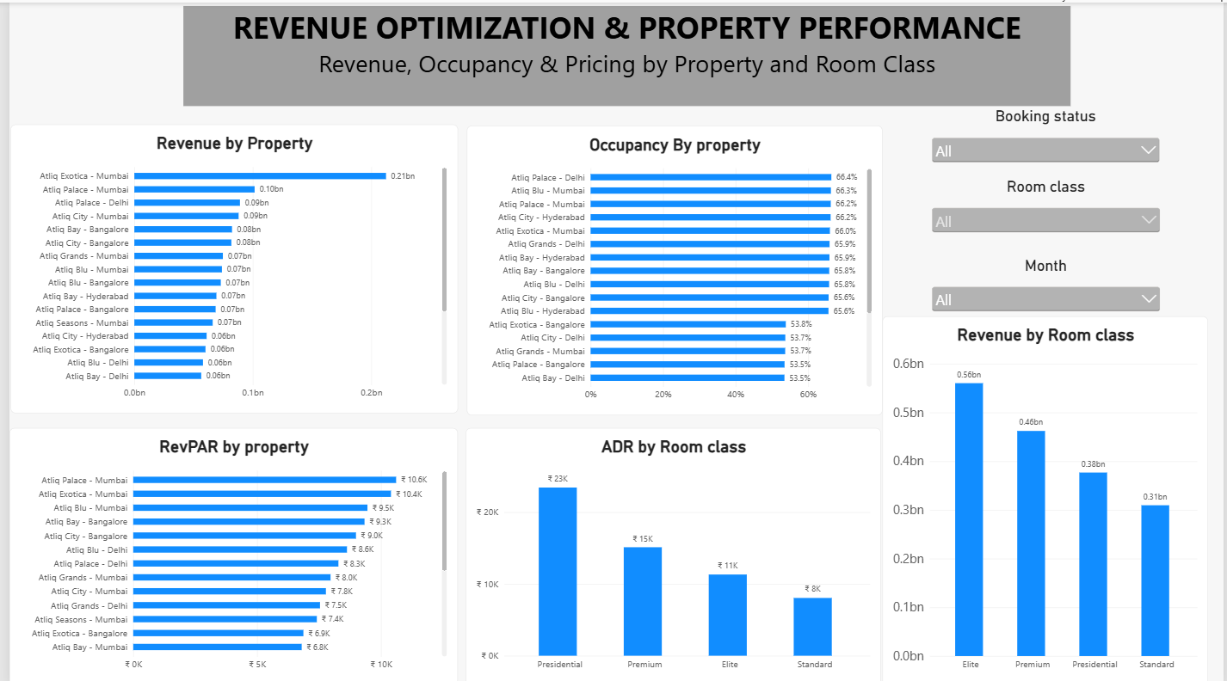
Figure 4. Power BI Page 2 - Revenue Optimization & Property Performance
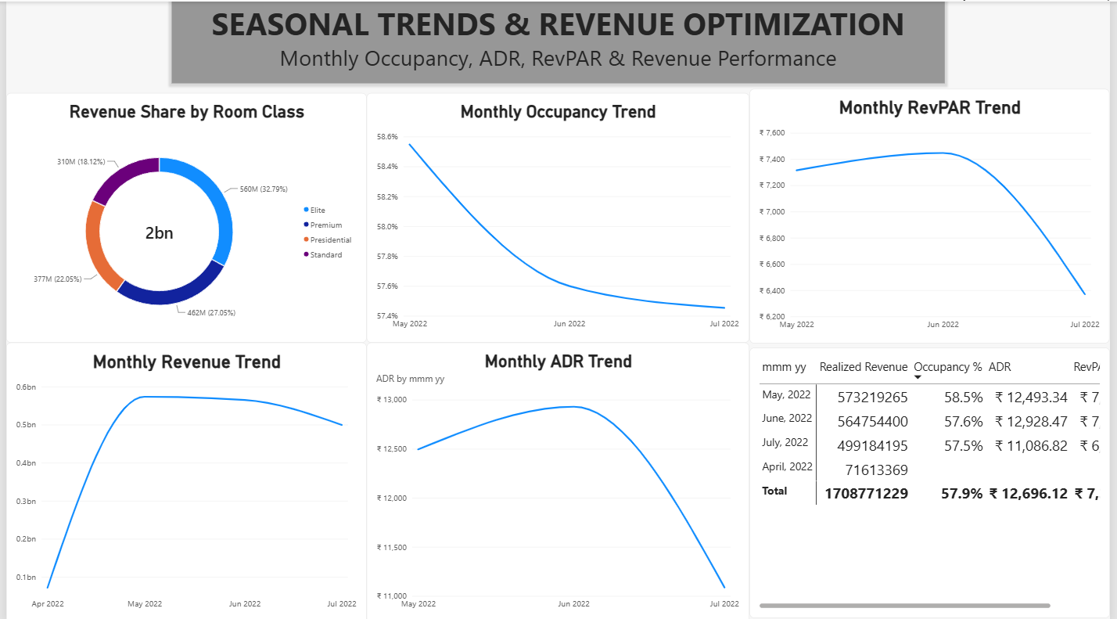
Figure 5. Power BI Page 3- Seasonal Trends and Revenue Optimisation

4.2 Hardware Interfaces
Standard deployment requires a desktop or laptop with keyboard, mouse/trackpad, and a display suitable for Power BI/Excel analysis. No dedicated sensor, microcontroller, embedded device, or other hardware interface is required.
4.3 Software Interfaces
Power BI Desktop: used for data modeling, DAX measures, interactive report pages, slicers, and visualization.
Power Query: used for data transformation and preparation.
Microsoft Excel: used for Raw_data handling, PivotTables, Booking Date Timeline, lookup mapping, and business-insight documentation.
Data Model: includes fact_bookings, fact_aggregated_bookings, dim_date, dim_hotels, and dim_rooms concepts used by the dashboard.

4.4 Communication Interfaces
The core analytical workflow is file-based and does not require runtime network communication. Where the completed Power BI report is shared through an organizational Power BI environment, internet access and organizational permissions may be required. No public API communication is required by the implemented solution.
5. Non-Functional Requirements (NFRs)
Attribute | Target Metric / Standard | Verification / Testing Method
5.1 Performance | Dashboard visuals and Excel PivotTables should render within an acceptable academic demonstration interval under normal desktop conditions. | Manual load/interaction check during demonstration.
5.2 Data Integrity | Measures must use consistent field definitions and avoid incorrect KPI values when denominator data is unavailable. | Cross-check DAX outputs against PivotTables / source summaries; verify blank handling for unavailable April denominators.
5.3 Usability | Page titles, KPI cards, legends, slicers, and labels should be readable and logically arranged. | Visual inspection at report presentation scale.
5.4 Maintainability | Power Query steps, DAX measures, PivotTables, and lookup mappings should be refreshable without rebuilding the report structure. | Refresh test and review of model components.
5.5 Portability | Workbook and PBIX should open in the supported Microsoft Office / Power BI Desktop environment used for evaluation. | Open-file and refresh test.
5.6 Security / Privacy | No user authentication or customer-facing PII workflow is implemented; project files are treated as academic project assets. | File-access review and visual inspection of exposed fields.

6. System Design and Analysis Models
The following models document the static structure, information flow, user interaction, and analytical processing sequence of the implemented dashboard solution.
6.1 Use Case Model
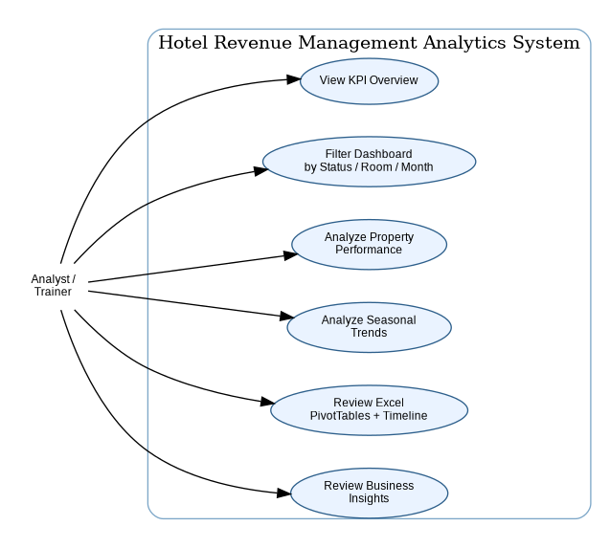
Figure 5. Use case model for the analytical dashboard user
6.2 Data Flow Diagram (DFD)
The DFD represents the movement of data from source ingestion through preparation, modeling, KPI calculation, visualization, and interpretation.

6.3 Entity / Relationship Model
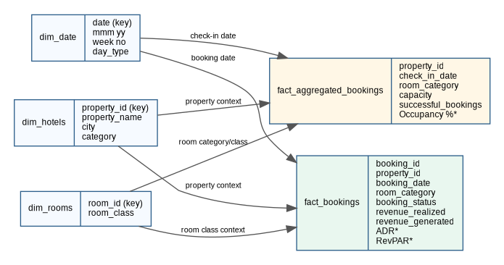
Figure 6. Conceptual analytical data model showing fact and dimension entities
- *ADR, RevPAR, and Occupancy % are calculated measures/analytics rather than stored master attributes in the conceptual model.

6.4 Activity / Processing Sequence
Figure 7. End-to-end activity sequence for the project implementation
6.5 KPI Calculation Specifications
KPI / Measure | Calculation / Definition | Use in Dashboard
Realized Revenue | Aggregated sum of realized revenue within the current filter context. | KPI card, monthly trend, property and room-class analysis.
Total Bookings | Booking count or model-derived total within the current filter context. | Overview KPI and booking-status analysis.
Successful Bookings | Sum of successful_bookings from fact_aggregated_bookings in the relevant context. | Denominator for ADR.
Occupancy % | Successful / occupied room performance expressed as a percentage of available capacity within the aggregated analysis. | Overview and monthly occupancy trends.
ADR | DIVIDE([Realized Revenue], [Successful Bookings], safe alternate result). | Pricing performance by month and room class.
RevPAR | DIVIDE([Realized Revenue], [Total Capacity], safe alternate result). | Revenue yield per available room and monthly trend.
Cancellation / Status Metrics | Booking counts segmented by booking_status. | Operational view of Cancelled, Checked Out, and No Show records.
6.6 Data Handling and Validation Rules
Readable property names are maintained through a property lookup mapping so that property-level Excel analysis can use business-friendly labels rather than numeric IDs.
April ADR and RevPAR are treated as unavailable where the required denominator is not available for the comparable period; the dashboard uses safe division / blank handling rather than presenting a misleading calculated value.
The dataset covers April–July 2022, so seasonal interpretation must be limited to the observed four-month period. Findings should be described as observed monthly trends rather than full-year seasonality.
7. Academic Review & Sign-Off
This Software Requirements Specification has been prepared for the individual 3rd-year project “Hotel Revenue Management Dashboard” and is submitted for academic review.
Project Coordinator / Guide | Internal Examiner | Head of Department (HOD)
Signature: __________________  Date: __________________ | Signature: __________________  Date: __________________ | Signature: __________________  Date: __________________

