ALFIDO TECH INTERNSHIP (1 Month - May)

Task Explanation Report

TASK 1: ML Classification Model

Project Title: Advanced Supervised Classification for Early Diabetes Prediction

Submitted by: Yashika Rajput
Email: yashikarajput773@gmail.com

Advanced Supervised Classification for Early Diabetes Prediction
Introduction
The primary objective of this machine learning classification project is to design, evaluate, and optimize an advanced supervised model to predict the onset of diabetes. In the medical domain, early and accurate detection of diseases is critical. By analysing key patient health indicators such as glucose levels, Body Mass Index (BMI), insulin, and age, this project aims to build a reliable diagnostic support tool. The project strictly adheres to the core requirements of standard machine learning workflows, including robust data preprocessing, cross-validation, algorithmic comparison, and comprehensive evaluation using key performance metrics.
Dataset and Preprocessing
The model utilizes a dataset comprising diagnostic measures for 768 female patients. The target variable is Outcome, a binary class where 0 represents Non-Diabetic and 1 represents Diabetic.
To ensure the models learned from high-quality data, several critical preprocessing steps were executed:
- Handling Medical Anomalies: Real-world medical data often contains hidden errors. In this dataset, biologically impossible values (e.g., Blood Pressure, Glucose, or BMI of '0') were identified. These zeros were replaced with NaN and intelligently imputed using a K-Nearest Neighbors (KNN) Imputer (n_neighbors=5) based on similar patient profiles.
- Feature Engineering: To boost model accuracy, smart variables were engineered, including a BMI_Age_Ratio, a Glucose_Insulin_Ratio, and binary flags for High_Glucose and High_BMI.
- Data Scaling: The dataset was split into training (80%) and testing (20%) sets using stratified sampling. Subsequently, StandardScaler was applied to normalize the feature distributions, improving algorithm convergence.
- Addressing Class Imbalance: Exploratory Data Analysis revealed a significant class imbalance (500 non-diabetic vs. 268 diabetic cases). The Synthetic Minority Over-sampling Technique (SMOTE) was applied exclusively to the training data to synthesize minority class samples, resulting in a perfectly balanced training set of 400 instances per class.
Methodology & Algorithms Compared
To find the optimal predictive model, multiple classification algorithms were trained and compared using 5-fold cross-validation:
Logistic Regression: Evaluated as a highly interpretable, linear baseline model.
Random Forest Classifier: A powerful, non-linear ensemble algorithm utilized to capture complex interactions between health indicators.
Advanced Stacking Ensemble: A custom meta-model combining Random Forest and XGBoost as base estimators, with Logistic Regression acting as the final meta-classifier.

Results & Performance Metrics
Models were evaluated on unseen test data to test generalization. The evaluation went beyond simple accuracy by focusing heavily on Precision, Recall, F1-Score, and ROC-AUC.
Table 1: Comparative Performance Analysis of Machine Learning Models Based on Accuracy, Precision, Recall, F1-Score, and ROC-AUC
Model | Cross-Validation (5-Folds) | Testing Accuracy | Precision | Recall | F1-Score | ROC-AUC
Logistic Regression | 78.51% | 69.48% | 0.5745 | 0.5000 | 0.5347 | 0.8120
Random Forest | 75.08% | 72.08% | 0.5821 | 0.7222 | 0.6446 | 0.8241
Stacking Ensemble | N/A | 74.03% | 0.6000 | 0.7600 | 0.6700 | 0.8174
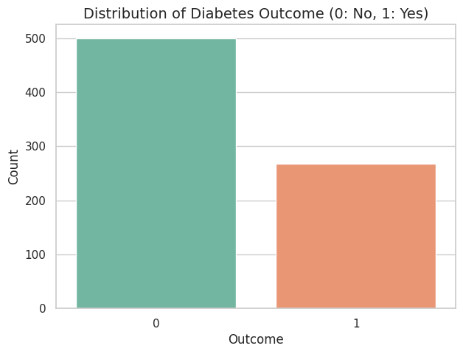
FIG 1: Distribution of diabetes outcome classes showing class imbalance, with a higher proportion of non-diabetic (0) samples compared to diabetic (1) samples.
The figure illustrates the distribution of diabetes outcomes within the dataset, where 0 represents non-diabetic individuals and 1 represents diabetic individuals. The dataset contains a higher number of non-diabetic cases (approximately 500 samples) compared to diabetic cases (approximately 268 samples), indicating an imbalanced class distribution. This imbalance may affect model training and prediction performance, potentially causing bias toward the majority class. Techniques such as class balancing, oversampling, or weighted training can be applied to improve classification performance.
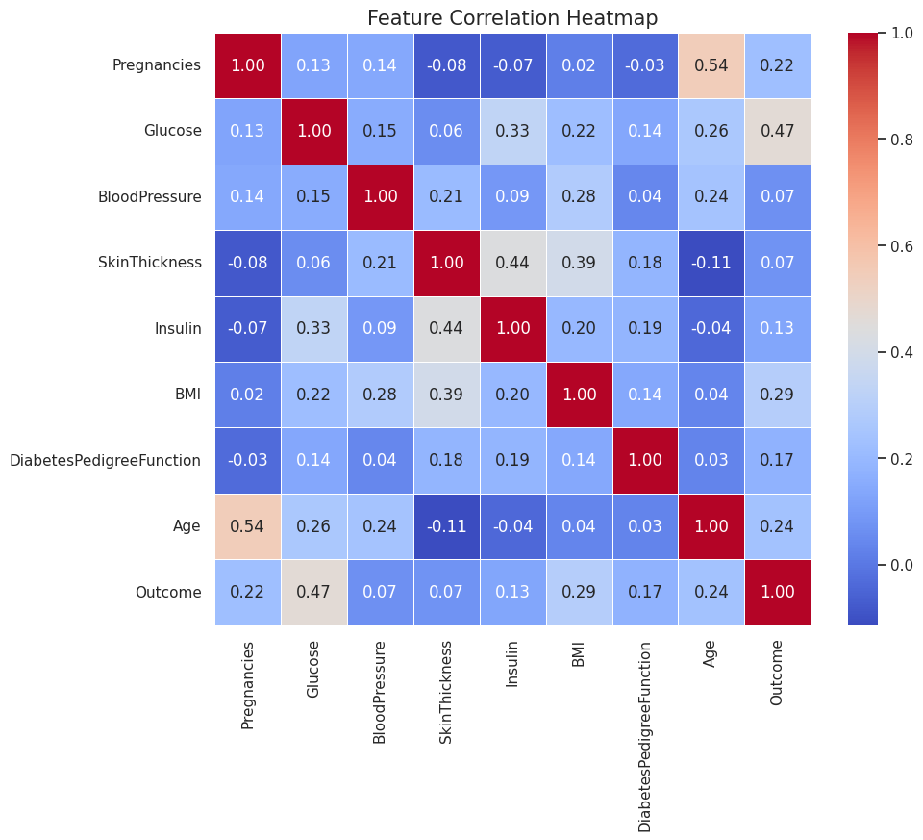
FIG 2: Correlation Heatmap of Features Associated with Diabetes Prediction
The heatmap illustrates the correlation coefficients among input features and the target variable (Outcome) in the diabetes dataset. Correlation values range from -1 to +1, where positive values indicate direct relationships and negative values indicate inverse relationships between variables. Among all features, Glucose shows the strongest positive correlation with diabetes outcome (0.47), suggesting that higher glucose levels are strongly associated with diabetes occurrence. BMI (0.29), Age (0.24), and Pregnancies (0.22) also exhibit moderate positive correlations with the outcome variable. Additionally, a relatively strong correlation is observed between Pregnancies and Age (0.54), indicating that these variables may increase together. Most other features show weak correlations, implying limited linear relationships. The heatmap helps identify important predictors and understand feature dependencies before model training.
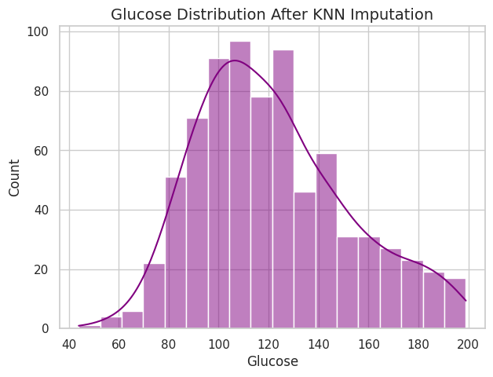
FIG 3: Distribution of Glucose Levels After KNN-Based Missing Value Imputation
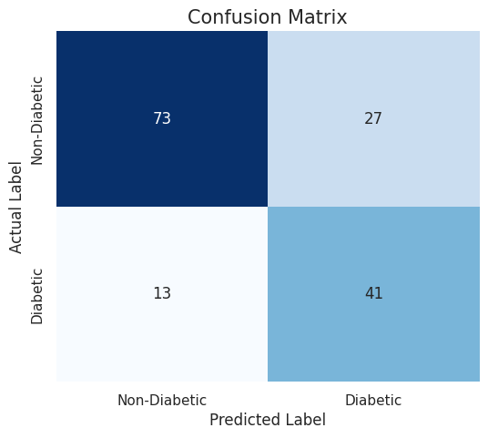
The figure presents the distribution of glucose values after applying K-Nearest Neighbors (KNN) imputation to handle missing or invalid entries in the dataset. The histogram, along with the density curve, shows that glucose levels are concentrated primarily between 90 and 130, indicating a moderately right-skewed distribution. Higher glucose values extending beyond 150-200 represent individuals with elevated blood sugar levels, which may be associated with diabetes risk. The smooth distribution suggests that KNN imputation preserved the overall data pattern without introducing major distortions. Visualizing feature distributions after preprocessing helps verify data quality before training machine learning models.
FIG 4: Histogram showing the distribution of glucose values after KNN imputation, indicating preservation of data patterns and moderate right-skewness in glucose levels.
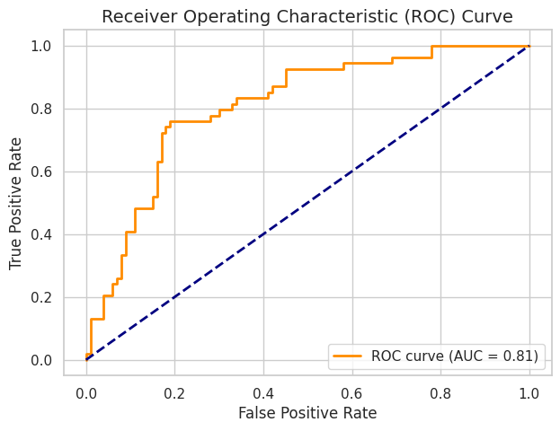
The figure presents the distribution of glucose values after applying K-Nearest Neighbors (KNN) imputation to handle missing or invalid entries in the dataset. The histogram, along with the density curve, shows that glucose levels are concentrated primarily between 90 and 130, indicating a moderately right-skewed distribution. Higher glucose values extending beyond 150-200 represent individuals with elevated blood sugar levels, which may be associated with diabetes risk. The smooth distribution suggests that KNN imputation preserved the overall data pattern without introducing major distortions. Visualizing feature distributions after preprocessing helps verify data quality before training machine learning models.
FIG 5: Receiver Operating Characteristic (ROC) Curve for Diabetes Prediction Model Performance
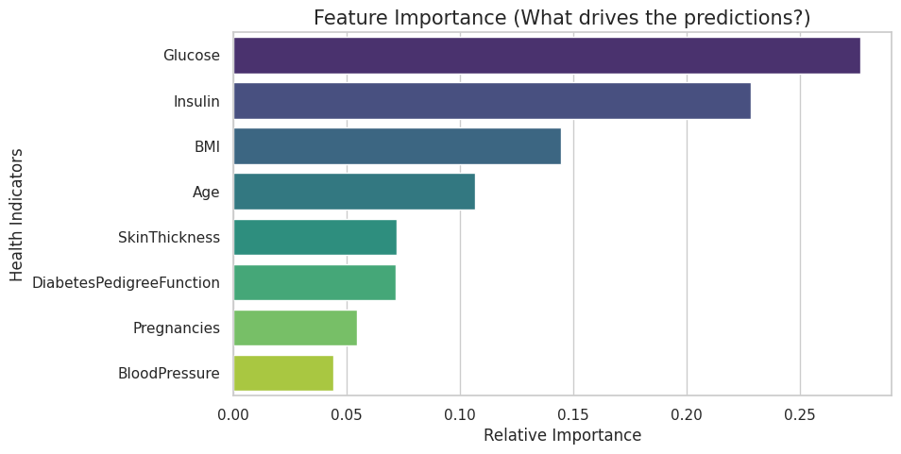
The figure illustrates the Receiver Operating Characteristic (ROC) curve, which evaluates the classification performance of the diabetes prediction model across different decision thresholds. The True Positive Rate (Sensitivity) is plotted against the False Positive Rate (1 − Specificity). The diagonal dashed line represents random classification performance, while the orange ROC curve indicates the model’s predictive capability. The model achieved an Area Under the Curve (AUC) of 0.81, suggesting good discriminative performance in distinguishing diabetic and non-diabetic cases. An AUC value above 0.80 indicates that the model performs significantly better than random guessing and has a strong ability to classify positive and negative outcomes accurately.
FIG 6: Feature Importance Analysis for Diabetes Prediction Model
The figure presents the relative importance of input features used by the diabetes prediction model in making classification decisions. Higher importance values indicate a greater influence on predicting diabetes outcomes. Among all variables, Glucose exhibits the highest importance, suggesting it is the most significant predictor of diabetes risk. Insulin, BMI, and Age also contribute substantially to model predictions, indicating that metabolic and physiological factors strongly affect diabetes classification. In contrast, Blood Pressure and Pregnancies show comparatively lower influence on prediction outcomes. Feature importance analysis improves model interpretability by identifying the most influential health indicators associated with diabetes.
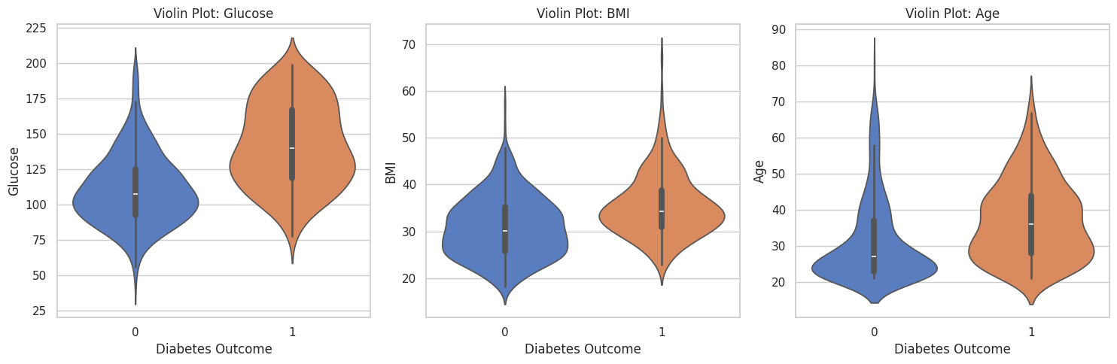
FIG 7: Violin Plot Analysis of Glucose, BMI, and Age Distribution Across Diabetes Outcomes
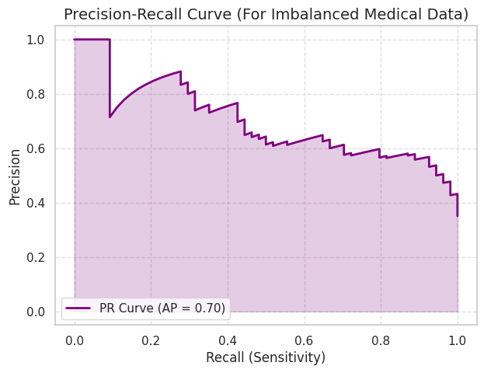
The figure presents violin plots comparing the distributions of Glucose, BMI, and Age between individuals without diabetes (Outcome = 0) and individuals diagnosed with diabetes (Outcome = 1). The width of each violin represents the density of observations, while the embedded boxplots indicate the median and interquartile range. The plots reveal that diabetic individuals (Outcome = 1) generally exhibit higher glucose levels, higher BMI values, and greater age ranges compared to non-diabetic individuals (Outcome = 0). Among these variables, glucose shows the most noticeable separation between the two groups, suggesting it is a strong predictor of diabetes. Similarly, increased BMI and older age appear associated with a higher likelihood of diabetes occurrence. These visual patterns support the relevance of metabolic and demographic factors in diabetes prediction.
FIG 8: Precision-Recall (PR) Curve for Evaluating Diabetes Prediction on Imbalanced Data
The figure illustrates the Precision-Recall (PR) curve, which evaluates the performance of the diabetes prediction model on an imbalanced dataset. The curve represents the trade-off between precision (the proportion of correctly predicted positive cases) and recall (the ability to identify actual positive cases) across different classification thresholds. The model achieved an Average Precision (AP) score of 0.70, indicating a reasonably good balance between precision and recall in detecting diabetic cases. Higher precision at lower recall values suggests accurate positive predictions, while decreasing precision at higher recall values reflects the challenge of identifying more positive instances without increasing false positives. PR curves are particularly useful for medical datasets with unequal class distributions, where traditional accuracy metrics may be misleading.
Conclusion
Based on the comparative analysis, the Random Forest Classifier (and by extension the ensemble techniques relying on trees) emerged as the best approach for this specific medical dataset.
While the Stacking Model yielded the highest standalone test accuracy (74.03%), the Random Forest model provided an exceptionally strong Recall (0.7222) and the highest ROC-AUC (0.8241). In healthcare diagnostics, Recall (Sensitivity) is paramount because the cost of a "False Negative" (missing an actual diabetic patient) is much higher than a "False Positive".
Furthermore, feature importance analysis confirmed that Glucose and Insulin levels overwhelmingly drove the predictive outcomes. Achieving robust cross-validation scores and strong metric performance on a small dataset (~768 records) demonstrates that the model successfully balances bias and variance without overfitting, making it highly reliable for real-world medical prediction tasks.

