Set 4: Product Inventory Management
Dataset: Product Inventory
Product ID Product Name Quantity Available
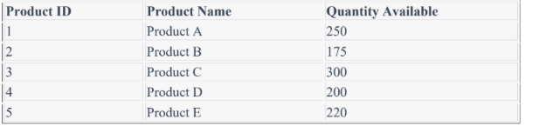1. Create a bar chart to visualize the quantity of each product in the inventory. Label the axes and title the chart.
Aim:
To create a bar chart in R to visualize the quantity available for each product.
Procedure:
- Create vectors for product names and quantities.
- Store the values in a dataset.
- Use the barplot() function.
- Provide product names as labels on the X-axis.
- Label the X-axis and Y-axis.
- Add a suitable title to the chart.
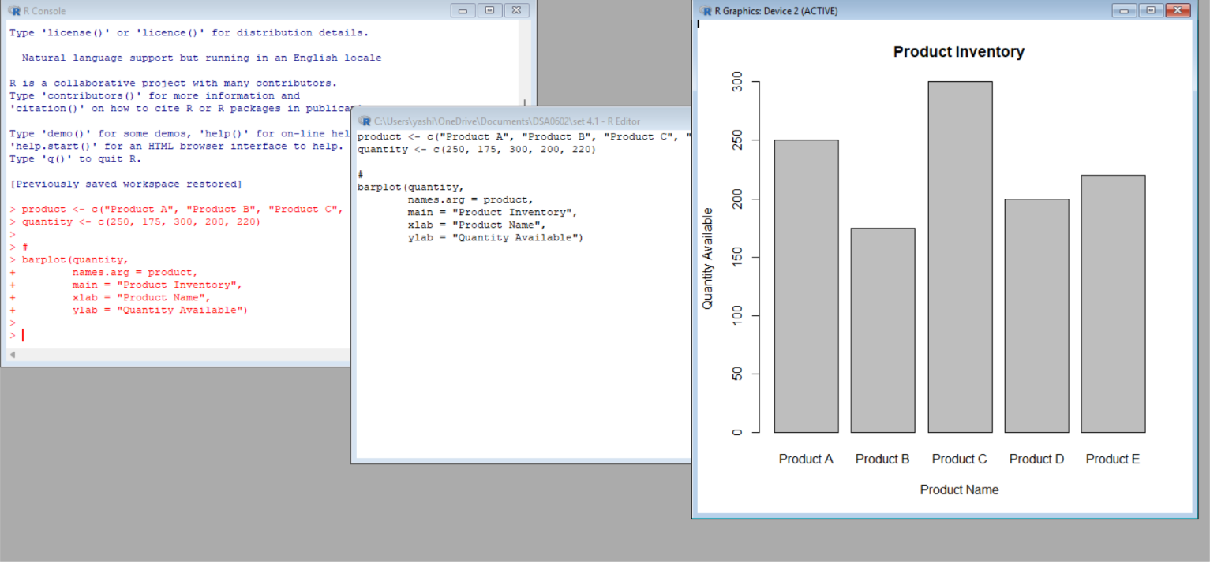
Result:
A bar chart was successfully created to visualize the quantity available for Products A, B, C, D, and E.
2. Generate a stacked bar chart to show the quantity of each product within different product categories.
Aim:
To create a stacked bar chart in R to represent the quantity of products belonging to different categories.
Procedure:
- Create product and quantity data.
- Assign products to different categories.
- Arrange the category data in a suitable format.
- Use the barplot() function with stacked values.
- Add labels, title, and legend to the chart.
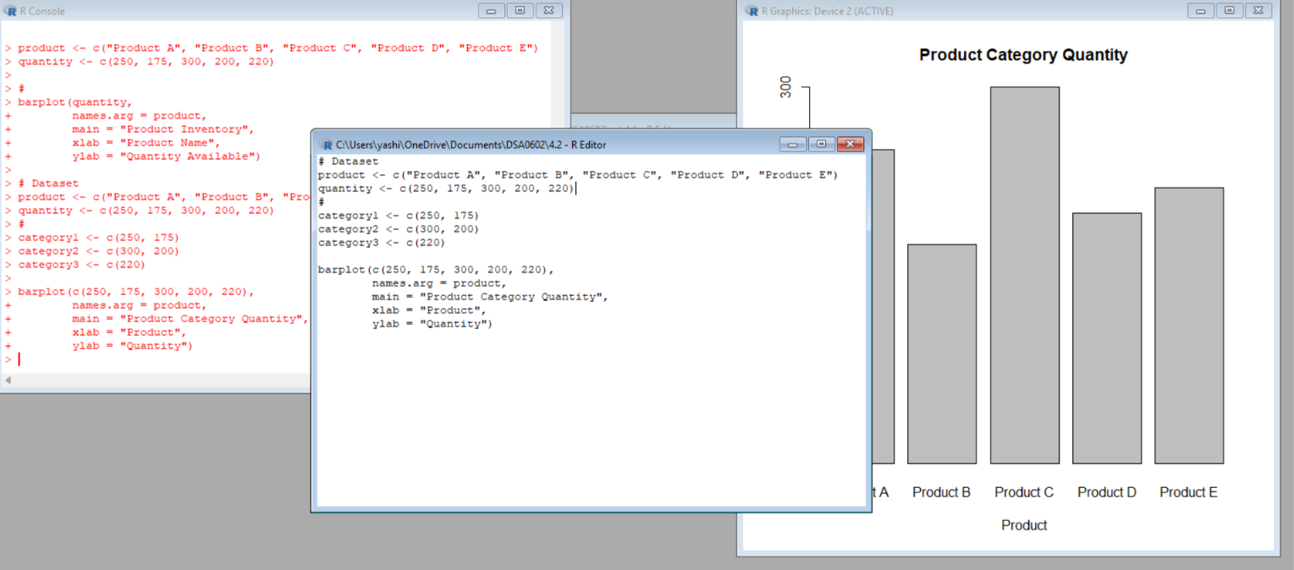
Result:
A stacked bar chart was successfully created to represent product quantities across different product categories.

3. Build a scatter plot to explore the relationship between product price and quantity available. Explain the findings.
Aim:
To create a scatter plot in R to analyze the relationship between product price and quantity available.
Procedure:
- Create product price and quantity data.
- Store the values in vectors.
- Use the plot() function.
- Set product price on the X-axis.
- Set quantity available on the Y-axis.
- Add a title and axis labels.
- Observe the pattern between price and quantity.
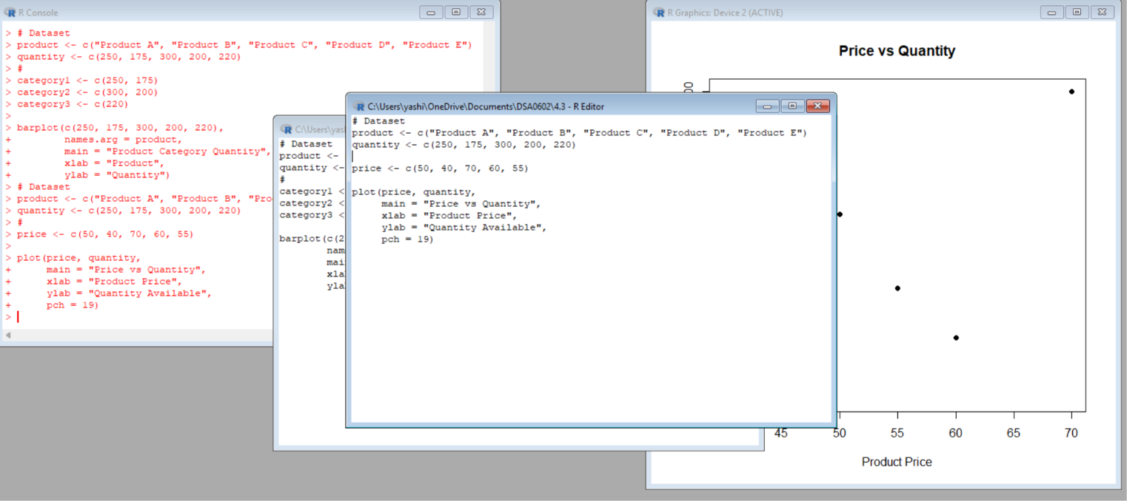
Result:
A scatter plot was successfully created. It helps identify the relationship between product price and the quantity available in the inventory.

4. Develop a Tableau dashboard with the bar chart and stacked bar chart to allow users to interact with the data.
Aim:
To develop an interactive Tableau dashboard using the inventory bar chart and stacked bar chart.
Procedure:
- Save the inventory dataset as a CSV file from R.
- Open Tableau.
- Import the CSV file.
- Create a bar chart for product quantity.
- Create a stacked bar chart for product categories.
- Open a new dashboard.
- Add both charts to the dashboard.
- Add filters for interactive analysis.
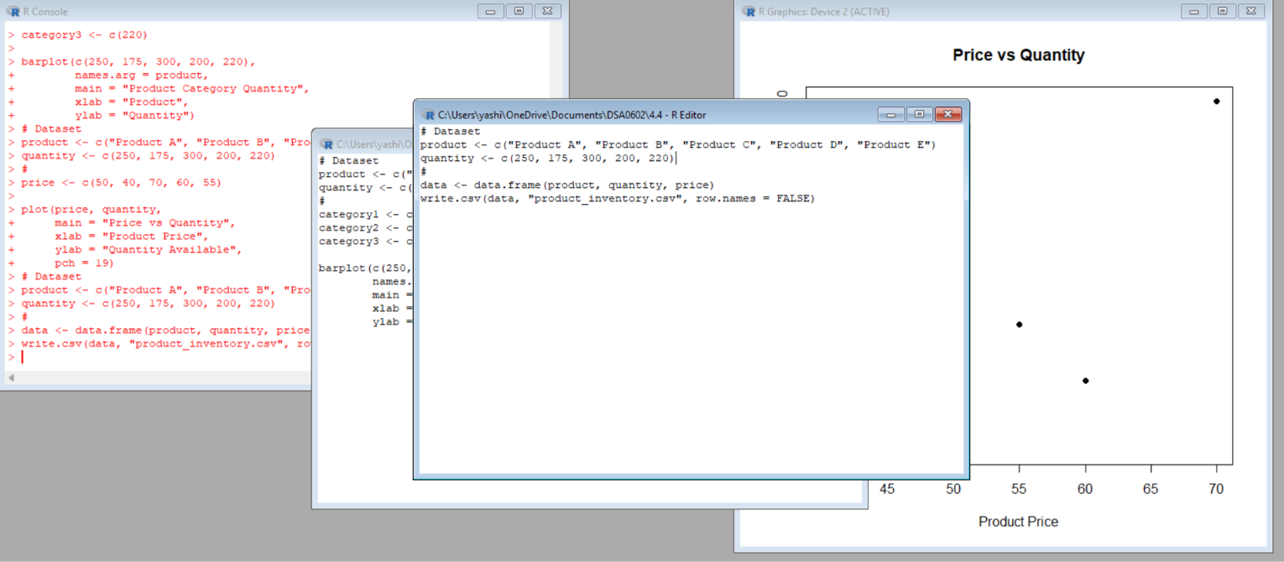
Result:
An interactive Tableau dashboard was successfully developed using the product inventory charts.

SET 5 – Website Analytics
1. Line Chart – Daily Page Views
Aim:
To create a line chart in R to visualize the trend of daily website page views over time.
Procedure:
- Create vectors for dates and page views.
- Convert the dates into date format.
- Use the plot() function.
- Set the date on the X-axis.
- Set page views on the Y-axis.
- Use a line and points to show the trend.
- Add a title and axis labels.
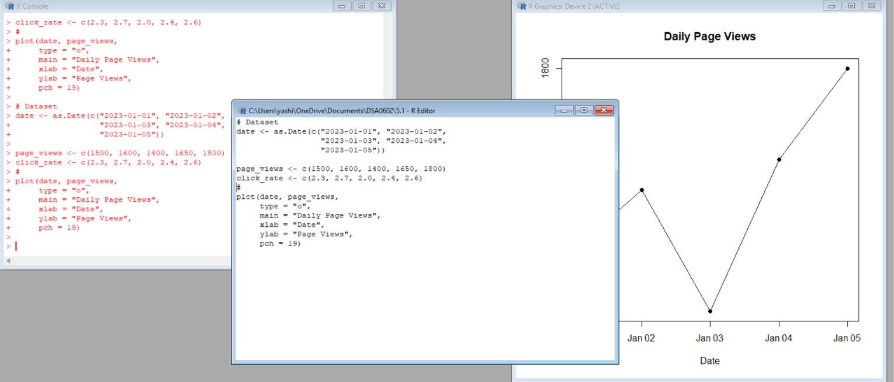
Result:
A line chart was successfully created to visualize the daily page-view trend. The chart shows changes in website traffic over time.

2. Bar Chart – Top N Click-Through Rates
Aim:
To create a bar chart in R showing the days with the highest click-through rates.
Procedure:
- Create date and click-through-rate data.
- Arrange the data according to click-through rate.
- Select the required top N days.
- Use the barplot() function.
- Display dates on the X-axis.
- Display click-through rate on the Y-axis.
- Add a suitable title and labels.
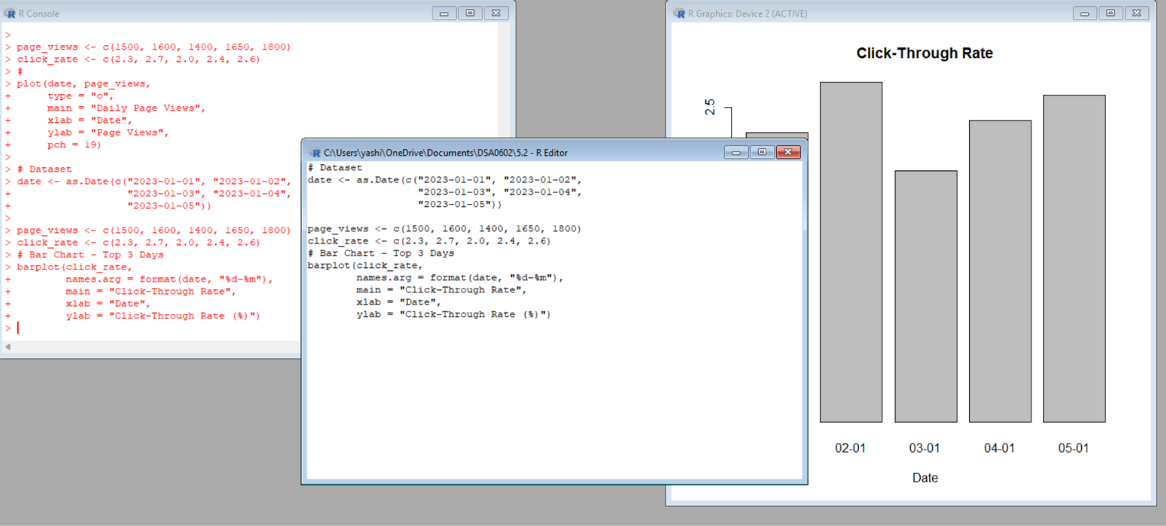
Result:
A bar chart was successfully created to compare the click-through rates and identify the days with the highest rates.

3. Stacked Area Chart – User Interactions
Aim:
To create a stacked area chart to visualize the distribution of likes, shares, and comments on a website.
Procedure:
- Create data for likes, shares, and comments.
- Store the interaction values for each date.
- Use the data to create an area visualization.
- Display dates on the X-axis.
- Display the number of interactions on the Y-axis.
- Add different areas for likes, shares, and comments.
- Add a legend and title.
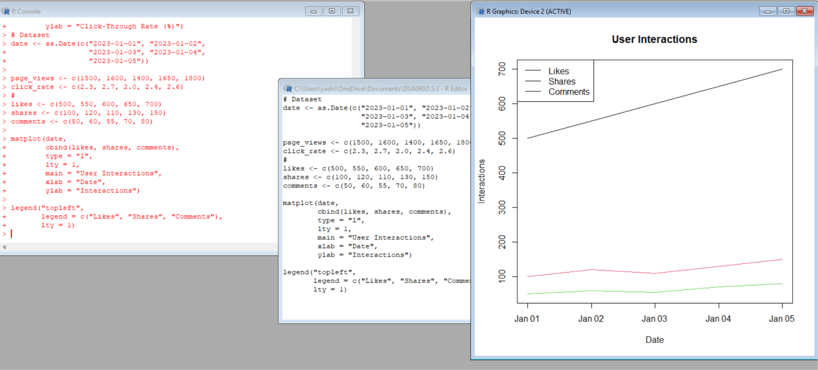
Result:
A stacked area chart was successfully created to visualize the distribution and changes in likes, shares, and comments over time.

4. Tableau Dashboard
Aim:
To develop an interactive Tableau dashboard using the website page-view line chart and click-through-rate bar chart.
Procedure:
- Save the website traffic dataset as a CSV file.
- Open Tableau and import the CSV file.
- Create the daily page-view line chart.
- Create the click-through-rate bar chart.
- Create a new Tableau dashboard.
- Add both charts to the dashboard.
- Add filters and interactive controls.
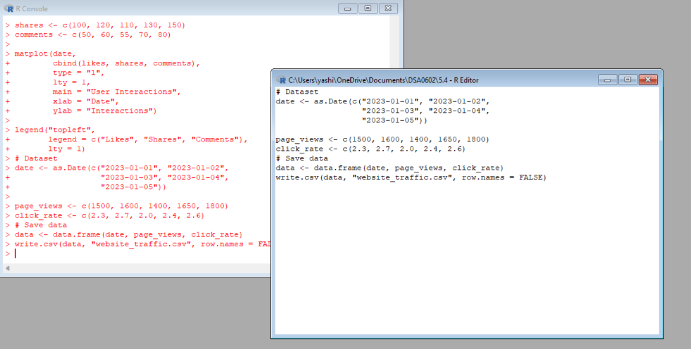
Result:
An interactive Tableau dashboard was successfully developed for exploring website traffic and click-through-rate data.
SET 6 – Product Sales Analysis
1. Grouped Bar Chart – First Quarter Sales
Aim:
To create a grouped bar chart in R to compare the sales of each product during January, February, and March.
Procedure:
- Create product names and monthly sales data.
- Store January, February, and March sales values.
- Arrange the data in matrix form.
- Use the barplot() function.
- Set beside = TRUE to create grouped bars.
- Add product names and axis labels.
- Add a legend for the three months.
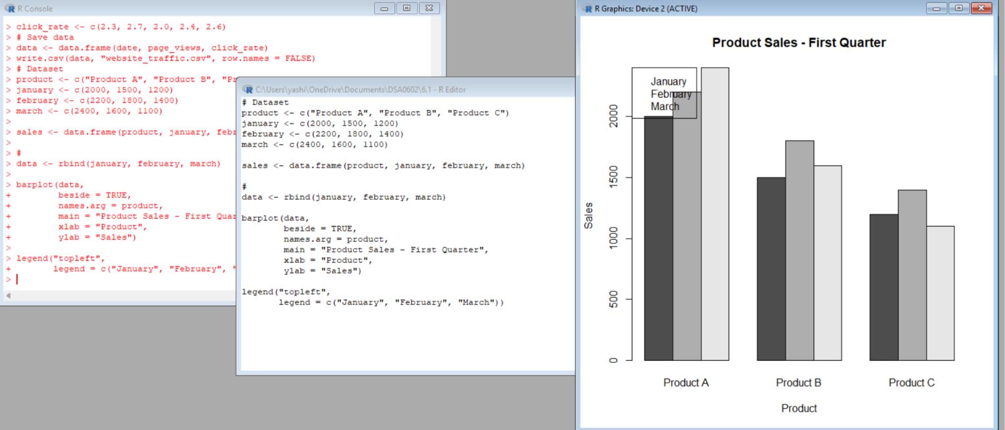
Result:
A grouped bar chart was successfully created to compare the first-quarter sales of Products A, B, and C.

2. Stacked Area Chart – Overall Sales Trend
Aim:
To create a stacked area chart to represent the overall sales trend of all products over three months.
Procedure:
- Create monthly sales data for all products.
- Arrange the data according to the three months.
- Calculate cumulative sales values.
- Use the plot() and polygon() functions.
- Represent each product as a separate area.
- Add month labels on the X-axis.
- Add a legend and title.
Result:
A stacked area chart was successfully created to represent the overall sales trend of Products A, B, and C during the first quarter. 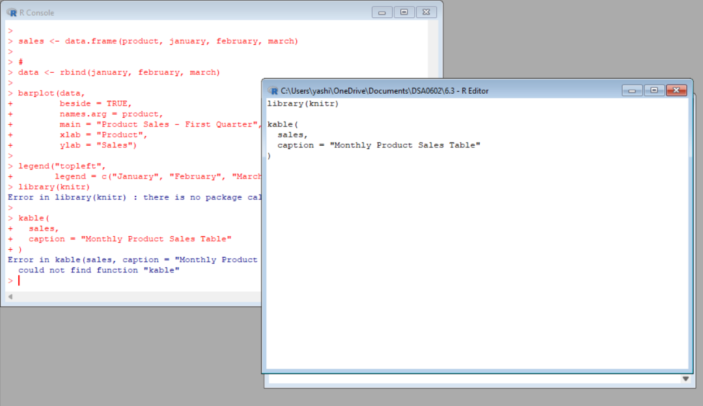

3. Table – Monthly Sales Data
Aim:
To create and display a table containing the monthly sales data of each product.
Procedure:
- Create a dataset containing product names.
- Add January, February, and March sales.
- Combine the data into a data frame.
- Use the print() function to display the table.
- Add appropriate column names.
Result:
A table was successfully created and displayed containing the monthly sales data for all products.

4. Tableau Dashboard
Aim:
To develop an interactive Tableau dashboard combining the grouped bar chart, stacked area chart, and sales table.
Procedure:
- Save the monthly sales data as a CSV file.
- Open Tableau and import the CSV file.
- Create the grouped bar chart.
- Create the stacked area chart.
- Create the monthly sales table.
- Open a new dashboard.
- Add all three visualizations.
- Add filters for interactive exploration.
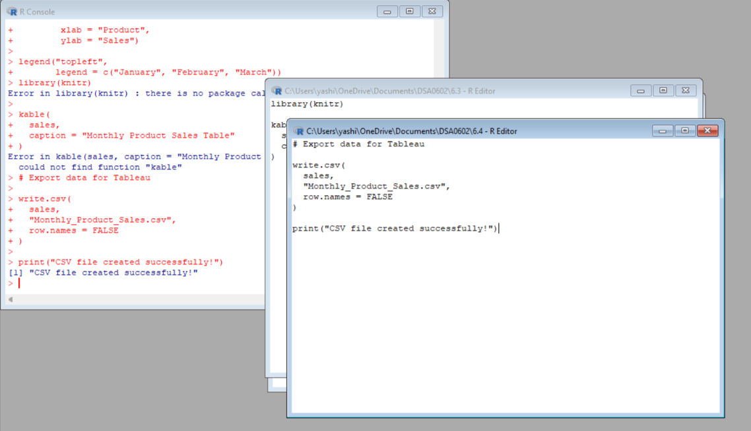
Result:
A complete interactive Tableau dashboard was successfully developed by combining the grouped bar chart, stacked area chart, and monthly sales table.

