* *At i = 0, prod = res[0]\*x + carry = 9\*10 + 0 = 90.  
  res[0] = 0, carry = 9*

*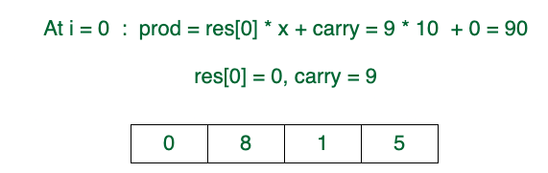*

* *At i = 1, prod = res[1]\*x + carry = 8\*10 + 9 = 89  
  res[1] = 9, carry = 8*

*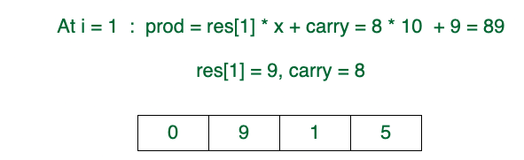*

* *At i = 2, prod = res[2]\*x + carry = 1\*10 + 8 = 18  
  res[2] = 8, carry = 1*

*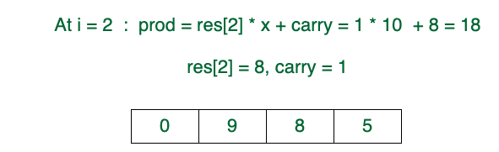*

* *At i = 3, prod = res[3]\*x + carry = 5\*10 + 1 = 51*