Team ID: 6997f7d8b750b5acb2d66d5e
Strategic Product Visibility and Placement Analysis Using Interactive Data Science
- Introduction

Modern retail success depends heavily on data-driven product visibility to maximize revenue and enhance the shopper journey. The specific placement of an item—whether in a standard aisle, the store entrance, or promotional end-caps—serves as a primary driver of consumer purchasing decisions.

This project investigates the multifaceted relationship between merchandising tactics, shopper demographics, and competitive pricing. By leveraging Tableau for advanced visual analytics and Flask for web-based deployment, this study provides actionable insights into optimizing store layouts for increased profitability.

- Problem Statement

Retailers frequently struggle to balance an intuitive store flow with a layout that maximizes high-margin sales. The core challenge addressed is:

How do store positioning, pricing fluctuations, and specific customer segments dictate sales outcomes? By resolving this, businesses can:
● Refine localized placement strategies.
● Enhance the visibility of underperforming categories.
● Calibrate pricing against market competitors.
● Boost total store conversion rates.

- Project Objectives

The primary goals of this analysis include:

1. Quantifying the link between shelf location and sales volume.
2. Identifying how demographic groups vary in their buying patterns.
3. Benchmarking internal pricing against competitor data.
4. Measuring the lift generated by promotional status.
5. Constructing an interactive Flask-integrated dashboard for stakeholders.

4 .Data Acquisition
The dataset used in this project was obtained from Kaggle, a well-known platform for public datasets.

Dataset Source: https://www.kaggle.com/datasets/amitvkulkarni/impact of-product-positioning-on-sales
The dataset contains retail sales information including:
• Product category
• Product position in store
• Sales volume
• Price
• Competitor price
• Consumer demographics
• Promotion status
• Seasonal demand
• Foot traffic
This dataset helps analyse how different retail factors influence product sales.

- .Data Variable Description

Column Name | Functional Description
Product Category | Classification (e.g., Electronics, Clothing, Food).
Product Position | Specific location: Aisle, End-cap, or Front of Store.
Sales Volume | Total units sold during the period.
Consumer Demographics | Target groups: Students, Families, Seniors, etc..
Foot Traffic | Level of customer movement (Low, Medium, High).

6.Data Preparation Pipeline

To ensure analytical integrity, the following cleaning steps were implemented:

● Null Handling: Incomplete records were scrubbed or imputed to maintain dataset balance.

● Type Casting: Metrics like Price and Volume were standardized as numerical floats/integers.

● Structural Validation: The data was audited for duplicates and categorical consistency.

7.Visual Analytics & Tableau Integration
A suite of interactive charts was developed to dissect retail performance: Visualizations Created

- Average Sales Volume vs Product Category
o Shows which category sells the most.

- Consumer Demographics vs Sales Volume
o Displays which customer groups purchase the most.

- Promotion vs Product Category
o Shows the impact of promotions on product sales.

- Foot Traffic vs Average Sales Volume
o Demonstrates how store traffic influences sales.

- Competitor Price vs Product Price
o Helps analyse pricing strategy against competitors.

- Product Category vs Price Distribution
o Shows price comparison across categories.

- Product Placement vs Sales Volume
o Evaluates the impact of location inside store.
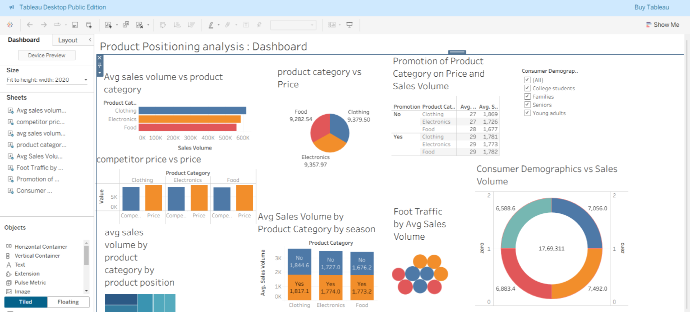
8.Tableau Story & Strategic Insights

The analysis revealed several critical "Story Points" regarding retail behavior:
● Point 1: Category Dominance
- Clothing emerged as the top performer with an average sales volume of 1830.1.

- Electronics followed closely (1748.6), while Food showed the lowest average volume (1727.7).

● Point 2: The Traffic/Position Synergy

- Items in High Traffic areas, specifically at the Front of Store, achieved peak sales (approx. 1811.7).

- Interestingly, Aisle placement performed robustly even in low traffic scenarios (1900.5), suggesting high "destination" demand for certain items.

● Point 3: Treemap Analysis of High-Performance Zones

- The highest specific conversion was Clothing located at the Front of Store (1923.7).

- This confirms that "Prime Real Estate" in-store significantly boosts high-interest categories.

- Final Conclusions & Future Scope
The study concludes that strategic placement is not a "one-size-fits-all" metric; it must be aligned with foot traffic and category demand.

Future Enhancements:
- Implementing Machine Learning for predictive sales forecasting.
- Integrating Real-time Inventory tracking.
- Enhancing the UI for mobile-responsive management viewing.
10. Key Findings

1. From the Tableau Story analysis, the following conclusions were drawn:
2. Clothing is the highest performing product category.
3. Product placement significantly affects sales performance.
4. Front-of-store placement improves product visibility and customer engagement.
5. Foot traffic plays an important role in driving retail sales.

These insights can help retailers optimize store layout, product positioning, and marketing strategies.

11. Conclusion
This project demonstrates how data visualization and analytics can help retail businesses improve product placement strategies and increase sales performance.
Using Tableau dashboards and interactive storytelling, businesses can clearly understand:
• Customer purchasing behavior
• Product placement effectiveness
• Pricing competitiveness
• Promotional impact
The integration of analytics into a web application makes the insights easily accessible and interactive.

12. Future Enhancements
Future improvements for this project could include:
• Real-time retail sales data integration
• Machine learning models for sales prediction
• Customer behavior analysis
• Inventory optimization
• Mobile responsive dashboard interface

