Supervised Learning Networks with Backpropagation

Yashila Ramesh
ECE 3803 Fall 2025
Georgia-Tech Europe
Metz, France
yramesh6@gatech.edu

Abstract—This project aims to create an unsupervised backpropagation network to predict and reconstruct an audio sequence.

Introduction to Unsupervised Learning and Backpropagation Methods
When developing learning algorithms, the motivation for error reduction is immediately clear: the lower the error, the better the prediction. Backpropagation is a computational method designed specifically to reduce this error in feedforward neural networks. A simple definition is as follows: backpropagation computes the gradient, in weight space, of a feedforward neural network with respect to a loss function. In other terms, one takes an input vector and runs it forward through a multilayer neural network with nonlinear units. The output of this forward pass is then compared with the desired target to produce an error signal. This error signal is subsequently propagated backward through the network to compute the partial derivatives of the loss with respect to each weight. With this gradient information, the weights can be updated in the direction that most efficiently reduces the error. Over many iterations, the network gradually reshapes itself to model the underlying input–output relationship. Backpropagation therefore serves as the core mechanism that enables multilayer neural networks to learn complex, nonlinear mappings from data, and forms the foundation of most modern supervised and self-supervised learning systems.

Mathematical Basis of Backpropagation
To proceed, it is important to set up a mathematical foundation for backpropagation. To begin we can think of our error term to be $E_{p} = \frac{1}{2}\sum_{ j}^{ }{{\left(t_{pj}-o_{pj}\right)}^{2}}$
With $E_{p}$ being our measure of the error on input/output pattern p. And the overall error can be measured as $\sum_{ }^{ }{E_{p}}$Then, since we wish to use this error signal to perform weight updates, we take the derivative of this error signal with respect to w. $\frac{∂E_{p}}{∂w_{ji}}=\frac{∂E_{p}}{∂o_{pj}} \frac{∂o_{pj}}{∂w_{ji}}$ This derivative is shown here as the product of two parts. The derivative of the error with respect to the output times the derivative of the output with respect to the weight. The derivative of the error with respect to the outputs tells us how much the error changes with the output of the jth unit and the derivative of the output with respect to the weights tells us how the output changes with respect to the weights. Using the equation for the error of a pattern p, we can calculate the derivative of the error with respect to the output as:
$\frac{∂E_{p}}{∂o_{pj}}=-\left(t_{pj}-o_{pj}\right)= -δ_{pj}$.
The term δ here represents the difference between the target and the output. Then to find the derivative of the outputs with respect to the weights we can use the definition of the artificial neuron as $o_{pj}= \sum_{ i}^{ }{w_{ji}}i_{pi}$ with this it is obvious that $\frac{∂o_{pj}}{∂w_{ji}}=i_{pi}$. Thus, we can model $-\frac{∂E_{p}}{∂o_{pj}}=δ_{pj}i_{pi}$. To complete the backpropagation derivation, we must now propagate the error signal backward into the hidden layer. The hidden units do not have explicit target values and use nonlinear activation functions. Each function computes $o_{j}=f\left(z_{j}\right)$. In this project we are using tanh as the function f. With this we can calculate
$\frac{∂o_{j}}{∂z_{j}}=f^{'}\left(z_{j}\right)=1-\tanh^{2}\left(z_{j}\right)= 1-o_{j}^{2}$.
The neuron computes $z_{j}=\sum_{ i}^{ }{w_{ji}}a_{i}$.Therefore, the derivative of $\frac{∂z_{j}}{∂w_{ji}}=a_{i}$. Now to find the change in error with respect to the weights of the hidden layers we can put together the components above: the output error, the activation derivative, and the input activation. With this we can say: $\frac{∂E_{p}}{∂w_{ji}}=-δ_{j}\left(1-o_{j}^{2}\right)a_{i}$. Since the usage of gradient descent requires this term to be subtracted. Therefore, we can display the output-layer weights: $∆w_{ij}=+ηδ_{pj}\left(1-o_{pi}^{2}\right)a_{i}$ where η represents the learning rate. The hidden unit has no target, so its delta must be computed from downstream deltas. $\frac{∂E_{p}}{∂o_{h}}=\sum_{ k}^{ }{\frac{∂E_{p}}{∂z_{k}}} \frac{∂z_{k}}{∂o_{h}}=\sum_{ k}^{ }{δ_{k}}w_{kh}$. Then the hidden layer delta term becomes $δ_{h}=\left(\sum_{ k}^{ }{δ_{k}}w_{kh}\right)⋅\left(1-o_{h}^{2}\right)$. The backpropagation weight update for any layer is $∆w_{ji}=ηδ_{j}a_{i}$. Where $a_{i}$is the activation feeding into weight $w_{ji}$, $δ_{j}=\left(t_{j}-o_{j}\right)$ for output units, and $δ_{j}=\left(1-o_{j}^{2}\right)\sum_{ k}^{ }{δ_{k}}w_{kj}$ for hidden units. In this project, we will be using a continuous time differential equation, not discrete updates, which we can model with the following $\frac{dw}{dt}=\frac{η}{τ_{slow}} \frac{∂E}{∂w}$ (1).

Methods And Results

Simulation Setup
For the purposes of this project the tanh nonlinearity was used for the hidden layers. The song “Ironic” by Alanis Morissette was used for the training data. The original sample can be heard in “Ironic.wav”. The audio was normalized by dividing by its maximum absolute value, ensuring all samples fell within the range [-1, 1]. The learning rate (η) was set to 0.01, the slow timescale 𝜏 was 100.0, yielding an effective step size of 0.0001. This two-timescale formulation separates the fast dynamics of signal propagation from the slow dynamics of weight adaptation.

Results
After running the simulation multiple times, with multiple different simulations, I was able to get the following data. With a simulation of 60 epochs of data, the reconstruction titled “Ironic-recon-60ep.wav” can be heard. Further a prediction with 60 epochs of data with an 8-sample prediction can be heard in “Ironic-pred-60ep.wav”. The overlay of the soundwaves resembles the following.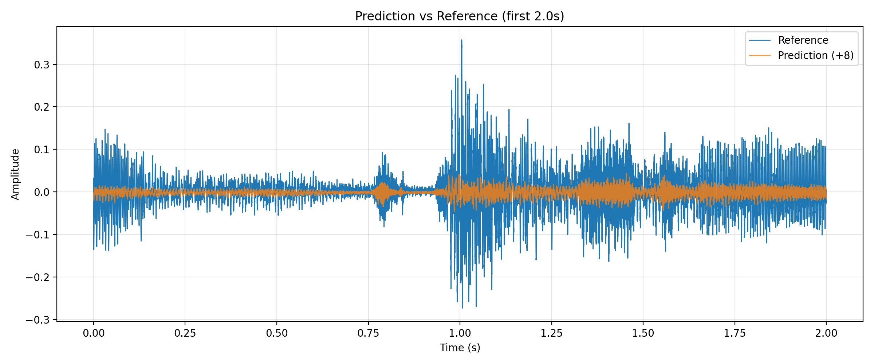 As can be seen in the graph, the prediction faces a slight delay that can be hard to hear with the naked ear. The amplitude is also reduced which can be heard in the wav files themselves. The loss curve is pictured below:
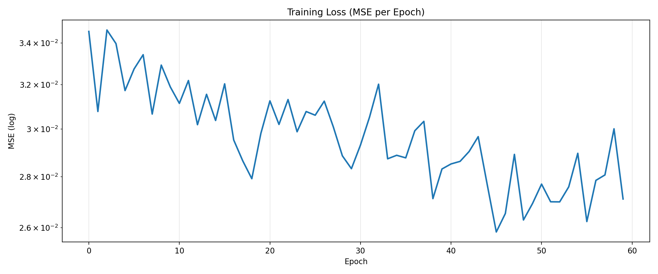
Since I ran multiple simulations, I also had a simulation with a loss curve of the following: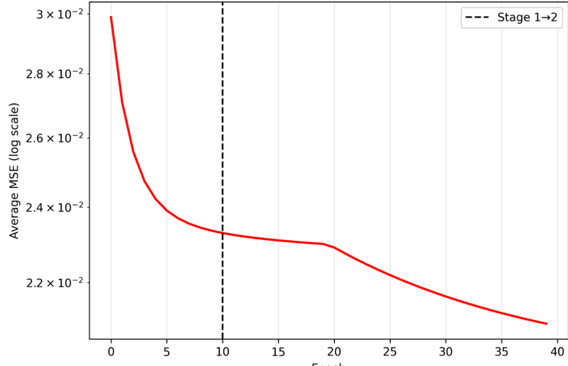
The two learning implementations produce distinct loss profiles. In the latter of the two, the average MSE decreases smoothly, consistent with full-batch or continuous-time gradient descent. This indicated stable error propagation and a well-conditioned update rule. In contrast, the former shows a noisy, “spiky” loss curve. The higher variance arises from more granular weight updates and a larger effective step size, causing sample-to-sample fluctuations in gradient estimates. Despite the noise, the trend is still downward, demonstrating that the system continues to learn but under a more stochastic training dynamic. However, the predictions and reconstructions sounded remarkably similar from each simulation. This was a very interesting to see while creating the project. Below is a graph that displays the covariance eigenvalue spectrum:
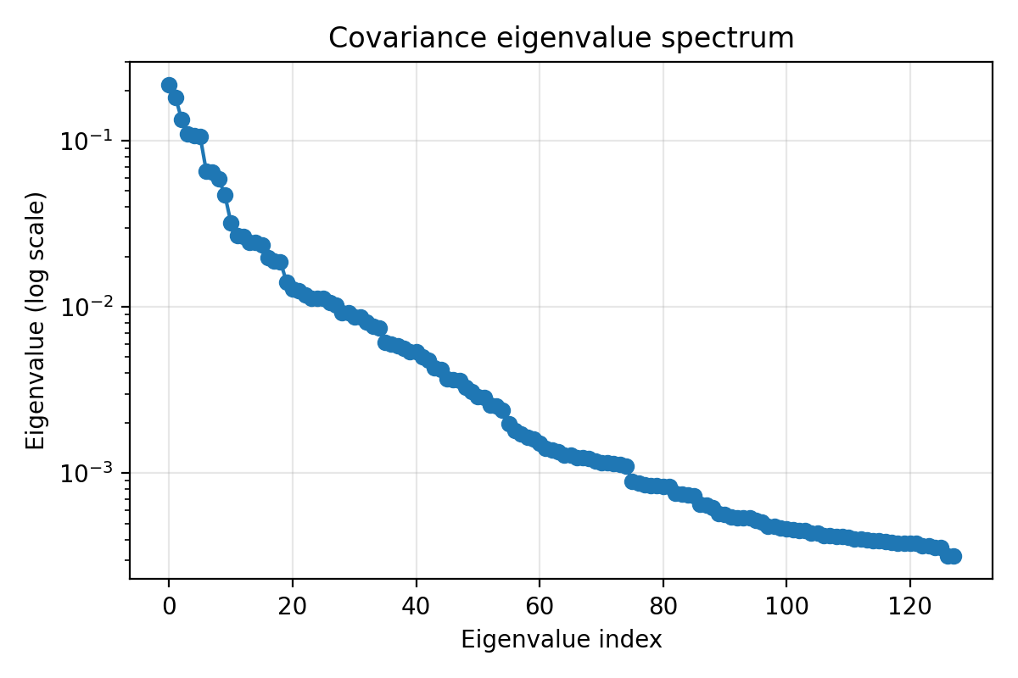
This plot shows that the first 10-20 eigenvalues are an order of magnitude larger than the rest. This means that a small set of principal components captures most of the variance. This indicates to me that the data is highly structured, which falls in line for my expectations of musical data. The tail is long and smooth, which shows that there are a mix of strong principal directions and many weakly correlated modes, rather than a sharp low-rank structure, this can help explain the diminishing returns later in training. For matters of convergence, the biggest eigenvalues dominate variance. Gradient descent immediately makes big progress in these directions. This explains why the loss drops quickly early on.

Conclusion
This project taught me a lot about training neural networks. I was able to make multiple simulations with different results and tunings. The simulation with the smooth curve took up to 2.5 hours for a simulation of 100 epochs. With a training set so small it is a small taste of the massive training requirements of the LLMs of today. Of course, their models are much more sophisticated, but the crisis of training power remains. I also played around with different nonlinearities such as the sigmoid activation from the Hinton paper. This gave me a very hands on approach with the neural network and really enhanced my understanding, by building it from scratch. If I were to extend this project I would use multiple pieces of training data and see what is produced by the network. Overall, I felt this project provided a clear picture of neural networks and the results it produced were very interesting.

References
- D. E. Rumelhart, G. E. Hinton, and R. J. Williams, Learning internal representations by error propagation, Sep. 1985. doi:10.21236/ada164453

