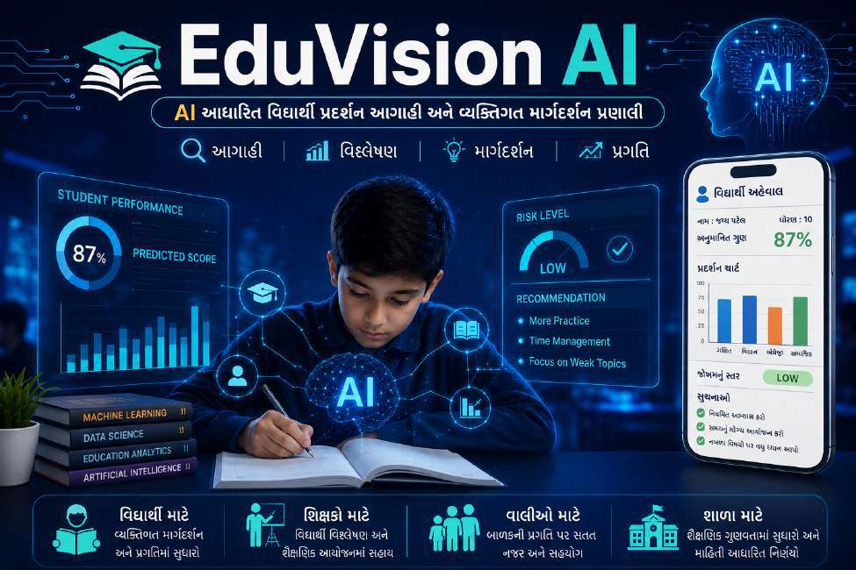
EduVision AI
AI-Powered Student Academic Performance Prediction & Personalized Guidance System
Project Live Website Link: https://eduvision-ai-kappa.vercel.app/ (Alternative: https://eduvision-ai.streamlit.app/)
─────────────────────────────────────────────
Project Mentor: Shri Manojbhai Parmar
School: M. M. Karodiya Primary School, Tarsadi Kosamba (R.S)
Developer & Researcher: Yash Patel (Science Fair 2026)

1
Project Title
EduVision AI – Artificial Intelligence Powered Student Performance Prediction and Personalized Academic Mentorship System
A professional, production-grade educational intelligence dashboard predicting final grades, assessing academic risk levels, and generating tailored study recommendations based on multi-dimensional student data.
Project Objectives
The primary objective of this project is to leverage cutting-edge Artificial Intelligence (AI) and Machine Learning (ML) technologies to analyze students' historical academic marks, daily study routines, behavioral factors, and attendance records, thereby accurately forecasting future academic performance and providing proactive, timely mentorship.
The system enables educators to identify academically vulnerable students well in advance of final board examinations, facilitating targeted remedial intervention. Simultaneously, it empowers students with clear self-awareness of their learning habits, fostering measurable performance improvement and academic confidence.
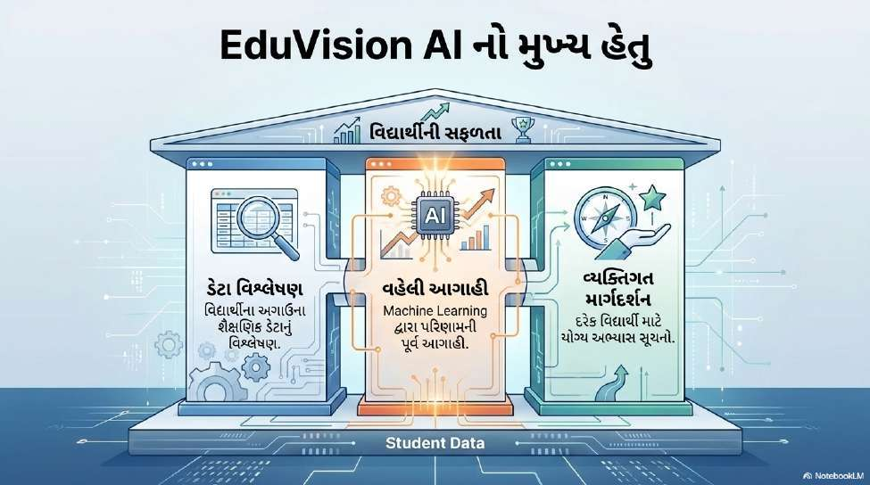

2
Core Scientific Principle
A student's future academic performance is strongly correlated with preceding internal evaluations (G1 and G2 exam scores) along with behavioral variables (daily study duration, school absences, educational support, and health status). By applying non-linear ensemble regression algorithms, these interactions can be mapped precisely, enabling timely corrective interventions that maximize academic potential.
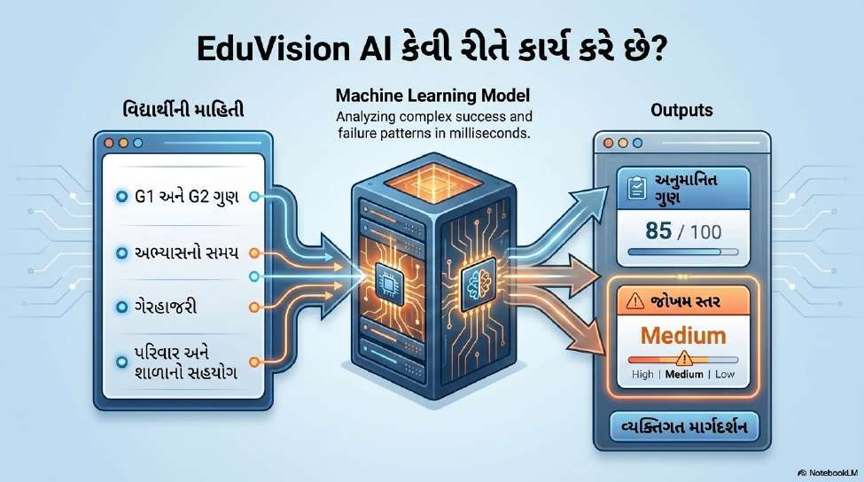
System Specifications & Requirements
Hardware Requirements
- Modern Computing Device (Laptop / Desktop / Tablet) with High-Speed Internet Connection
Software & Development Environment
- Python 3.11+ Runtime & Next.js 14 Production Web Application
- FastAPI High-Performance Asynchronous Python Microframework
- Visual Studio Code (VS Code) & Jupyter Notebook Development Suite
- Anaconda Package & Virtual Environment Manager

3
Python Scientific Libraries
- Pandas: High-performance structured data manipulation, CSV processing, and tabular analysis.
- NumPy: Numerical linear algebra computations, array transforms, and statistical calculations.
- Scikit-Learn: State-of-the-art machine learning model training, pipelines, and evaluation metrics.
- Matplotlib & Seaborn: Statistical data visualization, distribution plots, and correlation heatmaps.
- Joblib: High-efficiency serialization and persistent storage of the trained machine learning pipeline.
- FastAPI & Uvicorn: Production REST API server delivering low-latency inference endpoints.
Dataset Benchmark Information
- Student Performance Benchmark Dataset
- Repository Link: https://archive.ics.uci.edu/dataset/320/student+performance
- Dataset Description: Curated from the UCI Machine Learning Repository, comprising 395 verified student records spanning 33 demographic, academic, and social variables, capturing comprehensive behavioral profiles and subsequent academic outcomes.

4
System Architecture
EduVision AI is engineered as a robust, decoupled, cloud-ready web architecture. The framework comprises five foundational tiers: User Interaction Tier, Responsive Web Application (Next.js 14), Feature Preprocessing Pipeline, Machine Learning Inference Engine (Gradient Boosting), and Personalized Output Generation Module.
The user inputs student credentials and evaluation parameters through a responsive interface. The incoming payload undergoes real-time schema validation and transformation within the preprocessing pipeline.
The normalized features are forwarded to the trained Gradient Boosting model, which computes an exact numerical prediction of the student's expected final score (G3) out of 20.
Based on the prediction and key feature importances, the system categorizes the student into precise risk bands (Excellent, Good, Moderate, or High Attention) and generates dynamic remedial advice. Finally, the student report card and interactive dashboard visualizations are rendered instantaneously.
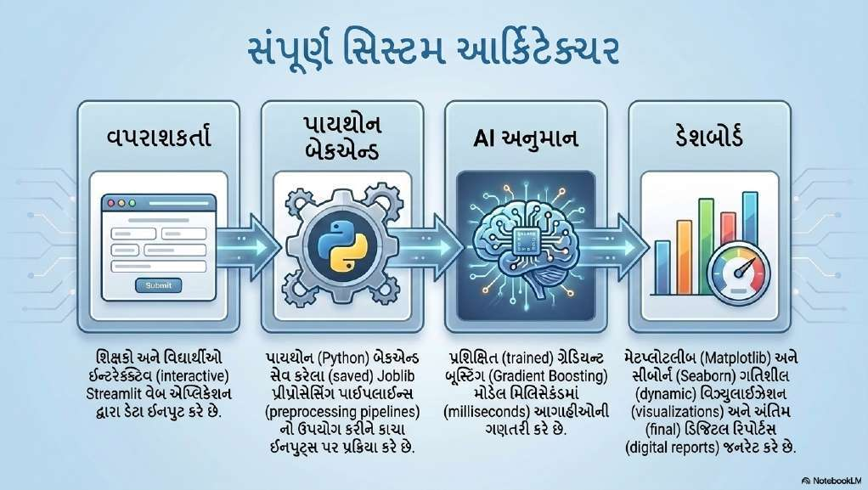

5
Machine Learning Methodology
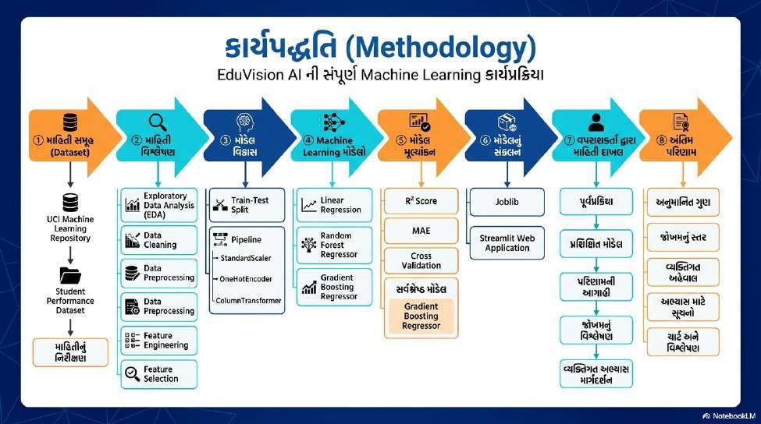
The development methodology follows a rigorous 7-stage Machine Learning lifecycle. Beginning with dataset acquisition from the UCI Machine Learning Repository, comprehensive quality verification and missing-value diagnostics were conducted.
Subsequent Exploratory Data Analysis (EDA) mapped the mathematical correlations between study hours, absenteeism, and evaluation scores. Rigorous data cleaning, feature engineering, and feature selection isolated the 12 most impactful academic indicators.
The dataset was partitioned into an 80% training set and a 20% independent testing set. Feature preprocessing pipelines incorporating numerical standardization (StandardScaler) and categorical encoding (OneHotEncoder) were integrated using Scikit-Learn's ColumnTransformer...

6
The unified ColumnTransformer guarantees deterministic, identical preprocessing transformations across both training and real-time production inference.
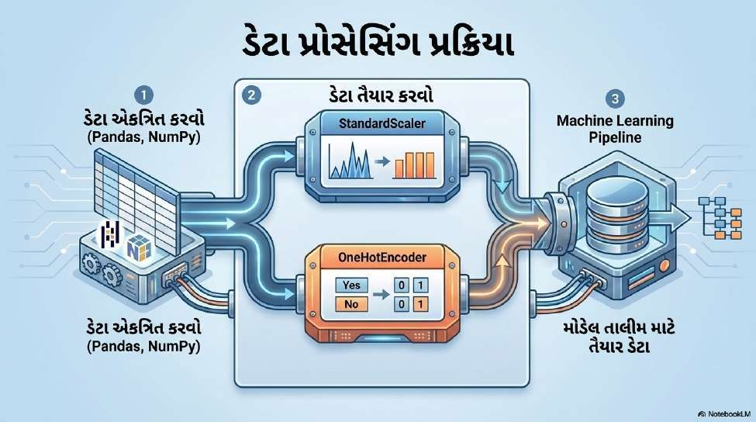
Candidate regression algorithms—including Linear Regression, Random Forest Regressor, and Gradient Boosting Regressor—were rigorously trained and validated. Comprehensive performance benchmarks evaluating the coefficient of determination (R² Score), Mean Absolute Error (MAE), and k-fold cross-validation confirmed that Gradient Boosting Regressor achieved the highest predictive accuracy and lowest residual variance, establishing it as the definitive production model.

7
Model Evaluation & Benchmark Comparison
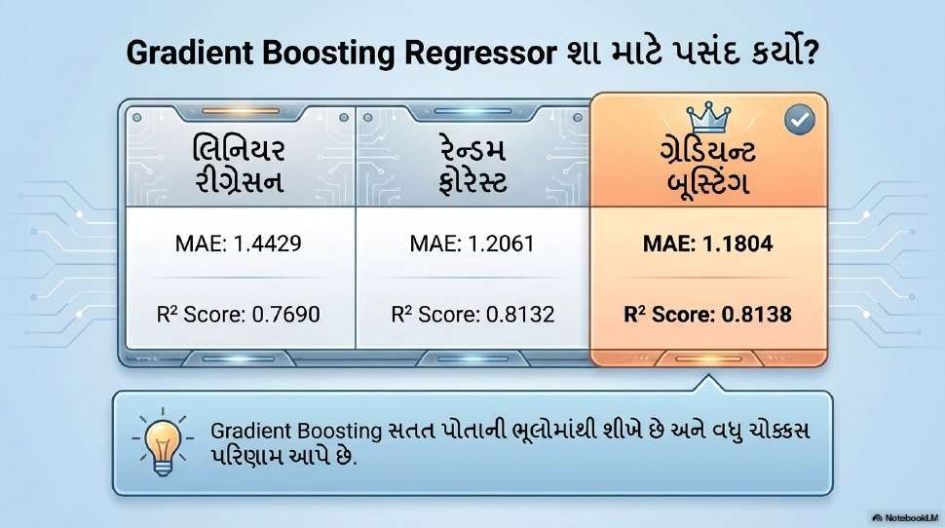
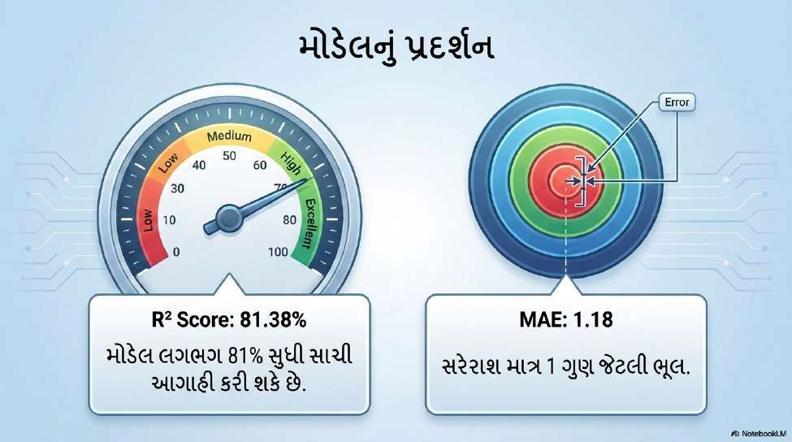

8
The finalized model pipeline was serialized using Joblib and integrated with the production web application. When a user submits student parameters, the system executes the pre-fitted preprocessing pipeline and feeds the transformed array to the model.
The application outputs the predicted score, performance percentage, academic risk tier, and customized actionable recommendations, delivering an end-to-end intelligent decision-support system.
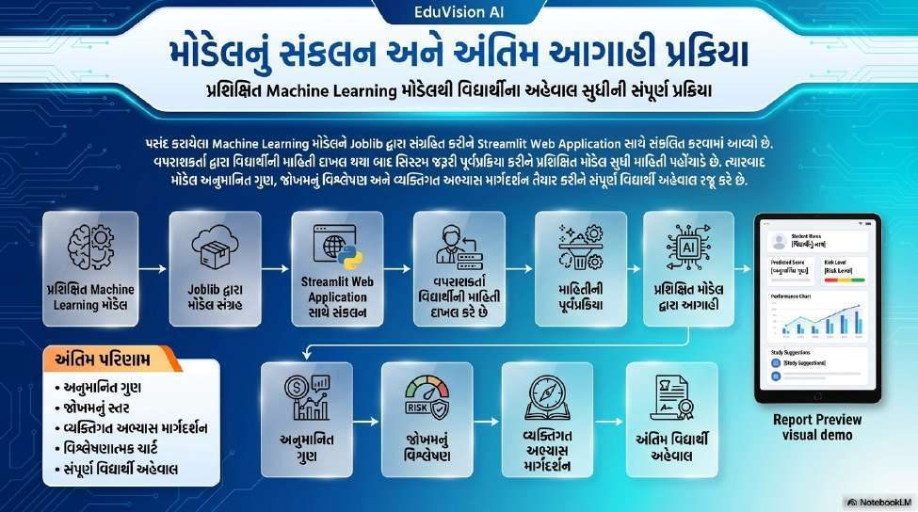
Applications & Stakeholder Benefits
- Schools & Administration: Enables data-driven strategic planning, optimized allocation of tutoring resources, and continuous monitoring of institutional academic quality.
- Educators & Mentors: Streamlines early detection of struggling students, reducing diagnostic overhead and facilitating timely personalized academic interventions.
- Students: Instills constructive self-awareness regarding study discipline and attendance, accompanied by clear, actionable pathways for grade improvement.
- Parents & Guardians: Provides transparent, objective insights into child academic progress, strengthening home-school collaboration.

9
- Evidence-Based Decision Making: Transforms traditional qualitative educational intuition into quantitative, evidence-based academic excellence strategies.
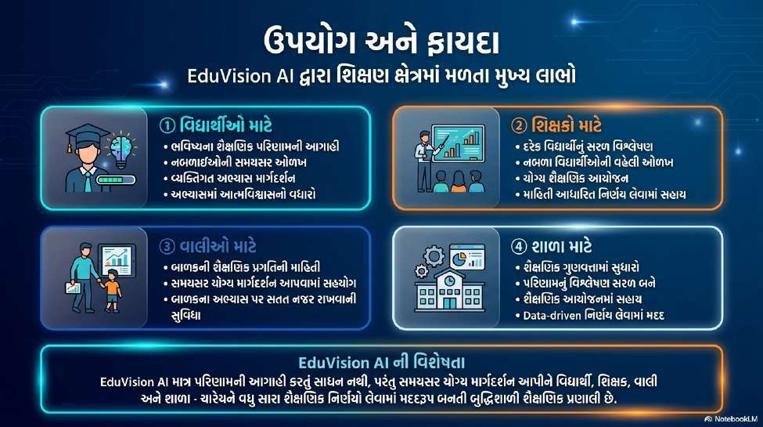
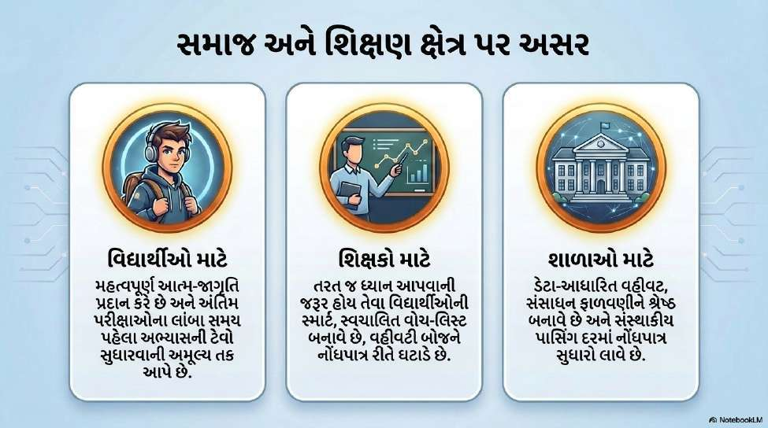

10
Future Scope & Strategic Roadmap
While EduVision AI currently delivers real-time prediction and tailored academic guidance, a comprehensive multi-phase roadmap is planned to expand its capabilities:
1. School ERP API Integration: Direct bi-directional integration with School Management Information Systems (MIS/ERP) to automate attendance synchronization, grade logging, and student onboarding without redundant manual data entry.
2. NLP-Based Feedback & Sentiment Analysis: Leveraging Natural Language Processing (NLP) to analyze student qualitative feedback, teacher remarks, and emotional sentiment to identify mental stress and non-academic learning impediments.
3. Native Mobile Applications for Parents: Developing cross-platform iOS and Android applications providing real-time notification alerts, push updates, and weekly progress telemetry directly to parents.
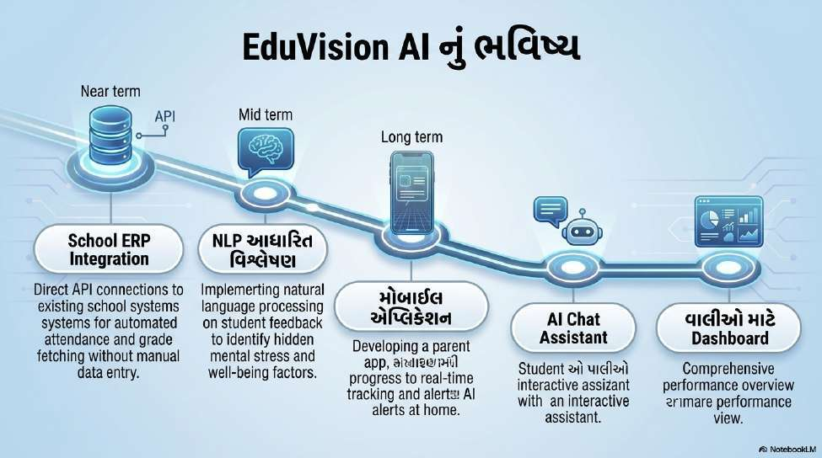

11
4. Interactive Conversational AI Tutor: Implementing an AI Chat Assistant powered by Large Language Models (LLMs) to answer student curriculum queries 24/7 and deliver individualized motivational coaching.
5. Unified Parent & School Analytics Dashboard: Centralized portal providing aggregated longitudinal tracking, institutional performance distributions, and predictive cohort analytics.
Through these systematic expansions, EduVision AI is dedicated to pioneering an intelligent, inclusive, and student-centric educational ecosystem that empowers every learner to realize their full potential.
Conclusion & Official Signatures
______________________________  Shri Manojbhai Parmar  Project Mentor & Head  M. M. Karodiya Primary School | ______________________________  Yash Patel  Developer & AI Researcher  Science Fair 2026

