SOFTWARE ENGINEERING
Software Architecture and Design Specification (SAD)
Name: Sakshi Srinivas Ghodke, Yashita Anand, Ujwal K, Varun Sahu
SRN: PES2UG24CS914, PES2UG24CS613, PES2UG24C566, PES2UG24CS576
Date: 14/09/2026
Problem Statement: Chat Application (Socket Programming)
Team Number: 5
Revision History
Version | Date | Author | Change Summary | Approval
1.0 | 14/09/2026 | Sakshi Srinivas Ghodke  Yashita Anand  Ujwal K  Varun Sahu | SAD with diagrams embedded

Approvals
Role | Name | Signature/Email | Date
Course Coordinator

1. Introduction
1.1 Purpose
This document specifies the software architecture and detailed design of the Real-Time Chat Application built using socket programming. It translates the functional and non-functional requirements defined in the Software Requirements Specification (SRS) into a concrete architecture, component design, API contracts, and security model, and serves as the primary technical reference for developers, evaluators, and maintainers of the system.
1.2 Scope
This document covers the architecture and design of a multi-client, server-mediated chat system in which clients communicate over persistent TCP sockets through a central multi-threaded server. It addresses one-to-one messaging, group chat/rooms, presence tracking, file transfer, administrative moderation, chat history persistence, and reconnection handling. It does not cover integration with third-party messaging protocols (e.g., XMPP, SIP) or mobile push-notification infrastructure, consistent with the SRS scope exclusions.
1.3 Audience
Developers, QA engineers, system integrators, security auditors, course instructors, and maintenance teams responsible for building, testing, and evolving the chat application.
1.4 Definitions
TCP, IP, Socket, Port, Thread, Client, Server, ACK (Acknowledgement), UI, JSON, SSL/TLS, GUI, PIN (not applicable here), RTM (Requirements Traceability Matrix), ADR (Architecture Decision Record).
2. Document Overview
2.1 How to use this document
This document provides the architectural deliverables for the Chat Application, including the component (UML) diagram, UML sequence diagrams for the two most critical flows (login/authentication and direct messaging), a threat model, and REST/socket-message API design. Section 3 describes the architecture; Section 4 describes the detailed design; Section 5 contains supporting appendices.
2.2 Related Documents
- Software Requirements Specification (SRS) - Chat Application, Team 5, v1.0
- Software Test Plan (STP) - to be developed
- Requirements Traceability Matrix (RTM) - Section 8 of the SRS

3. Architecture
3.1 Goals & Constraints
Goals:
- Deliver messages in real time with end-to-end latency ≤ 500 ms for 95% of messages (CHAT-NF-001).
- Support at least 200 concurrent client socket connections without dropping active sessions (CHAT-NF-002).
- Reliable detection and cleanup of dead connections within 30 seconds (CHAT-NF-003).
- Secure, auditable administration and moderation actions.
- Maintainable, modular server design that can evolve toward additional features (e.g., biometric login, mobile push).
Constraints:
- Must use raw TCP sockets rather than HTTP polling for real-time delivery.
- Single-threaded-per-client or thread-pool concurrency model on the server.
- Message size limits for buffer handling and file transfer chunking.
- Optional TLS wrapping is required whenever the system is deployed over an untrusted network (CHAT-SR-001).
3.2 Stakeholders & Concerns
Stakeholder | Primary Concerns
End User (Client) | Low-latency delivery, simple and responsive UI, reliable reconnection
Administrator | Ability to moderate rooms, broadcast announcements, and audit actions
Server Operator | Server health, connection counts, scalability, and log visibility
Security/Compliance | Encrypted transport, hashed credentials, input validation, audit logging
Developers | Modularity, testability, and clear API/message contracts
3.3 Component (UML) Diagram
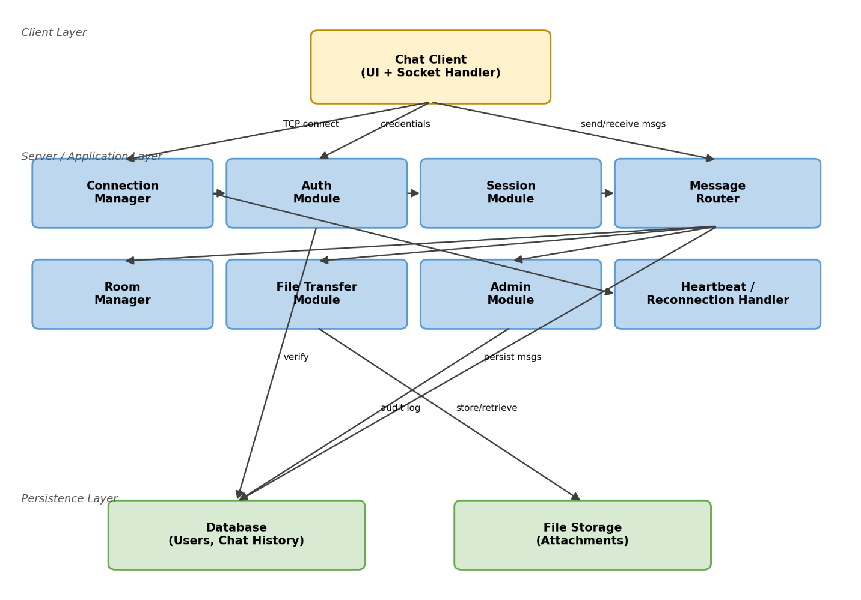
Figure 1: Component diagram of the Chat Application (client, server modules, and persistence layer)
3.4 Component Descriptions
Component | Responsibility
Chat Client (UI + Socket Handler) | Desktop/console/GUI application that opens and maintains a persistent TCP socket, renders the chat UI, and sends/receives protocol messages.
Connection Manager | Accepts incoming TCP connections, manages the connection pool/thread-per-client or thread-pool model, and coordinates heartbeat/keep-alive.
Auth Module | Registers users, authenticates credentials (hashed with bcrypt), and issues session tokens on successful login.
Session Module | Creates, validates, and terminates session tokens; enforces that every message carries a valid token.
Message Router | Routes one-to-one and room messages to the correct recipient socket(s), manages delivery/read acknowledgements and typing indicators.
Room Manager | Handles chat room creation, join/leave membership, and online user list per room and globally.
File Transfer Module | Chunked upload/download of file attachments, enforcement of size limits, and checksum verification.
Admin Module | System-wide broadcast announcements, kick/ban/mute actions, and administrative audit logging.
Heartbeat / Reconnection Handler | Sends periodic ping/pong messages, detects dropped sockets, and supports client-side exponential-backoff reconnection.
Database (Users, Chat History) | Persists user credentials (hashed), room metadata, and chat history for at least 90 days.
File Storage | Persists uploaded file attachments referenced by the File Transfer Module.
3.5 Chosen Architecture Pattern and Rationale
A layered, service-oriented architecture on top of a multi-threaded (thread-pool) TCP server was chosen: a Client layer, a Server/Application layer composed of loosely-coupled modules (Connection Manager, Auth, Session, Message Router, Room Manager, File Transfer, Admin), and a Persistence layer (relational database + file storage). This separation of concerns keeps socket-handling logic independent from business logic (authentication, routing, moderation) and from storage concerns, which simplifies unit testing and allows individual modules to be scaled or replaced independently.
A full microservices architecture (with each module as an independently deployed service communicating over a network) was considered and rejected: it would introduce inter-service network latency and operational complexity (service discovery, distributed tracing, independent deployment pipelines) that is disproportionate to the scale required by this application (up to 200 concurrent clients). An event-driven, single-process, in-memory pub-sub model within one server process, backed by a thread pool, was judged to best satisfy the latency and scalability NFRs while remaining simple to build, test, and reason about.

3.6 Technology Stack & Data Stores
Layer | Technology
Client | Java (Swing/JavaFX or console) or Python (Tkinter) socket client
Server | Java (ServerSocket/Socket API, thread pool via ExecutorService) or Python (asyncio/socket + threading)
Application Protocol | Custom JSON-based message protocol framed over the TCP byte stream
Transport Security | Optional TLS/SSL socket wrapper (SSLSocket / ssl module)
Database | SQLite for development; MySQL/PostgreSQL for production-scale deployment
File Storage | Local file system directory, referenced by file metadata in the database
Password Hashing | bcrypt with a unique salt per password
3.7 Risks & Mitigations
Risk | Mitigation
Server becomes a single point of failure under high concurrent load | Thread-pool sizing tuned to CHAT-NF-002 (200 concurrent clients); connection queuing and graceful degradation
Dropped connections leave stale sessions consuming resources | Heartbeat/ping-pong every N seconds; automatic cleanup within 30 seconds (CHAT-NF-003)
Sensitive data (passwords, messages) exposed on untrusted networks | Mandatory TLS/SSL wrapping for deployments over untrusted networks (CHAT-SR-001)
Malformed or oversized payloads crash the server or exhaust buffers | Server-side input validation/sanitization and file-size limit enforcement (CHAT-SR-003, CHAT-F-031)
Brute-force login or connection-flood attacks | Per-IP rate limiting on connection/login attempts (CHAT-SR-005)
Message loss for offline recipients | Persistence Module queues messages for offline users and delivers them on next login (CHAT-F-012)
3.8 Traceability to Requirements
Requirement | Architectural Element
CHAT-F-001/002 (Register/Authenticate) | Auth Module → Database
CHAT-F-003/004 (Logout/Disconnect detection) | Session Module, Connection Manager
CHAT-F-010–015 (Messaging) | Message Router → Persistence Module
CHAT-F-020–023 (Group Chat/Rooms) | Room Manager
CHAT-F-030/031 (File Transfer) | File Transfer Module → File Storage
CHAT-F-040–042 (Admin/Moderation) | Admin Module → Database (audit log)
CHAT-NF-001–005 (Performance/Scalability/Reliability/Usability) | Connection Manager, Message Router, Session Module (async I/O)
CHAT-SR-001–005 (Security) | Connection Manager (TLS, rate limiting), Auth Module (hashing), Message Router (validation), Session Module (token enforcement)
3.9 Security Architecture
Threat Modeling (STRIDE):
- Spoofing → mandatory authentication with hashed credentials (bcrypt + unique salt) and per-connection session tokens; impersonation is prevented by rejecting any message without a valid token.
- Tampering → server-side validation and sanitization of every incoming payload; checksum verification on received file attachments.
- Repudiation → administrative actions (kick/ban/broadcast) are logged with timestamp and admin ID for audit (CHAT-F-042).
- Information Disclosure → TLS/SSL encryption of the socket stream on untrusted networks; passwords never transmitted or stored in plaintext.
- Denial of Service → per-IP rate limiting on connection/login attempts and bounded message/file sizes to prevent buffer exhaustion.
- Elevation of Privilege → role-based access control distinguishing User, Administrator, and Server Operator, enforced in the Admin Module before executing moderation commands.

4. Design
4.1 Design Overview
The chat application is designed as a set of layered, cooperating modules within a single server process (see Section 3.3). The Client layer is responsible only for UI rendering and socket I/O; all business rules (authentication, routing, moderation, persistence) live in the Server/Application layer, which keeps the client thin and easy to port across platforms. Each server module exposes a narrow internal interface to the others, which simplifies unit testing and future extraction into separate services if the system needs to scale beyond a single process.
4.2 UML Sequence Diagrams
4.2.1 Flow 1: Login & Authentication
Covers requirements CHAT-F-001, CHAT-F-002, and CHAT-SR-002/004: a client connects, submits credentials, the server verifies them against the hashed record in the database, and a session token is issued for subsequent authenticated requests.
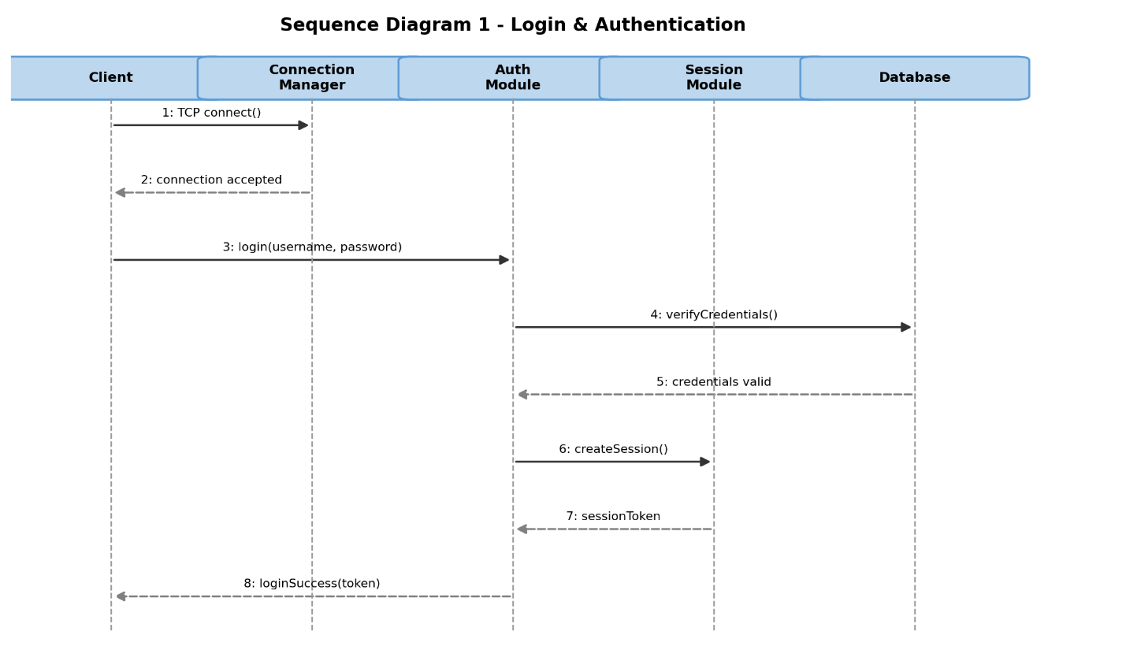
Figure 2: Sequence diagram - Login & Authentication
4.2.2 Flow 2: Send Direct Message
Covers requirements CHAT-F-010, CHAT-F-011, and CHAT-F-013: a validated client sends a private message, the server checks the session token, persists the message, delivers it to the recipient if online, and returns a delivery acknowledgement to the sender.
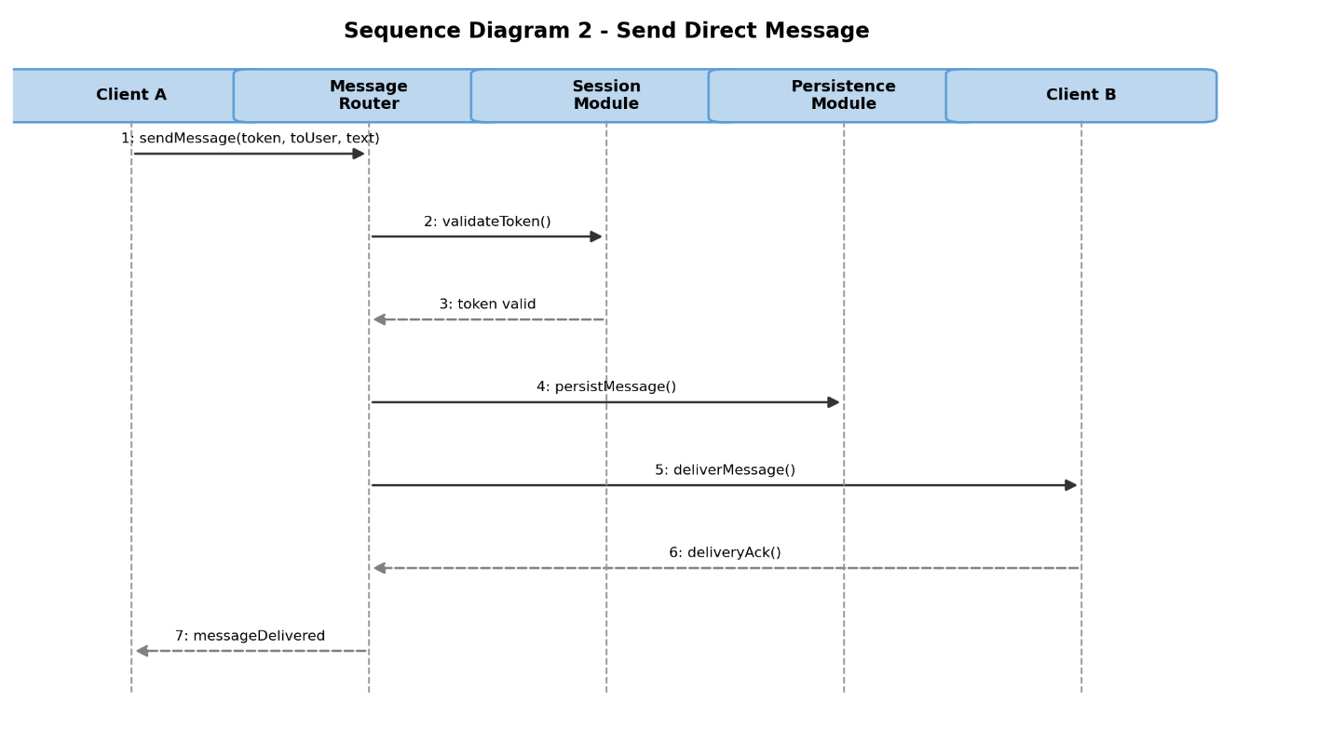
Figure 3: Sequence diagram - Send Direct Message
4.3 API Design
The client and server communicate using a custom JSON message protocol framed over the TCP socket stream. Each message has a "type" field identifying the operation, a payload, and (after login) a "token" field for authentication. The two core interfaces below correspond to the Auth Module and the Message Router.
4.3.1 Auth Module Interface
Message Type: LOGIN_REQUEST / LOGIN_RESPONSE
Request payload:
{ "type": "LOGIN_REQUEST", "username": string, "password": string }
Response payload (success):
{ "type": "LOGIN_RESPONSE", "status": "OK", "token": string, "userId": string }
Response payload (error):
{ "type": "LOGIN_RESPONSE", "status": "ERROR", "code": 401, "message": "Invalid credentials" }
Errors: 401 Invalid credentials; 409 Username already registered (on REGISTER_REQUEST).
4.3.2 Message Router Interface
Message Type: SEND_MESSAGE / MESSAGE_DELIVERED / MESSAGE_ERROR
Request payload:
{ "type": "SEND_MESSAGE", "token": string, "toUser": string, "roomId": string | null, "content": string, "timestamp": string }
Response payload (success):
{ "type": "MESSAGE_DELIVERED", "messageId": string, "deliveredAt": string }
Response payload (error):
{ "type": "MESSAGE_ERROR", "code": 401, "message": "Invalid or expired token" }
Errors: 401 Invalid/expired token; 404 Recipient/room not found; 413 Payload too large.
4.4 Error Handling, Logging & Monitoring
All error responses use a standardized envelope: { "type": "<OP>_ERROR", "code": <int>, "message": <string> }. No sensitive information (passwords, raw tokens, message content) is written to server logs; only user IDs, event types, and timestamps are logged for administrative and security audit trails, per CHAT-F-042 and CHAT-SR-002.
Monitoring covers:
- Active connection count vs. the 200-connection scalability target (CHAT-NF-002).
- Message delivery latency (95th percentile) against the 500 ms target (CHAT-NF-001).
- Transaction/message failure rate and dead-connection cleanup time (CHAT-NF-003).
- Rate-limiting triggers per IP for brute-force detection (CHAT-SR-005).
4.5 UX Design
The client UI consists of a contact/room list, a message pane, a text input box with a file-attach control, online-status indicators, and a typing-indicator affordance, all reachable via keyboard navigation per SRS Section 3.1. The UI performs all socket I/O asynchronously (a dedicated listener thread or non-blocking I/O) so that user input is never blocked while waiting on the network, satisfying CHAT-NF-005.
4.6 Open Issues & Next Steps
- Evaluate WebSocket-based fallback for browser-based clients.
- Add end-to-end encryption for message content in addition to transport-level TLS.
- Design a horizontal-scaling strategy (e.g., message broker) if concurrent-user targets grow beyond 200.
- Define retention/archival policy for chat history beyond the 90-day requirement (CHAT-NF-004).

5. Appendices
5.1 Glossary
TCP, IP, Socket, Port, Thread, Client, Server, ACK, UI, JSON, SSL/TLS, GUI, RTM, STRIDE, bcrypt.
5.2 References
- IEEE 42010 - Systems and software engineering - Architecture description
- OWASP - Secure coding and authentication guidelines
- NIST SP 800-160 - Systems Security Engineering
- Software Requirements Specification (SRS) - Chat Application, Team 5, v1.0
5.3 Tools
- Diagramming: Python/Matplotlib (UML-style component and sequence diagrams)
- API documentation: Swagger/OpenAPI-style JSON message contracts
- Version control: Git

