Aapwrite for backend as service Tinymce rich text editor for text editor functionality Html-react-parser using to parse html React Hook Forms to hamdle input forms Creating .env file to store environment variable

How to create a react file??
USING REACT APP
- Type the command “npx create-app-react __file name______
- Go to the folder (cd foldername) Run “npm run start”
- npm run build

USING VITE
- npm create vite@latest
- cd foldername
- npm run install
- npm run dev

REACT-DOM: Webpage
REACT-NATIVE: Mobile

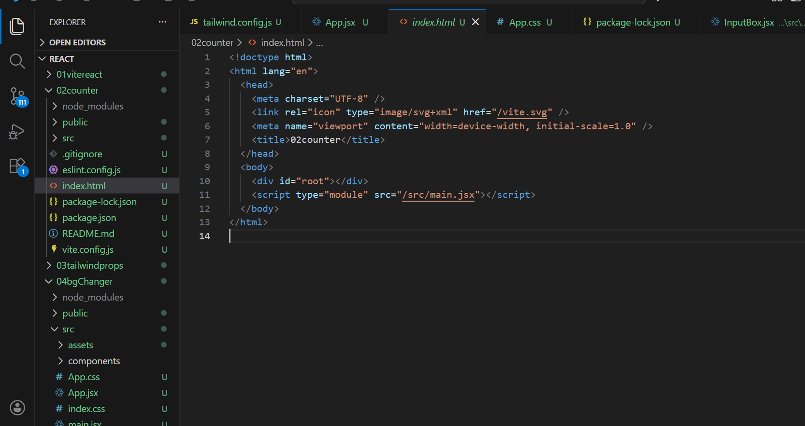

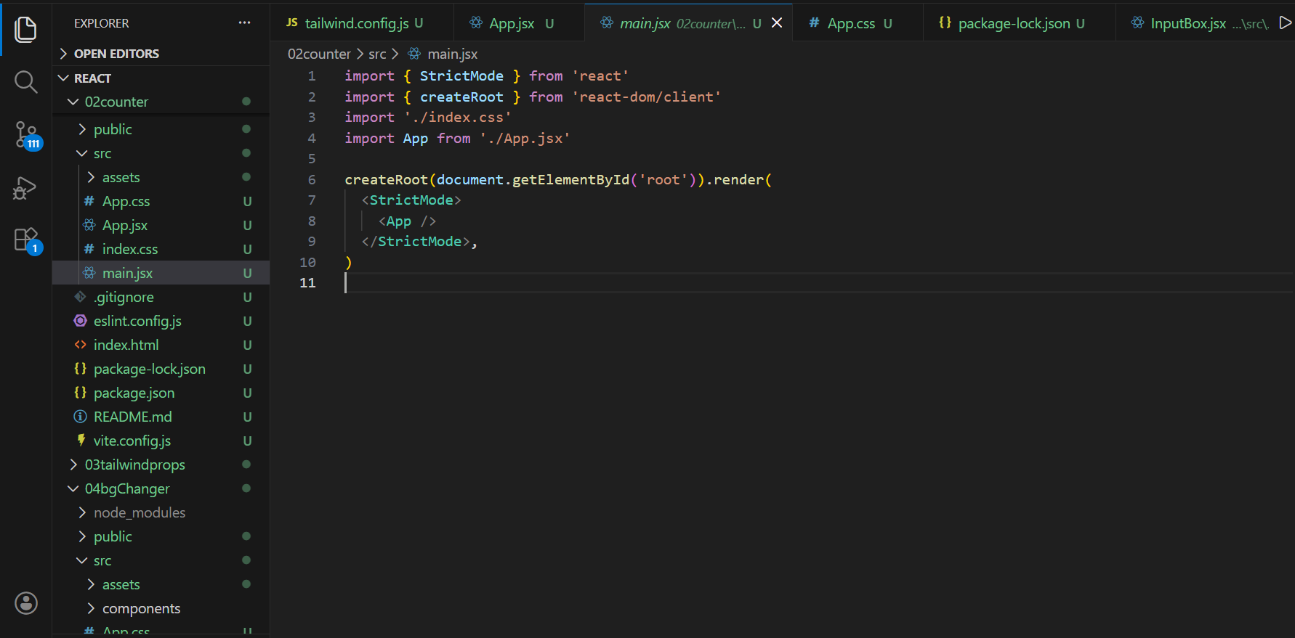
- In main.jsx, we specify the HTML element (root) where the React application should be rendered. Analogy, it connects react and html and react knows on which html file it needs to work on.
- React is a SPA. A Single Page Application uses only ONE HTML file. It means when you are normally working on a file.Traditionally,
a href="about.html">About</a>
- What the browser does:
- Leaves current page
- Requests about.html from server
- Downloads HTML, CSS, JS again
- Builds page from scratch
- This is a full page reload.

- Modernly,
<button onClick={() => setPage("about")}>About</button>
- What happens:
- Browser does NOT ask server for a new HTML
- React updates the Virtual DOM
- Only changed elements in #root update
- Page feels instant
- Same HTML, same JS, same page

- App.js is exporting its function, its code by using the syntax default default App.
- React has scripts command that automatically links the js file to the html file whereas in vite the js file is imported by using script tag only inside the html .
- The name of the files/components should always start with capital letter.In vitereact, you need to name the js files as jsx.
- DOM are tree like structures that contains various element of a web-page.
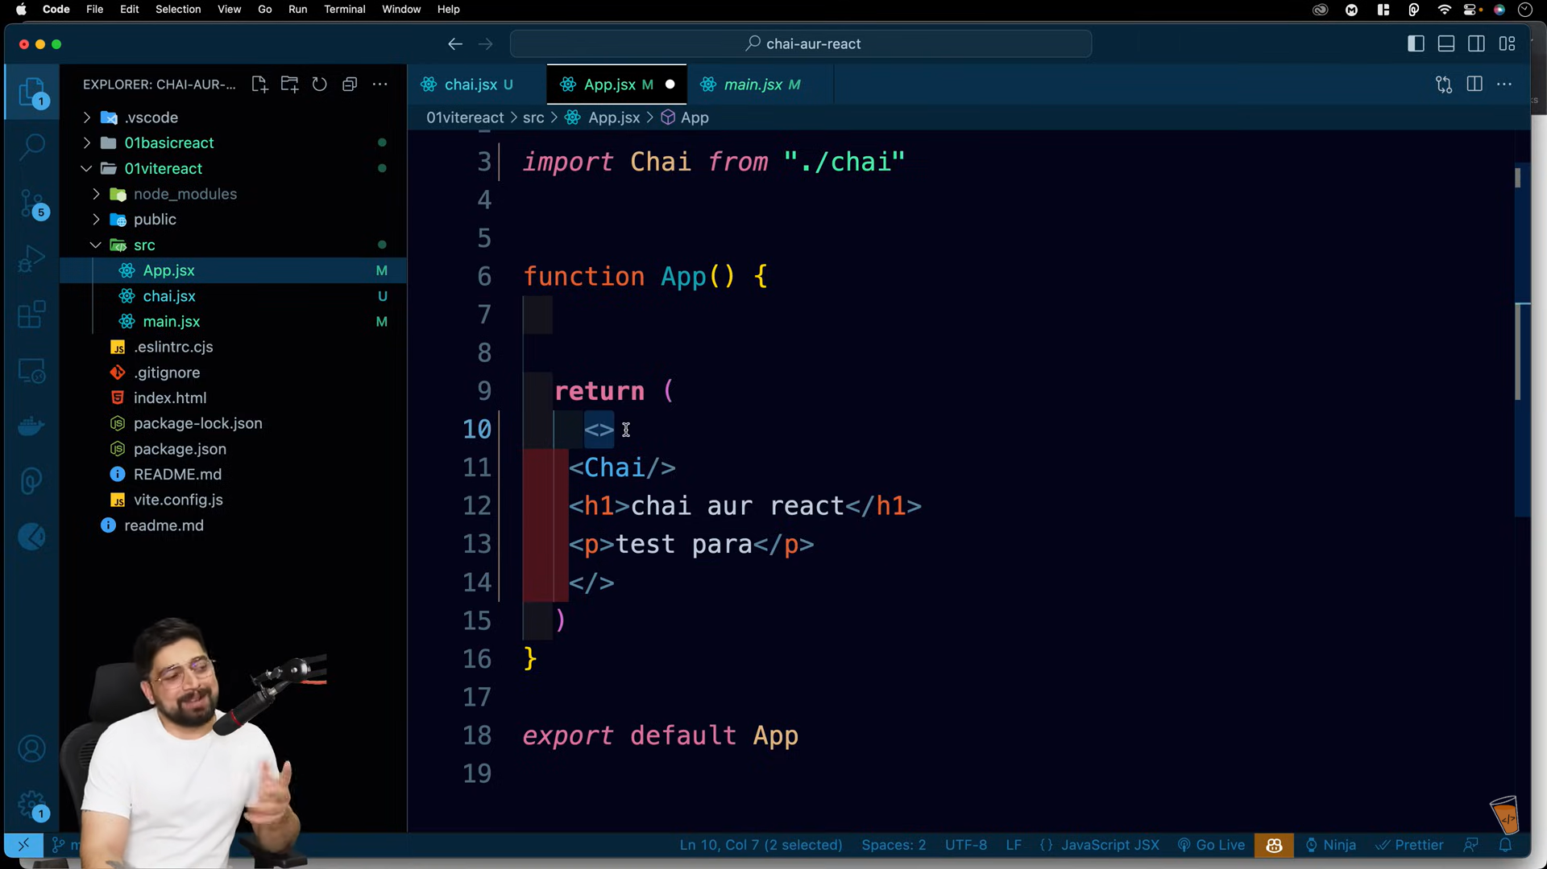

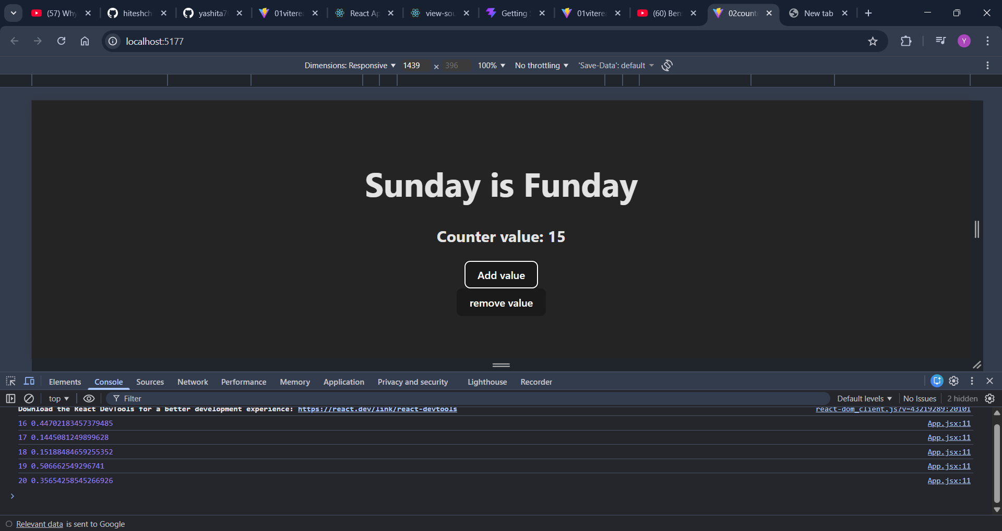
The value is changing in the console box but not on the website that is UI interface.
This is one of the property of react that it controls what needs to be displayed and it is responsible for reacting on UI.
We can change the data on ui by using hooks provided by react.

Summarising, the problem was ui updation for which the solution is hook

1.The createRoot create's its own DOM and then compare it with the web browser's DOM and only update those components which are actually updated.
2.But the browser removes the whole DOM and then recreates the whole DOM with the updated values this is called reload.
3. However virtual DOM (also known as ReactDOM)tracks whole DOM like a tree like structure and updates only those values which were only changed.
4. But some values depends on network call so if we update a value it might get update immediately via a network call and suppose other more updates come .
5. So we will have to update it again. What if we would have stopped and would have third update /optimised updation. To avoid this overhead we can drop the updation calls for the immediate value update.
6. The current algo used by the React is called the React Fibre algo which is behind Virtual DOM

REACT FIBRE
- The goal of React Fiber is to increase its suitability for areas like animation, layout, and gestures. Its headline feature is incremental rendering: the ability to split rendering work into chunks and spread it out over multiple frames.

Matlab ki ek baari mein hi teen updation kardo na jisse animation lag nhi maregi

- Other key features include the ability to pause, abort, or reuse work as new updates come in; the ability to assign priority to different types of updates; and new concurrency primitives.
Matlab pehle web pr kon aaye jaise pehle button/ pura web page paint hojata hai tab jakar JS inject hoti hai
7. The algo react uses to differentiate the web browser's tree and React's tree formed through create root is called reconciliation.
8. Reconciliation is the algo behind what popularly known as the Virtual-DOM.
9. Reconciliation is the algorithm behind what is popularly understood as the "virtual DOM." A high-level description goes something like this: when you render a React application, a tree of nodes that describes the app is generated and saved in memory. This tree is then flushed to the rendering environment — for example, in the case of a browser application, it's translated to a set of DOM operations. When the app is updated (usually via setState), a new tree is generated. The new tree is diffed with the previous tree to compute which operations are needed to update the rendered app

- 10. Different component types are assumed to generate substantially different trees. React will not attempt to diff them, but rather replace the old tree completely.
- Diffing of lists is performed using keys. Keys should be "stable, predictable, and unique." Matlab agar lists ko access karna hai toh keys ka use krke karna chahiye because vo react algo ko achha banati hai kind of

11.
We've established that a primary goal of Fiber is to enable React to take advantage of scheduling. Specifically, we need to be able to
- pause work and come back to it later.
- assign priority to different types of work.
- reuse previously completed work.
- abort work if it's no longer needed.
12. hydration : Jab pehli baar page load hota hai, buttons aur images dikhte hain (HTML aa gaya), lekin kuch click nahi hota kyunki JavaScript ab tak load nahi hui hoti. Phir jab JavaScript load ho ke React ko HTML ke saath connect karti hai aur sab interactive ho jata hai, us process ko hydration bolte hain. aur ye fibre algorithm k through kaafi aachi hoti hai

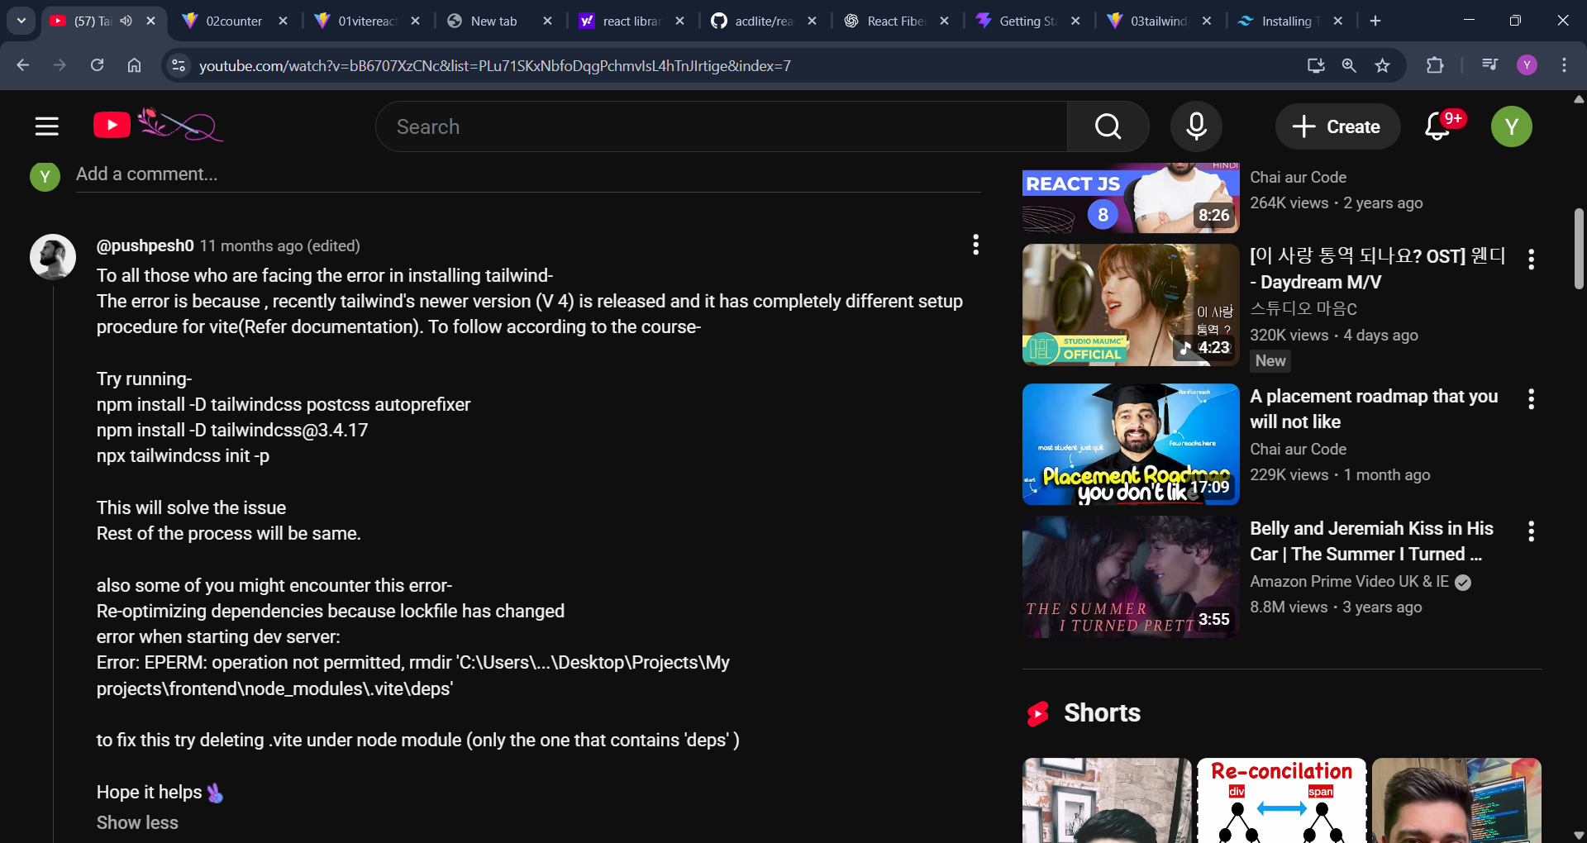

Tailwind using vite

npm install -D tailwindcss postcss autoprefixer npm install -D tailwindcss@3.4.17 npx tailwindcss init -p

Q1. | What is react?
React is a JavaScript library used to build user interfaces, mainly single-page applications. Instead of writing big HTML files, React lets you:
- Break UI into small reusable components

Think of a website like Instagram:
- Navbar → component
- Post → component
- Like button → component
- Comment section → component
React helps you build each part separately and reuse them.

Q2. | What is a component?
A component is just a JavaScript function that returns UI.
The name of React components must always start with capital letter.
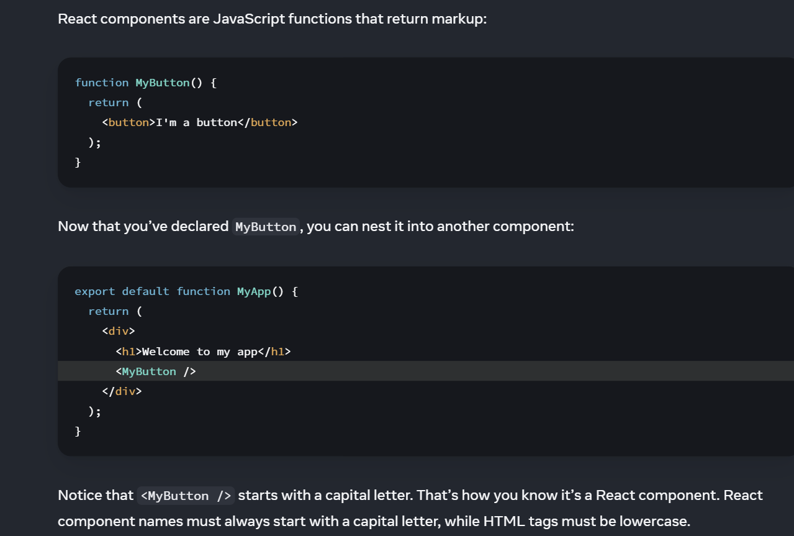

Q3. | What is this export default concept?
In react, we can create multiple components in different files. To make each component available to other files, we need to export the component/function from the file where it was created.
Later on, we need to import that component in another file by using import keyword.

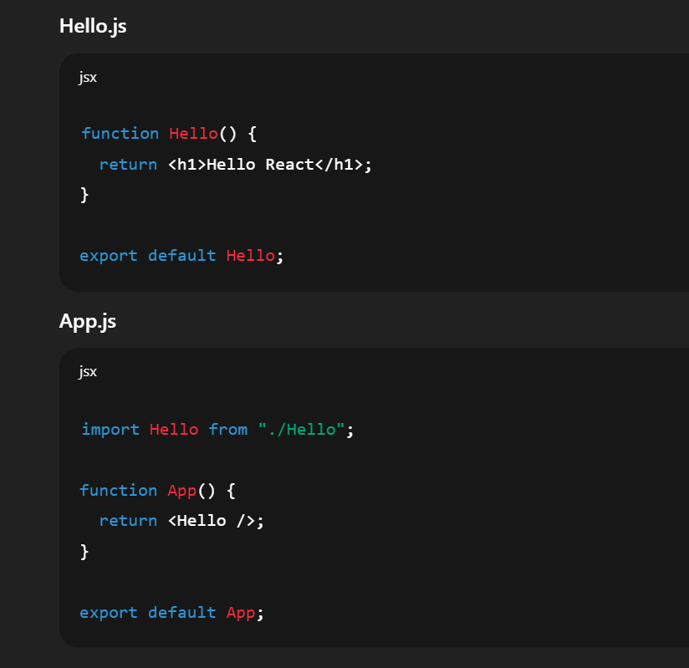
Q4. | What is the difference between default export and export?  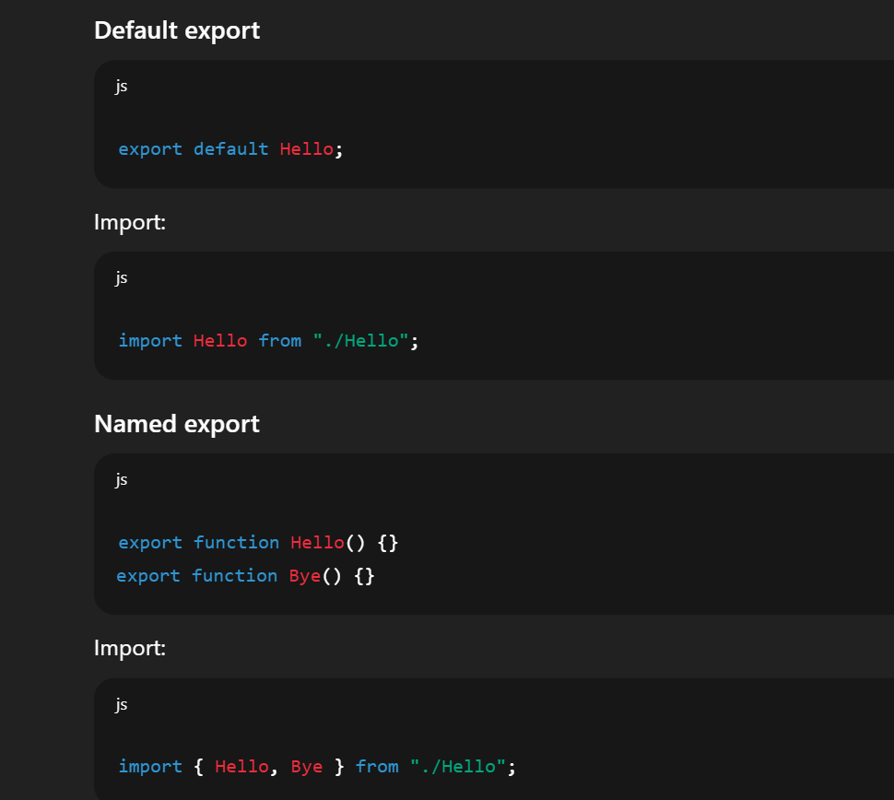
Q5. | What is JSX?  JSX is a syntax extension of JavaScript that allows writing HTML-like code in React components.  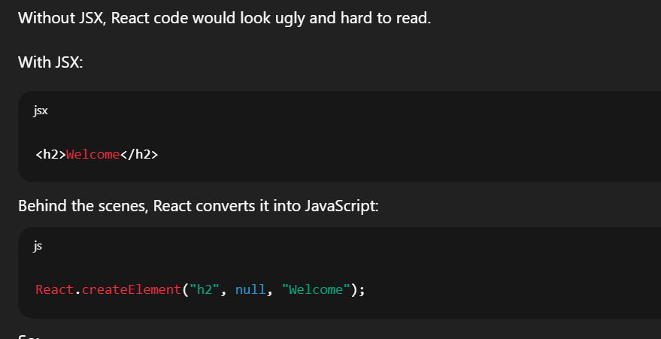
Q6. | What are the rules of JSX??
RULES:

1.One Parent Element:
Do all the work inside one div/<></> tags.

return (
<div>
<h1>Hello</h1>
<p>World</p>
</div>
);

2. JavaScript inside { }

const name = "Yashita";
<h1>Hello {name}</h1>

3.Use className, not class
<div className="box"></div>

You can also link a CSS file.

Q7. | DISPLAYING DATA
Curly braces let you “escape back” into JavaScript so that you can embed some variable from your code and display it to the user. For example, this will display user.name:

return (
<h1>
{user.name}
</h1>
);

For example, className="avatar" passes the "avatar" string as the CSS class, but src={user.imageUrl} reads the JavaScript user.imageUrl variable value, and then passes that value as the src attribute:

return (
<img
className="avatar"
src={user.imageUrl}
/>
);

for example, string concatenation: style={{}} is not a special syntax, but a regular {} object inside the style={ } JSX curly braces.

<>
<h1>{user.name}</h1>
<img
className="avatar"
src={user.imageUrl}
alt={'Photo of ' + user.name}
style={{
width: user.imageSize,
height: user.imageSize
}}
/>
</>

You can use same syntax for conditional operations like if, else, else if…

RENDERING LIST

You will rely on JavaScript features like for loop and the array map() function to render lists of components

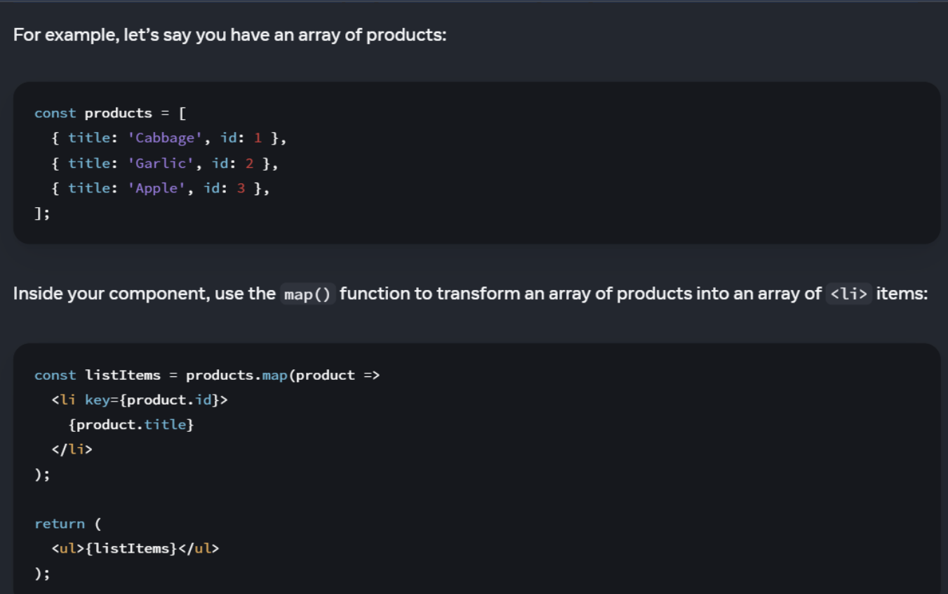

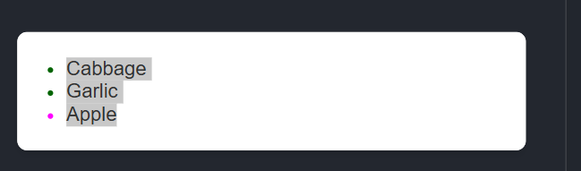
Q8. | Why did we need hooks?  It is because react controls UI updation. It is the boss of the UI.

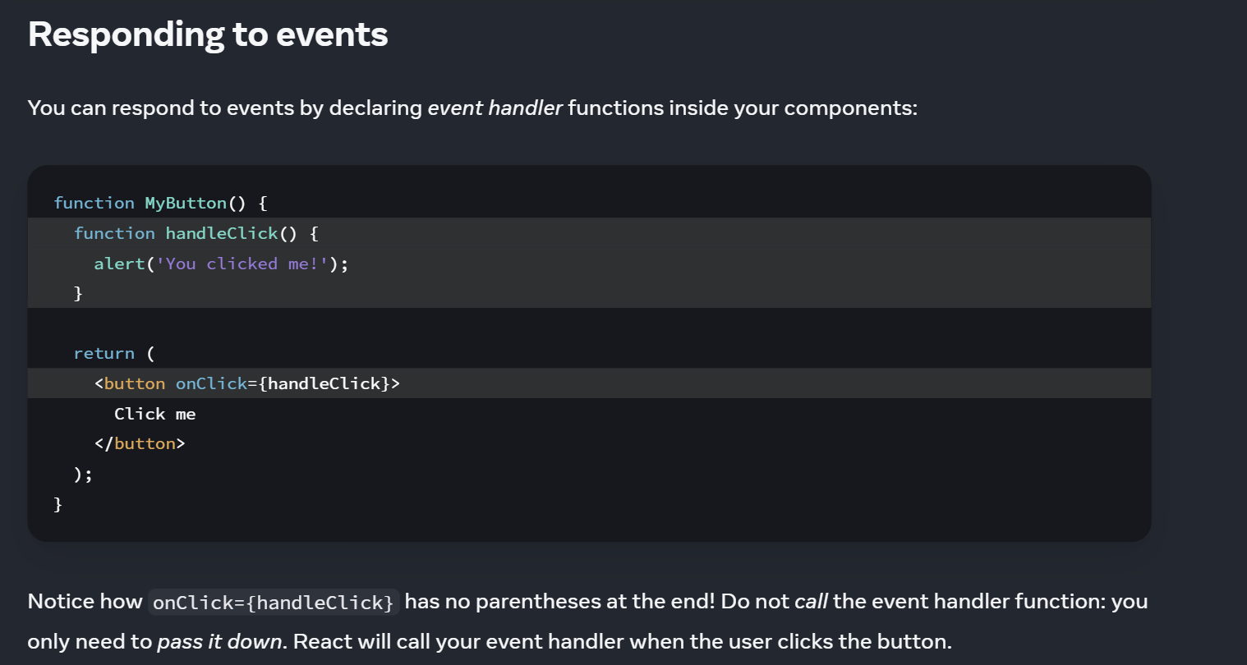

UPDATING THE SCREEN/ USE STATE
1.Import use-State from React:
2. Now you can declare a state variable inside your component:
3. You can give them any names, but the convention is to write [something, setSomething].

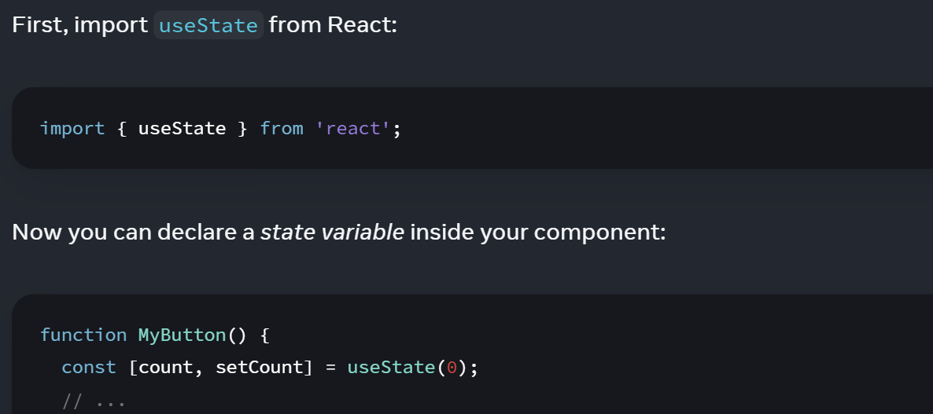

CONCEPT OF PROPS

In the above code, when we clicked on button, on clicking on one button only one button was getting incremented but now what if I want to increment both the buttons together by just clicking on one button? I can use props.

I am going to explain it simply in analogy format:
Consider MyApp as parent component and MyButton as child component.
The data is basically stored in parent. Child is not even aware of what the data is. It just works on the data that comes from parent/ it follows the command of parent.
- The parent owns the data.
- Children only use it.
- Props = data passed from parent to child
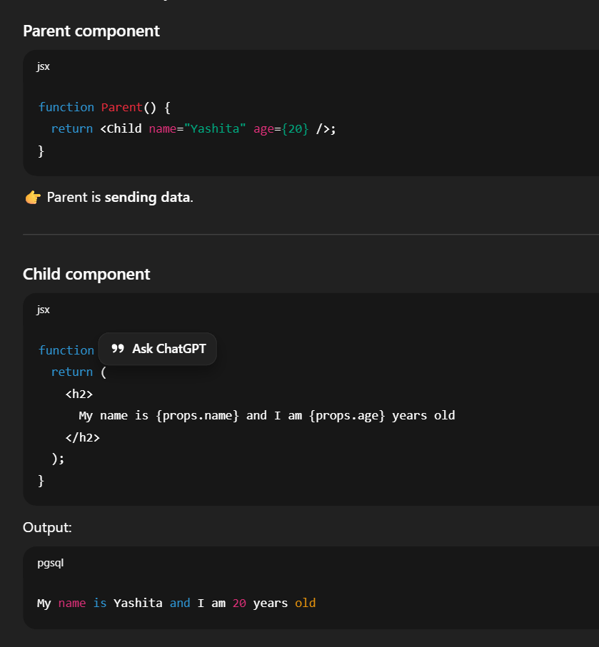

PROPS WITH FUNCTION
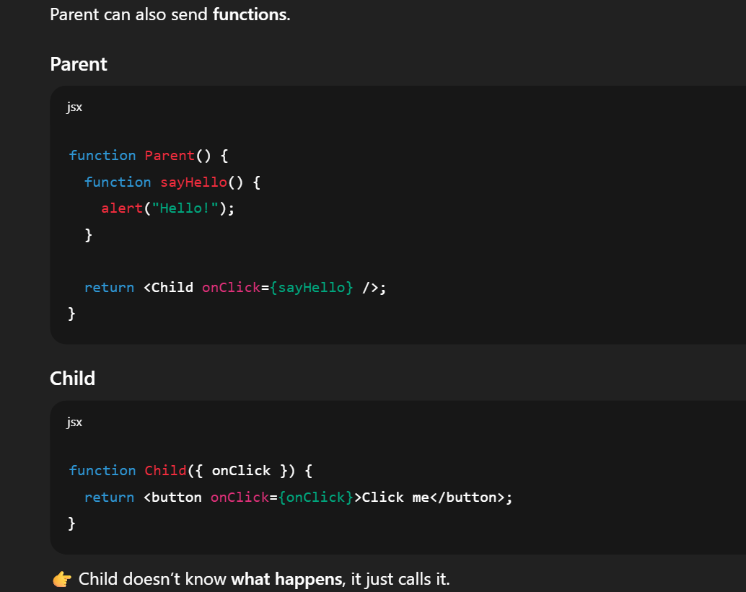
Over here, <MyButton count={count} onClick={handleClick} />
count → a prop
onClick → a prop

FILE-STRUCTURE

03tailwindProps
│
├── node_modules → libraries(Contains all installed packages (React, Tailwind, Vite, etc.)
├── public → static files(the logos, images u insert)
├── src → React code (main work)
Components (App.jsx, InputBox.jsx, etc.)
Hooks (useCurrencyInfo.js)
Styles (index.css)
Entry file (main.jsx or index.js)

├── package.json → project info
├── tailwind.config.js → Tailwind setup
├── vite.config.js → Vite setup

BABEL

is a javaScript compiler also known as transpiler.
converts modern JavaScript + JSX into plain JavaScript that browsers understand.
Browsers do NOT understand JSX
const element = <h1>Hello React</h1>

Babel converts it to
React.createElement("h1", null, "Hello React");

USE CALLBACK

- Use Callback is a React Hook used to remember (cache) a function so that React doesn’t create a new function again and again on every render.
- Dependencies are values used inside the function that can change:
Props
state
variables declared in the component

- If dependencies are the same → React returns the same function
- If dependencies changed → React stores and returns a new function

USE EFFECT

During rendering, useCallback memorizes the function reference based on its dependencies.
After rendering, useEffect runs, and when it calls that function, the cached version from useCallback is executed.

USE ID

Use Id is a React Hook for generating unique IDs that can be passed to accessibility attributes.
Do not call use Id to generate keys in a list. Keys should be generated from your data.

