**Steps to solve DS Round:**

1. Used pandas,numpy,seaborn and matplotlib.pyplot libraries
2. Imported table1,2,3
3. Dropped duplicates in all and merged table1,2 based on vehicle id and timestamp

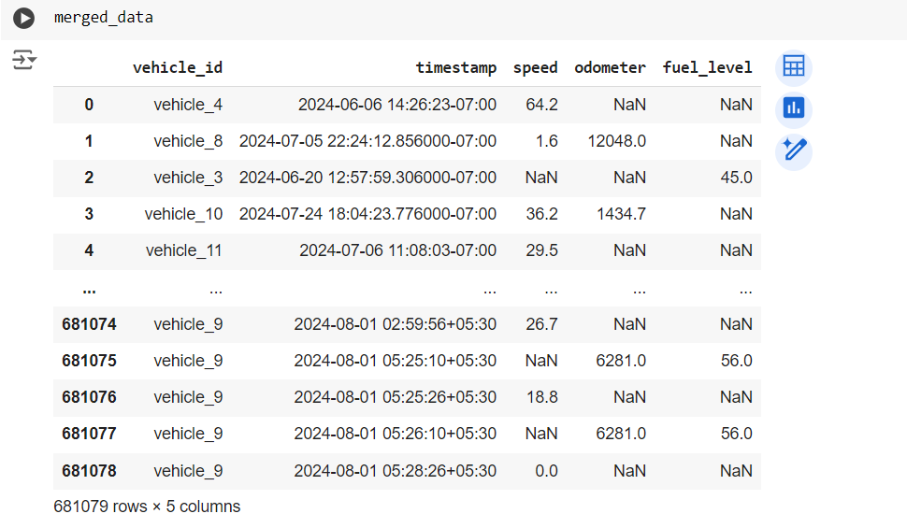

Above is final merged table

1. Try to use various graphs and visualization techniques to understand outliers

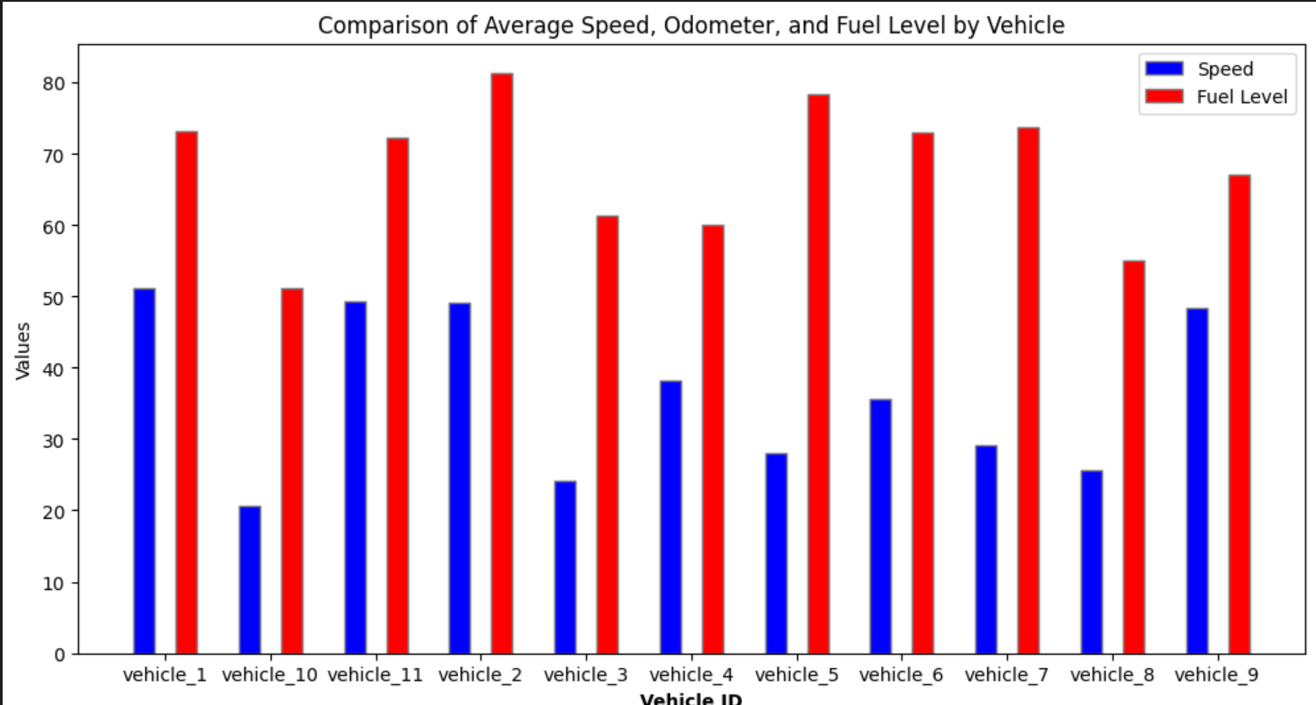

1. Used a quartile method to remove anomalies in the box plot and finally obtained the one with almost 0 anamolaies
2. A graph of a chart

   Description automatically generated with medium confidence
3. Doing a quick descriptive analysis by finding out vehicle_id wise average speed, fuel and odometer values
4. Finally using that to find fuel values

What could have been done differently for better output and values?

1. **Use the third table to filter out fuel capacity and removing values that were below the fuel capacity**
2. Do all the steps mentioned above to get a more optimized value for fuel capacities