**1. Trigonometry**

|  |  |
| --- | --- |
| * Trigonometry == relationships involving lengths and angles of triangles * Trigonometry works on a flat, two-dimensional surface (a plane) * Our application of trigonometry will be focusing on analyzing angles between vectors in space | angles between vectors |



**2. Radians**

|  |  |
| --- | --- |
| * Why use radians? For us, primarily, because C/C++ library functions such as sin(x), cos(x), etc. take angle *in radians*. * The formula to calculate the circumference of a circle is 2*radius*PI * One radian is equivalent to 180/PI degrees * There are 2*PI radians in a circle   one radian | * **/* radian, sin(), and cos() example */** * **#include** <iostream> * **#include** <cmath> * **using** **namespace** std; * **#define** PI 3.14159265 * **int** main () * { * **double** degrees = 30.0; * **double** result = sin( degrees * PI / 180 ); * cout << "The sine of "<< degrees << " degrees is "<< result << "\n"; * result = cos( degrees * PI / 180 ); * cout << "The cosine of "<< degrees << " degrees is "<< result << "\n"; * **// radians = (PI / 180) * degrees** * **// degrees = radians / (PI / 180) = radians * 180 / PI** * cout << "One radian is "<< 180 / PI << " degrees\n"; * **return** 0; * } * **/*Output:** * **The sine of 30 degrees is 0.5** * **The cosine of 30 degrees is 0.866025** * **One radian is 57.2958 degrees** * **\*/** * degrees and radians |



**3. Pythagorean theorem**

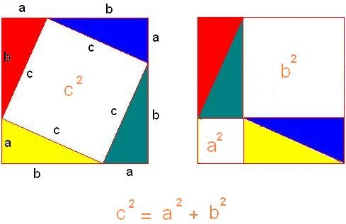



**4. sine cosine tangent**

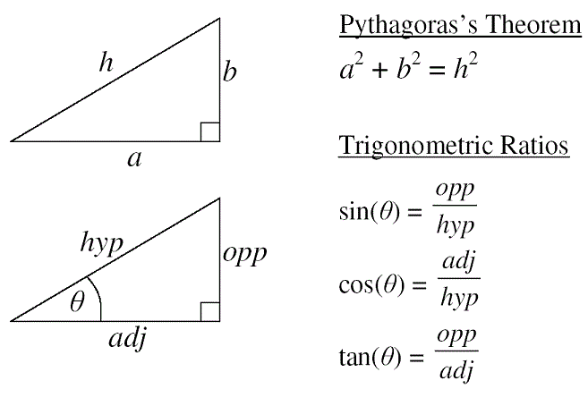

* 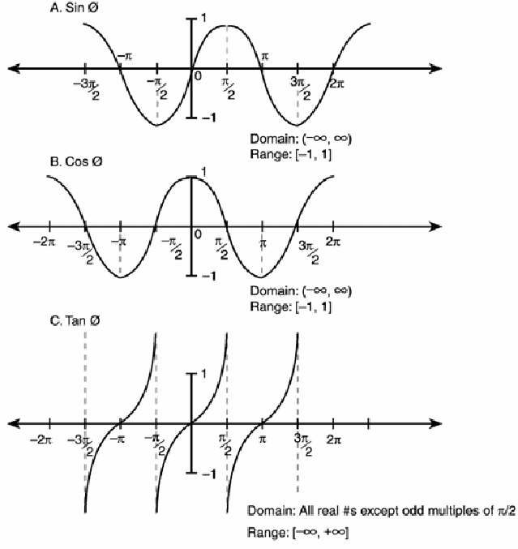

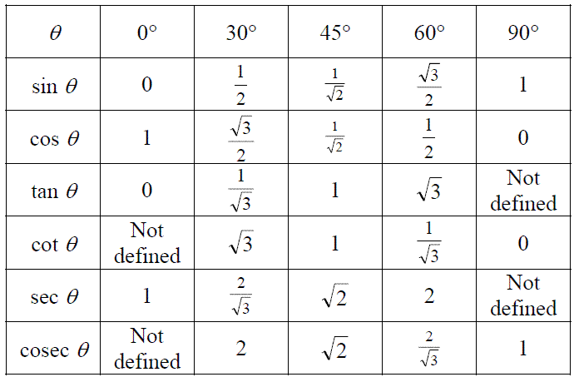

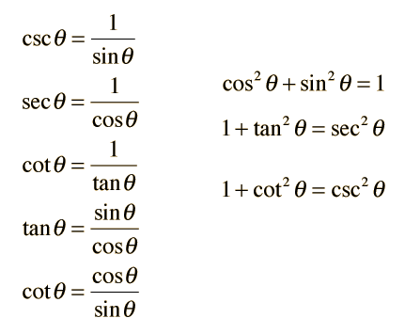

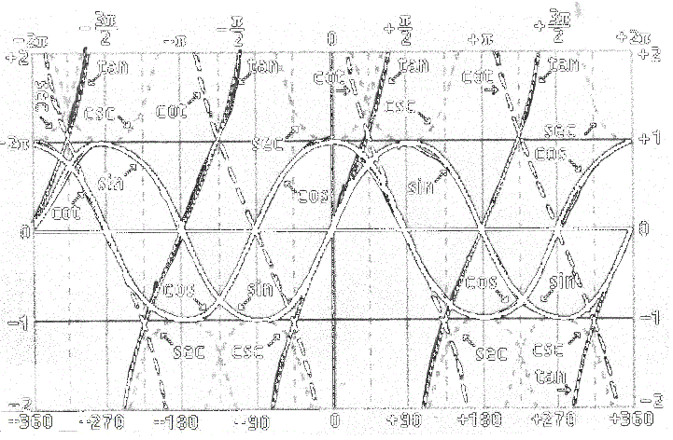

* Trigonometrical functions are defined by the relationships of the sides of a triangle
* Commonly used: sine, cosine, tangent and cotangent
* Sine and cosine produce the same values by adding/subtractng PI/2 (90 degrees)
* Less used: secant, cosecant, cotangent

**5. Triginoimetric identities and formulas**

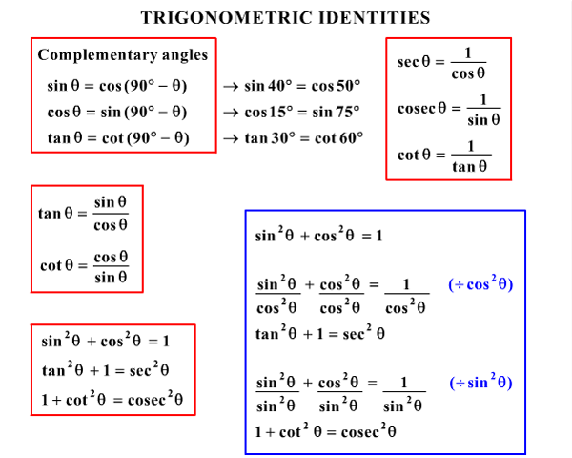

* 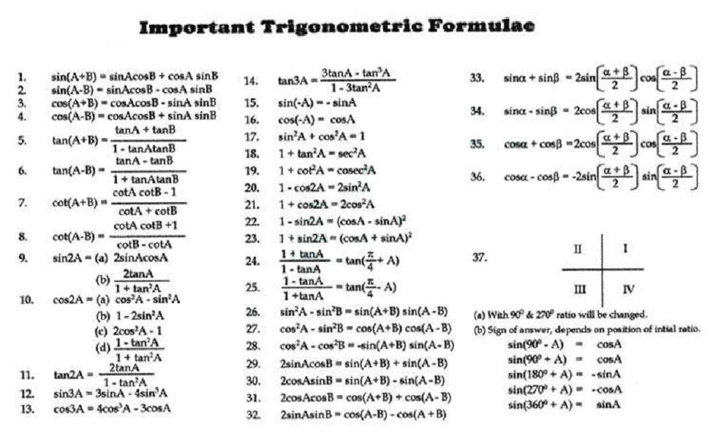

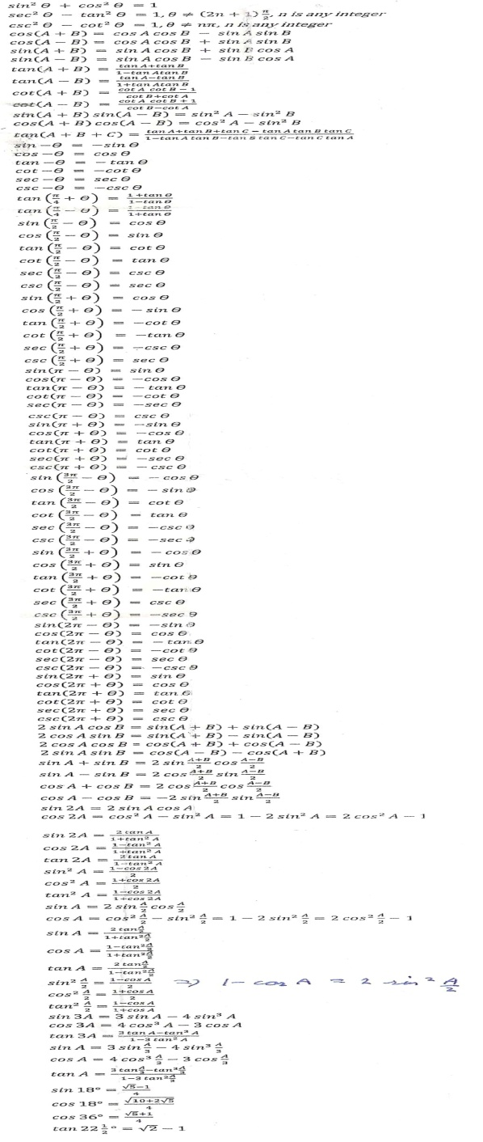

(From http://upload.wikimedia.org/wikipedia/commons/2/23/Trigonometry_Formulas.png)

* More: <http://www.alef.net/ALEFThings/ReferenceCards/ALEFReferenceCards-Trigonometry%20-%20Side%202.Jpg>