**ATOMIC STRUCTURE**

* **Dalton’s Atomic theory**
* **Cathode rays and discovery of electron**
* **e = 1.6 X 10 -19 C, e/m = 1.758 X 1011 C/Kg, m=9.31 X 10-31 kg**
* **Positive Rays and protons, mp = 1.6735 X 10-27 kg**
* **Neutron**
* **Thompson’s Model**
* **Rutherford’s Model**
* **Order of diameter of an atom is 10-10 m**
* **Order of diameter of nucleus is 10-15m**
* **Failure of Rutherford’s Model**
* **Electromagnetic Spectrum**
* **Quantum Theory of Radiation**
* **E= hν or hc/λ**
* **Pt = hν or hc/λ**
* **Photoelectric Effect**
* **Ei = KE + Φ**
* **E ( in eV) = 1240/ λ(in nm)**
* **Hydrogen Spectra**
* **Lyman, Balmer, Paschen, Brackett, Pfund, Humphry series**

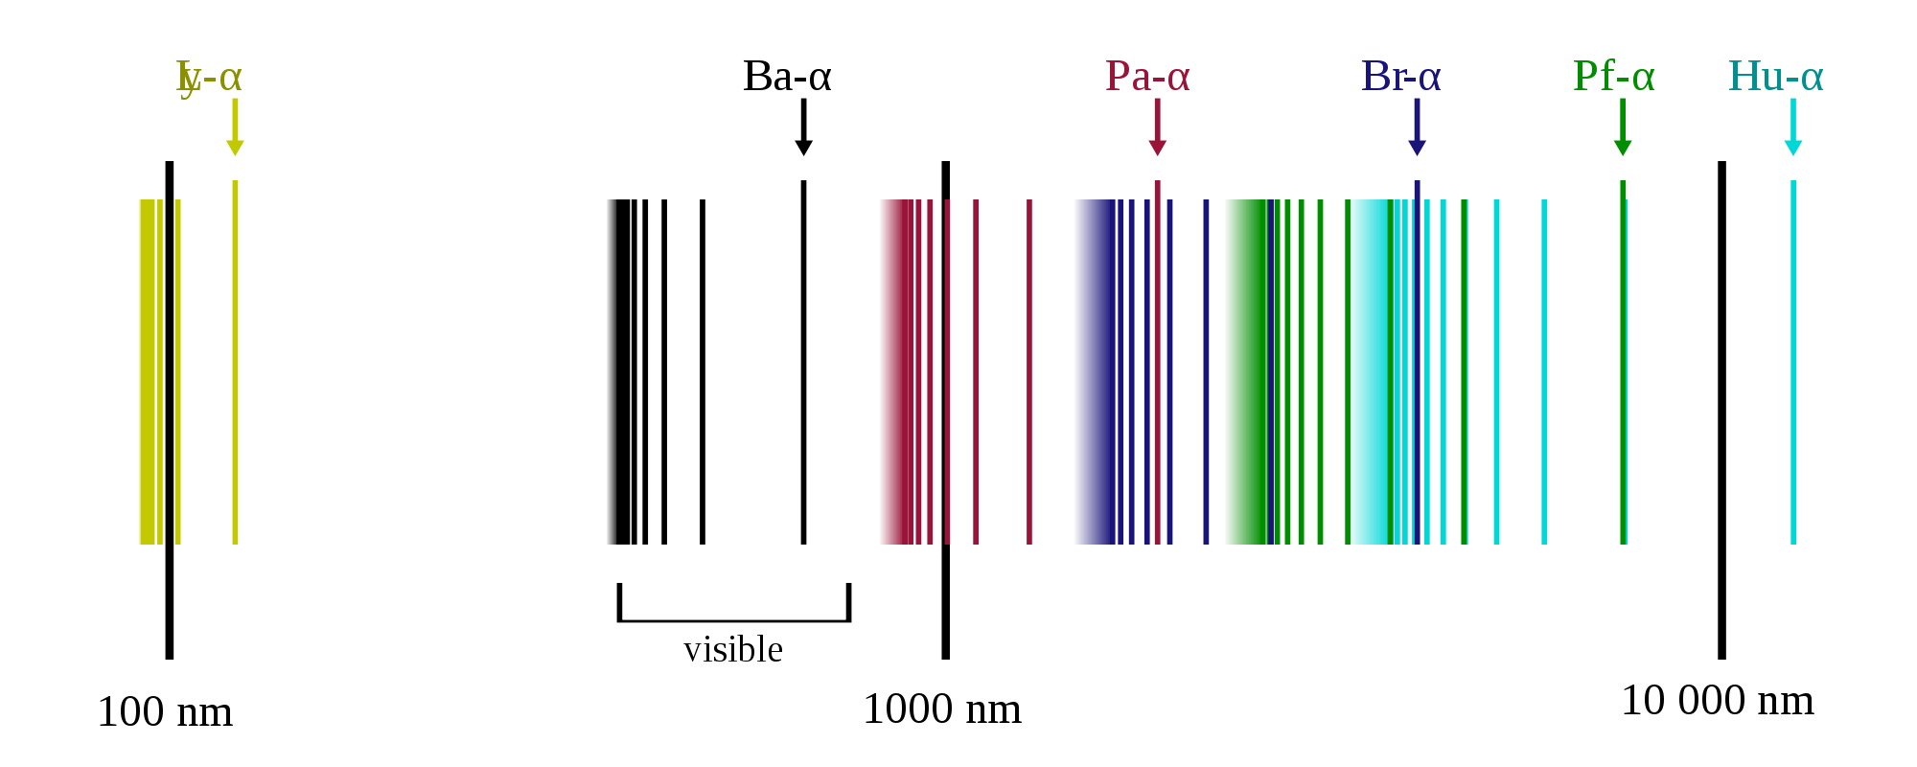

* **Wave number (1/λ) = RZ2 (1/n2 – 1/m2)**
* **Bohr’s Model**
* **L= mvr**
* **mvr = nh/2π**
* **ve = 2.18 X 106 Z/n (in m/s)**
* **rn = 0.529 X 10-10 n2/Z**
* **En = -2.18 X 10-18 Z2/n2 (J/atom)**
* **En = -13.6 Z2/n2 (eV/atom)**
* **En = -1312 Z2/n2 (KJ/mole)**
* **Frequency =1/Time period and Time period = Total distance covered/velocity**
* **De Broglie’s Principle**
* **Λ= h/ p = h/mv**
* **Heisenberg’s Uncertainty Principle**
* **∆x. ∆p >= h/4π**
* **Number of waves made by an electron in Bohr’s orbit**
* **Q. Find out the number of waves made by a Bohr electron in one complete revolution in its 3rd orbit.**
* **Q. Calculate the uncertainty in position assuming uncertainty in momentum within 0.1 % for**
* **tennis ball weighing 0.2 Kg and moving with a velocity of 10 m/s**
* **an electron moving in an atom with a velocity of 2 X 106 m/s**
* **Quantum Mechanics**
* **Ψ and ψψ\***
* **SWE can be solved exactly for single electron systems.**
* **Quantum numbers obtained : n , l and m**
* **S the spin quantum number was discovered experimentally.**
* **L, Orbital angular momentum = √*l(l+1)* h/2π**
* **Spin angular momentum = √s(s+1) h/2π**
* **Difference between an orbit and an orbital**
* **Shapes of atomic orbitals**
* **Aufbau’s Principle**
* **Pauli’s Exclusion Principle**
* **Hund’s Rule of Maximum Multiplicity**

**Q. 15 In all, how many nodal planes are there in the atomic orbitals for the principal quantum number n=3?**

**Q. 16 Write down the electronic configuration of the following species. Also find the number of unpaired electrons in each:**

**a) Fe, Fe2+, Fe3+**

**Q. 17 A compound of Vanadium has a magnetic moment of 1.73 BM. Work out the electronic configuration of vanadium in the compound.**

**Q. 18 Find the threshold wavelength for a copper plate, a sodium plate and cesium plate. The work function of these plates are 4.5 eV, 2.3 eV and 1.9 eV.**

**Q. 19 A UV light of wavelength 280 nm is used in an experiment on photoelectric effect with Li (work function = 2.5 eV) as cathode. Find:**

**a) The maximum KE of photoelectrons.**

**b) the stopping potential**

**Q. 20 Find the wavelength of the radiation required to excite the electron in Li2+ from first to the third Bohr orbit.**

**b) How many spectral lines are observed in the emission spectrum of the above excite system?**

**Q. 21 A hydrogen sample is prepared in a particular excited state. Photons of energy 2.55 eV get absorbed into the sample to take some of the electrons to a further excited state B. Find the quantum number of states A and B.**

**Q. 22. Find the wavelengths in the Hydrogen spectrum between the range 500 nm to 700 nm.**

**Q. 23. A beam of UV radiation having wavelength between 100 nm and 200 nm is incident on a sample of atomic hydrogen gas. Assumng that the atoms are in ground state, which wavelengths will have low intensity in the transmitted beam? If the energy of a photon is equal to the difference between the energies of an excited state and the ground state, it has large probablility of being absorbed by an atom in the ground state.**

**Q. 24. Light corresponding to the transition n =4 to n=2 in hydrogen atoms falls on a metal whose work function = 1.9 eV. Find the maximum kinetic energy of the photoelectrons emitted.**

**Q. 25. Calculate the smallest wavelength of radiation that may be emitted by a) Hydrogen b) He+ c) Li 2+**

**Q. 26. Find the binding energy of a hydrogen atom in the state n=2**

**Q. 27. Find the radius and enrgy of a He+ ion in the states: a) n=1 and n=4**

**Q. 28. A positive ion having just one electron ejects it if a photon of wavelength 228 angstrom or less is absorbed by it. Identify the ion.**

**Q. 29. A beam of light having wavelengths distributed uniformly distributed between 450 nm to 550 nm passes through a sample of hydrogen gas. Which wavelength will have the least intensity in the transmitted beam?**

**Q. 30 A hydrogen atom in ground state absorbs a photon of UV radiation of wavelength 50 nm. Assuming that the entire photon energy is taken up by the electron, with what kinetic energy will the electron be ejected?**

**Q. 31 Given below are the sets of quantum number for the given orbitals (n, l, m). Name these orbitals.**

**a) (2, 1,-1) b) (4, 2, 0) c) (3, 1, 0)**

**IITJEE**

aximum number of electrons in a subshell with *l*= 3 and *n*= 4 is**[CBSE AIPMT 2012]**

|  |  |
| --- | --- |
| A | 10 |
| B | 12 |
| C | 14 |
| D | 16 |

|  |
| --- |
| **Question 2** |

The correct set of four quantum numbers for the valence electron of rubidium atom (Z = 37) is **[CBSE AIPMT 2012]**

|  |  |
| --- | --- |
| A | 5, 0, 0, + http://www.questionpapers.net.in/chemistry/structure-of-atom-test-1_files/image001.gif |
| B | 5, 1, 0, + http://www.questionpapers.net.in/chemistry/structure-of-atom-test-1_files/image001.gif |
| C | 5, 1, 1, + http://www.questionpapers.net.in/chemistry/structure-of-atom-test-1_files/image001.gif |
| D | 6, 0, 0, + http://www.questionpapers.net.in/chemistry/structure-of-atom-test-1_files/image001.gif |

|  |
| --- |
| **Question 3** |

Identify the wrong statement in the following **[CBSE AIPMT 2012]**

|  |  |
| --- | --- |
| A | Atomic radius of the elements increases as one moves down the first group of the periodic table |
| B | Atomic radius of the elements decreases as one moves across from left to right in the 2nd period of the |
| C | Amongst isoelectronic species, smaller the positive charge on the cation, smaller is the ionic radius |
| D | Amongst isoelectronic species, greater the negative charge on the anion, larger is the ionic radius |

|  |
| --- |
| **Question 4** |

The work function () of some metals is listed below. The number of metals which will show photoelectric effect when light of 300 nm wavelength falls on the metal is **[IIT JEE 2011]**

|  |  |  |  |  |  |  |  |  |  |  |
| --- | --- | --- | --- | --- | --- | --- | --- | --- | --- | --- |
| Metal | Li | Na | K | Mg | Cu | Ag | Fe | Pt | W | |
| (eV) | 2.4 | 2.3 | 2.2 | 3.7 | 4.8 | 4.3 | 4.7 | 6.3 | 4.75 | |
| A | 4 | | | | | | | | |
| B | 6 | | | | | | | | |
| C | 8 | | | | | | | | |
| D | 12 | | | | | | | | |

|  |
| --- |
| **Question 5** |

A gas absorbs a photon of 355 nm and emits at two wavelengths. If one of the emissions is at 680 nm[,](http://www.questionpapers.net.in/chemistry_questions.html) the other is at: **[AIEEE 2011]**

|  |  |
| --- | --- |
| A | 518 nm |
| B | 1035 nm |
| C | 325 nm |
| D | 743 nm |

**More Practice Problems**



