**A Project Report**

**On**

“**Tesla coil**”

**Submitted to**

**Chhattisgarh Swami Vivekanand Technical University, Bhilai (C.G)**

**For the fulfillment of the award of degree**

**BACHELOR OF ENGINEERING**

**In**

**“Electrical & Electronics Engineering ”**

**Under the guidance of**

**Namrata Gupta**

**“Lecturer”**

**By**

**Vinay Jadwani 3262509047 AF0680**

**Ashutosh S. Khope 3262509051 AF0699**

**Jyoti Sahu 3262509052 AF0703**

**K.Nagaraju 3262508057 AE1164**

**Shivani singh Chandel 3262508064 AD5112**

**--------------------------------------------------------------------------------------------------------------------**



**Department of Electrical & Electronics Engineering**

**Columbia Institute of Engineering & Technology, Raipur (C.G)**

**Session: 2012-13**

**DECLARATION BY THE CANDIDATE**

I the undersigned solemnly declare that the report of the thesis work entitled “**Tesla Coil”**

Is based on my own work carried out during the course of my study under the supervision of

Mrs. Namrata gupta.

I assert that the statements made and conclusions drawn are an outcome of my project work. I further declare that to the best of my knowledge and belief the report does not contain any part of any work which has been submitted for the award of BE degree or any other degree/diploma/certificate in this University or any other University.

Signature Signature

(Vinay jadwani) (K.Nagaraju)

Enroll no.-AF0680 Enroll no.-AE1164

Signature Signature

(Ashutosh S. khope) (Shivani Singh Chandel)

Enroll no.-AF0699 Enroll no.-AD5112

Signature

(Jyoti sahu)

Enroll no. - AF0703

**CERTIFICATE BY THE EXAMINERS**

This minor project report entitled “**Tesla Coil”** Submitted by bearing has been examined by the undersigned as a part of the examination and is hereby recommended for the award of the degree of Bachelor of Engineering in Electrical & Electronics Engineering of Chhattisgarh Swami Vivekanand Technical University, Bhilai (C.G.).

Internal Examiner External Examiner

Date: Date:

Signature Signature

(Vinay jadwani) (K.Nagaraju)

3262509047 3262508057

Signature Signature

(Ashutosh S. khope) (Shivani Singh Chandel)

3260509051 3262508064

Signature

(Jyoti sahu)

3262509052

|  |  |  |
| --- | --- | --- |
|  |  |  |
|  |  |  |

**CERTIFICATE OF THE SUPERVISOR**

This is to certify that the work incorporated in this minor project report **TESLA COIL** is a record of project work carried out by bearing**,** under my guidance and supervision for the award of Degree of Bachelor of Engineering in Electrical & Electronics Engineering of Chhattisgarh Swami Vivekananda Technical University, Bhilai (C.G.), India.

To the best of my knowledge and belief the thesis

1. *i)*Embodies the work of the candidate herself,
2. *ii)* Has duly been completed,

*iii)* Fulfills the requirement of the Ordinance relating to the M.E /M.Tech degree of the University, and

*iv)* Is up to the desired standard both in respect of contents and language for being referred to the examiners.

|  |  |
| --- | --- |
|  | (Signature of the Supervisor)  Namrata Gupta  Lecturer  Deptt. of Electrical & Electronics Engineering  Columbia Institute Of Engineering & Technology, Raipur |
|  |  |

Forwarded to Chhattisgarh Swami Vivekananda Technical University, Bhilai.

Signature of the Principal

Dr. T.V.V. Sudhakar

Principal,

Columbia Institute of Engineering

& Technology , Raipur

Signature of the HOD

Mr.C.K Diwedi

Assistant Professor

Deptt. of Electrical & Electronics Engineering

Columbia Institute Of Engineering

&Technolgy,Raipur

# ACKNOWLEDGEMENT

This project defines and signifies in which numerous interaction tasks are performed by a group of committed members, each members bearing their own importance and invaluable contributions for the successful completion of the project.

We are very thankful to our honorable DR.T T V SUDHAKAR (Principal) and MR. C K DIVEDI (HOD).

It’s a matter of great pride and real joy to do this project and we are unable to express the feeling of gratitude in other words to MR.HARI BABU(Class teacher) and our project guide Mrs. NAMRATA GUPTA (lecturer) whose diligent guidance and encouragement have been valuable assets through progress of this training.

We thank them as without their support and parental guidance this project would not have been completed.

We also thank other Staff Members, My classmates, and my other friends inside our outside of CIET, Raipur for they always stood beside me in the time of shine and dark as well.

**CONTENTS**

**1 Introduction**

**2 Reminder of the basics**

**2.1 Resistor**

**2.2 Capacitor**

**2.3 Inductor**

**2.4 Impedance**

**2.5 LC circuit**

**2.6 Impedance**

**2.7 Resonant frequency**

**3 Tesla coil operation**

**3.1 Description of a cycle**

**3.2 Charging**

* 1. **Oscillation**

**3.4 Bounces**

**3.5Decay**

**3.6 Voltage gain**

**3.7 Energy losses**

**3.8 Overview**

**4 Conception and construction**

**4.1 HV transformer i.e. flyback transformer**

* + - 1. **Function of flyback**
      2. **Pin identification**
      3. **Driving FBT**
      4. **Troubleshooting**

**4.2 plans of bottle capacitor**

**4.3 Primary coil**

**4.4 Secondary coil**

**1. Assembly for secondary coil**

**4.5 Toroid**

**4.6 Spark gap**

**4.7 Wiring**

* 1. **Grounding**
  2. **Oscillation and tuning**

1. **Tesla coil calculation and formulae**
2. **Wire gauge table**
3. **Safety**
4. **Complete circuit diagram**
5. **Conclusion**
6. **References**
7. **Bibliography**

## Introduction

Nikola Tesla (1856 - 1943) was one of the most important inventors in human history. He

Had 112 U.S. patents and a similar number of patents outside the United States, including 30

In Germany, 14 in Australia, 13 in France, and 11 in Italy. He held patents in 23 countries,

Including Cuba, India, Japan, Mexico, Rhodesia, and Transvaal. He invented the induction

Motor and our present system of three-phase power in 1888. He invented the Tesla coil,

A resonant air-core transformer, in 1891. Then in 1893, he invented a system of wireless

Transmission of intelligence. Although Marconi is commonly credited with the invention of

Radio, the U.S. Supreme Court decided in 1943 that the Tesla Oscillator patented in 1900

Had priority over Marconi’s patent which had been issued in 1904. Therefore Tesla

Did the fundamental work in both power and communications, the major areas of electrical

Engineering. These inventions have truly changed the course of human history.

After Tesla had invented three-phase power systems and wireless radio, he turned his

Attention to further development of the Tesla coil. He built a large laboratory in Colorado

Springs in 1899 for this purpose. The Tesla secondary was about 51 feet in diameter. It was

In a wooden building in which no ferrous metals were used in construction. There was

A massive 80-foot wooden tower, topped by a 200-foot mast on which perched a large copper

Ball which he used as a transmitting antenna. The coil worked well. There are claims of

Bolts of artificial lightning over a hundred feet long, although Richard Hull asserts that from

Tesla’s notes, he never claimed a distance greater than 43 feet. From photographic evidence,

The maximum may have been closer to 22 feet.

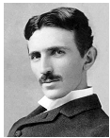 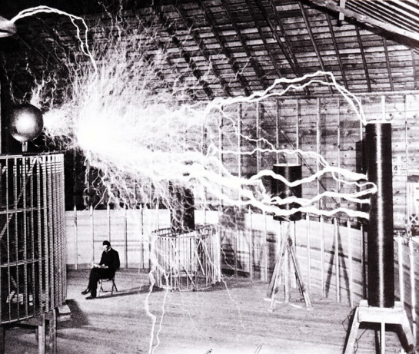

Figure 1.1: Nikola Tesla in 1890 Figure 1.2: His first laboratory in Colorado springs

Tesla then abandoned the Colorado Springs Laboratory early in 1900, having learned what he needed from that facility, and also having become somewhat unpopular as a result of frequently knocking the local sub-station off line. Since that time, it appears that no one has built a Tesla coil of both the size and performance of the Colorado Springs coil.

# Reminder of the basics

## Resistor:

A resistor is a component that opposes a flowing current. Every conductor has a certain resistance if one applies a potential difference V at the terminals of a resistor, the current I passing through it is given by

I=V/R

This formula is known as Ohm’s Law. The SI unit of resistance is the Ohm. One can show that the power P (in J/s) dissipated due to a resistance is equal to

P=VI=IR2

## Capacitor:

A capacitor is a component that can store energy in the form of an electric field. Less abstractly, it is composed in its most basic form of two electrodes separated by a dielectric medium. If there is a potential difference V between those two electrodes, charges will accumulates on those electrodes: a charge Q on the positive electrode and an opposite charge Q on the negative one. An electrical field therefore arises between them. If both of the electrodes carry the same amount of charge, one can write

Q=CV

Where C is the capacity of the capacitor. Its unit is the Farad [F].The energy E stored in a capacitor (in Joules) is given by

E= (1/2) QV= (1/2) CV2

Where one can note that the dependence in the charge Q shows that the energy is indeed the energy of the electric field. This corresponds to the amount of work that has to be done to place the charges on the electrodes

## Inductor:

An inductor stores the energy in the form a magnetic field. Every electrical circuit is characterized by a certain inductance. When current flows within a circuit, it generates a magnetic field B that can be calculated from Maxwell-Ampere’s law:



Where the electric field and J is the current density. The auto-inductance of a circuit measures its tendency to oppose a change in current: when the current changes, the flux of magnetic field øB that crosses the circuit changes. That leads to the apparition of an "electromotive force" ε that opposes this change. It is given by:

The inductance L of a circuit is thus defined as:



Where I (t) is the current that flows in the circuit and V the electromotive force (EMF) that a change of this current will provoke. The inductance is measured in henrys [H].The energy E (in Joules) stored in an inductor is given by:



Where the dependence in the current I shows that this energy originates from the magnetic field. It corresponds to the work that has to be done against the EMF to establish the current in the circuit.

## Impedance

The impedance of a component expresses its resistance to an alternating current (i.e. sinusoidal). This

Quantity generalizes the notion of resistance. Indeed, when dealing with alternating current, a component

Can act both on the amplitude and the phase of the signal.

### Expressions for alternating current

It is convenient to use the complex plan to represent the impedance. The switching between the two Representations is accomplished by using Euler’s formula. Let’s note that the utilization of complex numbers is a simple mathematical trick, as it is understood that only the real part of these quantities is meaningful. We are now given an expression of the general form of the voltage V (t) and current I (t):

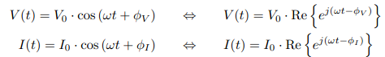

Where V0 and I0 are the respective amplitudes, ω= 2πν is the angular speed (assumed identical for both quantities) and ø are the phases.

### Definition of impedance

The impedance, generally noted Z, is formed of a real part, the resistance R, and an imaginary part, the reactance X:



Where j is the imaginary unit number, i.e. j2= 1, theta= arc tan(X/R) is the phase difference between Voltage and current, and |Z| = the Euclidean norm of Z in the complex plane.

At this point, we can generalize Ohm’s law as the following:

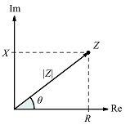When the component only acts on the amplitude, in other words when X= 0, the imaginary part vanishes and we find Z=R. We therefore have the behavior of a resistor. The component is then said to be purely resistive, and the DC version of Ohm’s law applies. When the component only acts on the phase of the signal, that is when R= 0, the impedance is purely imaginary. This translates the behavior of "perfect" capacitors and inductors.

Figure 3.5: The impedance Z plotted in the complex plane.

### Impedance formulas:

We can give a general formula for the impedance of each type of component.

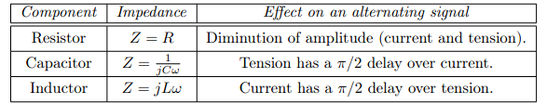

These formulas are easily recovered from the differential expressions of these components. For every combinations of components, one can calculate the phase difference between current and voltage by vector-adding the impedances (for example, in an RC circuit, the phase difference will be less than=2). Finally, it is good to keep in mind that any real-life component has a non-zero resistance and reactance. Even the simplest circuit, a wire connected to a generator has a capacitance, an inductance and a resistance, however small these might be.

## LC circuit:

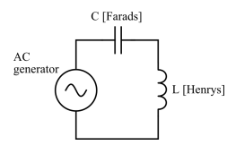An LC circuit is formed with a capacitor C and an inductor L connected in parallel or in series to a sinusoidal signal generator. The understanding of this circuit is at the very basis of the Tesla coil functioning, hence the following analysis. The primary and secondary circuits of a Tesla coil are both series LC circuits that are magnetically coupled to a certain degree. We will therefore only look at the case of the series LC circuit.

Fig: Schematic of a series LC circuit

Using Kirchhoff’s law for current, we obtain that the current in the inductor and the current in the capacitor is identical. We now use Kirchhoff’s law for voltage, which states that the sum of the voltages across the components along a closed loop is zero, to get the following equation:



For the inductor, express the time derivative of current in terms of the charge by we find:

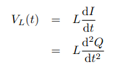

Now for the capacitor, we isolate the charge Q in the relation Q=CV and we get



Putting in Vgen (t) equation we get:



This equation describes an (undamped) harmonic oscillator with periodic driving, just like a spring-mass system! The inductor is assimilated to the "mass" of the oscillator: a circuit of great inductance will have a lot of "inertia". The "spring constant" is associated with the inverse of the capacitance C-1(this is the reason why C-1is seldom called the "elastance").

## Resonant frequency:

In our analysis of the LC circuit, we found that the oscillations of current and voltage naturally occurred at a precise angular speed, univoquely determined by the capacitance and inductance of the circuit. Without other effects, oscillations of current and voltage will always take place at this angular speed.

It is called the resonant angular speed. We can check that it is dimensionally coherent (its units are s-1).It is no less important to observe that, at the resonant angular speed, the respective reactive parts of an inductor and a capacitor are equal (in absolute value):

It is however much more important to talk about resonant frequency, which is just a rescale of the angular speed:

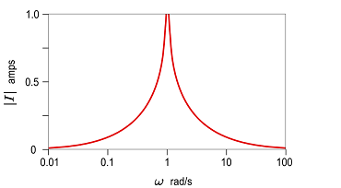When there is a sinusoidal signal generator, we also saw that if its frequency is equal to the resonant frequency of the circuit it drives, current and voltage have ever-increasing amplitudes. Of course, this doesn’t happen if they are different (the oscillation remain bounded)

Fig: Amplitude of the current plotted against the driving frequency (all constants normalized).

At low driving frequencies, the impedance is mainly capacitive as the reactance of a capacitor is greater at low frequencies. At high frequencies, the impedance is mainly inductive. At the resonant frequency, it vanishes, hence the asymptotic behavior of the current. However, in a real circuit, where resistance is non-zero, the width and height of the "spike" plotted her above are determined by the Q factor, which

We’ll talk about later. The fact that driving an (R) LC circuit at its resonant frequency causes a dramatic increase of voltage and current is crucial for a Tesla coil. But it can also be potentially harmful for the transformer feeding the primary circuit.

# Tesla coil operation:

This section shall cover the complete operational theory of a conventional Tesla coil. We will consider that the primary and secondary circuits are RLC circuits with low resistance, which accords with reality. We consider a slightly modified version of figure 3.1 to illustrate our explanations. For the afore-mentioned reasons, internal resistance of the component isn’t represented. We will also replace the current-limited transformer. This has no impact regarding pure theory. Note that some parts of the secondary circuit are drawn in dotted lines. This is because they are not directly visible on the apparatus. Regarding the secondary capacitor, we’ll see that its capacity is actually distributed, the top load only being "one plate" of this capacitor. Regarding the secondary spark gap, it is shown in the schematic as a way to represent where the arcs will take place.

# Description of a cycle:

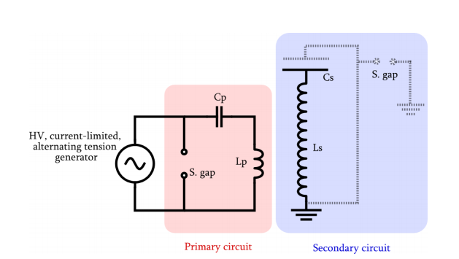 Fig: Schematic of the basic features of a Tesla coil.

## Charging:

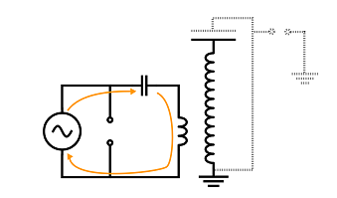This first step of the cycle is the charging of the primary capacitor by the generator. We’ll suppose its frequency to be 50 Hz. Because the generator is current-limited, the capacity of the capacitor must be carefully chosen so it will be fully charged in exactly 1/100 seconds. Indeed, the voltage of the generator changes twice a period, and at the next cycle, it will re-charge the capacitor with opposite polarity, which changes absolutely nothing about the operation of the Tesla coil

Fig: The generator charges the primary caps.

Oscillations:

When the capacitor is fully charged, the spark gap fires and therefore closes the primary circuit. Knowing the intensity of the breakdown electric field of air, the width of the spark gap must be set so that it fires exactly when the voltage across the capacitor reaches its peak value. The role of the generator ends here. We now have a fully loaded capacitor in an LC circuit! Current and voltage will thus oscillate at the circuits resonant frequency, this frequency is very high compared to the mains frequency, generally between 50 and 400 kHz. The primary and secondary circuits are magnetically coupled. The oscillations taking place in the primary will thus induce an electromotive force in the secondary. As the energy of the primary is dumped into the secondary, the amplitude of the oscillations in the primary will gradually decrease while those of the secondary will amplify. This energy transfer is done through magnetic induction. The coupling constant k between the two circuits is purposefully kept low, generally between 0.05 and 0.2. Several oscillations will therefore be required to transfer the totality of the energy. We will come back to the influence of coupling shortly.

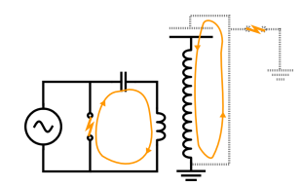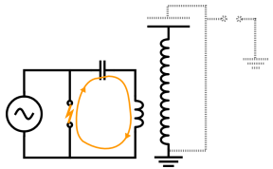

Fig: The spark gap fires and the current oscillate in the primary circuit. Fig: Oscillations in the primary will induce and emf in the

Secondary, which will also oscillate

The oscillations in the primary will thus act a bit like an AC voltage generator placed in series on the secondary circuit. To maximize the voltage in the secondary, it is intuitively clear that both circuits must share exactly the same resonant frequency.



This will allow the voltage in the secondary to increase drastically, this is called the resonant rise. The voltage being enormous, generally several hundreds of thousands of Volts, causing sparks to form at the top load. The following diagrams show the general waveforms (in arbitrary units) of the oscillations taking place in the primary and secondary.

## Bounces:

All the energy is now in the secondary circuit. With an ideal spark gap, things would stop here and a new cycle could begin. But this is of course not the case: the ring up is very fast and the path of ionized air subsists a few moments even when the intensity of the field has fallen below the critical value. The energy of the secondary can therefore be retransmitted to the primary in a similar fashion. Current and voltage in the secondary will then diminish while those in the primary will increase. Such bounces can occur 3, 4, 5 times or even more. At each rebound, a fraction of the energy is definitively lost, mainly in the sparks produced and in the internal resistances of the components

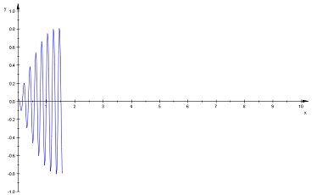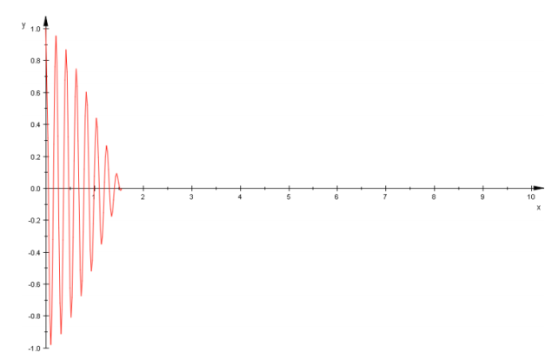

Fig: Oscillations of diminishing amplitude in the primary (ring down). Figure 3.19: Oscillations of rising amplitude in the primary (ring up)

This is the reason why the envelop of the waveform falls exponentially. After a certain number of bounces, voltage will have decreased significantly and the spark gap finally opens at the next primary notch.

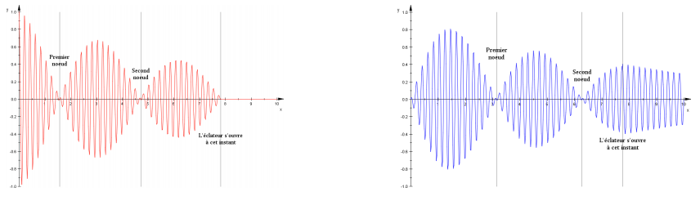

Fig: General waveform of the oscillation in the primary and secondary circuits. Here a cycle with 3 rebounds has been shown.

These rebounds are important for the creation of long arcs, because they grow on the ionized air path created during the preceding rebound. At each bounce, the spark gets longer. The complete process happens several hundred times per second.

## Decay:

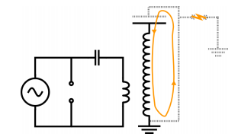Once the main spark gap has stopped firing, the primary circuit is open and all the remaining energy is trapped in the secondary. This situation is thus the same as in a free RLC circuit. Oscillations will decay exponentially as the charge dissipates through the sparks.

Fig: When the spark gap has opened, secondary oscillation will decay exponentially. Finally, a new cycle can begin.

## Voltage gain:

We will now derive a rough formula giving the secondary voltage Vout. We call V in the rms voltage supplied by the transformer. The following derivation is based on conservation of energy, we’ll suppose there’s no ohmic losses (R= 0) and that the primary and secondary circuits are perfectly at resonance. Let’s recall formula giving the energy stored in a capacitor as a function of the voltage. The energy of the primary Ep circuit is thus given by:

Where Cp is the capacity of the primary.

The energy Es stored in the secondary circuit (capacity is Cs) is:

Using the hypothesis that all the energy stored in the primary goes into the secondary, we equates and Ep:



The voltage gain is then: similarly,

Now we can understand how the Tesla coil can reach such tremendous voltages: the secondary coil, which has around 1000 turns, has an inductance considerably higher than the primary coil, which generally has about 10 turns. Using typical values, this formula will yield a V out of the order of 105 V or even106 V for the largest coils.

## Energy losses:

* The wiring and the inductances have an internal resistance that dissipates energy as heat following P=RI2. There are several hundred meters of wire in a Tesla coil. The skin effect, which accounts for the fact that at higher frequencies, the current flows mainly near the surface of the conductors, further increases the effective resistance.
* The sparks that occur in the spark gap act like a resistor, dissipating energy in the form of light, heat and sound.
* The dielectric inside the primary capacitor dissipates a fraction of the energy when an alternating current is applied. The loss tangent depends on the dielectric used and the frequency.
* The Tesla coil operates at radio frequencies (typically between 50 and 400 kHz). A fraction of the

Energy is thus radiated as electromagnetic waves.

* The Corona effect is a continuous discharge from the conductors in the ambient medium, producing a violet halo around conductors kept at high voltages. The energy used for ionizing the air is taken away from the coil.

## Overview:

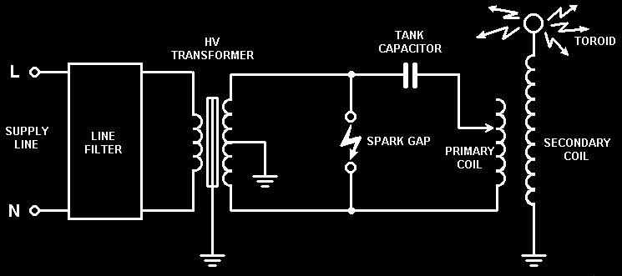A Tesla coil is a device producing a high frequency current, at a very high voltage but of relatively small intensity. Basically, it is a transformer as well as a radio antenna. Nevertheless, Tesla coils differ radically from a conventional transformer .It has some similarities with a standard transformer but the mode of operation is somewhat different. A standard transformer uses tight coupling between its primary and secondary windings and the voltage transformation ratio is due to turn’s ratio alone. In contrast, a Tesla Coil uses a relatively loose coupling between primary and secondary, and the majority of the voltage gain is due to resonance rather than the turn’s ratio. A normal transformer uses an iron core in order to operate at low frequencies, whereas the Tesla Coil is air-cored to operate efficiently at much higher frequencies

# Components of Tesla coil

1. 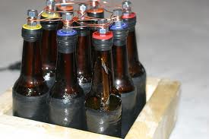**FLYBACK TRANSFORMER : 2) CAPACITORS:**

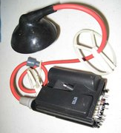

1. **TORRIOD : 3) CFL CIRCUIT 70W OR MORE :**

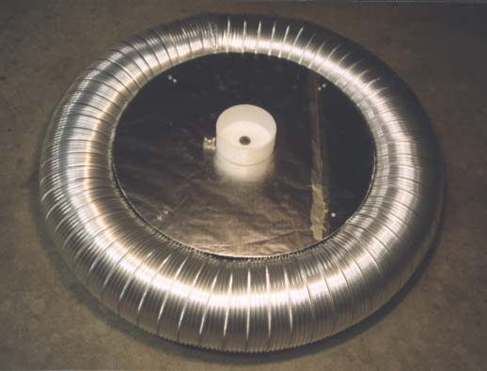 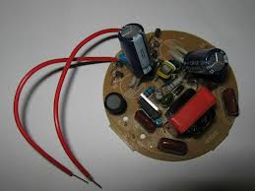

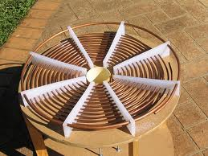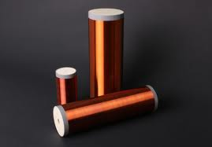 **4) PRIMARY COIL: 5) SECONDARY COIL:**

**6) SPARK GAPS: 5) Miscellaneous items:**

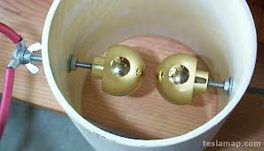**PVC PIPES**

**ENAMEL COATING**

**SOLDERING KIT**

**CARDBOARDS**

**ELECTRIC TAPE**

**AXEL BLADE**

**PLIER AND SCREW DRIVERS**

**SAND PAPER**

# Construction and concepts

## Flyback transformer:

A **flyback transformer** (FBT), also called a **line output transformer** (LOPT), is a special type of electrical transformer. It was initially designed to generate high current sawtooth signals at a relatively high frequency. In modern applications it is used extensively in switched-mode power supplies for both low (3V) and high voltage (over 10 kV) supplies. There are two main types of flybacks: DC and AC. AC flybacks are simply ferrite transformers, AC in equals AC out, but DC flybacks include a rectifying diode and often a multiplier stage inside. AC flybacks are found in older televisions and the rectifier and multiplying circuits will be found separately inside the television. It may be important to note that a plasma globe can only be effectively driven by an *AC* flyback. An AC flyback can be made from a modern DC flyback by either disabling the rectifier diode via high energy pulse or overvolt, or by cutting into the epoxy and removing the diode. These methods do not work very well, and the flyback tends to fail soon after conversion because the insulation is not designed to handle AC currents.

* Function of FBT:Flybacks supply high voltage to the CRT in a television or monitor. They are driven by a sawtooth waveform at the frequency of the video signal. It is an integral part of the horizontal deflection circuit that scans the beam from left to right, quickly returning the beam to the left. In a television, NTSC is 15 734 Hz, PAL is equal to 15 625 Hz, PAL M is equal to 15 750 Hz. A computer monitor's frequency varies generally between 30 kHz and 150 kHz. See the specifications for refresh rate to determine the horizontal frequency. Knowing the frequency at which the flyback is designed to run is beneficial in the design of a driver circuit.
* **Pin Identification:** Flyback transformers have complex internal construction with many separate windings. The high voltage secondary has a high resistance due to the winding length; some flybacks also contain internal diodes in the secondary. Due to the high resistance (and voltage drop due to diodes), the high voltage ground pin cannot be identified by testing resistance/continuity. To identify the HV ground pin, a low voltage (~30V) power supply can be connected in series with the HV output lead, and a voltmeter can be used to test each pin individually to determine the ground. Note that due to the internal diodes in most modern flybacks, polarity does matter and the power supply negative output should be connected to the HV output lead, with voltmeter in series testing for voltage at each pin. For primary windings, many separate windings exist with high impedance, and are normally driven by voltages between 100-200V by TVs or monitors. It is recommended to wind a custom primary for all low voltage driven methods (single transistor, dual, ZVS, etc) with the appropriate wire gauge for the current expected to be drawn. A simpler method for HV ground pin identification is to draw an arc to each ground pin, with the longest/strongest arc being the HV ground.

## Driving a Flyback:

CFLs are very popular high efficiency fluorescent lights. They are similar to their ancestor the fluorescent light tubes but use electronic ballasts instead of the big and heavy ballasts in the old technology. The electronic ballast works by generating high frequency currents that are fed to a tiny high frequency transformer that boost the voltage and run the fluorescent tube. It is the high frequency that makes the assembly compact. The electronic ballast generates less than 1000 volts. But by replacing the fluorescent bulb of the CFL with a flyback transformer, spectacular voltages can be achieved.

The challenge with the flyback transformer is to find 3 pins out of 10 to 20 pins. One pin will be the high voltage ground the other two pins will be that of the primary coil

That will connect to the CFL's electronic board.

**1. Connect a voltmeter to the output of the high voltage secondary coil. Connect**

**The other lead to the battery pack. Connect the battery pack to each pin one by**

**One, looking for a voltage read out on the voltmeter.**

**2. Connect three 9 volt batteries in series to look for the pin of the high voltage**

**Secondary coil.**

**3. The ground pin of the high voltage secondary pin can be anywhere at the base**

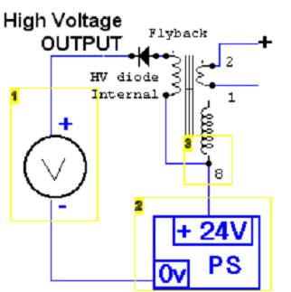**Of the flyback transformer.**

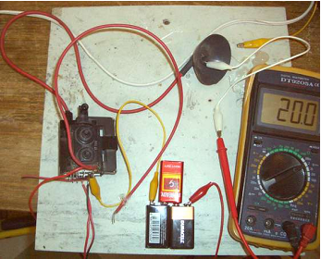

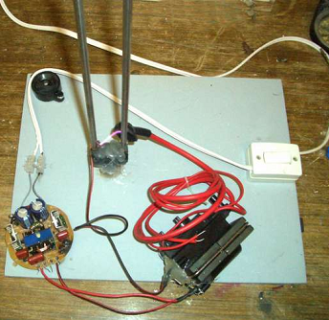

## Troubleshooting:

The first time I build the circuit, it worked immediately. I used a 26 watt CFL. Then I decided to get a bigger CFL and I build it exactly like the first circuit. It didn't work. I was disappointed. I thought that the CFL electronics were shot. But when I reconnected the fluorescent tube to the four wires, the CFL worked again. I realized that this type of CFL circuit needed to "sense" the filaments in order to operate. Remember, I was only using the outer wires and leaving the two inner wires alone. So I put a resistor across the outer wire and the inner wire. The circuit worked! But within seconds the resistor was in flames. So I decided to use a capacitor in place of resistor. The capacitor allows AC currents but blocks DC while a resistor allow both AC and DC currents to flow through it. Also a capacitor does not heat up because it provides a low resistance path for AC currents. The capacitor worked great! The arcs produced were very big and thick. So in summary there two things that can go wrong:

1. You wired it wrong, either on the CFL side or the flyback side.

2. The CFL electronics needs to sense the filament and you can use a capacitor as a substitute.

Use a high voltage rated capacitor 400v and above.

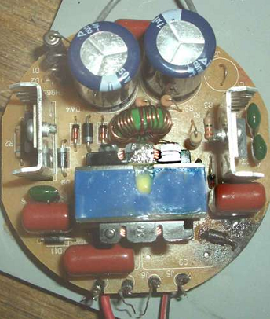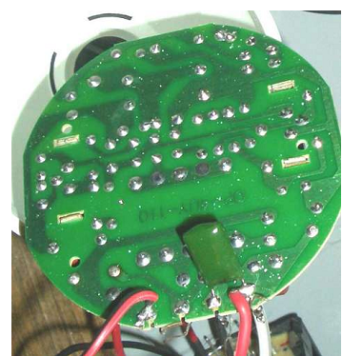

# PLANS OF BOTTLE CAPACITOR:

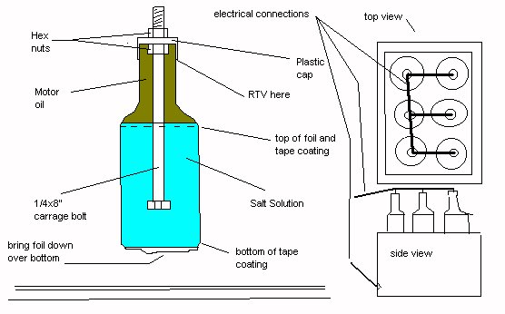

Discard the pop-tops and get six SCREWS on white plastic caps from 2-litre Schweppes bottles. Create a supersaturated solution of Morton salt and water. My solution was 8 tablespoons salt to 6 cups of water. Pour the solution into the bottles filling up to the level where the bottle is no longer cylindrical. For the remaining airspace, top off the bottles with 10W30 motor oil which will float above the salt solution. Drill. A 1/4 inch hole in the center of each plastic screw cap. Take six 1/4" by 8" long zinc coated carriage bolts, the kind with threads RUNNING ONLY about an inch at the end (these are common).SCREW A hex nut ONTO EACH bolt as far as it will go. Insert each bolt thread first through the bottom of each plastic cap through the hole you MADE SO that the cap rests on the nut. Screw another nut onto each bolt down over each plastic cap. There should be about 1/2" of thread left free. Take these six assemblies and screw one onto each bottle so the head of the bolt sticks down through the oil into the brine. Fit should be tight but seal the cap with RTV anyway. Now wrap the cylindrical portion of the outside of each bottle with Aluminum foil allowing the foil the cover the bottom of the bottle. Wrap over this tightly with electrical tape (at least two layers). Don’t wrap over the neck of the bottle or the foil on the underside. Construct a box of 3/4" pine or plywood just big enough to house the six packs and about 6" deep. Paint it flat black and varnish it or use some other insulating coating. Cover the bottom with a sheet of plate glass and place a sheet of Aluminum, COPPER, OR foil on the glass. Place the bottles in the box. The metal/foil on the glass on the box bottom will contact the FOIL ON the bottle bottoms forming one terminal of the capacitor. A hole should be drilled through the box near the bottom to bring out the lead away from the top end. Electrically tie the bolt ends (top) of each bottle together with small pieces of heavy gage wire and ring lugs. That is the other terminal.

# PRIMARY COIL

The primary coil is used with the primary cap to create the primary LC tank circuit. The primary coil also couples to the secondary coil to transfer power from the primary to the secondary circuit.

Typically 1/4 inch copper tubing is used to make the primary coil. I've used 6 AWG solid copper successfully, although my hands were sore for 3 days after bending the wire. Some people have used flat copper ribbon to save space, but tapping the turns can be more difficult. Avoid using other metals like steel due to its higher resistance at high frequencies. Leave about 1/4 inch spacing between turns. This will prevent arcing and allow space for a tap point. The primary coil can be constructed on just about any non conductive material. The material should be strong enough to support the weight of the copper. We need to design some means to hold the copper turns in place. Plastic wire ties or plastic bars with notches every 1/4 inch are common. If you get copper tubing or wire that is coiled or wound on a spool do not unwind it before making the primary coil. Use the natural shape of the coil to help do the winding. Try not to straighten and bend the tubing or wire too much as this will cause it to harden.

The primary coil is usually flat, called a "pancake" coil. Some smaller Tesla coils can use a vertical helix shaped primary. A cone shape or conical primary is also very common. The conical and vertical helix shapes will raise the top of the primary coil closer to the top load and increase the chances of an arc hitting the primary coil. It will also increase coupling between the primary and secondary coils. More coupling is typically better in most transformers, but Tesla coils need to be loosely coupled. Over coupling (or poor RF grounding) can cause arcing up and down the secondary coil. If you see arcs running up your secondary coil then the primary and secondary coils could be over-coupled and they should be moved further apart. An easy way to do this is to simply raise the secondary coil up a bit. If a conical primary is used the angle should not be greater than 45 degrees. Generally larger Tesla coil use flat primaries and smaller coil can use cone shape primaries. I recommend using a flat coil.

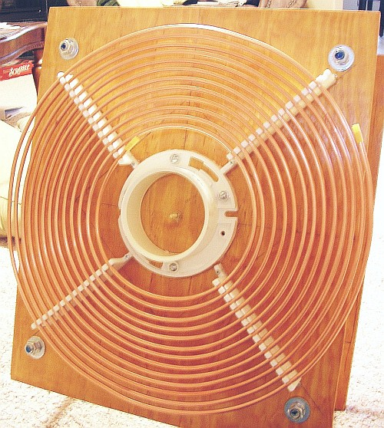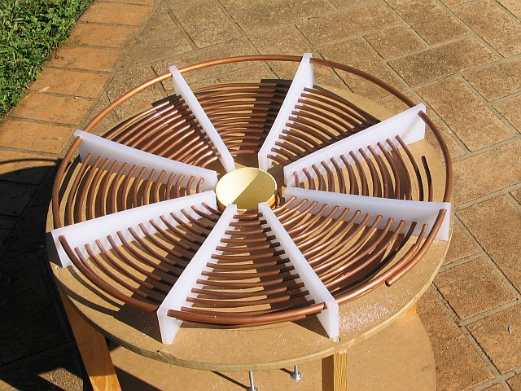 The primary coil should have a strike ring about 2 inches above the outer most turn. This ring will hopefully stop arcs from the top load from reaching the primary coil. The ring should not be completely closed. One end should attach to the secondary earth ground Smaller coils that do not produce arcs long enough to reach the primary coil do not require a strike ring, although it never hurts to have one.

# SECONDARY COIL:

The secondary coil and the top load create the secondary LC tank circuit. The secondary circuit also couples to the primary coil to transfer power from the primary circuit to the secondary.

The size of the secondary coil is generally governed by the power output of the power supply. For an average sized Tesla coil (about 1kW) you'll want a 4 inch to 6 inch diameter secondary coil. Smaller coils should have about 3 inch to 4 inch diameter, while larger coils should have at least a 6 inch diameter. The height to width ratio (also known as the aspect ratio) is important. If the coil is too short then you'll get a lot of strikes from the top load to the primary coil. The height of the coil should be about 4 or 5 times the diameter in an average sized Tesla coil. For example the secondary coil on a 1kW Tesla coil with a 4 inch diameter should be about 16 to 20 inches high. Remember to cut the secondary form a couple inches longer than the winding height to leave some space on each end! Smaller coils should have a height to width ratio close to 6, while larger coils should be close to 3.

The secondary wire is typically thin (22 AWG to 28 AWG) magnet wire wound on a PVC form. Magnet wire is solid copper wire with a thin coating of varnish as an insulator. It's sold by the pound or the gram. You'll probably need about 2 pounds to wind a typical coil. Double build magnet wire is available with extra insulation, but it's not necessary. Aim for about 1000 turns (+-200) on the secondary.

The secondary coil is usually wound on PVC pipe, although cardboard or most other non-conductive materials can be used. The PVC pipe should be clean and dry. Some PVC may come with a thin metal strip in it. This is used to help find the pipe after it's buried. Do not use this pipe as the metal strip will quickly short out the coil. In fact you'll want to avoid any metal screws, bolts, plates, etc on the secondary. A non-conductive nylon bolt can be used to attach the top load to the secondary coil. Winding the coil will take quite a while. Find a comfortable, well lit spot and plan to be there for quite a while. A lathe is ideal for holding the PVC pipe. Although I found that the lathe I used, even on its slowest speed, was too fast to wind the coil. So I just rotated the pipe by hand. The spool of magnet wire should be mounted so it will be easy to untangle during the winding. You may want to wear a thin glove to save the skin on your fingers. Before you start winding the coil, be sure the PVC pipe or other form is clean and dry. Be sure there's no metal shavings stuck on the form. It's probably a good idea to throw a Coat of Dolph's AC-43, polyurethane or varnish on the form, inside and out, to make sure it stays dry. Start by securing the end of the magnet wire a few inches from the end of the PVC. You can secure the wire with tape or drilling a couple small holes in the PVC and threading the wire through. Be sure to leave about a foot or two of magnet wire unwound on the end. Have some tape handy to easily hold the wire for rest breaks or untangling. Be careful not to leave any space between the windings. Keep some tension on the wire as you wind it. Tape the ends of the magnet wire down when finished and leave a couple feet of extra wire. Hopefully if your calculations were correct you have just about a few inches of PVC pipe left. Start coating with Dolph's AC-43, polyurethane or varnish. Remember not to coat the foot of extra wire on each end. I usually coil this extra wire up and let it stick up and out of the way while I varnish around it. Follow the instructions on the Dolph's AC-43, polyurethane or varnish and apply several coats. Keeps the pipe rotating as the coating dries?

## ASSEMBLY FOR SECONDARY COIL:

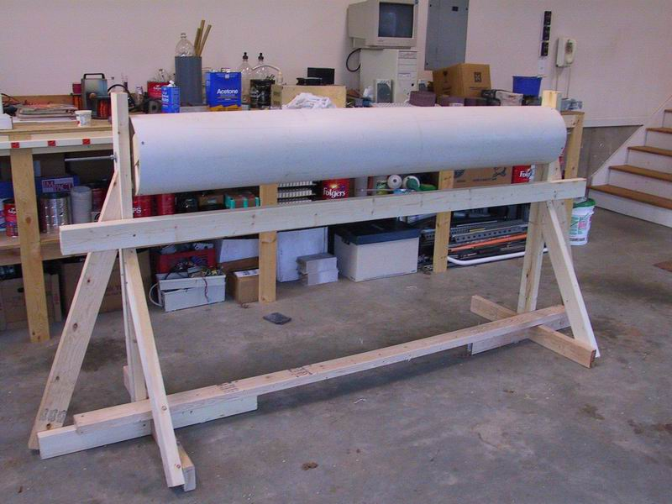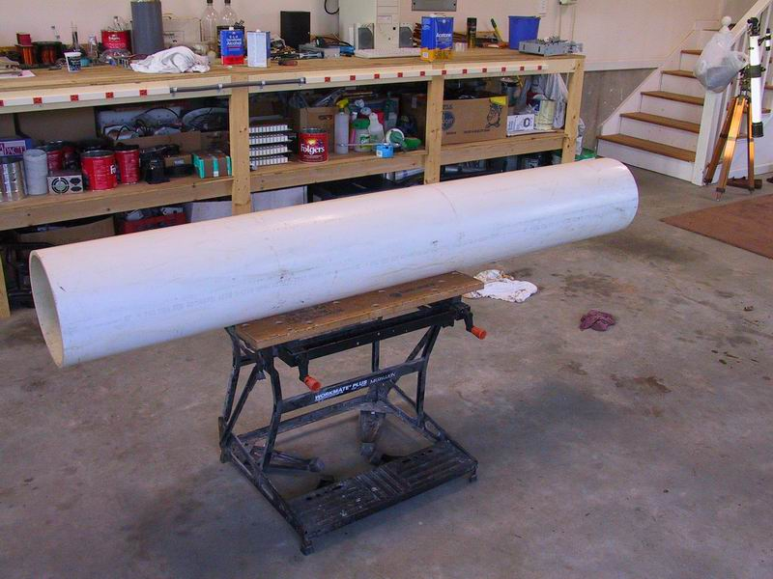

**Fig1: cut the PVC pipe of desired length with help of Fig2: assemble in stand with free rotating of**

**Axel blade PVC pipe**

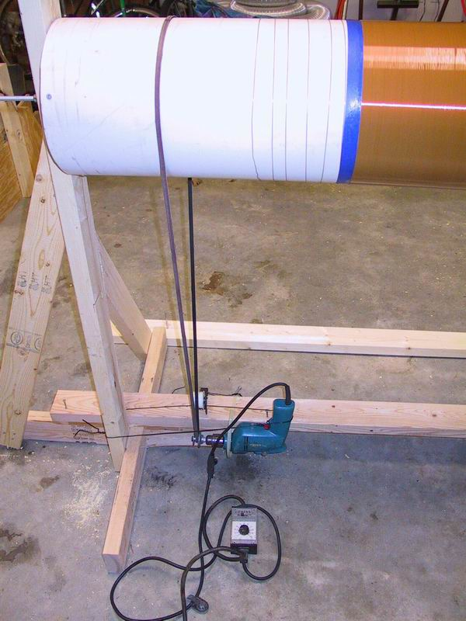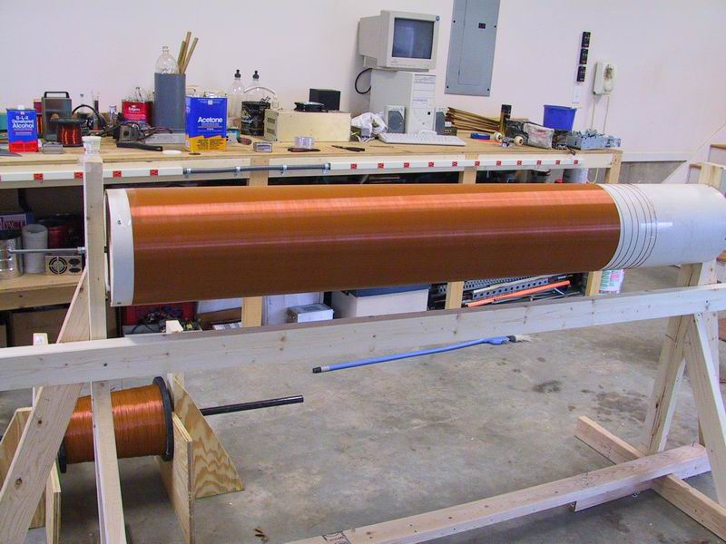

**Fig 3: with help of tape and winding coil mount and Fig4: Couple the drill bit head with belt**

**Stick the tape in PVC pipe connected to pipe for rotation**

# TOROID:

The top load is acts as a capacitor in the secondary circuit. The donut or torus (also called a toroid) is the preferred shape. As the Coil operates a charge will build up around the surface of the top load. A sphere will have evenly distributed field strength over its entire Surface. By flattening the sphere into a toroid, the field strength will Increase around the radius of the toroid. The arcs will break out where the field strength is greatest. The benefit of concentrating the field around the radius is to help direct the arcs outward. Using a sphere top load will result in evenly distributed smaller arcs.

The most common method of toroid construction is to wrap aluminum dryer duct around an aluminum pie pan. You can also use a spun aluminum toroid. A top load can be made of practically anything with a smooth shape covered in aluminum foil. Avoid using "metal" paint. Usually there is not enough metal in the paint to create a conductive surface, and even if there is sufficient metal, it's usually quickly burned off. The size of the top load and the amount of power applied will dictate the size and number of arcs that the Tesla coil produces. If the top load is small, then it will produce numerous simultaneous, shorter arcs. As the size of the top load is increased the number of arcs will be reduced and the arc length will increase. If the toroid is too large the field strength will not be strong enough to allow arcs to breakout. Placing a sharp pointed object like a thumb tack (called a break out point) on the toroid will create a disruption in the field and allow the arc to break out from the break out point.

Generally the diameter of the toroid ring should be about the same as the secondary coil, meaning a secondary coil wound on 4 inch PVC pipe should use 4 inch diameter dryer duct. The overall diameter of the toroid should be about 4 times the ring diameter, so 4 inch diameter dryer duct should be wrapped around an 8 inch pie pan for a total overall diameter of 16 inches.

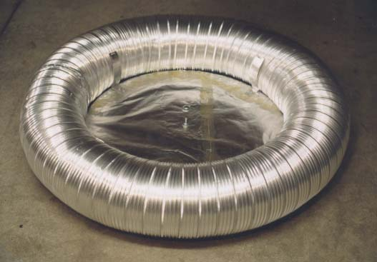It's important to physically attach the toroid to the top of the secondary coil. You can get by with sitting the toroid on there, but eventually it's going to fall or get bumped off. At best you'll dent up the toroid or your primary coil, at worst there could be a short that blows out your primary caps or something else. A good way to connect the toroid to the secondary is to get a PVC end cap, drill a hole in the middle and insert a nylon bolt sticking up. Drill a hole in the center of the pie pan and slide it onto the nylon bolt. You'll have to use nylon or some other non conductive bolt. A metal bolt will shoot an arc straight up. A wooden mount can be used, but wood should be avoided. Wood always has a bit of moisture and is slightly conductive. It can also swell, shrink, warp and crack.

It's important to have the toroid at the correct height above the secondary windings. If the toroid is too high, you'll see a corona develop near the top of the secondary windings. You may also see some little arcs from the top of the secondary coil. The corona and arcs can degrade the secondary winding insulation. If this is a problem try moving the toroid down. If the toroid is too low you may have frequent arcs striking the primary coil.

## SPARK GAP:

The spark gap is used as a switch to momentarily connect the primary capacitor to the primary coil. When the gap is shorted the cap is allowed to discharge into the coil. Many spark gap designs can be used. Spark gaps come in two basic designs: static and rotary. When the gap electrodes are stationary, the gap is referred to as a "static" gap. A rotary gap uses rotating electrodes.

The simplest design is a static gap consisting of 2 bolts, wires, drawer knobs, etc that acts as the electrodes. The electrodes should be smooth and rounded with no sharp edges that could cause the gap to short erratically. The gap between the electrodes is set to a specific width. The width determines the voltage required for the gap to short. The ideal gap will short just as the primary cap reaches its peak voltage. These gaps should be designed to allow small and easy adjustments to the gap width. Knobs screwed onto bolts are a good choice. Adjustments are made by screwing the knob off or on the bolt.

Static gaps are the most simple gap design, but they have some shortcomings. Often the gap will continue to short after the cap voltage has fallen below its peak. This happens because the air between the gaps becomes ionized when the gap shorts. The ionized air is more conductive and allows the gap to remain shorted. The performance of a static gap can be improved by blowing air through the gap. This is called "quenching" the gap. The goal of quenching is to blow the ionized air out of the gap; others have used vacuum cleaner motors. Generally the more air you can blow through the gap the better.

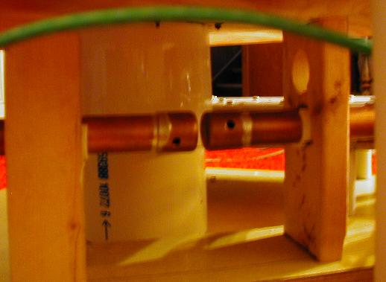HERE IN OUR PROJECT WE HAVE USED A SIMPLE SPARK GAP i.e. STATIC SPARK GAP

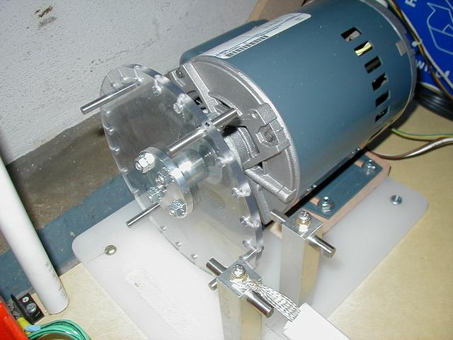



Fig1: SHOWS STATIC SPARK GAP

Fig2: ROTARY SPARK GAP

# Wiring:

I have tried to make the wiring diagram as simple as possible. Key points to keep in mind are all high voltage connections need to be made with the high voltage GTO wire. A 25 ft, 14awg extension cord with the female end removed makes a good main power cable for your coil. All other wiring can be made with 12 or 14 awg house wiring. The RF ground cable should be heavy, 4 to 8 gauge. I like welding cable for its flexibility and in fact, I use a welding clamp to terminate the cable and attach the cable to the RF grounding rod. Copper ribbon is also excellent, although it can be tough to work with. I recommend using crimp type connectors for all the terminal connections. If you wish, you can go the “extra mile” and crimp and solder them.

# Grounding:

Grounding is important for safety and proper operation of the coil. The Tesla coil should have two separate grounds. The first ground is the house or building ground. This is the green wire in the electrical outlets. The second ground is called the RF ground. This ground should be connected to a metal grounding rod that you pound into the ground. Although there is already a ground rod installed outside homes and buildings, you should not connect to this rod because it's connected to the house or building ground. You'll have to pound in your own ground rod. The grounding rod should be as close as possible to the Tesla coil, and as far from the house or building ground rod as possible. Generally 6 or 8 foot minimum depth is recommended, but it really depends on soil conditions and other factors. Deeper is always better. Several shorter ground rods can be placed around the Tesla coil if a single rod can't be used. If the ground is very hard, rocky or dry, you can place a piece of metal plate, chicken wire or mesh under the Tesla coil and use it as your RF grounding. The radius of the plate or mesh should be approximately equal to the height of the secondary coil and top load. This type of ground is called a "counterpoise". If you don't have access to a ground rod or counterpoise, you can connect to a cold water pipe. As a last resort, if you're on a ground floor that's at least semi-conductive you can wet the floor and put a layer of aluminum foil down. Braided copper wire can help the conductance of the RF ground, but regular wire will work just fine. Wetting the ground around the ground rod before running the coil helps conductivity to the earth. Be careful not to damage underground utilities when hammering in the ground rod. Poor RF grounding may not have any apparent effect on the Tesla coil - or it could cause reduced arc length, arcing up the secondary coil, or arcing between the primary and secondary coils.

## Warning

Proper grounding is extremely important. Proper grounding of a Tesla coil has been debated for quite some time. The general consensus is to connect anything you will touch during operation of the Tesla coil to the house or building ground. Anything that may be struck by an arc, or that may experience high voltage transients, should be connected to RF ground. The general idea is to pass all high voltage generated by the Tesla coil to the RF ground. We also need to prevent any high voltage spikes making their way into the house or building. I recommend connecting it to the RF ground because it's usually more likely to be struck by an arc or experience a voltage spike.

* **Oscillation and Tuning :**

The output waveform of a Tesla coil that is commonly referred to as "ringing" is caused by the oscillatory response of the tank circuit and secondary resonant circuit. Oscillation is the process where an interchange of energy takes place between the inductor and the capacitor in a tuned resonant circuit. This oscillation occurs in the tank circuit and in the secondary circuit. The firing of the spark gap is the electrical equivalent to striking the side of a bell with a hammer. The LC circuit is like the bell. A bell, when struck, will ring at a particular musical tone. The physical properties of the bell determine the frequency of its tone, just like the capacitance and inductance of a circuit determine the frequency of the circuit. The tank circuit will continue to "ring" for as long as the arc across the spark gap lasts. When the capacitor is charged to its peak voltage, the spark gap fires. The capacitor then discharges its energy into the primary coil. The capacitor starts off at its peak voltage and is discharged to zero volts, forming 1/4 cycle of the tank circuit's resonant frequency. As the capacitor is being discharged, the voltage drop is decreasing and current flowing through the circuit is increasing, causing the field strength of the primary coil to rise. The primary coil stores this energy in the form of its electromagnetic field. When the current flowing through the primary coil reaches its peak and the capacitor voltage is zero (because the capacitor is drained), current flow begins to fall because the capacitor can no longer supply current. The primary coil resists this decrease in current flow by producing emf (electromotive force). This emf is caused by the collapsing of the coil's magnetic field as the current flowing through it drops. A coil's magnetic field is sustained by current flow. The emf voltage causes current to flow in the same direction and the primary coil charges the capacitor with its emf at the opposite of the capacitor's original polarity. Now that the capacitor is charged at the new polarity, it also discharges into the primary coil at that new polarity, causing the electromagnetic field of the primary coil to change polarity. As the emf energy stored in the capacitor drops to zero, the primary produces emf again, causing the capacitor to be charged at its original polarity, and the cycle repeats itself. The oscillations continue to repeat until the spark gap is quenched, or the circuit runs out of energy (in secondary circuit).This back and forth recycling of energy can be compared to the swinging of a pendulum. The pendulum starts off in neutral position, pointing straight up and down. When it is pushed left it swings to the left until it peaks, and then swings back to the right. It goes past the neutral position, peaks, and swings back to the left again. It continues swinging, traveling a little less distance each cycle until it runs out of energy or is stopped. Below is a graphic of how oscillation behaves. The diagram shows the polarity of charge, the direction of current flow and pieces of the current flow wave generated by each part of the cycle. The sine wave shown is in relation to the flow of current when oscillation begins.





The result of the oscillations is a damped sine wave. Like the pendulum analogy, each cycle is weaker in magnitude than the previous. The decreasing of each cycle is caused by losses within the components of the LC circuit. The wave is also dampened by the transfer of energy to the secondary circuit. Losses occur because of the resistance of the wire in primary coil, not its impedance (inductive reactance), and the dissipation factor of the capacitor. For the tank capacitor, you should use a very low loss dielectric; "leaky" capacitors waste energy. The copper conductor of the primary coil offers significant resistance because of the skin effect. At high frequencies, electricity flows near the surface of a conductor more than through its center. The electrical current may only penetrate the conductor by a few mils, making the actual resistance much higher than the DC resistance of the wire. The solution to this problem is to use a conductor with maximum surface area. Below is a graphic of the damped sine wave produced in an LCR circuit. If there were no losses within the circuit, the oscillations would continue indefinitely and there would not be a dampening effect (excluding that of energy transfer), but such a condition does not exist.

Fig: Damped sine wave graphic.

It is very important for the primary coil to resonate at the same frequency as the secondary coil so that each pulse from the ringing of the primary is in sync with the secondary coil. This situation is like pushing a swing set. You must give the swing a push at the same frequency that it is moving back and forth in order to maintain its motion. If the swing is flying toward you and you give it a push before it is ready to go back the other way, then you will cancel out the motion and the swing will stop. The secondary resonant circuit of the secondary coil and toroid is an oscillator. Although the secondary circuit is magnetically induced with the primary circuit's energy, the secondary circuit can ring at a different frequency that is independent of the primary circuit. The oscillatory response of the secondary circuit operates in the same manner as in the primary circuit. The difference in the secondary circuit is that its excitation source is the primary coil, rather than the initial charge of a capacitor. Throughout the oscillations, the primary coil builds upon the oscillation of the secondary circuit by resonant rise. This is why it is absolutely critical that the primary circuit should resonate at the same frequency as the secondary circuit. Just as the circuits reinforce each other when they are in tune, they can cancel out the resonant rise in the secondary circuit if they are out of tune. In order to achieve the longest spark length (the goal of most coilers), it is necessary for the spark to break out at the first notch. This requires that the top load be of the correct size to only allow break out to occur at the peak voltage of the first notch. A given toroid will charge to a specific potential before it will allow the air surrounding it to break down and form a spark to ground. The optimum toroid size is usually found by experimentation, as it is affected by many factors.

It is important to note that these waveforms are produced by a Tesla coil that is not arcing to ground. If there were a spark to ground, the waveforms would be quite different, but still similar. At the point in time when the arc completed its path to ground, the energy level of the secondary would drop very quickly, and would not increase further. Any energy that the primary could continue to supply would be consumed in maintaining the arc. There would also not be any further oscillation between the circuits, since the secondary would never reach a peak energy level after the arc struck ground.

# Tesla Coil Calculations and formulae

1. **Ohm's Laws:**

V = I x R = P / I = SQRT (P x R)

I = V / R = SQRT (P / R) = P / V

R = V / I = P / (I^2) = V^2 / P

P = I x V = I^2 x R = V^2 / R

Where:

V = Voltage in Volts

I = Current in Amps

R = Resistance in Ohms

P = Power in Watts

1. **Resonate Frequency:**

Fo = 1 / (2 x pi x SQRT (L x C))

Where:

Fo = Resonant frequency in Hertz

Pi = 3.14159...

SQRT = Square root function

L = Inductance in Henries

C = Capacitance in Farads

1. **Reactance**

Xl = 2 x pi x F x L

Xc = 1 / (2 x pi x F x C)

Where:

Xl = Inductive reactance in Ohms

Xc = Capacitive reactance in Ohms

Pi = 3.14159...

F = Frequency in Hertz

L = Inductance in Henries

C = Capacitance in Farads

1. **RMS**

Vpeak = Vrms x SQRT (2) for sine waves only

Where:

Vpeak = Peak voltage in volts

Vrms = RMS voltage in Volts RMS

SQRT = Square root function

1. **Energy**

E = 1/2 x C x V^2 = 1/2 x L x I^2

Where:

E = Energy in Joules

L = Inductance in Henries

C = Capacitance in Farads

V = Voltage in Volts

I = Current in Amps

1. **Power**

P = E / t = E x BPS

Where:

P = Power in Watts

E = Energy in Joules

t = Time in Seconds

PS = The break rate (120 or 100 BPS)

1.  **Helical Coil**

Lh = (N x R) ^2 / (9 x R + 10 x H)

Where:

Lh = Inductance in micro-Henries

N = number of turns

R = Radius in inches

H = Height in inches

1. **Flat spiral**

Lf = (N x R) ^2 / (8 x R + 11 x W)

Where:

Lf = Inductance in micro-Henries

N = number of turns

R = Average radius in inches

W = Width in inches

1. **Conical Primary**

L1 = (N x R) ^2 / (9 x R + 10 x H)

L2 = (N x R) ^2 / (8 x R + 11 x W)

Lc = SQRT (((L1 x sin(x)) ^2 + (L2 x cos(x)) ^2) / (sin(x) +cos(x)))

Where:

Lc = Inductance in Micro henries

L1 = helix factor

L2 = spiral factor

SQRT = Square root function

N = number of turns

R = average radius of coil in inches

H = effective height of the coil in inches

W = effective width of the coil in inches

X = rise angle of the coil in degrees

1. **Resonant Primary Capacitance**

Cres = I / (2 x pi x Fl x V)

Where:

Cres = Resonant capacitor value in Farads

I = NST rate current in Amps

Pi = 3.14159...

Fl = AC line frequency in Hertz

V = FBT rated voltage in Volts

1. **Static Gap Primary LTR Capacitance**

Cltr = I / (4 x Fl x V)

Where:

Cltr = The LTR cap size in Farads

I = FBT rate current in Amps

Fl = AC line frequency in Hertz

V = FBT rated voltage in Volts

1. **Sync Gap Primary LTR Capacitance**

Cltr = 0.83 x I / (BPS x V)

Where:

Cltr = The LTR cap size in Farads

I = The FBT rated current in Amps

V = The FBT rated voltage in Volts

BPS = the break rate (120 or 100 BPS)

1. **Top Voltage**

Vt = Vf x SQRT (Ls / (2 x Lp))

Where:

Vt=Peak top voltage in Volts

Vf = gap firing voltage in Volts

SQRT = Square root function

Ls = Secondary inductance in Henries

Lp = Primary inductance in Henries

1. **PFC Capacitors**

Cpfc = Vo x Io / (2 x pi x Fl x Vi^2)

Where:

Cpfc = Power factor correction capacitance in Farads

Vo = FBT output voltage in Volts

Io = FBT output current in Amps

pi = 3.14159...

Fl = AC line frequency in Hertz

Vi = FBT input voltage in Volts

1. **Power-BPS**

P = BPS x 1/2 x Cp x Vf^2

Where:

P = Coil power in Watts

BPS = Breaks per second

Cp = Primary capacitance in Farads

Vf = Gap firing Voltage

1. **Transformers**

Vi x Ii = Vo x Io

Where:

Vi=Input voltage in Volts

Ii = Input current in Amps

Vo = Output voltage in Volts

Io = Output current in Amps

1. **Primary Peak Current**

IPpeak = Vf x SQRT (Cp / Lp)

Where:

IPpeak = Peak primary loop current Amps

Vf = Firing Voltage in Volts

SQRT = Square root function

Lp = Primary inductance in Henries

Cp = Primary capacitance in Farads

1. **Surge Impedance**

Zs = SQRT (Lp / Cp)

Where:

Zs = Surge impedance in Ohms

SQRT = Square root function

Lp = Primary inductance in Henries

Cp = Primary capacitance in Farads

1. **Secondary "Q" Factor**

Q = 2 x pi x Fo x Ls / Rac = SQRT (Ls / Cs) / Rac

Where:

Q = "Q" factor

Fo = Fundamental frequency in Hertz

Ls = Secondary inductance in Henries

Cs = Secondary capacitance in Farads

Rac = Secondary "AC" resistance in Ohms

SQRT = Square root function

1. **Freau Spark Length Formula**

L = 1.7 x SQRT (P)

Where:

L = Maximum spark length in Inches

SQRT = Square root function

P = Wall plug Watts

# Wire gauge Table

|  |  |  |  |
| --- | --- | --- | --- |
| **American Wire Gauge** | **Diameter** | **Diameter** | **Cross Sectional** |
| (AWG) | (inches) | (mm) | **Area** (mm2) |
| 0 | 0.46 | 11.68 | 107.16 |
| 0 | 0.41 | 10.4 | 84.97 |
| 0 | 0.365 | 9.27 | 67.4 |
| 0 | 0.325 | 8.25 | 53.46 |
| 1 | 0.289 | 7.35 | 42.39 |
| 2 | 0.258 | 6.54 | 33.61 |
| 3 | 0.229 | 5.83 | 26.65 |
| 4 | 0.204 | 5.19 | 21.14 |
| 5 | 0.182 | 4.62 | 16.76 |
| 6 | 0.162 | 4.11 | 13.29 |
| 7 | 0.144 | 3.67 | 10.55 |
| 8 | 0.129 | 3.26 | 8.36 |
| 9 | 0.114 | 2.91 | 6.63 |
| 10 | 0.102 | 2.59 | 5.26 |
| 11 | 0.091 | 2.3 | 4.17 |
| 12 | 0.081 | 2.05 | 3.31 |
| 13 | 0.072 | 1.83 | 2.63 |
| 14 | 0.064 | 1.63 | 2.08 |
| 15 | 0.057 | 1.45 | 1.65 |
| 16 | 0.051 | 1.29 | 1.31 |
| 17 | 0.045 | 1.15 | 1.04 |
| 18 | 0.04 | 1.02 | 0.82 |
| 19 | 0.036 | 0.91 | 0.65 |
| 20 | 0.032 | 0.81 | 0.52 |
| 21 | 0.029 | 0.72 | 0.41 |
| 22 | 0.025 | 0.65 | 0.33 |
| 23 | 0.023 | 0.57 | 0.26 |
| 24 | 0.02 | 0.51 | 0.2 |
| 25 | 0.018 | 0.45 | 0.16 |
| 26 | 0.016 | 0.4 | 0.13 |

# SAFETY

The high voltages and currents associated with Tesla Coils can cause injury and death. Do not touch any part of the unit while it is plugged in. Keep an ABC type fire extinguisher accessible.



Tesla Coils and Pacemakers do not mix!

Please inform all people in the area where

the unit will be operated. In addition, try and operate the unit as far away as possible from sensitive electronics i.e. computers, TV’s etc.

Do not look directly at the spark gap

when it is firing without eye protection

(welding goggles). The spark gap generates intense UV light.



Tesla Coils generate a significant

amount of ozone. Use in a well

ventilated area and keep the run

times short.

# COMPLETE CIRCUIT DIAGRAM

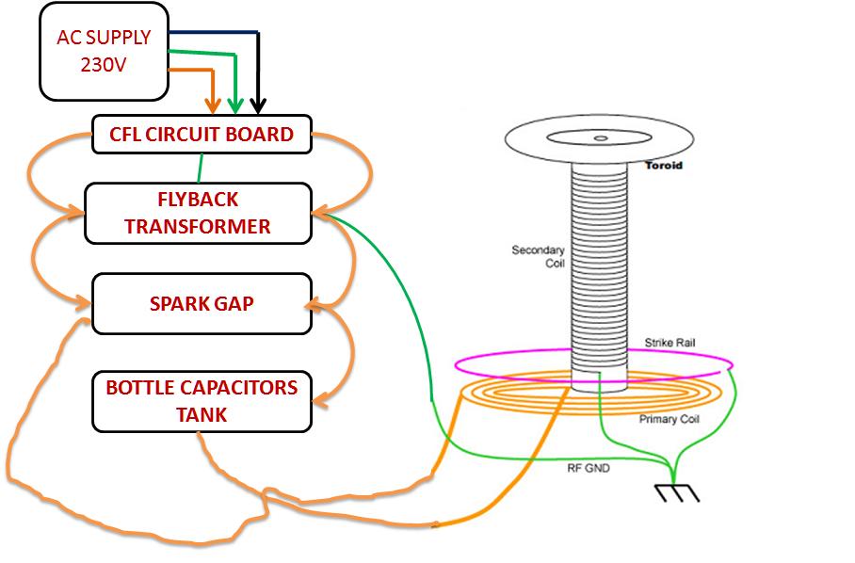

# CONCLUSION

The goal of this project was extend my knowledge of electrical and electronics engineering and shed some light on the technical and artistic nature of Tesla coils, while attempting to create a unique and tesla coil. The coil that was created was capable of producing spark, and spark was limited only by the lack of properly functioning of equipment. While there are a number of improvements that could be made, the project served its initial purpose in creating a coil capable of acting as a power source and illuminating the finer points of creating such a coil. While designing the tesla coil we learned many things from our high voltage concepts and it also helpful in brush up of our knowledge in practical application. The main aim was to build and see the practical application of witricity i.e. wireless transmission of electricity. Analyses of very simple implementation geometries provide encouraging performance characteristics and further improvement is expected with serious design optimization. Thus the proposed mechanism is promising for many modern applications. We tried to design the unique tesla coil combining both electronics and electrical. By this project we minimized the distance between the electronics and electrical components as practical aspects.

# REFERENCE

1. English Wikipedia. Nikola Tesla, <http://en.wikipedia.org/wiki/Nikola_Tesla>
2. Richard Burnett. Operation of the Tesla Coil, <http://www.richieburnett.co.uk/operation.html>

<http://www.richieburnett.co.uk/operatn2.html>

1. Matt Behrend. How a Tesla Coil works, <http://tayloredge.com/reference/Machines/TeslaCoil.pdf>
2. Tuning, <http://www.hvtesla.com/tuning.html>
3. Tesla coil Design, Construction and Operation Guide -Kevin Wilson.

<http://www.teslacoildesign.com>

1. <http://www.hvtesla.com/index.html>
2. <http://www.teslastuff.com>
3. <http://www.deepfriedneon.com/tesla_frame0.html>