DESIGN OF TESLA COIL

A Project Report

Submitted by:

ABINASH CHOUDHURY (1101210761)
R. NIKHIL KUMAR (1101210349)
KANHU CHARAN BEHERA (1101210325)

In partial fulfillment for the award of the Degree
Of

BACHELOR OF TECHNOLOGY
IN
ELECTRICAL & ELECTRONICS ENGINEERING

Under the esteemed guidance of
Mr. MONAJ KUMAR SWAIN

Asst. Prof. (EEE Dept.)
AT

DEPARTMENT OF ELECTRICAL & ELECTRONICS ENGINEERING
GANDHI INSTITUTE OF ENGINEERING AND TECHNOLOGY GUNUPUR – 765022
2011-2015

DECLARATION

I hereby declare that the project entitled “DESIGN OF TESLA COIL” submitted for the B.Tech Degree is my original work and the project has not formed the basis for the award of any degree, associate ship fellowship or any other similar titles.

Signature of the Students:
1.
2.
3.
Place:
Date:


Gandhi Institute of


Engineering & Technology
GUNUPUR – 765 022, Dist: Rayagada (Orissa), India
(Approved by AICTE, Govt. of Orissa and Affiliated to BijuPatnaikUniversity of Technology)
: 06857 – 250172(Office), 251156(Principal), 250232(Fax),
e-mail: gandhi_giet@yahoo.com visit us at www.giet.org

DEPARTMENT OF ELECTRICAL & ELECTRONICS ENGINEERING


CERTIFICATE
ISO 9001:2000
Certified Institute


This is to certify that the project work entitled “DESIGN OF TESLA COIL” is the bonafidework carried out by ABINASH CHOUDHURY(1101210761) , R.NIKHIL KUMAR(1101210349) , KANHU CHARAN BEHERA(1101210325) students of BACHELOR OF TECHNOLOGY, GANDHI INSTITUTE OF ENGINEERING AND TECHNOLOGY during the academic year 2011-15 in partial fulfillment of the requirements for the award of the Degree of BACHELOR OF TECHNOLOGY in ELECTRICAL & ELECTRONICS ENGINEERING.

Mr.MANOJ KUMAR SWAIN Mr. R.R SABAT

Project Guide (EEE) HOD (EEE)

{EXTERNAL EXAMINER}

ACKNOWLEDGEMENTS

It is a great pleasure and privilege to express my profound sense of gratitude to our esteemed guide Mr. Monaj Kumar Swain, Prof.(EE), who helped & coordinated us in completion of the project .I also sincerely thank to Mr. Srikant Mishra, Prof. &Asst HOD(EE) & thereby my special thanks to Mr. R.R Sabat Prof.& HOD(EEE) & lastly my sincere thanks to Mr. Balram Das ,Prof. & HOD(EE) and all the teachers for their suggestions, motivation and support during the project work and keen personal interest throughout the progress of my project work.

I express my thanks to all my friends, my family for their timely, suggestions and encouragements.

ABINASH CHOUDHURY
R. NIKHIL KUMAR
KANHU CHARAN BEHERA

An Abstract
On
Design of Tesla Coil

The Tesla Coil is a machine for generating extreme high voltages. It's sort of like the Van De Graff generator you might have played with in high school science classes, but much more powerful. When you fire it up, the shiny donut/sphere-shaped part on top is energized with about 500,000 volts of high-frequency current. Huge sparks shoot out from it with a deafening noise and the whole room stinks of ozone. The Tesla coil uses high-frequency transformer action together with resonant voltage amplification to generate potentials in the range of tens to hundreds, or even thousands of kilovolts. We describe a range of experiments designed to investigate the Tesla coil action, ending up with the design and development of a touring Tesla coil with a carefully considered trade-off between portability and performance.
About 100 years ago Nikola Tesla invented his "Tesla Coil". For about 70 years Hobbits and engineers alike have been constructing their own Coils. Tesla invented his coil with the intention of transmitting electricity through the air. He conducted much research in this area. He purposed using a few coils spread across the globe to transmit electrical energy through the earth. Where ever power was needed one would need only a receiving coil to convert the power into a useful form.
Tesla coil circuits were used commercially in spark gap radio transmitters for wireless telegraphy until the 1920s,and in electrotherapy and pseudo medical devices such as violet ray. Today, their main use is entertainment and educational displays. Tesla coils are built by many high-voltage enthusiasts, research institutions, science museums, and independent experimenters. Although electronic circuit controllers have been developed, Tesla's original spark gap design is less expensive and has proven extremely reliable.

Kanhu Charan Behera (11EEE024) (Sign. Of Concern faculty)
R. Nikhil Kumar (11EEE015) Mr. Manoj Kumar Swain
Abinash Choudhury (11EEE005) (EEE Dept.)

CONTENTS

CHAPTER TITLE PAGE NO.

ABSTRACT 5
LIST OF FIGURES 7
1 INTRODUCTION 9
2 BLOCK DIAGRAM 11
3 BLOCK DIAGRAM DESCRIPTION 12
3.1 POWER CIRCUIT 12
3.2 PRIMARY CAPACITANCE 13
3.3 SECONDARY COIL 13
3.4 TOP LOAD 14
3.5 PRIMARY COIL 16
3.6 TUNING PRECAUTIONS 17
3.7 AIR DISCHARGES 17
4 COMPONENT DESCRIPTION 19
4.1 RESISTOR 19
4.2 CAPACITOR 19
4.3 INDUCTOR 19
4.4 IMPEDANCE 20
4.5 LC CIRCUIT 22
4.6 RESONANT FREQUENCY 23
4.7 MAGNETIC WIRE 24
4.8 BATTERY 24
5 WORKING PRINCIPLE 25

6 CALCULATIONS & FORMULAS 26
6.1 OHM’S LAW 26 6.2 RESONATE FREQUENCY 26
6.3 REACTANCE 26
6.4 RMS 26
6.5 ENERGY 27
6.6 POWER 27
6.7 HELICAL COIL 27
6.8 FLAT SPIRAL 27
6.9 CONICAL PRIMARY 27
6.10 RESONANT PRIMARY CAPACITANCE 28
6.11 TOP VOLTAGE 28
6.12 TRANSFORMERS 28
7 APPLICATION 29
7.1 1902 DESIGN 29
7.2 WIRELESS TRANSMISSION & RECEPTION 29
7.3 HIGH-FREQUENCY ELECTICAL SAFETY 31
7.4 THE SKIN EFFECT 31
7.5 INSTANCES AND DEVICES 33
8 CONCLUSION 37

LIST OF FIGURES

FIGURE NO. DESCRIPTION PAGE NO.

Fig. 2.1 Block Diagram of Tesla coil 12
Fig 3.1.1 Power Circuit Diagram 14
Fig 4.4.2.1 The impedance Z plotted in the complex plane 25
Fig 4.5.1 Schematic of a series LC circuit 26
Fig 4.6.1 Amplitude of current plotted against the driving
Frequency 28
Fig 6.7.1 Helical Coil 34
Fig 6.8.1 Flat Spiral 34
Fig 6.9.1 Conical Primary 34
Fig 7.3.1 Student conducting Tesla coil streamers through
his body, 1909 39
Fig 7.51 Magnifying Transmitter 43

LIST OF TABLES

TABLE NO. DESCRIPTION PAGE NO.

Table 4.4.3.1 Impedance Formula 25

CHAPTER 1

Introduction

Nikola Tesla (1856 - 1943) was one of the most inventors in human history. He had 112 US patents and a similar number of patents outside the United States, including 30 in Germany, 14 in Australia, 13 in France, and 11 in Italy. He held patents in 23 countries, including Cuba, India, Japan, Mexico, Rhodesia, and Transvaal. He invented the induction Motor and our present system of 3-phase power in 1888. He invented the Tesla coil, a resonant air-core transformer, in 1891. Then in 1893, he invented a system of wireless Transmission of intelligence. Although Marconi is commonly credited with the invention of Radio, the US Supreme court decided in 1943 that the Tesla Oscillator patented in 1900 had priority over Marconi’s patent which had been issued in 1904. Therefore Tesla did the fundamental work in power and communications, the major areas of electrical Engineering. Their inventions have truly changed the course of human history. After Tesla had invented–phase power systems and wireless radio, he turned his attention to further development of the Tesla coil. He built a large laboratory in Colorado Springs in 1899 for this purpose. The Tesla secondary was about 51 feet in diameter. It was in a wooden building in which no ferrous metals were used in construction. There was a massive 80-foot wooden tower, topped by a 200-foot mast on which perched a large copper ball which he used as a transmitting antenna. The coil worked well. There are claims of bolts of artificial lightning over a hundred feet long, although Richard Hull asserts that from Tesla’s notes, he never claimed a distance greater than feet.

A Lightning Generator Capable of generating small miniature lightning bolts up to 24-in. long the device is unusually potent considering its overall simplicity and minimal power requirements. In operation, the Lightning Generator spouts a continuous, crackling discharge of pulsating lightning bolts into the air. These waving fingers of electricity will strike any conduction object that comes within it’s rang. A piece of paper placed on top the discharging terminal will burst into flames after a few seconds of operation, and a balloon tossed near the terminal will pop as though shot down by lightning.

Coiling is the popular term used to describe the building of resonant transformer of high frequency and high potential otherwise known as Tesla Coils. Nikola Tesla was the foremost scientist, inventor, and electrical genius of his day and has been unequaled since. Although never publicly credited, Nikola Tesla invented radio and the coil bearing his name, which involves most of the concepts in radio theory. The spark gap transmitters used in the early days of radio development were essentially Tesla coils. The fundamental difference is that the energy is converted to a spark instead of being propagated through a medium (transmitted). The old spark gap transmitters relied on very long antenna segments (approximately ¼ wavelengths) to propagate the energy in a radio wave; the quarter-wave secondary coil is in itself a poor radiator of energy. Tesla coils or resonant transformers of high frequency and high potential have been used in many commercial applications; the only variation being the high voltage is used to produce an effect other than a spark. Although not all commercial applications for Tesla coils are still in use some historical and modern day applications including:

- Spark gap radio transmitters
- Induction and dielectric heating (vacuum tube & spark gap types)
- Induction coils (differ only in the transformer core material being used)
- Medical X-ray devices (typically driven by an induction coil)
- Quack medical devices (violet-ray)
- Ozone generators
- Particle accelerators
- Electrical stage shows & entertainment
- Generation of extremely high voltage with relatively high power levels

The Tesla coil was invented more than 100 years ago, as part of mad genius Nikola Tesla’s plan to transmit electrical power without wires. Basically, he thought that by building a big enough Tesla coil, with a high enough voltage, he could ionize the whole Earth’s atmosphere, allowing it to conduct electricity. As he found out, millions of dollars and two nervous breakdowns late, this wasn’t going to work. It wasn’t a complete waste of time, though. Marconi borrowed heavily from Tesla’s work to create his first radio transmitter, which was basically a Tesla’s coil with a large wire antenna on top instead of the small sphere or toroid that Tesla used. From then on, the evolution of the Tesla coil split along two separate lines. The project involves a fairly large amount of work in electronics and mechanical construction. There are a few problems associated with this activity though. First, there is always a danger when high voltage is involved. Although the coils output poses no real problem, it is the primary circuit (sometimes called the "tank circuit") that carries dangerous (but much lower) voltages that come right from mains. The problem is easily solved by just enclosing that circuit. The other problem is one of materials. The coil uses some rather exotic (read: expensive) parts. One of those is the wire. The secondary requires about 800' if 28 AWG wire to be wound onto a round form. This amount is about $45 on the roll. This is not that big of a thing when compared with the transformer. To drive the high voltage section, a lower, but still considered high voltage neon sign transformer is used. There seems to be an odd shortage of used neon sign transformers in London, and new ones go for about $150. I don't even want to go into how hard it will be to find a 0.005uF 10KV capacitor. These parts related problems are easy enough to solve. Information Unlimited offers a TC kit for a very good price, which is what I am going to use. The only other real problem is the high frequency high voltage disrupting computers and such. Because of this, I will be unable to use my digital camera to take pictures of the coils operation because it simply won't work. These problems should are easy to solve by just not operating the coil around computers, and using an old fashioned camera and then scanning the pictures afterwards.

CHAPTER 2

BLOCK DIAGRAM

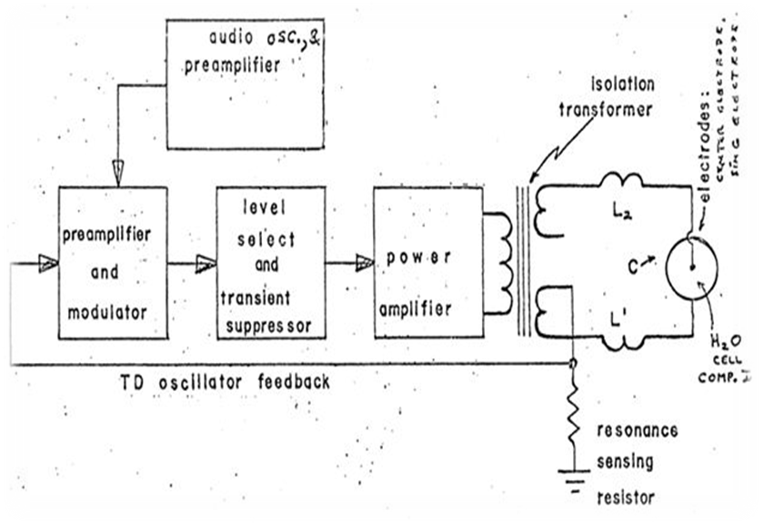

Fig 2.1: Block Diagram

CHAPTER 3
BLOCK DIAGRAM DESCRIPTION

3.1 POWER CIRCUIT

The Power supply is a high voltage transformer used to charge the primary capacitor. Neon Sign Transformers (NSTs) are the most common power supply used in small to medium sized Tesla coils.

These calculations will be used to determine the optimum sized primary capacitor (in the next section).

NST VA = NST Vout × NST Iout

NST Impedance = NST Vout/NST Iout

We aren’t required to calculate the NST watts, but it’s helpful for selecting fuses, wire gauges, etc.
NST watts = ((0.6/NST) + 1) × NST VA

A Power Factor Correction (PFC) capacitor can be wired across the NST input terminals to correct the AC power phase and increase efficiency. The optimum PFC capacitance is found with the following equation:

PFC Capacitance (F) = NST VA / (2 × π × NST × (NST ))

Where:
is input frequency
Π = 3.14

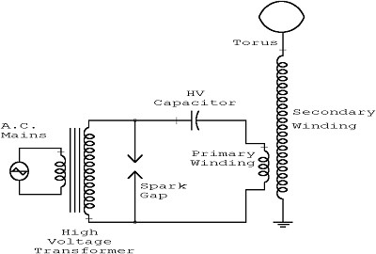

Fig 3.1.1: Circuit Diagram

3.2 PRIMARY CAPACITANCE

The primary capacitor is used with the primary coil to create the primary LC circuit. A resonate sized capacitor can damage a NST, therefore a Larger Than Resonate (LTR) sized capacitor is strongly recommended. A LTR capacitor will also deliver the most power through the Tesla coil. Different primary gaps will require different sized primary capacitors.

Primary Resonate Capacitance (uF) = 1 / (2 × π × NST Impedance × NST )

Primary LTR Static Capacitance (uF) = Primary Resonate Capacitance × 1.6

Primary LTR Sync Capacitance (uF) = 0.83 × (NST Iout/ (2 × NST) / NST )

3.3 SECONDARY COIL

The secondary coil is used with the top load to create the secondary LC circuit. The secondary coil should generally have about 800 to 1200 turns. Some secondary coils can have almost 2000 turns. Magnet wire is used to wind the coil. There’s always a little space between turns, so the equation assumes the coil turns are 97% perfect.

Secondary Coil Turns = (1/ Magnet Wire Diameter + 0.000001)) × Secondary Wire winding Height × 0.97

The capacitance of the secondary coil will be used to calculate the secondary LC circuit resonate frequency. Coil dimensions are given in inches.

Secondary Capacitance (pf) = (0.29 × Secondary wire winding Height + (0.41 × (Secondary Form Diameter / 2)) + (1.94 × sqrt(((Secondary Form Diameter / 2) / Secondary Wire winding Height))

The height to width ratio should be about 5:1 for small Tesla coil, 4:1 for average sized Tesla coils about 3:1 for large Tesla coils.

Secondary Height Width Ratio = Secondary Wire Winding Height / Secondary Form Diameter

The length of the secondary coil is used to calculate the wire weight. In the past it was thought that the secondary coil length should match the quarter wave length of the Tesla coils resonate frequency. However, it has since been determined that it’s unnecessary.
Secondary Coil Wire Length (ft) = (Secondary Coil Turns × (Secondary Form Diameter × π)) / 12

Magnet wire is typically sold by weight, so it’s important to know the required wire weight.

Secondary Coil Weight (lbs) = π × ((Secondary Bare wire Diameter / 2) × Secondary Coil Wire Length × 3.86

The inductance of the secondary coil will be used to calculate the secondary LC circuit resonate frequency.

Secondary Inductance = ((((Secondary Coil Turn) × ((Secondary Form Diameter / 2)) / ((9 × (Secondary Form Diameter / 2)) + (10 × Secondary Wire Winding Height))))

3.4 TOP LOAD

The top load is used with the secondary coil to create the secondary LC circuit. Generally a toroid or sphere shape is used. The ring diameter refers to the widest length from edge to edge of a toroid shape. I’ve found several equations for different sized top loads. Without knowing which is the most accurate in any case, I use the average of all the equations.

For large or small toroids with ring diameter < 3” or ring diameter > 20”, use the average of the 3 toroid capacitance calculations.

Toroid Capacitance 1 = ((1 + (0.2781 – Ring Diameter / (Overall Diameter – Ring Diameter))) × 2.8 × sqrt((π × (Overall Diameter × Ring Diameter)) / 4))

Toroid Capacitance 2 = (1.28 – Ring Diameter / Overall Diameter) × sqrt(2 × π × Ring Diameter × (Overall Diameter – Ring Diameter))

Toroid Capacitance 3 = 4.43927641749 × ((0.5 × (Ring Diameter × (Overall Diameter – Ring Diameter)))

Toroid Capacitance = (Toroid Capacitance 1 + Toroid Capacitance 2 + Toroid Capacitance 3) / 3

Ring diameter between 3” and 6”

Toroid Capacitance Lower = 1.6079 × Overall Diamete

Toroid Capacitance Upper = 2.0233 × Overall Diamete

Toroid Capacitance = (((Ring Diameter – 3) / 3) × (Toroid Capacitance Upper – Toroid Capacitance Lower)) + Toroid Capacitance Lower

Ring diameter between 6” and 12”

Toroid Capacitance Lower = 2.0233 × Overall Diamete

Toroid Capacitance Upper = 2.0586 × Overall Diamete

Toroid Capacitance = (((Ring Diameter – 6) / 6) × (Toroid Capacitance Upper – Toroid Capacitance Lower)) + Toroid Capacitance Lower

Small Tesla coils may use a sphere shaped top load.

Sphere Capacitance = 2.83915 × (Sphere Diameter / 2)

The total secondary capacitance includes the capacitance in the secondary coil and the capacitance of the top load. If you use multiple top loads, add their capacitance to calculate the total secondary capacitance. The total secondary capacitance will be used to calculate the secondary resonate frequency.

Total Secondary Capacitance = Secondary Coil Capacitance + Top Load Capacitance

The Secondary LC circuit resonate frequency will be used to calculate the amount of primary coil inductance required to tune the Tesla coil.

Secondary Resonate Frequency = 1 / (2 × π × sqrt((Secondary Inductance ×0.001) × (Total Secondary Capacitance)))

3.5 PRIMARY COIL

The primary coil is used with the primary capacitor to create the primary LC circuit. The primary coils also responsible for transferring power to the secondary coil.
First, we should determine the inductance required to tune the Tesla coil. After the inductance is calculated for each turn on the primary coil, we can use the Needed Primary Inductance value to indicate the proper turn where we should tap the primary coil. It will also indicate the minimum number of turns required in the primary coil. Of course, the primary coil should have several extra turns.

Needed Primary Inductance = 1 / (4 × × (Secondary × 1000 × Primary Capacitance)

Where:
is the Secondary Resonate Frequency

The equation will calculate the dimensions of the primary coil and the inductance of the coil at each turn. Unfortunately, you may need to run through these equations several times to determine the inductance at each turn. Of course, the TeslaMap program can quickly and easily calculate the dimensions and inductance of the coil out to 50 turns.

Primary Coil Hypotenuse = (Primary Coil Wire Diameter + Primary Coil Wire Spacing) × Turns

Primary Coil Adjacent Side = Primary Coil Hypotenuse × cos(toRadians(Primary Coil Incline Angle))

Primary Coil Diameter = (Primary coil Adjacent Side × 2) + Primary Coil Center Hole Diameter

Primary Coil Height = Primary Coil Wire Diameter + Primary Coil Adjacent Side × tan(toRadians(Primary Coil Incline Angle))

Primary Coil Wire Length (ft) = (Primary Coil Diameter × π) / 12

Primary Coil Average Winding Radius = (Primary Coil Center Hole Diameter / 2) + (Primary Coil Hypotenuse))

Primary Coil Winding Radius = (Primary Coil Hole Diameter / 2) + (Primary Coil Wire Diameter / 2)

Primary Coil Inductance Helix = ((Turns × Primary Coil Winding Radius) / ((9 × Primary Coil Winding Radius) + (10 × Primary Coil Height))

The inductance of a conical shaped coil is found by calculating the inductance of a flat and helical coil and using the average of the two coils weighted by the incline angle.

Angle Percent = 0.01 × (Primary Coil Incline Angle × (100 /90)

Angle Percent Inverted = (100 – (Angle Percent × 100)) × 0.01

Primary Coil Inductance = (Primary Coil Inductance Helix × Angle Percent) + (Primary Coil Inductance Flat × Angle Percent Inverted)

3.6 TUNING PRECAUTIONS
The primary coil's resonant frequency is tuned to that of the secondary, using low-power oscillations, then increasing the power until the apparatus has been brought under control. While tuning, a small projection (called a "breakout bump") is often added to the top terminal in order to stimulate corona and spark discharges (sometimes called streamers) into the surrounding air. Tuning can then be adjusted so as to achieve the longest streamers at a given power level, corresponding to a frequency match between the primary and secondary coil. Capacitive 'loading' by the streamers tends to lower the resonant frequency of a Tesla coil operating under full power. For a variety of technical reasons, toroids provide one of the most effective shapes for the top terminals of Tesla coils.

3.7 AIR DISCHARGES

A small, later-type Tesla coil in operation: The output is giving 43-cmsparks. The diameter of the secondary is 8 cm. The power source is a 10 000 V, 60 Hz current-limited supply.
While generating discharges, electrical energy from the secondary and toroid is transferred to the surrounding air as electrical charge, heat, light, and sound. The process is similar to charging or discharging a capacitor. The current that arises from shifting charges within a capacitor is called a displacement current. Tesla coil discharges are formed as a result of displacement currents as pulses of electrical charge are rapidly transferred between the high-voltage toroid and nearby regions within the air (called space charge regions). Although the space charge regions around the toroid are invisible, they play a profound role in the appearance and location of Tesla coil discharges.
When the spark gap fires, the charged capacitor discharges into the primary winding, causing the primary circuit to oscillate. The oscillating primary current creates a magnetic field that couples to the secondary winding, transferring energy into the secondary side of the transformer and causing it to oscillate with the toroid capacitance. The energy transfer occurs over a number of cycles, and most of the energy that was originally in the primary side is transferred into the secondary side. The greater the magnetic coupling between windings, the shorter the time required to complete the energy transfer. As energy builds within the oscillating secondary circuit, the amplitude of the toroid's RF voltage rapidly increases, and the air surrounding the toroid begins to undergo dielectric breakdown, forming a corona discharge.
As the secondary coil's energy (and output voltage) continues to increase, larger pulses of displacement current further ionize and heat the air at the point of initial breakdown. This forms a very conductive "root" of hotter plasma, called a leader that projects outward from the toroid. The plasma within the leader is considerably hotter than a corona discharge, and is considerably more conductive. In fact, its properties are similar to an electric arc. The leader tapers and branches into thousands of thinner, cooler, hair-like discharges (called streamers). The streamers look like a bluish 'haze' at the ends of the more luminous leaders, and transfer charge between the leaders and toroid to nearby space charge regions. The displacement currents from countless streamers all feed into the leader, helping to keep it hot and electrically conductive.
The primary break rate of sparking Tesla coils is slow compared to the resonant frequency of the resonator-topload assembly. When the switch closes, energy is transferred from the primary LC circuit to the resonator where the voltage rings up over a short period of time up culminating in the electrical discharge. In a spark gap Tesla coil, the primary-to-secondary energy transfer process happens repetitively at typical pulsing rates of 50–500 times per second, and previously formed leader channels do not get a chance to fully cool down between pulses. So, on successive pulses, newer discharges can build upon the hot pathways left by their predecessors. This causes incremental growth of the leader from one pulse to the next, lengthening the entire discharge on each successive pulse. Repetitive pulsing causes the discharges to grow until the average energy available from the Tesla coil during each pulse balances the average energy being lost in the discharges (mostly as heat). At this point, dynamic equilibrium is reached, and the discharges have reached their maximum length for the Tesla coil's output power level. The unique combination of a rising high-voltage radio frequency envelope and repetitive pulsing seem to be ideally suited to creating long, branching discharges that are considerably longer than would be otherwise expected by output voltage considerations alone. High-voltage discharges create filamentary multibranched discharges which are purplish-blue in colour. High-energy discharges create thicker discharges with fewer branches, are pale and luminous, almost white, and are much longer than low-energy discharges, because of increased ionization. A strong smell of ozone and nitrogen oxides will occur in the area. The important factors for maximum discharge length appear to be voltage, energy, and still air of low to moderate humidity. However, even more than 100 years after the first use of Tesla coils, many aspects of Tesla coil discharges and the energy transfer process are still not completely understood.

CHAPTER 4

COMPONENT DESCRIPTION

4.1 RESISTOR

A resistor is a component that opposes a flowing current. Every conductor has a certain resistance if one applies a potential difference V at the terminals of a resistor, the current I passing through it is given by

I=V/R

This formula is known as Ohm’s Law. The SI unit of resistance is Ohm (Ω). One can show that the powerP(in J/s) dissipated due to a resistance is equal to

P=VI=I

4.2 CAPACITOR

A Capacitor is a component that can store energy in the form of an electric field. Less abstractly, it is composed in its most basic form of two electrodes separated by a dielectric medium. If there is a potential difference V between those two electrodes, charges will accumulate on those electrodes: a charge Q on the positive them. If both of the electrode and an opposite charge Q on the negative one. An electrical field therefore arises between them. If both of the electrodes carry the same amount of charge, one can write

Q=CV

Where C is the capacity of the capacitor. Its unit is the Farad (F). The energy E stored a capacitor (in Joules) is given by

E= (1/2) QV= (1/2) CV2

Where one can note that the dependence in the charge Q shows that the energy is indeed the energy of the electric field. This corresponds to the amount of work that has to be done to place the charges on the electrodes.

4.3 INDUCTOR

An inductor stores the energy in the form a magnetic field. Every electrical circuit is characterized by a certain inductance. When current flows within a circuit, it generates a magnetic field B that can be calculated from Maxwell-Ampere’s law:

× B = J +

Where the electric field and J is the current density. The auto-inductance of a circuit measures its tendency to oppose a change in current: when the current changes, the flux of magnetic field that crosses the circuit changes. That leads to the apparition of an “ electromotive force” ɛ that opposes this change. It is given by:

ɛ = -

The inductance L of a circuit is thus defined as:

V = L

Where I(t) is the current that flows in the circuit and V the electromotive force (EMF) that a change of this current will provoke. The inductance is measured in henrys (H). The energy E (in Joules) stored in an inductor is given by:

E = LV = L

Where the dependence in the current I shows that this energy originates from the magnetic field. It corresponds to the work that has to be done against the EMF to establish the current in the circuit.

4.4 IMPEDANCE

The impedance of a component expresses its resistance to an alternating current (i.e. sinusoidal). This Quantity generalizes the notion of resistance. Indeed, when dealing with alternating current a component can act both on the amplitude and the phase of the signal.

4.4.1 EXPRESSIONS FOR ALTERNATING CURRENT

It is convenient to use the complex plan to represent the impedance. The switching between the two representations is accomplished by using Euler’s formula. Let’s note that the utilization of complex numbers is a simple mathematical trick, as it understood that only the real part of these quantities is meaningful. We are now given an expression of the general form of the voltage V (t) and current I (t):

V (t) = . Cos ( + ) V (t) = . Re {}

I (t) = . Cos ( + ) I (t) = . Re {}

Where and are the respective amplitudes, = 2 is the angular speed (assumed identical for both quantities) and are the phases.

4.4.2 DEFINITION OF IMPEDNCE

The impedance, generally noted Z, is formed of a real part, the resistance R, and an imaginary part, the reactance X:

Z = R + jX (Cartesian form)

= |Z| (Polar form)

Where j is the imaginary unit number, i.e. = 1, that a = arc tan(X/R) is phase difference between voltage and current and |Z| = the Euclidean norm of Z in the complex plane.

At this point, we can generalize Ohm’s law as the following:

V(t) = Z . I(t)

When the component only acts on the amplitude, in other words when X = 0, the imaginary part vanishes and we find Z = R. We therefore have the behavior of a resistor. The component is then said to be purely resistive, and the DC version of Ohm’s law applies. When the component only acts on the phase of the signal, that is when R = 0, the impedance is purely imaginary. The translates the behavior of “Perfect” capacitors and inductors.
lm

X Z

|Z|

Rc

R
Fig 4.4.2.1: The impedance Z plotted in the complex plane.

4.4.3 IMPEDANCE FORMULAS

We can give a general formula for the impedance of each type of each type of component.

Table 4.4.3.1
Component | Impedance | Effect on an alternating signal
Resistor | Z = R | Diminution of amplitude (current and tension)
Capacitor | Z = | Tension has a π / 2 delay over current.
Inductor | Z = jL | Current has a π / 2 delay over tension.

These formulas are easily recovered from the differential expressions of these components of these components. For every combinations of components, one can calculate the phase difference between current and voltage by vector-adding the impedances (for example, in an RC circuit, the phase difference will be less than = 2). Finally, it is good to keep in mind that any real-life component has a non-zero resistance and reactance. Even the simplest circuit, a wire connected to a generator has a capacitance, an inductance and a resistance, however small these might be.

4.5 LC CIRCUIT

An LC circuit is formed with a capacitor C and an inductor L connected in parallel or in series to a sinusoidal signal generator. The understanding of this circuit is at the very basis of the Tesla coil functioning, hence the following analysis. The primary and secondary circuits of a Tesla coil are both series LC circuits that are magnetically coupled to a certain degree. We will therefore only look at the case of the series LC circuit.
C (Farads)

AC L (Henrys)
Generator

Fig 4.5.1: Schematic of a series LC circuit

Using Kirchhoff’s law for current, we obtain that that the current in the inductor and the current in the inductor and the current in the capacitor are identical. We now use Kirchhoff’s law for voltage, which states that the sum of the voltage across the components along a closed loop is zero, to get the following equation:

= +

For the inductor, express the time derivative of current in terms of the charge by I =dq/dt we find:

= L

= L

Now for the capacitor, we isolate the charge Q in the relation Q=CV and we get

=
Putting in equation we get:

= LQ +

This equation describes an (undamped) harmonic oscillator with periodic driving, just like a spring-mass system! The inductor is assimilated to the ”mass” of the oscillator: a circuit of great inductance will have a lot of “inertia”. The “spring constant” is associated with the inverse of the capacitance C (this is the reason why C is seldom called the elastance).

4.6 RESONANT FREQUENCY

In our analysis of the LC circuit, we found that the oscillations of current and voltage naturally occurred at a precise angular speed, univoquely determined by the capacitance and inductance of the circuit. Without other effects, oscillations of current and voltage will always take place at this angular speed.

=

It is called the resonant angular speed. We can check that it is dimensionally coherent (its units are s). It is no less important to observe that, at the resonant angular speed, the respective reactive parts of an inductor and a capacitor are equal (in absolute value):

|| = = = ||

It is however much more important to talk about resonant frequency, which is just a rescale of the angular speed:

=

When there is a sinusoidal signal generator, we also saw that if its frequency is equal to the resonant frequency of the circuit it drives, current and voltage have ever-increasing amplitudes. Of course, this doesn’t happen if they are different (the oscillation remain bounded).
1.0

|I| amps 0.5

0
  - 1 10 100

Rad/s
Fig 4.6.1: Amplitude of the current plotted against the driving frequency (all constants normalized).

Low driving frequencies, the impedance is mainly capacitive as the reactance of a capacitor is greater at low frequencies. At high frequencies, the impedance is mainly inductive. At the resonant frequency, it vanishes, hence the asymptotic behavior of the current. However, in a real circuit, where resistance is non-zero, the width and height of the “spike” plotted her above are determined by the Q-factor. The fact that driving an (R) LC circuit at its resonant frequency causes a dramatic increase of voltage and current is crucial for a Tesla coil. But it can be potentially harmful for the transformer feeding the primary circuit.

4.7 MAGNETIC WIRE

Magnet wire or enameled wire is a copper or aluminum wire coated with a very thin layer of insulation. It is used in the construction of transformers, inductors, motors, speakers, hard disk head actuators, electromagnets, and other applications which require tight coils of wire.
The wire itself is most often fully annealed, electrolytic ally refined copper. Aluminum magnet wire is sometimes used for large transformers and motors. An aluminum wire must have 1.6 times the cross sectional area as a copper wire to achieve comparable DC resistance. Due to this, copper magnet wires contribute to improving energy efficiency in equipment such as electric motors. For further information, see: Copper and Copper wire and cable: magnet wire (Winding wire).
Smaller diameter magnet wire usually has a round cross section. This kind of wire is used for things such as electric guitar pickups. Thicker magnet wire is often square or rectangular (with rounded corners) to provide more current flow per coil length.

4.8 Battery
An electric battery is a device consisting of one or more electrochemical cells that convert stored chemical energy into electrical energy. Each cell contains a positive terminal, or cathode, and a negative terminal, or anode. Electrolytes allow ions to move between the electrodes and terminals, which allows current to flow out of the battery to perform work.
Primary (single-use or "disposable") batteries are used once and discarded; the electrode materials are irreversibly changed during discharge. Common examples are the alkaline battery used for flashlights and a multitude of portable devices. Secondary (rechargeable batteries) can be discharged and recharged multiple times; the original composition of the electrodes can be restored by reverse current. Examples include the lead-acid batteries used in vehicles and lithium ion batteries used for portable electronics. Batteries come in many shapes and sizes, from miniature cells used to power hearing aids and wristwatches to battery banks the size of rooms that provide standby power for telephone exchanges and computer data centers.
According to a 2005 estimate, the worldwide battery industry generates US$48 billion in sales each year, with 6% annual growth. Batteries have much lower specific energy (energy per unit mass) than common fuels such as gasoline. This is somewhat mitigated by the fact that batteries deliver their energy as electricity (which can be converted efficiently to mechanical work), whereas using fuels in engines entails a low efficiency of conversion to work.

CHAPTER 5

WORKING PRINCIPLE

As the capacitor charges from the high voltage power Supply, the potential across the static spark gap electrodes increases until the air between the spark gap ionizes allowing a low resistance path for the current to flow through; the “switch” is closed. Once the capacitor has discharged, the potential across the spark gap is no longer sufficient to maintain ionized air between the electrodes and the “switch” is open. This happens hundreds of times a second producing high frequency (radio frequency) AC current through the primary coil. The capacitor and primary coil produces an LCR (inductor-capacitor-resistor) circuit that resonates at a high resonant frequency. The secondary coil and top load also create an LCR circuit that must have a resonant frequency equal to the resonant frequency of the primary circuit. The high resonant frequency coupling of the primary coil with the secondary coil induces very high voltage spikes in the secondary coil.

The top load allows a uniform electric charge distribution to build up and lightning like strikes are produced from this to a point of lower potential, in most cases ground. The coupling between the primary and secondary coils do not act in the same way as a normal transformer coil would but works by high frequency resonant climbing or charging to induce extremely high voltages. The true physics is still not completely understood but can be modeled experimentally.

CHAPTER 6
CALCULATIONS & FORMULAS

6.1 OHM’S LAW

V = I × R = P / I = SQRT (P × R)
I = V / R = SQRT (P / R) = P / V
R = V / I = P / () = / R
P = I × V = × R = / R
Where:
V = Voltage in Volts
I = Current in Amps
R = Resistance in Ohms
P = Power in Watts

6.2 RESONATE FREQUENCY

= 1 / (2 × × SQRT (L × C))
Where:
= Resonant frequency in Hertz
Π = 3.14159…
SQRT = Square root function
L = Inductance in Henries
C = Capacitance in Farads

6.3 REACTANCE

Xl = 2 × π × F × L
Xc = 1 / (2 × π × F × C)
Where:
Xl = Inductive reactance in Ohms
Xc = Capacitive reactance in Ohms
Π = 3.14159…
F = Frequency in Hertz
L = Inductance in Henries
C = Capacitance in Farads

6.4 RMS

= × SQRT (2) for sine waves only
Where:
= Peak voltage in volts
= RMS voltage in Volts RMS
SQRT = Square root function

6.5 ENERGY

E = 1 / 2 × C × = 1 / 2 × L ×
Where:
E = Energy in Joules
L = Inductance in Henries
C = Capacitance in Farads
V = Voltage in Volts
I = Current in Amps

6.6 POWER

P = E / t = E × BPS
Where:
P = Power in Watts
E = Energy in Joules
t= Time in Seconds
PS = The break rate (120 or 100 BPS)

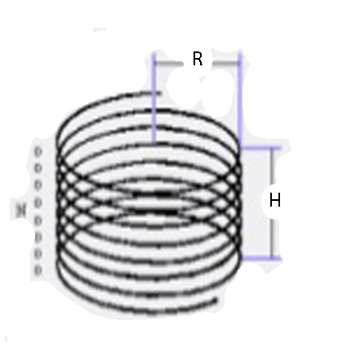
6.7 HELICAL COIL

Lh = (N × R / (9 × R + 10 × H)
Where:
Lh = Inductance in micro-Henries
N = number of turns Fig 6.7.1: Helical coil
R = Radius in inches
H = Height in inches
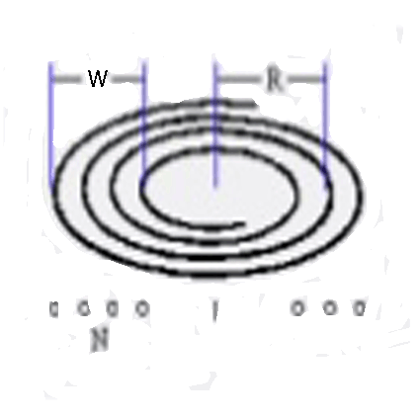
6.8 FLAT SPIRAL

Lf = (N × R / (8 × R + 11 × W)
Where:
Lf = Inductance in micro-Henries
N = number of turns Fig 6.8.1: Flat Spiral
R = Average radius in inches
W = Width in inches

6.9 CONICAL PRIMARY

L1 = (N × R / (9 × R + 10 × H)
L2 = (N × R / (8 × R + 11 × W)
Lc = SQRT (((L1 × sin(x) + (L2 × cos(x)) / (sin(x)+cos(x)))
Where:
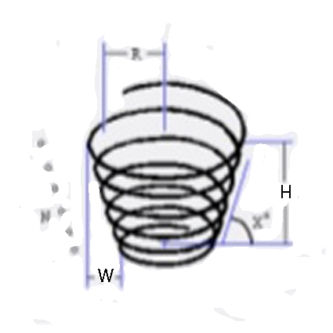
Lc = Inductance in Micro henries
L1 = helix factor
L2 = spiral factor
SQRT = Square root function
N = number of turns
R = average radius of coil in inches
H = effective height of the coil in inches Fig 6.9.1: Conical Primary
W = Effective width of the coil in inches
X = Rise angle of the coil in degrees

6.10 RESONANT PRIMARY CAPACITANCE

= I / (2 × π × Fl × V)
Where:
= Resonant capacitor value in farads
I = NST rate current in Amps
Π = 3.14159…
Fl = AC line frequency in Hertz
V = FBT rated voltage in Volts

6.11 TOP VOLTAGE

Vt = Vf × SQRT (Ls / (2 × Lp))
Where:
Vt = Peak top voltage in Volts
Vf = Gap firing voltage in Volts
SQRT = Square root function
Ls = Secondary inductance in Henries
Lp = Primary inductance in Henries

6.12 TRANSFORMERS

Vi × Ii = Vo × Io
Where:
Vi = Input voltage in Volts
Ii = Input current in Amps
Vo = Output voltage in Volts
Io = Output current in Amps

CHAPTER 7

APPLICATION

Tesla coil circuits were used commercially in spark gap radio transmitters for wireless telegraphy until the 1920s, and in electrotherapy and pseudomedical devices such as violet. Today, their main use is entertainment and educational displays. Tesla coils are built by many high-voltage enthusiasts, research institutions, science museums, and independent experimenters. Although electronic circuit controllers have been developed, Tesla's original spark gap design is less expensive and has proven extremely reliable.

7.1 1902 DESIGN

Tesla's 1902 design for his advanced magnifying transmitter used a top terminal consisting of a metal frame in the shape of a toroid, covered with hemispherical plates (constituting a very large conducting surface). The top terminal has relatively small capacitance, charged to as high a voltage as practicable. The outer surface of the elevated conductor is where the electrical charge chiefly accumulates. It has a large radius of curvature, or is composed of separate elements which, irrespective of their own radii of curvature, are arranged close to each other so that the outside ideal surface enveloping them has a large radius. This design allowed the terminal to support very high voltages without generating corona or sparks. Tesla, during his patent application process, described a variety of resonator terminals at the top of this later coil.

7.2 WIRELESS TRANSMISSION AND RECEPTION
The Tesla coil can also be used for wireless transmission. In addition to the positioning of the elevated terminal well above the top turn of the helical resonator, another difference from the sparking Tesla coil is the primary break rate. The optimized Tesla coil transmitter is a continuous wave oscillator with a break rate equaling the operating frequency. The combination of a helical resonator with an elevated terminal is also used for wireless reception. The Tesla coil receiver is intended for receiving the no radiating electromagnetic field energy produced by the Tesla coil transmitter. The Tesla coil receiver is also adaptable for exploiting the ubiquitous vertical voltage gradient in the Earth's atmosphere. Tesla built and used various devices for detecting electromagnetic field energy. His early wireless apparatus operated on the basis of Hertzian waves or ordinary radio waves, electromagnetic waves that propagate in space without involvement of a conducting guiding surface. During his work at Colorado Springs, Tesla believed he had established electrical resonance of the entire Earth using the Tesla coil transmitter at his "Experimental Station".
Tesla stated one of the requirements of the World Wireless System was the construction of resonant receivers. The related concepts and methods are part of his wireless transmission system (US1119732 – Apparatus for Transmitting Electrical Energy – 1902 January 18). Tesla made a proposal that there needed to be many more than 30 transmission-reception stations worldwide. In one form of receiving circuit, the two input terminals are connected each to a mechanical pulse-width modulation device adapted to reverse polarity at predetermined intervals of time and charge a capacitor. This form of Tesla system receiver has means for commutating the current impulses in the charging circuit so as to render them suitable for charging the storage device, a device for closing the receiving-circuit, and means for causing the receiver to be operated by the energy accumulated. A Tesla coil used as a receiver is referred to as a 'Tesla receiving transformer'. The Tesla coil receiver acts as a step-down transformer with high current output. The parameters of a Tesla coil transmitter are identically applicable to it being a receiver (e.g.., an antenna circuit), due to reciprocity. Impedance, generally though, is not applied in an obvious way; for electrical impedance, the impedance at the load (e.g.., where the power is consumed) is most critical and, for a Tesla coil receiver, this is at the point of utilization (such as at an induction motor) rather than at the receiving node. Complex impedance of an antenna is related to the electrical length of the antenna at the wavelength in use. Commonly, impedance is adjusted at the load with a tuner or a matching network composed of inductors and capacitors.
A Tesla coil can receive electromagnetic impulses from atmospheric electricity and radiant energy, besides normal wireless transmissions. Radiant energy throws off with great velocity minute particles which are strongly electrified and other rays falling on the insulated-conductor connected to a condenser (i.e., a capacitor) can cause the condenser to indefinitely charge electrically. The helical resonator can be "shock excited" due to radiant energy disturbances not only at the fundamental wave at one-quarter wavelength but also is excited at its harmonics. Hertzian methods can be used to excite the Tesla coil receiver with limitations that result in great disadvantages for utilization, though. The methods of ground conduction and the various induction methods can also be used to excite the Tesla coil receiver, but are again at a disadvantage for utilization. The charging-circuit can be adapted to be energized by the action of various other disturbances and effects at a distance. Arbitrary and intermittent oscillations that are propagated via conduction to the receiving resonator will charge the receiver's capacitor and utilize the potential energy to greater effect. Various radiations can be used to charge and discharge conductors, with the radiations considered electromagnetic vibrations of various wavelengths and ionizing potential. The Tesla receiver utilizes the effects or disturbances to charge a storage device with energy from an external source (natural or man-made) and controls the charging of said device by the actions of the effects or disturbances (during succeeding intervals of time determined by means of such effects and disturbances corresponding in succession and duration of the effects and disturbances). The stored energy can also be used to operate the receiving device. The accumulated energy can, for example, operate a transformer by discharging through a primary circuit at predetermined times which, from the secondary currents, operate the receiving device.
While Tesla coils can be used for these purposes, much of the public and media attention is directed away from transmission-reception applications of the Tesla coil since electrical spark discharges are fascinating to many people. Regardless of this fact, Tesla did suggest this variation of the Tesla coil could use the phantom loop effect to form a circuit to induct energy from the Earth's magnetic field and other radiant energy sources (including, but not limited to, electrostatics). With regard to Tesla's statements on the harnessing of natural phenomena to obtain electric power, he stated:
Ere many generations pass, our machinery will be driven by a power obtainable at any point of the universe. – "Experiments with Alternate Currents of High Potential and High Frequency" (February 1892)
Tesla stated that the output power from these devices, attained from Hertzian methods of charging, was low, but alternative charging means are available. Tesla receivers, operated correctly, act as a step-down transformer with high current output.^{[46]} To date, no commercial power generation entities or businesses have used this technology to full effect. The power levels achieved by Tesla coil receivers have, thus far, been a fraction of the output power of the transmitters.

7.3 HIGH-FREQUENCY ELECTICAL SAFETY

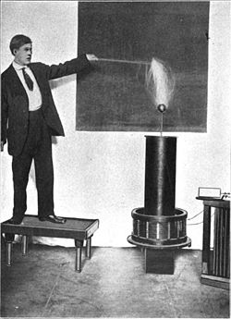
Fig 7.3.1: Student conducting Tesla coil streamers through his body, 1909

7.4 THE SKIN EFFECT
The dangers of contact with high-frequency electrical current are sometimes perceived as being less than at lower frequencies, because the subject usually does not feel pain or a 'shock'. This is often erroneously attributed to skin effect, a phenomenon that tends to inhibit alternating current from flowing inside conducting media. It was thought that in the body, Tesla currents travelled close to the skin surface, making them safer than lower-frequency electric currents.
Although skin effect limits Tesla currents to the outer fraction of an inch in metal conductors, the 'skin depth' of human flesh at typical Tesla coil frequencies is still of the order of 60 inches (150 cm) or more. This means high-frequency currents will still preferentially flow through deeper, better conducting, portions of an experimenter's body such as the circulatory and nervous systems. The reason for the lack of pain is that a human being's nervous system does not sense the flow of potentially dangerous electrical currents above 15–20 kHz; essentially, for nerves to be activated, a significant number of ions must cross their membranes before the current (and hence voltage) reverses. Since the body no longer provides a warning 'shock', novices may touch the output streamers of small Tesla coils without feeling painful shocks. However, anecdotal evidence among Tesla coil experimenters indicates temporary tissue damage may still occur and be observed as muscle pain, joint pain, or tingling for hours or even days afterwards. This is believed to be caused by the damaging effects of internal current flow, and is especially common with continuous wave, solid state or vacuum tube Tesla coils operating at relatively low frequencies (10's to 100's of kHz). It is possible to generate very high frequency currents (tens to hundreds of megahertz) that do have a smaller penetration depth in flesh. These are often used for medical and therapeutic purposes such as electro cauterization and diathermy. The designs of early diathermy machines were based on Tesla coils or Oudin coils.
Large Tesla coils and magnifiers can deliver dangerous levels of high-frequency current, and they can also develop significantly higher voltages (often 250,000–500,000 volts, or more). Because of the higher voltages, large systems can deliver higher energy, potentially lethal, repetitive high-voltage capacitor discharges from their top terminals. Doubling the output voltage quadruples the electrostatic energy stored in a given top terminal capacitance. If an unwary experimenter accidentally places himself in path of the high-voltage capacitor discharge to ground, the low current electric shock can cause involuntary spasms of major muscle groups and may induce life-threatening ventricular fibrillation and cardiac. Even lower power vacuum tube or solid state Tesla coils can deliver RF currents capable of causing temporary internal tissue, nerve, or joint damage through Joule heating. In addition, an RF arc can carbonize flesh, causing a painful and dangerous bone-deep RF burn that may take months to heal. Because of these risks, knowledgeable experimenters avoid contact with streamers from all but the smallest systems. Professionals usually use other means of protection such as a Faraday cage or a metallic mail suit to prevent dangerous currents from entering their bodies.
The most serious dangers associated with Tesla coil operation are associated with the primary circuit. It is capable of delivering a sufficient current at a significant voltage to stop the heart of a careless experimenter. Because these components are not the source of the trademark visual or auditory coil effects, they may easily be overlooked as the chief source of hazard. Should a high-frequency arc strike the exposed primary coil while, at the same time, another arc has also been allowed to strike to a person, the ionized gas of the two arcs forms a circuit that may conduct lethal, low-frequency current from the primary into the person.
Further, great care must be taken when working on the primary section of a coil even when it has been disconnected from its power source for some time. The tank capacitors can remain charged for days with enough energy to deliver a fatal shock. Proper designs always include 'bleeder resistors' to bleed off stored charge from the capacitors. In addition, a safety shorting operation is performed on each capacitor before any internal work is performed.

7.5 INSTANCES AND DEVICES
Tesla's Colorado Springs laboratory possessed one of the largest Tesla coils ever built, known as the "Magnifying Transmitter". The Magnifying Transmitter is somewhat different from classic two-coil Tesla coils. A magnifier uses a two-coil 'driver' to excite the base of a third coil ('resonator') located some distance from the driver. The operating principles of both systems are similar. The world's largest currently existing two-coil Tesla coil is a 130,000-watt unit; part of a 38-foot-tall (12 m) sculpture owned by Alan Gibbs and currently resides in a private sculpture park at Kakanui Point near Auckland, New Zealand.
The Tesla coil is an early predecessor (along with the induction coil) of a more modern device called a flyback transformer, which provides the voltage needed to power the cathode ray tube used in some televisions and computer monitors. The disruptive discharge coil remains in common use as the 'ignition coil' or 'spark coil' in the ignition system of an internal combustion engine. These two devices do not use resonance to accumulate energy, however, which is the distinguishing feature of a Tesla coil. They do use inductive "kick", the forced, abrupt decay of the magnetic field, such that the voltage provided by the coil at its primary terminals is much greater than the voltage applied to establish the magnetic field, and this higher voltage is then multiplied by the transformer turns ratio. Thus, they do store energy, and Tesla resonator stores energy. A modern, low-power variant of the Tesla coil is also used to power plasma globe sculptures and similar devices.
Scientists working with a glass vacuum line (e.g. chemists working with volatile substances in the gas phase, inside a system of glass tubes, taps and bulbs) test for the presence of tiny pin holes in the apparatus (especially a newly blown piece of glassware) using high-voltage discharges, such as a Tesla coil produces. When the system is evacuated and the discharging end of the coil moved over the glass, the discharge travels through any pin hole immediately below it and thus illuminates the hole, indicating points that need to be annealed or reblown before they can be used in an experiment.

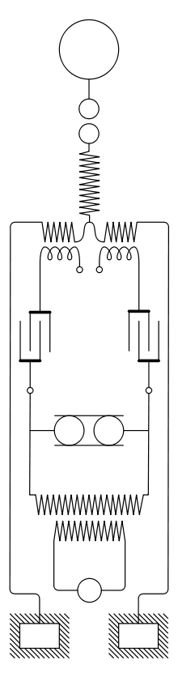  Classically driven configuration. | 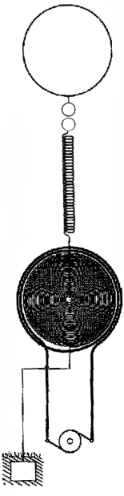  Later-type driven configuration. Pancake may be horizontal; lead to resonator is kept clear of it.
Fig 7.5.1: Magnifying Transmitter

7.6 SAFETY
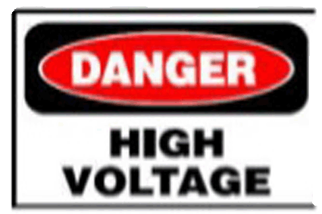
The high voltage and currents associated with Tesla Coils can cause injury and death. Do not touch any part of the unit while it is plugged in. Keep an ABC type fire extinguisher accessible.

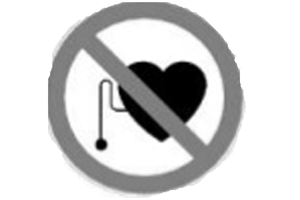
Tesla Coils and Pacemakers do not mix! Please inform all people in the area where the unit will be operated. In addition, try and operate the unit as far away as possible from sensitive electronics i.e., computers, TV’s etc.

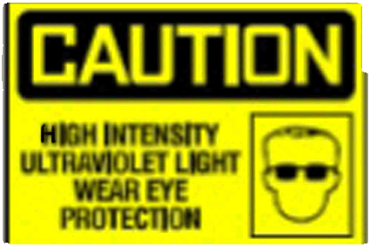
Do not look directly at spark gap when it is firing without eye protection (welding goggles). The spark gap generates intense UV light.

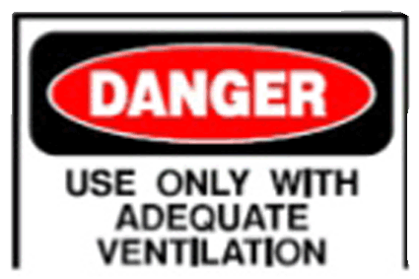

Tesla Coils generate a significant amount of ozone. Use in a well ventilated area and keep the run times short.

7.7 POPULARITY

Tesla coils are very popular devices among certain electrical engineers and electronics enthusiasts. Builders of Tesla coils as a hobby are called "coilers". A very large Tesla coil, designed and built by Syd Klinge, is shown every year at the Coachella Valley Music and Arts Festival, in Coachella, Indio, California, USA. People attend "coiling" conventions where they display their home-made Tesla coils and other electrical devices of interest. Austin Richards, a physicist in California, created a metal Faraday Suit in 1997 that protects him from Tesla Coil discharges. In 1998, he named the character in the suit Doctor MegaVolt and has performed all over the world and at Burning Man 9 different years.
Low-power Tesla coils are also sometimes used as a high-voltage source for Kirlian photography.
Tesla coils can also be used to create music by modulating the system's effective "break rate" (i.e., the rate and duration of high power RF bursts) via MIDI data and a control unit. The actual MIDI data is interpreted by a microcontroller which converts the MIDI data into a PWM output which can be sent to the Tesla coil via a fiber optic interface. The YouTube video Super Mario Brothers theme in stereo and harmony on two coils shows a performance on matching solid state coils operating at 41 kHz. The coils were built and operated by designer hobbyists Jeff Larson and Steve Ward. The device has been named the Zeusaphone, after Zeus, Greek god of lightning, and as a play on words referencing the Sousaphone. The idea of playing music on the singing Tesla coils flies around the world and a few followers continue the work of initiators. An extensive outdoor musical concert has demonstrated using Tesla coils during the Engineering Open House (EOH) at the University of Illinois at Urbana-Champaign. The Icelandic artist Björk used a Tesla coil in her song "Thunderbolt" as the main instrument in the song. The musical group Arc Attack uses modulated Tesla coils and a man in a chain-link suit to play music.
The most powerful conical Tesla coil (1.5 million volts) was installed in 2002 at the Mid-America Science Museum in Hot Springs, Arkansas. This is a replica of the Griffith Observatory conical coil installed in 1936.

CHAPTER 8

CONCLUSION

The goal of the this project was extend my knowledge of electrical electronics engineering and shed some light on the technical and artistic nature of Tesla coils, while attempting to create a unique and tesla coil. The coil that was created was capable of producing spark and spark was limited only by the lack of properly functioning of equipment. While there are a number of improvements that could be made the project served its initial purpose in creating a coil capable of acting as a power source and illuminating the finer points of creating such a coil. While designing the tesla coil we learned many things from our high voltage concepts and it also helpful in brush up of our knowledge in practical application. The main aim was to build and see the practical application of witricity i.e. wireless transmission of electricity. Analyses of very simple improvementation geometries provide encouraging performance characteristics and further improvement is expected with serious design optimization. Thus the proposed mechanism is promising for many modern applications. We tried to design the unique tesla coil combining both electronics and electrical. By this project we minimized the distance between the electronics and electrical components as practical aspects.

After studying and developing the model of TESLA COIL we came to following conclusion:

- We are able to generate high voltage with high frequency and it can be used for testing the apparatus for switching surges.

- It can also be used for study of visual corona and ionization of gases under the electrical stress.

- It can also transmit the electrical power wirelessly up to certain distance depends upon its ratings.

REFERENCE

- English Wikipedia. Nikola Tesla, http://en.wikipedia.org/wiki/Nikola_Tesla
- Richard Burnett. Operation of the Tesla Coil, http://www.richieburnett.co.uk/operation.html http://www.richieburnett.co.uk/operatn2.html
- Matt Behrend. How a Tesla Coil works, http://tayloredge.com/reference/Machines/TeslaCoil.pdf
- Tuning, http://www.hvtesla.com/tuning.html
- Tesla coil Design, Construction & Operation Guide – Kevin Wilson. http://www.hvtesla.coil/index.html
- http://www.hvtesla.com/index.html
- http://www.teslastuff.com
- http://www.deepfriendneon.com/tesla_frame().html

