Skies Across Cultures: Visualizing Constellation Patterns Across Different Sky Traditions
Carlos Banks, Dhruv Jore, Priyanshu Laddha, Yashkumar Burnwal
Fig. 1. The visual abstract figure should show a visually engaging summary of the project--including the problem, data used, methods/algs/tools applied, and key visualizations. Use simple graphics and minimal text.

1. INTRODUCTION AND PRIOR WORK
This client project focuses on exploring how different cultures interpret patterns in the night sky. Across history, people have grouped stars into shapes or figures, commonly referred to as constellations or asterisms. These shapes often represent animals, people, objects, or symbolic ideas, and the same stars can appear in completely different constellations depending on the cultural tradition.
For this project, we will work with datasets that describe how stars are connected to form constellations in different sky cultures. Instead of treating constellations simply as drawings in the sky, the data represents them as connections between stars. This naturally forms a network structure where stars are nodes and constellation lines are edges.
Previous work by Bucur and collaborators has collected and structured constellation data across multiple cultures, making it possible to study these patterns computationally. The datasets also align with the Stellarium sky culture format, which allows constellation information from different traditions to be stored in a comparable way.
Our goal in this project is to explore how these constellation structures differ across cultures and to design visualizations that make these differences easier to observe. By representing constellation data as networks or spatial maps, we aim to create visual tools that allow users to compare cultural interpretations of the same night sky.
1.1 Stakeholder Groups
The main stakeholders for this project include researchers, educators, and people interested in astronomy or cultural studies.

Researchers working in cultural astronomy or network science may use constellation datasets to study structural patterns in how different cultures interpret the sky. Educators and students may use visualizations to better understand how constellations are formed and how interpretations vary across cultures. In addition, astronomy enthusiasts or the general public may find interactive visualizations useful for exploring different cultural perspectives of the night sky.
Each of these groups interacts with the data differently, but they all benefit from visual representations that make constellation structures easier to understand.
1.2 Stakeholder Needs
Different stakeholders have slightly different expectations from the visualizations.
Researchers may want tools that allow them to analyze structural properties of constellation networks or compare patterns between cultures. Educators and students may prefer visualizations that clearly show how stars are connected to form different constellation shapes. For general users, simplicity and ease of exploration are important so that they can intuitively navigate the sky cultures without needing technical background.
When designing our visualizations, we plan to keep these needs in mind by focusing on clarity, comparison across cultures, and intuitive exploration of constellation patterns.

2. DATA ACQUISITION
For this project we will work with constellation datasets provided by the project sponsor. These datasets contain structured information describing how stars are connected to form constellations in different cultural traditions.
The primary dataset comes from the constellation-lines repository, which was created through a scientific data collection process. A second dataset from the Stellarium skycultures project contains additional constellation data collected by the open-source community. Both datasets follow a similar format where constellation structures are represented as connections between star identifiers.
Before analysis, the datasets will need to be explored and possibly standardized so that star identifiers and formats match across sources. This step will allow constellation patterns from different cultures to be compared more easily.
2.1 Data Sources
Two main datasets will be used in this project.
The first dataset is the constellation-lines dataset, which contains referenced constellation line structures collected across multiple sky cultures.
The second dataset is the Stellarium skycultures dataset, an open-source collection of sky culture definitions used in the Stellarium planetarium software.
Both datasets contain compatible representations of constellation line structures.
2.2 Data Description, Quality and Coverage

The dataset contains structured representations of constellations. Each entry describes how a set of stars are connected to form a constellation pattern within a particular cultural tradition. Key attributes include star identifiers, constellation names, and the connections between stars. Some entries also include descriptive information about the constellation and its cultural meaning.Since the data describes connections between stars, it can be modeled as a network structure. This representation allows constellation patterns to be visualized and compared across cultures.

3. PLANNED DATA ANALYSIS
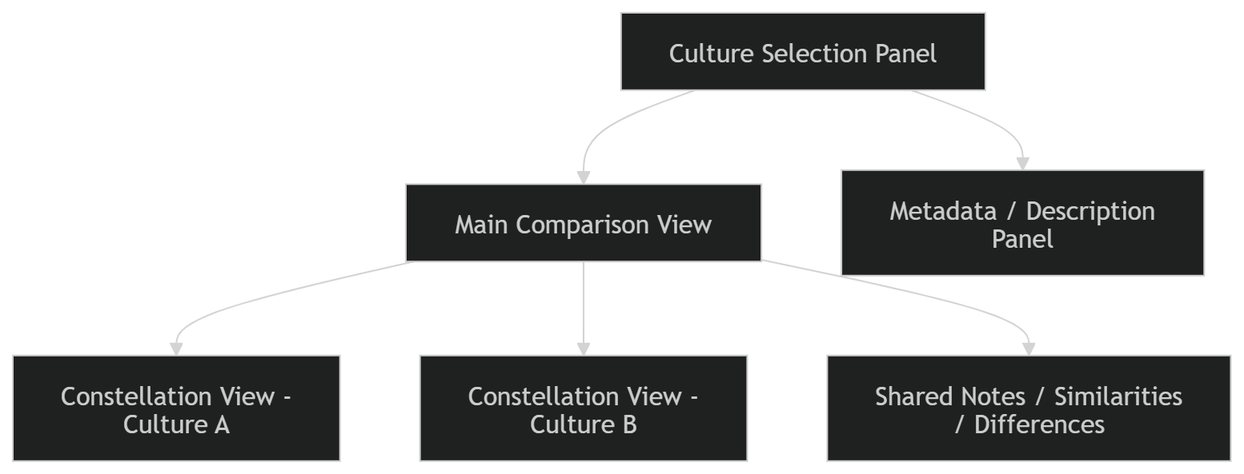
Our initial analysis will focus on understanding the structure of the dataset and preparing it for visualization.
We plan to convert constellation definitions into network representations where stars are treated as nodes and the connecting lines are treated as edges.
After constructing these networks, we will explore structural characteristics such as the number of stars per constellation, connection patterns, and differences between cultures.
This analysis will help us determine what types of visualizations will best represent the constellation structures.

4. PLANNED VISUALIZATIONS
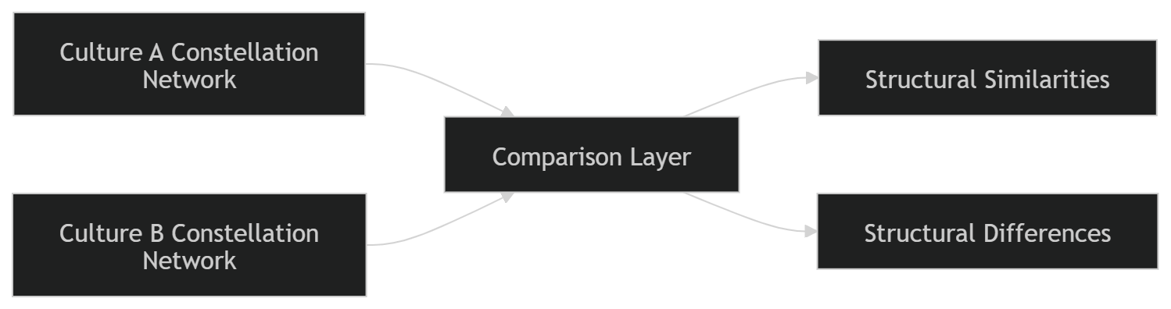
Based on the structure of the dataset, we plan to design visualizations that allow users to explore constellation structures and compare them across cultures.
One visualization will represent individual constellations as network diagrams showing how stars are connected.
Another visualization will allow users to compare constellation patterns from different cultures side by side.
We also plan to explore a spatial sky map visualization that displays constellation lines on top of star positions, helping users understand how different cultures interpret the same region of the sky.
5. USAGE AND CRITIQUE OF AI TOOLS
Students should discuss how AI tools were or could have been used in the client project.They must also critique the limitations of these tools, such as biases or interpretability issues, and suggest improvements or alternatives for future use.

ACKNOWLEDGEMENTS
Students should express gratitude to individuals or organizations that supported their research. This might include advisors, collaborators, funding bodies, or institutions that provide resources or guidance. Maintain a formal tone, listing contributors in order of significance.
REFERENCES
- K. Börner. Atlas of Knowledge: Anyone Can Map. MIT Press, 2015.
- K. Börner, A. Bueckle, and M. Ginda. "Data visualization literacy: Definitions, conceptual frameworks, exercises, and assessments." PNAS, 116 (6): 1857-1864, 2018.

