Skies Across Cultures: Visualizing Constellation Patterns Across Different Sky Traditions
Carlos Banks, Dhruv Jore, Priyanshu Laddha, Yashkumar Burnwal
Fig. 1. The visual abstract figure should show a visually engaging summary of the project--including the problem, data used, methods/algs/tools applied, and key visualizations. Use simple graphics and minimal text.

1. INTRODUCTION AND PRIOR WORK
This client project focuses on exploring how different cultures interpret patterns in the night sky. Across history, people have grouped stars into shapes or figures, commonly referred to as constellations or asterisms. These shapes often represent animals, people, objects, or symbolic ideas, and the same stars can appear in completely different constellations depending on the cultural tradition.
We work with datasets that describe how stars are connected to form constellations in different sky cultures. Instead of treating constellations simply as drawings in the sky, the data represents them as connections between stars, forming a network structure where stars are nodes and constellation lines are edges.
Previous work by Bucur and collaborators has collected and structured constellation data across multiple cultures, making it possible to study these patterns computationally. The datasets align with the Stellarium sky culture format, allowing constellation information from different traditions to be stored in a comparable way.
Our goal in this project is to explore how these constellation structures differ across cultures and to design visualizations that make these differences easier to observe. By representing constellation data as networks or spatial maps, we aim to create visual tools that allow users to compare cultural interpretations of the same night sky.
1.1 Stakeholder Groups
The main stakeholders for this project include researchers in cultural astronomy or network science, educators and students in astronomy or cultural studies, and astronomy enthusiasts or the general public seeking interactive visual exploration of different sky traditions.

Each of these groups interacts with the data differently, but they all benefit from visual representations that make constellation structures easier to understand.
1.2 Stakeholder Needs
Researchers need tools for analyzing structural properties of constellation networks and comparing patterns between cultures. Educators and students prefer visualizations that clearly show how stars connect to form different constellation shapes. General users benefit from simplicity and intuitive navigation of sky cultures without requiring technical background.
When designing our visualizations, we plan to keep these needs in mind by focusing on clarity, comparison across cultures, and intuitive exploration of constellation patterns.

2. DATA ACQUISITION AND DESCRIPTION
For this project we work with constellation datasets provided by the project sponsor. These datasets contain structured information describing how stars are connected to form constellations in different cultural traditions.
The primary dataset comes from the constellation-lines repository, a referenced, Creative-Commons-licensed collection of constellation data created through a scientific data collection process by Doina Bucur. The data is compatible with the Stellarium sky culture format and identifies stars using SIMBAD identifiers.
2.1 Data Sources
The primary dataset is the constellation-lines dataset, which contains referenced constellation line structures collected across multiple sky cultures.
2.2 Dataset Statistics
The dataset comprises 40 JSON files, each representing a distinct sky culture from around the world. The following table summarizes the key aggregate statistics:
Metric | Value
Total sky cultures | 40
Total constellations defined | 539
Constellations with line figures | 523 (97.0%)
Constellations with IAU mapping | 257 (47.7%)
Total unique stars referenced | 1,068
Unique semantic categories | 15
Constellations with descriptions | 205 (38.0%)
Constellations with certainty ratings | 254 (47.1%)
The cultures span five geographic regions. The Americas dominate with 23 cultures (57.5%), followed by Asia with 12 (30%), Europe with 3 (7.5%), Oceania with 1, and the IAU standard representing the World. Constellation counts per culture range from 1 (e.g., Banjara, Tutchone) to 102 (Dien, a European tradition). The largest cultures by star coverage are Dien (759 stars), IAU (740 stars), and Ruelle (593 stars).
2.3 Key Data Attributes
Each JSON file contains the following major attributes:
Attribute | Description
id, name | Unique culture identifier and display name
region | Geographic region (Americas, Asia, Europe, Oceania, World)
constellations | Array of constellation records with star connections
lines | Star-to-star connections forming line figures (SIMBAD IDs)
semantics | Category labels (mammal, humanoid, bird, man-made object, etc.)
names | Native and English names for each constellation
IAU | Mapping to the IAU standard sky region, if applicable
certainty | Degree of confidence in the star identification
description | Cultural/mythological context and practical usage notes

3. DATA ANALYSIS AND VISUALIZATION METHODS
We applied several data analysis and visualization techniques to explore the structure, distribution, and cultural patterns within the constellation dataset. The following subsections describe each method and present the initial results.
3.1 Distribution Analysis: Constellations per Culture
A horizontal bar chart was produced to show the number of constellations defined in each sky culture, color-coded by geographic region. This visualization immediately reveals the dramatic variation in constellation catalog size across cultures, ranging from a single constellation for some indigenous traditions to over 100 for the European Dien tradition.
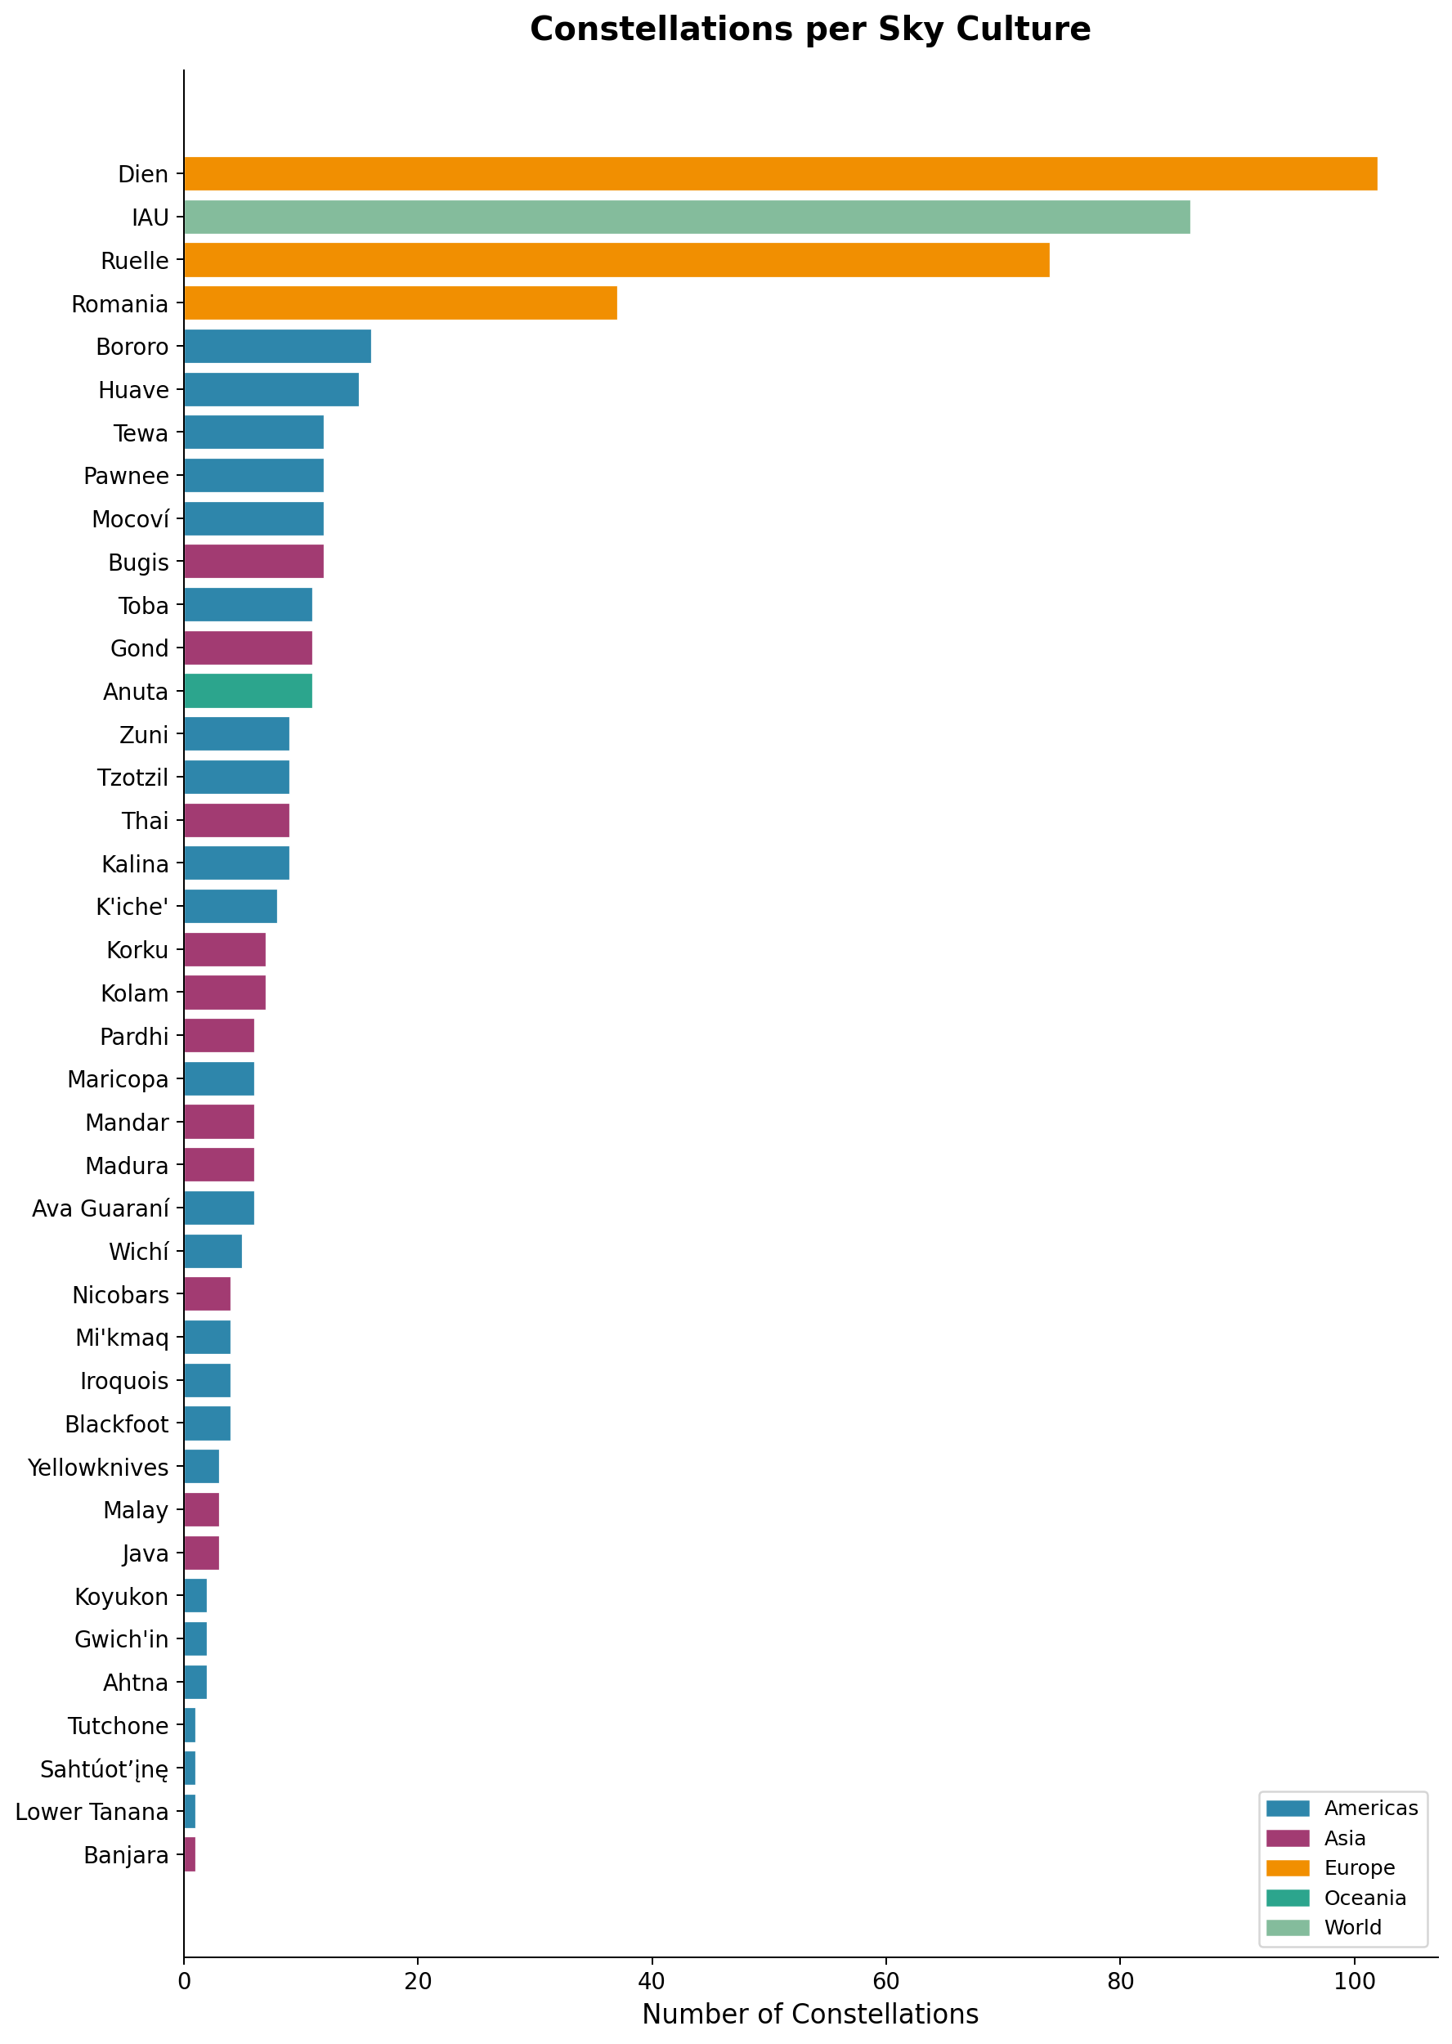
Fig. 2. Number of constellations per sky culture, color-coded by region.

3.2 Regional Distribution
A pie chart illustrates the geographic distribution of the 40 sky cultures in the dataset. The Americas are the most represented region with 23 cultures (57.5%), reflecting extensive ethnographic documentation of indigenous astronomical traditions. Asia follows with 12 cultures (30%), while Europe contributes 3 cultures with notably large constellation catalogs.
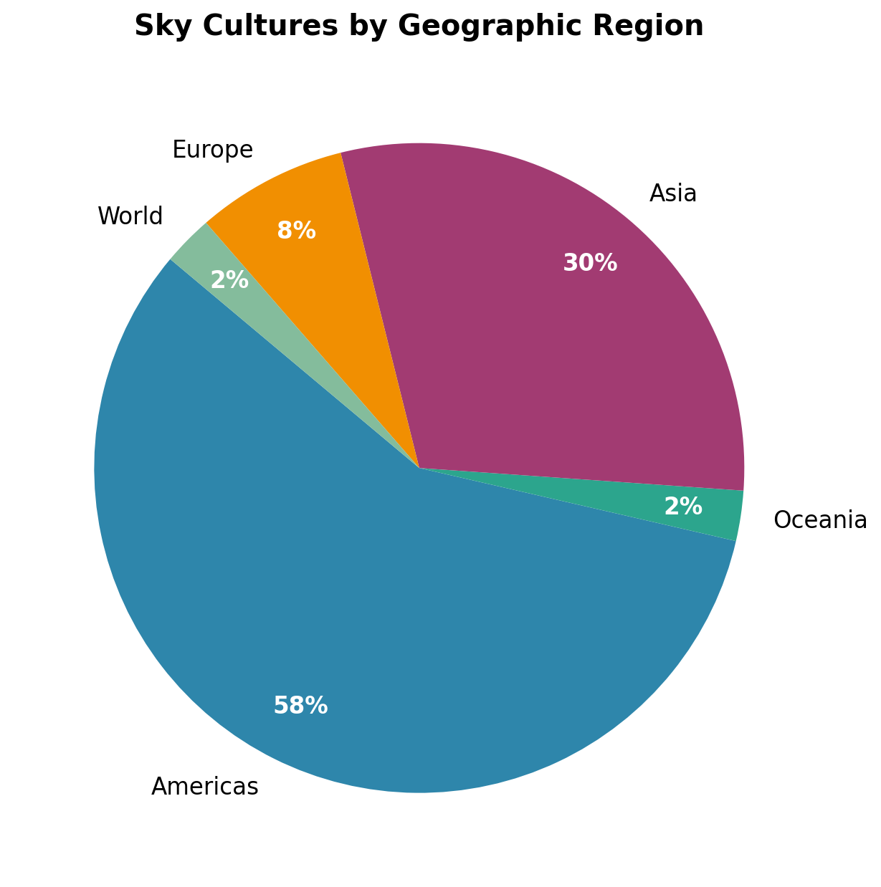
Fig. 3. Distribution of sky cultures by geographic region.

3.3 Semantic Category Analysis
A frequency analysis of the 15 semantic categories assigned to constellations reveals what types of objects and concepts different cultures project onto the sky. Man-made objects (118 occurrences) lead the distribution, followed by mammals (92) and humanoid figures (83). This analysis highlights a universal tendency to see familiar terrestrial concepts in the stars, though specific categories vary by region.
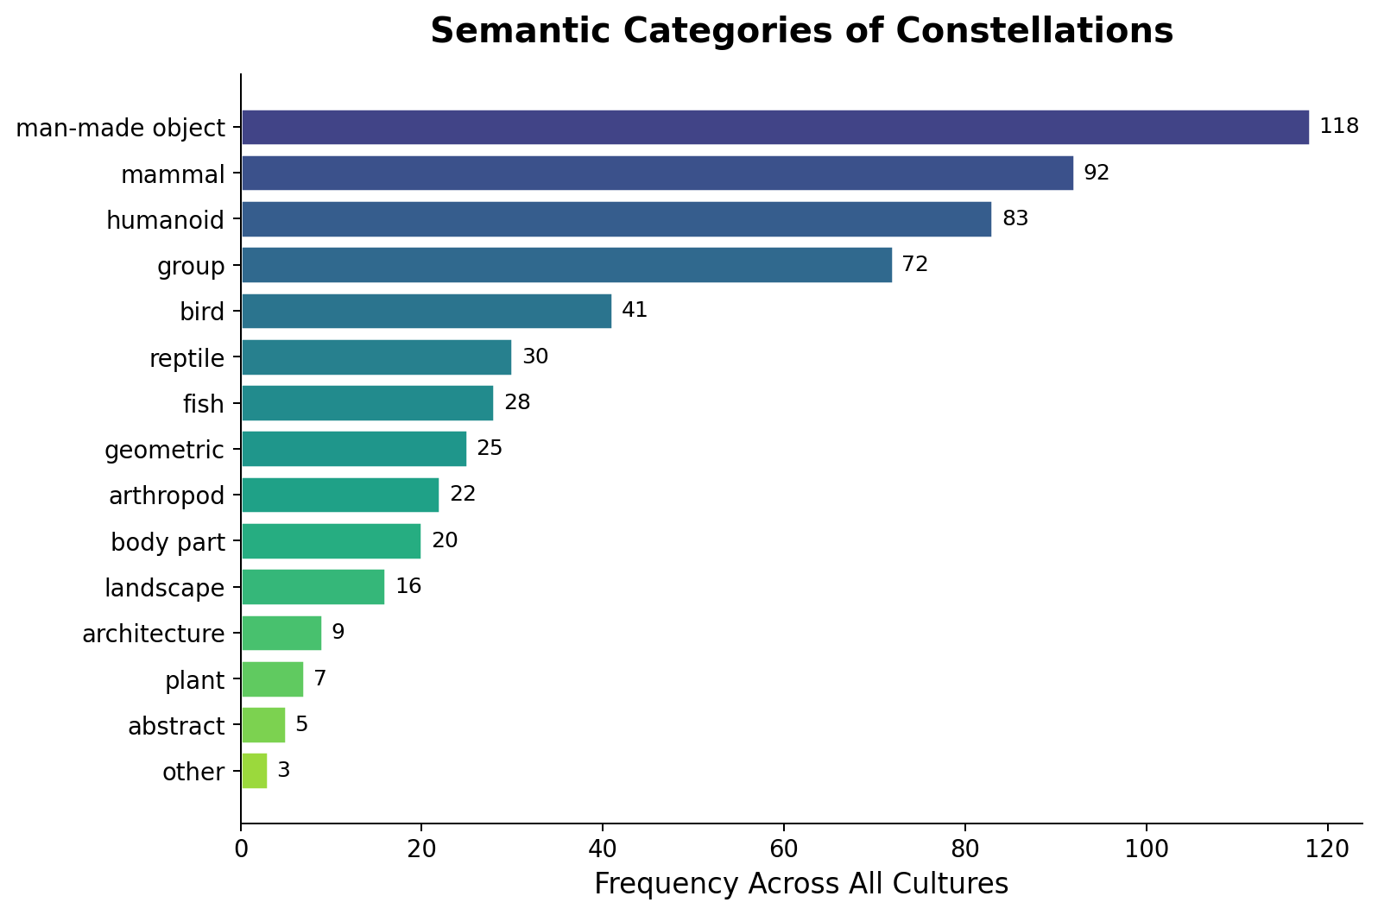
Fig. 4. Frequency of semantic categories across all constellations.

4. KEY INSIGHTS FROM INITIAL ANALYSIS
4.1 Dramatic Variation in Catalog Size
Sky cultures range from a single constellation (Banjara, Tutchone, Lower Tanana) to over 100 (Dien with 102). This variation reflects both the depth of astronomical knowledge within each tradition and the extent of ethnographic documentation. European cultures tend to have larger, more systematically recorded catalogs, while many indigenous traditions are represented by smaller but culturally significant subsets.
4.2 Regional Bias in Dataset Coverage
The Americas dominate the dataset with 57.5% of cultures, while Oceania has only one representative (Anuta). This geographic imbalance must be considered when drawing cross-cultural comparisons, as it reflects data availability rather than the actual global distribution of sky knowledge.
4.3 Universal and Culture-Specific Semantic Themes
While man-made objects, mammals, and humanoid figures appear across most regions, the relative emphasis varies dramatically. European cultures favor animal-based constellations (mammals: 61, birds: 20), while American cultures emphasize group patterns (46) and geometric forms (11). Asian cultures show unique architectural semantics not found elsewhere. This suggests that constellation naming reflects the material culture and environmental context of each society.
4.4 Constellation Complexity as Cultural Signature
The average number of stars per constellation varies from 7 (Banjara) to 67 (Lower Tanana). Some cultures with very few constellations define extremely elaborate star patterns that trace long paths across the sky, while others create many small, simple groupings. This structural diversity provides a rich basis for network-science analysis.
4.5 High Line-Figure Coverage
Fully 97% of constellations in the dataset include line figures (523 of 539), making this dataset exceptionally well-suited for network analysis. The remaining constellations are star clusters or region identifications without specific connecting lines.

5. PLANNED VISUALIZATIONS
Building on the initial analysis, we plan to develop the following advanced visualizations: interactive sky maps overlaying multiple cultures on the same star field, allowing users to toggle between traditions and compare how different cultures connect the same stars; side-by-side network comparison views showing how two or more cultures structure their constellations differently, with shared stars highlighted; semantic treemaps or sunburst diagrams showing the hierarchical distribution of constellation meanings across cultures; and a cultural similarity matrix based on shared star usage and structural features, to identify which sky traditions are most similar to each other.

6. USAGE AND CRITIQUE OF AI TOOLS
Although the core analysis and visualizations in this project were developed through our own research and programming efforts, AI tools such as large language models could have been leveraged at certain stages to further enhance the project. For instance, when working with constellation descriptions and cultural metadata across dozens of sky cultures, a language model could have assisted in summarizing or translating native cultural narratives to help identify thematic patterns more efficiently. AI-based natural language processing could also have been useful for extracting and categorizing semantic labels from unstructured text descriptions, potentially speeding up the annotation process. Additionally, tools like ChatGPT or GitHub Copilot could have been used to help debug visualization code or suggest optimizations for network layout algorithms. However, such tools come with notable limitations: they can introduce subtle inaccuracies when interpreting culturally specific content, and they lack the domain expertise needed to make informed judgments about ethnoastronomical data. There is also a risk of bias in how AI models represent non-Western cultural knowledge, since their training data is predominantly rooted in Western sources. For these reasons, any use of AI in a project like this would need to be carefully supervised, with outputs critically evaluated against the original scholarly sources to ensure accuracy and cultural sensitivity.
ACKNOWLEDGEMENTS
We would like to thank our project sponsor, Doina Bucur, for providing the constellation datasets and guidance throughout this project. We also thank the course instructors for their feedback and support.
REFERENCES
- D. Bucur. The network signature of constellation line figures. PLOS ONE 17(7): e0272270, 2022.
- K. Börner. Atlas of Knowledge: Anyone Can Map. MIT Press, 2015.
- K. Börner, A. Bueckle, and M. Ginda. "Data visualization literacy: Definitions, conceptual frameworks, exercises, and assessments." PNAS, 116 (6): 1857-1864, 2018.

