Skies Across Cultures: Visualizing Constellation Patterns
Across Different Sky Traditions
Carlos Banks, Dhruv Jore, Priyanshu Laddha, Yashkumar Burnwal

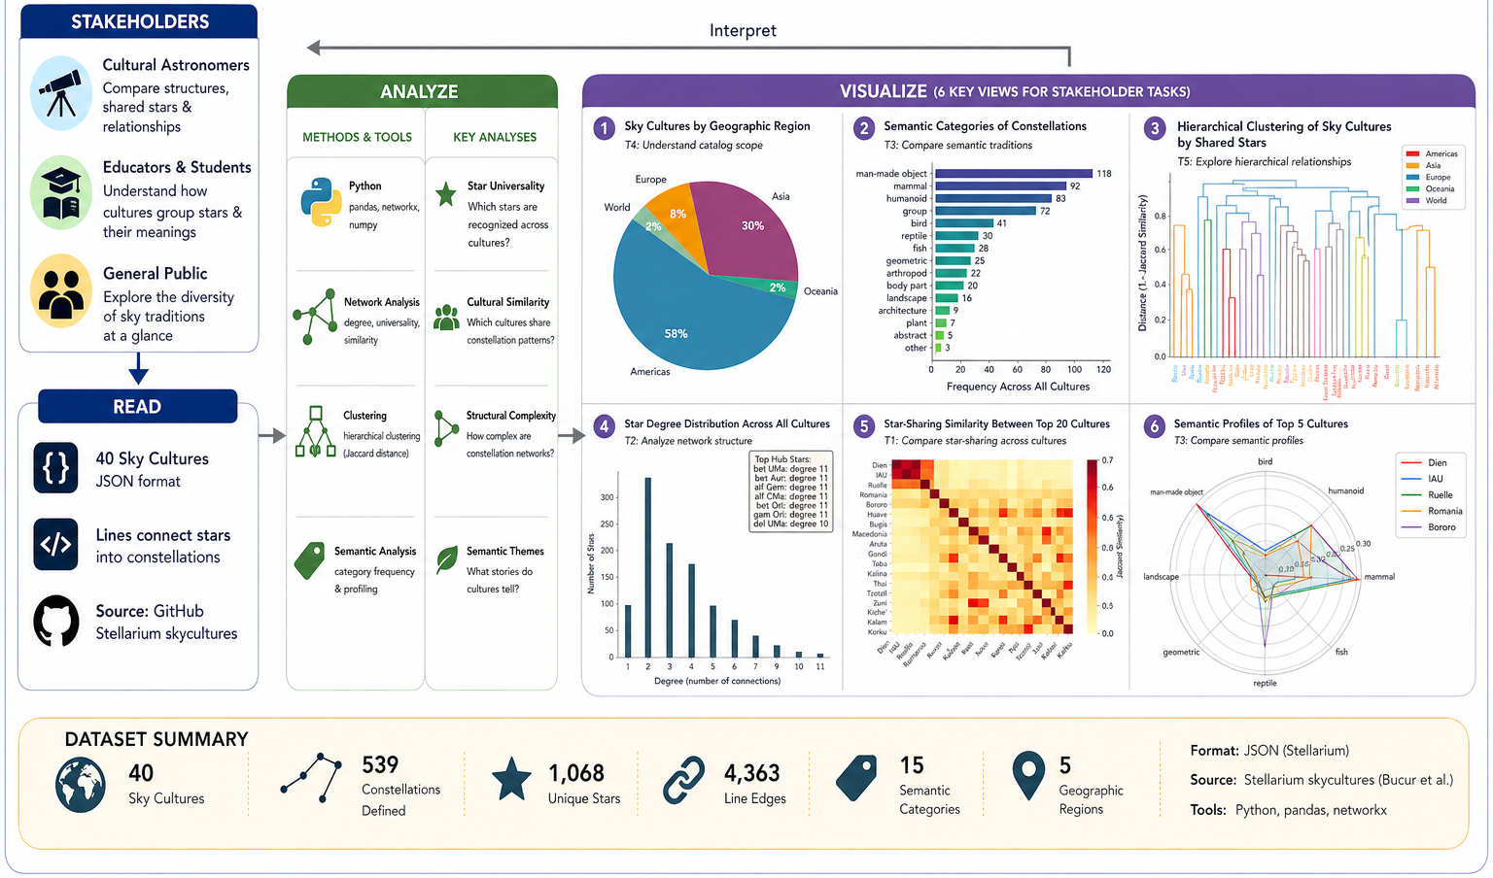
Fig. 1. Visual abstract of the project workflow, showing stakeholder groups, data sources, cleaning steps, analysis methods, six visualization views, and the dataset summary.

1. INTRODUCTION AND PRIOR WORK
This client project examines how different cultures organize stars into constellations and how those line figures can be compared as data. The same night sky can be grouped into different animals, objects, people, routes, and symbols depending on cultural tradition. Treating constellations as networks makes the similarities and differences measurable: stars become nodes and constellation line segments become edges.
The project builds on structured Stellarium sky-culture data and prior research on the network signature of constellation line figures [1]. Instead of treating the files only as drawings of the sky, the analysis combines geography, semantic labels, and graph structure. The result connects stakeholder needs to reproducible data preparation, comparative network measures, and visual explanations that work for both technical and non-technical audiences.
1.1 Stakeholder Groups
The primary stakeholders are cultural astronomy researchers, network-science researchers, educators and students, astronomy enthusiasts, and the project sponsor. Researchers need evidence about structural patterns across sky traditions. Educators and students need visuals that explain cultural variation without requiring advanced graph theory. General users need a simple way to explore unfamiliar sky cultures, while the sponsor needs a documented and extensible analysis pipeline.
1.2 Stakeholder Needs
Across these groups, the main needs are reliable comparison, interpretability, and traceability. Researchers need metrics such as shared-star similarity, graph degree, clustering, and semantic frequency. Educators need clear encodings and concise captions that explain what each chart means. Public audiences need approachable summaries and views that avoid overwhelming labels. The sponsor needs source files, scripts, and cleaning notes that make the analysis reproducible.
These needs led to four design priorities: show dataset coverage before comparison, make star-sharing relationships visible, identify culturally common anchor stars, and explain semantic categories in plain language. Limitations are stated with the results because uneven regional coverage and inconsistent star identifiers affect how confidently users can interpret each comparison.
The selected figures cover the three main reading tasks: Fig. 1 gives the project overview, Fig. 3 summarizes dataset coverage, and Fig. 6 shows the main cross-cultural similarity result. Additional graphs are summarized in Section 4.
2. DATA ACQUISITION
2.1 Data Sources
The project uses the sponsor-provided constellation-lines data derived from Stellarium sky cultures. This dataset directly supports the client question: how do cultures connect stars into meaningful constellation figures? The data contains one JSON file per sky culture, with star identifiers, constellation names, line connections, region metadata, and semantic categories. No additional web data was used.
2.2 Data Description, Quality and Coverage
The cleaned working dataset covers 40 sky cultures, 539 named constellations, 523 constellations with line figures, 1,068 unique referenced stars, 4,363 star-to-star line edges, 15 normalized semantic categories, and 5 geographic region labels. These fields provide both high-level descriptive summaries and graph-ready structures. Culture is the main unit of comparison; constellation and star are the main units for structural analysis.
Preparation steps included parsing JSON files, creating a culture-level metadata table, extracting star-to-star edge lists, standardizing region labels, normalizing semantic categories, and flagging records with missing or uncertain star identifiers. Star names sometimes use different SIMBAD-style notations, so we preserved original labels while grouping identical references where possible. We also retained counts of removed or flagged records so that the final results can be audited.
Data quality is uneven, which is expected for a cross-cultural collection. Approximately 3 percent of constellation line figures lacked usable star IDs, and the certainty field was present for only about 47 percent of constellations. The regions are also imbalanced: the Americas and Asia are represented far more heavily than Europe, Oceania, and World. These issues do not invalidate the dataset, but they require careful wording: our results describe patterns in this collection, not universal claims about all sky traditions.
The cleaning record includes parsing decisions, normalized region and semantic labels, flagged missing IDs, and the intermediate tables used to create the figures. These notes make the results easier to verify and allow the sponsor or future teams to rerun the analysis if the sky-culture files are updated.
3. DATA ANALYSIS
The analysis was organized around the project questions. Overview measures counted cultures, constellations, regions, stars, and line edges. For comparison, each sky culture was represented as a set of stars and as a graph. Pairwise Jaccard similarity measured how much two cultures share the same stars, while average-linkage hierarchical clustering converted the similarity matrix into a dendrogram. For network structure, degree distributions identified hub stars and common low-degree patterns. For meaning-making, semantic category counts summarized the kinds of objects projected into the sky.
Python, pandas, and NetworkX supported parsing, cleaning, and graph construction; SciPy supported hierarchical clustering; and matplotlib generated the static figures. These tools fit the project because constellation line figures are naturally relational and because stakeholders asked for cross-cultural comparison rather than isolated catalog summaries. The selected methods also have assumptions that can be explained clearly in captions and documentation.
The data pipeline produced three layers of output. The first layer was descriptive: counts by culture, region, and semantic label. The second layer was relational: edge lists, node degrees, and star-sharing sets. The third layer was comparative: similarity matrices, clusters, and top-culture summaries. Keeping these layers separate made it easier to explain why a visualization exists and what question it answers.
Quality checks were performed after each layer. Culture counts were compared against the number of JSON files, edge totals were checked against parsed line segments, and star-sharing matrices were inspected for symmetry. We also compared early plots with manual spot checks of several cultures to ensure that missing records, duplicated names, or unusual semantic labels were not driving the main conclusions. These checks improved confidence in the final figures and captions.
4. VISUALIZATIONS
Figures 1, 3, and 6 are included here because they cover the project overview, dataset coverage, and main similarity result. Additional graphs and code: github.
The sequence moves from overview to evidence. Fig. 1 orients the reader to the project, Fig. 3 explains sampling and coverage, and Fig. 6 presents the central comparative result. This order keeps the narrative clear before the report moves to limitations and interpretation.
4.1 Regional Distribution
The regional pie chart shows coverage in the 40-culture sample. The Americas account for 23 cultures, or 57.5 percent, followed by Asia with 12 cultures, or 30 percent. Europe contributes 3 cultures, and Oceania and World each contribute 1. This imbalance is important for interpreting later comparisons because regional representation is not uniform.
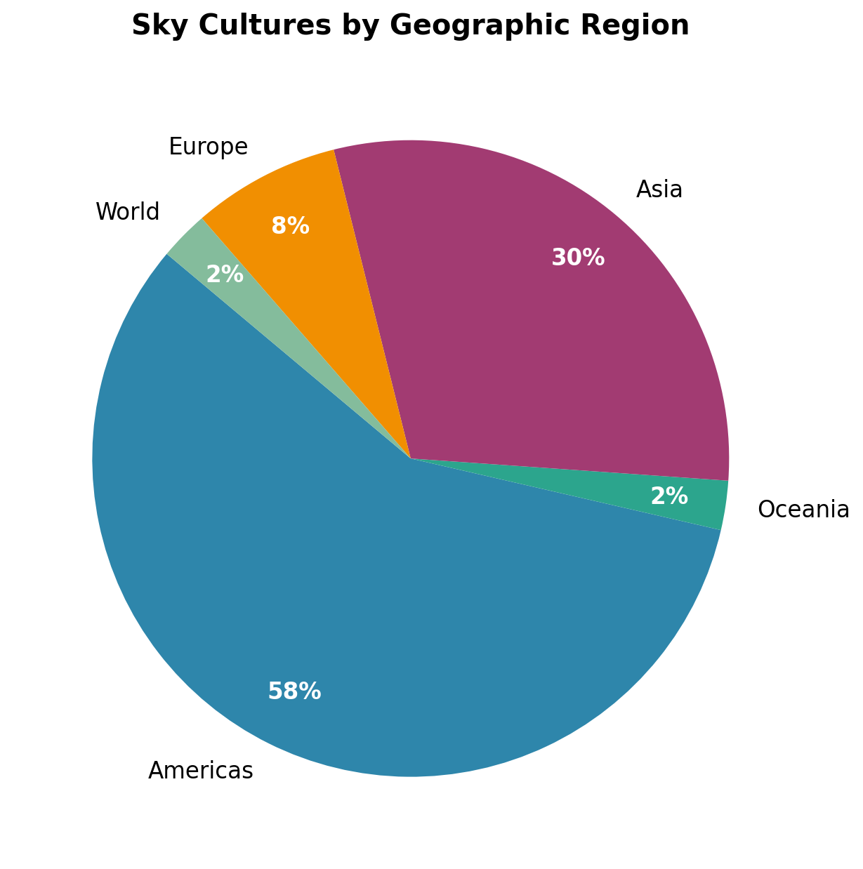
Fig. 3. Distribution of sky cultures by geographic region.
4.2 Cross-Cultural Similarity and Clustering
The dendrogram answers the core comparison question. Cultures are clustered by Jaccard similarity over shared star sets, so nearby leaves indicate traditions that use more of the same stars. Dien, IAU, and Ruelle cluster tightly, while many American and Asian cultures form smaller or more distant groups. This view exposes relationships that simple bar charts cannot show.
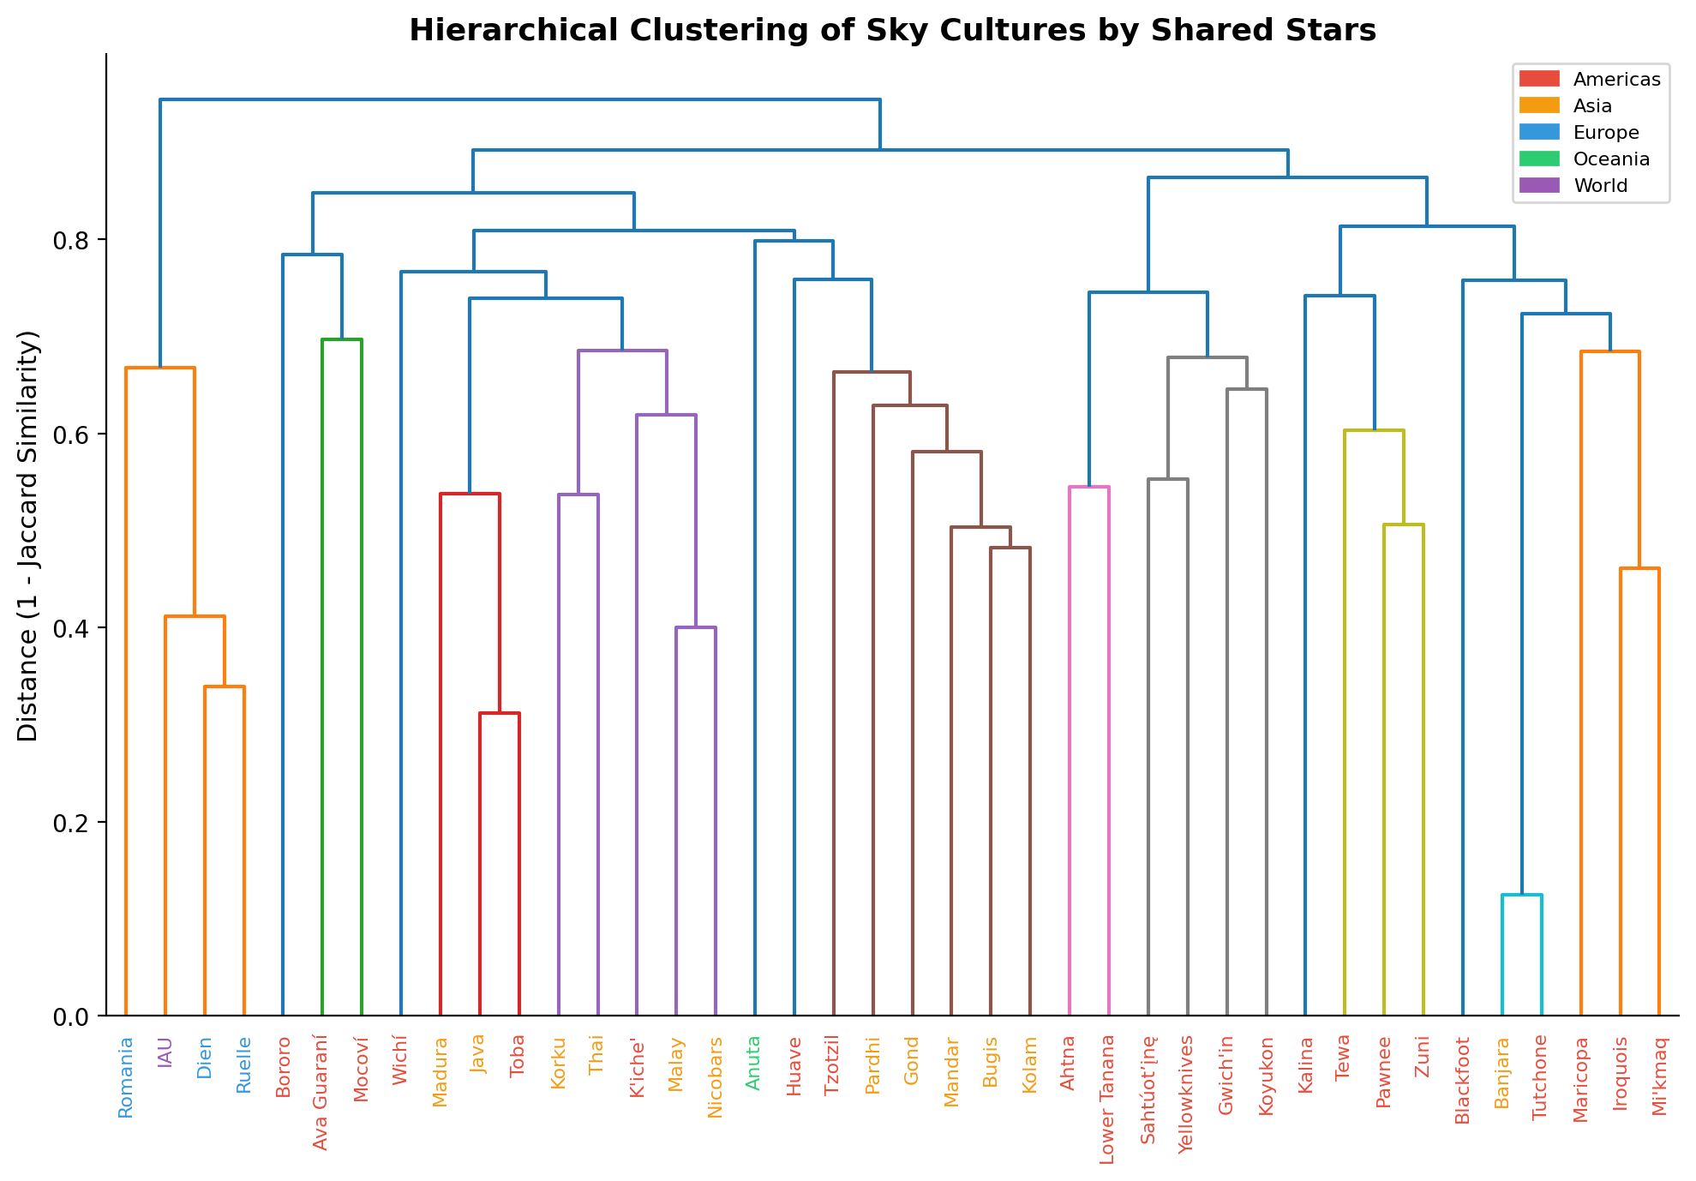
Fig. 6. Hierarchical clustering dendrogram of sky cultures based on shared star similarity.
4.3 Evaluation and Revisions
Peer and instructor feedback highlighted four issues in the initial visualization set: too much reliance on aggregate bar and pie charts, limited cross-cultural comparison, insufficient network-science rigor, and no interactive exploration path. Revisions added shared-star similarity, hierarchical clustering, star universality, graph degree distributions, complexity measures, and semantic profiles. Captions were also tightened so that each figure states the task it supports and the limitation that affects interpretation.
Additional figures documented in the repository include the constellation-count bar chart, semantic category bar chart, star-universality histogram, complexity bubble chart, network degree chart, Jaccard heatmap, and semantic radar chart. Together, these views show catalog-size variation, dominant semantic labels, anchor stars, line complexity, low-degree network patterns, top-20 similarity, and semantic fingerprints for the largest cultures.
The revised visualization set also improves accessibility and communication. Color distinguishes regions, while the text explains the patterns so that users are not required to infer meaning from color alone. Captions identify the variables, the comparison task, and the main takeaway. Interactive filters by culture, region, and semantic category would let users move from overview to detail without creating a crowded static page.
The revised set was evaluated against stakeholder tasks: can users explain dataset imbalance, identify similar cultures, and describe semantic emphasis without relying on unsupported assumptions? This task-based evaluation matters more than visual polish alone because each chart should support a clear interpretation.
5. USAGE AND CRITIQUE OF AI TOOLS
For this project, AI tools are appropriate only for low-risk support work such as checking grammar, drafting captions, checking code structure, or explaining library errors. They should not be treated as sources for cultural meaning or numerical results.
Because the dataset involves cultural traditions, translations, and uneven documentation, any AI-assisted suggestion must be checked against the original JSON files, sponsor guidance, and computed outputs. A model may invent meanings, overlook missing-certainty fields, or confuse shared stars with shared edges.
Acceptable AI uses include editing prose for clarity, identifying code-style problems, and offering interface ideas that can be tested. Unacceptable uses include inventing interpretations, replacing sponsor-provided data, or reporting unverified results. This boundary keeps the analysis accountable to the client and to the data.
6. INTERPRETATION OF RESULTS
The main result is that constellation traditions differ in both coverage and structure. Some cultures define many constellations and reuse familiar anchor stars, while others have smaller catalogs or line figures with very different connection patterns. The clustering analysis confirms that shared stars can reveal cultural proximity in some cases, especially among European traditions, but geography alone does not explain every grouping. The regional imbalance in Fig. 3 also means results should be interpreted as patterns in this dataset rather than universal claims about all sky traditions.
The visualizations improve the project by moving from descriptive summaries toward comparative, task-driven analysis. Researchers can inspect similarity and network structure; educators can explain how the same sky supports different cultural stories; and public users can begin with intuitive regional and semantic summaries. The project therefore meets the client need for a clearer bridge between raw constellation files and interpretable cultural comparison.
The supporting figures add context to this interpretation. The constellation-count chart shows that catalog size varies dramatically, from very small catalogs to more than 100 constellations in the European Dien tradition. The semantic frequency chart shows that man-made objects, mammals, and humanoid figures are the most frequent categories. The star-universality histogram shows that most stars appear in only one culture, while a small set of anchor stars appears across many traditions; Ursa Major stars such as delta, gamma, epsilon, zeta, and eta UMa appear in roughly 29-32 cultures, and Orion's belt stars are also widely shared. Together, these results show why raw counts need relational context. Complexity and network views add another layer of interpretation. The complexity bubble chart shows that a small catalog can still contain detailed constellations; Lower Tanana has only two constellations but averages about 67 stars per constellation. The combined degree-distribution chart shows many low-degree stars and a few hub stars, including Alpha Centauri A and Southern Cross stars. The top-20 Jaccard heatmap confirms the tight European block and moderate similarity among several Asian cultures, while the radar chart shows that semantic emphasis varies across major sky cultures.
Several limitations remain. The all-pairs similarity computation scales quadratically with the number of cultures, so larger future datasets may require optimized similarity search or precomputed caches. The heatmap becomes crowded beyond roughly 20 to 25 cultures, and radar charts become unreadable when too many semantic profiles overlap. Time constraints also prevented per-culture centrality measures, interactive D3 or Plotly prototypes, and a sky-map overlay that would show shared stars in their spatial context.
The most valuable future extension is an interactive dashboard that links the dendrogram, a sky-map overlay, semantic filters, and downloadable data notes. A user could select a cluster in Fig. 6, view the corresponding cultures on a sky map, compare semantic categories, and then inspect data-quality warnings. This coordinated view would serve all three stakeholder groups: researchers could perform detailed structural analysis, educators could demonstrate cross-cultural astronomy concepts, and public users could explore sky traditions intuitively.
A next evaluation round should test this dashboard with representative users. Researchers could be asked to identify similar cultures and explain the evidence; students could be asked to describe how two traditions differ; general users could be asked to find one culture and interpret its semantic profile. Success would be measured by task completion, explanation quality, and whether users correctly notice limitations such as missing certainty fields or regional imbalance.
The report and repository serve different purposes. The written report communicates the story with the figures that support the main argument. The repository contains the complete graph set, source notebooks or scripts, cleaned intermediate files, and a short README that explains how each figure was generated. This organization supports client review and future reuse.
A second recommendation is to avoid ranking cultures as more or less complex without context. Catalog size, line-edge density, semantic label coverage, and shared-star similarity measure different properties. A small catalog can still contain detailed line figures, and a large catalog can be similar to another culture only because both use bright anchor stars. The discussion should therefore compare patterns rather than imply a single cultural hierarchy.
Finally, any future public-facing version should include explanatory text for culturally specific names and meanings. Network measures are useful for comparison, but they do not replace historical or ethnographic context. The most expressive final product would combine computational comparison with careful attribution to the source sky-culture traditions.
ACKNOWLEDGEMENTS
We thank our project sponsor, Doina Bucur, for providing the constellation datasets and guidance. We also thank the course instructors and reviewers for feedback that helped shift the project from isolated charts toward comparative, stakeholder-centered analysis.
REFERENCES
1. D. Bucur. The network signature of constellation line figures. PLOS ONE 17(7): e0272270, 2022.
2. K. Börner. Atlas of Knowledge: Anyone Can Map. MIT Press, 2015.
3. K. Börner, A. Bueckle, and M. Ginda. "Data visualization literacy: Definitions, conceptual frameworks, exercises, and assessments." PNAS 116(6): 1857-1864, 2018.

