# Analysis Answers

1. How many students reported their “0.1 Extra Credit” bonus points?  
 Answer: 503 students reported their "0.1 Extra Credit" bonus points.

2. What are the mean, the min, and the max of students’ reported “0.1 Extra Credit” bonus points?  
 Answer:  
 - Mean: 0.798  
 - Min: 0.1  
 - Max: 5.0

3. Among students who reported their extra credits, what is the percentage of the students who reported no more than 1 point?  
 Answer: 73.95626242544732% of the students reported no more than 1 point.

4. What is the correlation coefficient between students’ extra credits and their final score? Is correlation positive or negative?  
 Answer:  
 - Correlation coefficient: 0.187  
 - The correlation is positive.

5. Scatter plot showing the relationship between Extra Credits and Final Score:

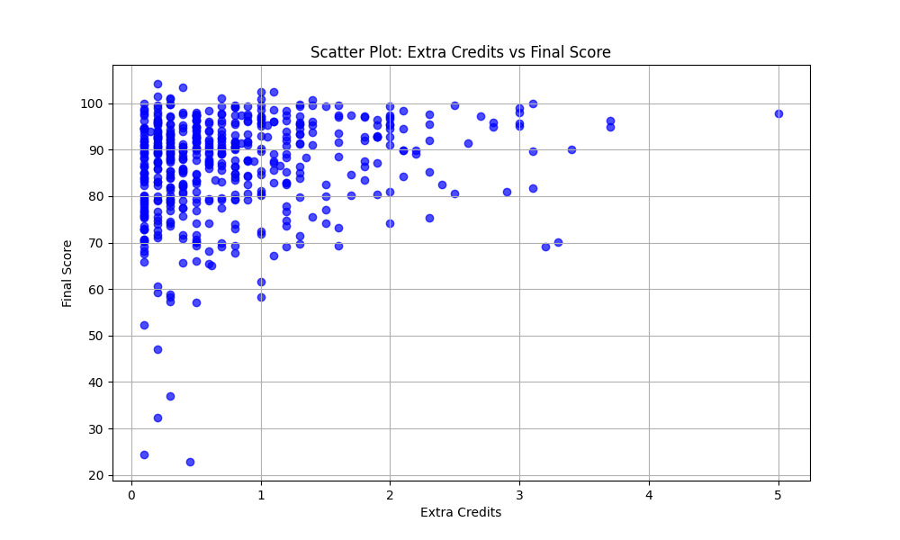

6. The linear equation that predicts a student's final score based on their extra credits:  
 Answer: Final Score = 2.79 * Extra Credits + 84.54

7. What is the root mean square error (RMSE) of the prediction of the linear regression model when the model is applied to all data samples?  
 Answer: RMSE is 10.71.

8. Scatter Plot with Regression Line:

