

**EXPERIMENT-1**

**Name-Yash Jain**

**UID-19BCS3553**

* **AIM – TO Design an LED Flasher**
* **Apparatus**: **Arduino Board, LED, Resistance - 220ohm**
* **Circuit Diagram :**



* **Theory :**
* 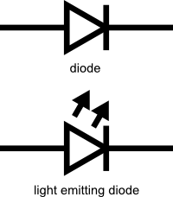LEDs are a particular type of [diode](https://learn.sparkfun.com/tutorials/diodes/introduction) that convert electrical energy into light. In fact, LED stands for “Light Emitting Diode.” And this is reflected in the similarity between the diode and LED schematic symbols:
* In short, LEDs are like tiny lightbulbs. However, LEDs require a lot less power to light up by comparison. They’re also more energy efficient, so they don’t tend to get hot like conventional lightbulbs do . This makes them ideal for mobile devices and other low-power applications.

# LED Series Resistor Circuit

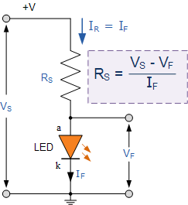

**Observations :**

LED starts Blinking after the execution of code

Delay between the Blinking is equals to 1 second

**PRECAUTIONS :**

1. Incorrect Hardware installation can cause short circuit.
2. Broken wire can cause Electric shock.

**RESULT :**

Blinking of LED was verified after uploading the program